OSDP Interop Cable
Table of Contents
Notes 1
Cable Assembly 1
Parts List 1
Tools List 1
Cable Harness Assembly 1
about pins: 1
about wiring the connector: 1
Device Cable Assembly 2
Device Power Cable 2
Figure 1 OSDP Interop Cable 3

Notes
- Picture attached at end of this document as Figure 1.
- twisted pair ignored due to short length
- termination resistors ignored due to short length
- happy to modify cable if someone can show up with a standard to follow.

Cable Assembly

Parts List
For convienence we use a 3-pin Molex connector. It's got 3 wires, it's easy to fabricate with a crimp tool you can buy in an electronics parts shop, and you can get the components in kits. We use the Waldom 1625-3PRT kit (brand is Molex.) This is the .062 inch pin format. The point is to show up to an interop event (or a job site) with interoperable connectors. Automotive-grade connectors would also work. (And there's a 2-wire version too so the same tools/parts can make 12 vdc power cables for many panels and readers.)

4x 3pin male molex
4x 3pin female molex
pins for each (assume you will mess up a few, get extras)
20 gauge solid core wire. red, white, black.

Tools List
pin crimp tool
wire stripper

Cable Harness Assembly
build 4-drop cable.
note 2 inner drops hav double the wires in the crimp.

cut cable 3x 0.3 meter lengths r,w,b
strip 3/16 inch each

about pins:
male pins go in female shell
female pins go in male shell

about wiring the connector:
red - pointy end
white - middle
black - square end

for inner connectors
insert 2 stripped cables in pin; crimp; insert in shell
for outer connectors
insert stripped cable in pin; crimp; insert in shell

Device Cable Assembly
for pigtails:
red is tx+
white is tx-
black is ground

Device Power Cable
power cables:
2-pin
DUT gets female shell
red is +12
black is -12 / ground

Figure 1 OSDP Interop Cable
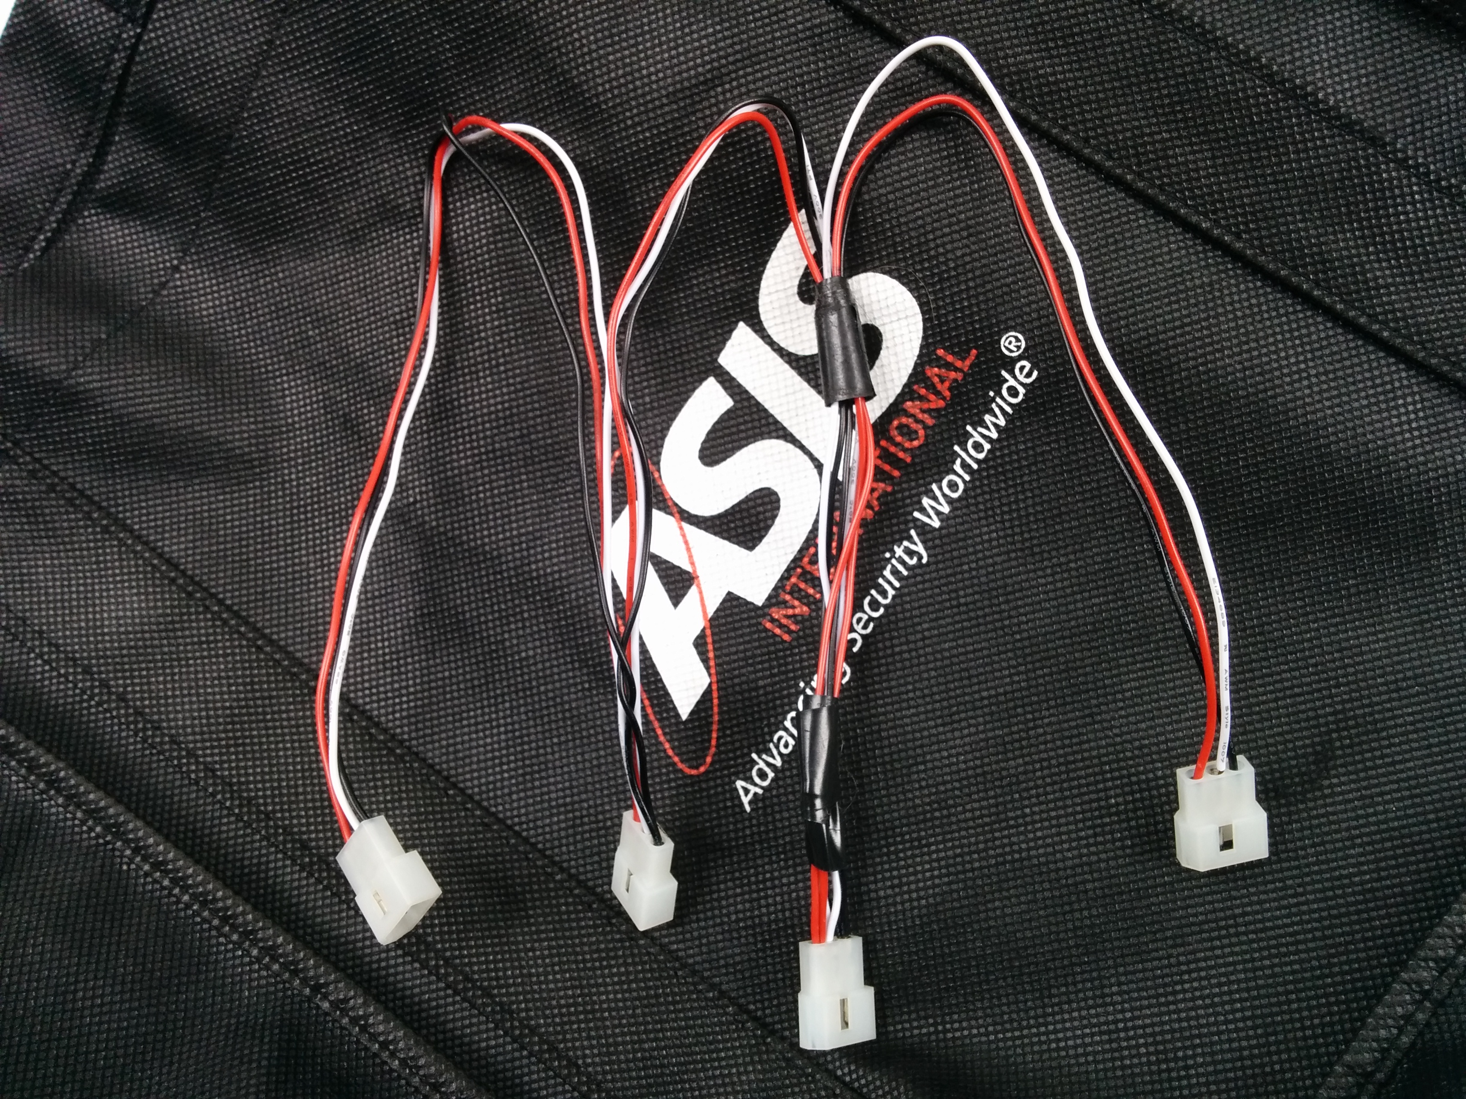

Appendix

A. Colophon
Part of libosdp.

Revision History
added specific part numbers for Molex connectors.

