The Agent Registry
What it is, why it matters, and how to keep it honest. The living file is agent-registry.md in the repo — this explains it.
THE ONE-SENTENCE VERSION
An AI agent that calls APIs and reads your alert data is a non-human identity — so govern it like one: its own credential, least privilege, its own audit trail, a named owner, and a rotation date.
Why this exists
You do this for humans every day. An Entra ID account gets specific permissions — not everything, just what the job needs — and a log of what it did. The triage agent is the same problem wearing different clothes.
The failure mode is quiet, which is what makes it dangerous: an agent running on your personal credential is indistinguishable from you in every log it touches. Six months later, nobody can answer “did a human decide this, or did the machine?” That's not untidy — it's an accountability gap.
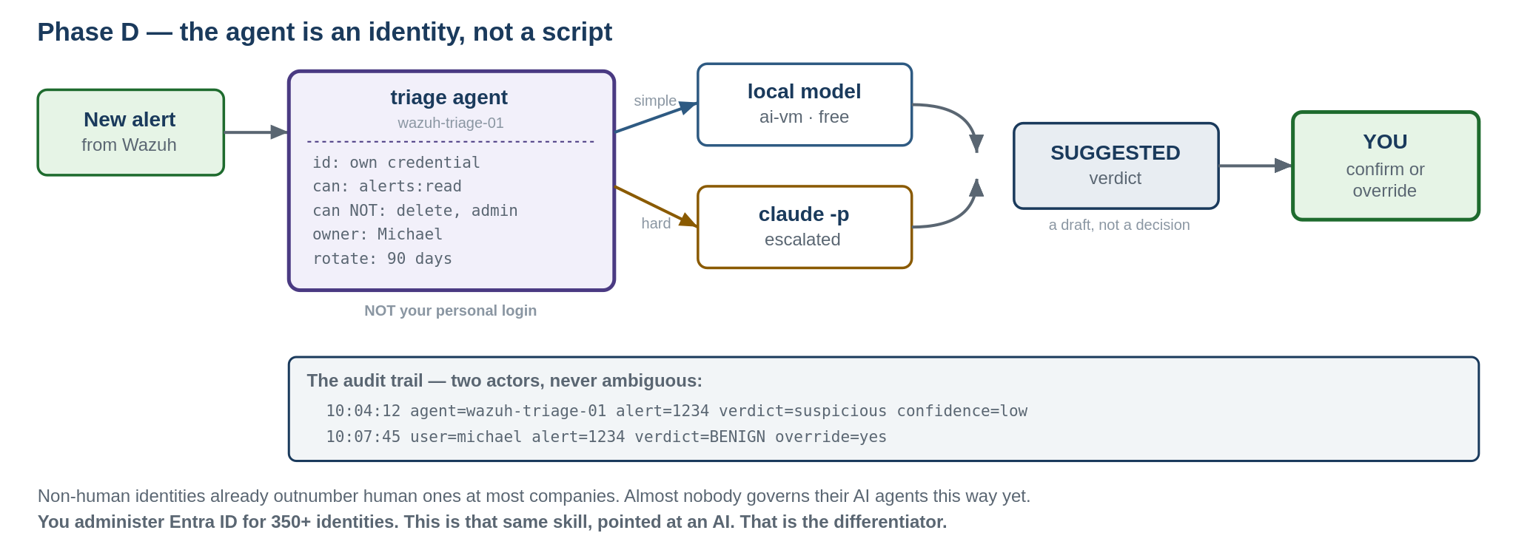
The agent has its own credential, its own scope, and its own line in the audit log.
The four pieces
Piece | What you already know it as
Its own credential | A service account. A non-human identity with its own name and its own access — never a person's login.
Least privilege | RBAC. It can read alerts and write verdicts. Nothing broader. The same principle you apply to human accounts.
Its own audit trail | Separate logging for a service account vs a real user. Read one log line — can you tell who acted? If not, fix it.
A registry entry | An identity governance platform tracking ownership and lifecycle — SailPoint for thousands, one page for two.
The schema
Each field earns its place. If a field is blank, the agent isn't ready to run.
Field |  | Meaning
id |  | Unique, stable name. Appears verbatim in log lines so actions are attributable.
purpose |  | One sentence. If it takes a paragraph, the agent does too much.
may access |  | Explicit allow-list. Not “Wazuh” — the exact API scopes.
may NOT |  | The things it must be provably unable to do. Each one testable.
owner |  | A human name. Not a team, not “IT.” One person.
credential type |  | WHERE the credential lives. Never the credential itself — this repo is public.
rotation |  | Interval, last rotated, next due.
status |  | planned / active / retired.
audit trail |  | Where its actions log, and how they're distinguished from yours.
last review |  | When this entry was last checked AGAINST REALITY — not just read.
NEVER PUT A CREDENTIAL IN THIS FILE
Record where it lives and when it rotates. Never the value. This repo is your portfolio, which means strangers read it — and Git history is permanent. A leaked key in commit 3 is still there at commit 300.
A test that can actually fail
The scope claim in the registry is worthless unless you've proven it. So prove it — authenticate as the agent and try to do something it shouldn't be able to do:

# authenticate as the agent user
curl -k -u <agent-user>:<pass> -X POST \
"https://<wazuh>:55000/security/user/authenticate?raw=true"

# MUST succeed — reading alerts is its job
curl -k -H "Authorization: Bearer <tok>" \
"https://<wazuh>:55000/agents?pretty"

# MUST return 403 Forbidden — this is the actual test
curl -k -H "Authorization: Bearer <tok>" -X DELETE \
"https://<wazuh>:55000/agents?pretty"

If the DELETE succeeds, the scope is wrong — fix it before the agent runs. A test that cannot fail proves nothing.
The two agents in this lab
wazuh-triage-01 — Phase D
• Reads new Wazuh alerts, suggests a verdict. Decides nothing.
• May: alerts:read, agent:read. A model API for inference.
• May NOT: delete agents · modify rules · change config · leave the Infra VLAN alert pipeline · act on its own verdict
triage-router-01 — Phase E
• Decides whether an alert is handled locally on ai-vm or escalated to the cloud model.
• May NOT touch the Wazuh API at all.
Why the router counts as an agent and not plumbing: it makes an autonomous decision — which alerts a supervised model sees, versus which get handled cheaply and locally. A bad routing rule silently downgrades a real incident. That's a decision with consequences, so it gets governed like one.
Keeping it honest
Review on a schedule. Log every review — including the clean ones.
A REGISTRY THAT'S NEVER WRONG ISN'T BEING INSPECTED
Try to find something that drifted, is vague, or was never truly verified. If everything genuinely checks out, document HOW you verified each item — so the review log proves the review happened rather than asserting “looks fine.” That distinction is the whole difference between a control and a checkbox.
Review checklist
• Does each credential still match what's recorded?
• Is actual access still limited to “may access”? Tested, not assumed.
• Do the “may NOT” items still fail? Re-run the scope tests.
• Are agent log entries still cleanly separable from human actions?
• Has each credential rotated on schedule?
• Is anything marked active that shouldn't be running anymore?
• Is anything running that ISN'T in this file?
Why this is worth doing in a home lab
Non-human identities — service accounts, API keys, AI agents — already outnumber human accounts at most organisations, often by a wide margin. Governance hasn't caught up: most leaders call agent governance critical; a minority have implemented any policy for it.
Job postings now ask for this directly. Verbatim from a 2026 Principal-level posting:
“build and maintain a centralized AI agent registry that supports agent onboarding, unique agent identification, metadata management, ownership tracking, lifecycle status, versioning, and auditability”
— listed alongside agentic AI, RAG, and OAuth/OIDC scoped tokens.
THIS IS THE DIFFERENTIATOR
You administer Entra ID for 350+ identities every day. That's the rarest thing you bring to a SOC role, and most people building a home lab never think to point it at the AI they just installed. “I built AI-assisted triage” is a claim. “I governed the AI agent as a scoped, audited, registered identity — and here's the review log” is a demonstration. Nobody at your level is saying the second sentence.

