SOC Lab — Lesson Plans
What you read. Two brains: the engineer who builds it, the analyst who runs it.
Which document do I actually open?
You build this WITH Claude, in chat. You run the commands, you paste the output, Claude reads it and gives you the next step. Same as the iDRAC recovery and the bridge fix — that worked, and that is the model.
File | Who reads it | When
Project instructions | Claude, every chat | Paste CLAUDE.md's contents here ONCE. Then every new chat starts knowing your hardware, IPs and gotchas.
This document | YOU | Before/during each phase, and once things are live.
Phase Checklists (Word) | YOU — printed | Beside the keyboard. Tick as we go.
Cheatsheet (Word) | YOU — printed | When you need a command, an IP, or the Recovery Ladder.
LAB-BLUEPRINT.md | shared reference | What we're building, in what order. Open it if you want the whole map.
build_log.md | YOU maintain | What changed, when, and what the output ACTUALLY said.
agent-registry.md | YOU maintain | Phase D onward. Keep it true.
You never need VS Code. The Word docs are yours; the .md files are reference.
CLAUDE CANNOT SEE YOUR SCREEN OR YOUR TERMINAL
This is the most important thing about this workflow. What you paste is ALL Claude gets. So: session recording ON, and when something looks wrong, paste the WHOLE output — not your summary of it. The line you would think to leave out is usually the one that matters. Claude in Chrome can see browser tabs (Proxmox, pfSense, Wazuh); it cannot see PuTTY, BIOS, or a VM console.
How to use this document
• Read a module when its phase is about to start — or right after. Don't binge ahead; concepts land better attached to something you just watched happen.
• Lesson Plan 1 (engineer) explains what got built and why. Lesson Plan 2 (analyst) starts once something is running.
• Every module ends with a checkpoint. The bar is: say it out loud, cold, without notes. That's the only honest test.
• Diagrams throughout. If a diagram makes a module unnecessary, the diagram wins — look at it and move on.
WHY THE CHECKPOINTS MATTER MORE THAN THE LAB
You could get through this by pasting whatever Claude says and never reading a word of it. You would end up with a working lab and nothing to say about it. The checkpoints are the difference between "I built a SOC lab" (a claim anyone can make) and being able to explain, cold, why a SPAN port has no IP address. One of those gets you hired.

The Big Picture
Before any module — this is what you're building and why it hangs together.
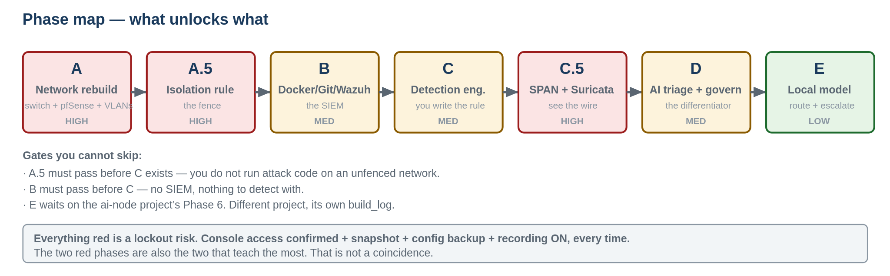
Phases A through E. Red = lockout risk. The two riskiest phases teach the most.
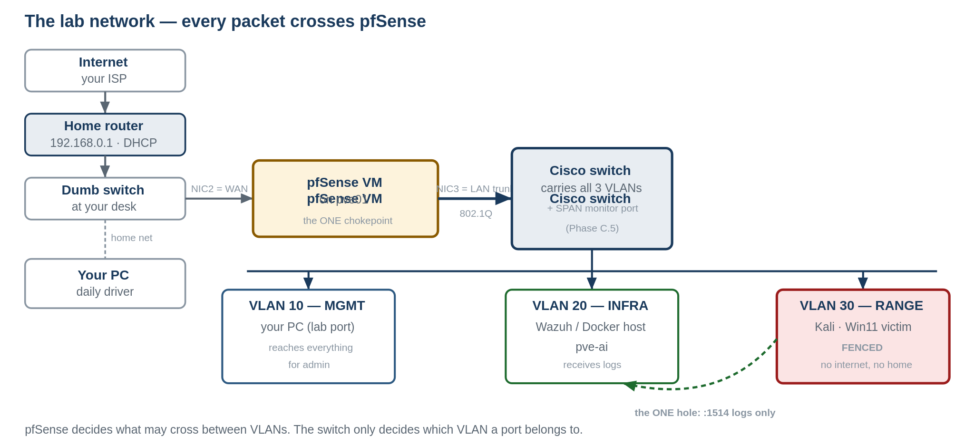
The lab network. Every packet between VLANs crosses pfSense — that's the whole design.
Two ideas carry the entire build:
• The switch decides which VLAN a port belongs to. pfSense decides whether traffic may cross between VLANs. Those are different jobs — that's why you need both.
• The Range VLAN is fenced so you can attack it on purpose. Everything downstream — running real attack code, disabling Defender, generating real malicious traffic — is only safe because that fence exists.

Lesson Plan 1 — The Builder
What got built, and why. Read alongside each phase.
Module 0 — Before Phase A: bridges, and why Kali went dark
You already lived this one, which makes it the best place to start.
Proxmox turns one physical server into many virtual ones. The part that trips everyone: a VM's network card isn't plugged into anything physical. It's plugged into a bridge — a software switch inside Proxmox. The bridge is then tied to a real NIC.
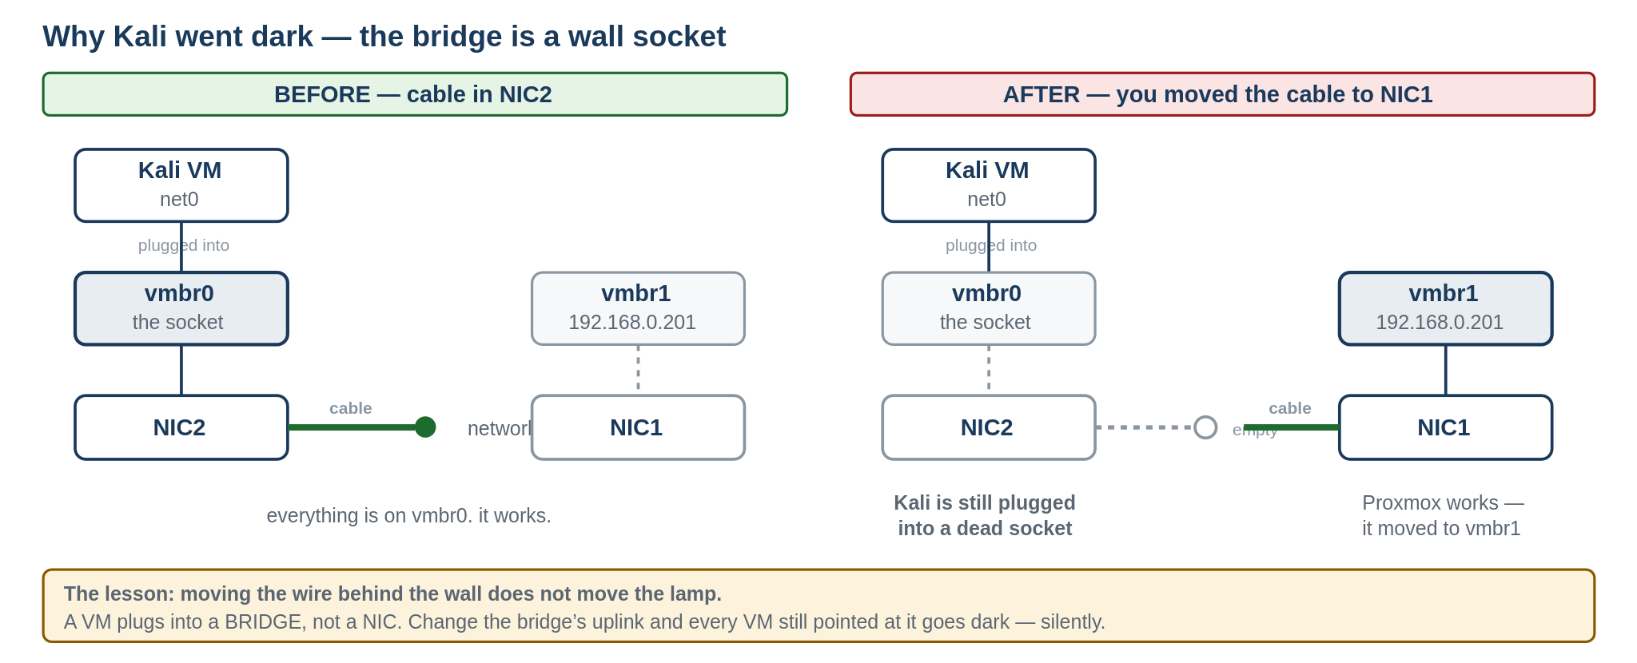
The bridge is the wall socket. The NIC is the wire behind the wall. The VM is the lamp.
Move the wire behind the wall to a different socket, and the lamp plugged into the old socket goes dark — even though nothing about the lamp changed. That is exactly what happened to Kali when you moved the cable from NIC2 to NIC1: Proxmox's own management followed to vmbr1, but Kali was still plugged into vmbr0, which now had no uplink.
THE TWO GOTCHAS THIS EXPLAINS
(1) Two bridges can claim the same IP simultaneously — the kernel can't decide which should answer ARP, so pings silently fail even though everything "looks" configured. (2) Moving a cable or bridge orphans every VM still pointed at the old one, with no error message. Check every VM's Hardware tab after any bridge change.
CHECKPOINT — say it out loud. Can't? Re-read this module.
In your own words: why did Kali lose network after the NIC1/NIC2 cable swap? Use the socket idea.

Module 1 — Phase A: VLANs, and why pfSense sits in the middle
A VLAN makes one physical switch behave like several separate switches. Devices on different VLANs can't talk to each other by default, even plugged into the same box — the switch tags traffic with a VLAN ID and keeps it apart.
Why this matters here: Kali is about to attack a Windows VM on purpose. Without VLANs, that traffic shares a broadcast domain with your management PC and your home network. VLANs are the fence.
Trunk vs access port
• An access port belongs to exactly one VLAN. Your PC's lab port is an access port on VLAN 10 — full stop.
• A trunk port carries multiple VLANs at once, each packet tagged. NIC3 is a trunk because it has to carry Management, Infra and Range to pfSense over one wire.

# the two commands that tell you if it actually worked:
show vlan brief # do my VLANs exist?
show interfaces trunk # is the trunk actually trunking?

Why pfSense specifically
VLANs only control which broadcast domain traffic lives in. They don't decide whether traffic may cross between domains. That's a firewall's job. pfSense has a leg in each VLAN and enforces what's allowed across.
CHECKPOINT — say it out loud. Can't? Re-read this module.
What's the difference between a VLAN and a firewall rule — what does each actually control, and why do you need both?

Module 2 — Phase A.5: default-deny
Two philosophies:
• Default-allow, block known-bad: everything passes unless specifically blocked. Fast to set up, fragile — you only block what you thought of.
• Default-deny, allow known-good: nothing passes unless explicitly allowed. Slower, but an attacker (or a misbehaving test) can't reach anywhere you didn't name.
The Range VLAN rule is default-deny: block everything, then poke exactly one hole — to Wazuh's log port. You're not trying to anticipate every bad outcome. You're only trusting what you explicitly named.

# pfSense rules evaluate TOP-DOWN. First match wins. Order is everything.
Rule 1: PASS RANGE net -> <wazuh IP>:1514 # the one hole
Rule 2: BLOCK RANGE net -> any # everything else dies

IF BLOCK IS ABOVE PASS
Nothing gets through, ever. And if you write a Block rule on the interface you manage pfSense FROM, you lock yourself out — that is the single most common self-inflicted outage in this whole build. Read the rule twice before applying.
CHECKPOINT — say it out loud. Can't? Re-read this module.
If Atomic Red Team tried to reach an external IP mid-simulation, what happens under this rule — and why?

Module 3 — Phase B: containers vs VMs
A VM virtualises an entire computer — kernel, drivers, the lot. That's why VMs are heavy: each one boots a full OS. A container shares the host's kernel and packages only the application plus what it directly needs.
That's why a container starts in seconds and a VM takes minutes: a container isn't booting an operating system, it's launching a process in an isolated pocket of one that's already running.
So Wazuh's manager, indexer and dashboard run as three containers on one Ubuntu VM — not three VMs. They're three isolated processes, not three computers.

# Docker Compose = a text file describing the desired end state
docker compose up -d # build it all, detached
docker compose ps # what's actually running?
docker compose logs -f # why is it unhappy?

THE VOLUME MOUNT THAT MATTERS
Wazuh's rules live INSIDE the manager container by default — which means a rebuild wipes them, and you can't commit them to Git. Mounting ./config/rules/local_rules.xml from the host is what makes your detections survive rebuilds AND become a portfolio artifact. That one line in docker-compose.yml is the difference between a lab and a portfolio.
CHECKPOINT — say it out loud. Can't? Re-read this module.
Why does Wazuh's manager/indexer/dashboard make more sense as three containers on one VM than three separate VMs?

Module 4 — Phase B: what Git is actually for
Git tracks changes over time, not just copies. Every commit is a snapshot with a message explaining what changed and why.
The value isn't recovery. It's history you can point at in an interview: "here's the detection rule I wrote, here's why I changed it two days later when I found it was too noisy." That sentence is worth more than any bullet on a resume, because it shows judgment over time rather than a one-off.

git status # what's changed?
git add config/rules/local_rules.xml
git commit -m "detect: T1059.001 - tighten to reduce FP on admin scripts"
git push
git log --oneline # your story, compressed

Read that commit message again. It says what, why, and what you learned. That's the artifact.
BEFORE YOUR FIRST PUSH
Is there anything in these files you'd rather not publish? Credentials, keys, internal IPs? Check now. Git history is permanent, and this repo is your portfolio — which means strangers will read it.
CHECKPOINT — say it out loud. Can't? Re-read this module.
Why is "here's my Git history — the rule, the false positive I found, the fix" a stronger interview story than "I wrote a detection rule"?

Module 5 — Phase C: what a SIEM actually does
Wazuh does three things: collects logs from many sources, normalises them into a common format so different log types can be compared, and matches them against rules to generate alerts.
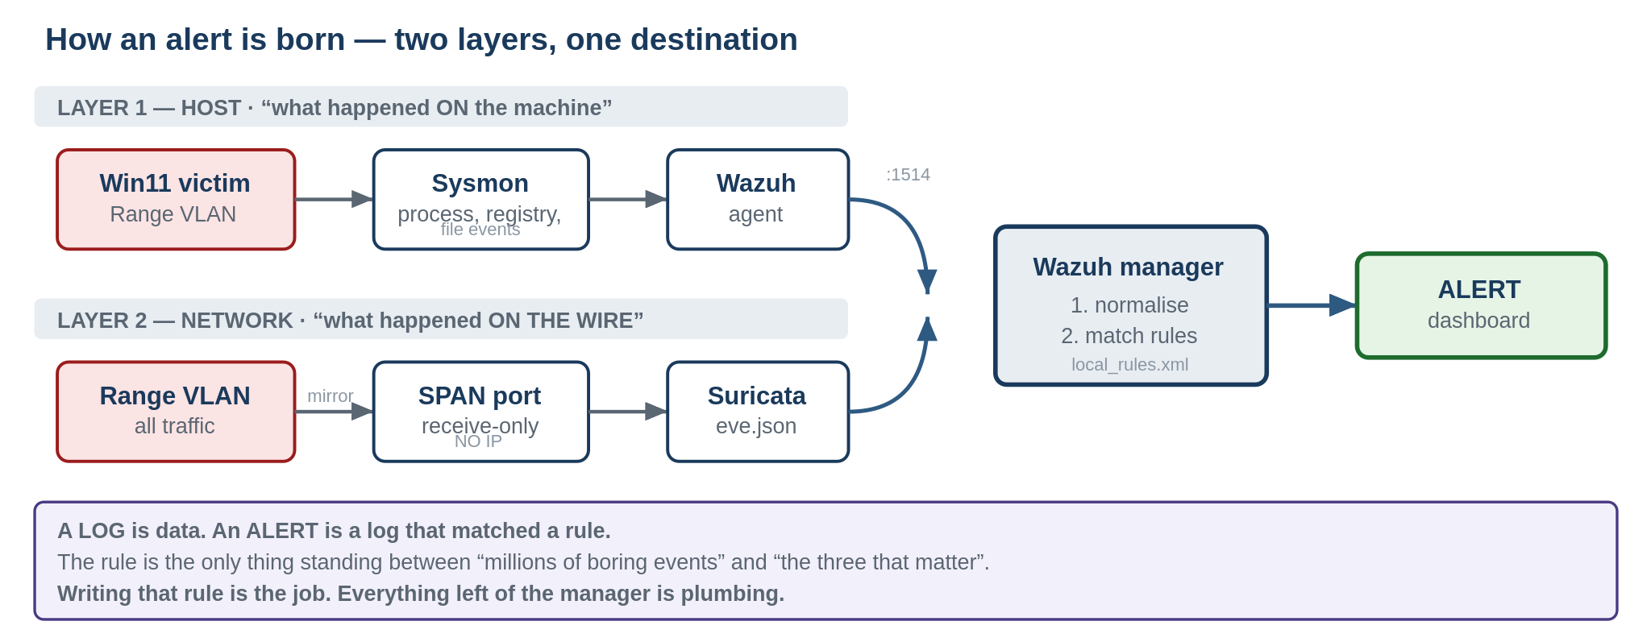
A log is data. An alert is a log that matched a rule. The rule is the only thing in between.
Atomic Red Team exists so you can generate a known attack pattern on demand and confirm your rule actually catches it. Attacking your own lab isn't the point — proving your detection works is.

# on the Win11 victim (ART runs ON the box you want telemetry from):
Invoke-AtomicTest T1059.001 -ShowDetailsBrief # read before you run
Invoke-AtomicTest T1059.001 -GetPrereqs
Invoke-AtomicTest T1059.001
Invoke-AtomicTest T1059.001 -Cleanup # always

DEFENDER WILL QUARANTINE THE ATOMICS FOLDER
That's Defender working correctly — it's real attack tooling. You'll add an exclusion for C:\AtomicRedTeam, which is only acceptable because that VM is fenced on the Range VLAN. Phase A.5 is what makes Phase C safe. If you ever find yourself disabling AV on a box that isn't fenced, stop.
CHECKPOINT — say it out loud. Can't? Re-read this module.
What's the difference between a log and an alert — and what has to happen for one to become the other?

Module 6 — Phase C.5: two kinds of visibility
Sysmon tells you what happened on a machine — a process ran, a registry key changed. Suricata, fed by a mirrored (SPAN) port, tells you what happened on the wire — connections, beaconing, tunnelling — regardless of whether the endpoint is logging anything at all, or even has an agent.
Why mirror instead of just plugging Suricata into the network
A SPAN destination port only receives a copy of traffic. It doesn't participate in the network otherwise. That's why it gets no IP address — it's a passive tap, not a network citizen. This is exactly how enterprise SOCs get network visibility without an agent on every device.

monitor session 1 source vlan 30
monitor session 1 destination interface <port>
show monitor session 1

# on the Wazuh host — the tap gets NO IP:
sudo ip link set <iface> up
sudo ip link set <iface> promisc on
ip addr show <iface> # MUST show no inet address

THE SKILL THIS BUILDS
Correlating both layers. "Sysmon says this process ran" AND "Suricata says that host then called out to a strange IP" is a far stronger signal than either alone. Recognising that two alerts are one story is what separates an analyst who reads alerts from one who builds an incident picture.
CHECKPOINT — say it out loud. Can't? Re-read this module.
If an attacker compromised a device with no Sysmon and no agent at all, how would Suricata still have a chance of catching it?

Module 7 — Phase D: what AI triage actually means
An AI reading a Wazuh alert and producing a plain-English verdict is not the same as the AI deciding anything. You are the analyst of record. The AI's output is a first draft of judgment, not a replacement for it.
This mirrors exactly where the SOC analyst job is going: reviewing and confirming machine-generated verdicts rather than reading every raw log by hand. Tier 1 is becoming a verdict queue. The person who can supervise the machine — and catch it when it's wrong — is the one who stays employed.
CHECKPOINT — say it out loud. Can't? Re-read this module.
Why does "the AI flagged it as malicious" need a human verdict logged next to it, rather than standing alone as the final answer?
Module 7.5 — Phase D: governing the agent as an identity
You do this for humans every day. An Entra ID account gets specific permissions — not everything, just what the job needs — and a log of what it did. Apply the same discipline to the triage agent instead of a human, and you get agent-identity governance.
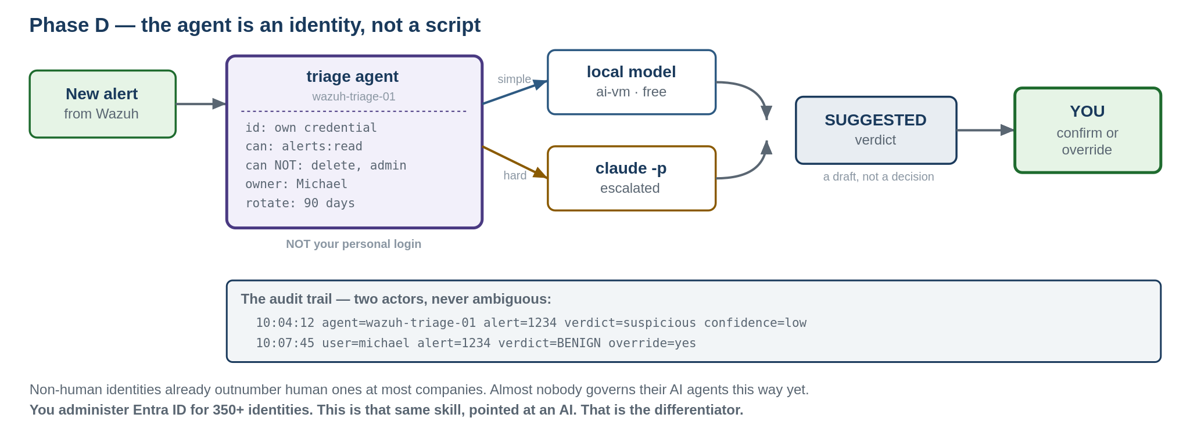
The agent has its own credential, its own scope, and its own line in the audit log.
The four pieces, mapped to what you already know
• Its own credential — never yours. Same idea as a service account: a non-human identity with its own name and access.
• Least privilege — it can read alerts and write verdicts, nothing broader. The same RBAC principle you already apply at work.
• Its own audit trail — every agent action logs as the agent, never blended with your actions. Test it: read one log line. Can you tell who acted?
• A registry entry — what it is, what it may touch, who owns it, when the credential rotates, whether it's still active. An identity governance platform in miniature.
A TEST THAT CAN ACTUALLY FAIL
Get a token as the agent user and try to DELETE an agent via the Wazuh API. It should return 403 Forbidden. If it succeeds, your scope is wrong. A test that can't fail proves nothing — this one can.
CHECKPOINT — say it out loud. Can't? Re-read this module.
In terms of least privilege and audit trails, why would the agent using your personal Claude login be a governance gap — not just a style preference?

Module 8 — Phase E: local vs cloud, and why route between them
A local model on the RTX 3070 costs electricity, not per-request fees, and keeps data on your network — good for routine, high-volume triage. A larger cloud model costs more per call but reasons better about ambiguous or novel situations.
The router's job is deciding which alerts are routine enough for the local model and which deserve the better model's attention. That "escalate only when needed" pattern is itself an architecture decision worth explaining in an interview — it shows you think about cost and capability, not just whether something works.

curl http://192.168.0.203:11434/api/tags # is Ollama alive?

THE ROUTER IS A SECOND AGENT
It makes autonomous decisions — which alerts escalate. That's an agent, not plumbing. It gets its own entry in agent-registry.md: scope, owner, credential, lifecycle, review date. Same treatment as the first one.
CHECKPOINT — say it out loud. Can't? Re-read this module.
Give one example of an alert you'd trust the local model to triage alone, and one you'd want escalated — and explain what makes the difference.

Lesson Plan 2 — The Operator
Starts once something is running. This is where you practise being the analyst.
THE WRITEUP IS THE POINT
Every module here ends with a short investigation writeup committed to the repo. Over weeks those become a running log of real analytical work — exactly what a hiring manager wants linked from a resume, and exactly what "I built a home lab" alone can't demonstrate. The lab proves you can build. The writeups prove you can think.
Writeup format — every time. Half a page is plenty.

What happened — plain language
What I saw — the actual alert / log evidence
My verdict — malicious / benign / needs more info, and WHY
What I'd do next— contain / escalate / tune the rule / ignore

investigations/2026-07-15-atomic-t1059.md

Module 1 — Reading raw logs before you trust an alert (after Phase B)
Before touching the dashboard, look at a few raw Sysmon events directly. Get comfortable with what a process-creation event actually contains: parent process, command line, user context, timestamp.
This matters because an alert is somebody else's interpretation of a log. You want to be able to check that interpretation, not just trust it.
Exercise: find one boring process-creation event and one that looks unusual — even if nothing flagged it. One sentence on what made the second one stand out.
No writeup. This is a warm-up.
Module 2 — Your first triage (after Phase B acceptance)
Wazuh will generate baseline alerts from normal Windows activity. That's real life, not a flaw. Most alerts in any SOC are benign noise — and telling noise from signal is the actual Tier 1 skill.
Walk through: what triggered it, what the underlying log looks like, whether the activity makes sense given what you know is running, and whether you'd escalate, dismiss, or need more data.
Writeup: one real alert Wazuh generated on its own. Full format.

Module 3 — Catching a known attack (after Phase C)
This is the heart of detection engineering: run a known technique, see if your rule catches it, and if it doesn't, work out why not. Attack, observe, tune, re-attack. That loop is what "writing detections" means day to day — far more than writing a rule from scratch.
Exercise: run the same atomic twice — once before your custom rule exists, once after. Compare what Wazuh shows.
Writeup: the technique (name the ATT&CK ID), what your rule looks for, and the before/after difference.
Module 4 — Correlating host and network (after Phase C.5)
Once Suricata is live you'll sometimes get two alerts for one incident — one host-based, one network-based. Recognising "these are the same story" is what separates an analyst who reads alerts in isolation from one who builds an incident picture.

# from Kali — a real network attack, not an atomic:
nmap -sS -p- <win11-victim-ip>

Writeup: both alerts side by side, and why they're one incident rather than two.

Module 5 — Reviewing an AI verdict, not accepting it (after Phase D)
Practise deliberately: read the AI's suggested verdict, then form your own opinion before reading its full reasoning — then compare. Sometimes you'll agree. Sometimes you'll catch something it missed, or it catches something you missed. Both are useful data about where the tool is strong.
IF YOU NEVER DISAGREE, SOMETHING IS WRONG
Find at least one alert where your read differs from the AI's, even slightly. If you can't after several, that's worth noting too — either the tool is well-calibrated for that alert type, or you're anchoring on its answer instead of forming your own first. Be honest about which.
Writeup: the alert, the AI's verdict, your independent verdict, and — if they differed — which was actually right and why.
Module 5.5 — Auditing the agent, not just the alerts (after Phase D)
Module 5 reviews what the AI concluded. This one reviews what the AI is, and what it's allowed to be.
An agent's real behaviour drifts from its scope — through a config change, an expanded permission, a credential that should have rotated and didn't. Catching that drift is its own analyst skill, and it's the thing most teams aren't doing yet for AI agents.
This is where your IAM background becomes a security-operations skill on paper: you're running a miniature access review against a non-human identity. The same discipline you'd apply to a service account at work — now framed as a SOC control, not an IT chore.
Exercise — check agent-registry.md against reality
• Does the credential still match what's recorded?
• Is actual access still limited to what the registry claims — read alerts, write verdicts, nothing more?
• Are agent log entries still cleanly separate from your human actions?
• Has the credential rotated on the schedule you wrote down?
A REGISTRY THAT'S NEVER WRONG ISN'T BEING INSPECTED
Try to find at least one thing that's drifted, is vague, or was never truly verified. If everything genuinely checks out, document HOW you verified each item — so the writeup proves the review happened rather than just asserting "looks fine".
Writeup: treat any mismatch as a finding — what the registry claimed, what you found, why the gap matters, how you'd close it.

Module 6 — Working with a local model's limits (after Phase E)
Notice where the local model is confident and fast versus where it hedges or gets a low-severity alert wrong. That's not a flaw to hide — it's exactly the judgment a security-analyst-plus-AI role requires: knowing when to trust automation and when a case needs escalation.
Exercise: deliberately send it one alert type it handles well and one it struggles with. You may need to try several to find the struggle case.
Writeup: describe the routing rule you'd write from this observation — what stays local, what escalates, why.
Ongoing — the standing habit
After any real triage, if it's the least bit interesting, write it up. The lesson modules are training wheels. The goal is doing this instinctively once the lab is just... running.
The final test
For any phase, out loud:
1. What did I build?
2. What problem does it solve?
3. What went wrong while building it?
4. How did I fix it?
QUESTION 3 IS THE ONE THAT MATTERS
Interviewers lean on it hardest, and it's the one candidates smooth over. Don't. The pfSense lockout that cost a full reinstall. The duplicate-IP ARP failure that made pings vanish with no error. The orphaned bridge that took Kali offline silently. Those are the answers that sound like somebody who has actually done the work — because you have.
If you can do that for every phase, the lab has done its job — whether or not it's still running six months from now.

