 | 
February 2013 Volume 9, Number 7 | Monthly ENewsletter of Maine Department of Education
“Extraordinary claims require extraordinary evidence.” ~Carl Sagan | This month’s edition of Literacy Links examines the fifth of the six critical instructional shifts required of the Common Core State Standards for ELA— evidence based responses, often referred to as writing from sources. Spotlight on… Evidence Based Responses/Writing from Sources One of the strongest characteristics of proficient readers and writers is their ability to locate and use evidence from text sources. According to the National Assessment of Educational Progress, the ability to cite evidence differentiates strong from weak student performance. A pivotal shift required of the Common Core State Standards is the emphasis on students gathering evidence from their reading and using this evidence to support their writing about their reading, as well as their writing of arguments, informational text, and even narratives. The demand for evidence can be thought of as “reading like a detective and writing like a reporter” (ACHIEVE the Core). “Writing from sources is, in general, analytical writing in response to literary and informational texts. This might be writing an opinion about a book, an analysis of a story’s characters, or writing an informational piece from social studies or science texts” (Oregon Department of Education, 2012). When students read closely and engage with text, they identify evidence to support conclusions drawn from text. An evidence-based response includes multiple sources beyond print text including evidence gathered in conversation, presentations, and a variety of media. This shift will mean changes for instructional emphasis across the K-12 span. The CCSS stress argument and informative writing over narrative writing as students advance through the K-12 span. “Further, the standards promote the type of argument and informative writing that is tied closely to texts, deriving its content from the texts. Logical arguments are supported with evidence from texts; explanations are developed with evidence from texts” (Oregon Department of Education, 2012). This shift is balanced by a decrease across K-12 in the amount of time spent writing narratives, and de-emphasizes the use of decontextualized prompts that require no reference to texts, such as ‘What is your favorite after school activity?’” (Oregon Department of Education, 2012; CCSS, 2010). Why is this shift critical to college and career readiness? According to ACHIEVE the Core, “Most college and career writing requires students to take a position or inform others citing evidence from the text, not provide a personal opinion. Across the grades, and even across the content areas,

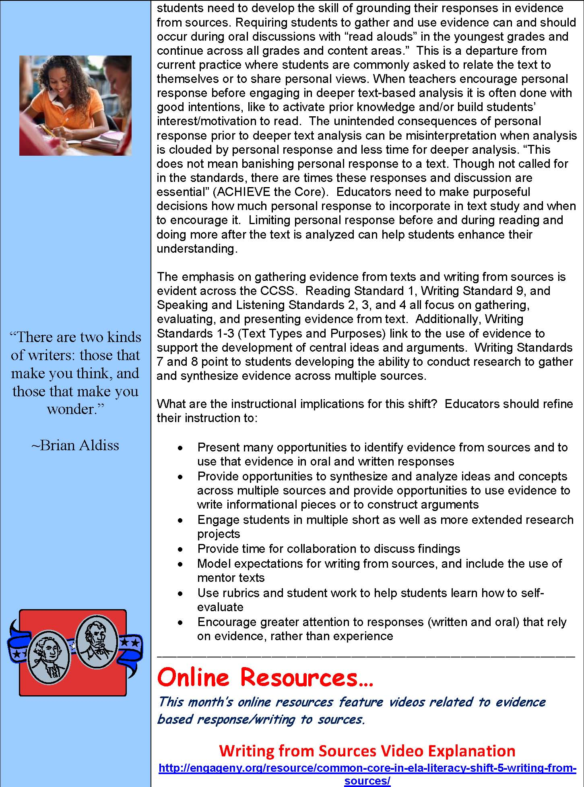
students need to develop the skill of grounding their responses in evidence from sources. Requiring students to gather and use evidence can and should occur during oral discussions with “read alouds” in the youngest grades and continue across all grades and content areas.” This is a departure from current practice where students are commonly asked to relate the text to themselves or to share personal views. When teachers encourage personal response before engaging in deeper text-based analysis it is often done with good intentions, like to activate prior knowledge and/or build students’ interest/motivation to read. The unintended consequences of personal response prior to deeper text analysis can be misinterpretation when analysis is clouded by personal response and less time for deeper analysis. “This does not mean banishing personal response to a text. Though not called for in the standards, there are times these responses and discussion are essential” (ACHIEVE the Core). Educators need to make purposeful decisions how much personal response to incorporate in text study and when to encourage it. Limiting personal response before and during reading and doing more after the text is analyzed can help students enhance their understanding.
The emphasis on gathering evidence from texts and writing from sources is evident across the CCSS. Reading Standard 1, Writing Standard 9, and Speaking and Listening Standards 2, 3, and 4 all focus on gathering, evaluating, and presenting evidence from text. Additionally, Writing Standards 1-3 (Text Types and Purposes) link to the use of evidence to support the development of central ideas and arguments. Writing Standards 7 and 8 point to students developing the ability to conduct research to gather and synthesize evidence across multiple sources.
What are the instructional implications for this shift? Educators should refine their instruction to:
- Present many opportunities to identify evidence from sources and to use that evidence in oral and written responses
- Provide opportunities to synthesize and analyze ideas and concepts across multiple sources and provide opportunities to use evidence to write informational pieces or to construct arguments
- Engage students in multiple short as well as more extended research projects
- Provide time for collaboration to discuss findings
- Model expectations for writing from sources, and include the use of mentor texts
- Use rubrics and student work to help students learn how to self-evaluate
- Encourage greater attention to responses (written and oral) that rely on evidence, rather than experience

Online Resources…
This month’s online resources feature videos related to evidence based response/writing to sources.

http://engageny.org/resource/common-core-in-ela-literacy-shift-5-writing-fromsources/
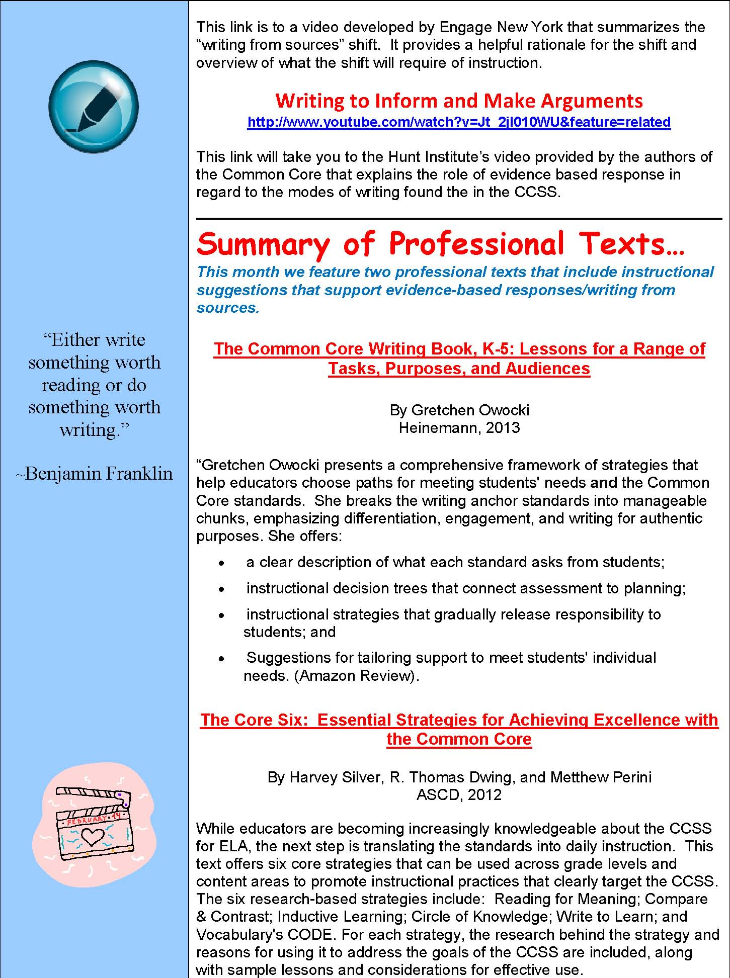
This link is to a video developed by Engage New York that summarizes the “writing from sources” shift. It provides a helpful rationale for the shift and overview of what the shift will require of instruction.

http://www.youtube.com/watch?v=Jt_2jI010WU&feature=related
This link will take you to the Hunt Institute’s video provided by the authors of the Common Core that explains the role of evidence based response in regard to the modes of writing found the in the CCSS.

Summary of Professional Texts…
This month we feature two professional texts that include instructional suggestions that support evidence-based responses/writing from sources.
The Common Core Writing Book, K-5: Lessons for a Range of
Tasks, Purposes, and Audiences
By Gretchen Owocki
Heinemann, 2013
“Gretchen Owocki presents a comprehensive framework of strategies that help educators choose paths for meeting students' needs and the Common Core standards. She breaks the writing anchor standards into manageable chunks, emphasizing differentiation, engagement, and writing for authentic purposes. She offers:
- a clear description of what each standard asks from students;
- instructional decision trees that connect assessment to planning;
- instructional strategies that gradually release responsibility to
students; and
- Suggestions for tailoring support to meet students' individual
needs. (Amazon Review).

The Core Six: Essential Strategies for Achieving Excellence with the Common Core
By Harvey Silver, R. Thomas Dwing, and Metthew Perini
ASCD, 2012
While educators are becoming increasingly knowledgeable about the CCSS for ELA, the next step is translating the standards into daily instruction. This text offers six core strategies that can be used across grade levels and content areas to promote instructional practices that clearly target the CCSS. The six research-based strategies include: Reading for Meaning; Compare & Contrast; Inductive Learning; Circle of Knowledge; Write to Learn; and Vocabulary's CODE. For each strategy, the research behind the strategy and reasons for using it to address the goals of the CCSS are included, along with sample lessons and considerations for effective use.
Children’s Literature…
This month we feature two informational texts that lend themselves to students finding evidence for text based responses and writing from sources.
Electric Ben: The Amazing Life and Times of Benjamin Franklin
By Robert Byrd
“A true Renaissance man, Benjamin Franklin was the first American celebrity. In pictures and text, master artist Robert Byrd documents Franklin's numerous and diverse accomplishments, from framing the Constitution to creating bifocals. The witty, wise, and endlessly curious Franklin is the perfect subject for Byrd's lively style and vibrant art. The pages pulse with facts, quotes, and captions, while the inventive design and intricately detailed illustrations make a striking tribute to the brilliant American” (Amazon Review).
Titanic: Voices from the Disaster
By Deborah Hopkinson
“In what’s sure to be a definitive work commemorating the 100th anniversary of the sinking of the RMS Titanic, Hopkinson offers a well-researched and fascinating account of the disaster. It’s a well-known story, though maybe not to young readers. Hopkinson orchestrates a wealth of material here, using a third-person narrative voice to tell the story while incorporating eyewitness accounts of people on the “most luxurious ship the world had ever seen.” A huge number of archival photographs and reproductions of telegrams, maps, letters, illustrations, sidebars and even a dinner menu complement the text, yielding a volume as interesting for browsing as for through-reading. She encourages readers to think like historians and wonder what it would have been like on the Titanic.” (Kirkus review).
News from Maine’s English Language Arts Team…
s

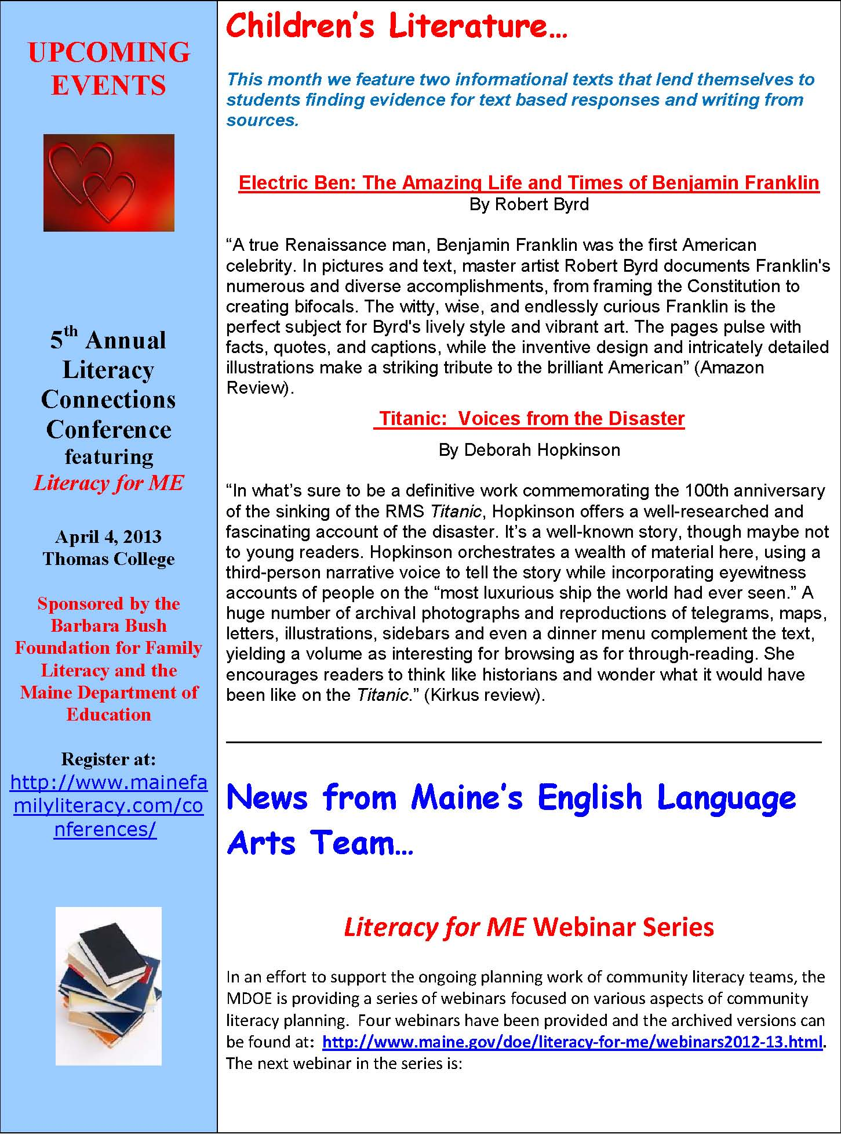
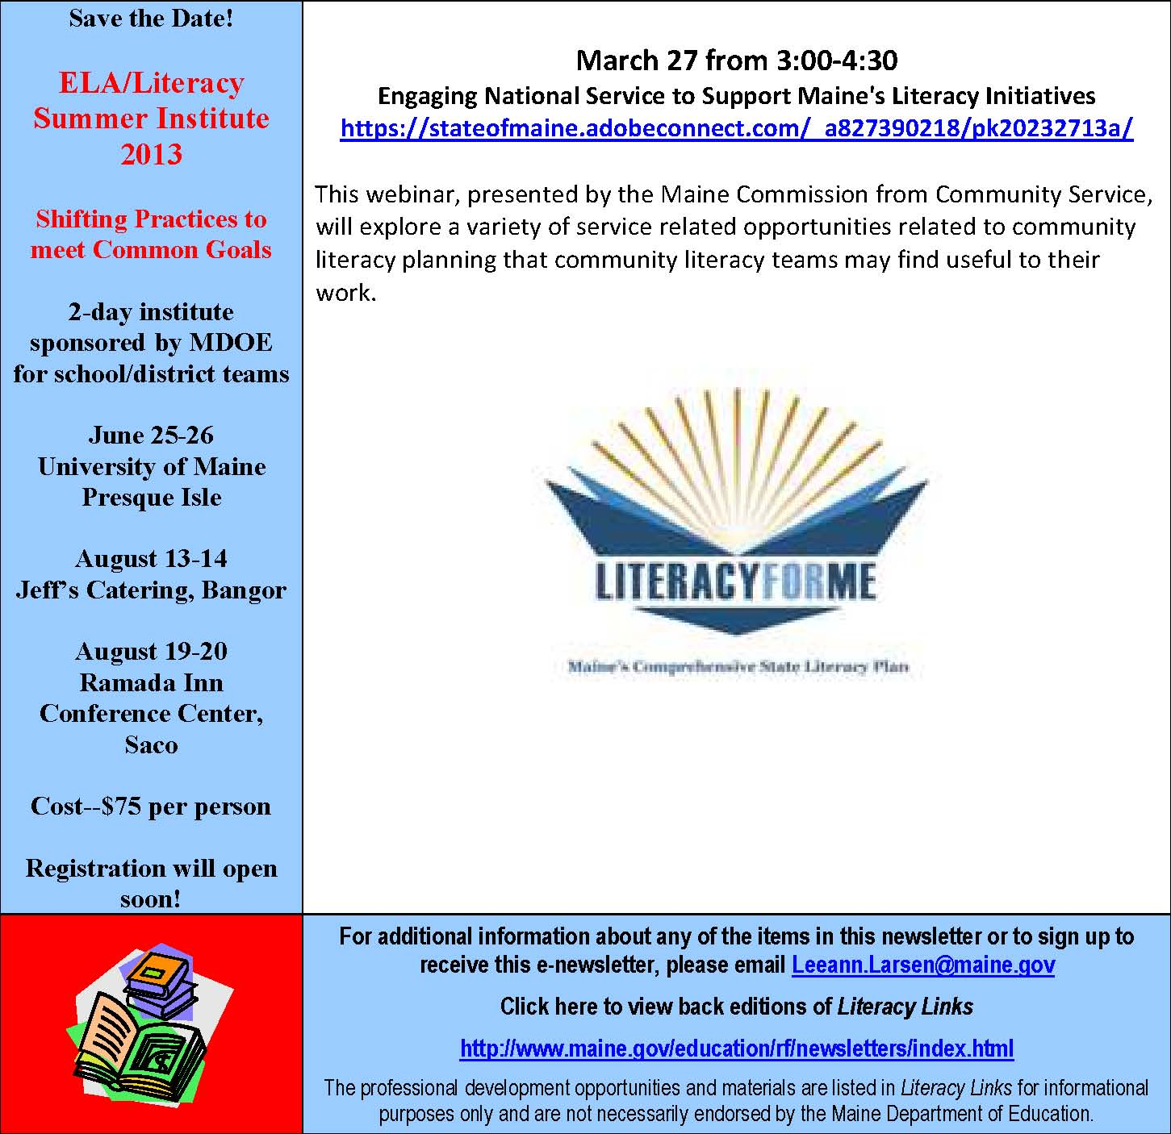

For additional information about any of the items in this newsletter or to sign up to receive this enewsletter, please email Leeann.Larsen@maine.gov
Click here to view back editions of Literacy Links
http://www.maine.gov/education/rf/newsletters/index.html
The professional development opportunities and materials are listed in Literacy Links for informational purposes only and are not necessarily endorsed by the Maine Department of Education.

