Business Case

Summary Sheet

Title: Sustainable Manufacturing and Environmental Pollution (SMEP).
Programme Summary: This programme will aim to reduce the environmental and social impacts of manufacturing in developing countries by generating the evidence and developing technical solutions that will help reduce the levels of pollution and environmental degradation generated by industrial/manufacturing processes in Sub-Saharan Africa (SSA) and South Asia (SA).
Programme Value: £ 20 million |  | Country/Region: Sub-Saharan Africa and South Asia
Programme Code: 300124 | Start Date: April 2018 | End Date: 30/04/2023
Overall programme risk rating: | Moderate
Vault Number: | 300124

Intervention Summary (2 pages max)
Narrative summary of why UK support needed, what the funds will be spent on, where, over what period of time, via whom and what they will deliver (1/2 page max)
The manufacturing processes currently being employed in most developing countries have a number of characteristics that render them unsustainable in the long term. These include outdated infrastructure, machinery and inefficient methods, which generate high levels of pollution and widespread environmental degradation, as well as inefficient use of energy and natural resources and high levels of carbon emissions. Environmental degradation and pollution have been directly linked to a number of life-threatening illnesses and chronic health problems among manufacturing workers in many developing countries. They are also responsible for affecting the health of the general population through toxic contamination of vital resources, such as: air, drinking water, soils, food crops, livestock and fish. Furthermore, some production processes hinder economic development because of low productivity outputs compared to those found in developed economies.

The Sustainable Manufacturing and Environmental Pollution (SMEP) programme will tackle the problem of pollution and environmental degradation generated by manufacturing processes in DFID priority countries across SSA and SA. More specifically, it will focus on preventing pollution from manufacturing sources being released in to the environment in the first place. It will do so by developing and testing the application of technology-based solutions and cleaner production methods aimed at reducing the levels of environmental pollution generated by targeted manufacturing activities, and by identifying the most suitable policy-based interventions and business models to enable change to happen. It will also generate evidence to support practical solutions with a high chance of take up and impact, including evidence on the environmental, economic and social impacts and the social and political economy influences that drive these changes. It will target specific manufacturing sectors that are prevalent in DFID priority countries involving commodities, such as: textiles, clothing, leather, light manufacturing, household products, chemicals and petrol-chemicals, rubber and plastics. The SMEP programme has three core components:
- Research to develop the evidence to support practical solutions with a high chance of take up and impact;
- Developing and testing innovative technology based solutions that improve the environmental impacts of manufacturing;
- Identifying and developing suitable supporting business models and policies to adopt innovative technology based solutions.

The SMEP programme will also focus on generating evidence and practical solutions to address the problem of plastic ocean pollution, which was recently highlighted as a policy priority by the UK Prime Minister, the Secretary of State for International Development and the Secretary of State for Environment, Food and Rural Affairs.

We are proposing an investment of £20million over five years (2018-2023). DFID resources will be used to fund research and development (R&D) activities commissioned through open competition and managed by a competitively procured programme management agent. DFID will partner with the United Nations Conference on Trade and Development (UNCTAD) based in Geneva, which will provide a range of technical assistance and support services to the programme, as well as ensuring political leverage at the country level and with multinational corporations, whose involvement will be key to the success of the programme. UNCTAD will provide £2million in kind contributions towards the implementation of programme activities in the form of technical support and dedicated staff time, venues for high-level meetings and events and related resources.

The SMEP programme will address the overarching principle and commitment towards achieving value for money and delivering efficiently by adopting a flexible structure that enables DFID to reduce overall administrative costs, streamline management and improve performance and delivery. Additional value for money will be generated by partnering with key private sector partners, who will provide direct access to their manufacturing operations and value chains in target countries to enable the testing of programme funded technology-based solutions and business models.

Does the programme fit with DFID’s strategic architecture: the UK Aid Strategy, Single Departmental Plan, International Development Act and the department’s Business Plan? Yes. This programme will tackle the following objectives under the UK Aid Strategy and the SDP:
Objective 2 Strengthening resilience and response to crisis
This programme will help poor people in target countries to respond to environmental crises and adapt to future climate by protecting the environmental and natural resources that are crucial to ensuring resilience to future climate. It will also contribute to reducing carbon emissions, which will contribute to the target of preventing climate change.

Objective 3 Promoting global prosperity
This programme will promote economic development and prosperity in target countries. It will do so by generating evidence and technical solutions that will improve economic productivity and production efficiency in the manufacturing sector, which is crucial to ensuring the success of developing economies across Sub-Saharan Africa and South Asia. This will contribute to the reduction of poverty and to strengthen UK trade and investment opportunities around the world. It will also ensure that people in target countries have access to sustainable and productive jobs, which do not cause physical harm or affect their long term health and well-being, thus contributing to creating sustainable livelihoods.
Objective 4 Tackling extreme poverty and helping the world’s most vulnerable
This programme will contribute to the UK government’s commitment to work with others to eliminate extreme poverty by 2030, and support the world’s poorest. It will do so by tackling directly a number of issues and target included under the UN Sustainable Development Goals 12, 6, 8, 9, 3 and 11.

The SMEP programme has also been included as one of the DFID-funded interventions which will contribute to help reducing plastics in production and in the sale of goods and services, as part of the UK Government pledge to be announced at the next Commonwealth Heads of Government Meeting (CHOGM) 2018.

The SMEP programme is fully compliant with the 2002 International Development Act and its subsequent amendments, including the Gender Development Act 2014.

What percentage of DFID’s Single Departmental Plan results target does this programme represent? Could the programme be adjusted in scope or scale to deliver SDP results? This programme will contribute to address, in various measures, 4 out of 16 targets under the 4 objectives of the SDP and UK Aid strategy. The four targets that will be addressed by this programme to various extents are as follows:

- Help at least 60 million people get access to clean water;
- Work to prevent climate change and assist the poorest in adapting to it;

- Boost growth and jobs;
- Work to increase the global economic empowerment of women and girls.

Is the programme coherent with the wider international community and partner government response? Yes - the programme will address priorities listed under six SDGS (see above reference) and is also aligned with the emerging international discourse and narrative on sustainable economic growth and the circular economy. Our strategic partnership with UNCTAD will ensure that our programme activities remain aligned with the wider international agenda and consensus in this field, as well as priorities of key partner governments in developing countries (DCs).
Has the programme set out a sustainable exit strategy?
Yes - we will build unconditional break and/or withdrawal clauses into the contracts and/or agreements we will sign with all our partners. Furthermore, the modular structure of the programme and its flexible management arrangement will ensure that, if any component of the programme is not successful, it can be terminated without significantly affecting the remaining elements (for further details see also management case pg. 38-39).

Our strategic partnership with UNCTAD will ensure that our programme activities remain aligned with the wider international agenda and consensus in this field, as well as priorities of key partner governments in developing countries (DCs) after the programme end date in 2023. Part of UNCTAD’s remit will also be to ensure that robust outreach, dialogue and communications are developed to raise awareness, disseminate lessons learned and best practice to a range of partners and policy holders in the DCs to build sustainability in the longer term.

Has the programme considered working with HMG Departments and accessing cross-HMG funds?
Yes. During the scoping phase we approached BEIS, DEFRA and the UK Engineering & Physical Sciences Research Council (EPSRC) and proposed options to collaborate and/or partner in implementing this programme; this included provision of joint funding. All parties expressed an interest in the programme but were not able to partner with DFID, because of their current focus on implementing UK based activities and research. We have agreed that we will continue to keep all parties informed of developments in the programme with a view of reviewing potential for synergies and options for collaboration further down the line.

How does the programme relate to other UK aid within the specific sector, including multilateral, bilateral and centrally managed programmes?
This programme (i.e. the SMEP programme) will complement the work of the Pollution Management & Environmental Health (PMEH) programme, which is also funded through the Climate Energy and Water team in Research and Evidence Division (RED-CEW) and is managed by the same Senior Responsible Owner. The PMEH programme is a multilateral intervention implemented by the World Bank and currently funded by DFID, DBEIS, NORAD, BMUB and GIZ, which is implementing activities aimed at: i) reducing the levels of pollution that have already been released in the environment; ii) developing technical solutions to detect and monitor different types of pollution more effectively; and iii) cleaning-up contaminated sites to reduce harmful impacts on human health. The SMEP programme will focus on preventing pollution from manufacturing from being released in to the environment in the first place. The objectives and work of the SMEP programme will also be aligned with those of a programme on Child Labour, which is currently being developed by DFID’s Asia Regional Team.

Is there sufficient flexibility to learn and adjust to changes in the context? What level of flexibility is there to shift this and future commitments?
Yes – this is a relatively new and still expanding field of knowledge and we are cognisant of the fact that we may need to adapt and adjust the scope of our planned research activities and learning approaches accordingly. For this reason during Year 1 of the programme we will conduct a thorough scoping analysis, which will also serve to test the Theory of Change in the context of the manufacturing realities on the ground in various target countries. We will also maintain a flexible and dynamic approach to identifying new thematic priorities and learning needs throughout the lifetime of the programme, as these emerge. This will include conducting yearly reviews and, if necessary, revisions of the logframe, as well as the Theory of Change.

Does the proposed level of risk to be taken fit with DFID’s risk appetite for this portfolio? Yes – the programme overall risk level at approval has been assessed as Moderate and this in line with DFID’s risk appetite for this field of research and innovation.

Is there a clear communications strategy to reinforce our objectives? Will the programme be branded with the UK aid logo and recognise UK Government funding – and, if not, why not? Yes - we already have agreed a set of preliminary principles, which will be used to develop a communications strategy during the inception phase of the programme. This will be reviewed and revised as needed during the implementation phase of the programme, in collaboration with our strategic implementation partners. The aforementioned principles include specific references to implementing local communication activities, which will be led by the Programme Management Agent (PMA) and our strategic partner UNCTAD under DFID’s direction and supervision. All programme activities and communications products will be branded with the UK-aid logo and UK Government funding will be acknowledged whenever possible.

In addition to the above, we have been working closely with colleagues in Climate & Environment Department (CED) to ensure that all messages related to the inclusion of the SMEP programme in the Core Script documents for CHOGM 2018 are handled appropriately. Once the programme has been approved, we will also engage with relevant colleagues in Communications Department to ensure that all further communications activities are managed in line with departmental expectations and requirements.

Has the programme been quality assured? How confident are we that the skills, capability, resources and political will exist to deliver the programme?
The programme has been reviewed internally at SCS level by the Deputy Chief Scientific Adviser as well as the Heads of Professions for Climate & Environment and Infrastructure.

Does the SRO and team have the capability and resources to deliver this programme? Yes- this programme was identified as a priority in the 2015 Research Review and adequate resources have been allocated to its design, delivery and implementation.

- Strategic Case
1. Context and need for a DFID intervention
The role of manufacturing in the global economy is constantly evolving and continues to provide strong opportunities for economic growth and sustained levels of investment in developing countries, offering a pathway out of poverty and to higher living standards for millions of people (UNIDO, 2015). In future years, building a manufacturing sector that is efficient, technologically innovative and sustainable, both in environmental and social terms, will be crucial to ensuring continued economic growth and improving the lives and health of millions of people in developing countries (DCs).
In the current global market, most low and mid-complexity industries are based in developing countries and produce final and intermediary products to be sold world-wide through global value chains. This type of manufacturing activity takes place in various sectors, such as textiles, clothing and apparel, plastics, chemicals and petrol-chemicals, rubber, cosmetics, household products and food processing. The growth of manufactured products exports from DCs increased by an average 11.5% over the 2005-2013 period amounting to a total value of $11,998 billion in 2013 (UNIDO, 2015). This was significantly higher the global GDP growth of 2.5% for the same period (UNIDO, 2015; WB, 2017).

Bangladesh and the growth of the Ready Made Garments Industry
In 2013, the total export of goods from Bangladesh was $35.6 billion, mainly due to the Ready Made Garments (RMG) Industry which accounted for more than 80% of the total exports. This has contributed to generating a range of significant economic and social benefits for the country:
- Poverty rate has declined by 26% in the last 10 years.
- New jobs have provided opportunities for women to work outside the home, which has helped reducing the fertility rate and delay marriage and childbearing.
- Better paying manufacturing jobs have also increased girl’s school enrolment because they require basic literacy and numeracy.
- The RMG industry pays around $50 million towards consumption of utilities, which has further boosted this service industry.
- The banking and insurance industry has grown in Bangladesh as 98% of manufacturing firms depend on commercial banks for capital requirement and have their machinery and plants insured.
Box 1: The impact of garment manufacturing on Bangladesh’s economy (Source: World Bank, 2013).
Recent data from the International Labour Organization (ILO) shows that approximately 300 million people are employed in manufacturing in DCs (fig.1). Of this 8.5 percent is in low-income countries (LICs), 21.5% in lower-middle income countries (LMICs), and 24.1% in upper-middle income countries such as China and India (ILO, 2016).
While the average manufacturing employment share in a developing country ranges between 13% and 15%, the impact of such activity to national GDP is often double that figure. Manufacturing development is key to future prosperity in LMICs, as manufacturing jobs build skills and capacities which unlock further economic growth (Lavopa and Szirmai, 2014; UNIDO, 2015).
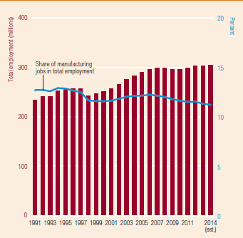 Fig.1 Manufacturing employment in DCs, 1991–2014 (Source: ILO, 2016).
2. What are the key challenges that the programme will address?
However, in developing countries, manufacturing is very often associated with severe environmental degradation (fig. 2), high levels of pollution and negative impacts on public health (NBER, 2010; Islam et al, 2015, Pure Earth & Green Cross, 2016).
Fig. 2: Toxic chromium compounds from an abandoned chemical factory in Ranipet - India, leach into the watershed. The factory produced chromium-based chemicals used in the leather tanning industry. This chromium waste accumulated in massive mounds on the factory grounds, where it remains today, more than 20 years after the plant closed 1995.
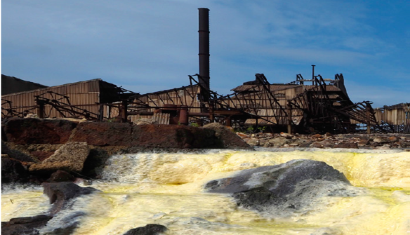 Source: Pure Earth & Green Cross (2016). Photo by Larry C. Price.
Chronic health conditions caused by pollution were responsible for an estimated 9 million premature deaths in 2015, which were equal to 16% of all deaths worldwide. This number was three times higher than the combined number of deaths from HIV-AIDS, tuberculosis, and malaria and 15 times more than all wars and other forms of violence (fig.3). A recent ground-breaking study by the Lancet Commission on Pollution and Health found evidence that in the most severely affected countries, pollution-related disease is responsible for more than one in four deaths (Landrigan et al.2017). The 2015 Global Burden of Disease study also found that pollution is a major cause of disability, with lead alone estimated to account for 12.4% of the global burden of idiopathic intellectual disability (GBD, 2015).
Fig.3: Estimated number of deaths from pollution vs other leading causes worldwide.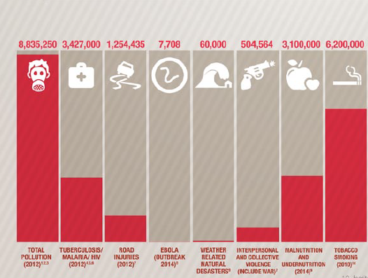 Source: Blacksmith Institute (2014).
Among the various types of pollution, chemical pollution is a serious and growing global problem, whose effects on human health and animal health are still poorly defined and almost certainly underestimated. Since 1950, more than 140,000 new chemicals and pesticides have been synthesised the vast majority of which are used in a number of manufacturing and industrial processes. Fewer than half of these high-production volume chemicals have undergone any testing for safety or toxicity, and rigorous pre-market evaluation of new chemicals has become mandatory only in the past decade and in only a few high-income countries (Landrigan et al. 2017).
The main sources of pollution in low and middle-income countries (LMICs) are: industrial and manufacturing processes (table 1), vehicle emissions, and toxic chemicals, which are also produced for and widely employed in industry and manufacturing (UNIDO, 2015; Pure Earth & Green Cross, 2016; Landrigan et al. 2017).
Table 1: Sources of pollution from manufacturing and estimated impacts
Sources of pollution | Estimated deaths per year  (in millions) | Estimated economic costs*  (developing countries, % GDP) | Examples of associated  industries | Associated world regions  (developing countries)
Unsafe water | 1.7 | 2% | Leather, food processing, Textiles, Rubber, Plastics | Lat.Am, South Asia, SSA
Indoor smoke | 1.6 – 2.9 | 1.6% | Rubber, Food processing | SSA, South Asia
Lead exposure | 0.23 | 1.2% | Chemicals, | South Asia
Urban Air pollution (PM2.5) | 0.8 | 2.8% | Timber, Plastics, | South Asia, Lat.Am.
Unintentional poisonings | 0.35 | 0.47%** | Apparel, plastics, Rubber, Food | South Asia, SSA
Sources: WHO (2012, 2015), Vishnu et al (2011), Van Minh (2011), World Bank (2016), and NIH (2013). *Estimated economic costs as percentage of GDP. ** Estimated based on accident cost proxy.
Pollution disproportionately kills the poor and the vulnerable and has been historically overlooked by both the international development and the global health communities of practice (Pure Earth & Green Cross, 2016, Landrigan et al. 2017). Recent data show that 94% of pollution-related illness and deaths occur in LMICs and are most prevalent among vulnerable social groups such as women, children, those with disabilities and the elderly, as well as minorities and the marginalised (Blacksmith Institute, 2014). Figure 4 below, shows the location of a number of contaminated toxic sites, which were identified over a period of four years from 2010 to 2014 (Blacksmith Institute, 2014). Children and unborn babies are particularly vulnerable to pollution-related disease because even extremely low-dose exposures to pollutants in utero (i.e. during gestation) and in early infancy can result in chronic illness, disability, and death (Landrigan et al. 2017).
Fig.4: Geographical distribution of disease caused by pollution worldwide.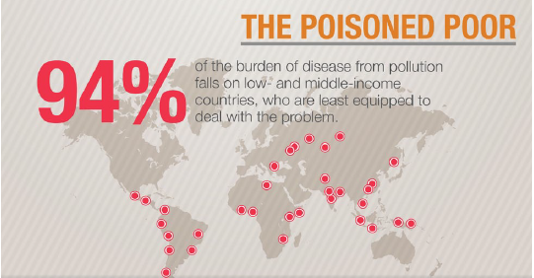Source: Blacksmith Institute (2014).
Pollution-related diseases are responsible for productivity losses that reduce gross domestic product (GDP) worldwide, but especially in LMICs, where losses can be as high as 2% of GDP per year. Pollution-related disease can also generate substantial health-care costs that are currently estimated to be around 1.7% of annual health spending in high-income countries and up to 7% of health spending in middle-income countries (MICs) that are heavily polluted and rapidly developing. Moreover, welfare losses due to pollution are estimated to amount to US$4·6 trillion per year equal to 6.2% of global economic output (Landrigan et al. 2017). World Bank data, illustrated in figure 5 below, reveals that air pollution alone is responsible for welfare losses equivalent to 7.4% of GDP in South Asia and 3.8% in Sub-Saharan Africa (World Bank, 2016).
The problem of plastic pollution, which can significantly affect soils, waterways and oceans, should also be considered. Living organisms, particularly marine animals and fish, which represent an important source of protein for millions of people across SSA and SA, can also be affected through entanglement, direct ingestion of plastic waste, or through exposure to chemicals within plastics that cause interruptions in biological functions (Mathieu-Denoncourt et al. 2014). Humans are also affected by plastic pollution, such as through the disruption of the thyroid or hormone levels (Hester & Harrison, 2011).

Fig. 5: Welfare losses due to air pollution, by region. Source: World Bank (2016).
Pollution is also a transboundary problem, which is not confined to national borders. It is therefore in our national interest to limit levels of pollution worldwide, as these will ultimately affect the health of people living in the UK (fig. 6) either directly (i.e. through transboundary air and marine pollution) or indirectly (e.g. through contaminated food-chain products).
Fig. 6 Linkages between pollution in DCs, the global economy and public health world-wide. 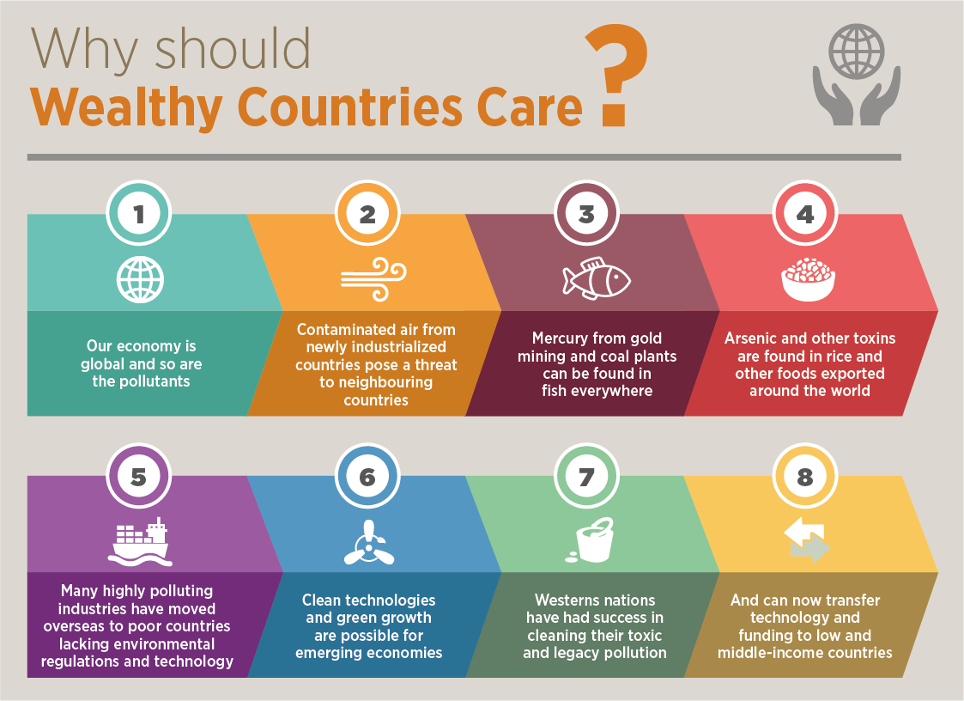 Source: Blacksmith Institute (2014)
As evidence of this, the World Health Organisation (WHO) recently found that despite reductions in emissions levels of air pollutants across Europe, premature deaths from air pollution throughout the continent will fall only marginally over the next 15 years, in part due to transboundary pollution originating outside Europe (WHO, 2006). We also have a moral obligation to address this issue, because many of the consumer goods and products that we enjoy in our daily lives are produced -either entirely or partially- in developing countries, where they lead to many of the environmental and health impacts described so far. Funding research in this field is also in our national interest, because it will help reinforce economic links with trading partners in DCs and will contribute to ensure better standards of production for goods that we may import directly following the UK exit from the European Union.
In addition to the manufacturing processes already mentioned, the sourcing of raw materials needed to supply these, as well as a range of informal activities connected with the disposal and recycling of discarded consumer goods are adding to the pollution burden in a growing number of LMICs (Ackah, 2017; Park et al. 2017). According to a recent study by the World Health Organisation (WHO), 36 of the 80 countries that are worst affected by land degradation world-wide are situated in Africa, with inadequate disposal of industrial waste and informal recycling of manufactured goods at the end of their life-cycle being significant factors (WHO, 2015).
Table 2 below, lists the ten most polluting industries and economic activities in LMICs, which are connected either directly or indirectly to manufacturing processes, and their impact on public health measured in Disability-Adjusted Life Years (DALYs).
Table 2: Worst Polluting Industries (involving manufacturing) Ranked by DALYS.
Rank | Industry | DALYs
1 | Used lead Acid Battery recycling | 2,000,000 - 4,800,000
2 | Mining and Ore Processing | 450,000 - 2,600,000
3 | Lead Smelting | 1,000,000 - 2,500,000
4 | Tanneries | 1,200,000 - 2,000,000
5 | Artisanal Small-Scale Gold Mining | 600,000 - 1,600,000
6 | Industrial Dumpsites | 370,000 - 1,200,000
7 | Industrial Estates | 370,000 - 1,200,000
8 | Chemical Manufacturing | 300,000 - 750,000
9 | Product Manufacturing | 400,000 - 700,000
10 | Dye Industry | 220,000 - 430,000
Source: Pure Earth & Green Cross (2016).
3. What are the areas where DFID can have an impact/make a difference?
The argument that pollution control will stifle economic growth does not hold true in most cases. However, in order to be adopted, solutions that reduce harmful emissions need to have both environmental credentials and a strong business case that is relevant to the country context in which they are being deployed. This is due to the large capital nature of manufacturing equipment, which makes the business case for large scale change more challenging. In low-income countries, where the cost of equipment is a larger proportion of operational costs than elsewhere, this factor is even more prevalent. On the other hand, the development of solutions which can improve the environmental and health impacts of manufacturing is highly needed, but severely underfunded.
Looking holistically at any given manufacturing process, overall harmful emissions can be reduced if: i) we reduce the harmful impact of what goes into the process, ii) improve the efficiency of what occurs within the process and iii) capture any residual pollutants form the process (Fig.7).
Fig.7: Solution categories to reduce harmful impacts of manufacturing.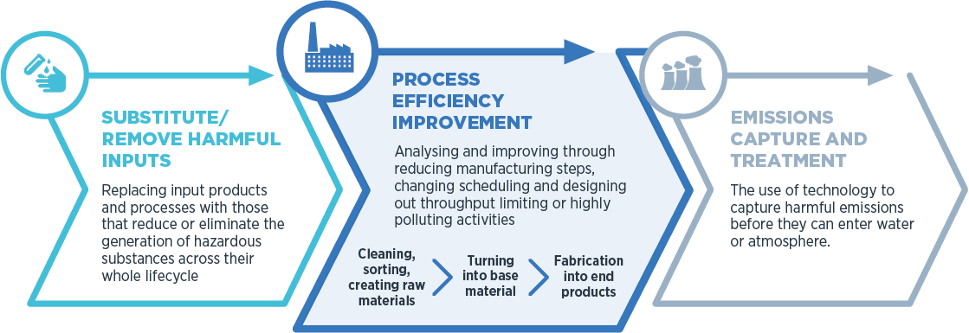 Source: PA consulting.
Substituting and Removing
There are clear opportunities to reduce the levels of environmental degradation and pollution associated with various manufacturing processes by looking at ways to modify how some materials are sourced and used or by replacing them altogether. The approach of substituting has been most evidently demonstrated in the paint industry, where water based paints are now far more common than their solvent based predecessors. A similar example is related to the scouring and bleaching processes in textile manufacture, where more benign agents are beginning to replace traditional more polluting ones.
Process Efficiency Improvement
Manufacturing processes tend to grow organically over time. This means that processes and equipment are often not optimised at the factory level. Examples range, from core processes or equipment that have not been updated for generations, to state of the art manufacturing equipment not being properly used or integrated into the production cycle, which is more common in more advanced manufacturing contexts. Reviewing these aspects of various production processes, regardless of their level of complexity and technology used, can deliver cost effective solutions that achieve significant efficiency gains and reduced environmental impacts.
Emissions Capture & Treatment
This area of work involves preventing any harmful substances from entering the environment through contact with either air or water. This is a complex and rapidly developing field, and the technology mix required is very dependent on the harmful substances that are being captured. The technology to capture these has been advancing rapidly in recent years; it would therefore be possible to develop tailored solutions that reduce the levels of emissions from a range of manufacturing processes. A typical example is textile process dust, which is well documented as a cause of conditions such as byssinosis, occupational asthma and respiratory irritation. Dust from dyes adds another level of potential harm. Most of the dust in textile production is from converting raw fibres into yarn and fabric. In most countries across SSA and SA this is often done in very open, uncontrolled settings, allowing much of this pollutant to enter the workers respiratory tracks and the wider environment. Given that dust capture is a significant industry, with a large number of highly commoditised products on the market, it would likely be possible to take a selection of these technologies and with some technological modifications develop a solution that would address a good proportion of the harmful effects being caused in specific settings.
Another example is that of water-pollution from effluents generated during manufacturing and industrial processes. There are currently a number of treatment techniques available, ranging from large scale infrastructure through to mobile units and natural processes, which could be further developed and adapted to deliver innovative solutions that are also cost effective and tailored to specific contexts.
In all of these cases, the building blocks for these systems are commercially available, but the exact architecture and chemistry needs to be designed and adapted to every specific context/scenario.
A factor that further underpins the importance of a DFID funded intervention in this area, is the recent scientific evidence showing that the vast majority of plastics now entering the world oceans originates from countries in Asia and Africa (fig. 8), where weak or non-existent waste-collection systems lead to their dispersal into the environment (Jambeck et al. 2015; Schmidt et al. 2017).
Figure 8: In-land sources of ocean plastic waste.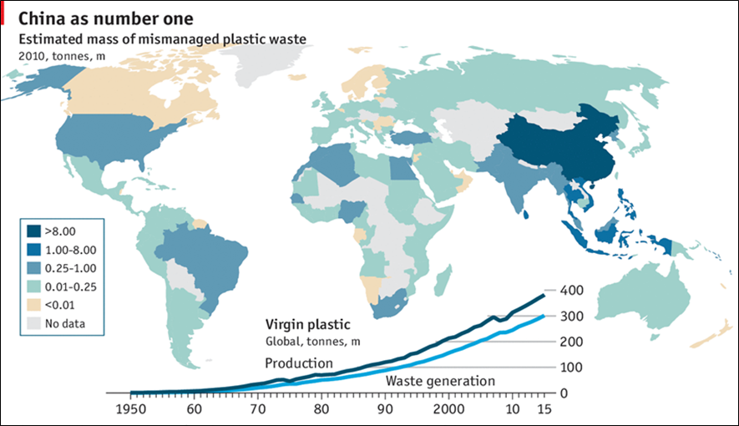Source: The Economist (data from Jambeck et al. 2015).
In addition to making an effective contribution to the technical areas mentioned above, a DFID-funded intervention can make a difference on re-balancing the political economy contexts and addressing the market failures, which enable unsustainable manufacturing operations to continue in countries across SSA and SA, in spite of their environmental and societal impacts.
In the current situation, this is due in large part to the fact that environmental degradation and pollution are seen as ‘externalities’, which are not properly costed. One of the driving factors for this situation is that the majority of the costs are borne by poor and politically disempowered people, who hold little or no influence in society, whereas the majority of profits are accrued by politically connected and economically wealthy classes. As a result of this political imbalance there is little incentive to enact change.

4. The Proposed Solution
In order to address the issues described so far, DFID will establish a five-year research programme. The Sustainable Manufacturing and Environmental Pollution (SMEP) programme will tackle the problem of pollution generated by manufacturing in developing countries. It will do so by developing and testing the application of technology-based solutions and cleaner production methods that will reduce the levels of environmental pollution generated by manufacturing activities in developing countries. The development of such technologies will be supported by a range of business models and policy frameworks that enable and incentivise adoption and application by private sector entrepreneurs and policymakers. The Programme will work in close collaboration with the private sector to test the technology-based solutions and business models it will develop more widely in factory production lines and shop-floors.
The SMEP programme will also generate cutting-edge evidence/knowledge that will contribute to advancing global understanding of the environmental, economic and social impacts of selected manufacturing processes in developing countries.
Research activities will target specific manufacturing sectors that are prevalent in developing countries, are known to have significant issues of sustainability of supply chains and impact on the environment, and involve several types of commodities, such as: textiles, clothing and leather, light manufacturing, household products, chemicals and petrol-chemicals, rubber and plastics.
We are proposing an investment of £20million over five years (2018-2023).
The SMEP programme is expected to deliver the following outputs:
- New scientific evidence aimed at improving current knowledge and understanding of the environmental and health impacts of pollution from manufacturing.
- Development of technology based solutions and supporting business models, to reduce the environmental impact of selected manufacturing processes.
- Identification and development of policy and regulatory models that can promote and facilitate the adoption of technology based solutions.

- Establishment of new symbiotic production processes that reduce environmental waste and establish new sources of wealth and growth.
- Co-design/ development of toolkits to be used by policy makers and planners.
These outputs will lead to the realisation of the following programme outcomes:
- Partner governments have the necessary tools, technical advice and knowledge to address the problems identified.
- Increased production efficiency and environmental sustainability of selected manufacturing processes create the business case for adoption and replication of technological solutions and improved manufacturing processes.
- Businesses are motivated and enabled to improve manufacturing practices and processes through a mix of incentives, technology-based solutions and business models.

The successful realisation of the programme outcomes should in turn make a contribution towards the achievement and realisation of a range of broader long-term impacts. These include the following:
- At least five million fewer people exposed to dangerous levels of toxic pollution from manufacturing in DFID target countries by 2030 (with higher estimates of up to 10 million people).
- At least five hundred thousand DALYs linked to pollution and manufacturing in developing countries gained by 2030.
- An improvement in worker productivity by 2030 of at least 15% per capita per year:
-For SMEP target countries in SA: from US$25,411 (BCG, 2015) to US$29,477;
-For SMEP target countries SSA: from US$ 9,664 (BCG, 2015) to US$ 11,210.
5. Gender Equality, Leave No-one Behind & Safeguarding.
In most developing countries, women are employed widely in a range of manufacturing jobs and sectors and are often exposed to very high levels of toxic pollution either directly (i.e. by handling and/or being exposed to toxic chemicals in the place of work) or indirectly (e.g. by living in polluted areas, which are located near manufacturing and industrial production facilities). Fig. 9 shows some typical examples of women employed in two sectors that are either directly and/or indirectly related to manufacturing. The picture on the left shows how in the Vellore district of Tamil Nadu - India, women lack the necessary protective clothing and equipment that would be required for anyone using the toxic chemicals and heavy metal compounds employed in the leather tanning process. As seen in the picture, some have basic protective equipment to protect their clothes, but other lack even this minimal and already inadequate level of protection.
Fig. 9: Left a woman working in a tannery in Tamil Nadu, India. Right a woman in Indonesia breaks up lead slag left over from the recycling of used lead-acid batteries with minimal protection.
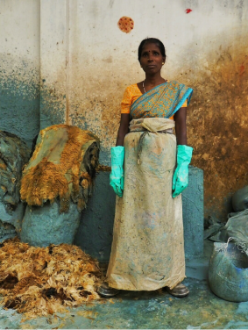
Source: Pure Earth & Green Cross (2016).
Pregnant women and children are most vulnerable to the harmful effects of pollution, which can affect physical and cognitive development in children, as well as foetal development during pregnancy. Children and girls are often employed informally and illegally in a variety of activities that are either directly or indirectly related to manufacturing processes (fig. 10), endangering their health and depriving them of access to education.

The design of this programme has considered gender issues in depth and is expected to have a direct positive impact by improving the working conditions and health of thousands of women and girls, who are currently employed in manufacturing or are affected by pollution derived from it. The research element of the SMEP programme will aim to improve current knowledge on the causes, compounding factors and impacts of environmental pollution on women’s health, with specific emphasis on pregnancy. It will also touch upon issues of gender equality in the workplace, including the ability for girls to access personal and professional development opportunities such as formal education, technical and vocational training.

We expect that the programme activities will lay the foundations for further and more significant benefits to accrue in future years, with specific reference to long term health prospects of women and girls, children, the elderly, people living with disabilities and debilitating chronic health conditions, and other vulnerable social groups in affected areas (for a more detailed discussion of gender and disability, see social development and gender appraisal on page 25-26).

Fig. 10: Children working and living in the Hazaribagh tannery district of Dhaka, Bangladesh. Hazaribagh is the most polluted area of Dhaka, where the effluents from more than 200 tanneries flow into the nearby Buriganga River.

Source: Pure Earth and Green Cross (2016).

Following the recent and on-going developments in policy and practice to improve safeguarding across the aid sector, we will also work closely and seek advice from the newly created DFID Safeguarding Unit, to ensure that: a) this programme is compliant with the latest requirements in this area; b) that all delivery partners and agents employed as part of it uphold the highest standards in practice and behaviours; and c) that we establish robust mechanisms to report any concerns.
The considerations and measures included in the operational framework of this programme are in line with the provisions made under the 2014 International Development (Gender Equality) Act.
6. Terrorism and financing
Because of the research topic and the funding mode that will be applied to this programme, we do not expect it to be any significant risk of financing terrorism, either directly or indirectly. However, we expect to implement research activities in at least one country with a significant terrorism threat, as such there are some risks associated with this aspect that will be closely screened and monitored.
The DFID programme management team, under supervision from the DFID Senior Responsible Owner (SRO) for this programme will also ensure that all implementing partners associated with this intervention have rigorous processes in place to ensure that no funds are transferred to individuals or groups associated with terrorism.
The overall risk level related to terrorist financing associated with the programme has been assessed as low.

Appraisal Case

What are the feasible options that address the need set out in the Strategic case?

Option 1: Counterfactual - do nothing

Details of the approach:
DFID would not provide any additional funding for research and innovation to tackle the problem of pollution generated by manufacturing and industrial activity in developing countries. Instead DFID-RED would try to support innovation in this area, if and where possible, through existing programmes and interventions in country and any relevant policy programming. Currently we do not have any knowledge of interventions trying to do anything in the field that the Sustainable Manufacturing & Environmental Pollution (SMEP) programme would cover, therefore it is unlikely that the objectives described in this business case would be achieved.

Benefits:
If we followed this option, there would be a monetary cost saving to DFID.
Costs and risks:
The evidence presented so far in this business case makes a compelling argument in support of the need for a robust intervention aimed at tackling pollution from manufacturing in developing countries and mitigating the devastating impact this is having on the health, livelihoods and economic prospects of millions of people. Poor people and other vulnerable groups in society suffer most from the effects of pollution and will continue suffering disproportionally in future years if this urgent problem is not tackled and resolved. Ultimately, this scenario means forfeiting the humanitarian and economic benefits that could otherwise be achieved by acting on the issue as proposed in this business case, which in some cases could potentially undermining existing development gains. Failure to improve the efficiency and sustainability of manufacturing processes in developing countries would miss an opportunity to foster economic growth and technological innovation, improve resource efficiency and mitigate the financial burden derived from associated health care costs currently being borne by governments and millions of people in LMICs. It would also result in a missed opportunity to contribute to the delivery of objectives under a number of Sustainable Development Goals (i.e. SDG12: Responsible consumption & production; SDG 9: Industry innovation & infrastructure; SDG 8: Decent work & economic growth; SDG6: clean water & sanitation; SDG 11: Sustainable cities & communities).

Option 2: DFID partners with other UK Government Departments or UK Research Councils to launch a joint programme
Details of the approach:
Under this option, DFID would provide co-funding to one or more UK Research Council(s) (RC-UK) and/or would partner with another UK Government (HMG) Department to launch a new programme on sustainable manufacturing, focusing on one or more of the areas identified. The focus areas would be further defined and adjusted following discussions with the potential RC-UK or HMG partner(s) in order to suit respective policy priorities. If partnering with a UK Research Council, they would also provide on-going management and administration services for the programme. Commissioning of research activities would be via the standard RC-UK model. During the implementation phase, engagement with projects would be managed by the Research Council partner, as would all M&E. The RC partner would also assume responsibility for quality assurance (QA) and peer review of results and outputs, and for ensuring co-ordination and coherence between different programme activities. Based on their expertise in this field, the most likely partners for this type of intervention were identified as the Department for Business, Energy and Industrial Strategy (BEIS) and/or the Engineering and Physical Sciences Research Council (EPSRC).

Benefits:
Delivering this intervention in partnership with a UK Research Council has some advantages. These include the Research Councils’ established systems and expertise in managing the commissioning of high-quality research projects through competitive and transparent processes and delivering research excellence and good value for money. Going through the RCs would also provide more direct access to the wealth of knowledge and capacity within UK universities, which could be used not only to reinforce the design and scoping of the research, but also to strengthen the QA and peer-review process of results and outputs. RC partners would also normally cover some of the commissioning and management costs associated with the programme, although this should be negotiated, thereby potentially increasing the proportion of funds available for programme activities. Partnering with another HMG department such as BEIS would involve the pooling of financial and staff resources and would enable the creation of a larger programme, which would also leverage more influence with some UK industry partners.
Costs and risks:
Working with UK RCs entails some obvious risks and costs. Their long tendering process, which in some cases can be longer than one year, may delay implementation. In addition, current experience from other programmes shows that the RCs have less experience in ensuring suitable developing country stakeholder engagement, capacity building and outreach. Working with a RC-UK partner would also provide very limited opportunities for influencing policy-making at the international, national or even local level (this being another lesson that is emerging from ongoing programmes). Similarly, our experience suggests that none of the RCs could provide significant opportunities for influencing the operations of governments or offer a direct route towards generating developmental impact on the ground. These aspects of a potential DFID-RCUK collaboration for this programme would increase the transaction costs for DFID, who will need to deploy additional resources to cover the areas outlined above and ensure delivery of impact on the ground.
Furthermore, we approached BEIS and EPSRC and after a series of meetings and consultations we realised that their priorities were different from our own in this area, as both were focused on UK centred policies and had no specific interest to fund this type of research in DCs. EPSRC stated that they did not have the capacity to support any additional work. Their timeline were also different and would have slowed down the design and launch of the programme considerably.

Option 3: DFID contributes to an existing international research programme already working in this area
Details of the approach:
Under this option DFID would provide targeted funding to an existing research programme that was already covering the priority focus areas identified in the strategic case of this document. Because of the need to tackle issues affecting several countries across SSA and SA, this would need to be an international research programme. Furthermore because of the need to influence government policy and some of the practices of large international corporations, this should also be preferably managed and implemented by an international research institution, development agency or another bilateral donor (i.e. the Implementing Partner). Under this model, the programme would be managed by the Implementing Partner (IP), which would be responsible for commissioning all research under open and competitive tenders and for implementing all programme management functions such as: communications, outreach and uptake of results. The IP would also be responsible for monitoring and evaluation of results and for coordinating various types of learning activities across the programme. DFID staff would have direct oversight and may have an option to input into the research commissioning and selection process. The IP would implement and oversee the peer-reviewer process to assess the quality and relevance of all research proposals submitted for funding and would consult DFID as needed. Having conducted a preliminary scoping of all major institutions working in this area, the best placed in terms of expertise and ability to influence relevant international stakeholders are: a number of specialised UN agencies (i.e. UNIDO, ILO, UNCTAD and UNEP), the World Bank (WB) and a number of Civil Society Organisations [e.g. Ellen MacArthur Foundation (EMF), Tearfund (TF), Friends of the Earth (FoE)].

Benefits:
Joining an existing programme would substantially shorten the amount of time needed to set up the programme’s management and governance structure, and would accelerate the usual inception process leading to the implementation of programme activities. It would also reduce the administrative burden and potentially the staff-time input requirements for DFID. Working in partnership with the WB or a UN specialised agency would guarantee access to strong technical expertise and -subject to negotiations- additional resources that could be deployed across the programme. Joining a multi-donor programme managed by an international institution could also generate economies of scale that could lower overall management costs and increase efficiency through pooling of resources. In addition, most international institutions have access to strong networks of experts and contacts in partner governments, which could be leveraged to improve outreach and uptake of evidence among key stakeholders.
Costs and risks:
Firstly we did not find any ongoing research programmes that targeted the areas of work described in this business case.

Secondly, research on this topic has traditionally been focused on developed countries and investment in research to tackle issues affecting DCs has been traditionally very low across the board (Landrigan et al. 2017). This means that there are only a limited number of institutions with a track record of working in this area in DCs.

Thirdly, joining an existing programme would limit significantly DFID’s ability to influence its strategic direction and scope, therefore limiting the impact of our investment.

The only organisations that have done substantial research on sustainable manufacturing in DCs in the past and are currently active are: UNIDO, ILO, UNCTAD and UNEP; with the WB covering other important related aspects (i.e. environmental restoration, pollution management and remediation). After the 2011 Multilateral Aid Review, DFID stopped core funding to the United Nations Industrial Development Organisation (UNIDO) and the International Labour Organisation (ILO); therefore we did not explore further the potential for providing direct funding to either organisation. A partnership with UNCTAD was found to be the most feasible and relevant to the scope of this programme and will be discussed further in option 4 below.

DFID-RED is already providing funding to the WB Pollution Management and Environmental Health (PMEH) programme, which covers a related and complementary aspect of the wider pollution problem. The PMEH programme is also implemented through the RED-CEW team and is managed by the same SRO as the SMEP programme, which will ensure synergy and complementarity between the two programmes.

Option 4: DFID launches a self-standing research programme, partnering with others, using an innovative structure and approach based on prior experience from existing programmes.
Details of the approach:
This option would involve setting up a new international research programme that will deliver innovative solutions to improve the environmental footprint and health impacts of manufacturing in DCs. DFID would be contracting a Programme Management Agent (PMA) and would be working directly with players from across the manufacturing industry operating locally, nationally and internationally. DFID would directly supervise the PMA, who will be directly accountable to DFID and will be in charge of contracting out the main programme research funding and operations. The PMA will also be responsible for the financial and fiduciary risk management for the whole programme and for undertaking other routine programme management tasks such as Monitoring Evaluation & Learning (MEL) and communications.

DFID will also form a strategic partnership with the Trade, Environment and Sustainable Development Branch (TED) of the United Nations Conference on Trade and Development (UNCTAD), which is based in Geneva. UNCTAD-TED will provide a range of technical assistance and support services to the programme (see page 39), as well as ensuring political leverage at the country level and with multinational corporations, whose involvement will be key to the success of the programme. UNCTAD-TED will also provide in kind contributions towards the implementation of programme activities in the form of dedicated additional staff time, venues for meetings and events and related resources. In order to ensure co-ordination with wider DFID objectives and HMG priorities on engaging and working with the UN, we are liaising with UK-MIS in Geneva and have agreed that we will be co-ordinating our interactions with UNCTAD, to ensure that we pursue common UK-HMG interests and policies. We will also leverage DFID’s contribution to UNCTAD through this programme to support any wider HMG policy discussions with UNCTAD.

The main research activities under the SMEP programme will be delivered by Research Consortia, which will be appointed through an open competitive process by the PMA under DFID supervision. UNCTAD-TED will provide additional technical support in evaluating technical bids and research proposals.

In addition we will also seek to work with a range of private sector companies, which have manufacturing operations in DFID priority countries. The scope of such partnerships will be to implement targeted projects aimed at testing the potential application and effectiveness of the technical solutions that will be generated by the programme, as well as a range of innovative production methods and business models that could reduce toxic pollution and waste whilst improving productivity levels. Potential partners will be selected on the basis of the following four criteria: i) relevance of their operations to the scope of the SMEP programme; ii) presence of manufacturing operations in DFID priority countries; iii) willingness to collaborate, including by offering access to own operations and facilities; iv) proven leadership, track-record and/or commitment to environmental sustainability issues. So far we have we have tested the market-place using the aforementioned criteria and have established that there is significant interest from a range of potential partners.

A scoping phase of about 6-9 months would be required to: (i) develop a more detailed understanding of the manufacturing landscapes in different DFID-priority countries and the nature of their operations; (ii) help identify, approach and engage suitable private sector partners. This scoping research would be undertaken by UNCTAD-TED under DFID supervision and direction and will happen in parallel with the setting-up of the governance structure of the programme and the contracting process for the PMA, which is expected take approximately nine months. Under this model DFID, the PMA and UNCTAD-TED will work closely under DFID supervision to deliver various aspects of the programme and ensure that there is enough technical expertise and capacity within the core structure of the programme to deliver the programme objectives effectively and on time (see page 38-39).

Benefits:
The proposed research is technically feasible and there is enough pre-existing knowledge that can be built upon to enable the success of the programme and the delivery of ambitious objectives.
Under this option the programme would adopt an innovative structure and approach, which builds upon the experience of similar interventions and incorporates elements from existing delivery models that have been tested across DFID-RED. The flexible management arrangements will ensure that, if any component of the programme is not delivering the expected results, it can be modified or terminated without affecting the remaining components. Equally, if any contracts are underperforming and agreed remediation actions are not successful they can be terminated promptly. DFID will have a direct line of control on how its money is spent and programme resources allocated to achieve best results. It will also have direct supervision over the two key delivery partners (i.e. the PMA and UNCTAD), who will be directly accountable to DFID.

The PMA will manage all the fiduciary risk elements and ensure strong financial management standards, as well implementing day to day programme management tasks, thus reducing the administrative and staff-time input requirements from DFID, but without compromising the standards required of any DFID intervention. UNCTAD will play a crucial role in providing additional technical expertise and leveraging political support, and collaboration with key ministries and regulatory agencies in developing country partners, as well as securing engagement of key private sectors firms and partners – all of which are key to the success of the programme.

Our strategic partnership with UNCTAD will substantially increase the reach and influence of the programme on the global agenda through access to and influence on the UN Global Compact. It will also enable access to the technical expertise and intellectual resources of other UN specialised agencies which are leaders in this field (e.g. UNEP, UNIDO and ILO). Furthermore, our co-ordinated approach with UK-MIS in Geneva will ensure that we support wider DFID policy objectives and that our programme contributes to furthering UK-HMG priorities in engaging with the UN system.
Costs and risks:
This is an innovative model, which has not been tested before in this specific form, therefore there is an inherent element of risk that the various components of the programme will not work well together to produce the desired results. We have already considered the potential for this risk, and although we expect this to be highly unlikely, we have devised a remedial plan of action, but implementing this would cause delays and may add to the management/admin burden on DFID staff resources. Furthermore, if a component does not deliver this may also require additional contracting and procurement further down the line, which would also cause delays. DFID RED-CEW has consolidated experience in managing programmes of similar size and complexity, which will help reducing demands on staff time through programmatic learning of lessons from other programmes and interventions. DFID and its partners will also need to secure the participation and collaboration of key private sector partners and firms to ensure that the solutions developed deliver appropriate returns in economic terms and can be tested in a variety of contexts.
Table 3: Summary of Appraisal Assessment of Options (1 = poor fit against the objective, 5 = strong fit).
Criteria | Option 1 -Counterfactual | Option 2 – Partnership with other UK Govt. Dept. or UK RC | Option 3 - Contribute to an existing international research programme | Option 4 - Launch a self-standing research programme
- Provision of incentives for manufacturers and industry in DCs to implement meaningful changes to their operations on the ground. | 1 | 5 | 3 | 5
- Provide test-beds cases of innovative technology solutions that work to enable adoption and scaling-up by targeted manufacturing sectors | 1 | 4 | 3 | 5
- Enable the testing of commercially scalable business models with manufacturers in DCs and international PS partners along the value chain | 1 | 3 | 3 | 5
- Maximising impact and potential from partnerships with leading actors in this field to ensure adequate technical expertise in support of programme activities. | 1 | 3 | 4 | 5
- Delivering UK’s commitments against the SDGs | 1 | 3 | 4 | 5
- Affordability and value for money for the UK taxpayer | 3 | 4 | 4 | 4
Total | 8 | 22 | 21 | 29

Preferred option from the appraisal
For the reasons set out in the appraisal, Option 4 – to launch a self-standing research programme- is the preferred approach. This option demonstrates the greatest potential to:

- Achieve the intended impact, outcome and outputs as set out in the strategic case;
- Deliver on DFID and UK priorities;
- Present good value for money for the UK tax payer; and
- Complement other DFID programmes (including a new regional child labour programme, which is currently under development).

The key factors that made this a clear preferred option are:
- The potential to generate impact and deliver innovation potential on the ground through sourcing the best available technical expertise internationally, as well as the agility and adaptability of programming offered by the current programme structure;
- The potential for replication and adoption of the technology based solutions, which will be developed through the technical research and development activities to be funded through this programme;
- The potential for building effective partnerships with institutional and private sector partners; and
- The expected level of efficiency in the use of DFID financial and staff resources.
All of these points will be discussed and evaluated further in the value for money section of the commercial case of this document, to be found on page 33 below.

Appraisal of likely impacts of preferred option on economic development
As countries in Sub-Saharan Africa (SSA) and South Asia (SA) experience economic growth, the share of manufacturing in their economies will increase. Over the past century manufacturing has been a fundamental component and driver of development stimulating innovation, technological advancement, and increased productivity, improving economic growth, prosperity and the structural transformation of society (UNIDO, 2015).

However, in many developing countries, the presence of unsustainable manufacturing practices often negates the full benefits of industrial development, which are offset by a range of “negative externalities” elsewhere in the economy. A typical example of this is the burden placed by environmental pollution on public health, which is leading to substantial decreases in productivity and GDP losses for the countries affected (Roozbahani et al. 2009; EPC 2017; Fu et al. 2017). Along similar lines, the individuals directly and indirectly exposed to pollution generated from manufacturing activities, face substantial costs including medical care and medications costs, and financial losses including loss of income due to missed work days and lower productivity rates which often lead to wage deflation.

Such losses in turn make it more difficult for countries to consolidate economic growth and break out of poverty. In developing countries across SSA and SA, this is an acute problem, with the chemicals and textile manufacturing sectors being particularly at risk (EPC, 2017). Measurements of pollution-induced costs (PICs) to the overall GDP of developing countries across SSA and SA range from 1% to 7%, with an average of 3.04% for SA and 1.4% for SSA (Kosonen 2004; Navrud 2005; World Bank 2007; World Bank 2016).

Using this context as a basis to understand the impacts of unsustainable manufacturing practices on the economy of developing countries in SSA and SA and the potential benefits that can be generated by the SMEP programme, we have calculated the estimated impacts of the SMEP programme using asset of macro-economic indicators, which look at the level of GDP losses that could be avoided by the countries affected.

Table 4 below presents a summary of what the cost of pollution and thus potential cost savings might look like for one year, based on the most recently available GDP figures for a number of selected countries. Under this methodology, we estimated the cost of environmental pollution as equivalent to 2.5% of GDP, using average values of data from the recent literature (UNIDO 2015; Pure Earth & Green Cross 2016; World Bank 2016; GAHP 2017; Landrigan et al. 2017), as well as the country’s latest GDP growth figures over the 2010-2015 period, which indicated high-growth levels in multiple instances thus suggesting a potential amplification of the pollution problem in the near future. The resulting total combined scenario, which considers total environmental pollution impacts on GDP, results in total estimated losses for both regions to be approximately USD 18.9 billion each year.
Table 4: Estimated cost of pollution in selected countries in SA and SSA (in USD, 2015).
Country | GDP in 2015  (USD billions) | Average GDP % Growth  (2010-2015) | Estimated yearly cost of pollution on GDP  (USD billions)
South Asia
Bangladesh | 194.5 | 6.2 | 4.9
Nepal | 20.7 | 4.3 | 0.5
Pakistan | 266.5 | 3.6 | 6.7
Total | 481.7 | 4.7 | 12.1
Sub-Saharan Africa
Ghana | 37.4 | 7.7 | 0.9
Senegal | 13.6 | 4.1 | 0.3
DR Congo | 37.6 | 7.7 | 0.9
Ethiopia | 59.9 | 10.6 | 1.5
Zambia | 21.2 | 6.0 | 0.5
Tanzania | 45.6 | 6.8 | 1.1
Kenya | 63.8 | 6.0 | 1.6
Total | 279.1 | 7.0 | 6.8
Sources: Kosonen 2004; Navrud 2005; World Bank 2007, 2016; GAHP, 2017.

Considering the proposed scale and scope of the broader SMEP programme, we can expect that it could directly reduce the pollution levels currently found in key areas of manufacturing and thus contribute to mitigating some of the economic costs illustrated above. Even though it is difficult to determine the exact levels of such reduction at this stage, if we presuppose a mitigation of 1% of current economic costs associated with pollution and then replicate this across all countries targeted by the programme (see table 4 above for a preliminary list), we could expect yearly economic gains of approximately GBP 140.2 million (USD 189 million), split in GBP 90 million (USD 121 million) for South Asia and GBP 50.2 million (USD 68 million for Sub-Saharan Africa, which would be equal to a return of approximately £7 for every pound invested.

Appraisal of likely impacts of preferred option on social development, gender and disability.
This intervention and the research outputs it will fund have the clear potential to have a number of beneficial impacts on social development. These will be realised mainly through improving the health, quality of life, economic productivity and prospects for poor people in developing countries, who tend to be the worst affected by all types of environmental pollution. A number of studies published in recent years have generated ample evidence of the impacts of pollution on the health of poor people in developing countries and the consequent impacts on social development (Caravanos et al 2013; Chatham-Stephens et al. 2013; WHO 2014). These include a number of analyses looking at issues such as the health impacts of exposure to toxic waste and chemicals or the paediatric exposure to lead from contaminated sites in a number of countries in Asia. The results show that toxic waste sites often associated with manufacturing complexes are responsible for a significant burden of disease and disability in low- and middle-income countries, including DALYs, loss of IQ points (especially relevant for children) and a range of other pathologies that include several type of cancer, as well as respiratory and cardio-circulatory diseases (GAHP, 2013).

Among the social groups at risk, which mostly consist of poor people without the means to ‘escape’ pollution, women and children tend to be particularly affected. This is not only because of physiological reasons (e.g. children as well as pregnant and breast feeding women tend to be more vulnerable), but also because of socio-cultural patterns and associated behaviours, which in some locations result in longer periods of exposure to particular chemicals and types of pollution. There is a strong link between social exclusion and exposure to pollution which can be further accentuated by gender and age differentiation. Hence reducing exposure to pollution from manufacturing sites is likely to have most impact on some of the most excluded and marginalised people. For those countries where data exist, the documented impacts of pollution from manufacturing and industry are staggering. For example, in India, Indonesia and the Philippines over eight million people were found to be a direct risk from exposure to industrial pollutants at 373 toxic waste sites (Chatham-Stephens et al., 2013). Whereas in 2008, 18 children died from lead poisoning associated with unsafe recycling of used lead acid batteries in the neighbourhood of Thiaroye Sur Mer in Dakar (GAHP, 2013).

This programme will aim to improve current knowledge on the impacts of manufacturing on public health and related issues such as social emancipation, economic prospects and ability to access and maximise social mobility opportunities such as education. The programme will look at opportunities to promote women’s economic empowerment in areas affected by pollution caused by manufacturing. On this basis, we expect to see some beneficial gender impacts within the life of the programme. We also expect that the programme activities will lay the foundations for further more significant benefits to accrue in future years, with specific reference to long term health prospects of women, children and the elderly in affected areas and the intellectual/education attainments of future generations of children. Children are at high risk of pollution-related disease and even extremely low-dose exposures to pollutants during windows of vulnerability in utero and in early infancy can result in disease, disability, and death in childhood and across their lifespan (Landringan et al. 2017). The 2015 Global Burden of Disease study found that pollution is a major cause of disability, with lead alone estimated to account for 12.4% of the global burden of idiopathic intellectual disability (GBD, 2015).

This intervention will also have a clear and significant impact on reducing the causes of some forms of disability, which are caused by exposure to a number of pollutants during pregnancy and infancy. The SMEP programme will also focus on generating evidence and solutions that will ultimately reduce the number of DALYs from pollution in DCs.

Appraisal of likely impacts of preferred option on climate and the environment
Due to the nature of the activities proposed under this programme, it is expected that considerable net benefits will accrue to both climate and the environment if this intervention is implemented and all its activities are successfully completed.

Pollution is a huge problem that is affecting human health and economic productivity and is also compromising the vital resources upon which poor people in developing countries depend for their livelihoods. Environmental pollution (especially air pollution) is also contributing to climate change, because a number of air pollutants are also powerful GHGs (World Bank, 2012). Therefore reducing air pollution will also reduce related emissions of GHGs and as a result limit their impact on the global climate (Bowerman et al. 2013).

Air pollution is currently regarded as the deadliest form of pollution having been linked to an estimated 7 million premature deaths every year, mostly in low- and middle-income countries (WHO, 2014). Other primary examples are water and soil pollution in rural or peri urban areas. Water, if polluted with toxic chemicals or other harmful substances, will become unsuitable for human and animal consumption thus directly compromising public and animal health; whilst soils, if polluted, would become unsuitable for agriculture and livestock keeping, thus compromising food security, rural livelihoods and -depending on the area- net incomes from farming (US-EPA, 2012).

Plastic pollution is another significant issue, which has recently come under increasing scrutiny because of its catastrophic impacts on marine life and ecosystems, as well as potentially significant repercussions on human health. The vast majority of plastic pollution originates in land, where it can normally be collected and recycled more easily, but often ends up in waterways and ultimately in the oceans where it becomes very difficult to manage and causes an array of environmental impacts and challenges.

Once in the sea, salt and sunlight will break most plastics physically into smaller pieces. However, chemically the hydrocarbons that make up the building blocks of plastics do not spontaneously decompose into other compounds, but rather accumulate in the environment where it takes on average between 500-1,000 years for them to degrade.

The constituents of plastics, as well as the chemicals and metals they absorb, can also be ingested and assimilated by marine organisms and fish (Rochman et al.2013; Lamb et al. 2018), where they can ‘bio-accumulate’ and climb the food chain up to humans. This is particularly worrying if considering that a number of the additives commonly found in plastics have been linked to serious health effects ranging from reproductive abnormalities and disruption of the endocrine system, to impaired neurological functions and some types of cancer.

The three most common compounds that have been linked to such diseases are: i) BPA or Bisphenol A, often used in food and beverages containers, such as water bottles (The EU has taken steps to ban the use of BPA in baby bottles); ii) Plasticisers or Phthalates, primarily used in PVC to make it flexible, but also used in children’s toys, clothes and flooring; iii) Flame retardants, mostly used in electric and electronic equipment and upholstery. Some of these substances have now been banned by the UN due to their detrimental effects on the environment and human health, but they still persist in the environment because of their historic use in plastics.
Theory of Change for Preferred Option

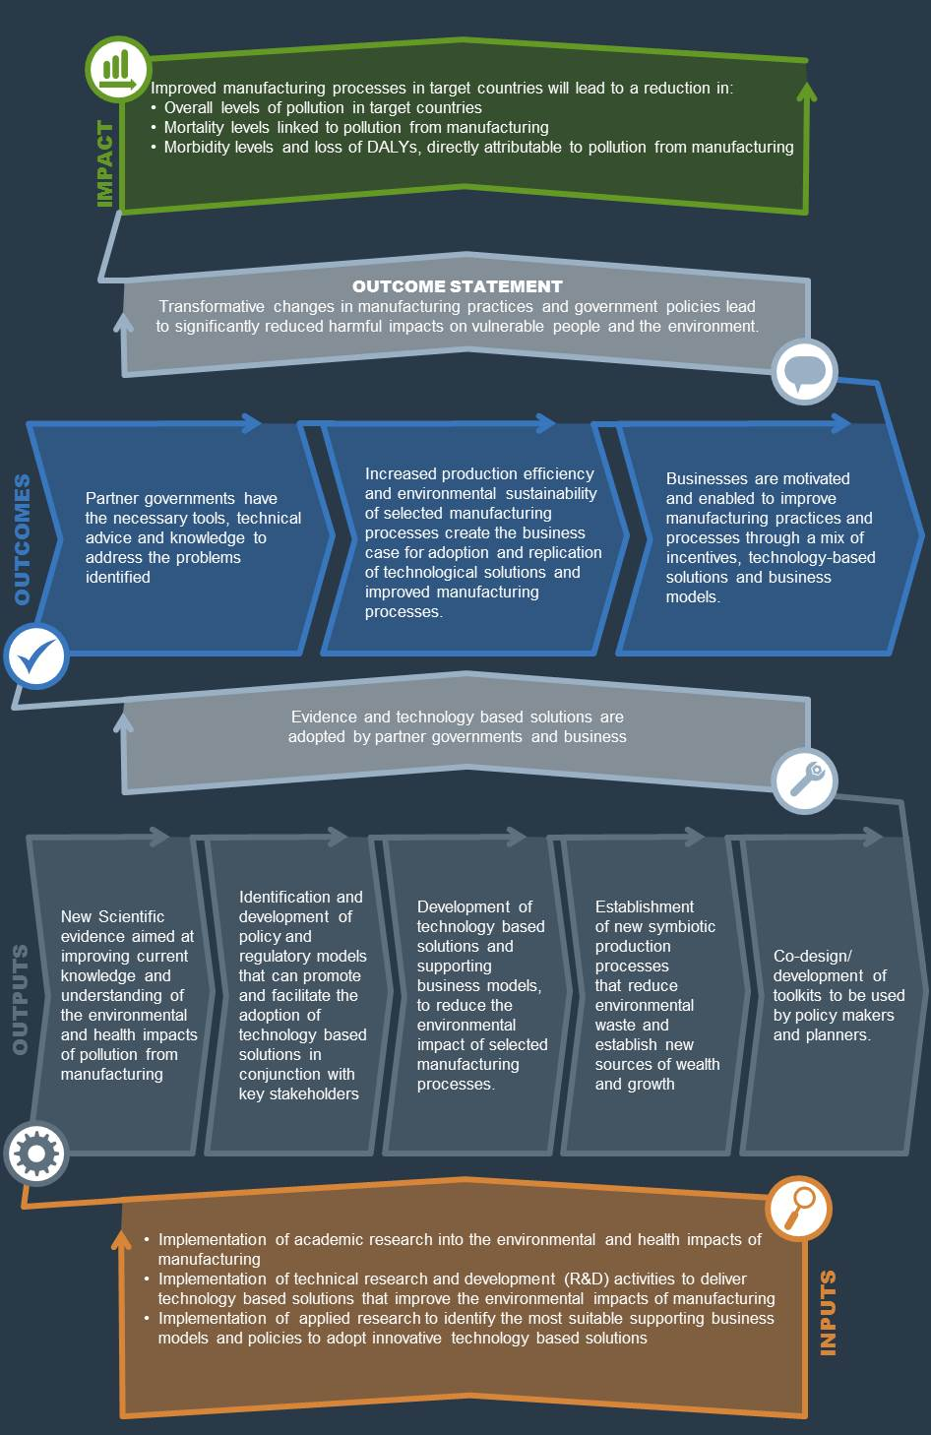
Fig.11: Theory of Change diagram SMEP programme.

Model for Impact
The programme will generate impact through a combination of: research; testing innovative technologies; and identifying effective business models and policies that will drive take up. These three components are outlined below:

- Research to develop the evidence to support practical solutions with a high chance of take up and impact.
As outlined in the Strategic Case of this document, there are still critical gaps in evidence around the impact of manufacturing on public health and key environmental resources (e.g. clean air, water and soils) in developing countries and the practical solutions to tackle these. These gaps are preventing a full understanding of the challenges facing government agencies tasked with ensuring public safety and delivery of crucial services, and the suitable interventions and solutions to tackle the most dangerous and harmful sources of manufacturing-related pollution.
The outputs of this component will include: mapping of industries and manufacturing clusters by sector and polluting potential; a better understanding of pollution sources and pathways, including the relationship between the presence of specific pollutants in the environment and various types of manufacturing and impacts on public and occupational health; and a suite of case studies, which provide a clear understanding of the type of technology-based solutions needed to improve manufacturing processes and identify the sectors that are responsible for the most harmful types of pollution. All research undertaken under this component will be aimed at developing evidence to support practical solutions with a high chance of take up and impact.
- Developing and testing innovative technology based solutions that improve the environmental impacts of manufacturing.
This component will focus on developing innovative technological solutions, tailored specifically to the realities of developing country manufacturing, which will improve the environmental impact and resource use efficiency of selected manufacturing processes (especially those that also improve productivity and reduce costs). There is already a strong focus in OECD countries on achieving environmental sustainability and maximising efficiency in the use of natural resources in industrial processes. Historically, this progress was driven, not only just by technological innovation, but also by growing pressure from public opinion, civil society, and government agencies, which were mandated with addressing the issues of pollution and public health. However, these technological advancements and progress have largely bypassed most developing countries, where the realities of manufacturing are often decades behind, in terms of efficiency, as well as occupational and environmental safety.

- Identifying and developing suitable supporting business models and policies to adopt innovative technology based solutions.
This component will focus on identifying and developing business models, policy regulation and incentives as well as financing options to enable the adoption of the technology-based solution developed under this. It will do so by working closely with a range of stakeholders, including private sector and institutional partners, to ensure that design reflect the needs of relevant actors on the ground. Even the best and most innovative technological solutions need the right supporting policies and business environment, in order to be adopted widely and succeed. Without the right mix of policies, incentives and regulations the success and widespread adoption of any innovation will be challenging and haphazard, as it will be left to the “goodwill” of local entrepreneurs, who in some cases may be faced with substantial initial capital investments and a lack of understanding of the long term benefits that such innovation would bring.

The components described above will be complemented by targeted outreach and consensus-building activities, which will focus on the dissemination and sharing of results and evidence that will be validated by the testing of technology-based solutions and business models in real manufacturing settings.

The programme will aim to include private sector partnerships with partners who provide pound for pound matching, with an emphasis on working with UK High Street names.

All of the programme activities will be underpinned by a robust monitoring and evaluation framework, which will ensure that programme impact is assessed rigorously, and will allow for continual learning and adaptive programming.

Summary Value for Money Statement

The total estimated impact for this intervention ranges from minimum of 5 million to a maximum of 10 million people as a result of DFID’s £20 million investment, equivalent to a cost of roughly £4 per person shielded from harmful levels of pollution under the low-impact scenario and £2 per person under the high impact scenario. In addition to this, the programme is expected to generate yearly cumulative economic benefits and financial savings in the range of £140 million at the macro-economic level and £18.8 million at the micro-economic level over a period of twenty/thirty years (see economic appraisal above on page 24-25).

The research and innovation activities undertaken as part of this programme will be commissioned through open, competitive tenders and will follow the latest DFID procurement requirements, therefore driving value for money.

UNCTAD has provided in-kind technical support and advice for the development of this business case and will provide £2m of in-kind contribution during programme implementation, in the form of: technical assistance to country stakeholders, technical support to the programme, organisation and running of high-level international events and policy dialogue and associated costs. With support from UNCTAD we will also aim to leverage additional financial and/or in-kind contributions from relevant private sector partners to implement targeted projects aimed at testing the potential application and effectiveness of the technical solutions that will be generated by the programme, as well as a range of innovative production methods and business models that could reduce toxic pollution and waste whilst improving productivity levels.
- Commercial Case

As set out in the Appraisal Case, we expect the impacts and Value for Money of this programme to be substantially enhanced if we work in partnership and with key institutional, private sector and civil society actors, than if we work alone. The SMEP programme’s overall effectiveness will be ultimately determined by the degree to which it influences individual, corporate and institutional decision making, and the extent to which its research outputs, technology and business solutions will drive the adoption and application of cleaner production methods. Partnerships with industry, governments, academia, civil society and development institutions are considered essential to the programme’s long-term impacts and to achieving wider environmental outcomes.

Procurement and commercial requirements for intervention
This programme will be delivered through a number of Research Consortia and will be managed by a Programme Management Agent (PMA), which will be appointed through an open competitive process that will follow standard DFID procurement policy and rules.

The PMA will be expected to conduct a series of open call procurement exercises throughout the lifetime of the programme and may implement some activities directly, depending on its level of technical expertise. The procurement exercises will be used to appoint the Research Consortia that will implement the programme research activities. The PMA will be required to use DFID-compliant procurement systems and will need to demonstrate the necessary technical capacity and competence levels needed to apply robust financial and commercial control mechanisms that are required for all DFID-funded interventions.

Therefore the procurement requirements for this intervention will be limited to one full procurement exercise to appoint the PMA. All further procurement to be carried out by the PMA will only require DFID’s supervision to ensure that the required standards are being applied and due diligence processes followed.

How does the intervention design use competition to drive commercial advantage for DFID?
Appointing a PMA through a full open and competitive procurement exercise will ensure that we achieve the best possible value for our investment. The contract arrangements and fees will be negotiated with the PMA through DFID Procurement and Commercial Department, thus ensuring that we achieve competitive market rates. We will ensure that any downstream procurement follows our best practice, driving commercial gains through the life of the contract(s).

Our proposed strategic partnership with UNCTAD offers a strong value for money proposition in a number of areas. UNCTAD, as part of the UN secretariat has a core budget to cover staff costs, among others. As such, contributions from DFID to the SMEP programme will not be used to pay any UN staff wages and any contributions made by UNCTAD staff will be covered under the in-kind contributions that UNCTAD will make towards the programme. Instead, DFID’s contribution will be used to engage individuals through consultancy contracts to provide technical support, lead group dynamics and undertake project-wide analysis and trainings, among others. Consultancy rates will be in accordance with the established UN retribution scales for consultants. The entry level is A with a maximum daily rate of £173 (US$240), the highest level is E with a maximum daily rate of £ 707 (US$ 980). For the SMEP programme, it is envisioned that the consultants engaged will be within Level B and E with maximum daily rates of £274 and £707 respectively. However UNCTAD will keep the costs of any consultancy rates to DFID capped at a maximum of £500 per day and will cover any excess above that limit from its contributions to the programme.

In light of the recent Supplier Review, we will engage with UNCTAD to ensure that all overhead rates are justified and in line with DFID’s guidance. UNCTAD will make in-kind contributions to the programme equal to just under £2million in value. Our agreement with UNCTAD will be based on a Memorandum of Understanding (MoU). This will clearly specify that all payments from DFID to UNCTAD will be subject to delivery of outputs and will be based on performance, to be monitored via Key Performance Indicators (KPIs). It will also include conditional break clauses that will enable DFID to rescind from the agreement at any point, if performance will not be judged to be satisfactory.
How do we expect the market place will respond to this opportunity?
We have already conducted some preliminary scoping of the market place for the role of PMA and the Research Consortia and have found that there is a strong field of competitors with clear expertise located within the UK as well as Europe, the US and Canada. We therefore expect to have a good/strong response to our calls for proposals, which should ensure we select high-quality bids and achieve high value for money.

In terms of the bidders that are expected to compete for the various programme roles, we expect that the role of PMA will attract interest from private sector management firms and non-profit organisations which operate in the field of circular economy and sustainable manufacturing. For the delivery of programme research activities we expect to attract bids from academia and specialised research institutions, as well as specialised private sector firms, which operate in the field of sustainable manufacturing and have an established track-record of delivering projects for UK, EU and US government agencies. We will engage with PCD colleagues to establish if an Early Market Engagement event is advisable.

How will contract & supplier performance be managed through the life of the intervention?
The SRO and DFID programme manager (PM) will oversee implementation of the programme activities and performance of our strategic partner (UNCTAD) and the PMA. Any contractual and/or commercial issues will be referred to Procurement Department, who will provide advice on how to proceed and implement any relevant actions. UNCTAD will assist the DFID SRO and PM to select the PMA and asses the bids for the research proposals.
There will be quarterly meetings and reporting from the PMA to assess the progress made by the programme’s research components and against the contract KPIs. We will work collaboratively to ensure that performance is monitored on a regular basis. Progress will also be reviewed as part of DFID’s Annual Review and Project Completion Report process. These reviews will include travel to one or more project countries, as appropriate, which has been budgeted for under the monitoring and evaluation component.
Due diligence of downstream partners
The PMA will conduct detailed due diligence assessment on downstream partners. The downstream partners for this programme will be the members of the Research Consortia and any sub-contractors they will appoint with our approval.

We do not expect having more than a total of three layers of downstream partners including the PMA, who will be the 1st tier partner (for more information please refer to the programme management structure diagram on page 38). Working with multiple partners may not lend itself to a coherent and focused programme, we also wish to minimise the costs for the PMA, which could be increased if they are managing large numbers of partners. We will keep this under review as SMEP development progresses.

Payments to all partners will be output based and will be triggered upon delivery of previously agreed key milestones.

Value for Money assessment for the intervention
This intervention is being assessed on the basis of the following VFM criteria:

Economy (Outcome to Impact)
The economic impact of the programme will be measured using three different sets of indicators. The first set will look at academic impact, which will be measured in terms of numbers of academic outputs (including journal articles and working papers) and citations in ISI-listed journals. The second set of indicators will look at the policy impact, which will be measured by the number of policy decisions that have been directly influenced and/or informed by the programme generated evidence and tools. A proxy indicator, measuring the number of policymakers from key partner countries attending the programme’s high-level policy dialogue forums and dissemination events, will also be used to gauge the level of interest and outreach it achieved (i.e. how policymakers use the information). Finally, the third set of indicators will focus on the transformational impact of the programme, which will be measured in terms of the numbers of innovative technology based solutions and business models that have been developed by the programme and tested successfully through collaborative innovation partnerships with private sector partners.
Effectiveness and Innovation potential (Output to Outcome)
The innovation potential of this intervention will be assessed on the basis of the technological advancement that will be introduced through the programme’s technical research and development activities. This will be measured not only in terms of the sophistication levels introduced through the programme’s research and outputs, but also by the effectiveness of the ideas in achieving transformational change on the ground. The latter will be assessed by measuring against quantitative indicators the effectiveness of the solutions developed in reducing the overall levels of pollution generated by various industrial production methods. Another parameter to test the effectiveness of this intervention will be the “potential for replication and adoption”, which will be assessed by measuring the technical complexity, accessibility and commercial viability of the business and technology-based solutions developed by the programme. These will be measured using a set of Key Performance Indicators (KPIs) that will be developed in collaboration with UNCTAD and the PMA, using criteria and parameters from the academic literature.

Efficiency in the use of (DFID) resources (Input to Output)
The efficiency of the programme will be calculated through how well it will use DFID and UNCTAD resources to create outputs that are relevant and cost effective. These will typically be monitored by measuring the unit costs for new innovative technologies and scalable business models developed, tested and trialled over the lifetime of the programme. The structure of the programme will allow costs to be compared, including for low, medium and high results scenarios.
Equity in building effective partnerships
This aspect of the programme’s VfM profile will be assessed by measuring the number of partnerships that will be developed throughout the lifetime of the programme with stakeholders and partners on the ground, as well as their terms, inclusiveness, scope and success in testing and rolling out more widely the technology-based and business solutions developed by the programme’s research components.

Financial Case
What are the programme costs?
The total DFID contribution will be up to £20 million over 5 years (April 2018 to September 2023). An indicative outline budget for the project is given in table 5 below.

UNCTAD will contribute £2 million in-kind over the lifetime of the programme and we expect further in-kind and/or financial contributions from private sector partners to be negotiated and determined further down the line. UNCTAD contributions will be used to provide technical assistance and support functions as well as contributing to the cost of hosting conferences and high-level policy events. Any partnership with private sector entities will be limited to gaining access to production and/or manufacturing facilities in order to test technology based innovations developed as part of the innovative technologies component of the programme The programme will aim to include private sector partnerships with partners who provide pound for pound matching, with an emphasis on working with UK High Street names.

How will it be funded: capital/programme/admin?
It will be funded from DFID’s Research and Evidence Division’s programme budget, Climate, Energy & Water Team. Research is classified as capital expenditure; this programme meets the criteria to classify as research capital spend.

How will funds be paid out and allocated?
The programme operational funds will be distributed between the PMA, who will manage the core component programme funds (up to £16.5m) and UNCTAD, who will deliver a range of technical assistance and support functions (£2m). Direct programme management fees for the PMA to administer disbursed programme funding will be capped at 5% of disbursed programme funding.

The programme will use a range of financial instruments. Our partnership with UNCTAD will be underwritten by a standard UN Memorandum of Understanding, whereas our commercial relationship with the PMA will be underwritten either by a commercial contract or an accountable grant, depending on the legal status of the organisation that will be successful in the tendering process and based on advice from DFID procurement and Commercial department.

Recognising that the project will have start-up costs, DFID may advance the first payment tranche to UNCTAD and/or the PMA, based on approval from DFID Finance and Procurement departments and a detailed proposal from either UNCTAD and/or the PMA, on the strict understanding that future payments will be made in arrears. When considering if making any advance payments to the PMA, its legal/charitable status will be upheld as a deciding factor and the funding modality will be taken into account.
Key cost drivers
The key cost drivers for this programme, in order of magnitude, will be funding for: the core research and innovation activities under the three components by the research consortia and delivery partners (up to £16.5m); technical assistance and support functions provided through UNCTAD to help deliver the three components and scoping phase (£2m from DFID, matched by £2m in-kind contribution from UNCTAD); programme management fees to administer disbursed programme funding carried out by a competitively procured programme management agent (to be confirmed, but expected to be around £0.8m); and monitoring, evaluation and learning (up to £0.5m)

Table 5: Indicative overall budget breakdown for SMEP programme
Component | DFID financial contribution | Other partners’ contributions
Scoping phase | £0.5m | £0.5m  (UNCTAD)
1. Research to develop the evidence to support practical solutions with a high chance of take up and impact. | £4.0m | £0.5m (UNCTAD)
2. Developing and testing innovative technology based solutions that improve the environmental impacts of manufacturing. | £10.0m | £0.2m (UNCTAD)  + tbc  (PS partners)
3. Identifying and developing the most suitable supporting business models and policies to adopt innovative technology based solutions. | £4.0m | £0.8m  (UNCTAD)
Direct programme management fees to administer disbursed programme funding (amount tbc through DFID’s open procurement process but steer is to cap at 5% of disbursed programme funding. | £0.83m | -
Monitoring, Evaluation and Learning | £0.5m | -
Totals | up to £20m | £2m + tbc
How will funds be profiled and how will you ensure accurate forecasting?
The operational funds for this programme will manged and spent by two implementing partners, namely the PMA and UNCTAD, who will be responsible for ensuring that money is spent in line with DFID financial rules and requirements. We will agree a multi-year budget profile and spending forecast with each partner in advance, at the time of the signing of our contracts and/or service level agreements. Considering that in practical terms, long term spending forecasts are very difficult to be set so far in advance; these will be revised and agreed annually with each relevant partner, who will then be responsible for ensuring compliance.

Table 6: Indicative Annual Spend Profile-SMEP programme
 | Year 1  FY2018/19 | Year 2  FY2019/20 | Year 3  FY2020/21 | Year 4  FY2021/22 | Year 5  FY2022/23 | Total
Yearly total budget allocated (£m) | 0.50 | 3.00 | 7.00 | 5.00 | 4.50 | 20.0

Fig.12: SMEP spend profile by semester over lifetime of the programme FY2018-23.

What is the assessment of financial risk and fraud?
The risk of fraud or financial mismanagement for the SMEP programme has been assessed to be low. The two main implementing partners for this intervention will be the PMA and UNCTAD, who will be in charge of spending 95% of programme funds. Both partners (our 1st tier) will fund other delivery partners (the 2nd tier) but robust due diligence following DFID guidance and processes will be undertaken on any partner in the delivery chain which will minimise the risk of misappropriation of funds and protect DFIDs reputation.
UNCTAD is an agency of the United Nations that is part of the core UN secretariat. As such, UNCTAD’s handling of donor contributions is bound by the United Nations accounting and reporting procedures, the UN Risk Management system and the UN’s Internal Control Policy.

The rules of the UN Secretariat’s Enterprise Risk Management and Internal Control Policy and Methodology are based on UN policy A/66/692, which include many safeguards for project and finance operations that are constantly monitored for known fraud risk factors, potential fraud schemes, control gaps, and red flag identification issues. Furthermore, all United Nations (and UNCTAD) staff members are obliged to provide assurance regarding the adequate utilisation of resource, reliable financial reporting, as well as preventing and detecting fraud.

The UN has also multiple internal instruments to protect whistleblowers against any form of retaliation and ensure financial disclosure on all of its projects and operations. The oversight functions include the Office of Internal Oversight Services, the Board of Auditors, the Joint Inspection Unit and the Independent Audit Advisory Committee.
The PMA will be appointed through an open competitive procurement exercise and will be assessed on a set of stringent criteria including: its capacity to manage funds and conduct procurement exercises in line with DFID requirements and its established track record in fiduciary risk management and assessment. In order to be selected, the PMA will also need to undergo a due diligence assessment to ensure its own financial standing and reputability.
How will expenditure be monitored, reported, and accounted for?
Payments to the Research Consortia and other implementing partners will be managed and administered by the PMA. DFID will make payments to the PMA on a quarterly basis on receipt of full financial statements of expenditure and satisfactory programme performance, in line with the provisions included in the contract that will be agreed between DFID and the PMA and within the individual accountable grant or memorandum of standings that are set up following due diligence.

Forecasting will be undertaken by DFID on its own system based on the payment schedule (see budget and forecast above). The PMA will inform DFID at least 2 months prior to any request for payment, or to make changes to pre-agreed forecasted expenditure. There will also be two opportunities per year, where DFID and the PMA will discuss and agree any proposed/required changes to the financial profile of the project and or pre-agreed financial forecasts.
Payments to UNCTAD will be made on a quarterly basis following submission of a valid expenses claim and submission of quarterly reports of expenditure. All payments will be subject to continued performance and achievement of programme objectives, including delivery of any outputs agreed in the MoU that will be agreed between DFID and UNCTAD.
Terrorism and Financing
Because of the research topic and the funding mode that will be applied to this programme, we do not expect it to be any significant risk of financing terrorism, either directly or indirectly. However, we expect to implement research activities in at least one country with a significant terrorism threat, so there are some risks associated with this aspect that will be closely monitored.
DFID will also ensure the implementing partner has rigorous processes in place to ensure that no funds are transferred to individuals or groups associated with terrorism. The overall risk level related to terrorist financing associated with the programme has been assessed as low.

Asset monitoring and control
The programme research activities will involve the purchase and/or development of material assets, which will be used to develop and test the effectiveness, adoption potential and commercial viability of technology-based solutions.

Any assets that will be developed as part of the process described above will either be donated to small-scale entrepreneurs and/or family businesses that will participate in the pilot studies, or alternatively will be disposed of and/or written-off in line with DFID procedures and regulations.

The PMA will be in charge of maintaining an asset register, which will be reviewed periodically by the SRO and the DFID PM. Disposal of any asset, irrespective of its monetary value will need to be approved by eth DFID PM and SRO.

What conditions apply (for financial aid only)? Partnership Principles
Not applicable – this programme does not support a bilateral programme and or budget support in a partner country.
- Management Case
The SMEP programme will operate under the management structure illustrated in figure 13 below. As outlined in the appraisal case section of this document, this structure builds on elements of other DFID-funded programmes, which have been selected because on their suitability to the context of this programme and their previously demonstrated effectiveness. Lessons learned in other programmes have also been applied to the design and development of the management structure and delivery model used for this intervention.
Fig.13 Governance & management structure for the SMEP programme. 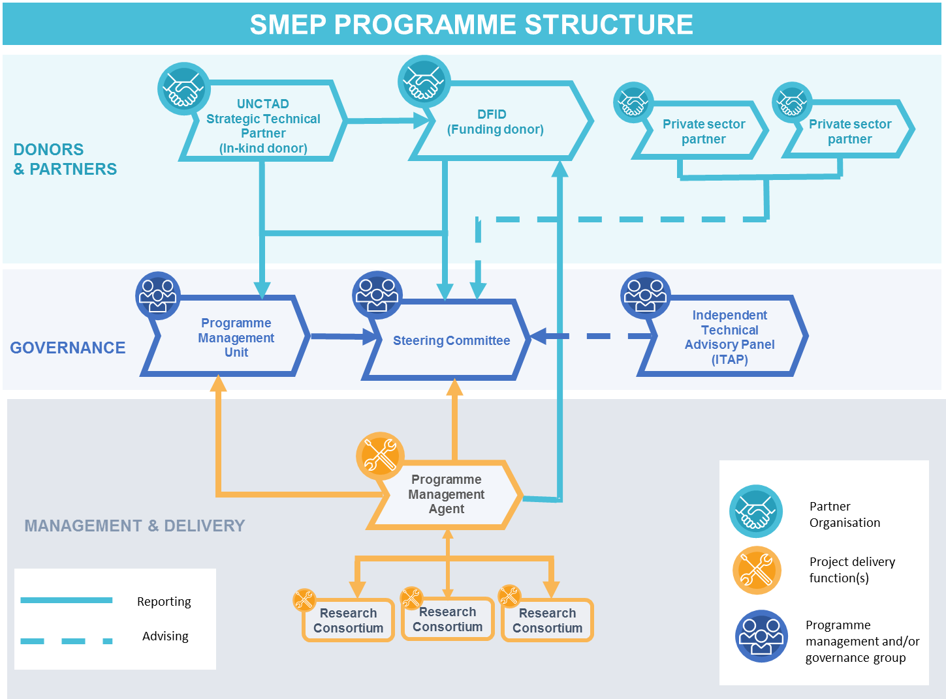
What are the management & governance arrangements for implementing the intervention?

The SMEP programme will adopt a ‘distributed’ management and governance structure, which will see DFID as the main financial contributor for the programme. UNCTAD will provide in-kind contributions equal to a value of £2m and we are expecting to receive further financial and/or in-kind contributions from potential PS partners with whom we are currently exploring potential partnership options (see Appraisal Case pg. 21).

Procuring a fund manager with the capacity and capability to respond quickly to the adaptive and flexible nature of SMEP is critical to the success of the model and to delivering the expected results. The procurement for the PMA will stipulate a need for a partner with experience in the general thematic area. This will ensure buy-in and ownership of the outcomes. An indicative list of activities to be undertaken by the PMA is outlined below and will be further refined before any procurement:
- Manage call for proposals for funding rounds;
- Assist DFID and UNCTAD in assessing all applications;
- Prepare and put in place all grant or contractual arrangements for successful applicants;
- Undertake any required due diligence checks on all organisations receiving grants to manage risk and ensure close fiduciary control in line with DFID guidance;
- On-going, regular monitoring of outputs and financial tracking including verification through spot checks, ensure compliance;
- Assist DFID and UNCTAD in conducting annual reviews;
- Financial analysis and risk management of research portfolio;
- Perform programme management functions for all downstream grants;
- Financial Management of all downstream grants – including: checking and verifying expenditure claims, disbursement, review audited accounts, monthly financial forecasting (within a 1% variance) and reporting;
- Financial monitoring against yearly accounts and regular reporting to DFID SRO/PM on finances;
- Monitoring and reporting of results.

UNCTAD will be act as a strategic technical partner and will assists the DFID SRO in setting up the governance structure for the programme, highlighted in the dark blue boxes in fig. 12 above. It will also deliver a range of technical and/or specialist functions, which include providing technical assistance to partner countries government agencies and/or line ministries, as well as ensuring leverage and buy-in from institutional and PS partners. An indicative list of activities to be undertaken by UNCTAD is outlined below and will be further refined before any procurement:

- Scoping work during inception phase;
- Preparation of policy briefings and grey literature reports;
- Organization of and convening high-level policy dialogues and consensus building activities with DCs government agencies and other institutional partners;
- Outreach activities with private sector & civil society groups;
- Technical Assistance & Capacity building for government ministries and agencies in partner countries;
- Technical assistance and support for local entrepreneurs;
- Communications & outreach ;
- Liaison with local, national and international media, including issuing press releases and curating social media profile with the programme (in collaboration with DFID comms department).

We will set up a coherent management framework to ensure regular discussions between the DFID, UNCTAD, PMA programme teams. Strategic relationship management will be key to the success of the programme as this will allow us to be flexible and develop the programme as the research projects develop evidence. This will be developed when the PMA is selected.

The governance structure of the programme will consist of three main elements, the Steering Committee (SC), the Programme Management Unit (PMU) and the Independent Technical Advisory Panel (ITAP).

The Steering Committee will be in charge of making executive decisions and setting the strategic direction for the programme. Membership of the SC will be limited to any partners who provide financial and/or in-kind support to the programme, such as UNCTAD and any potential PS partners, as well as DFID and a representative from the PMA. The SC will aim to make decisions by consensus, however if for any reason consensus cannot be reached, voting will be weighted according to the size of the financial contribution made by each partner/donor.

The Programme Management Unit will be in charge of making decisions concerning the management and administration of programme operations and finances. It will also review operational procedures and make any adjustments that may be needed throughout the lifetime of the programme to improve efficiency, value for money and delivery of operations. Any substantial changes and those that will have financial implications will be submitted to the programme SRO, who will make any final decisions or refer issues upwards in line with the DFID Smart Rules. Membership of the PMU will comprise a DFID representative, a representative for the PMA, representatives from the Research Consortia and -depending on need- any other implementing partners who will be invited to join specific sessions.

The Independent Technical Advisory Panel will be in charge of providing specialist technical advice to the Steering Committee on specific issues that will emerge from the research activities and/or which will be identified by the SC as requiring further technical advice. The ITAP will also provide evidence to help inform the SC decision-making process and steer the strategic direction of the programme. Membership of the ITAP will comprise exclusively external experts from academia, industry, private sector, government and international institutions. Members of the ITAP will be required to have an established track record in their field and should not be recipients of direct financial support from the SMEP programme.

Research activities will be implemented directly by Research Consortia, which will be appointed through open competitive tenders that will be managed by the PMA. The outcome of the tendering process will be decided by an evaluation panel, which will be appointed by the PMA in line with DFID procurement rules. The SC will provide technical and strategic advice to inform the evaluation panel’s decisions. DFID will have ultimate decisional powers and powers of vetoing any decisions that may contravene DFID policies and/or procurement regulations. DFID representatives will be present at key decision making points and advisers from across DFID will input into the specific thematic areas. The PMA will also manage up to three small-size projects, which will focus on further testing of the programme-funded technology-based solutions and business models, in partnership with private sector partners. Procurement, management and implementation of these projects will be subject to the rules that are applicable to all DFID-funded interventions.
What are the risks and how these will be managed?

The overall risk rating for the programme has been assessed as Moderate. The SMEP programme will be operating in a space that has already been highlighted as a priority by the SDGs and has been recognised as a key issue by a growing number of private sector firms and multinational conglomerates, as well as international development agencies OECD countries governments. However the programme involves various levels of risk under a number of categories, which have been identified as the following:

- ​Programme technical complexity;
- Number of components and sub-components;
- Programme informed by strong analytical work;
- Experience of implementing partner in delivering similar programmes;
- Experience of implementing partner working with us;
- Design technologies and processes;
- Monitoring and evaluation arrangements;
- ​Implementing partner capacity;
- Oversight and control mechanisms;
- Fraud and corruption in the implementing agencies.

These have been analysed and rated against the two criteria of probability and impact, mitigation actions against each risk have also been identified and briefly described in table 7 below.

Table 7: Risk Management matrix for the SMEP programme.
Risks and Description | Probability  (H, M, L) | Potential Impact  (H, M, L) | Mitigating Actions
Programme technical complexity | M | L | - Programme structure will ensure adequate technical support from UNCTAD and ITAP;  - Competitive process to select proposals will ensure that implementing partners have necessary technical skills to deliver technical outputs.
Number of components and sub-components | M | M | - The programme structure involves the appointment of a PMA, which will manage all programme components.  - Selection process for PMA through open competition will ensure that they have the necessary capacity and skills to manage programme.
Programme informed by strong analytical work | L | M | - The BC for this programme involved a detailed analysis of existing evidence from the academic literature  - We will also conduct a research scoping project during year 1 of the programme to deepen understanding of manufacturing realities on the ground in target countries.
Experience of implementing partners in delivering similar programmes | L | H | - The PMA and Research Consortia will be selected through competitive process. Following an initial scoping of the market place we expect a strong field of competitors.  - UNCTAD is one of the international leading agencies in the subject matter covered by the programme
Political economy factors lead manufacturers not to adopt less polluting technologies and business models. | L | M | - The SMEP programme is going to tackle this important aspect from different angles by:  - working with PS partners to incentivise the adoption of clean production methods and business models;  - working with government agencies and line ministries in DCs to ensure the right balance of regulatory enforcement and policy incentives.
Design technologies and processes | M | H | - We will put in place a strong peer-review mechanism, which should ensure that all programme outputs and results are validated by external parties.  - We are also planning to organise wider testing of technological innovations with PS partners, which have operations in the manufacturing sectors and countries that will be covered by the programme.
Monitoring and evaluation arrangements | L | M | - We are putting in place a three tier M&E mechanism for the programme, which will involve the PMA, our strategic partner UNCTAD and DFID programme staff, which will be supervising overall M&E for the programme.
Oversight and control mechanisms | L | H | - We are putting in place a two-tier control mechanism, where the PMA will implement all operational oversight and control mechanisms under DFID supervision and in line with DFID Smart Rules.
Fraud and corruption in the implementing agencies | L | H | - Given the technical complexity of the programme, we expect that its operations will be mostly implemented by established research institutions with robust financial management and auditing systems.  - The programme structure will also ensure that there are no more than two layers of delivery partners and that PMA conducts all necessary due-diligence and financial control procedures to minimise the risk of fraud. DFID will also conduct a due diligence assessment of the prospective PMA candidates before awarding any contracts.  - Any request for funding of institutions with a “riskier” profile will be referred directly to DFID and the programme SRO, who will have the right to veto any funding proposals made by downstream partners.

How will progress and results be monitored, measured and evaluated?
The SMEP programme involves a wide range of risks and even though these have been assessed as moderate, a robust methodology of monitoring, evaluation and continuous learning will be required to ensure the programme maximises its impact. A comprehensive business intelligence, monitoring and evaluation (M&E) strategy will be created to track commercial KPIs and indicators and end-user impact.

At the end of the first year of the programme, following initial landscaping and prioritisation of areas of intervention, which will be identified during the scoping phase, an M&E framework specifying KPIs, tools and frequency of data collection will be established and managed by the PMA. UNCTAD will contribute M&E expertise as required.

The DFID SRO and UNCTAD will define review cycles, which will take into account data available from a variety of sources. This will then be analysed using both qualitative and quantitative tools thus allowing for adaptive programme management and learning, as well as making improvements to the programme structure and operations if needed.

At the next level down, grantees will be provided with tailored monitoring and evaluation framework and tools to better understand the success and impact of their services. In addition, grantees will be required to consider their own approaches to M&E when putting forward their proposals – with a clear indication of how those results of a non-commercial nature could be collected and shared.

Elements of the M&E Framework
The M&E framework will include the following elements:
- Theory of change which describes the causality pathways through which the project is expected to achieve its goals – from changes in policy or practice to technology adoption by end-users to desired outcomes and impact.
- A detailed logframe, which will be the main M&E tool for the programme and will be used to assess performance against the programme’s objectives and outcome. This will be reviewed and further developed in collaboration with UNCTAD and the PMA. A preliminary version is included in Annex 1.
- A set of detailed KPIs, which will be monitored on ongoing basis to assess the progress of individual projects and validate or disproof hypotheses made in the theory of change, underlying implementation model and design. KPIs will be reviewed regularly to allow for agile decision making and improvements.
- Data sources and analytical tools. As KPIs include both qualitative and quantitative metrics, a variety of data sources and tools will have to be identified. These will allow assessment of progress and to identify any bottlenecks towards achieving outputs, outcomes and impact, as well as the reasons behind them.

References

Ackah M. (2017):”Informal E-waste recycling in developing countries: review of metal(loid)s pollution, environmental impacts and transport pathways”. Environ Sci Pollut Res Int. 2017 Nov; 24(31):24092-24101. doi: 10.1007/s11356-017-0273-y.

ADB (2014):” Industrial Energy Efficiency Opportunities and Challenges in Bangladesh” (https://www.adb.org/sites/default/files/project-document/80742/45916-014-tacr-01.pdf)> Accessed on 24/11/2017.

Blacksmith Institute (2014):“Top Ten Countries Turning the Corner on Toxic Pollution”. Blacksmith Institute, New York.

Boston Consulting Group (2015):”Takeoff in Robotics will power the next productivity surge in manufacturing”. (https://www.bcg.com/d/press/10feb2015-robotics-power-productivity-surge-manufacturing-838)

Bowerman Niel H. A., David J. Frame, Chris Huntingford, Jason A. Lowe, Stephen M. Smith and Myles R. Allen (2013):“The role of short-lived climate pollutants in meeting temperature goals”. Nature Climate Change ,Vol 3, pg. 1021-1024, December 2013.

Caravanos J, Chatham-Stephens K, Ericson B, Landrigan PJ, Fuller, R. (2013) The burden of disease from pediatric lead exposure at hazardous waste sites in 7 Asian countries. Environmental Research. 120:119-125.

Chatham-Stephens, K., Caravanos, J., Ericson, B., Sunga-Amparo J, Susilorini B, Sharma P, Landrigan, P., & Fuller, R. (2013). Burden of Disease from Toxic Waste Sites in India, Indonesia, and the Philippines in 2010. Environmental Health Perspectives. http://ehp.niehs.nih.gov/1206127/

EPC (2017): What is workplace pollution? Environmental Pollution Centres. (https://www.environmentalpollutioncenters.org/workplace/) Accessed on: 21/12/2017.

Fu Shihe, Viard Brian V., Zhang Peng (2017): Air Pollution and Manufacturing Firm Productivity: Nationwide Estimates for China. (https://papers.ssrn.com/sol3/papers.cfm?abstract_id=2956505). Accessed on 21/12/2017.

Global Alliance on Health and Pollution (2013):”The Poisoned Poor: Toxic Chemicals Exposures in Low- and Middle-Income Countries”. Report published on behalf of GAHP by the Blacksmith Institute, New York.

GBD 2015 Mortality and Causes of Death Collaborators. Global, regional, and national life expectancy, all-cause mortality, and cause-specific mortality for 249 causes of death, 1980–2015: a systematic analysis for the Global Burden of Disease Study 2015. Lancet 2016; 388: 1459–544.

Hester, Ronald E.; Harrison, R. M. (editors) (2011). Marine Pollution and Human Health. Royal Society of Chemistry. pp. 84-85. (ISBN 184973240X)

Islam, Saiful Md., Ahmed Kawser MD., Raknuzzaman, Mohammad., Al Manun, Habibullah Md., Islam, Muhammad Kamrul (2015): Heavy metal pollution in surface water and sediment: A preliminary assessment of an urban river in a developing country. Ecological Indicators (48), pp 282-291.

ILO (2012):”Improvement of national reporting, data collection and analysis of occupational accidents and diseases” (http://www.ilo.org/wcmsp5/groups/public/---ed_protect/---protrav/---safework/documents/publication/wcms_207414.pdf). Accessed on 24/11/2017.
ILO (2016):”Employment by sector - ILO modelled estimates, November 2016. ILO Statistical service

Jambeck Jenna R., Roland Geyer, Chris Wilcox, Theodore R. Siegler, Miriam Perryman, Anthony Andrady, Ramani Narayan, Kara Lavender Law (2015): Plastic waste inputs from land into the ocean. Science 13 Feb 2015: Vol. 347, Issue 6223, pp. 768-771 (DOI: 10.1126/science.1260352)

Joleah B. Lamb, Bette L. Willis, Evan A. Fiorenza, Courtney S. Couch, Robert Howard, Douglas N. Rader, James D. True, Lisa A. Kelly, Awaludinnoer Ahmad, Jamaluddin Jompa, C. Drew Harvell (2018): Plastic waste associated with disease on coral reefs. Science, Vol. 359, Issue 6374, pp. 460-462 (DOI: 10.1126/science.aar3320)

Kosonen, R. (2004) The effect of perceived indoor air quality on productivity loss. Energy and Buildings 36, Issue 10, pp 981-986. Accessed on 21/12/2017. (http://www.sciencedirect.com/science/article/pii/S0378778804001823).

Landrigan Philip J, Richard Fuller, Nereus J R Acosta, Olusoji Adeyi, Robert Arnold, Niladri (Nil) Basu, Abdoulaye Bibi Baldé, Roberto Bertollini, Stephan Bose-O’Reilly, Jo Ivey Boufford, Patrick N Breysse, Thomas Chiles, Chulabhorn Mahidol, Awa M Coll-Seck, Maureen L Cropper, Julius Fobil, Valentin Fuster, Michael Greenstone, Andy Haines, David Hanrahan, David Hunter, Mukesh Khare, Alan Krupnick, Bruce Lanphear, Bindu Lohani, Keith Martin, Karen V Mathiasen, Maureen A McTeer, Christopher J L Murray, Johanita D Ndahimananjara, Frederica Perera, Janez Potočnik, Alexander S Preker, Jairam Ramesh, Johan Rockström, Carlos Salinas, Leona D Samson, Karti Sandilya, Peter D Sly, Kirk R Smith, Achim Steiner, Richard B Stewart, William A Suk, Onno C P van Schayck, Gautam N Yadama, Kandeh Yumkella, Ma Zhong (2017): The Lancet Commission on pollution and health. The Lancet, London - New York. Published Online: October 19, 2017 (http://dx.doi.org/10.1016/) S0140-6736(17)32345-0
Lavopa and Szirmai (2014): Structural Modernization and Development Traps: An Empirical Approach. UNU-MERIT Working Paper Series No. 2014–076. Maastricht: United Nations University, Maastricht Economic and Social Research Institute on Innovation and Technology.

Luo, Yunpeng., Chen, Huai., Zhu, Qiu’an., Peng, Changhui., Yang, Gang., Yang, Yanzheng., Zhang, Yao. (2014): Relationship between air pollutants and economic development of the provincial capital cities in China during the past decade. PLOS Issue 9, PCM4119013.4.

Mathieu-Denoncourt, Justine; Wallace, Sarah J.; de Solla, Shane R.; Langlois, Valerie S. (November 2014). "Plasticizer endocrine disruption: Highlighting developmental and reproductive effects in mammals and non-mammalian aquatic species". General and Comparative Endocrinology. (doi:10.1016/j.ygcen.2014.11.003)

Navrud. Staele (2005): The Costs of Inaction with respect to Human Health Impacts from Pollution. Accessed on 20/12/2017. https://www.researchgate.net/publication/277287436_The_Costs_of_Inaction_with_Respect_to_Human_Health_Impacts_from_Pollution_1

NBER (2010) Trade growth, Production Fragmentation, and China’s Environment. National Bureau of Economic Research. (http://papers.nber.org/books/feen07-1) Accessed on: 09/11/2017.

NIH (2013): Economic Costs of Childhood Lead Exposure in Low and Middle-Income Countries. (https://ehp.niehs.nih.gov/1206424/) Accessed on: 07/11/2017

O'Sullivan, Arthur; Sheffrin, Steven M. (2003): “Economics: Principles in Action”. Upper Saddle River, New Jersey 07458: Pearson Prentice Hall. p.301. ISBN 0-13-063085-3

Park JK, Hoerning L, Watry S, Burgett T, Matthias S (2017) Effects of Electronic Waste on Developing Countries. Adv. Recycling Waste Manag 2:128. doi:10.4172/2475-7675.1000128

Preker, Alexander S., Adeyi, Olusoji O., Gil Lapetra, Marisa., Simon, Diane-Charlotte., Keuffel, Eric. (2016) : Health Care Expenditures Associated with Pollution: Exploratory methods and findings. Annals of Global Health Vol. 82, Issue 5, pp 711-721.
Pure Earth & Green Cross (2016): “The Toxics Beneath Our Feet: 2016 world’s worst pollution problems”. Pure Earth, NY - Green Cross Switzerland, Zurich, Switzerland.

Rochman CM, et al. Ingested plastic transfers hazardous chemicals to fish and induces hepatic stress. (Sci Rep 33263.2013; 10.1038/srep03263)

Roozbahani, Mohammadi., Nassiri, P., Shalkouhi, Jafari. (2009): Risk assessment of workers exposed to noise pollution in a textile plant. International Journal of Environmental Science & Technology vol. 6 Issue 4, pp 591-596.

Schmidt Christian, Tobias Krauth and Stephan Wagner (2017): Export of Plastic Debris by Rivers into the Sea. Environ. Sci. Technol., 2017, 51 (21), pp 12246–12253
(DOI: 10.1021/acs.est.7b02368)

Tampere University of Technology (2014):” Global estimates of occupational accidents and fatal work-related diseases in 2014. (https://www.wsh-institute.sg/files/wshi/upload/cms/file/Global%20Estimates%20of%20Occupational%20Accidents%20and%20Work-related%20Illness%202014.pdf). Accessed on: 24/11/17.

Tarricone, Rosanna (2006) Cost-of-illness analysis : What room in health economics ? Health Policy Volume 77, Issue 1, pp 51-63.

UNIDO (2015): “Industrial Development Report 2016: The Role of Technology and Innovation in Inclusive and Sustainable Industrial Development”. Vienna.

UN Water (2017) The United Nations World Water Development Report 2017. Facts and Figures. Wastewater – the Untapped Resource. (http://unesdoc.unesco.org/images/0024/002475/247553e.pdf)

US-EPA (2012): Reducing Toxic Air Pollutants. US Environmental protection Agency, Washington D.C. (http://www.epa.gov/airquality/peg_caa/toxics.html). Accessed on: 07/11/ 2017.

Van Minh, Hoang, Nguyen-Viet, Hung (2011):” Economic Aspects of Sanitation in Developing Countries”. Environmental Health Insights Issue 5, pp 63-70.

Vishnu, V., Priyandarshini, C. S., Hilbert, Hainy (2011):”Environmental issues caused by the rubber industry”. (https://businessimpactenvironment.wordpress.com/2011/10/03/environmental-issues-caused-by-rubber-industry/). Accessed on: 07/11/2017.

WHO (2006): Health risks of particulate matter from long-range transboundary air pollution. World Health Organization Regional Office for Europe. (http://www.euro.who.int/__data/assets/pdf_file/0006/78657/E88189.pdf). Accessed on: 10/11/2017.

WHO (2012): Violence and injury prevention report 2012. (http://www.who.int/violence_injury_prevention/publications/road_traffic/world_report/chapter2.pdf?ua=1) Accessed on: 07/11/2017.

WHO (2014): Burden of disease from Household Air Pollution for 2012; http://www.who.int/phe/health_topics/outdoorair/databases/en/ (Accessed on 07-11-2017)

WHO (2015): Continental Challenges & Change: Environmental Determinants of Health in Africa. (http://apps.who.int/iris/bitstream/10665/177155/5/Synt_R_5.pdf). Accessed on: 07/11/2017

World Bank (2007): Cost of Pollution in China. Economic Estimates of Physical Damages. (https://siteresources.worldbank.org/INTEAPREGTOPENVIRONMENT/Resources/China_Cost_of_Pollution.pdf) Accessed on: 20/12/2017.

World Bank (2012): "Integrated Air Pollution Management in China: Developing Particulate Matter Control". WB Washington D.C.

World Bank (2013): “Bangladesh Reduced Number of Poor by 16 million in a Decade”. (http://www.worldbank.org/en/news/press-release/2013/06/20/bangladesh-reduced-number-of-poor-by-16-million-in-a-decade). Accessed on: 07/12/2017.
World Bank (2016):” The Cost of Air Pollution: Strengthening the Economic Case for Action”. (http://documents.worldbank.org/curated/en/781521473177013155/pdf/108141-REVISED-Cost-of-PollutionWebCORRECTEDfile.pdf) Accessed on: 07/11/2017

World Bank (2017): World Bank Data - GDP growth annual percentage (http://data.worldbank.org). Accessed on: 08/112017.

World Economic Forum (2015):”Africa Competitiveness Report” (http://reports.weforum.org/africa-competitiveness-report-2015/structural-transformation/). Accessed on: 24/11/2017.

________________

SDG12: Responsible consumption & production; SDG6: clean water & sanitation; SDG 8: Decent work & economic growth; SDG 9: Industry innovation & infrastructure; SDG 3: Good Health & Well-Being; SDG 11: Sustainable cities & communities.
BEIS: UK Department for Business Energy & Industrial Strategy; NORAD: Norwegian Agency for Development Co-operation; BMUB: Germany’s Federal ministry for the Environment; GIZ: German Agency for International Co-operation.
Intermediate goods or semi-finished products are goods, such as partly finished goods, used as inputs in the production of other goods including final goods (O'Sullivan & Sheffrin, 2003). For instance, steel plates and components are intermediary products used in the production of many other goods, such as bicycles and cars.
These activities are often focused on the re-selling of raw materials used to produce manufactured goods. Typical examples include lead used in car batteries or valuable metals such as gold, silver and platinum from discarded electronic products (i.e. e-waste).
Disability-Adjusted Life Years (DALYs) are a measure of the overall disease burden for a given activity or cause, expressed as the number of years lost due to ill-health, disability or early death.
Byssinosis, also known as "brown lung disease", is an occupational lung disease caused by exposure to cotton dust in inadequately ventilated working environments. Byssinosis commonly occurs in workers who are employed in yarn and fabric manufacture industries.
Based on the assumption that programme-funded technological solutions will reduce overall levels of pollution below dangerous levels in 10 manufacturing areas across six DFID-priority countries (i.e. Ghana, Kenya, Zambia, Tanzania, Bangladesh, and Pakistan) benefitting 10% people living in those areas.
Calculated using 10% reduction from combined baseline estimates of DALYs caused by two key industries (tanneries and product manufacturing) operating in DFID priority countries.
Calculated using 2011 Purchasing Power Parity levels as a baseline indicator.
BCG: Boston Consulting Group.
A number of NGOs such as EMF, TF and FoE have mostly focused on the subject of circular economy and more broadly on environmental stewardship.
The PMEH programme is multi-donor programme implemented by the World Bank and supported by DFID, DBEIS, Norway and Germany. The programme activities are aimed at: i) reducing the levels of pollution that have already been released in the environment; ii) developing technical solutions to detect and monitor different types of pollution more effectively; and iii) cleaning-up contaminated sites to reduce harmful impacts on human health. The SMEP programme will focus on preventing pollution from manufacturing from being released in to the environment in the first place.
The United Nations Global Compact is a UN-led initiative to encourage businesses worldwide to adopt sustainable and socially responsible policies, and to report on their implementation. It is the world's largest corporate sustainability and social responsibility initiative, with 13,000 corporate participants and other stakeholders, including labour groups, civil society organisations and cities’ governments from over 170 countries.
USD 12.1 billion for selected South Asian countries and USD 6.8 billion for selected Sub-Saharan African Countries.
Estimated cost of pollution was calculated using a 2.5% share of GDP, which was achieved using data from a variety of verified sources.
This could be the case -for example- of women and children, who tend to spend most of their daily lives within the confines of their dwellings or immediate neighbourhood, which in many cases tend to be located near manufacturing sites in highly polluted settings.
GHGs= Green House Gases.
Based on the assumption that programme-funded technological solutions will reduce overall levels of pollution below dangerous levels in 10 manufacturing areas across six DFID-priority countries (i.e. Ghana, Kenya, Zambia, Tanzania, Bangladesh, and Pakistan) benefitting 10% people living in those areas.
(http://www.un.org/en/aboutun/structure/pdfs/UN_System_Chart_30June2015.pdf)
For more information see: (http://undocs.org/A/66/692).

