Version 8.3: 15.07.19
Summary Sheet

Department CDD/Portfolio/ Business Plan Summary:

The Department for International Development (DFID) Research and Evidence Division (RED) will contribute to the achievement of the ODA strategy and accelerated progress of the 2030 Agenda. Over the period to 2020 RED will ensure that DFID remains a global leader in knowledge, technology and innovation - funding high-quality, problem-focused research that generates new technologies and knowledge, able to deliver tangible development impacts.

This programme will deliver against commitments in the RED Business Plan to increase investments in technologies, their delivery and take up to generate new opportunities for evidence and development returns. These investments prioritise testing products and services, building evidence and ensuring they can be scaled. This will be achieved through strategic partnerships, including with the private sector.

The programme also aligns and delivers against the priorities set out in the 2018 DFID Strategic Direction on Harnessing Technological Innovation for Development (HT4D) and DFID’s Disability Inclusion Strategy.

Title: AT2030 – Life Changing Assistive Technology for All
AFRICA, ASSISTIVE TECHNOLOGY, DISABILITY
Programme summary (100 words maximum):
The scale-up will triple the impact of AT2030, DFID’s flagship ‘what works’ programme for Assistive Technology (AT), by doubling the investment with a focus on DFID priority countries in Africa. Harnessing existing momentum, this new investment will enable the programme to reach 9 million people by improving access to life-changing AT through AT2030’s existing partnerships. The new investment will enable further learning on ‘what works’ to shape markets and health systems through piloting country capacity assessments (CCAs) and rapid investment, driving AT innovation in East Africa where it is even harder to overcome the ‘valley of death’ for AT entrepreneurs, and supporting countries on inclusive design so that AT can be used appropriately in the built environment, based on the London 2012 legacy principles. An anticipated 6 million more people will be reached through harnessing the power of the Paralympics to overcome stigma through screening of the Paralympics in Africa.

What is the rationale for UK Aid spending? (200 words maximum):
Over 1bn people live with moderate to severe functioning difficulties of whom 80% live in developing countries, and 90% do not have access to the AT they need. Access to appropriate AT is key to achieving the SDGs, enabling users to participate in education, work, family, and community life. People with disabilities are disproportionally poor and often excluded from development efforts.

Approval of this business case will provide an additional £9.8m Africa focused investment, aligned to DFID’s Strategic Direction on Harnessing Technology for Development (HT4D). The scale-up underpins DFID’s Disability Inclusive Development Strategy cross-cutting pillar on AT, it’s vision to leave no one behind and supports the Global AT Strategic Priorities. It will heighten DFID’s global leading role across the disability sector and complement the UK Aid’s portfolio.
Building on rapid learning from AT2030, the additional £9.8m will reach 6m more people through the core programme, plus another 6m people through Paralympic sport, i.e. in total, five times the overall impact of the existing programme. It will include (in addition to the original AT2030 programme outputs); 30 new disruptive technologies with potential for life-changing impact; development of 4 innovative service delivery models; up to 50 new start-ups; more extensive development and testing of new market shaping interventions on assistive technologies; strengthening the establishment of an East African Inclusive AT Innovation ecosystem (Innovate Now) through the development of inclusive business support curriculum and more support to successful start-ups; support to countries on inclusive design so that AT can be used appropriately in the built environment, based on the London 2012 legacy principles; and tackle stigma and discrimination, across Africa through Paralympic sport.
As with DFID’s initial contribution, this £9.8m scale-up will be 100% match funded.

Programme Value:  £9.8m |  | Country/ Region or Sector:  Africa, AT, Disability
Department/Country Office confirmation  Contact name  Anne MacKinnon, Research and Evidence Division |  | HoO/HoD: Alastair Ager  Point of Contact for CN: Anne MacKinnon
Threshold for Approval of Business Case:  Deputy Directors <£40m |  | DD/D/ Minister / SofS  Minister Baldwin
Date of Approval of Concept Note: | 13 March 2019 | Name of Approver  Minister Baldwin
Date of Approval of Business Case |  | Name of Approver  Alastair Ager
Programme Code: | Start Date:  16 July, 2019 | End Date:  No later than 1.10.2024
Overall programme risk rating: | Moderate
Vault Number:

Strategic Case

- Overview of Programme

AT2030: Africa will triple the impact and reach of AT2030, DFID’s flagship ‘what works’ programme for AT, by doubling the investment with a focus on DFID priority African countries. The programme will harness the existing momentum and utilise current AT2030 global partnerships, expanding this partnership as necessary. The programme extension will enable the whole AT2030 programme to reach a total of 9 million people through improving access to life-changing AT. AT2030 is structured around the ‘Global Overarching Strategic Priority’ pillars in Figure 1 below.

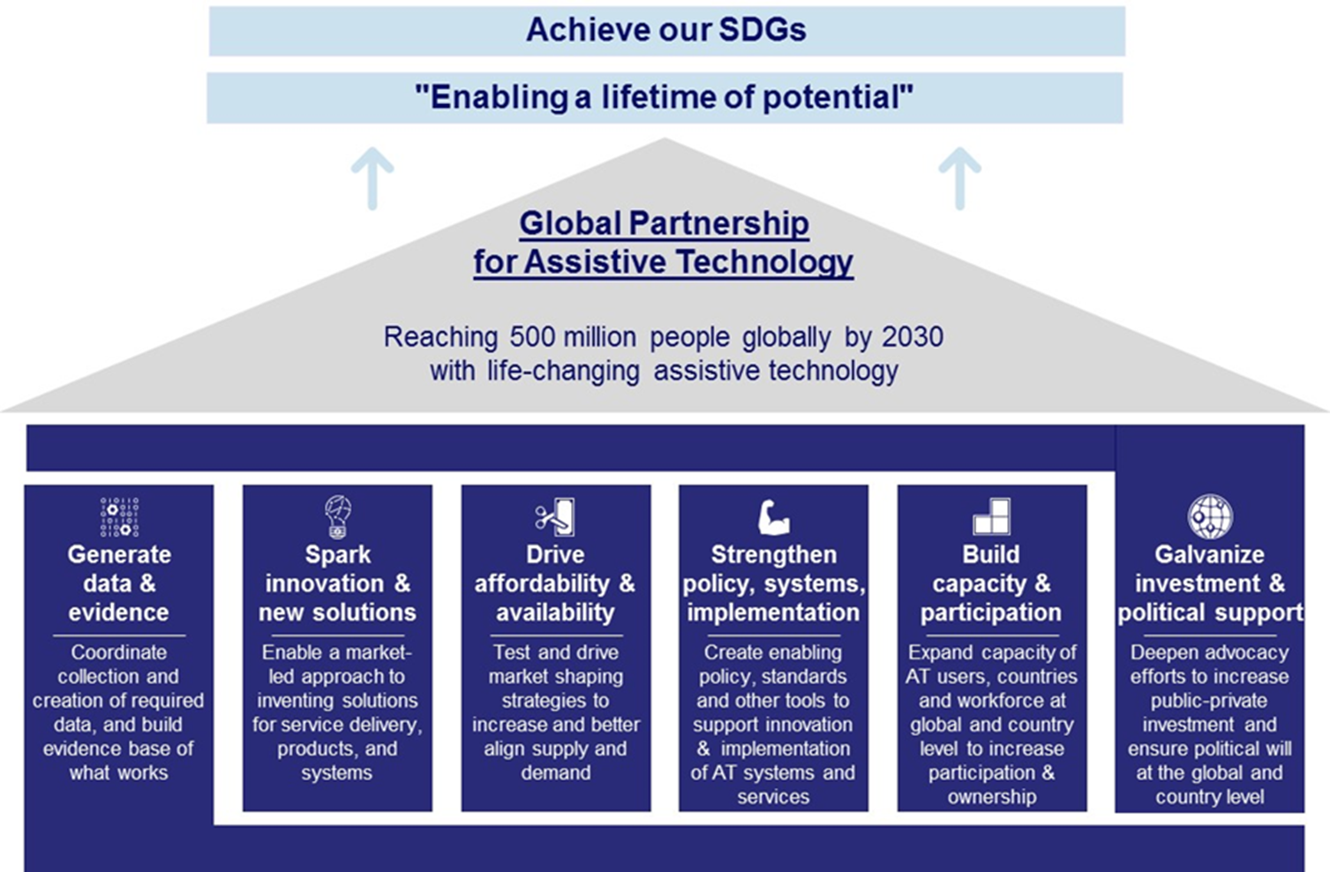
Reaching 500 million people
globally by 2030 with life changing assistive technology

Figure 1: Global Overarching Strategic Priorities on AT

This extension programme – AT2030: Africa – is based on learning from the ongoing successful delivery of AT2030, announced at the Global Disability Summit in July 2018. Already the GDI Hub led consortium have begun work in thirteen countries and attracted £3.6m of matched funding.

Since AT2030 was designed in 2018, further opportunities have become possible due to the growing global momentum in this sector. These opportunities, combined with initial AT2030 learnings, present the following key factors for consideration:
- The World Health Organisation has begun work on the World Report on AT, to be launched in 2021. This provides an unrivalled opportunity to promote work on AT but also a need to bring forward as much evidence as possible as soon as possible;
- The Paralympic movement contains key AT2030 partners, and an opportunity exists to align activities to harness the potential of Tokyo 2020 and Paris 2024 to shift mindsets and opportunity for access to AT. Learning from London 2012, these present a rare opportunity to significantly address stigma which continues to be a barrier to successfully implementing AT solutions;
- The success of the Global Disability Summit, the ATscale strategy and global partnership, and the profile of AT2030’s work to date have generated momentum through country governments to take action on AT which we must harness;
- Everywhere that AT2030 works, the inaccessibility of the Built Environment is proving to be a severe barrier to access. Country Governments are feeding back that they need advice and practical case studies from which they can develop policy and practice; and
- Innovation in the AT space is harder than initially anticipated. The ‘Valley of Death’ (VOD) is longer and deeper for AT, requiring much more investment before sustainability is reached – yet particularly in East Africa, India, and South Asia AT2030 is demonstrating a strong and growing interest for sustained investment in AT once “product-market fit” is established.

AT2030: Africa will, therefore, enhance the thematic approach of AT2030, adding Sport to Overcome Stigma and Inclusive Design as themes, while honing down on the testing of innovation and market-led approaches, working with local partners to drive sustainable solutions. Global Disability Innovation (GDI) Hub lead the consortium for AT2030. Please see their proposal for the AT2030: Africa scale-up at Annexe 1.

The proposed AT2030: Africa programme scale up outline is shown in Figure 2 below. This also maps the original AT2030 programme (in orange) and shows how both link together and contribute towards the ‘Global Overarching Strategic Priority’ pillars on AT in Figure 1. AT2030: Africa funding will support the following activities (shown in red in Figure 2 ):

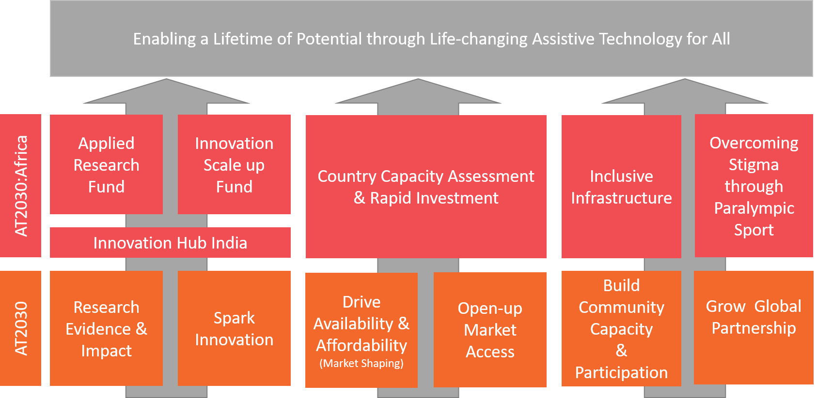
Figure 2: AT2030 Africa and AT2030 Programme Overview
- Applied Research Fund: Additional Data and Evidence. This includes specific resource to support the first World Report on Assistive Technology as well as £1m for an open call for research. The call will be finalised following the WHO ‘GREAT’ Summit consultation on AT where state of the art of AT research will be presented. The research call will address the gaps found in the evidence.
- Innovation Scale up Fund: Increased funding for innovation to support larger grants to successful start-ups to help them overcome the significant challenges faced with proving product-market fit for new products and services within the AT space. A specific focus will be on innovative service models, including new financing models for AT.
- Innovation Hub India – India is both a regional lead and a gateway to Africa for innovation. The small amount of funding to create an Innovation Hub India with the All Indian Institute for Medical Sciences (AIIMS) and the Indian Institute of Technology, Delhi (IIT-Delhi) and UCL will allow Indian Government funds to be leveraged to help support AT2030’s global AT aims. It is envisaged that a significant number of innovators will be supported through this investment to develop products for both the Asian and African marketplaces.
- Country Capacity Assessments (CCAs) and a new rapid implementation fund will be created to allow two countries to trial the National AT provision model. This will include the costs of assistive products and will lead to the creation of at least two national trials which integrate a collectively procured AT, personnel training and service provision with clear sustainability tracking. The majority of the funding will cover the delivery of these trials through local delivery teams.
- Inclusive Infrastructure – a repeated result from AT2030 research is the need for improved accessibility of the built environment. This component will support the development of research in pilot countries and the development of a series of international case studies to highlight the opportunity and cost-effectiveness of inclusive design. The programme will also provide support to countries already working on the AT2030 programme, who have not budgeted for inclusive design but where this addition could significantly improve accessibility and therefore AT usability.
- Overcoming Stigma through Paralympic Sport builds on lessons learned from London 2012 and will provide an opportunity to capture the effect of the Paralympics on enabling a shift in attitudes within a country. This will be tested through three methods: TV coverage, a school's education programme and by utilising the abilities of Paralympians to inspire

The £9.8m programme scale up will support an additional 30 new disruptive technologies with the potential for life-changing impact; develop and test 4 innovative service delivery models; and continue to provide insights and evidence to help inform others working on increasing access to AT under the Global AT Strategic Priorities. Further, it will support up to 50 start-ups, and strengthen the establishment of the East Africa Disability Innovation ecosystem (Innovate Now), led by enterprise partners in Nairobi. Innovate Now will provide opportunities to trial and implement new approaches to accelerate innovative AT products to market with a focus on two sustainable AT investment country pilots in east Africa and a product focus on wheelchairs in Kenya. Additionally, AT2030’s research funding will be matched to drive academic-private partnership to meet community needs and provide access to world-class research facilities and expertise for start-ups.

The ‘Targets and KPI table: Proposed indicators’ in the Management Case sets out AT2030: Africa targets against those of the original AT2030 programme, clearly showing the additionality of the scale-up.

The programme extension will reach 6 million people through the core programme. A further 6 million people will be reached through ‘Sport against Stigma’, a programme connected to the Paralympics. This new workstream will inspire young people in Malawi and Ethiopia based on our learning from London 2012 to Tokyo 2020, and continuing to Paris 2024.

As with DFID’s initial contribution, this £9.8m scale-up will be 100% match funded.
- Rationale & Policy Fit

1bn people worldwide require a form of AT. Numbers are expected to rise above 2bn by 2050, yet 90% lack access. People with disabilities are disproportionally poor and often excluded from development efforts. Access to appropriate AT is key to achieving the SDGs, enabling users to participate in education, work, family, and community life.

WHO’s 2016 report on ‘Improving Access to AT’ states that access to appropriate AT reduces the need for caregivers, prevents health deterioration and helps rationalise health and welfare costs. With a rise in the number of injuries, noncommunicable diseases and ageing populations, demand for AT is increasing. Without it, people in need are often excluded, isolated and locked into poverty. This often makes health problems worse , resulting in societal losses as people who would otherwise contribute are economically and socially excluded.

Current statistics report a higher incidence of disability among women. This percentage tends to be higher for low- and middle-income countries. Women and girls with disabilities are subjected to multiple layers of discrimination. Based on their gender and disability status, they often face “double discrimination”. This inequality is exacerbated for women and girls with disabilities who are members of marginalised ethnic or racial groups. Programme impacts, therefore, will support DFID to deliver our strategic vision for women who face multiple discriminations.

The programme will disaggregate research data collected as appropriate and when it is possible to do so. In these cases, disaggregation will typically be by; sex, income, geographic area/ethnicity and disability. It is understood that disaggregating data may not always be possible, for example, when calculating TV audience numbers or publication downloads etc.

AT2030 Scoping Evidence
The GDI Hub-led Assistive Technology Research Report, including an East Africa Case study, set the framework for the AT2030 partnership and the methodology for the programme. The scoping report identified that the following priority interventions were needed to increase access to AT for those who need it the most*:
- Global coordination
- Research, evidence, and impact
- AT innovation
- Markets
- Global standards
- Communities
*These are not ranked or listed in any particular order
The findings were shared at the 2018 Global Disability Summit (GDS) and summarised in the Policy Paper on AT. To address the gap in the provision of AT, DFID’s Secretary of State announced the £10m AT2030 programme at the GDS (100% match funded, £3.6m achieved to date).

AT2030’s six existing sub-programmes were aligned to the priority interventions identified in the scoping report: coordinate research, evidence and impact; spark innovation; drive availability and affordability; open up market access; build capacity and participation driving community-led solutions; and support for the global partnership for AT. The existing programme is already providing excellent results. Designed to reach at least 3 million people with assistive technology, AT2030 is increasingly finding evidence of what works; testing the user-centred design of technology; trailing new service delivery innovations, and opening market access in priority countries. Annexe 1 slide 3 highlights the AT2030 programme’s current level of country engagement: individual components are already working or scoping in 13 countries.

In his public statement at the recent Sightgeist event (March 2019), Lord Bates, then Parliamentary Under-Secretary of State for International Development, highlighted the GDI Hub’s “incredible early results”, “…at the Global Disability Summit we announced £10m, and it's been such a success that we've decided to almost double our investment to £19.8m”. This was further acknowledged by Darren Welch, DFID’s Director of Policy, at the recent FT/IFC Transformational Business Awards (June 2019).

Strategic Fit to DFID Policy Priorities
Approval of this business case will provide an additional £9.8m Africa focused investment, addressing DFID’s ambition on technological innovation and disability, supporting the HT4D strategic direction workstream. The scale-up underpins the cross-cutting pillar on AT and vision to leave no one behind within DFID’s Strategy for Disability Inclusive Development as well as supports the Global AT Strategic Priorities. It will heighten DFID’s global leading role across the disability sector and complements UK Aid’s portfolio. As with DFID’s initial contribution, this £9.8m scale-up will be matched 100% by the private sector, governments and NGOs. Beyond that, the consortium will engage with partner governments, donor agencies, beneficiaries, the private sector and international organisations to provide a coordinated response to this global challenge.

Strategic links to DFID’s ‘Best Buy’ Papers…
DFID’s ‘Best Buys’ thematic papers outline the cost-effectiveness of possible investment approaches through an economic evaluation of existing literature. While there is not a paper on disability or assistive technology, there is a clear alignment between the AT2030 programme and the ‘health’ and ‘education’ papers:

…on Health: “DFID can achieve greater impacts by actively seeking opportunities to invest in global public health goods and public goods that can achieve large scale, cross-national impacts.” ‘Great buys’ include; ‘Retinopathy screening via telemedicine’, ‘Functional interventions for self-care for individuals with disabilities’; ‘Pressure area prevention and supportive seating interventions for wheelchair users’; ‘Provision and training in the use of basic assistive products (such as canes, braille displays, and other aides) and compensatory strategies needed to communicate and perform activities of daily living’; ‘Review of prosthetics, orthotics, and splints, with referral to hospital if indicated’; ‘Assessment, provision, and training in the use of assistive products including assistive devices for hearing’ and; ‘Fabrication, fitting, and training in the use of prosthetics, orthotics, and splints’.

AT2030’s focus on ICT, hearing aids, vision technology (including white canes), wheelchairs, and prosthetic programmes, will address the ‘great buys’ listed.
“DFID’s health investments should prioritise the most vulnerable. Although the marginal unit costs of delivery may increase, given the increased likelihood that a more vulnerable person or community will have poor health, returns on investments targeted at the most vulnerable are often higher and are most likely that ill health will push them further into poverty. In health, underserved populations commonly include the poor, adolescents, people with disabilities, and marginalised populations”.
Our focus on reaching people with disabilities and impairments of all ages and across a wide geographical spread including rural areas with assistive technologies, will positively impact the most vulnerable. This will enable children with disabilities and impairments to attend and stay in education for longer and improve their livelihoods across their lifetime, providing greater economic prosperity at the individual, household and national levels.

…on Education: The Rapid Evidence Assessment on ‘Improving educational outcomes for people with disabilities in low and middle-income countries: why does it matter and what works?’, clearly states why education for children with disabilities was important.
“The inclusion of people with disabilities in education, so that they can achieve good academic and social outcomes, is an important right, as well as a development need. Currently, people with disabilities are more likely to be excluded from school and to fail to achieve equitable educational outcomes than those without disabilities.”
The Best Buys in Education paper explains, “The investment in evidence on the cost-effectiveness of alternative ways to improve learning gives us an opportunity to increase the value for money of DFID’s education spending and influencing.” The paper reviews “…interventions on their cost-effectiveness, with the aim of improving learning outcomes” and rates ‘Targeted support for children living with disabilities’ as ‘Low Evidence’. In the context of the paper, this category means, “aspects of schooling and learning that have not been robustly evaluated. This … could help to inform future research priorities.” The purpose of AT2030 and AT2030: Africa is to generate evidence of what works. Already AT2030’s ‘School Eye’ programme in Liberia, intends to improve the uptake of referrals, which will improve attendance at school. The inclusive schools programme proposed as part of ‘Sport Against Stigma’ in AT2030: Africa will work with African school children and with Ministries of Education to address stigma and discrimination at school based on the Paralympic Values in advance of the Tokyo 2020 and Paris 2024 Paralympic Games. These programmes will assess what works and share lessons, thus building up an evidence base.

Sustainable Engineering and Climate Change
In a recent House of Commons report on DFIDs Economic Strategy, the threat posed by poorly coordinated international development and sustainability of the planet was addressed. It was noted, “a common theme through the submissions was a recommendation that DFID’s Economic Development Strategy should promote sustainable use of natural resources and climate protection”. Bond warned that there was a significant risk that economic development could, if not designed appropriately, cause environmental degradation, which in turn increases rather than decreases poverty and adversely affects DFID’s broader work around sustainable development”.

Through the success of the ATscale global partnership and AT2030 (including AT2030: Africa), there will be increased demand for AT products and services globally as well as the supply and finance mechanisms needed to reach this new demand. Through following the principles laid out by the Royal Academy of Engineering, the programmes will ensure sustainability is core to the mechanisms being developed to unlock the potential – for example ensuring repairability is integrated through the product specifications and implementation plans. Distributed design and manufacture allowing for local production and repair will be actively explored, and life cycle assessments conducted on innovations. Additionally, harnessing the power of local partnership will also be a key factor. Through this sustainable engineering approach, we will ensure alignment with SDG 13 (Take urgent action to combat climate change and its impact).

Legislation
In line with the International Development Act, AT2030: Africa will seek to improve welfare and generate sustainable benefits to people with disabilities and their communities in developing countries around the world.

The programme will comply with the 2014 Gender Equality Act. Women are significantly more likely to have disabilities than men, and this percentage increases in LMICs. The AT2030: Africa scale-up will support equality for women, particularly those who face multiple discriminations. It has Gender Equality Marker “significant”.

Inclusion and empowerment of people with disabilities are the primary objectives of AT2030 and AT2030: Africa. It has Disability Inclusion Marker “principal”.

AT2030’s mission is “To develop and scale new strategies for enabling access to Assistive Technology for the poorest people”. AT2030: Africa will continue to inform the global AT mission through further investment and learning in Africa and informing the delivery of the ATscale strategy. AT2030’s public strapline is to provide ‘life-changing Assistive Technology for all’. This is in line with the Public Sector Equality Duty.

Robust due diligence processes, including counter-terrorism and safeguarding, have already successfully been completed with GDI Hub (in June 2018). GDI Hub have completed full assessments on their consortium partners, following DFID guidance, through the sub-contracting process (July – December 2018).

- Learning from AT2030: geographical pilots and thematic responses

The learning from AT2030 tells us that there is a critical link between the product narratives, AT product specifications, communities and informal provision of AT, and innovation. This therefore requires a more formal country-specific scoping process to pilot-test the ability to generate sustainable provision in any given location.

As evidence and learning are generated around these ‘thematic’ interventions (e.g. market access, system, community, innovation), it becomes essential to ‘live test’ the tools in key locations with matched funding and long-term sustainable commitments (e.g. AT2030 learning from the countrywide trial in Tajikistan). AT2030: Africa will therefore focus on developing a set of formal ‘CCA’ tools, which will result in country (or region) level action plans and pilots backed by rapid investment to stimulate demand. This will lead to sustainable provision through the long-term interventions of local partners, likely tied to health systems.

This does not eradicate the need for innovation in distribution and manufacture methods, but AT2030: Africa will develop a more systematic geographical test approach (in 2-3 country pilots), alongside investment in innovation and new thematic programmes where opportunities have been identified. This is illustrated in Figure 3 below.

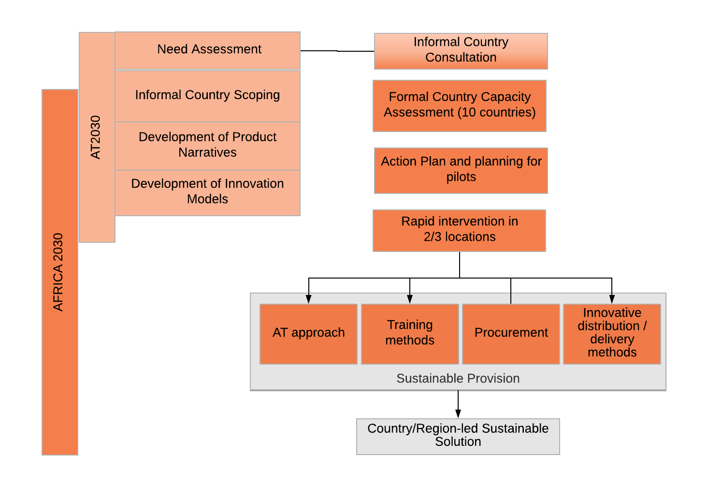
Figure 3: Roadmap to sustainable provision – detailing how the results of AT2030 and AT2030: Africa will help inform others working on increasing access to AT under the Global AT Strategic Priorities, to stimulate sustainable provision.
The diagram above shows AT2030 highlighted in lighter orange. Capacity scoping was conducted informally as part of the AT2030 programme, and the need was identified to formalise and resource this so that partners – including the ATscale global partnership – can be informed by the results. AT2030: Africa will use the CCA tool to gather critical data on need in 10 DFID priority countries and provide in-country capacity building to develop frameworks for action.

Following this, at least two countries will be prioritised for rapid investment (aligned to ATscale activities), kick-starting change to shift a non-functioning market to one with sustainable long-term solutions at scale. The Data & Evidence theme alongside the Innovation theme will support this process. The CCA and accompanying research will inform country governments in the design of national AT strategies and services which could comprise AT centres, procurement approaches and trained personnel as well as innovative methods. The results of these pilots will further inform the Economics of AT model already funded for development as part of AT2030, which will help to drive sustainable provision.

Understanding what works for the provision of AT, improving the use and accessibility of emerging technology and sparking new innovations, will begin to address the gap in need. Learning and building the capacity of existing community-led activities, and aligning and consolidating global AT efforts, the overall AT2030 programme will lay the foundations for systems-level change – significantly scaling up the provision of affordable and appropriate AT.

The overall AT2030 programme will increase access to those who need it the most, accelerated through market-shaping over time through the ATscale global partnership. The AT2030: Africa scale-up will deliver further innovation and research as well as building on new opportunities to encourage match funding and aligned investment from DFID offices (funding would go into in-country delivery). Additional work for Country Implementation may therefore be contracted directly by DFID country offices through the AT2030 partnership in line with its strategic principles for the development of AT communities in countries and/or regions.

Maximising impact
Together the AT2030 and AT2030: Africa programmes will reach at least 15 million people through AT interventions, including through the Paralympic programmes. AT2030: Africa will continue to leverage resources from a range of private sector and NGO stakeholders to match 100% of DFID’s investment. Beyond that, the consortium will engage with partner governments, donor agencies, beneficiaries, the private sector and international organisations to provide a coordinated response to this global challenge.

This expansion also increases the impact of DFID’s other investments, including the £20m committed to the ATscale global partnership. ATscale is already being informed by the AT2030 programme, (particularly by the product narratives), and this will continue through AT2030: Africa, in particular through the CCAs. These tools and the research generated by AT2030 and AT2030: Africa will provide useful evidence and data for ATscale and others invest their funding (including UK funding) where the impact will be greatest.
- Theory of Change

The Theory of Change (ToC) for AT2030 has been re-worked and refined to encompass the AT2030: Africa scale-up, see Figure 4/Annexe 2 . It has also been simplified to reflect the insights learned from the first months of AT2030 programme implementation and to keep the indicators clear and simple. The underlying logic of the programme interventions remain unchanged.

AT2030 works from the assumption that coordinating evidence and impact to understand what works for AT is the best way to understand what interventions are necessary to increase access to AT for those who need it the most. This can be achieved by testing the use of emerging technology for accessibility to spur on new innovations; addressing the need gap and significantly scaling up the provision of affordable and appropriate AT; aligning and consolidating global AT efforts to lay the foundations for systems-level change; learning and building the capacity of existing community-led activities, and accelerating the access to AT through providing support to the global partnership.

The delivery of the first nine months of the AT2030 programme has shown that an accessible built environment and stigma are particularly important thematic issues; that innovation requires more investment, that there are opportunities to maximise research through partnership, and that there is a need for rapid, targeted investment in exemplary countries. The concept of AT2030: Africa has been informed by these insights and was designed to respond to these needs. It comprises:
- Bringing together AT experts to produce further research and evidence to support the impact of AT, particularly to increase evidence support for the World Report on AT and to strengthen data systems;
- Supporting AT innovation and scaling up best practices, particularly tackling the Valley of Death in AT, as well as testing AT Innovation Incubators in ‘live labs’ environments;
- Transforming the availability and affordability of AT through a fund to activate Product Narratives and develop CCAs and diagnostics;
- Working to create and coordinate global standards and systems strengthening through AT investment in low-income priority countries;
- Working with communities to harness good practices;
- A global approach to Inclusive Design best practice;
- Sport against Stigma harnessing the power of the Paralympics; and
- Continuing to support global efforts.

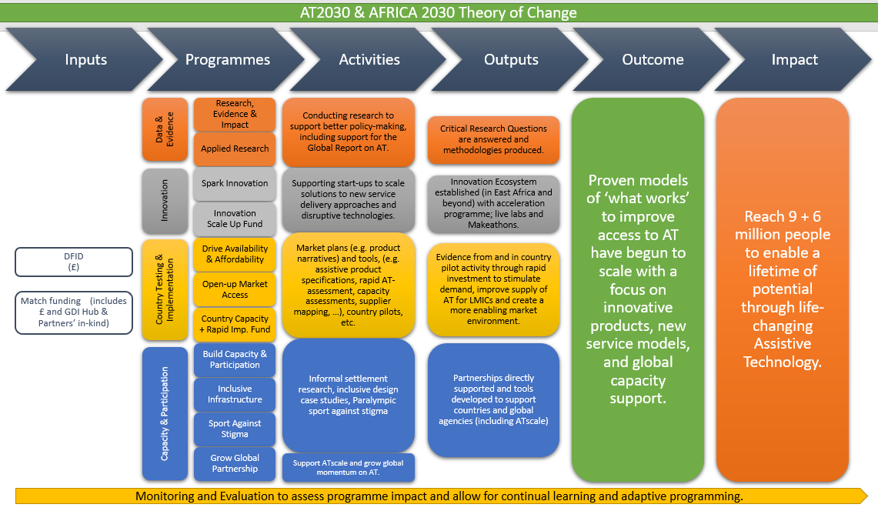

Figure 4: Theory of Change

Appraisal Case

There are several alternative options, summarised below:

1 | Deliver through ATscale | The ATscale global partnership has a clearly defined strategy of market shaping supported by creating an enabling environment. Though this strategy is complemented by AT2030:Africa, the two programmes differ in focus and timescale. Additionally, ATscale is undergoing a process of establishing a funding mechanism, secretariat, and governance structure, and therefore is not yet implementing interventions, so could not immediately take on an expansion. Not Recommended.
2 | Stop using the GDI Hub led consortium and deliver the programme in a different way | Creating consortia is a risk, and the current one is functioning and delivering well. The momentum gained over the past year in creating the current consortium would fail to be leveraged if this option were taken. Therefore, this option is deemed neither efficient nor effective. It would also cost additional funds to establish a new consortium, and there is no guarantee the 100% matched funding would be maintained, which would reduce value for money. It is likely the same partners would need to be involved in a new partnership, so this option makes little sense. Not Recommended.
3 | Extend AT2030 to include AT2030: Africa, led by GDI Hub consortium | This would maximise existing investment and triple the impact with double the funding. It would involve further investment in and slightly expanding the current consortium and building capacity at a country level. This option provides a sensible and realistic investment in Assistive Technology innovation. Overall for a £9.8m investment, the programme will generate over £9.8m in matched funding over the lifetime of the programme. This option offers the best value for money and high levels of efficiency and effectiveness. Recommended option.
4 | Continue AT2030 at its original level of ambition (i.e. don’t extend) | Deliver only the programmes within AT2030 which are already committed. While the programme would reach the intended 3 million people with assistive technology, the programme would not be maximising the opportunity to have a multiplier effect on the existing impact (i.e. reaching 6 (direct) + 6 (indirect) million more people). As opportunities have been identified to embed the learning and to reach more per capita with the UK’s current investment, pursuing this option would not improve the efficiency or value for money of DFIDs initial investment. Consider this option as reference case.

OPTIONS ANALYSIS  Value for Money (VFM) | OPTION 3: Preferred  Build AT2030: Africa using knowledge and learning from AT2030 (figures show the additionality of the AT2030: Africa extension only) | OPTION 4: Reference Case  AT2030  only | AT2030 plus AT2030: Africa
Cost to DFID (£, ‘000000) | £9.8 | £10m | £19.8m,
Match | £9.8 | £10m | £19.8m
Total Investment | £19.6m | £20m | £39.6m
People ‘reached’ | 6 million  Plus  6 million through the Paralympic Games stigma and discrimination media programme | 3 million | 9 million  Plus  6 million through the Paralympic Games stigma and discrimination media programme
Cost to DFID per unit of ‘reach’ (VFM) | The scale-up of AT2030 will cost:  £1.63/additional unit | Currently the AT2030 unit cost is:  £3.33/unit | Combining AT2030 and AT2030: Africa together (the latter cannot exist without the former), the current unit cost of AT2030 will drop by a third to: £2.2/unit

Delivery option chosen
After a careful assessment of the four options, this Business Case recommends Option 3 as the best value for money, most efficient and most effective option because it reduces the cost per unit overall and harnesses an additional £9.8m in match funding (bringing the AT2030 and AT2030: Africa combined total to £19.8m in match funding). It also further supports the programme to successfully deliver the AT2030 mission of, ‘AT for all’.
Through this option, the AT2030 consortium partnership will also be able to ensure efficient transfer of evidence, technical knowledge and proven mechanisms for ‘what works’ to ATscale. This is made possible through close alignment of partners and work within AT2030 and ATscale.

Efficiency and economic operation
To ensure that the UK Government receives best value for money, the GDI Hub have also put in place several other effectiveness mechanisms in addition to the match funding. This includes building on economies of scale within the partnership where possible, building local capacity, and maximising the sustainability of investment. Some examples include:

- Working with the existing Sierra Leone Research Centre (set up by UCL) to reduce set up costs and build capacity locally, employing a local researcher;
- Working with University of Nairobi and Strathmore in Kenya to lead the innovation programme reducing travel costs for London team;
- Combining scoping work for Indonesia on the Community Programme with visit to CHAI in country team to reduce travel costs;
- Drawing on capacity savings (including set up costs ‘donated’ by the 2012Paralympic legacy programme) to minimise overhead costs;
- Encouraging existing GDI Hub Board and Chair (Lord Holmes) to support the programme at events e.g. Conference of State Parties (COSP) and the Global Disability Summit;
- In person meetings always have virtual options; and
- Combining necessary in person meetings with ATscale colleagues with the ATscale global partnership meetings to reduce costs where possible.

Commercial Case

The commercial case for the original AT2030 programme lies in providing the vital evidence needed unlock the market potential for assistive technology globally. This works across both supply and demand channels tackling not only future global funding mechanisms through public-private partnerships (PPPs) but also: working to establish an African base of innovation, a stream of initiatives to overcome stigma (as part of the research steam, and within the Sport against Stigma Programme) and working with people living in poor communities to develop plans for AT provision. AT2030 has built a global reputation in just a few months for working both collaboratively and innovatively this will be strengthened through AT2030: Africa.

AT2030: Africa will be delivered through a cost extension to DFID’s existing AT2030 Accountable Grant with GDI Hub, which will expand the work to include:
CCAs and a Rapid Implementation Fund - implemented by GDI, WHO, CHAI, UCL and additional new delivery “in country partners”. The fund will allow at least two countries to trial the National AT provision model. This will include the costs of assistive products and will lead to the creation of at least two national trials which integrate collective AT procurement, personnel training and provision all with national reach.
The Innovation Investment Fund - implemented by GDI Hub, UCL, GDI, AMREF and additional new delivery partners including Bethnal Green Ventures (BGV). Through competitive calls, the fund will provide grants to successful start-ups to help them overcome the significant challenges faced with proving product-market fit for new products and services within the AT space. A specific focus will be on innovative service models including new financing models for AT.
The Data and Evidence component - implemented by UCL, WHO, GDI and additional new partners. This includes provision of a specific resource to support the first World Report on Assistive Technology as well as a £1m open call for research. The call will address the gaps found in evidence.
Overcoming Stigma through Paralympic Sport - implemented by Loughborough University London (LUL), the International Paralympic Committee/ Agitos Foundation and GDI. Building on lessons learned from London 2012, AT2030: Africa will capture the effect of the Paralympics on enabling a shift in attitudes within a country. This will be tested through three methods: TV coverage, a school's education programme and by utilising the abilities of Paralympians to inspire.
Accessible Built Environment - implemented by GDI, UCL, LUL and the Royal College of Art (RCA). AT2030 has repeatedly found a need for improved accessibility of the built environment. AT2030: Africa will support research in pilot countries and a series of international case studies to highlight the opportunity and cost-effectiveness of the inclusive design. It will also provide support to AT2030 countries who have not budgeted for inclusive design but where this addition will significantly improve accessibility and therefore AT usability.
GDI Hub India - implemented by UCL and the Indian Institute of Technology (IIT). India is both a regional lead and a gateway to Africa for innovation. A small amount of AT2030: Africa funding (with scope to add in additional support from DFID’s regional desks) will help establish a new AT ‘Innovation Hub India’ with the IIT and UCL. This will also allow Indian Government funds to be leveraged to support AT2030’s global AT aims. A significant number of innovators will be supported through this investment.

As with the existing AT2030 programme, workplans including key milestones / decision points and corresponding payment schedules will be agreed between the GDI Hub and the delivery partners. Any new partners sub-contracted by GDI Hub as part of the AT2030: Africa scale-up will use the agreed DFID/GDI Hub terms and conditions from the existing Accountable Grant (AG) and DFID’s due diligence requirements (annotated in an Amendment to the current AT2030 AG). Key performance indicators are embedded in sub-programme Log frames and contracts are based on ‘payment by results’ on output delivery with quarterly payments processed in arrears. Known new partners include (but are not restricted to):
- Loughborough University London (LUL)
- Helen Hamlyn Centre for Design at the Royal College of Art (RCA)
- International Paralympic Committee (IPC)
- Agitos Foundation
- Bethnal Green Ventures (BGV)
- Royal Academy of Engineering (RA Eng)
- others (TBC)

DFID’s funding will be 100% matched by private sector investment, other research monies, partner match and business growth. This is set out clearly in the Log Frame and will be monitored quarterly.

In the special case of research, match funding will be generated through three mechanisms:
1) cash match through leveraging support of existing funding mechanisms to focus on AT e.g. Royal Academy of Engineering (RAEng) Africa Prize; cash match through institutional support and private sector funding in each research proposal;
2) infrastructure support, e.g. RAEng/UCL will help to administer the grants and track the outcomes of the grants;
3) alignment of activities across the ‘Technology Readiness Levels’ and funders (RAEng/UK Research & Innovation).
Already AT2030 has exceeded expectations, matching £3.6m in less than one year (just under two-times DFID’s spend (£1.75m) in the same period).

Economy, Efficiency, Effectiveness and Equity are embedded in the design of AT2030 and the AT2030: Africa scale-up. A ‘fail-fast’, adaptive programme, AT2030 + AT2030: Africa will respond to ongoing validation of results and continuously reassess interventions, adapting to maximise impact.

VFM will be achieved through:

Economy: Interventions and partners are selected against an economy criteria and cost drivers are closely monitored. AT2030: Africa will increase economy of resources into activities across the AT2030 partnership.

Efficiency: DFID oversees the selection of interventions and monitors progress including changes to unit costs, access, and quality (including through beneficiary feedback). DFID also ensures the programme has the right incentives to drive maximum impact. Efficiency is also driven through support to develop activities such as research workshops in Africa which results in joint research proposals as outputs.

Effectiveness: 100% match funding will engage private sector, NGOs and other stakeholders for programme longevity and sustainability. These interventions are designed to achieve long-run, sustainable improvements in access to AT without ongoing donor support. AT2030: Africa’s approach to product design will focus on user-centred design for quality AT to facilitate participation in education, work, family, and community. By joining forces across a range of organisations, the programme will increase the effectiveness of turning outcomes into sustainable impact by strengthening networks, communications and advocacy. Examples are the connected nature of AT research and the writing of the World Report on AT by the WHO.

Equity: In low- and middle-income countries, people with disabilities and their families are poorer than those without disabilities across all socio-economic indicators. AT2030: Africa targets the poorest in society. It sets out to develop and scale new strategies for enabling access to life-changing AT for all. For example, AT2030’s approach ensures open research calls which will ensure equity of process and opportunity which in turn will further increase VFM.

AT2030: Africa complements DFID’s disability inclusive development portfolio, continuing to enhance the VfM of DFID’s investments.

Commercial Innovation in the AT sector
The set-up of ‘Innovate Now’, the AT2030 inclusive innovation ecosystem in East Africa has already generated several insights and learnings which are enabling growth and innovation in AT. An increase in the Innovation Challenge Fund will allow for more and slightly larger grants to support business models which can unlock scale and demonstrate how AT can ensure sociotechnical impact.

- The innovation challenge fund is expected to be supported by Bethnal Green Ventures (BGV). BGV provide inspiration, funding and support to founders (start-ups) building technology ventures with the aim of improving people’s lives. BGV have an established reputation in the, ‘tech for good’ space, since 2012. AT2030: Africa will leverage their recent insights from running the Department for Digital, Culture Media and Sport (DCMS) ‘Go Global’ accelerator initiative. The exact nature and scope of the relationship with BGV is being explored with GDI Hub and will be the subject of appropriate Due Diligence and procurement activity.

- The innovation challenge fund will be structured around consecutive innovation focus area challenges. Initial ‘Innovate Now’ focus areas include:
  - Innovations in prosthetic device design and delivery;
  - Innovations in ensuring disability inclusion in humanitarian disasters through inclusive design and assistive technology provision;
  - Innovations which scale locally designed and produced AT; and
  - Innovations which exploit the rise in mobile phone availability.

- The accelerators will be run by African partners with a depth of experience within both the technical domain and business domain. The first of these will be delivered by AMREF. AMREF can reach people across East Africa, including in rural settings, and people without an Internet-enabled smartphone using their ‘LEAP’ platform. LEAP is a mobile health solution that provides training to community-based health workers in Kenya and across the region. This platform will ensure that AT2030 can provide equality of opportunity for innovators to come from across East Africa. The platform has already been developed, as has the initial accelerator programme, which allows AT2030 to make efficiency improvements across the programme.

Financial Case
The programme will be funded from DFID’s Climate, Energy, Water and Innovation Team within DFID’s Research and Evidence Division, but set up in a way that would enable DFID regional/country offices to simply add additional support for work focussed in their region.

The programme budget breakdown for the additional £9.8m scale-up is summarised below with a detailed finance budget breakdown and forecast in Annexe 4:

Programme Activity Strand | Delivery Through Existing Partners | New Delivery Partners | Forecast Budget (£)
Rapid Implementation Fund | GDI, WHO, CHAI, UCL | tbc including ‘in country’ partners | £2.5m
Innovation Investment to Beat the Valley of Death | UCL, GDI, AMREF, | BGV, others tbd | £1.85m
Data and Evidence | UCL, WHO, GDI | TBC | £2.45m
Overcoming Stigma Through Paralympic Sport | GDI | Loughborough University, International Paralympic Committee/ Agitos Foundation | £1.9m
Accessible Built Environment | GDI, UCL | LUL, RCA | £0.9m
GDI Hub India | UCL | Indian Institute of Technology | £0.2m
Total: |  |  | £9.8m

Appended to this business case is the proposal for AT2030: Africa (Annexe 1); a combined Theory of Change (Annexe 2); a combined programme risk register matrix (Annexe 3), and a detailed finance budget breakdown and forecast (Annexe 4), and a revised and combined Programme Log frame (Annexe 5) setting out further details; a programme management organogram (Annexe 6); and the AT2030 Advisory Board Membership (Annexe 7).

Following approval of this business case, an addendum will be issued to the existing AG agreement between DFID and GDI Hub. The addendum will include an update to the grant amount, the disbursement schedule from DFID to GDI Hub and the consolidated programme proposal.

This scale-up funding for AT2030: Africa will be disbursed, controlled, monitored, reported and accounted in the same way as the existing £10m AT2030 AG. All funds will be paid by DFID to GDI Hub to be then dispersed to programme delivery partners as required.

Disbursement:
Agreed Schedule:
For the disbursement of funds both from DFID to GDI Hub and then from GDI Hub to delivery partners, a disbursement schedule will be agreed in advance as part of the contracting process. Payment in advance to the GDI Hub is necessary as the GDI Hub requires funds to commence and continue the project – this is therefore not ‘payment in advance of need’. The Senior Responsible Owner, in line with DFID guidance, therefore judges that in this case, advance payment is required. Payment requests will be justified by credible forecasts of commitment and disbursement for the coming period. The process has worked well over the first year of AT2030 with spend being very closely aligned to the original disbursement schedule set out in the original AG. Therefore, this is an appropriate action to continue to follow and it will continue to be monitored quarterly through the existing quarterly payment request and reporting process.

GDI Hub will request payment from DFID quarterly and in advance to ensure the programme has a sufficient and accurate cash flow. As now, a quarterly payment request will be submitted to DFID that will provide a narrative of programme activity completed in the previous quarter and planned for the following quarter. This will be supplemented with a financial report detailing spend accrued in the previous quarter and planned in the following quarter.

To inform this, GDI Hub will request a disbursement schedule from each delivery partner. Delivery partners will be paid quarterly and in arrears except the World Health Organisation who require annual payments as agreed in relevant treaties between the UK Government and WHO.

Making Payments:
Payments for AT2030: Africa will be made in the same way as the existing AT2030 programme.

DFID to GDI Hub:
- Payment will be made via bank transfer within 30 days of payment request as per the accountable grant agreement

GDI Hub to Partners:
- Payment will be made via bank transfer within the agreed number of days in the contract (30 days for most partners)

Control and Monitoring:
Due Diligence:
GDI Hub has recently undertaken a comprehensive due diligence process (including enhanced safeguarding) with DFID for the original AT2030 accountable grant agreement (June 2018). GDI Hub are therefore not required to undertake any further due diligence checks with DFID for this scale up funding.

GDI Hub have flowed down DFID’s due diligence requirements (including enhanced safeguarding) to all programme delivery partners. Existing delivery partners have completed this due diligence process. New delivery partners contracted as a result of the scale-up will be required to undertake DFID’s full due diligence checks. Full due diligence will be completed prior to funds being disbursed to partners.

Reporting and Accounting:
Log frames:
The logical framework (log frame) has been updated (Annexe 5) to include the additional programme content resulting from the scale up.

Existing delivery partners each have log frames for programme activity that they are responsible for delivering. These will be updated and agreed accordingly to the same timeline.

New delivery partners will be contractually obliged to create their own log frame for programme delivery and agree these with GDI Hub. Their log frames will form the basis for reporting their results and progress, alongside the quarterly payment request processes. DFID will agree and approve programme level log frames and delivery results.

Quarterly Reports:
The quarterly payment request and reporting process is used to monitor expenditure, progress and results. Information gathered from this process informs accurate financial forecasts.

All partners (new and existing) will follow the existing, quarterly payment request process and reporting:
- Partners will submit quarterly payment requests by the date agreed in contract;
- These will include a short narrative report (linked to their log frame) and a succinct financial report detailing spend in the previous quarter;
- They will include forecasts for the next quarter, broken down by sub-programme with a comparison to their original fee disbursement schedule, mapping any changes including potential delays for accurate forecasting;
- GDI Hub will inform DFID at the earliest opportunity if any changes to their agreed disbursement schedule is necessary including between partner lines/activities;
- GDI Hub will share financial reports on a quarterly basis and when requested by DFID.

All current partners are also required to submit succinct summary reports to the AT2030 Advisory Board of which DFID are members) outlining programme activity and impact in the preceding period and planned activity and forecasts for the forthcoming quarter. AT2030 Advisory Board meetings occur quarterly and will be expanded to review both AT2030 and AT2030: Africa activities (and therefore also include reports from new partners).

Annual Reports:
GDI Hub will submit an annual report to DFID on the AT2030 and AT2030: Africa programmes combined by mid-March each year. Scale-up funded programme activity will be captured in this report. Annual reporting will include an annual financial statement that provides a clear picture of spend over the course of the previous year.

GDI Hub, therefore, requires all delivery partners to submit their annual reports to them in advance of creating the programme level report for DFID. This contractually applies to all delivery partners, new and existing.

DFID will conduct an Annual Review and Programme Completion Report against the outputs, outcomes, impact and milestones in the log frame and programme indicators and objectives. This will indicate progress against plans and highlight any changes or further actions required.

Management Case

Summary
The management of the programme will remain largely unchanged from its first year. GDI Hub will continue to lead a (slightly expanded) consortium using the existing governance and management arrangements. DFID will provide the necessary oversight through an SRO (DFID’s Disability Assistive Technology Adviser) and a programme manager, both in DFID’s Research and Evidence Division. GDI Hub programme management structure is designed to ensure maximum programme impact. The programme management framework and action plans keep track of all programme components, achievement of programme goals and therefore impact.

Governance and Management Arrangements
To ensure key positions are covered thoroughly a new structure will be put in place encompassing both AT2030 and AT2030: Africa management relationships. The AT2030 and AT2030: Africa consortium organogram shows the programme’s functional structure delineating interrelationships of respective roles and responsibilities, governance structure, accountability, and decision-making processes between the GDI Hub and its programme consortium. The structure also delineates checks and balances among the programme stakeholders. For example, a new Evaluation and Impact Manager position will be created to address the specific needs of the monitoring and evaluation framework.

The management, advisory and decision-making levels are as follows: (See Annexe 6)

Advisory Board
GDI Hub set up an AT2030 Advisory Board (AT2030 AB), chaired by Lord Chris Holmes, whose function is to provide strategic advice and oversight, and promote informal sharing of learnings, to enable the GDI Hub and implementing partners to successfully deliver AT2030’s mission, “to support proven models of ‘what works’ on AT innovative products, new service models, and global capacity support to improve access to AT to for the people who need it most.” The AT2030 AB also provides challenge, technical advice, supports strategic decision making offers an external point-of-view and advises on strategic issues of risk-mitigation. The AT2030 AB comprises external advisors appointed upon their areas of expertise and interests. The AT2030 AB will offer the same role for AT2030 Africa Scale-up, through a joint AT2030/AT2030: Africa Advisory Board, and we will continue to strengthen the value add of this Advisory Board, as it moves beyond its first year. (See Annexe 7).

Core Delivery Team
The Core Delivery Team is a cross-functional, interdisciplinary group made up of consortium organisation leads which is responsible for the day-to-day implementation of the programme as well as for ensuring the achievement of the programme’s goals. Its purpose is to coordinate, direct, and oversee the implementation of the range of activities that fall under their scope, meeting regularly to discuss and resolve operational and co-ordinational issues. The Core Delivery Team includes WHO, CHAI, UCL, and GDI Hub representatives.

Director
The Programme Director (80% FTE) is responsible for ongoing management on behalf of the Advisory Board and the Core Delivery Team to ensure that programme outcomes and objectives are delivered. The programme director acts as the first point of contact with the Senior Programme Manager, Project Manager, and Evaluation & Impact Manager. The programme director also works closely with the Research (Academic) Director and Operations Director for the day-to-day programme management and with the Communications Manager to ensure the programme is actively promoted.

Programme Management
The Senior Programme Manager acts as a strategic coordinator between the different sub-programmes to ensure they are aligned with overall strategic programme objectives as well as creating and managing long-term programme goals. They are also in charge of developing budgets and operating plans and supporting new programme funding proposals.

Project Managers work closely with programme team members to ensure all project requirements, deadlines, and schedules are on track. They are responsible for submitting project deliverables, preparing status reports, and establishing effective project communication plans as well as the proper execution of these plans.

Evaluation & Impact Management ensures the Log Frame is delivered across for the entire programme. GDI will work with programme partners to monitor and review impact, outcomes and outputs against the Log Frame for each of the sub-programmes and its projects. They will ensure that the programme captures data that enables a measure of progress towards/against agreed outcomes. They are responsible for working with external evaluators.

Communications
The Communications Manager oversees all internal and external communications for the programme, ensuring its messaging is consistent and engaging. They produce high-quality content that engages programme stakeholders and builds brand recognition. They work in coordination with Evaluation & Impact, Research, and Programme Management to share and communicate research, encourage uptake, and share lessons internally and externally.

Research (Academic) Director
The Research (Academic) Director is responsible for the overall design, development and review of all research under the programme, as well as overseeing research conducted by partners on behalf of the programme. They work alongside Programme and Operations Directors and supervise Research Manager(s).

Research Management
The Research Manager(s) are responsible for undertaking and delivering a wide range of research projects under the programme. They work with programme partners and the Research (Academic) Director to build a programme-wide research framework and to manage the relationships among them.

Operations Director
The Operations Director oversees financial and administrative operations of the programme. They hold overall responsibility for the operations and administration functions of the programme ensuring it runs smoothly and efficiently. They oversee setting up and improving organisational processes, and work to improve quality, productivity, and efficiency. They supervise the Operations Manager.

Operations Management
The Operations Manager operates the day-to-day financial and administrative functions for the programme. They are in charge of financial transactions and works in tandem with the Programme Director and Senior Programme Manager to ensure contract payments are delivered against achievement of outputs, KPI, and specific milestones.

Combined List of Sub-programmes
The AT2030- AT2030: Africa Programme is made up of eight different sub-programmes including:

Data & Evidence | Research, Evidence, and Impact (Leads: UCLIC, UCL IIPP, LCD)
Data & Evidence | Applied Research (Leads: GDI Hub with UCLIC, RA Eng, WHO)
Innovation | Spark Innovation (Lead: UCLIC with UoN, Motivation, GSMA, HI)
Innovation | Innovation Scale Fund (Lead: GDI Hub, BGV)
Country Implementation | Market Shaping [Drive Availability and Affordability] (Lead: CHAI)
Country Implementation | Open-up Market Access (Leads: WHO, UNICEF, LSHTM)
Country Implementation | Rapid Investment Fund (Lead: GDI Hub, with CHAI, WHO, UCLIC)
Capacity & Participation | Build Capacity & Participation (Leads: UCL DPU)
Capacity & Participation | Inclusive Infrastructure (GDI Hub, UCLIC, RCA)
Capacity & Participation | Sport Against Stigma (Leads: LUL, IPC)
Capacity & Participation | Grow Global Partnership (Lead: GDI Hub with ATscale)

Sub-programme Leads
Each sub-programme has a Sub-programme Lead who oversees coordinating all their sub-programme work. They act as point of contact with Programme Director and the Senior Programme Manager and are responsible for reporting back on sub-programme progress to the Advisory Board. They are also part of the Core Delivery Team.

Key Country Coordination Group
The programme has several Key Country Coordination Groups. The objective of these groups is to ensure the coordination of all the activities happening in a specific country. They involve programme delivery partners from across different programmes. They also serve to coordinate stakeholder management to ensure that programme partners working on a single country know what local stakeholders are involved and in what way, as well as to avoid stakeholder burnout and task replication. Key Country Coordination Groups are coordinated by the programme management team.

Fiduciary Governance
The programme team takes an active role in reducing fiduciary risk across the AT2030 and AT2030: Africa programmes so that it is only used for its intended purposes and it is accounted for. The thorough DFID due diligence process has been undertaken for GDI Hub and flowed down to programme delivery partners by GDI Hub. This includes the requirements to have current corporate policies that address these issues. Any sub-contractor added to the delivery chain will undertake the same due diligence process.

Targets and KPIs
AT2030: Africa will generate impact by:
- Reaching an additional 6m people directly, increasing the overall target reach to 9m.
- Reaching an additional 6m people through Sport against Stigma.

Wherever possible the impact on quality of life will be collected and disaggregation of data completed.
Targets and KPI table: Proposed indicators:
OUTCOME | Outcome Indicator OCI1 | Combined | Africa 2030 | AT2030* (reference)
(OC) New models of ‘what works’ to improve access to AT have been tested and have begun to scale with a focus on innovative products, new service models and global capacity support.  e | OPI1 RESEARCH  Number of innovative service delivery models (frameworks and methodologies created) | 10 | 4 | 6
 | Outcome Indicator OCI2
 | OCI2: NEWTECH  Percentage of total innovative technologies that are on track to take to scale | 25% | 25% | 25%
 | Outcome Indicator OCI3
 | OC3: STARTUPS  Number of start-ups sustainably supported. | 80 | 50 | 30
 | Outcome Indicator OCI4
 | OCI4: IDEAS  Number of entities (countries or organisations) implementing AT2030 funded findings, research or new methodologies. | 20 | 20 | 0

OUTPUT 1 | Output Indicator OPI1 | Combined | Africa 2030 | AT2030* (reference)
OP1: RESEARCH  - Research Questions answered and Methodologies produced | OPI1 RESEARCH  Number of research questions answered | 20 | 10 | 10
OUTPUT 2 | Output Indicator OPI 2
OP2: INNOVATION  East Africa Innovation Ecosystem (inc. acceleration programme; live labs and Makeathon) | OPI2 INNOVATION  - Number of technologies supported overall.  Also, tracking (no targets set) to monitor year on year change/adjustments:  - Number of applications for Acceleration programme;  - Number of Live Labs rapid design iteration opportunities established to support businesses;  - Number of Makeathon applications;  - Number of other pre-acceleration support opportunities offered. | - 40 | - 30 | - 10
OUTPUT 3 | Output Indicator OPI3
OP3: COUNTRY PILOTS  Country pilots (inc. rapid investment to stimulate demand, CCAs and Action Plans) | OPI3: COUNTRY PILOTS  - Number of country pilots;  - Number of countries delivering CCA action plans  - Number of countries with high levels of initial investment in AT matched to be sustainable (also links to significant numbers of ‘reach’). | - 10  - 5  - 2 | - 10  - 5  - 2 | - 0  - 0  - 0
OUTPUT 4 | Output Indicator OPI4
OP4: SYSTEMS STRENGTHENING  - Partnerships directly supported  - Tools developed for country/global agency support (inc ATscale). | OPI4 SYSTEMS STRENGTHENING  - Number of partnerships supported  (Also, tracking:  - Number of strategic tools supported )  to develop new service delivery models and increase global capacity on AT. | - 10 | - 9 | - 1

* This is an indicative comparison. Indicators have been slightly revised based on new evidence and new understanding of programme as set out in the new log frame and theory of change.

Monitoring and Evaluation Approach
Monitoring
A suite of extended tools will be designed which will collect data across the sub-programmes for delivery against the logframe and to gather evidence for adaptive programming. These monitoring tools will be developed during the first year of the scale-up and are likely to include: a monitoring and evaluation framework covering the overall AT2030 and AT2030:Africa programme, including; an evaluation of the programme’s intervention logic; an assessment of the existing process and outcome indicators; a definition of data collection methodologies and timelines; an analysis plan and reporting templates and; a plan for results dissemination and donor reporting. Regular supervision visits (including by DFID staff) will take place as part of the monitoring plan.

Evaluation
An impact evaluation will answer questions about how well the programme interventions have produced the planned results, delivered expected benefits, and made it easier for people to access AT. The impact evaluation will take a series of steps to identify and measure the outcomes and impacts resulting from the programme.

Learning
An overall AT2030/AT2030: Africa programme Learning/Knowledge Management strategy will turn sub-programme learnings and experiences into a collective knowledge repository that can be widely shared for future programme interventions. The programme will capture knowledge acquired through programme implementation, optimising its usefulness and making it available to improve decision-making. This will allow future interventions to avoid repeating avoidable mistakes. It will also serve to cement implementing partners’ organisational learning ability and maturity.

Risks
A risk matrix has been developed for the overall AT2030/AT2030: Africa programme, and it is included as an annexe to this business case (see Annexe 3). Programme risks include, among others:

External risks refer to situations outside of the control of the programme. Among the external risks identified for the programme is national government’s political will to engage with programme partners at any state of the programme implementation. Changes in government and/or senior officials may result in weakened ownership and/or coordination which may weaken their ownership or lack of political will. Mitigation efforts include strengthening collaboration through engagement activities designed to increase their ownership in the programme.

Operational risks refer to deficiencies resulting from poor process or implementation problems. An example would be lack of coordination for programme stakeholders work, leading to duplication of work and/or difficulty synthesising and aggregating findings and lessons across the board. Mitigation efforts include the creation of key country coordination groups focused on communicating current efforts by stakeholders within a country as well as creating opportunities to better integrate workplans.

Log frames & Process
The existing GDI Hub programme management team will review partner proposals to identify programme status, outputs, milestones, and to establish the link across sub-programme deliverables and between consortium partners. Stakeholder mapping will identify and map the relationships between programme partners and sub-programmes, as well highlight programme personnel and their roles and responsibilities within the programme. Emphasis will be given to identifying the direct and indirect programme beneficiaries. Altogether, this will form the basis for the programme’s strategy including scope, timeline, activities, inputs, outputs, and outcomes for each of the sub-programme components and for AT2030: Africa overall (i.e. the whole will equal more than the sum of its parts).

The logframe was designed with implementing partners (bottom-up) and at the GDI Hub/DFID level (top-down) to ensure a comprehensive, multi-stakeholder approach. Programme indicators were agreed as were the means of verification. On approval of the business case, an action plan including all activities, their expected duration, time required and sequence in which they will be taking place will be developed. The action plan will become the basis for the next phase of implementation and monitoring & evaluation.

The implementation phase of AT2030: Africa will accompany a series of regular meetings and check-ins with delivery partners and with DFID, both formal and informal. These interactions are important to monitor progress, status updates, as well as to make any necessary adjustments. Regular team meetings and Away Days with implementing partners and DFID will ensure co-operation and co-ordination.

Annexes

Annexe 1 – Africa 2030 Proposal (attached as PowerPoint file)

Annexe 2 – Combined Theory of Change (attached as PowerPoint file)

Annexe 3 – Risk Register (attached as Excel file)

Annexe 4 – Detailed Finance Breakdown (attached as Excel file)

Annexe 5 – Combined AT2030/Africa2030 Log Frame (attached as Excel file)

Annexe 6 – Programme Organogram (attached as a Word file)

Annexe 7 – AT2030 Advisory Board Membership (attached as a Word file)

Diagrams and Figures

Figure 1: Global Overarching Strategic Priorities on AT 3
Figure 2: AT2030 Africa and AT2030 Programme Overview 4
Figure 3: Roadmap to sustainable provision – detailing how the results of AT2030 and AT2030: Africa will help inform others working on increasing access to AT under the Global AT Strategic Priorities, to stimulate sustainable provision. 10
Figure 4: Theory of Change 13

Inclusive Design and Inclusive Infrastructure are sometimes used interchangeably.
http://www.undp.org/content/undp/en/home/democratic-governance-and-peacebuilding/rule-of-law--justice--security-and-human-rights/disability-inclusive-development.html
https://www.who.int/phi/implementation/assistive_technology/en/
https://globalizationandhealth.biomedcentral.com/articles/10.1186/s12992-016-0220-6
https://www.ucl.ac.uk/iehc/research/epidemiology-public-health/research/leonard-cheshire-research/research/publications/documents/working-papers/wp-21.pdf
£9.8m in addition to the existing £10m AT2030 programme approved last year
https://www.gov.uk/government/publications/dfids-disability-inclusion-strategy-2018-to-2023
See page 6 of the 2019 ATscale Strategy: https://atscale2030.org/strategy
https://static1.squarespace.com/static/5b3f6ff1710699a7ebb64495/t/5ca3cfd3fa0d60051a9a7703/1554239448526/ATscale_Strategy_Overview_February_2019.pdf
https://www.gov.uk/government/topical-events/global-disability-summit-2018
https://atscale2030.org/
Ferri, D., 2015. “Does accessible technology need an ‘entrepreneurial state’? The creation of an EU market of universally designed and assistive technology through state aid.” International Review of Law, Computers & Technology. Vol. 29, Nos. 2-3, 137-161, http://dx.doi.org/10.1080/13600869.2015.1055660
AT in this context includes wheelchairs, hearing aids, eyeglasses, prosthetics or personal digital devices
http://apps.who.int/iris/bitstream/handle/10665/250428/RC_technical_papers_2016_4_19025_EN.pdf?sequence=2&isAllowed=y
Ibid.
https://www.ucl.ac.uk/iehc/research/epidemiology-public-health/research/leonard-cheshire-research/research/publications/documents/working-papers/wp-21.pdf
https://globalizationandhealth.biomedcentral.com/articles/10.1186/s12992-016-0220-6
http://apps.who.int/iris/bitstream/handle/10665/250428/RC_technical_papers_2016_4_19025_EN.pdf?sequence=2&isAllowed=y
https://www.disabilityinnovation.com/uploads/images/AT-Scoping-Report-Final-compressed.pdf
https://www.who.int/disabilities/world_report/2011/report.pdf
https://read.oecd-ilibrary.org/social-issues-migration-health/transforming-disability-into-ability_9789264158245-en#page24 https://www.usaid.gov/sites/default/files/Women-with-Disabilities-EE-Region-FINAL-2012.pdf
https://www.researchgate.net/publication/330578075_Scoping_research_report_on_assistive_technology_on_the_road_for_universal_assistive_technology_coverage
https://www.researchgate.net/publication/330578075_Scoping_research_report_on_assistive_technology_on_the_road_for_universal_assistive_technology_coverage
https://www.disabilityinnovation.com/uploads/images/DFIDHandouts_HarnessingTechnology_V5.pdf
https://www.disabilityinnovation.com/uploads/images/GDI_AT2030_A4-flyer_final.pdf
https://assets.publishing.service.gov.uk/government/uploads/system/uploads/attachment_data/file/745398/National-Government-UK-DFID-commitments.pdf
https://www.disabilityinnovation.com/gdi-community/news/dfid-to-double-investment-in-at-2030-programme-from-10million-to-19-8million
£9.8m in addition to the existing £10m AT2030 programme approved last year
https://www.gov.uk/government/publications/dfids-disability-inclusion-strategy-2018-to-2023
See page 6 of the 2019 ATscale Strategy: https://atscale2030.org/strategy
‘Health Best Buys 10Jan2019’, Tom Drake, Lizzie Smith, Lucia Barbone
Ibid
https://assets.publishing.service.gov.uk/government/uploads/system/uploads/attachment_data/file/738205/Education_Rapid_Review_Summary.pdf
‘Best Buys in Education’, Rachel Glennerster, Anna Rudge, DFID Chief Economist’s Office, 8 April 2019
Ibid
https://publications.parliament.uk/pa/cm201719/cmselect/cmintdev/941/941.pdf
http://data.parliament.uk/writtenevidence/committeeevidence.svc/evidencedocument/international-development-committee/dfids-economic-development-strategy/written/82477.html
https://www.raeng.org.uk/publications/reports/engineering-for-sustainable-development
https://www.researchgate.net/publication/256071489_Disability_prevalence_among_adults_Estimates_for_54_countries_and_progress_toward_a_global_estimate
The public sector Equality Duty (PSED) requires public bodies to have due regard to the need to eliminate discrimination, advance equality of opportunity and foster good relations between different people when carrying out their activities.
Product narratives: detailed analysis of the global market that identifies investable opportunities for short- and long-term interventions to sustainably increase access to high quality, low cost AT. A product narrative will be produced for each of the five priority AT products: wheelchairs, spectacles, hearing aids, prosthetics and personal digital devices
www.bethnalgreenventures.com
https://amref.org/news/amref-health-africa-unveils-revolutionary-mobile-solution-for-training-community-health-workers/# http://www.leaphealthmobile.com/
AT2030’s initial £200k will help to kick-start a new AT innovation hub in India, designed in a way that could channel additional support from DFID-India and DFID’s Asia Research Hub - as a model for other potentially interested DFID desks.
DFID Smart Guide ‘Advance of Need and Advance Payments’, Finance and Control, September 2017
UCLIC: UCL Interaction Centre
UCL IIPP: UCL Institute for Innovation and Public Purpose
LCD: Leonard Cheshire Disability
UoN: University of Nairobi
HI: Humanity and Inclusion
BGV: Bethnal Green Ventures
LSHTM: London School of Hygiene and Tropical Medicine
UCL DPU: The Bartlett Development Planning Unit at UCL
RCA: Hamlyn Centre for Design at the Royal College of Art
LUL: Loughborough University London
IPC: International Paralympic Committee
These measures are being tracked year on year to (a) assess where programme adjustments including targeted communications may be required and (b) better understand the market and behaviours over time following the interventions.
This measure is being tracked to assess what (and how many) tools are required in different locations to strengthen country systems. This will be part of our lessons learned and contribute to the global understanding of AT

