CHAPTER 1

Experiential Exercises

A. Suppose you are a project manager using a waterfall development–based methodology on a large and complex project. Your manager has just read the latest article in Computerworld that advocates replacing this methodology with prototyping and comes to your office requesting you to switch. What do you say?

The major problem with prototyping is that its fast-paced system releases challenge attempts to conduct careful, methodical analysis. Often the prototype undergoes such significant changes that many initial design decisions become poor ones. This can cause problems in the development of complex systems because fundamental issues and problems are not recognized until well into the development process.

While one might think prototyping-based methodologies would also be appropriate with unfamiliar technology, they are much less so, since the early prototypes that are built usually only scratch the surface of the new technology. Usually, it is only after several prototypes and several months that the developers discover weaknesses or problems in the new technology.

Prototyping-based methodologies are not well suited to detailed analysis and design of complex projects. The traditional structured design–based methodologies can handle complex systems, but without the ability to get the system or prototypes into the users’ hands early on, some key issues may be overlooked.

B. The basic types of methodologies discussed in this chapter can be combined and integrated to form new hybrid methodologies. Suppose you were to combine throwaway prototyping with the use of waterfall development. What would the methodology look like? Draw a picture (similar to those in Figures 1-2 through 1-7). How would this new methodology compare to the others?

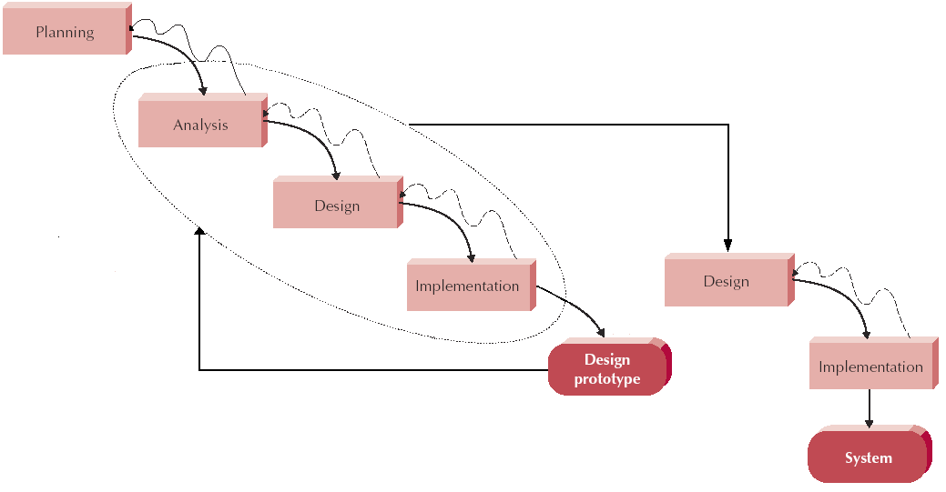

This new methodology would have a similar structure to the traditional waterfall approach; however, a throwaway prototyping component is inserted into the planning, design, and implementation stages to provide feedback for further system improvements. The throwaway prototype serves only to assist system design and development, and is not directly integrated into the final system.
C. Suppose you were an analyst working for a small company to develop an accounting system. What type of methodology would you use? Why?

I’d assume there are very specific tasks the accounting department wants, so the system requirements will be well defined. They will typically have high volumes of transactions that are each generally fairly straightforward, but may have many slight variations. Secondly, I’d assume that most account department personnel have experience with standard office and spreadsheet applications therefore we’ll be working with familiar technology. Thirdly, we must consider the importance of the financial integrity of the data managed; therefore the system must be very reliable. For example, accounting systems should be close to 100% reliable and correct; have very strict requirements for auditing and examining all steps in all transactions

The above considerations appear ideal for throwaway prototyping development. In this case, different accounting tasks can be developed, and the systems tested to determine optimum performance. Although the project probably will not be large enough for parallel development, different applications may be simultaneously developed, and then consolidated into one system.

D. Suppose you were an analyst developing a new executive information system intended to provide key strategic information from existing corporate databases to senior executives to help in their decision making. What type of methodology would you use? Why?

Its important to identify the special requirements that a management decision support system would have. For example, management decision support systems will involve a great deal of extraction from other databases, a great deal of interface design (which may vary among individual users), and a great deal of making additional tools available for users to refine data as they wish.

In this case, an XP agile methodology may be an effective method of development if a cohesive team of developers, programmers, and users can collectively share the necessary effort and communication to carry out the project.

Three of the key principles that XP uses to create successful systems are continuous testing, simple coding performed by pairs of developers, and close interactions with end users to build systems very quickly. After a superficial planning process, projects perform analysis, design, and implementation phases iteratively For small projects with highly motivated, cohesive, stable, and experienced teams, XP should work just fine.

E. Suppose you were an analyst developing a new information system to automate the sales transactions and manage inventory for each retail store in a large chain. The system would be installed at each store and exchange data with a mainframe computer at the company’s head office. What type of methodology would you use? Why?

First, considerations must be made regarding the characteristics of the system to be designed. Consider the special requirements that a marketing/retail information system would have. For example, such a system will require real-time information processing, distributed databases of information, significant telecommunications linkages, and interfaces that can be used very quickly to speed response times with customers.

In this case, the analyst may want to consider a Phased Method of development that breaks the overall system into a series of versions that are developed sequentially. Phased development–based methodologies have the advantage of quickly getting a useful system into the hands of the users. While the system does not perform all the functions the users need at first, it does begin to provide business value sooner than if the system were delivered after completion, as is the case with the waterfall or parallel methodology. Likewise, because users begin to work with the system sooner, they are more likely to identify important additional requirements sooner than with structured design situations.

F. Look in the classified section of your local newspaper. What kinds of job opportunities are available for people who want analyst positions? Compare and contrast the skills that the ads ask for to the skills that we presented in this chapter.

The following are important skills for analyst to possess according to Chapter 1:
- Technical
- Business
- Problem solving
- Communication
- Interpersonal
- Management of people
- Management of situations
- Ethics
- Confidentiality

I went to the website, www.monster.com ad entered a job search for “IT development analyst”. This resulted in nearly 1,300 results. Here are the first three listings:

1. IT Analyst - Integration Development National Grid

Chapter 1 skills
- interpersonal
- communication
- managerial
Additional skills
- team participation
- self supervision.

2. Lead IT Development Analyst Avon Products, Inc.
Chapter 1 skills
- communication
- interpersonal
- management
- project management
- technical

3. IT Systems Analyst Moran Towing Corp

Chapter 1 skills
- communication
- problem solving
- technical
Additional skills
- ability to quickly learn

G. Think about your ideal analyst position. Write a newspaper ad to hire someone for that position. What requirements would the job have? What skills and experience would be required? How would an applicant be able to demonstrate having the appropriate skills and experience?

The Senior IT/Business Analyst provides a link for IT Services to all appropriate company departments and specific clients for purposes of furthering the corporation’s business objectives and client initiatives. The fundamental objective of this position is to provide analysis, recommendation, communications and technical guidance associated with developing client systems and corporate Products.
Interacts with the IT groups and helps determine appropriate computer-related solutions to business problems. Provides analysis and definition to computer-related development and maintenance activities. Understands the relationship between and can define, business needs, functional requirements and technical requirements.
Works with Product Management to obtain an understanding of the varied business needs of multiple interrelated products. Understands the role of the system within the big picture and provides ideas and recommendations regarding the evolution of the system.
Works directly with all levels of staff at companies’ clients to understand their business challenge(s), and identify the technology solution companies can deploy to positively impact the client enterprise. Responds authoritatively to internal and external questions about technology issues at any level of granularity. Consults with Business Development Staff to develop an understanding of specific client needs.
The ideal candidate will have an understanding of Use Case Definition, Quality Attributes, and Business Process Flows, leading to detailed System Specifications as well as proven project and change management experience, including (but not limited to): assessment, risk management, communications, organizational design and development, performance improvement, and cultural change as well as a broad base of IT systems and process knowledge.
This analyst will:
*Be Well Traveled
*Have detailed systems and process knowledge
*Familiarity with the Aviation Industry
*Excellent Verbal & Written Communication skills
*Ability to achieve goals on multiple Projects
Responsibilities:
*Business Requirements Gathering – Use Cases, Quality Attributes, Glossary of Terms, Data Dictionary, etc.
*Team Communication – Facilitate collaborative problem solving and leverage existing solutions
*Scheduling – Maintains calendars and appointment schedules with business experts controlling the flow of information to and from Technical Developers
*Client Relationship Management – Identify client current and future needs via a close working relationship with client project management and project teams
*Report Requirements according to company Standards to Project Leaders
*Draft Test Plans to validate business requirements
*Project Initiation – Business Requirements Gathering, Team Formation, Contact Information, Identification of Deliverables, Timetables, Resources, and Dependencies
*Project Monitoring – Preparation and circulation of summarized project status
Requirements
*BS/BA, MA/MS/MBA preferred
*5+ years experience in IT Business Analysis
*3+ years experience in IT project Management
*Extensive IT experience
*Excellent Management and Communication skills
*Desire to travel, ability to travel extensively
*Desire to work in fast paced, rapidly changing IT environment
*Fluent Spanish A+
*Microsoft Certification A+
*Will be required to submit samples of work from one or more of the following categories: Use Cases, Business Process Flows, Business Glossary.

