PROSPERITY FUND BETTER HEALTH PROGRAMME

STRATEGIC OUTLINE BUSINESS CASE

CONTENTS

Executive Summary………………………………………………………………….……………....2

Strategic Case……………………………………………………………………….…………….....6

Economic Case………………………………………………………………………….................16

Commercial Case……………………………………………………………………….…………..31

Management Case…………………………………………………………………….……………44

Financial Case………………………………………………………………………….…..............53

Appendices:

A. Log Frame………………………………………………………………….. | 58
B. Country Analysis………………………………………………………..…. | 59
C. Market Engagement List………………………………………………..… | 77
D. Economic Case methodology and calculations………………………... | 79
E. Costed interventions by pillar…………………………………………….. | 97
F. Risk register………………………………………………………………… | 101
G. HMG staffing……………………………………………………………….. | 106
H. Transition Bid………………………………………………………………. | 109
I. Programme Cost Profile……………………………………………………. | 114
Endnotes……………………………………………………………………………………………115

EXECUTIVE SUMMARY

Purpose of the programme
This proposed £79.5m-£85.5m FCO-led cross-Whitehall Prosperity Fund programme – developed with DH, DFID and DIT – is designed to increase life expectancy, improve productivity and deliver economic growth in 9 emerging markets. The programme would also unlock opportunities for UK organisations and business with distinctive and world-leading capability to engage in mutually beneficial trade with these fast-growing economies.

The problems it addresses
Health is a widely recognised driver of economic growth due to the established links between life expectancy and productivity. As the Strategic Case explores, the most significant threat to growth in Low and Middle Income Countries (LMICs) currently comes from the rising burden of lifestyle or Non–Communicable Diseases (NCDs) – chiefly heart disease, diabetes and cancer. The impact is greatest in LMIC emerging economies where uneven development and changing lifestyles (e.g. more sedentary, less nutritious) have a disproportionate effect on the poor. Women also bear the greater brunt of the NCD burden due to constraints on their ability to access health services and share of caring responsibilities. Alongside this, the quality of healthcare in the target countries is variable and sub-optimal levels of care, contributing to infection, injury or premature death, also pose a major obstacle to productivity-led growth. The programme also tackles the barriers that dissuade UK businesses from exporting or reduce profitability. It is no coincidence that reducing NCDs and improving access to safe, quality care are two major elements of the Sustainable Development Goals for health.

How it works
A. Constraints / Barriers
The programme fills a development niche and addresses market failure by tackling the barriers that target countries face in creating a healthier population and workforce, and in attracting international trade. The constraints that have been revealed by diagnostic and scoping work include:
- A need for stronger co-ordination and implementation of clinical best practice in health systems;
- A lack of regulatory certainty and clarity;
- A lack of local contacts and relationships (for business);
- A lack of consistency in health care delivery;
- Health system fragmentation (including integration of systems);
- A lack of local capability and capacity;
- Unequal access to health services for women and poor people.

B. Scope: priority geographies and themes
The design process has identified 9 countries (Brazil, Mexico, South Africa, Vietnam, Malaysia, Philippines, Thailand and Peru) as the best partners for a global health programme. These countries were selected on the basis of interest from in-country stakeholders, ease of doing business, and the health financing landscape. The programme comprises of 5 pillars of activity that represent best match between partner country priorities, potential for development impact and areas of UK capability:
Pillar 1 | Strategies to Counter NCDs
Pillar 2 | Digital Health initiatives
Pillar 3 | Education and Training
Pillar 4 | Provider Performance Improvement
Pillar 5 | Life Sciences initiatives

C. Interventions and Outputs:
The programme interventions will be fully tested during an initial strategic development phase but based on substantive scoping of opportunities, existing initiatives and best practice, outputs under each pillar are likely to include:
- Coordinated and comprehensive approaches to reducing NCDs – encompassing strategies for prevention and treatment, tailored clinical guidelines and training;
- Enablers such as training, governance, guidelines and referral systems that increase use of telemedicine (and other digital services) and widen access to care, including for poor women, excluded and difficult to reach groups;
- Developing and institutionalising quality indicators to monitor the performance of hospitals and primary care clinics; training on data and performance management in order to reduce deaths, infections and injuries due to sub-optimal patient safety;
- Targeted community health worker, primary and secondary care education and training covering NCD prevention, diagnosis and treatment; better data analytics; and stronger clinical leadership;
- Regulatory best practice; upskilling principal clinical investigators; and joint research that improves the availability of vital medicines and medical devices.

D. Outcomes:
The result of these outputs will be measured in two ways:
- Through improved prevention and treatment, healthier lifestyles that reduce the risk of NCD-related premature mortality;
- Improved patient safety and quality of care that reduce the risk of illness, injury and premature mortality.

E. Impact:
The programme will measure impact on two levels – developmental and commercial:
- Progress against the Sustainable Development Goals;
- Extended life expectancy, with associated increases in labour productivity;
- An additional increase in UK exports.
The economic case, supported by a detailed and tested methodology, assesses a resulting rise in GDP of 0.26% after 10 years and an increase in UK exports over the same period of £2.1bn.
These Outputs, Outcomes and Impacts are captured in the programme’s summary Theory of Change below:

Theory of Change Diagram:
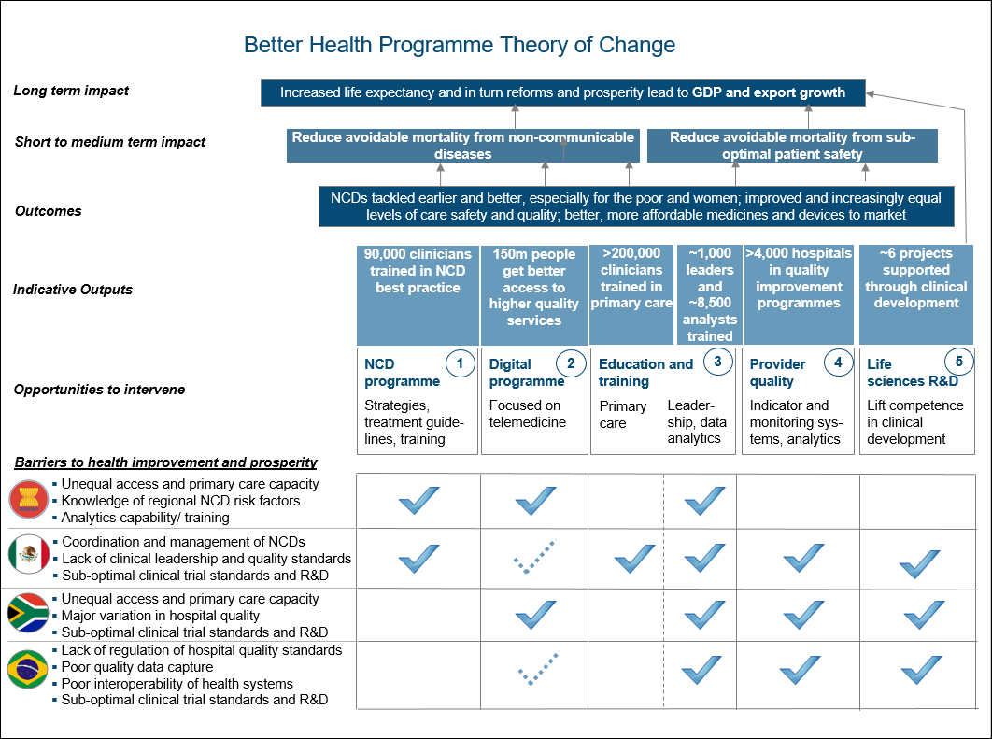
Note: see programme Log Frame (Appendix A) for greater detail, including gender and poverty outcomes
As the Commercial Case sets out, the programme will deliver the work outlined above in two phases:
- A 3-4 month Strategic Development Phase between February and May 2018 that will refine and confirm the actual programme interventions with the partner countries, based on the scope and indicative activities included in this Strategic Outline Business Case, and to inform commissioning of Phase 2;
- A Delivery Phase from September 2018 to April 2021 that will engage commercial delivery partners, supported by separately engaged programme management and strategic advisory partners to deliver the agreed interventions established at Phase 1.
This is a medium risk / high reward programme and it will be key to establish effective co-operation with partner governments and a set of deliverable interventions with measurable impact for it to succeed. At the same time, the authors have considerable confidence that the objectives are realistic, the delivery plan is credible, and the impact is achievable. Scoping has shown that the partner countries need support in the thematic areas of this programme, that there is strong interest from UK suppliers in delivering and benefiting from it, as well as the potential for very significant development and commercial impact.

Strategic Case

Introduction
- This section explains how a global Better Health Programme would support inclusive growth in a range of opportunity markets for the UK and so fit with the Prosperity Fund and wider UK objectives.

Health as enabler of inclusive growth
- A healthy population supports country prosperity by contributing to productivity and GDP growth – including through the significant contribution of employment in the health sector. A healthier population and better health throughout the human life cycle leads to a more capable workforce, longer and more productive working lives, and a better ratio of workers to dependants, which in turn leads to economic growth. Good public health can also have a significant impact on economic growth and development by underpinning educational attainment and increasing population wellbeing.

- Alongside education and essential social programmes, governments that invest in health make the greatest gains in human development. Numerous studies have found evidence for an association between increases in life expectancy and growth in GDP. The size of this effect is thought to be in the region of 1.4-4% additional growth per additional year of life expectancy. This effect is associated with income level, with the strongest effects in lower income brackets. The rationale is that healthier workforces are more productive, with fewer people economically inactive due to ill health or caring responsibilities (where there is a disproportionate effect on women), and reduced costs from health-related absenteeism.

- Improving the health of the population and growing the economy form a virtuous cycle. Moving from limited coverage to universal health coverage leads to greater growth, with research suggesting that a 1% increase in GDP can in turn raise the probability of adopting universal health coverage by 5-6%. Universal health coverage is among the core health targets under the United Nations Sustainable Development Goals. It includes the provision of universal access to high quality essential care services and safe, effective, quality-assured and affordable medicines (including vaccines), as well as financial risk protection.

- Strong health systems improve the health status of the whole population, but especially of the poor among whom ill health and poor access to health care tends to be concentrated, as well as protect households from the potentially catastrophic effects of out-of-pocket health care costs. In general, poor health is disproportionately concentrated among the poor.

- There is a strong gender dimension to the case for health investment too. Poor patient safety impacts women in their child-bearing years, leading to avoidable mortality. The maternal mortality ratio (maternal deaths per 100,000 live births) for middle income countries is 170 (compared to 450 for lower-income countries and 57 for high income countries), showing there is still scope for improving maternal health in PF target countries. In addition, gender norms and societal structures, such as women’s caregiving role and restricted mobility of women to travel to seek healthcare in middle-income countries, have led to reduced access to appropriate care for women compared to men. As principle care-givers, girls are often taken out of education to support the household when a family member is sick. Investment in girls’ and women’s health can reduce gender discrimination, and increase participation in the labour market, empowering women as decision-makers to drive healthy consumption and lifestyle choices for themselves and their families. Investment in reproductive health increases children and mother’s life expectancy, labour productivity, income and asset accumulation.

- According to evidence from the World Bank, health and nutrition in early life also has a positive effect on physical and cognitive development and economic success as an adult. There is also evidence that public health care systems significantly reduce infant mortality, leading to positive effects on growth of income per capita. Good childhood health improves school attendance and ability to learn in class. In addition, lower infant mortality may encourage parents to invest more resources in fewer children. UNICEF has demonstrated that investment in the early years, including in healthcare, is more effective in terms of economic return than investment in later life.

- Investing in health creates employment in the health sector – within the health system itself and within the life sciences and other industries that serve and support the health sector. Both of these sectors of the economy are associated with significant positive economic multiplier effects. These effects are estimated at around £2-3 for every £1 invested in life sciences and around £4 for every £1 invested in the public health sector.

- Health investment in low and middle income countries is therefore an essential lever for increasing prosperity and enabling stable growth and the PF has a strategic opportunity to support the transformation of national health provision and systems to effect greater equality of health outcomes, longer and more productive lives.

Health as a barrier to inclusive growth
- Conversely, poor health generates costs that hinder economic progress, both directly (increasing burden of prevention and treatment crowding out other public and private investments) and indirectly (lost productivity or working years due to illness/death). It creates downstream costs for governments, pushes families into poverty and reinforces gender inequality. This is due to women bearing a disproportionate burden of care at home, foregoing more productive work, as well as meaning households have fewer resources available for healthcare. This makes health an important development outcome in its own right.

- There are a range of health barriers which this programme could address. The biggest challenge facing many of the Prosperity Fund’s target countries comes from the shift in disease burden from communicable (infectious) to non-communicable (chronic or lifestyle) disease. Indeed, these so-called NCDs account for 74% of premature fatalities in Lower and Middle Income Countries (LIC/MICs) and are forecast to cost 4% of GDP by 2025. The returns, through resulting improvements in productivity, from reductions in preventable NCD deaths are expected to be three times greater than the costs of prevention and treatment. There is a real imperative to act now: youthful populations and favourable ratios of workers to dependants in middle income countries provide a demographic dividend or window in which to scale up economic growth by promoting positive behaviours, a healthier more productive workforce and the shape of health services. It is no coincidence therefore that the UN’s third Sustainable Development Goal (SDG 3) includes the aspiration of reducing mortality from NCDs by a third by 2030.

- Infectious diseases also carry significant GDP impacts in a number of the PF target countries. A Harvard study found countries with severe malaria grew 1.3% less per year and linked a 10% reduction in malaria to 0.3% higher growth, whereas a review of studies in the British Medical Journal found HIV/AIDS reduced GDP growth by 2-4% a year in Africa. A 10% increase in cases of tuberculosis has been shown to reduce GDP growth by 0.2-0.4% a year.

- Poverty is a major cause of ill health and a barrier to accessing safe and affordable health care. This relationship is financial: the poor cannot afford to purchase those things that are needed for good health, including quality food and health care. But, the relationship is also related to other factors related to poverty, such as lack of information on appropriate health-promoting practices or lack of voice and power needed to make social services work for them and for government to be responsive and accountable to them.

- Ill health, in turn, is a major cause of poverty. This is partly due to the costs of seeking health care, which include not only out-of-pocket spending on care (such as consultations, tests and medicine), but also transportation costs and any informal payments to providers. It is also due to the considerable loss of income associated with illness in developing countries, both of income earners, but also of family members who may be obliged to stop working or attending school to take care of an ill relative. In addition, poor families coping with illness might be forced to sell assets to cover medical expenses, borrow at high interest rates or become indebted to the community.

- Other health-related challenges that undermine growth include the quality of care, which also undermines faith in health services and increases out of pocket expenses. This points to a second area for the fund to focus on: increasing access to high quality essential health-care services, ensuring patient safety. Again, this is a goal that features prominently in the SDGs. The programme could make a significant difference to population health and hence productivity by increasing the quality of care and case management. Adverse events due to medical care represent a major source of morbidity and mortality globally, with approximately two-thirds of all adverse events, and the healthy life years lost as a result, occurring in LIC/MICs.

- And finally, but crucially, the failure to invest in women’s health reinforces gender inequality and limits women’s participation in the labour market, and in turn labour productivity, income and asset accumulation. According to UN Women, women and youth continue to make up the majority of people living in poverty. This is because of lack of ready access to health services, gender-bias in the home and associated care burdens, or the unequal distribution of incomes and economic opportunities.

Gender Equality Act compliance and impact
- The global health programme will integrate an inclusive and gender-sensitive approach that seeks to actively improve women’s access to affordable health services. A requirement to consider impact on gender equality in line with the Gender Equality Act (2014) will be enshrined into the Terms of Reference for the programme’s design and implementation partners, as well as a key feature of impact measurement, including disaggregation of impact on men and women. This will support Gender Equality Act (GEA) compliance. For example, research shows that gender bias is often evident in clinical trials and this will need to be addressed by any PF interventions in this area.

- Gender outcomes have been considered in the programme’s Theory of Change and measures to ensure gender is mainstreamed across the programme are set out in the logframe at Appendix A. Gender outputs and outcomes have been considered as part of the diagnostic work and will be fully integrated into design work. This includes any work that is carried out pre-delivery to develop Terms of Reference for procurement (including in the assessment criteria), and any inception period during the main delivery of the programme. GEA compliance and gender sensitivity will be rated at bid stage as a distinct and separate component. Suppliers will need to demonstrate that they possess gender expertise and that gender will be properly mainstreamed. This may involve a gender action plan that ensures solutions and approaches are responsive to the needs of excluded women and men. Gender issues will also need to be properly integrated into the results framework, with data disaggregated by sex, socio-economic group and age. Gender equality act compliance and impact measurement will be properly monitored as part of risk identification, monitoring and management.

Poverty impact
- The programme will also integrate a poverty-sensitive approach, ensuring poverty reduction considerations and impact into design, implementation and evaluation. It will seek to address both absolute and relative poverty by equalising health outcomes. The work of the programme will include increasing levels of access to good quality affordable primary care, still a key challenge facing the poorest segments of the population in middle income countries despite progress towards universalisation.
- The interventions of this programme will be designed for poverty impact at all levels. They will be both relevant to the particular poverty context and take account of and give voice to the needs of the poor. Specific standalone components will complement this mainstreaming in order to strengthen the equality of health outcomes. Measures to ensure poverty reduction is mainstreamed across the programme are set out in the logframe at Appendix A and poverty reduction outcomes are reflected in the Theory of Change. Poverty outputs and outcomes will feature in the Terms of Reference for the main delivery phase of the programme and the bid assessment criteria will seek poverty reduction experience and expertise. The programme will request bidders develop a poverty reduction action plan for implementation. Inclusion issues will be factored into the results framework and, as suggested above, KPI data will be disaggregated by sex, socio-economic group and age in order to determine and measure impact. Poverty reduction impact will be properly monitored as part of risk identification, monitoring and management

Environmental impact
- The programme is expected to deliver important environmental side benefits. These may include the reduced travel and hence CO2 emissions that result from the increased access to and reliance upon better, local services and corresponding lower demand on secondary and tertiary level care. Other potential benefits – due to the proposed design of the programme to be explored in the economic case – include changes in diet (leading to reduced meat consumption).

Bilateral impact
- The clear association of PF support with the UK throughout implementation, as well as the likely involvement of UK expertise in programme design and delivery, will add weight to the UK’s bilateral relationships and help create the right environment for positive discussions on future Free Trade Agreements of mutual benefit to both the UK and the partner countries. The programme also demonstrates HMG’s continued commitment to development in countries transitioning from aid dependency and the UK’s international reputation for excellence in healthcare, both of which mean increased soft power.

Programme Development
- It is clear then that a prospective PF global health programme has multiple entry points in pursuit of its goals of reducing and removing the key obstacles that target countries face in creating a healthier population and workforce. Moreover, by tackling these constraints, the programme will be able to deliver strong poverty reduction and gender equality outcomes, as well as other important additional benefits.

- Following scoping work that identified health sector needs in potential partner countries, assessed potential primary (development) benefit and secondary (commercial) benefit, and included an assessment of UK capability to meet demand, the programme’s Steering Committee settled on two of the priority areas outlined above for the focus of the programme at an outcome and impact level – to the particular benefit of poorer and female populations:

- Improved prevention and treatment of NCDs, leading to healthier lifestyles that reduce the risk of related premature mortality;
- Improved patient safety and quality of care that reduce the risk of illness, injury and premature mortality.

The Steering Committee also elected to focus on 8-9 countries, including Brazil, Mexico, South Africa, Vietnam, Malaysia, Myanmar, Philippines and Thailand. (This business case also recommends adding a programme in Peru.) The process that led to decision to focus on these thematic outcomes and countries is explained in the Economic Case. The conclusions are introduced here briefly so as to inform the remaining sections of this Case.

Fit with the Prosperity Fund
- Health is a key driver of prosperity and the Prosperity Fund is the right niche for addressing the issue. Other large sources of programme funding, including the Conflict Security and Stability Fund (CSSF) and the Department for International Development (DfID), have different areas of focus (security in the CSSF case) or target countries (lower income in DfID’s case). Although Burma and – for a transitional period – South Africa remain countries in which DfID work, the focus of their work (reproductive health and communicable diseases) is different to the proposed focus of this programme.
- It also complements Whitehall funds tackling other global health priorities but whose geographic or thematic scope is constrained and/or where the secondary benefits are different or smaller. These include: the Newton Fund (not health specific), health elements of the Global Challenges Research Fund, the Fleming Fund (limited to AMR/surveillance in low-income countries), and the Ross Fund (infectious diseases). In tackling NCDs in particular, the PF would address a substantial and different area of need. A PF programme could strengthen the potential marketability of Newton Fund research outcomes e.g. by addressing clinical trial regulation in host countries to better align with international standards. The Newton Fund is also supporting research on public health systems. The health elements of the Global Challenges Research Fund, the Fleming Fund (limited to AMR/surveillance in low-income countries), and Ross Fund (infectious diseases) would be complemented by this programme e.g. by work to improve capacity and capability for disease surveillance. A life sciences component to the PF programme would support implementation of the UK’s industrial strategy, which identified the UK life sciences sector as critical to the UK economy and UK health.
- The programme will focus on PF priority countries where its work has the potential to effect development outcomes and improve economic opportunities for international business, including the UK. Bilateral aid flows constitute less than two percent of total health expenditure in all of the proposed target countries except Burma. The Prosperity Fund is thus an ideal fit in these markets as the governments of these middle-income countries are responsible for covering the cost of basic healthcare.

Fit with HMG policy
- The programme is aligned with the policy, priorities and activities of the Department of Health (and related health organisations) (DH), DfID and the Department of International Trade (DIT). Health programmes associated with DH and DfID have been mentioned. A PF programme would complement DIT’s work in fostering collaboration and relationships with potential trading partners in overseas healthcare markets, which is vitally important to the UK health sector following the UK’s decision to exit from the EU. DIT will look to seize the programme’s commercial benefits through follow-on trade missions and through the work of the joint DH/DIT-backed Healthcare UK. The programme will complement Healthcare UK in its Latin American priority markets and sectors, which include clinical services, digital health and education and training. It will additionally help to unlock and broaden horizons towards future markets. The programme also complements the international agendas of UK government health agencies, including Public Health England, Health Education England and NHS Improvement.
- The programme fits well with existing government direction. It aligns with the UK Aid Strategy by reducing poverty and serving our national interest, and the National Security Strategy and Strategic Security and Defence Review (2015) in terms of increasing UK prosperity abroad and boosting UK exports. The National Security Council has highlighted that the UK should seek to use ODA to “unlock private and public sector investment….” The programme is also consistent with the UK’s strategic goal to support implementation of the UN’s Sustainable Development Goal 3 (as well as SDG 5 in gender equality) and DFID’s Economic Development Strategy. It is also IDA and Gender Equality Act compliant and aligned.

Fit with partner country and donor activity
- The programme will complement wider donor activity dedicated to global health priorities, as well as potentially act as an enabler for larger scale programmes and health systems development. Multilaterals, including World Health Organisation (WHO) and World Bank, are supportive of and are indeed active in the thematic and geographical areas proposed. The WHO has set Member States the aim to reduce premature mortality from non-communicable diseases by 25% by 2025. Despite this, the majority of bilateral donor activity remains focused on communicable diseases and reproductive health. Therefore this programme is ideally placed to fill this ‘gap’ in development assistance and build on the WHO’s efforts – and limited resources – to address the growing NCD burden.

Fit with other PF Programmes
- This programme has significant levels of synergy with other PF programmes (see table below), amplifying the overall impact of the PF. Local PF governance mechanisms operating at posts will have a vital role to play in this process.

Programme | Link
Anti-corruption (covering most/all countries) | This programme will help create complementary environments and approaches that the proposed programme will benefit from (e.g. procurement).
Business environment (Mexico, Brazil, South Africa, SE Asia) | Business Environment will help improve competitiveness and regulatory environments, important for new and affordable medicines and medical devices – including from the UK
Trade (Brazil and others) | This will work with Brazil’s local patents and intellectual property office to reduce the time needed to approve new patents, including those for new medications, facilitating the entry of innovative pharmaceuticals
Future Cities (Brazil, South Africa, SE Asia) | The programme will help reduce congestion and pollution, easing access to vital services and improving respiratory health. Better managed urban expansion means better access to health services and improved public transport and traffic management reduces pollution.
Digital (South Africa, Brazil) | The programme will improve internet access, creating an improved platform for digital health services among marginalised populations. The digital programme’s pillar on trust and resilience will increase confidence in digital services and health could be a focus for digitalisation pilots.
Education (Mexico, Malaysia, Philippines, South Africa) | This programme will reinforce efforts to raise standards of medical education and professional development.
China (Health) | There are similarities in the common focus on strengthened primary care, quality and standards of hospital care as well as potential cross-over in the area of life sciences regulation and policy

Fit with national priorities
- This is explored in more detail in the Economic Case, but UK diplomatic missions are active in all of the partner countries and have actively participated in programme design and related government to government engagement. Staff at these missions (Posts) – including FCO, DFID and DIT staff – will be essential for managing local stakeholders and ensuring programme outputs lead to the projected levels of primary (development) and secondary (commercial) benefits. This effort will be reinforced by Healthcare UK and its efforts to strengthen and support the UK’s commercial offer and through DIT trade missions. There are MOUs in place between the UK and Mexico, South Africa and Brazil on health that could integrate and provide a key supporting framework for Prosperity Fund health programming. Several HMG programmes have already helped lay the foundations for a successful PF programme, including:

- successful early PF year 1 projects in the partner countries e.g. Brazil
- related Newton Fund projects e.g. in South Africa, Mexico
- relationships established through the UK’s global Science and Innovation Network

Better Health is good business:
- The programme is primarily designed to address development obstacles, but additionally seeks to address barriers that prevent both better health and better trade i.e. by tackling common issues faced by international business, including UK business, in these markets. This is on the premise that trade is mutually beneficial and good for growth. The PF is thereby addressing an area of market failure: private sector organisations cannot inject the resources needed to resolve some of these obstacles, which in any case affect many commercial actors.

- Health is a significant area of opportunity. The world’s largest industry, it consumes an average of 10.5% of GDP globally. The Carlyle Group estimates the global market is worth almost £8trn annually and health spending is expected to grow at 6% a year for the next decade as both emerging markets become richer and populations start to age. There are particular opportunities for the UK in the focus countries for this programme. They are both forecast to grow and already established UK trade partners. They are projected to grow annually from 2024-28 at the following rates: 1.9% (Brazil), 1.3% (Mexico), 2.6% (South Africa) and 4.6% (South East Asia). In 2015 the value of UK global health exports was £32.6bn and is currently estimated to increase to £40bn by 2020 due to increasing global commitments to healthcare investment and therefore opportunities in development of public health systems, health infrastructure, clinical services, education, training and digital health, as well as in pharmaceuticals and medical products.

- Scoping work carried out for this programme suggested that the health sub-sectors with the greatest potential to drive secondary (commercial) spillovers are:

- Clinical education and training
- Digitally-enabled primary care using telemedicine
- Health systems quality improvement

Given the strong correlation with partner country requirements, these have all been selected as core thematic areas in the prospective programme. In addition to creating direct opportunities in these health sub-sectors, supporting local health systems (through capacity and capability-building, access, and standardisation) in high-growth-potential, middle-income markets, could be expected to create a more favourable environment in which to export evidence-based, innovative pharmaceuticals and medical products. When combined, these sectors contribute a substantial amount to UK exports. This is analysed further in the Economic Case.

- The UK has an internationally distinctive reputation in health care organisation and delivery. The NHS was the world’s first free at the point of use health system and, as a family of organisations, is recognised and renowned around the world – and in particular in low and middle income countries – for quality, efficiency and fairness, at scale. This provides a comparative advantage and unique platform for UK health organisations that are part of the broader NHS ecosystem (the Royal Colleges and professional associations, national health agencies, the universities, research institutions the regulators and agencies, and the organisations which supply and partner with the NHS) to build on, and benefit from, this high ‘brand recognition’. The significant comparative advantage of the UK’s health institutions has been noted by the All Party Parliamentary Group on Global Health (APPG). The UK has a globally respected national health service from which partner countries want to learn as they build their own public health offer. Although not an aim of the programme, this could create partnerships that help reinforce domestic capacity – where not to the detriment of the partner country.

- UK companies have strengths in all of the thematic areas relevant to the programme, including: health consultancy; digital services and IT innovation; health research; health education; quality of care; efficiency; public finance; pharmaceuticals and medical devices. The UK is, for example, the G20’s most internet-based economy and the expertise and experience available due to this technical advantage is significant. The UK is, furthermore, projected to benefit from the strength of its services sector. There are a number of consultancies that combine sector know how and generalist consulting expertise. The UK also has a strong reputation for setting and monitoring implementation of standards. UK standards are performance-oriented compared to US standards, which are more prescriptive, one size fits all – this makes them more adaptable and applicable to MICs.

- The PF’s Health scoping studies interviewed a wide number of UK organisations to assess their capabilities, the obstacles they face entering middle income markets, and their desire to enter those markets. It was clear from the scoping studies that the UK has the required capabilities to assist and desires to enter these markets. The key barriers identified to exporting were

- Regulatory certainty or clarity
- Depth of local relationships
- Lack of consistency in health care delivery
- Health system fragmentation and the lack of integrated systems
- Lack of local capability and capacity

- This programme has been explicitly designed to address these barriers and builds on sub-sectors where the UK has competitive advantage, thereby maximising export opportunities. The implementation of this enabling programme will result in a pipeline of contracts that UK organisations will be well positioned to win. The UK already has a strong foothold across in most of the markets covered by the programme. In South Africa, for example, it holds a 7% share of the market for goods and 15% of the market for services. Where the UK has a lower share(the market share in Peru is 1%), DIT see considerable room and opportunity for growth.

Objective and outcomes
- Based on the above health sector context in middle income countries, UK policy and commercial strengths, the core objective of this programme is as follows:
“To collaborate with 8-9 middle income countries over a 3 year period to lengthen the number of healthy years lived, resulting in increased local prosperity and quality of life, reduced poverty and gender inequality, and mutually beneficial trade”
- The overall programme outcomes and impact will be:
- Primary: The outcomes will be the improved prevention and treatment of NCDs and improved quality and safety of care, leading to the impact of reduced premature deaths due to non-communicable (chronic) diseases and reduced early mortality due to adverse events in care (quality of care). The resulting increase in healthy life years among the worst affected segments of society (including women and the poor) will facilitate inclusive economic growth and increase domestic purchasing power (thus capacity to trade).
- Secondary: The increasing purchasing power created as the result of the productivity impact of increased health will generate economic opportunities and mutually beneficial trade, including with the UK.
- The programme Log Frame that links the outputs, outcomes and impacts of the programme, and shows the indicators and assumptions used to make these causal linkages, is set out at Appendix A. As the log frame shows, the programme will contribute to the following Prosperity Fund-level Theory of Change intermediate outcomes: investment in human capital through upgrading health systems and clinical best practice (pillars 1, 2, 4, 5); innovation and knowledge transfer, including through digital upskilling (all pillars); and strengthened, more co-ordinated and predictable systems where it is easier to do business, including through application of standards and transparent procurement (all pillars). In support of these it will also deliver improved policy and regulatory capacity.

Economic Case

Introduction
- The Economic Case has been prepared with reference to HM Treasury’s Green Book (A Guide to Investment Appraisal in the Public Sector) and considers a range of options for delivering the core programme objective identified in the Strategic Case.
- The options assessment was overseen by a cross-Whitehall Steering Committee, and involved wider consultation across HMG, extending to BEIS and organisations affiliated with the NHS (Public Health England, Health Education England, NHS Improvement, Royal Colleges), as well as with the UK private and third sectors active in the health field. Outside the UK, the design process involved consultations with multilaterals (including WHO, World Bank, IFC) and dozens of local stakeholder governmental and non-governmental organisations. Independent consultants carried out the detailed scoping of opportunities for the options assessment, while market engagement was held to test and refine the Steering Committee’s preferred options for programme structure and delivery (see Appendix C for participating organisations). The method developed to assess the costs and benefits is summarised here and set out in detail at Appendix D.

Methodology
- The cross-Whitehall Steering Committee used the following process to determine and agree potential options:

- Prioritisation of countries
- Determining development needs and constraints
- Determining business constraints
- Assessing UK comparative advantage
- Matching advantage and need to establish thematic priorities (pillars)
- Agreeing priorities

- These steps are now examined in closer detail.

Prioritisation of Countries
- Firstly, in order to identify a set of priority countries for the programme, a long list of countries for assessment was drawn up from the 19 countries identified by PF economists as being the strongest fit for the PF’s objectives. This list reflects both degree of poverty and size of market opportunity. In addition, any countries likely to feature health as part of PF country-specific (as opposed to global sector-based) programmes were excluded (China). Those remaining were then assessed against the following criteria:

- interest from in-country stakeholders
- health sector and market growth potential (GDP, health expenditure)
- ease of doing business;
- the health financing landscape;
- the existence of barriers to growth that the Prosperity Fund could address

- The needs in the medium list of countries were then considered in the context of the UK’s distinctive capabilities in health relative to its competitors, based on research and interviews with a wide-range of health-related organisations in the UK. This suggested the prioritisation of 4 key countries / regions: South East Asia, Mexico, South Africa and Brazil. Within South East Asia, the priority targets were Thailand, Vietnam, Malaysia and Philippines, but the Steering Committee also showed strong appetite to work with Myanmar. There was also strong interest from the FCO mission in Peru, which the committee agreed to include, subject to funding and benefits to be explored at business case stage. On the other hand, engagement in – for example – India suggested more pressing short term local priorities than health and it was not ultimately prioritised. Summary analysis for each country is presented at Appendix B.

Determining development needs and constraints
- Scoping revealed the following needs and constraints on health-based growth. They may be broadly summarised as being rooted in capability and capacity gaps, but also a need for stronger co-ordination and implementation of clinical best practice in health systems. Country needs were then assigned to one of 12 thematic areas. Only a selection of the needs and hence thematic areas are reflected in the table below as the remainder were de-prioritised during the process of matching need to area of UK capability and potential impact.

Country | Need / barrier to better health | Thematic area
SE Asia | Primary care access and workforce capacity  Knowledge of regional NCD risk factors  Analytics capability, poor quality data capture | Education/Training  - NCD Strategy  - Digital Health and Education/Training
South Africa | Access and workforce capacity in primary care  Major variation in quality of secondary care provision  - Sub-optimal clinical trials and R&D | Digital Health and  Education/Training  - Provider Performance  - Life Sciences
Brazil | Lack of regulation of quality standards and governance in the health system  Poor quality data capture  Poor interoperability of health system and lack of architecture for innovation  Clinical trials not to international standards | Provider Performance  - Education / Training  - Provider Performance  - Life Sciences
Mexico | Lacks coordinated chronic disease (NCD) strategy  Primary care workforce lack skills to tackle large disease burden.  Lack of clinical leaders  Variable quality levels in hospitals  Clinical trials not to international standards | NCD Strategy  - Education/Training  - Education/Training  - Provider Performance  - Life Sciences

Determining Business constraints

The scoping involved dozens of interviews with UK organisations to assess their capabilities, the obstacles they faced in entering the selected markets, and their desire to enter those markets. Scoping demonstrated that the UK has the required capabilities to assist health sector development in target countries. The key barriers identified to exporting included: lack of strategic perspective, lack of system-wide coherence and coordination; decision-making capacity; and inefficient regulation. There is a significant degree of correlation with the needs identified in-country – providing assurance that programme interventions designed to tackle business constraints also correspond to local needs.

Assessing UK comparative advantage
- Following the scoping, market and desktop research, the emerging thematic areas of work (see table at paragraph 6) were tested against areas of UK comparative advantage. As noted at paragraph 6, there were 12 thematic areas in all, but those shown below reflected themes eventually selected:
Clinical education and training
- Healthcare UK identified £17m wins in this sub-sector alone in 2015/16 and there are over 200 export ready UK organisations. The UK has a globally distinctive reputation in medical education (with 5 of the top 10 medical schools globally based in the UK). UK universities are active internationally in medical education, with large numbers of international students based in the UK and a relatively smaller number of entrepreneurial universities opening international campuses – for example the University of Newcastle has a medical campus in Malaysia. Many Royal Colleges have active international education programmes and have developed ‘train the trainer’ and other delivery models, including digital channels. In addition, a number of private companies are very active internationally in nurse education, for example Annie Barr Associates, often working in collaboration with the Royal Colleges (which operate on a not-for-profit basis). The UK Health Partnership Scheme has built relationships in 26 Asian and African nations, with 1,000 NHS health workers providing – on a voluntary basis – training and education to over 25,000 health workers. Other leading players include HEE, NHS Digital and the Russell Group. HEE has developed a number of initiatives including the International Postgraduate Medical Training Scheme (IPGMTS) and the Modernising Scientific Careers (MSC) for which the PF can be become a facilitator of commercial expansion.

Digitally-enabled Primary care/telemedicine
- The UK has a 9% share of the global telemedicine market (i.e. remote consultations with clinicians), where the main competition comes from US and Indian players. Here the UK has a number of established telemedicine) providers including Babylon Health, Doctor Now, Synergix, DoctorCareAnywhere, Dr Thom, DrDoctor and others, some of which are already active in low and middle income countries. Babylon Health set up a national digitally-enabled primary care service in Rwanda, in collaboration with the national Ministry of Health. Other telemedicine providers are also proactively pursuing opportunities in Kenya, South Africa, Nigeria and South East Asia. In the field of mHealth (health apps), BMJ are active in 60 markets. Digital Health is a rapidly growing health industry that, when incorporated at scale, could generate $600-$800bn of market opportunity. In 2015, the value of new digital health investments topped $4bn. Healthcare UK have identified 150 companies looking to export and this figure is set to grow. A PF programme would further strengthen the UK’s position in the market. The CQC (Care Quality Commission) have developed a regulatory framework to assure quality and safety for digital providers of clinical care services. This helps give UK organisations an advantage when pursuing opportunities in countries where the regulatory environment is less well-developed.

Provider Performance / Quality Improvement
- The UK has an international reputation for systematic, transparent and proactive performance management of healthcare providers. The UK has done more than many to reduce variation in quality. This is both due to having a national health service, but also due to the efforts of organisations including NHS Improvement and the Care Quality Commission. University Hospitals Bristol NHS Foundation Trust’s Releasing Time to Care module has been adopted in the US and Canada, for example. Bupa has been active internationally to improve quality and safety. In parallel with systematic regulation and performance management, a market has developed for tools and analytics to support performance improvement from which a tail of UK SMEs stand to benefit. Bupa’s ‘Hospital Quality Programme’ evaluates medical facilities to help improve how hospitals monitor and improve the quality of care provided; their use of evidence-based, cost-effective medical practice; and their use of recognised safety protocols, for example the World Health Organisation Safe Surgery checklist. They have worked with hospitals in Mexico, Brazil, Nigeria, Ghana and Indonesia, for example. NICE International and the University of Manchester have reviewed institutional arrangements and structures for developing and implementing quality indicators in Mexico.

NCD Strategy
- UK companies and organisations also stand to benefit from supporting national efforts to develop effective NCD strategies. BMJ and NICE International (now Imperial Global Health and Development) are renowned providers of evidence-based clinical pathways with a reputation for creating tools and materials tailored for use by front-line clinicians and health system managers. NICE cover all major NCDs within its clinical guidance and pathways. Public Health England has a strong national and growing international reputation for providing strategic leadership in public health; NHS England has developed the world’s first national Diabetes Prevention Programme, a possible model for NCD prevention in target countries. Support at the institutional level could leave a legacy of policy and regulatory frameworks based on the UK model which could give the UK disproportionate influence and associated commercial advantage for decades.

Life Sciences R&D
- In helping to establish partnerships with developing local Life Sciences sectors, the PF could also open doors to a wide range of firms, from global to SME. Two of the top ten global pharmaceuticals companies are based in the UK: GlaxoSmithKline and AstraZeneca. The UK also hosts a vibrant SME life sciences sector with a range of smaller biotech companies with a reputation for innovation (e.g. Oxitec, Medisieve). This is reinforced by extensive government support for life sciences and a strong academic and not-for-profit sector. Leading organisations including the Wellcome Trust, the Sanger Centre, UK Genomics, the universities of Cambridge and Oxford, and Imperial.

Matching
- Where there was a match between advantage and need, the theme was prioritised. The points below explain how the matching assessment was carried out.
- Priority local development needs identified, via literature review, then interviews with stakeholders;
- Needs matched to UK capabilities, also based on literature review and interviews;
- Degree of added value alongside local or donor-funded initiatives and alignment with national policies
- Potential impact on inclusive growth, poverty reduction and gender equality
- Potential for opportunities for UK business to result
15. This information was fed into a matching tool whereby a traffic light system and ratings were applied to 4 categories:

- Primary Impact Potential
- Secondary Impact potential
- UK supplier international experience
- Local need and perspectives

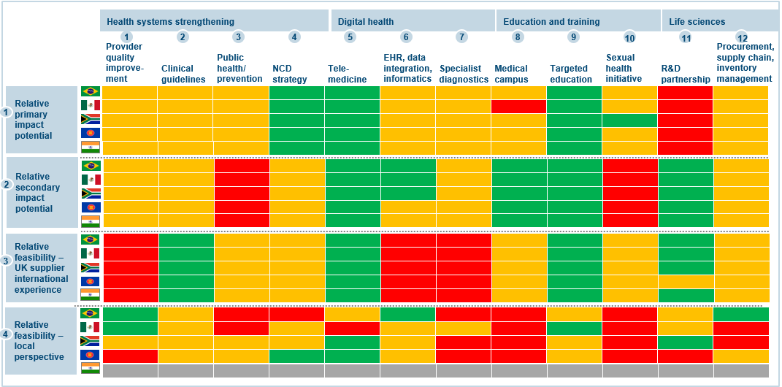

Agreeing priorities
- Following Steering Committee discussion and voting, a shortlist of thematic priorities for interventions in priority countries was agreed. The final prioritisation of themes resulted in the following pillars:

- NCD Strategy
- Digital Health
- Health Education and Training
- Provider Performance Improvement and Quality of Care
- Life Sciences R&D Partnership Initiatives
These five pillars did not necessarily represent those options bearing the greatest frequency of green and amber ratings. Discussion, for instance, highlighted that Provider Performance Improvement was a significant priority for a number of the target countries as well as an area of potential export strength that the UK was underexploiting. Although the Clinical Guidelines pillar was positively rated, the Steering Committee decided to combine this with the NCD strategy pillar, as this was the area where guidelines were most in demand. Within the five pillars, two effectively act as leads (NCD and Quality) and two act as support (Digital and Education). Life Sciences supports both – in terms of ultimately being about new and more effective medicines and devices coming to market – but has wider application.
- These five pillars – explored further under “Programme Design and Structure” below – cover much of the key ground in relation to national health systems strengthening. Targeted programming within these areas will not only address early deaths and lead to increased productivity, but it will increase the equality of health outcomes, notably through increased access to care – a change that will especially benefit women.
- In addition to the matching exercise, our network of overseas Posts in the proposed partner countries have undertaken government to government engagement at national and sub-national levels to test the degree of alignment between the programme’s pillars and local need, as well as to discuss possible areas of programme activity or intervention in response to the constraints. Additional scoping has also been conducted. The indicative interventions are explored in greater depth in the section to follow.

Programme design and structure
- This section groups the barriers to development and commercial benefit under the five pillars of the programme, along with possible activities that would address them. These emerged from scoping and from the government to government engagement by our overseas Posts.

Pillar 1 – Strategies to counter Non-Communicable Diseases
- The barriers to a more effective response to the NCD challenge include: lack of horizontal co-ordination across government on policy and the inconsistent application of NCD best practice across healthcare providers. There was also a lack of understanding of the prevailing risk factors and their interaction. Business seeks clear strategic and policy direction in response to the NCD challenge and access to data.
- Activities in this pillar therefore could best focus on
- supporting holistic solutions to NCDs within countries, enabled by coherent and evidence-based strategy and policy
- improved understanding of risk factors (excess alcohol, poor diet, smoking, lack of exercise and their interplay with poverty, ethnicity, location)
- effective and integrated public health campaigns
- empowerment, training and better preventive action at GP levels

- Implementation of this pillar and others will have clear benefit for and specifically target lower socio-economic groups and women. Those on lower incomes are most affected by NCDs due to poor diet and higher prevalence of smoking. NCDs are the leading cause of death for women worldwide, leading to 65% of all female deaths. Women also account for over half of the deaths due to NCDs each year. Twice as many women as men suffer from malnutrition and two-thirds of illiterate adults are women. Moreover, the community healthcare staff working with lower socioeconomic groups are predominantly women and the programme will directly educate, train and create opportunity for women in the health labour force.

Pillar 2 – Digital Health initiatives
- Growing penetration into partner countries by affordable smartphones is presenting opportunities to transform health delivery in under-served areas as small scales initiatives in South Africa and Mexico are already demonstrating. The main barriers to effective digital health are lack of governance and regulatory frameworks (including on privacy), lack of access to patient data, insufficient data collection and analysis, capacity and capability at national and regional levels to assess and capitalise on opportunities, as well as patchy or localised impact and financing models. Business seeks a clearer regulatory environment and supportive operating framework, as well as access to data.
- Activities include:
- provision of technical advice on establishing effective governance and regulatory frameworks, including robust mechanisms to enable use of but protect patient data
- assessment and prioritisation of potential digital services according to impact on beneficiary populations
- setting up mechanisms to learn from the data
- advice to government and IP owners on financing models

Pillar 3 - Education and Training
- Common barriers related to education and training include a relative lack of leadership and managerial skills in healthcare facilities (undermining efficiency and quality of operations), under-developed evidence-based and data-based decision-making, lack of clinical decision-making capacity at primary care levels. Business seeks clear standards governing institutions operating in the sector, policy commitment from government.
- Activities under this pillar include:
- Strengthening of accredited management and leadership training, including ongoing professional education to enable healthcare professionals to adapt e.g. to epidemiological shifts
- Empowering and upskilling primary care workers through training programmes, whether community healthcare workers, nurses or doctors
- Short courses and training for data analysts in healthcare settings

Pillar 4 – Provider Performance Improvement

Some of the partner countries have relatively crude or under-developed systems for monitoring and learning from provider performance. Business seeks clear commitment at policy level to concept of national standards.
- Activities under this pillar could include:
- Evaluating existing mechanisms of monitoring quality of care
- Technical advice to governments on how to establish quality monitoring mechanisms at the national level (as, for example, the UK’s Care Quality Commission)
- Technical advice on data collection and management

Pillar 5 – Life Sciences initiatives

Though a number of the countries have Life Sciences sectors, there is often a long time lead time on new pharmaceuticals products and, when combined with an opaque or confusing regulatory environment, this can deter innovation. Domestic sectors would benefit from research partnerships in order to share data from drugs trials and to reduce the time and resources needed to bring new products to market. Business seeks a clear commitment to facilitate the approval of new medicines and medical devices.

Activities that respond to these challenges could include:
- Improved and efficient regulatory systems
- Increasing research capacity through joint collaboration on new IP
- Establishing incubators for research and development of priority medicines

- The Theory of Change diagram on the next page shows the logic for how the programme will create impact through the interventions, while a more detailed breakdown of costed activities for each pillar of the programme is included at Appendix E. The Appendix shows how the programme could deliver activities that address the barriers set out in this section. The activities set out there – albeit indicative and subject to agreement by partner countries in the pre-delivery phase – also serve as the basis for calculating the potential benefits of the programme. For instance, there is a causal link between delivering primary care training and GDP impact. This is explained further in the next but one section entitled “Assessing costs and benefits”.

Sustainability
- The interventions have been selected on the basis of strong alignment with partner country policies and national priorities e.g. stakeholders in Mexico City have confirmed their interest in learning from the UK regarding systems for improving quality of care. Once local prosperity barriers have been overcome as a result of the programme, the primary benefits should be sustained without further significant HMG involvement e.g. training of trainers schemes that allow for continued expansion without further HMG funding. Changes of government are likely within the lifetime of the programme and the programme will be insured against change by focusing on themes that are not considered partisan and by mapping and consulting a wide range of stakeholders.
- On secondary benefits, DIT has committed – subject to the availability of non-ODA programme resources – to follow up the opportunities created. A significant number of organisations have expressed interest in the opportunities that the programme will create in growing markets right from the start. The following section now looks at what those opportunities are worth both to the partner country and the UK.

Assessing costs and benefits
- The programme has a developed economic model for estimating the costs and benefits of the proposed programme activities.
- In this model, primary or development benefit is measured as an increase in GDP. This is calculated via the following method:
- Estimate the cost to the economy of the constraint e.g. burden of NCDs will rise to x in country y if nothing is done (i.e. the do-nothing option)
- Estimate the proportion of the constraint that that the intervention will ultimately address and the associated value e.g. reduction in premature deaths by 10%
- Proportion which can be legitimately allocated to the programme i.e. sometimes subsequent action by others will be required before the constraint can ultimately be addressed
- Estimate the proportion of population that will be positively impacted by the intervention, including targeted impact of vulnerable populations e.g. women and low-income populations

- Secondary or commercial benefit is based on source data, secondary literature and scoping consultations and is expressed in additional UK exports. Initially the PF’s recommended model – SERGMA – was considered as a basis for the calculations, but FCO economists agreed that a bespoke model was acceptable.
- The methodology attributes additional exports to two main factors: (i) proportionate growth in imports from existing trading partners, including the UK; (ii) an increase in the UK market share attributable to the programme due to anticipated follow-on work flowing from it and from the increased exposure to UK market strengths during the implementation phase. Moreover, as the programme specifically addresses the barriers that UK exporters face, we deduce an increased – although unquantified – uptick in interest from UK suppliers in capturing opportunities in the programme markets.
- Sensitivity analysis produced ranges of impact around a median value. The range of secondary benefits was estimated from a reduction of 25% (based on lack of follow-on projects or increased competition for market share) through to an increase of 25% (based on the reverse scenario).
- The costs and benefits of a provisional set of interventions is set out in detail at Appendix D and summarised below.

Primary Impact
- The cumulative primary or economic development impact on partner country GDP from 2018 to 2027 is estimated to be an increase of £32bn with lower/upper ranges of £6bn/£51bn. This would include an increase in GDP in the final year of the programme of £13.2bn or 0.27%. Discounted primary benefits (from the cumulative figure) are £13.7bn and 10% of this is assumed attributable to the Prosperity Fund investment itself i.e. £1.37bn. This gives a primary benefit-cost ratio of 20:1 (£1,369m/£68m). Primary impact broken down by country as shown in the table below:

Country/Region | Programme Cost (£m) excl staffing and PM | Estimated primary benefits (2018-2027) (£m) | Impact on GDP in 2027 (%)
South East Asia | £23.0m | £11,821m | +0.25-0.31%
South Africa | £15.0m | £3,214m | +0.38%
Brazil | £16.0m | £11,474m | +0.26%
Mexico | £19.0m | £5,703m | +0.21%
TOTAL | £73m | £32,213m | +0.27*
TOTAL DISCOUNTED | £68m | £13,686m | N/A
TOTAL DISCOUNTED AND ATTRIBUTABLE | £68m | £1,369m | N/A
*Weighted average

Secondary Impact
- The secondary or commercial impact is defined in terms of increased UK exports. This Business Case (see Appendix D for working) assess there to be an estimated increase of £2.0bn in UK exports over the 10 years from the point that the programme would launch in 2018 through to 2027. £1.36bn of this is for higher UK exports of pharmaceuticals, healthcare and medical devices as a result of improved market access to the programme countries. In 2015, the UK exported approximately £800m of these goods and services to the programme countries and over the appraisal period the additional exports represent an (average) exports uplift of 6%. The cautious and optimistic lower/upper ranges of benefit, generated using the economic model, are £0.9bn and £3.1bn.
- Secondary benefits in terms of potential UK exports in health-related services are grouped together by pillar below, along with the values placed on wider benefits generated by the programme (part of the £2.0bn) and the programme’s indicative distribution of costs. Once discounted, these figures generate a benefit-cost ratio of 22:1 (£1,523m/£68m).

Pillar | Programme Cost, excl staffing and PM | Estimated secondary benefits (2018-27)
Pillar 1: NCD Strategy | £12m | £53m
Pillar 2: Digital Health | £16m | £165m
Pillar 3: Education and Training | £12m | £89m
Pillar 4: Provider Performance | £15m | £164m
Pillar 5: Life Sciences | £17m | £58m
Wider Benefits Structural | n/a | £111m
Wider Benefits Market Access | n/a | £1358m
TOTAL | £73m | £1999m
TOTAL DISCOUNTED | £68m | £1,523m

- The wider secondary benefits come as a result of the programme’s interventions and the enhanced sector and trade relationships between the UK and the partner countries, including:

- Increased opportunities for UK investors to invest in the partner countries
- Opportunities for the UK to benefit from local innovation and expertise

Peru
- At this point the Case considers the impact on costs and benefits of adding Peru to the programme, as the Steering Committee had agreed to do at Concept Note stage. Building on the strategic context and diagnostic material presented in Appendix B (Country Analysis), a programme in Peru would have three central elements: support to NCD strategy, including undertaking a full assessment of NCD risk factors; support on digital health in order to raise clinical standards and levels of access in primary care; and primary care training itself in order to help address, for example, workforce challenges and inefficiency resulting from under-use of nurses in care delivery.
- The breakdown by country based on the indicative activities under a programme including Peru is:

Country/Region | Programme Cost (£m), excl staffing and PM | Estimated primary benefits (2018-2027) (£m) | Impact on GDP in 2027 (%)
South East Asia | £23.0m | £11,821m | +0.25-0.31%
South Africa | £15.0m | £3,214m | +0.38%
Brazil | £16.0m | £11,474m | +0.26%
Mexico | £19.0m | £5,703m | +0.21%
Peru | £6.0m | £893m | +0.15%
TOTAL | £79.0m* | £33,106m | +0.26%
TOTAL DISCOUNTED | £74m | £14,067m | N/A
TOTAL DISCOUNTED AND ATTRIBUTABLE | £74m | £1,407m | N/A
**Weighted average

- This illustrates that a Peru programme would achieve a similar GDP and therefore primary impact to the other countries in the programme. The next table illustrates the comparative secondary benefits
- When the costs of a Peru programme are distributed across the programme pillars, the impact on the overall secondary benefits are as indicated below:

Pillar | Programme Cost (£m), excl staffing and PM | Estimated secondary benefits (2018-27) (£m)
Pillar 1: NCD Strategy | £14m | £57m
Pillar 2: Digital Health | £18m | £178m
Pillar 3: Education and Training | £15m | £103m
Pillar 4: Provider Performance | £15m | £164m
Pillar 5: Life Sciences | £17m | £58m
Wider Benefits Structural | n/a | £112m
Wider Benefits Market Access | n/a | £1,410m
TOTAL | £79m | £2,083m
TOTAL DISCOUNTED | £74m | £1,587m

- When comparing the table at paragraph 42 with the table above, we see that including a £6.0m Peru programme would generate an additional £84m in secondary benefits, increasing overall benefits to £2.1bn (£1.59bn discounted). Given the strategic and trade case (country analysis at Appendix B shows Peru is eager to work with and trade with the UK, while DIT rate Peru as a priority market), this Case recommends that a Peru programme is added. There are alternatives to this. For example, additional funds may be allocated to other country sub-programmes within the programme that yield higher returns. But there are important strategic benefits to partnering with a country that is keen to work with the UK and where Post assesses the trade benefits – in health and wider – to be potentially more significant than the statistical analysis here may suggest.

Discounted costs, Risks and Sensitivity Analysis
- The total discounted benefits and costs for the programme are set out in the Economic Case Methodology at Appendix D. The key risks associated with the programme, together with their mitigation strategy are set out in Appendix F, though specific key benefit-cost risks are also reviewed at Appendix D. The programme is recommended to forecast benefits according to a central or medium risk scenario.

Preferred programme
- The conclusion of the economic appraisal, based on an assessment of efficiency, effectiveness and equity (consistent with the programme log frame), is that the Better Health programme should cover 9 target countries, including Peru, and be organised around 5 themes. The core programme would cost £79m, on to which staffing and programme management costs would be added. These are costed at the management and finance case stage. If successfully implemented the programme would – over a 10 year cycle and through improvements in population health and health systems – help to deliver cumulative benefits of the order of £33bn in additional GDP for the partner countries and £2.1bn in additional exports for the UK.

Commercial Case

Introduction
- This section considers how the services required of the programme will be delivered and therefore procured.

Service requirements
- The approach to delivering the programme has been informed by the views of the programme’s Steering Committee and by market testing (see Appendix C for details). Programme implementation consists of two phases as outlined below:

- Phase 1 – strategic engagement and programme definition phase (3-4 months)
- Phase 2 – programme delivery phase (2.5 to 3 years)

- Phase 1 involves use of a core team deployed to each country to build upon the initial scoping and government to government engagement, to develop an agreed set of interventions for the programme in the following way:

- Review the programme as presented in the SOBC with partner countries, including its provisional set of interventions
- Develop and implement a stakeholder and community consultation and engagement plan to ensure demand side issues inform and shape proposed interventions in line with IFC performance standards on social and environmental sustainability.
- Confirm strategic fit and, where partners prioritise other initiatives within the broad parameters of the programme, assess the impact and feasibility of alternative options
- Review and ensure these contribute to poverty reduction and are Gender Equality Act compliant, and that an inclusive approach is embedded among them that leads to measurable impacts on poverty and gender equality
- Secure sign-off on the work of the programme, including the availability of local in-kind or financial resources
- Transfer the agreed outputs into Terms of Reference for a commercial procurement (for phase 2)

- Phase 2 will involve contracts for delivery and for programme management, as well as an MOU or contract for a strategic advisory facility. This facility is to be either specified in the ToRs or part of a consortia formed by lead delivery partners, and potentially the Authority (the FCO), throughout the programme. In either event, the strategic advisory facility and lead delivery partners will form a core team for the duration of the programme. The roles are as follows:

Strategic Advisory Partner or Facility:
- Primary interlocutor for the programme with decision-makers in partner countries
- Looks across the activities in other countries in the programme to spot synergies and lessons
- Shares knowledge with partner governments on sector challenges both related to the programme and wider health needs
- Provides advice to the programme on changes required to maximise impact
- Provides advice on social inclusion and gender equality in health programmes, as well as methods of measuring impact by gender/socio-economic group
- Keeps abreast of international best practice to ensure that a range of practice is called upon to address the capacity constraints
- Enables the Authority to be a fully intelligent customer, through role in supporting programme delivery

Programme Management Partner:
- Ensures effective reporting from the across the programme
- Ensures progress towards benefits is appropriately tracked
- Ensures risks and other issues are managed
- Ensures clear communications on the programme
- Provides effective financial management of the programme
- Enables the Authority to be a fully intelligent customer

Delivery Partners:
- Deliver interventions with intended primary and secondary impacts, including on gender and poverty reduction
- Spot synergies within country environments
- Build effective relations with stakeholders such that buy-in and ownership is achieved

Delivery Options
- The following options were considered for fulfilling the functions required at phase 1 and phase 2:

Strategic Partner (Phase 1 and 2):
Option | Advantages | Disadvantages | Conclusion
In-house delivery | -Increased HMG control  -Cost | -Lack of departmental capacity and expertise | Not feasible as solution
Multilateral delivery | -Credibility with partner governments  -Access to sector expertise to see primary benefits and inclusive growth | -Low HMG control  -Cost  -Less scope to spot and achieve secondary benefits | Good option given level of expertise and independence
UK health Non-Departmental Public Bodies (NHS partners) active in the international development space | -Credibility with partner governments  -Access to sector expertise needed to see primary benefits and inclusion  -Links to UK supply chain  -Cost and control | -Overseas presence  -Organisational capacity/agility  -Risk of UK-centric approach | Strong option given level of expertise, existing relationships and international development work (to which their expertise is contributing), combined primary and secondary benefit potential
Private sector delivery | -Capacity/agility  -Experts to draw on  -Ability to spot and seize secondary benefits | -Cost  -Relationships with partner governments  -Conflict with interest in wider delivery | Not a realistic solution given potential conflict with role in delivery; lower credibility with government partners
*Preferred option for Strategic Partner to be confirmed

Programme Management Partner (Phase 2 only):
Option | Advantages | Disadvantages | Conclusion
In-house delivery | -HMG control  -Cost | -Capacity  -Capability  -Confidence | Insufficient PPM capability and capacity renders unrealistic
Multilateral/NGO delivery | -Ability to realise primary benefits | -HMG Control and Cost  -Capacity and Capability  -Cost | Concern over lack of PPM capability and capacity
No partner (remit of delivery partners) | -Cost saving (PM functions integrated into delivery contract) | -Loss of coherence, view across portfolio  -Reduced oversight and confidence | Loses key portfolio view unless HMG and MREL contract adopt functions – unlikely, given current scope / capacity
Private sector delivery | -Management capacity and capability  -Degree of HMG control, confidence | -Cost | Strong option given level of PPM expertise

Delivery Partners (Phase 2 only):
Option | Advantages | Disadvantages | Conclusion
In-house delivery | -HMG control  -Cost | -Lacking expertise and capacity | Lack of capability and capacity means this option is unrealistic
Multilateral/NGO delivery | -Expertise and ability to deliver primary benefits | -HMG control and cost  -Delivery at scale and speed | Doubts over ability / agility to deliver and the surrender of HMG control
Private sector delivery | -Confidence in delivery of outputs  -Degree of HMG control | -Cost | Strong option given level of global delivery expertise
*Private sector will be asked to involve SMEs and local suppliers

Recommendations
- Based on the above assessments, the recommended delivery model involves:
- A strategic partner is engaged to deliver phase 1
- Either UK Non-Departmental Public Bodies related to health or a multilateral/NGO are engaged as the programme’s strategic advisory partner for phase 2
- A private sector organisation is engaged as the programme management partner for phase 2
- A private sector organisation is engaged as the programme’s intervention delivery partner for phase 2

Bundling of services
- Phase 1 Strategic Partner. This service would be commissioned as one or potentially two service packages, dependent on the outcome of an Expression of Interest exercise (noting the Strategy Partner may be engaged via an MOU rather than commercial contract):
- Strategy Partner (partner engagement and programme definition)
- Administrative Agent (administrative support to the Strategy Partner, if required, to be procured via the PF Framework)
- Phase 2 Strategic Advisory Partner. This service would be commissioned as one service package, with a select number of credible multilateral/public sector organisations. An MOU or commercial contract would be agreed between the FCO and the implementing organisation
- Phase 2 Programme Management Partner. This service would be commissioned as one service package, via a competitive process using the Prosperity Fund Framework. A commercial contract would be agreed between the FCO and the winning bidder.
- Phase 2 Delivery Partners. The bulk of programme spend will be allocated to this service. The options for procurement are:
- A single delivery partner or consortia covering the whole programme
- delivery partners delivering a programme of work in one or more countries
- providers delivering one or more pillars across countries (or regions)
- Posts and potential delivery partners, via a market engagement phase, were consulted on these options to provide the programme with assurance on which options were feasible and could be delivered by the market. The criteria against which the options were tested consisted of ability to:
- deliver local buy-in
- understand context, underpinned by political and social analysis
- achieve inclusive growth, including gender equality and women’s economic empowerment
- deliver additional secondary benefits
- foster innovation and additional benefits
- deliver sustainable benefits over the medium to long term
- be overseen and managed easily and effectively
- benefit from synergies with other PF programmes
Option | Advantages | Disadvantages | Conclusion
Single partner: one organisation to deliver all pillars in all countries | - Programme wide learning  - Single procurement  - One partner to manage  - Delivery partner manages integration across pillars  - Relatively easy to commercially manage dynamic programming (moving funds within programme) | - Size may reduce number of bidders and choice  - May mean financial exposure to supplier  - Complex supply chain is likely  - Risk of one size fits all, generic approaches and low innovation | Simplest supplier arrangement, but likely to be poor VfM as reduces number of bidders and carries the probability that the best in the supply chain are split among these
Pillar partner: up to 5 pillar delivery partners working across countries | - Enables transnational learning and synergies on single thematic area  - Low number of procurements  - Delivery by thematic experts | - Complex programme footprint in country, with risk of supplier overlap  - Potential need for HMG or PM partner to coordinate this  - Harder dynamic programming (funds needing to move between themes) | Maps on to structure of programme, but managing coherence in country likely to be a challenge.
Country partners: contracts with up to 9 country delivery partners | - Clear lead and coherence in country for stakeholders (e.g. government and Posts)  - Aids responsiveness to needs and emerging opportunities  - Greater country expertise  - Easier to move funds within countries | - Learning and linkages across countries  - Larger number of procurements  - Harder to move funds between countries if needed  - Need for PM partner or HMG to manage links across countries | Harder to oversee larger number of contracts, but important coherence and co-ordinated effort at country level – good for secondary benefits
Regional partners: groups of countries e.g. Africa, Latin America, SE Asia, enabling direct HMG programme management | - Simple model with 2 or 3 groupings  - Enables synergies, moving funds across countries in region  - Low number of procurements  - Taps into regional expertise | - Harder to move funds across regions if needed  - Need for PM partner or HMG to manage links across regions  - May result in fewer bidders due to increase scale, with less choice  - Potentially less country focus | Few relationships to manage, but potentially fewer bidders on this scale and reduced choice; also potential loss of country focus

- Based on the options table, the “country partners” option is recommended, but suppliers may not be restricted to bidding to deliver in multiple countries (not more than 5) or regions as per the final option. But bids should work as standalone proposals, not be submitted as “regional” bids. A competition would be run via the PF Framework for a commercial contract.
- To summarise, the bundling approach would be as follows:

Service | Commissioning approach
Phase 1 Strategic Partner | HMG / NHS experts
Phase 1 Administrative Agent (if required to supplement lead Partner) | Competed via PF Framework
Phase 2 Strategic Advisory Partner | Competition between eligible multilaterals/UK NPDBs/NGOs
Phase 2 Programme Management Partner | Competition via PF Framework
Phase 2 Delivery Partners | Country partners (individual or several countries) competed via PF Framework

Market engagement
- The preparation of this business case has involved wide market engagement that has helped gauge the capability, capacity and interest of the market to deliver the programme. There have been:
- Individual meetings with over 30 potential suppliers
- Optional and detailed supplier questionnaires completed by 10 suppliers to set out their interest and broad capabilities – including track record of supporting economic growth
- Half day soft market testing event with over 30 potential suppliers
- Additional consultations with multilaterals/IFIs/NGOs/NDPBs
- This market engagement activity has shaped the programme design and delivery model, revealing the following:
- Organisations have extensive and relevant experience in the countries of the programme, including programmes that address barriers to prosperity
- Capability and capacity exists to deliver the required services exists in the private, public, multilateral and NGOs sectors
- Some companies have a footprint in all of the target countries
- Political economy and election cycles could hinder the programme and would need to be carefully considered and handled
- Global organisations are expected to draw on SME and local partners as part of their supply chain
- There has been a good level of interest in the Health Lot under the PF Framework, which covers the Global Health programme and the China Health programme: 30 organisations submitted responses to the invitation to tender.

Contracting and risk transfer
- Contracting will follow the general principle of transferring risk to the party best able to manage them. The following table outlines the proposed allocation of risk in a number of key areas. The spread of risk allocation will be similar for all contracts, albeit not all categories will be relevant to all contracts.
Risk Category | Party | Comment
Design of interventions | Supplier | Terms of Reference will define outcomes/outputs to allow suppliers to indicate how they would most efficiently deliver the impact. Terms of Reference will be non-prescriptive in terms of how outcomes and outputs are achieved
Mobilisation | Shared | The FCO is responsible for mobilisation of budgetary resources whilst the supplier will hold the risk in terms of beginning and being able to continuously resource activity as per the timelines indicated in the Terms of Reference and their tenders (or MOUs)
Delivery of interventions | Supplier | Suppliers will be accountable for delivery of the outputs of the programme, as per contractual arrangements
Achievement of impacts | FCO | Due to the complex and long-term nature of the programme’s impacts, often impacted by factors and stakeholders outside the control of suppliers, the FCO is best positioned to own this risk. However, the Terms of Reference for suppliers will specify interventions aligned with the impacts and the programme’s theory of change
Changes in scope | Shared | All parties will work together to ensure the scope of programme activity remains in line with the aims of the programme. Re-focusing or shifting resources (dynamic programming) will occur as appropriate. Any changes to the scope of the work with a commercial implication will require the approval of all parties

Overall Approach to Value for Money and Managing Performance
- In terms of overall efficiency, effectiveness, economy and equity, the delivery model and approach to commissioning the work is expected to achieve high value for money:

VfM factor | High/Medium/Low assessment | Rationale
Efficiency | High | As a result of scoping and specifying interventions; as a result of using a competitive process (PF Framework) to allocate 85-90% of the programme funding; due to the strong degree of HMG control
Effectiveness | Medium/High | As a result of appointing health experts with strong knowledge of both primary and secondary benefit agendas to act in a strategic capacity in phase 1 and 2, as well as attached to the central/Post teams; due to annual reviews and use of adaptive programming
Economy | Medium/High | As a result of running a competitive process to allocate most of the funding; due to use of maximum day rates; due to dividing the programme into service and geographic components to generate maximum competition; due to no limits being placed on the number of potential delivery partners
Equity | High | As a result of specifying interventions that address gender and income inequality, with accountability for them; due to an inclusive approach to programme design and delivery (e.g. participative)

- The following sections elaborate on how VfM and effective performance will be achieved.
Payments
- As part of the overall approach to VfM, payments will be made according to the following plan, subject to confirmation at Outline Business Case stage:

Service | Payment structure | SLAs/KPIs/Milestone
Phase 1 Strategic Partner | Mix of monthly service fee and milestone-based | -Strategic alignment reports on each country  -List of agreed interventions  -Direct evidence of stakeholder support  -Local partner satisfaction
Phase 1 Administrative Agent (if required) | Monthly service fee | -Timeliness and quality of reporting  -Speed and quality of support services  -Customer satisfaction
Phase 2 Strategy Advisory Facility | Mix of monthly service fee and milestone-based | -Reporting on contacts with in-country stakeholders and advisory services provided  -Local partner satisfaction  -Delivery and PM Partner reports
Phase 2 Programme Management Partner | Monthly service fee | -Quality of reporting  -Timeliness of reporting  -Provision of management information  -Customer satisfaction
Phase 2 Delivery Partners | Milestone-based | -Output based deliverables  -Timeliness of deliverables  -Provision of management information  -Customer satisfaction

- In relation to service fees, service credits will be applied where the partner fails to achieve contractual KPIs.
- Quarterly and annual reviews will be conducted as part of overall programme governance set out in the management case. These will take account of and be aligned with the contracted Monitoring and Reporting service and Evaluation and Learning service.

Type of contract
- The FCO will be the contracting authority for all contracts. The contract type to be used for each service is set out below, together with the indicative budget. The commercial agreements, unless an administrative agent is procured to support the Strategic Partner, will utilise the terms and conditions of the PF Framework. Supplementary terms and conditions will be included as appropriate and agreed with the FCO commercial team. This may for instance be required to cater for dynamic programming options and the need to potentially both scale up and down.

Service | Type of contract | Indicative budget
Phase 1 Strategic Partner | MOU / Administrative agreement | £0.4m
Phase 1 Administrative Agent | Commercial contract | £0.1m
Phase 2 Strategic Advisory Facility | MOU/Administrative agreement | £2.5m
Phase 2 Programme Management Partner | Commercial contract | £3m
Phase 2 Delivery Partners | Commercial contract | £76.5m

Contract length
- The expected contract length for each service is set out below. In the event that funding may be available beyond April 2021 and to support the need for quality as well as pace of delivery, an option to extend will be included in the contracts. Annual reviews and breakpoints will be included for all phase 2 services.
Service | Contract length
Phase 1 Strategic Partner (and Administrative Agent) | 3 months (assumes start date of 1 Feb 2018)
Phase 2 Strategic Advisory Facility | 30 months (assumes start date of 1 September 2018)
Phase 2 Programme Management Partner | 30 months (assumes start date of 1 November 2018)
Phase 2 Delivery Partners | 30 months (assumes start date of 1 October 2018)

Procurement Methods
- The planned procurement route and rationale for each service are set out below:
Service | Procurement route | Rationale
Phase 1 Strategic Partner | Single Source | Role best suited to HMG health experts
Phase 1 Administrative Agent (if required) | Open competition promoted via the Bravo service | Multiple potential NGO and commercial providers
Phase 2 Strategic Advisory Facility | Limited informal competition | Expertise and independence best suited to HMG health agencies, multilaterals, IFIs, NGOs
Phase 2 Programme Management Partner | PF Framework competition or open competition via the Bravo service | Best suited to private or NGO delivery
Phase 2 Delivery Partners | PF framework competition | Best suited to private / NGO sector competition and PF framework designed on these requirements

- The contract will be awarded to the organisation offering the ‘Most Economically Advantageous Tender’ which will be identified by assessing the quality of bidders’ proposals and their pricing proposals.
- A range of weighted quality criteria, appropriate to each service will be developed, and used to evaluate suppliers’ proposals. The list of technical criteria for assessing bids will include, inter alia and depending on the service, the following elements: experience and qualifications of bid team; expertise in the fields of health, gender and poverty; track record of delivery; organisational agility and capacity.
- Pricing evaluations will vary according to the service component but typically cover:
- Fixed fees for set-up/inception
- Daily rates (subject to maximum rates in the PF framework where appropriate)
- Monthly service fees
- Pricing of deliverables/outputs
- Where commercial pricing applies, an overall quality/price weighting in the range of 60:40 to 70:30 is likely to be used. This weighting will be applied to the quality and financial evaluation scores to identify the final score for each bidder. The bidder with the highest score will be deemed the bidder offering the Most Economically Advantageous Tender.
- The Strategic Programme Board (see the management case for details), under the direction of the SRO, will agree the final list of criteria and weightings, and will evaluate – or delegate evaluation to authorised representatives – supplier responses. As the Board includes representation from Posts, the views of partner governments may be taken into account. The Strategic Programme Board will ensure that the terms of reference and other contractual documentation properly reflect HMG’s requirements. All final decisions will be taken by the SRO.

Timelines
- The estimated commissioning process for services is as follows:
- December 2017-January 2018 – commissioning of Strategic Partner and supporting Administrative Agent
- July-August 2018 – commissioning of Strategic Advisory Facility
- July-September 2018 – commissioning of Delivery Partners.
- September-October 2018 – commissioning of Programme Management Partner. (This follows the commissioning of Delivery Partners as doing so mitigates the risk that there would be a low number of bidders, given the likelihood that some suppliers prioritise the Delivery Partner competition. It will not be possible to deliver both contracts given the conflict of interest.)
- An overview of the timeline is set out below.

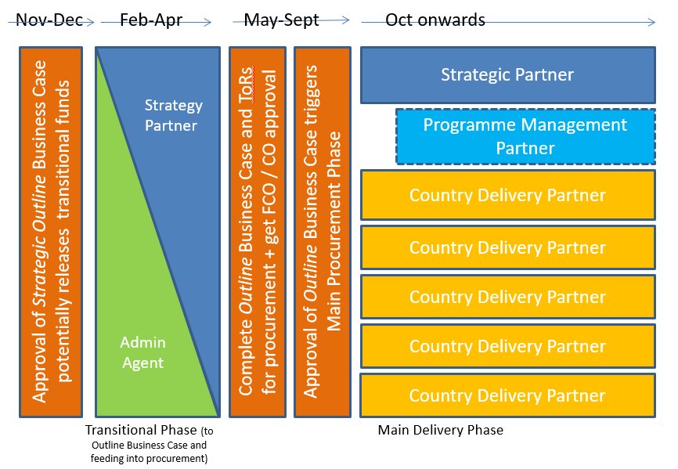
*Note: to minimise the risk of lost momentum between Strategic Partners, commissioning of Phase 1 will include a requirement to provide interim engagement until the Phase 2 Strategic Partner is agreed.
Expertise
- This is a complex procurement and the central programme team will seek advice proactively or as required from the following in pursuit of a defensible, legal and value for money approach is taken:

- Commercial – FCO CPG and PFMO
- Procurement – FCO CPG and PFMO
- Legal – FCO Legal
- Financial – FCO Finance and PFMO
- Communications – FCO Communications and PFMO
- Economic – FCO Economics Unit; FCO PF Department Economist
- Gender – PFMO and FCO PF Department Social Development Adviser
- Health – DFID, DH and DIT experts (pending a dedicated Programme Health Adviser)

- Further information on the roles and responsibilities of staff involved in the programme are available from the management case.

Risks
- An assessment of the key commercial risks, and associated mitigations, are set out in Appendix F.

Management Case

Introduction
- This section describes how the overall programme will be implemented and governed.

Programme Governance
- The programme will be led by the FCO and the Senior Responsible Owner (SRO) will be the FCO Director of Economic Diplomacy.
- The SRO will report via the PFDU and PFMO to the Portfolio Board and PF Ministerial Board in accordance with standard FCO and PF reporting arrangements. The cross-Whitehall Steering Committee that has guided the development of the concept note and business case will cease in its current form once this business case is approved, though many of its members will participate in the new the Strategic Programme Board and/or the Operational Programme Committee.
- The overall governance structure is set out in the diagram below.

- PFDU will also report to the PUS as the senior accounting officer.
- The key roles of the above governance levels are as follows.
Governance level | Roles
PF Ministerial Board | Ministerial approval of the programme
Minister for the PF | FCO approval of PF programmes
PF Portfolio Board | Cross-Whitehall approval of the programme
PUS | Lead FCO accounting officer
PFMO | PFMO approval of the programme and change control
PFDU | PFDU approval of the programme and change control
Programme SRO | Accountable for programme delivery; high level direction of programme and responsible for key decisions
Strategic Programme Board (SPB) | Drives programme forward strategically and supports SRO
Expert Panel | Provides independent expert advice to the SPB and SRO
Programme Lead | Heads the Operational Committee and is link to SPB. Day to day oversight of programme delivery
Operational Programme Committee | Responsible for programme delivery and operational decisions; reports to SPB
Country Steering Committees | Drives programme forward locally and takes local decisions; reports to Operational committee, but can elevate issues direct to SPB; help to spot synergies with wider HMG and PF work

- The SPB will include the following members:
  - SRO (chair)
  - Senior representatives from Posts
  - Senior representatives from DH, DFID, DIT and FCO
  - Senior representatives from delivery partners (to be invited as required to report)
  - Programme lead – day to day programme leadership and oversight
- The Expert Panel members will include the following members:
  - SRO (chair)
  - Health, gender and poverty expert advisers (both HMG and third sector)
  - Senior representative(s) from the strategic advisory partner(s)
  - Programme lead
- The Operational Programme Committee will include the following members:
  - The programme lead (chair)
  - Working level representatives from Posts
  - Core programme team
  - Programme management partner (advisory role)
- The Country Steering Committees will include the following members:
  - Senior representatives from Posts (e.g. Head of Prosperity) (chair)
  - Working level representatives from Posts, including post health advisers
  - Representatives from the partner government (advisory role)
  - Representatives from the delivery partners (advisory role)
  - Wider stakeholders as appropriate (advisory role)
- The SPB would meet quarterly, as would the Expert Panel. The Operational Steering Committee and Country Steering Committees would meet monthly. Meeting frequency will be kept under review. The chair reserves the right to call additional meetings.

Programme Staffing
- Programme interventions will be primarily delivered by the private sector, as will programme administration. HMG’s role in the programme will be predominately focused on:
  - Government to government engagement
  - Supplier management
  - Ensuring programme outputs lead to short term impact (for example, gender impact of training or improved access to services), as well as longer-term planned outcomes and impacts, both primary and secondary.
- HMG’s core programme resource will be led by a central programme team in London, supported by a South East regional team in Singapore that provides leadership in that region, and resource in individual posts. The broad split of roles is set out in the table below.

Function | Role of Central Programme Team / Singapore Team | Role of Posts
Leadership | Leadership of programme globally/regionally | Leadership in-country
Delivery oversight | In conjunction with global programme management partner: global co-ordination, quality assurance | Oversight of local delivery partners, quality assurance and interdependencies
Commercial/procurement | All contractual activity and supplier management | Highlight any local risks or issues
Communication | Global programme communications and UK communications | In-country communications and ensuring coherence of HMG branding
Stakeholder management | Management of UK stakeholders (including across Whitehall) | Management of in-country stakeholders and ensuring alignment with diplomatic engagement
Monitoring | Attending key events (UK) | Attending key activities and taking feedback from key stakeholders (Post)
Finance | Budgeting, forecasting and payments | Sign-off local delivery partner milestones, informed by monitoring (receipting)
Reporting | Reporting to the Strategic Board, PFDU, PFMO, Portfolio Board and Ministerial Board | Reporting to the central programme team, based on monitoring
Coherence | Ensure programme coherence across countries | Ensure programme coherence in-country and fit with other local programmes (incl. PF)
Risk management | Identify and manage global/regional risks | Identify and manage local risks
Governance | Own and manage the global governance framework | Own and manage the local governance framework
Programme Support | Protocol-related and other programme admin support in UK | Protocol-related and other admin support at Post
Staffing | Appoint and manage core programme team | Appoint and manage local programme team

- The team structure is set out below. Note that not all roles are full-time – see Appendix G for details.

Note that some advisory functions may be provided on a contracted basis. Linkages with the PF MREL (Monitoring, Reporting, Evaluation and Learning) contracts are to be determined.
- The central programme team will manage the programme in accordance with HMG best practice, following MSP and PRINCE2 principles. In addition to the roles and functions of the central programme team and programme functions at Posts set out above, the programme will need to draw on expertise in the fields of health and inclusive growth. Options for meeting the need will be set out at the Outline Business Case phase, but include appointing health advisers in Posts or regions, accessing health technical expertise in the UK, and gaining long term access to social development and gender expertise to ensure quality and value for money delivery.

Implementation Plan
- The key milestones to the end of phase 1 are set out below. A broad implementation plan for the duration of the programme will be developed at the end of this phase, once detail is known about the specific interventions. Where feasible, programme rollout will make use of piloted activity wherever possible so that lessons may be applied to similar activity within and in other countries of the programme.

January 2018
- Confirm Strategic Development Phase with Partner Governments and Sign MOU
- Procure Strategic Development Phase Administrative Partner (if applicable)
- FCO Scrutiny – IIOC approval of SOBC
February 2018
- Begin Strategic Development Phase, working with partner countries on intervention detail (to early May 2018)
May 2018
- Review outputs of Strategic Development Phase and integrate into Outline Business Case (OBC)
- Conclude OBC and submit to PFDU and IIOC
June 2018
- IPA/CO/HMT approval of OBC
- FCO Ministerial Approval
July 2018
- Procurement of the main delivery phase begins
- Strategic Advisory Facility established.
September 2018
- Bids evaluated
- IIOC and Management Board Approval
October 2018
- Programme Launch

Flexible Programming
- The programme will allow for flexible or dynamic programming where lessons learned or changes in economic, political and social context during implementation suggest interventions should be scaled up or down within a country, or resources earmarked for one country programme shifted towards a more productive programme in another country within the portfolio. Contracts with delivery partners will require annual reviews on the basis of which programme funds may be shifted if necessary. This process will be managed by the core programme management team as part of their ongoing monitoring role, but with decisions taken by the SPB under the SRO’s guidance. Decisions could, exceptionally, also be made by the SPB at other junctures within the programme, for example in response to immediate feedback about the feasibility or impact of any one programme intervention.

Monitoring, Reporting, Evaluation and Learning
- The monitoring, reporting, evaluation and learning (MREL) for this programme will be consistent with the PF approach to MREL. The core programme management team and Posts will work with the PF Monitoring and Reporting contractor to define the indicators – including poverty reduction and gender indicators – that will be developed for the programme to ensure consistency and quality of reporting across the whole PF portfolio.
- The central programme management team, Posts and implementation partners will work closely with the PF’s appointed partner for Evaluation and Learning to ensure an effective and iterative learning process that benefits the ongoing programme.
- If this programme is selected as one of the sample for PF level evaluation, the core programme team, Posts and delivery partners will work with the PF evaluation and learning contractor to develop the strategic questions that will be required for both the PF evaluation and to provide feedback to the programme on routes to impact. The overarching evaluation methodology will be decided by the PF level evaluators, and the core programme team and Posts will work to deliver the required coordination with delivery partners at programme level.
- If the programme is not selected for PF level evaluation, the core programme team and Posts will work with the PF level evaluation and learning contractor to develop a set of strategic questions to answer as part of the programme level MREL approach. These questions may include PF level questions if appropriate.

Results Framework

The programme’s indicators will be consistent with the programme’s theory of change and the log frame analysis that flows from this – see page 3 and Appendix A. Results will be disaggregated by sex and socio-economic group so that impact on gender and income inequality can be established. Expenditure will be reported monthly and impacts (results) quarterly in line with PF reporting rhythms.

As part of regular reporting requirements, partners will provide a proportionate and meaningful assessment of how the programme is contributing to reducing gender inequality and supporting women’s economic empowerment including a specific assessment on progress against gender related indicators and commitments.

Reporting Frequency and Costs
- Consistent with PF requirements, the core programme team will instruct delivery partners to develop a quarterly results reporting system and will work with the PF monitoring and reporting contractor to ensure consistency with PF processes and systems – particularly around data frequency, quality and consistency. Programme data capture and base lining will be the responsibility of the core programme team, Posts and delivery partners but, as instructed, the costs of this will be charged to the central MREL budget. This element of the programme is capped at 1% of programme allocation.

Annual Reviews
- An annual review process will be led by the central programme team with Posts, involving delivery partners as appropriate. The programme would include an annual review conference to bring together programme teams and suppliers to discuss advances and setbacks, lessons learned. Expert resource in the shape of health and gender and social development advisers will play a central role, ensuring programmes contribute to gender and income parity, as well as comply with the Gender Equality Act. Guidance will be sought from the PF MREL team to ensure alignment with PF level reviews. The results of the annual reviews will be reported to the SRO and the Strategic Programme Board.

Communications
- The programme lead will have overall responsibility for setting the programme’s communication strategy, advised by and working with the FCO Programme Support Team Communications Manager, FCO Media Office, PFMO, Posts and delivery partners; and ensuring consistency and coherence across the countries in the programme, especially where related work is being carried out. The programme lead will also be responsible for overseeing development and implementation of a communications plan for pan-programme communications.
- The key objectives of the communications strategy will be to:
  - Map stakeholders and ensure all are actively involved in the programme
  - Positively influence key stakeholder audiences, whether decisions of policy-makers or healthy behaviours in the wider population
  - Ensure UK organisations are aware of and responsive to opportunities arising from the programme
  - Create positive narratives and news stories that demonstrate programme successes
- The communication strategy will contain (and build upon) a specific plan for each component, working with Posts (including local media managers), partner governments and delivery partners.
- The programme’s main audiences are:
  - National/regional decision makers
  - Beneficiary populations in partner countries
  - UK business and investors
  - Partner country businesses and investors interested in partnerships with UK companies
  - Partner country media
  - HMG departments e.g. DFID and DIT
  - HMG Posts and the programme team (internal comms)
- The programme does not expect to directly target UK audiences beyond potential beneficiaries (i.e. UK companies). However, if there are significant successes resulting from programme activity, the programme will consult with both the appropriate departmental teams (e.g. the FCO Media Office) and the PFMO communications team on the potential for informing UK media. The programme will develop defensive press lines and FAQs in readiness for any parliamentary questions or negative UK media interest about the programme.
- Strategic activities will include:
  - Engagement with relevant national and regional officials in partner countries to raise the profile of programme activities and, where appropriate, advertise the potential of UK companies;
  - Monitoring for new and emerging opportunities (e.g. key contracts, reforms) and risks
  - Meetings and presentations with UK companies that could benefit from the programme (linked to DIT work)
  - Social and mainstream media opportunities (blogs, tweets, editorials) that highlight programme activities and successes to wide audiences
- The communications strategy will use the Government Communications Service (GCS) OASIS framework.
  - Objectives – what the communications is intending to achieve
  - Audience – who are you targeting and what attitudes or behaviors do you want to influence
  - Strategy – approach, messages, channels and partners
  - Implementation – delivery plan
  - Scoring – monitoring, evaluating and feedback loop
- All programme outputs will branded with the UK aid logo and recognise UK Government funding.

Risk Management
- The central programme management team owns the risk. The risk register (see Appendix F) has been developed in the following way:
  - Risk capture – initial process of risk identification
  - Risk assessment and evaluation – categorisation of risk and assessment of likelihood and impact
  - Risk treatment and response – development of options and preferred mitigation strategies and actions to avoid the risk, minimise its likelihood of occurring or reduce its impact
- All risks will be allocated to risk owners to ensure that the risk is continually assessed and mitigation strategies and actions are implemented.
- Risk tolerances will be agreed by the SPB and feed into the risk assessment.
- Risks will be reviewed at the SPB and the Operational Programme Committee. The discussions will be used to capture new risks and ensure ongoing risks are being appropriately managed. The annual review process will also include an assessment of programme risks.
- Risks will be escalated via the programme governance structure depending on severity. The central programme management team will develop and own a programme level risk tracker containing all high severity risks. All high severity risks will be reported to the SPB and SRO.

Financial Case

Introduction
- This section covers the estimated financial implications of the programme, flowing from the indicative interventions set out in the economic case, the proposed delivery model explained in the commercial case, and the staffing model described in the management case.
- The programme is seeking £85.5m (excluding VAT) of Prosperity Fund ODA funding over three years, divided between a Phase 1 Strategic Development Phase (with transition funding) and a Phase 2 Main Delivery Phase. This includes all implementing activities, such as administrative costs. A request for transition funding is set out at Appendix H.

Financial expenditure and cost drivers
- The projected cost profile is set out below:
 | 17/18 |  |  | 18/19 |  | 19/20 | 20/21 | Total
£m | 0.8 |  |  | 18.1 |  | 33.3 | 33.3 | 85.5

- The following table shows the breakdown of these costs by requirement, including administrative costs:

Cost item | Cost (£m)
Phase 1 Strategic Development Partner (transition funding) | £0.7m
Phase 1 Administrative and Programme Management Partner (transition funding) | £0.15m
Phase 1 (and pre-phase 1) staffing to July 2018 | £0.87m
Phase 2 Strategic Advisory Facility | £2.5m
Phase 2 Programme Management Partner | £1.7m
Phase 2 Programme Delivery Partners | £76.5m
Phase 2 HMG programme staff and advisers (London and Singapore hubs plus Posts) from August 2018 | £3.0m
TOTAL | £85.5m

- The breakdown of phase 2 intervention delivery by pillar is as follows:
Pillar | Cost (£m)
NCD Strategy | £14m
Provider Performance Improvement | £15m
Education and Training | £15m
Digital Health | £18m
Life Sciences | £17m
Programme Management Partner | £1.7m*
Staffing | £3.0m*
TOTAL | £84m
*Takes account of MREL activity (collection and analysis of MREL data by posts and PM partner) is costed separately at up to £750,000. This effect has been applied evenly across the two lines.

- The table below shows the breakdown of phase 2 intervention delivery by country:
Country | Cost (£m)
Brazil | £16m
Mexico | £19m
Peru | £6m
South Africa | £15m
South East Asia | £23m
Programme Management Partner | £1.7m*
Programme Staff and Advisers | £3.0m*
TOTAL | £84m
*As with preceding table

- Cost estimates will be revised after phase 1, when the indicative interventions upon which these costs are derived will become agreed interventions, as well as after competitive tender exercises for phase 2’s programme management and intervention delivery partners have been run.
- The costs of staffing to support front line delivery of the main programme (HMG staff costs) is estimated at £3.0m, which is equivalent to 3.5% of the programme’s overall cost. An additional £0.87m will cover back-charged HMG staff costs from, and including, July 2017 and costs through phase 1 until, and including, July 2018. This would bring staffing to 4.5% of the overall cost. HMG staff costs cover the following activities:
- Business case development
- Procurement
- Central programme leadership and management
- Regional/Post oversight and government-to-government engagement
- Payments will be in arrears and output/deliverable based. The schedule of payments will be agreed with delivery partners.

Financial Assumptions
- The key financial assumptions which underpin the programme are:
- All budgets are indicative and subject to further development during the strategic and full business cases. The budgets have been developed based on known information.
- There are no contingent liabilities. All HMG programme staff will either be permanent UK based civil servants (who can be subsequently redeployed) or locally engaged staff on fixed term contracts matching their role on the programme.
- All contracts will be in pounds sterling

Accountability
- The funds will be held by the FCO after being released from HMT. The FCO is the Department responsible for spend compliance. The funds will be approved by HMT and FCO in accordance with delegated authority transmitted from Cabinet Office/HMT through FCO PUS.

Impact on the balance sheet
- The proposed expenditure does not cover any assets or equipment and will therefore have no impact on the FCO’s balance sheet.

Overall affordability
- The proposed cost of the programme is £85.5m over the expected lifespan of the programme. Funding will be ‘programme’ spending (RDEL). The amount of £75m has been ring-fenced by the Prosperity Fund, subject to approval of this business case. At this stage the schedule of disbursements is not scheduled to go beyond the current spending round (expires March 2021). All funds are ODA eligible and there are no contingent liabilities associated with this funding.
- The cost of risk (any contingency or allowance for risk adjustment and optimism bias) shown separately.
- There will be no ongoing costs to be covered once this programme has finished as there are no plans to establish structures with future resource implications under programme design.

Monitoring and reporting
- Programme spend and forecasts will be monitored by the Programme team using FCO financial systems. Budgets will be entered onto the FCO's systems using Hyperion, the FCO's online forecasting tool, at the start of each financial year. The central programme team will use the FCO’s financial dashboard, Oracle Business Intelligence Enterprise Edition (OBIEE) and Hyperion systems to monitor and report spend to date and forecasts. The programme team will work closely with delivery partners to ensure accurate forecasting. Accurate forecasting will be managed by ensuring payments follow an agreed schedule defined by clear and time-bounded deliverables and fees. Payment schedules will be monitored monthly, reviewed bi-annually and can be adjusted if necessary.
- The programme team will formally report spend and forecasts to PFDU and the PFMO, in line with their financial requirements. An audit trail will be maintained to show all financial decisions taken.
- All delivery partners will submit an annual report containing audited accounts [tbc] for each of the financial years covered by the programme.
- The programme team will produce a programme level annual report, which will be approved by the programme’s SRO and contain a summary of historic financial information and forward forecasts.
- The cost of data collection and analysis for MREL purposes is estimated at £750,000 and accounted for separately to the costs of staff and the core functions of the Programme Management Partner.

Scaling
- The programme will adopt the principle of adaptive programming to ensure that the programme’s impact and value for money are optimised. The central programme team will recommend any changes to the programme’s portfolio, including scaling up or down, to the Strategic Programme Board and for subsequent approval by the SRO. Any such changes to the portfolio may have financial implications and these will be thoroughly assessed before any decisions are made, with updates to financial forecasts made after any decisions have been taken. Ideas for scaling up activity will be considered at the transitional phase.

Financial and Fraud risk assessment
- Several of the countries that this programme will operate in have environments that present a fiduciary and fraud risk. These risks will be mitigated through:
- No funds will be transferred to any partner governments, all payments will be made to appointed delivery partners
- Funds will be disbursed directly by HMG to a limited number of delivery partners
- The majority of funds will be dispersed to pre-vetted delivery partners on the PF Framework. Due diligence will be carried out on all delivery partners not commissioned via the PF Framework before any payments are made
- Standard FCO procedures will be followed to verify payments before funds are disbursed
- Delivery partners will be obliged to following similar suitably robust procedures to ensure probity of their supply chain [endnote]
- All payments will be for services received with appropriate milestone type payment points. Funds will be disbursed in arrears
- Each invoice will be supported by a breakdown of the costs being claimed against each budget line in the contract

- As a result of the above, the financial risk and fraud is assessed as low throughout the programme. The financial and fraud risks will be kept under review by the programme via its governance arrangements.

Financial risks
- The key financial risks, together with their associated mitigations, are set out in Appendix F.

APPENDIX A – LOG FRAME
Log Frame | Programme Description | Indicators | Source | Assumptions
Impact | Primary: Reduction in avoidable disability and mortality (overall and premature) due to NCDs; increased access to healthcare, reduced gender and income inequality; improved patient safety/quality of care; new vaccines, treatments; higher rate of GDP growth due to larger, healthier, and more productive female and male workforce; stronger health systems and human capital due to knowledge transfers  Secondary: Increased UK exports in education, digital health, health systems strengthening, pharmaceuticals and medical products; improved local capacity, standards and transparency, ease of business | +Age-standardised mortality rates  +Life expectancy, lower Disability Adjusted Life Years (DALYs)  +National productivity data (e.g. GDP)  +UK exports in absolute and annual growth rates  +UK share of market  +Progress against SDG targets  +% of females under poverty line  +Gender equality Gap (WEF) | +Life expectancy and mortality data (WHO, IHME, national routine reporting)  +Economic data (World Bank, IMF, national reporting)  +Trade statistics (e.g. Comtrade)  +Business/market research
Outcomes | +More women and men with NCDs (and other common conditions) will receive prevention support, timely diagnosis, and ongoing management for their conditions, in the most appropriate digitally-enabled setting, leading to reductions in disability and avoidable mortality  +Improved access to and affordability of services for poor women and men and other marginalised groups  +Female and male healthcare workers have greater skills and tools to reduce avoidable patient safety incidents  +New diagnostics, vaccines and treatments reach patients  +Together, these lead to a healthier female and male workforce with longer life expectancy and reduced caring burden, especially for women, that is more productive | +Prevalence of risk factors (e.g. tobacco use, BMI/obesity, dietary metrics, exercise, poverty, gender)  +Prevalence of NCDs (e.g. hypertension, diabetes, CVD)  +Rates of patient safety incidents  +Successful trials of vaccines, treatment  +Patient satisfaction for men and women  +Access disaggregated by gender, age, income group | +Epidemiological reporting and surveillance (set up with programme)  +Patient safety surveillance (set up with programme)  +National health surveys/routine data  +Beneficiary impact assessment and feedback | +Trained health workers provide cost-effective guidance, diagnosis and care  +Education for quality improvement is effective in changing practices  +A proportion of Life Sciences projects are successful
Outputs | NCD programme: More health workers are trained in non-communicable disease prevention, diagnosis and management  Digital health: More care is delivered using affordable, accessible digital technology and health information is better integrated and used to inform practice  Education and training: More health analysts, health system leaders, and primary and community care workers receive training  Provider performance improvement: More providers (hospitals/clinics) engage in systematic performance improvement, incorporating patient feedback schemes  Life sciences R&D partnerships: More projects progress to clinical development | +Strategies, policies and plans which support inclusive growth, enhancing women’s health, productivity and helping gender equality and poverty reduction  # people trained by role and training type (disaggregated by sex, socio-economic group, age)  # people with access to affordable digitally-enabled health services (sex, age, income disaggregated)  # providers (hospitals/clinics) participating in system-wider performance monitoring  # of life sciences R&D bids | +Formal reporting – to programme’s management office | +Health system environment able to support and integrate digital providers and data integration  +Training is appropriately targeted and tailored  +Sufficient quality and volume of life sciences R&D bids

Appendix B – Country Analysis

Brazil
Brazil is one of the ten largest economies globally, and by far the largest economy in South America. It has strong trading links with the UK: it is the UK’s largest trading partner in the region and UK exports have grown 20% over last 4 years. Further, it is a major hub in Latin America for the Life Sciences area of the healthcare sector. Brazil has a well-established basic health system. A paradigm innovation in the system has been the rapid scaling up of a community-based approach to providing primary health care. The Family Health Strategy (FHS) has evolved into a robust approach to providing primary care for defined populations by deploying interdisciplinary health care teams. Total health spending in Brazil is similar to the Organization for Economic Cooperation and Development (OECD) average at 8.3% of gross domestic product (GDP), however, less than half this amount comes from public sources — a proportion that places Brazil far below the OECD average for government share of health expenditures. Brazil needs much more evaluation of public spending, competitive procurement, quality control and focus on value for money. Progress is still needed to ensure consistently high standards of care including adverse drug events, nosocomial infections and sub-optimal levels of patient safety in hospitals. Procurement of healthcare equipment is costly, lengthy and results in substantial waste. Obsolete technology fills storerooms. Local health priorities include:
- Better regulation of healthcare services – to improve quality and safety overall and to reduce unjustified variation in these areas
- Better regulation of public procurement including reform of health regulator ‘Anvisa’
- A fully integrated health service IT system supporting a fully integrated health system, enabling access to clinical data, managing clinical performance, and tracking use of treatments and drugs. Stakeholder interviews suggest that this may be an ambitious target, though possible within the bounds of the programme.
- Introduction of telehealth services to improve access in rural areas, specialist diagnosis and clinical advice and training for staff. There is regulation that limits opportunity for a tele-health programme, but scope for the UK to support Brazil in passing a newly proposed legislation opening the market for such services.
- Strengthening primary care to ensure equitable geographic access, improve prevention and early detection and reduce hospital admissions.

Stimulating growth in life sciences and R&D-intensive industries are also a priority for Brazil.

Mexico
Mexico is the 15th largest global economy (11th by PPP), and is predicted to reach 6th by 2050. In 2016 the trade balance between the UK and Mexico was £3.8bn, a 6% increase from 2015. Mexico’s health spending in 2016 was 5.8% of GDP (a higher proportion than China) and demographic trends alone mean that this is likely to rise in the coming years. Around 52% of healthcare costs are financed publicly and 48% are sourced privately – comparable with other major Latin American economies such as Argentina, Brazil and Chile, but well below the OECD average. In the last 15 years, Mexico has made strong progress towards universal health coverage through the introduction of Seguro Popular, an insurance system designed to guarantee healthcare coverage to the roughly 50% of the Mexican population which did not have access to care through their public or private sector employer. However, a significant proportion of the population is still paying out-of-pocket for healthcare, due partly to lack of awareness/education and partly to the low/patchy quality of the care on offer. According to the OECD, out-of-pocket spending remains at approximately 50% of total health spending, indicating that Mexicans continue to feel the need to visit private clinics despite having access to public care through their insurance. The quality of care varies very significantly between urban and rural settings and between poor and middle-income or higher-income communities – and within these variations there is significant gender disparity, for example in terms of rural women’s access to healthcare.
One of Mexico’s major challenges is the fragmentation of the health system, which features numerous sub-systems with different budgets, indicators and outcomes, and insufficient integration between primary and secondary care. The system is also poorly administered (despite an investment of 8.9% (2016) of total health spending in administration) and susceptible to corruption in public procurement. If these constraints were addressed, in particular in public institutions such as the Mexican Social Security Institute (the largest spending institution in any sector in the whole of Latin America), the potential positive impact on the wider economy would be substantial given the scale of financial flows involved, with a budget of US$ 36.4 bn in 2014 (coverage of 57.9 mn people). A study looking at low and middle income countries (including Mexico), estimated the average impact of an additional year of life expectancy at a 9% increase in FDI.
Obesity-related chronic disease is Mexico’s most immediate and urgent public health challenge. The country has the highest rate of obesity in the world among those older than 15 – a third of Mexican adults are overweight – and according to some studies, the highest rate of child obesity too. Diabetes-related illness is the highest cause of death in Mexico, with around 80,000 people dying every year; approximately 17 million sufferers (nearly 15% of the population) and the recorded number of new cases increased from 307,000 in 2016 to 335,000 in 2017. Ischaemic heart disease is another major cause of death in Mexico.
The lack of an adequate public health system and insufficient focus on primary care are major factors in allowing the spread of diabetes and other preventable chronic conditions, creating an unsustainable burden on national and state health budgets which better public policy could reduce. Social programmes such as Prospera, which gives grants to poor families on condition that they register at their local health centre and school, is one way in which the federal government is trying to address this. Mexico also needs more general practitioners – partly a matter of workforce planning and partly one of culture change (combating the perception that specialisation is necessary for career success). Stronger clinical leadership is much needed in many primary and secondary settings across the country
Many major pharmaceutical companies, including British companies, are present in Mexico; however, regulation, patenting and procurement processes are cumbersome and present a barrier to progress, as well as to research and development opportunities. Mexico’s overarching regulatory agency, COFEPRIS, is working to address this, and is already liaising with UK institutions to that end.
At the macro level, the health sector in Mexico is ripe for reform, and it’s anticipated that the issue may grow in political importance during the forthcoming election period and subsequent new administration.

South Africa
South Africa’s economy is expected to have the highest GDP in Africa this year, and is considered the most advanced and diverse on the continent. It is an engine of growth in Africa, with a GDP that is 12.5% of Africa’s as a whole, and 52% of the Southern African Development Community (SADC) region. The UK’s interests are deep, with UK individuals and firms holding more than five times the FDI than US, China, India, France and Germany combined. It is by far the UK’s largest trading partner in Africa, with exports to SA (£4.2 billion of goods in 2014), greater than to Brazil and higher than Nigeria and Egypt combined.
South Africa’s health spending in 2014 was 8.8% of GDP. However, disparities in healthcare remains a major issue, with swathes of the population being uninsured. Annual per capita expenditure on health ranges from $1,400 in the private sector to approximately $140 in the public sector. There are health workforce capacity issues, with the national public health sector, staffed by approximately 30% of the doctors in the country, being the sole provider of health care for more than 40 million people who are uninsured and who constitute approximately 84% of the national population. DFID retain a presence, albeit a transitional one that reflects South Africa’s move away from aid dependency.
The country is undertaking a comprehensive transformation of its health system with the ultimate purpose of achieving universal health coverage. Its plans include: developing public health and primary care capacity; investigating measures to implement a national based insurance health scheme; improving the training and development of healthcare workers and hospital governance capabilities; addressing the issue of AMR nationally, regionally and internationally; implementation of electronic patient records and moving away from paper-based systems; and implementing measures to improve maternal and new-born care. The life sciences sector is also a priority for the South African government, which sees the research and development of pharmaceuticals and vaccines as both a means of alleviating its disease burden and a means to create high value-added employment opportunities and economic growth.
The UK and South Africa have a positive dialogue on health, underpinned by an MOU between the respective health ministries.

Peru

Peru is one of Latin America’s fastest growing economies, growing at 5.9% over the last decade (World Bank 2016). It’s expected to grow faster than its peers in the next two years (IMF 2016). UK export trend analysis (ONS 2016) shows UK exports to Peru have been steadily increasing over the last decade. DIT (for whom Peru is a priority market) suggest this growth will increase rapidly in the next 5 years. The current UK market share is under 1% with room to grow. Health ranks as a current national priority and the government has a planned $1.74 billion investment. It’s priorities for the sector improvement include:

Education and Training/Clinical Guidelines. There is a general need to improve both capacity and quality of the healthcare system in Peru. According to the WHO there has been an increase in demand for health services as a result of the implementation of universal healthcare policies (legislation passed in 2009). Despite remarkable advances in coverage (now around 80%, up from 63.5% in 2010), obstacles remain: access to and trust in the healthcare system remain low and service quality is poor. Major problems are long waiting lines, delayed appointments and complaints on the quality of treatment and incomplete drug delivery. This discourages the potential affiliates, generates public distrust, and undermines the effectiveness of the system and its financial sustainability. In 2014 the Ministry of Health here estimated that they had a deficit of 16,000 doctors. Prosperity Fund activity provide training to improve the quality of primary care provision, as well as monitoring and evaluate local health services.

Digital Health

There is a regional imbalance in the provision of healthcare services in Peru, with rural, hard to reach areas disadvantaged. Telemedicine and remote access would allow far more effective provision of healthcare in remote areas. The UK has previously provided technical assistance focused on connectivity in rural areas. In Lima there is a need for effective electronic management systems, be that for the management of services (building on UK training for blood banks on the use of IT systems) or electronic patient record systems. Private and public healthcare providers are keen to procure e-record systems as soon as possible.

Non-Communicable Diseases

Peru has seen a rise in lifestyle-related diseases, including heart disease, diabetes and cancer. The World Bank says, ‘NCDs (CVD, cancer, and diabetes) are becoming the most important causes of morbidity and mortality as a consequence of the accelerated increase of risk factors in the population (obesity, sedentary life, tobacco, alcoholism, accidents and violence), and the health delivery system is not ready to address those challenges’. Related interventions and clinical guidelines would be valuable, as would work to strengthen government efforts to raise public awareness and generate lifestyle changes.

Infrastructure for Health

Infrastructure for health is also a top priority and Peru is planning to build three entirely new hospitals under a PPP model, as well as expanding capacity in existing facilities. There are currently only 15.3 beds per 10,000 people with an estimated shortage of 5,000 beds. Peru could benefit from UK support in designing and helping run the PPP process, to ensure it delivers against their needs. DIT is currently chasing an accessible value of £19million in this area, which is around 10% of the total value. Prosperity interventions could help increase that percentage significantly.

General

A health programme would build on the Embassy’s recent health projects focussing on TB, heart disease, connectivity in rural areas and blood systems. These have generated significant interest from both the government and congress, both of whom would like to use UK expertise more. The Embassy assesses the UK would be Peru’s preferred partner, both given positive attitudes to the UK (Minister of Health included) and given other major bilateral donors are focused on other sectors. Among the firms showing interest in the market are Carillion, BUPA and Great Ormond Street Hospital. By shining a light on UK expertise, the Prosperity Fund would help create market opening opportunities for them.

South East Asia

General Context

Over the last few years an increasing focus on health investment and health outcomes from international organisations and donors has been pushing it up the international agenda, which in turn is attracting private sector interest.

In 2015 the Asian Development Bank (ADB) released a 5-year strategy (2015-2020) called “Health in Asia and the Pacific: a focused approach to address the health needs of ADB Developing Member Countries (DMCs)”. This focused among other things on helping Asian countries to arrive at Universal Health Coverage (UHC), to implement good governance and to expand health care through innovative financing.

The World Bank Group is also committed to helping governments achieve UHC (by 2030) and provides financing, analysis, and policy advice to Asian countries to achieve this goal. The World Health Organization and AusAid also have similar goals.

In both absolute and per capita terms, healthcare spending has been growing substantially across Southeast Asia in recent years. World Health Organization data from 2009-2012 and 2014 shows that increased per capita healthcare spending has been increasing year on year.

Per Capita Healthcare Spending in Southeast Asia:
(2009-2012 and 2014 in $USD)

Country | 2009 | 2010 | 2011 | 2012 | 2009-12 % growth | 2014
Malaysia | 285.2 | 345.1 | 384.2 | 409.5 | 43.6 | 455.8
Myanmar | 13.2 | 15.2 | 19.0 | 19.8 | 50.5 | 20.3
Philippines | 78.1 | 90.3 | 104.7 | 118.8 | 52.1 | 135.2
Thailand | 163.6 | 182.9 | 213.9 | 215.1 | 31.5 | 227.5
Vietnam | 71.8 | 82.8 | 93.5 | 102.5 | 42.7 | 142.4

To put SEA investment into context: in 2016 Brazil spend sat at $1,085, the UK at $3,598 and Germany at $5,006. So there is still tremendous long-term growth potential in this region.

South East Asia is also going through relatively rapid development and urbanisation which will have significant consequences for public health and healthcare service provision. By 2020, the number of people living in urban areas will increase by nearly a third. McKinsey estimate urbanisation will add $520-$930 billion to ASEAN’s GDP by 2030. This represents substantial scope for benefits from well-planned urbanisation, including greater access to public services such as healthcare. With economic development has come an increasing incidence of “Western diseases” (diabetes, cancer, cardio-vascular) that pose major challenges to healthcare systems across S.E. Asia and could undermine growth potential if not handled effectively.

Turning specifically to NCDs: according to the WHO, NCD mortality in SEA countries exceeds that of communicable, maternal, perinatal and nutritional conditions combined. This is the case for our proposed 5 countries:

Estimated % of annual deaths in programme countries accounted for by NCDs:

Country | Percentage
Malaysia | 73% (146,000 deaths)
Myanmar | 87% (441,000)
Philippines | 67% (571,000)
Thailand | 71% (501,000)
Vietnam | 73% (520,000)

While all five countries have Health Strategies - which will include measures to tackle NCDs - they lack (to varying degrees) the infrastructure and / or governance structures to deliver their vision. Often it is not clear how new money will be spent, who decides, what is prioritised, and how much long-term thinking has been done to provide answers. While there is a risk of bureaucratic reactiveness (and in some cases corruption) there are also massive opportunities for international (including UK) expertise and know-how to help shape strategic healthcare solutions for these countries.

Country by country analysis follows, though will be updated following the completion of supplementary scoping work in January 2018. Some detail is provided on opportunities in Vietnam.

Malaysia

Key Statistics

Total Population: 30,331,000
Life expectancy at birth m/f: 73/77
Total expenditure on health per capita (Intl $, 2014): $ 455.8
Total expenditure on health as % of GDP (2014): 4.2%
Estimated total % deaths caused by NCDs: 73%
Projected GDP world ranking 2017: 36 (of 189)
Projected GDP world ranking 2022: 31
Ease of Doing Business (best 1, worst 189): 23

The Impact of NCDs
A WHO statistical profile shows that in 2012, the probability of death from 4 major NCDs for people in Malaysia between ages 30 and 70 stood at 20% (both sexes). The same stat for the UK and the Netherlands is 12%.
The WHO break out the percentage of male and females affected by core NCD-related risk factors:
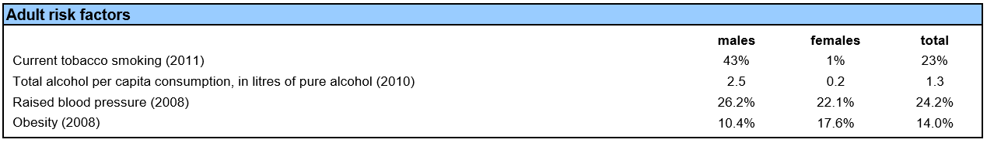
The risk to males from smoking is an obvious stand-out statistic.
Malaysia’s Healthcare Strategy (snapshot)

The WHO also records some of the strategic level responses to NCDs that Malaysia has / has not put in place:
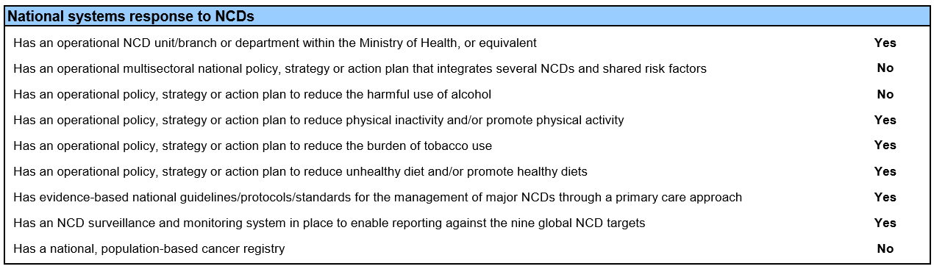

The proportion of GDP Malaysia spend on healthcare is expected to rise slightly by 2018, to 4.5 percent, as spending growth outpaces economic expansion. In dollar terms, the nation’s health care spending is projected to rise to $22.9 billion by 2018.

Malaysia’s public health system is financed mainly through general revenue and taxation collected by the federal government, while the private sector is funded principally through out-of-pocket payments from patients and some private health insurance. The majority of health spend comes from public spending, (reaching 56% of total health expenditure in 2009).

UK-Malaysia trade
Overall UK-Malaysia bilateral trade totaled £4.4 billion in 2015; Malaysia is our second largest export market in ASEAN. It is a competitive economy, projected to get stronger, and trading there is considered to be relatively straight-forward.

Myanmar (Burma)

Key Statistics

Total Population: 53,897,000
Life expectancy at birth m/f: 65/68
Total expenditure on health per capita (Intl $, 2014): $ 20.3
Total expenditure on health as % of GDP (2014): 2.3%
Private expenditure on health as a percentage of total expenditure on health (2014): 87%
Estimated total % deaths caused by NCDs: 59%

Projected GDP world ranking 2017: 71 (of 189)
Projected GDP world ranking 2022: 65
Ease of Doing Business (best 1, worst 189): 170

The Impact of NCDs
A WHO statistical profile shows that in 2012, the probability of death from 4 major NCDs for people in Myanmar between ages 30 and 70 stood at 24% (both sexes) which is double the number in the UK. (The same stat for the Malaysia was 20%). That statistic is unlikely to have improved in the interim.
The WHO break out the percentage of male and females affected by core NCD-related risk factors:
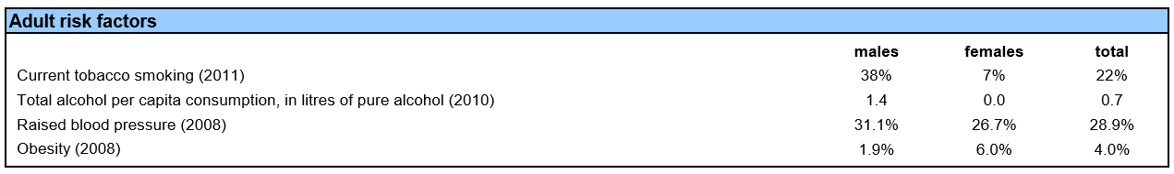
Male smoking and male and female blood pressure stand out as problem issues.

Myanmar’s Healthcare Strategy (snapshot)
Historically Myanmar has spent less than 2% of its budget on healthcare and healthcare outcomes have been poor. Spending has increased by 800% since the reform process began in 2010 when healthcare became a government priority. However Myanmar’s healthcare spending per capita remains the lowest in the region. It’s anticipated that government spending on healthcare will continue to increase and that the demand for medical devices will continue to increase. Burmese consumers are hungry for wider variety and better quality when it comes to healthcare.

The WHO also records some of the strategic level responses to NCDs that Myanmar has / has not put in place:
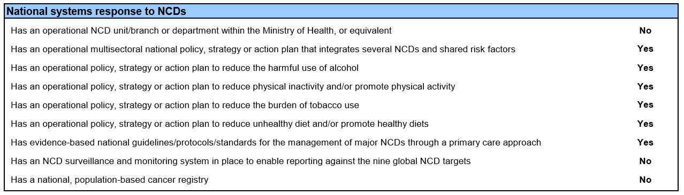

UK-Myanmar trade

Trade between the UK and Myanmar has been extremely limited over recent years due to sanctions. Following the lifting of sanctions, trade is now on the increase. UK goods exports to Myanmar increased from £13 million to £44 million between 2012 and 2013, a 239% increase.
The Department for International Trade have identified the following health opportunities for UK companies:
- pharmaceuticals (distribution and manufacturing)
- medical devices
- medical architecture, infrastructure and equipment
- training and international standards
DIT (or UKTI as it was) warn of the challenges to doing business posed by bureaucracy and corruption.

Philippines

Key Statistics and General

Total Population: 100,699,000
Life expectancy at birth m/f: 65/72
Total expenditure on health per capita (Intl $, 2014): $ 135.2
Total expenditure on health as % of GDP (2014): 4.7%
Private expenditure on health as a percentage of total expenditure on health (2014): 65.72
Estimated total % deaths caused by NCDs: 67%

Projected GDP world ranking 2017: 34 (of 189)
Projected GDP world ranking 2022: 26
Ease of Doing Business (best 1, worst 189): 99

The Impact of NCDs
A WHO statistical profile shows that in 2012, the probability of death from 4 major NCDs for people in the Philippines between ages 30 and 70 stood at 28% (both sexes) more than double the number in the UK. That statistic is unlikely to have improved in the interim.
The WHO break out the percentage of male and females affected by core NCD-related risk factors:
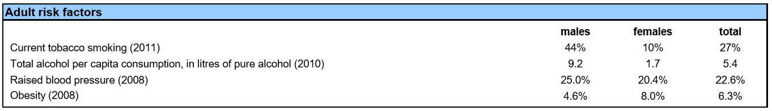
Male smoking stands out as one immediately identifiable problem area.

The Philippine’s Healthcare Strategy (snapshot)

The healthcare system in Philippines is a mixed public-private system. The private sector is much larger than the public sector in terms of human, financial and technological resources and caters to 30% of the population. It is structured according to the North American model, organised around independent free-standing hospitals, individual medical offices and private clinics, dependent on fee-for-service payments.

The Philippines has made significant investments and advances in health in recent years. Rapid economic growth and strong country capacity have contributed to Filipinos living longer and healthier. However, not all the benefits of this growth have reached the most vulnerable groups, and the health system remains fragmented. Health insurance now covers 92% of the population. Maternal and child health services have improved; there are several initiatives to reduce illness and death due to (NCDs).
However, deep inequities persist between regions, rich and the poor, and different population groups. Many people lack sufficient knowledge to make informed decisions about their own health. Rapid economic development, urbanization, escalating climate change, and widening exposure to diseases and pathogens in an increasingly global world increase the risks associated with disasters, environmental threats, and emerging and re-emerging infections.
The Department of Health has a Philippine Health Agenda 2016–2022. The aspiration is universal health coverage which is underpinned by three health guarantees: 1) ensuring financial protection for the poorest people; 2) improving health outcomes with no disparities; and 3) building health service delivery networks for more responsiveness.
The WHO also records some of the strategic level responses to NCDs that the Philippines has / has not put in place:

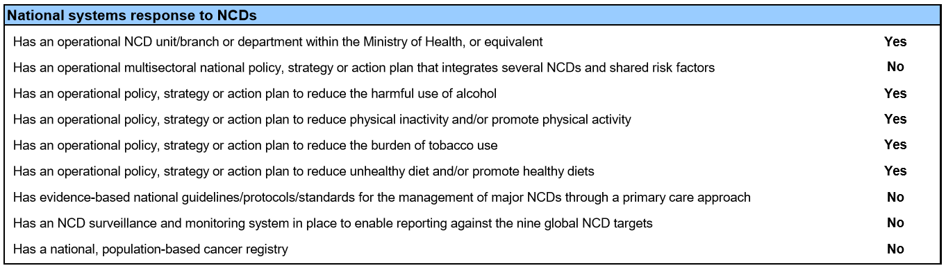

UK-Philippines trade
UK exports of goods and services to the Philippines in 2013 were £510 million and valued at USD 601.2 in 2014. Latest available information shows that UK export of goods were up by 44% for the first half of 2015. Pharmaceutical products and optical, photo, technical, medical, etc apparatus feature in the top 10 UK exports to the Philippines. The Philippine government has identified PPP projects in healthcare as a priority. There are a range of opportunities in the life sciences sector, including provision of:
- medical equipment and supplies
- health and wellness facilities
- e-health solutions, particularly to private hospitals
DIT warn of the challenges to doing business posed by bureaucracy, corruption, restrictions on foreign ownership of companies.

Thailand

Key Statistics

Total Population: 67,959,000
Life expectancy at birth m/f: 72/78
Total expenditure on health per capita (Intl $, 2014): $ 227.5
Total expenditure on health as % of GDP (2014): 4.1%
Estimated total % deaths caused by NCDs: 71%

Projected GDP world ranking 2017: 26 (of 189)
Projected GDP world ranking 2022: 29 (Decrease)
Ease of Doing Business (best 1, worst 189): 46

The Impact of NCDs
A WHO statistical profile shows that in 2012, the probability of death from 4 major NCDs for people in Thailand between ages 30 and 70 stood at 16% (both sexes) This is closer to EU levels than the other SEAs, but there is still room for improvement.
The WHO break out the percentage of male and females affected by core NCD-related risk factors:

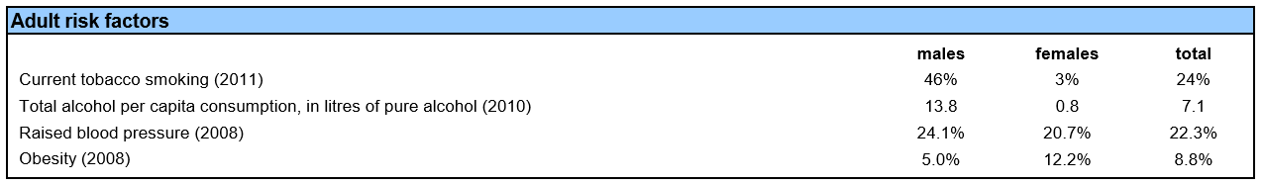

Thailand’s Healthcare Strategy (snapshot)

Most services in Thailand are delivered by the public sector, which includes 1,002 hospitals and 9,765 health stations. UHC is provided through three programs: the civil service welfare system for civil servants and their families, Social Security for private employees, and the universal coverage scheme that is theoretically available to all other Thai nationals. Some private hospitals are participants in the programs, but most are financed by patient self-payment and private insurance. According to the World Bank, under Thailand’s health schemes, 99.5 percent of the population have health protection coverage.
The WHO also records some of the strategic level responses to NCDs that Thailand has / has not put in place:

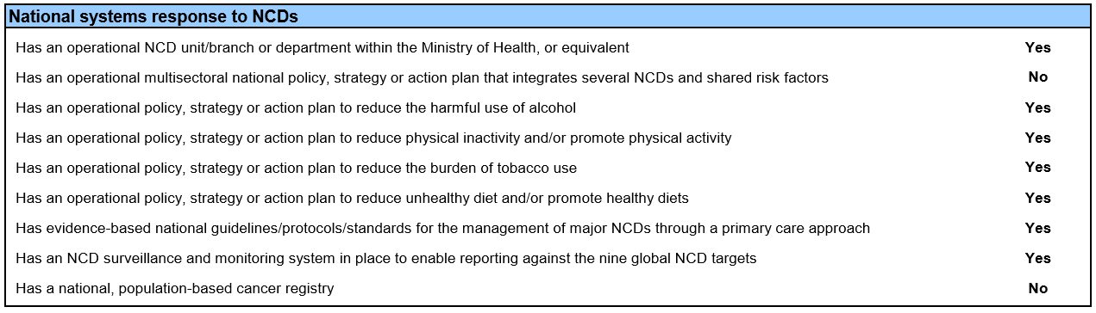

UK-Thailand trade

Thailand is the second largest economy in the Association of Southeast Asian Nations (ASEAN), accounting for 17% of ASEAN Gross Domestic Product (GDP). It is ranked in the top 20% of countries listed in the World Bank’s “Ease of Doing Business Survey”. Challenges include mid-ranking corruption and poor IPR enforcement.
UK goods exports to Thailand were valued at £1.96 billion in 2013 making Thailand the UK’s 29th largest export market. Services exports totalled £708 million in 2013. Amongst the top 10 UK export sectors to Thailand was the medicinal and pharmaceutical sector.
DTI state that Thailand is a leading medical tourism hub. It’s healthcare and pharmaceutical sector continues to grow offering opportunities for new products and services.
Thailand imports 70% of medical devices from overseas.
There are opportunities for UK companies in:
- medical equipment and devices
- specialist treatment/technology
- hospital standard certification
- diagnostic equipment
- e-health
- elderly care equipment/technology and carer training

Vietnam

Key Statistics

Total Population: 93,448,000
Life expectancy at birth m/f: 71/81
Total expenditure on health per capita (Intl $, 2014): $ 142.4
Total expenditure on health as % of GDP (2014): 7.1%
Estimated total % deaths caused by NCDs: 73%

Projected GDP world ranking 2017: 47 (of 189)
Projected GDP world ranking 2022: 45
Ease of Doing Business (best 1, worst 189): 82

The Impact of NCDs
A WHO statistical profile shows that in 2012, the probability of death from 4 major NCDs for people in Vietnam between ages 30 and 70 stood at 17% (both sexes). This is closer to EU levels than the other SEAs, but there is still room for improvement.
The WHO break out the percentage of male and females affected by core NCD-related risk factors:
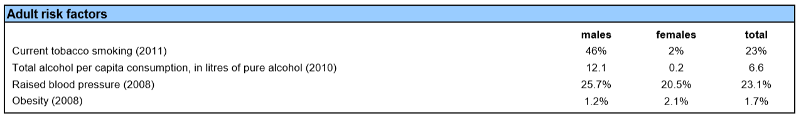

Vietnam’s Healthcare Strategy (snapshot)
Vietnam’s health care system is a mixed public-private system. However, the healthcare system has been slow to develop. Around 30,000 Vietnamese people travel abroad annually to seek treatment in foreign hospitals.
The government has offered incentives to healthcare investors including:
- lower corporate income tax rate
- 4 year tax exemption
- land rent reduction/exemption for at least 7 years
Most hospital medical equipment is imported as most domestic health equipment in Vietnam has yet to meet national and international quality standards. Local production accounts for only 5% of the market. Therefore, there is potential for UK medical equipment companies to export to Vietnam.
The WHO also records some of the strategic level responses to NCDs that Vietnam has / has not put in place:

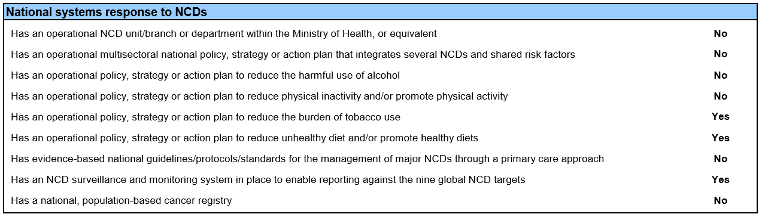

UK-Vietnamese trade

UK exports to Vietnam were £300 million in 2014, an increase of 12% on 2013. Vietnamese pharmaceutical production and supply capacity is weak. It spends more than USD 1 billion every year on imported drugs. UK medicinal and pharmaceutical products accounted for 11% of total imports in 2013 with a value of £33 million, an increase of 21% year on year. Medicinal and pharmaceutical products feature among the UK’s top 10 exports to Vietnam.

Opportunities for the PF
Recent scoping work carried out by Healthcare UK identified on opportunities for UK business in supporting Vietnam’s health sector (not including pharmaceuticals and medical devices) and assessed Vietnamese priorities as
- treatment of non-communicable diseases, mainly due to insufficient funding for a fast-growing problem;
- expanding the number of well-qualified doctors and nurses. Quality of training in Vietnam is low in relation to international standards and many go overseas for training (though costs and competition means the UK is not the destination of choice);
- hospital beds and overcrowding in city hospitals. This is linked to both lack of hospitals, standards and reputations of city versus provincial, and a need to improve primary care;
- operational efficiency improvements. Management of hospitals is generally poor but performance management is underdeveloped;
- achieving universal healthcare coverage, which is being modelled on Korea’s system

The PF could make a difference in several areas:
- by institutionalising better levels of domestic training and raising the qualifications and performance levels of existing personnel;
- supporting quality improvement at hospital level through the development of KPIs (there are currently no publicly available indicators of operational efficiency and measures of clinical quality could benefit from review);
- piloting of quality monitoring systems could drive hospitals to make investments in the nascent digital health sector (particularly Laboratory Information Systems, PACS and telemedicine) and in strengthening health systems. It could also trigger demand for education and training e.g. in areas of leadership;
- development of electronic patient records, currently being piloted in 40 hospitals (to 2020).

Appendix C – Participants at Better Health Market Engagement Event, 25 July 2017

Organisation | Name
AstraZeneca | Alec Van Gelder
Attain Health Management Services Ltd | Martin Wilson
Birmingham University | KK Cheng
BMJ | Mitali Wroczynski
British Expertise | Phil Dowrick
Central and North West London NHS Trust | Pramod Prabhakaran
Cepa Ltd | Kaveri Kumar
CGT Catapult | Hidetoshi Hoshiya
Crown Agents | Viv Davies
DAI Europe | Taylor Foshee
Dalberg Global Development Advisors Ltd | Santanu Bhattacharya
Dalberg Global Development Advisors Ltd | Ian Thornton
Guy's and St Thomas' NHS Foundation Trust | George Wharton
Health Education England | Thomas Hughes
Health Education England | Ged Byrne
Imperial College Health Partners | Reetan Patel
KPMG | Matthew Glanville
London School of Economics | Zlato Nikoloski
McKinsey & Company | Samantha Streicher
Montrose | Sam Thomson
Mott MacDonald | Dr Ken Grant
Mott MacDonald | Simon Harris
NHS Improvement | Murray Cochrane
NICE | Moira Godbert-Laird
Ove Arup and Partners International Ltd | Ripin Kalra
PA Consulting Service Ltd | Glenn McCauley
Palladium International Ltd | Shalini Raste
Primary Care International | David Mant
Primary Care International | Jonathan Winter
Public Health England | Neil Squires
PriceWaterhouseCoopers LLP | Sheetal Vyas
Ridgewhite Consultancy Ltd | Hanif Wazir
Royal College of General Practitioners | Thomas Owen
Royal College of Surgeons | Duncan Jackman
The Open University | Tom Bartram
THET | Louise McGrath

Appendix D – Economic Case Methodology

Summary
The Economic Case should demonstrate the programme’s Value for Money. This appendix provides additional detail on the methodology used to estimate the Better Health programme’s benefits in relation to its costs.
The primary benefits of the programme are measured as the projected impact on programme countries’ GDP over the appraisal period (2018-2027) as a result of improving life expectancy by reducing non-communicable and improving quality of care. The secondary benefits are measured as the estimated uplift in UK exports over the appraisal period, both in the healthcare industry and generally.
Two programme options have been considered. Option 1 targets Brazil, Mexico, South Africa and South-East Asia and Option 2 additionally targets Peru at higher cost. The benefit-cost ratios for the programme indicate it offers value for money (see table 1) and stands up to sensitivity analysis. A key uncertainty remains though in terms of the proportion of the addressable populations in programme countries that the programme can reach; this has been explored through the risk analysis.
When comparing the options in table 1, we see that including a £6.0m Peru programme would generate an additional £84m in secondary benefits, increasing overall benefits to £2.1bn. Given the strategic and trade case (country analysis at Appendix B shows Peru is eager to work with and trade with the UK, while DIT rate Peru as a priority market), it is recommended that a Peru programme is added i.e. Option 2 is the preferred option.
Table 1 – Value for Money Estimate of Better Health Programme – Central Risk Scenario
Total for 2018-2027  £m | Option 1 | Option 2
Total Costs | 73 | 79
Present Value Costs | 68 | 74
Total Primary Benefits | 32,213 | 33,109
Present Value Primary Benefits | 13,686 | 14,067
Present Value Attributable Primary Benefits* | 1,369 | 1,407
Primary Benefit-Cost Ratio | 20 | 21
Total Secondary Benefits | 1,999 | 2,083
Present Value Secondary Benefits | 1,523 | 1,587
Secondary Benefit-Cost Ratio | 22 | 23
Primary benefits are discounted to 2017 using a 10% discount rate. Secondary benefits and Prosperity Fund costs are discounted to 2017 using a 3.5% discount rate. Benefit-Cost Ratios = PV Benefits / PV Costs
* 10% of the total primary benefits are attributed to the Prosperity Fund expenditure on the basis that other activities and the country healthcare systems will also be required to deliver the Primary Benefits.

Programme Costs Estimation

Estimates
The programme will fund different activities in each country to deliver the overall impact of extended life expectancy and improved GDP growth. A summary of programme costs under each of the options is presented in tables 2 and 3, with the difference in options being the additional spend for Peru under NCD Strategy, Digital Health and Education and Training. Programme costs by year are provided in the Additional Tables section at the end of this appendix.

Table 2 – Programme Costs By Intervention - £m
Total for 2018-2027  £m | Option 1 | Option 2
NCD Strategy programme | 12 | 14
Digital Health | 16 | 18
Education & Training | 12 | 15
Provider Quality Improvement | 15 | 15
Life Sciences R&D partnerships | 17 | 17
Total | 73 | 79
Total Discounted | 68 | 74

Table 3 – Programme Costs By Country - £m
Total for 2018-2027  £m | Option 1 | Option 2
Mexico | 19 | 19
Brazil | 16 | 16
South Africa | 15 | 15
South East Asia | 23 | 23
Peru | - | 6
Total | 73 | 79
Total Discounted | 68 | 74

The principal interventions are the Non-Communicable Diseases (NCD) Strategy and Provider Quality programmes. These are in turn supported by secondary interventions in Digital Health and Education and Training. A relatively stand-alone intervention pillar focuses on Life Sciences research and development e.g. but with an indicative focus (subject to finalisation of the programme of work in the Strategic Development Phase) on communicable diseases. Not all countries have been assessed as requiring Prosperity Fund support across all intervention pillars, given the particular healthcare challenges each faces. This is summarised in table 4.

Table 4 – Country Intervention Pillars
 | NCD Programme | Digital Health | Education & Training | Provider Quality Improvement | Life Sciences R&D Partnerships
Mexico | X |  | X | X | X
Brazil |  | X | X | X | X
South Africa |  | X | X | X | X
South East Asia | X | X | X
Peru | X | X | X

Methodology
The intervention costs for each country have been estimated by consultants to the programme by considering the nature and volume of Prosperity Fund resources that would be required in each country and the cost per unit. A summary of the resources included under each intervention pillar is shown in table 5:

Table 5 – Prosperity Fund Resource Activity By Intervention Pillar
 | Programme Manager | Epidemiological Studies | Technical Assistance Package | Incubator Events | Pilot Programmes | Seed Funding | Training
NCD programme | X | X | X
Digital Health | X |  | X | X | X
Education & training | X |  | X | X
Provider quality improvement | X |  | X |  | X
Life sciences R&D partnerships | X |  |  | X |  | X | X

Intervention costs are assumed to be realised over 2018/19 - 2020/21 and are discounted to 2017 using the HMT Green Book Social Discount Rate for the UK of 3.5%. The timing of costs is front-loaded in years 2018/19 and 2019/20 for conservatism.

Primary Benefits Estimation
The primary benefits for the Better Health Programme are estimated as the projected increase in GDP of the target countries due to the healthcare interventions. Improved GDP outcomes arise as a result of extending country life expectancies through the Non-Communicable Disease Strategy programme and Provider Quality interventions (supported themselves by Digital Health and Education and Training).

Estimates
The headline primary benefit estimates are shown in tables 6 and 7 for the central risk scenario (see below). The options are projected to deliver £32-33bn additional GDP across the target countries in each case. Option 2, which adds Peru to the programme has a marginally higher benefit-cost ratio for primary benefits, though this is within the bounds of uncertainty for the analysis.

Table 6 – Central Risk Scenario - Primary Benefits By Intervention - £m
Total for 2018-2027  £m (2016) | Option 1 | Option 2
NCD programme | 8,145 | 8,545
Digital Health | 13,590 | 13,990
Education & training | 10,445 | 10,542
Provider quality improvement | 32* | 32*
Life sciences R&D partnerships | -** | -**
Total | 32,213 | 33,109
Total Discounted | 13,686 | 14,067
Total Discounted and Attributable | 1,369 | 1,407
Benefit-cost Ratio | 20 | 21
* Provider Quality improvements are largely delivered through the Education and Training interventions
**Life Sciences R&D primary benefits have not been estimated owing to uncertainty over probability of success

Table 7 – Central Risk Scenario - Primary Benefits By Country - £m
Total for 2018-2027  £m (2016) | Option 1 | Option 2
Mexico | 5,703 | 5,703
Brazil | 11,474 | 11,474
South Africa | 3,214 | 3,214
South East Asia | 11,821 | 11,821
Peru | - | 899
Total | 32,213 | 33,109
Total Discounted | 13,686 | 14,067
Total Discounted and Attributable | 1,369 | 1,407
Benefit-cost Ratio | 20 | 21

Methodology
The primary benefit impacts are assessed under three risk scenarios; central, low and high. These differ by the proportion of the affected populations in each country (affected by non-communicable diseases/provider quality issues) that are projected to be treated by the Better Health Programme over time (‘uptake rate’) i.e. reflect different success rates in addressing the target healthcare challenges of the programme. The central risk scenario assumes 50% of the affected population are treated by 2028 whilst the low risk and high risk assume 80% and 10% respectively – see chart 1 for the assumed impact profiles. The risk scenarios also assume different dates for the first impact of the programme. These scenarios were tested with a steering group with healthcare expertise.

Chart 1 – Uptake Rate Assumption By Risk Scenario - Proportion of Affected NCD/Provider Quality Population Addressed By Interventions
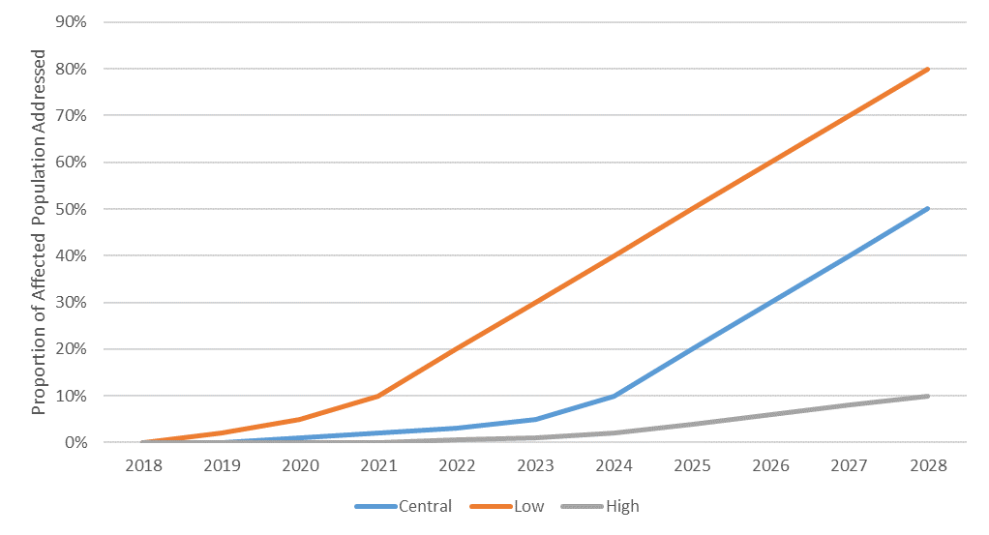

To estimate the additional life expectancy impact of the Better Health Programme, the following approach was taken for the populations affected by NCDs and by care quality issues.
NCDs
The addressable population in each country has been estimated using 2015 World Health Organisation (WHO) statistics on the proportion of adults (18+) that have raised blood pressure and World Bank country population data. The raised blood pressure population is used as a proxy for the population with a NCD amenable to prevention and management. This addressable population is projected forward over the appraisal period (2018-2027) using estimated growth rates in cardiovascular disease premature mortality, as a proxy for expected growth in NCD prevalence.
The projected addressable population is multiplied by the uptake rate profile (for the scenario in question) to estimate the (cumulative) number of individuals addressed at the end of each year. The total number of individuals treated over the appraisal period is then multiplied by a life expectancy change of +1.25 years per person to give the total number of additional life years generated by the programme. This is combined with World Bank total population data and WHO data on average life expectancy (absent the intervention) to estimate the increase in average life expectancy for each country’s population as a whole as a result of improving NCD outcomes.

Provider Quality
A similar approach is taken for estimating the life expectancy impact of the interventions to address provider quality issues. Statistics on quality-related errors are not readily available for Middle-Income Countries so to estimate the addressable population, a WHO estimate of 0.02% of the population (each year) for the EU is used, in conjunction with World Bank population data. This population is not increased over time based on the expert steering group’s view that demographic growth would be offset by improvements in patient safety not attributable to this programme. The addressable population each year was again multiplied by the scenario uptake rate to estimate the number of addressable individuals “treated” over the appraisal period. The same method as for NCDs was then followed, except a life expectancy change of +1.20 years per person was recommended by the expert steering group for individuals avoiding a patient safety incident.
Overall, the programme is estimated to increase average life expectancy in the programme countries by 0.07 years (on average across countries) in the central-risk scenario, 0.01 years in the high-risk scenario and 0.12 years in the low-risk scenario.

Relationship Between Life Expectancy and Economic Growth
Assumptions from two academic papers exploring the relationship between population health and economic growth were then used to inform the impact on economic growth of an additional year of life expectancy. A working paper by Liu et al for the China Centre for Health Economics Research, Peking University estimates that economic growth is lifted by 1.43% for an additional year of life expectancy and a paper by Bloom, Canning, and Sevilla separately estimates the effect to be +4.0% on steady state growth, which is attributed to improved health and therefore labour productivity. For the Primary Benefit estimates, an average of these two figures has been used in all risk scenarios i.e. +2.72% economic growth. The growth uplift impact is assumed to occur over a five year period starting in 2024 and is divided equally across these five years. This is a simplification and a caveat is that some of the growth impact could occur over a longer time horizon.
Overall this suggests an elevated GDP growth rate over the five year period of 0.05% on average (across countries) in the central-risk scenario, 0.1% on average in the low-risk scenario and 0.01% on average in the high-risk scenario (i.e. combining the economic growth impact assumption with the estimated increases in average life expectancy above).
To estimate the additional GDP impact on the target countries flowing from the programme, a baseline scenario was first constructed to project country GDP over the appraisal period (2017-2027) absent the programme. This used 2015 GDP estimates and forecasts of GDP growth from tradingeconomics.com (table 8). Then projections were constructed for each of the risk scenarios, in which the growth rate between 2024-2027 was elevated by the amounts indicated above.

Table 8 – Programme GDP baseline and do nothing scenario
Country | Current (2015) GDP, $m | Do nothing scenario: Current forecast GDP Growth Rate
Brazil | 1,774,725 | 1.90%
Mexico | 1,143,793 | 1.30%
South Africa | 314,572 | 2.60%
Malaysia | 296,283 | 3.50%
Myanmar | 62,601 | 7.90%
Philippines | 292,451 | 6.00%
Thailand | 395,168 | 3.00%
Vietnam | 193,599 | 6.30%
Peru | 192,000 | 3.70%
Source: Tradingeconomics.com

The additional GDP over 2024-2027 over the baseline was then calculated for each country under each scenario and discounted to 2017 using a discount rate of 10%, the rate assumed for primary benefits as these are realised by the MICs themselves.
A 10% attribution factor has then been applied to the estimated primary benefits. There are corollary activities that would be required to deliver the primary benefits plus deliver of the impacts are dependent upon the existing healthcare framework in each country; as such, it is not reasonable to attribute 100% of the estimated primary benefits to the Prosperity Fund expenditure alone. It is difficult to assess what this proportion should be – however, the Prosperity Fund expenditure accounts for approximately 10% of the total expenditure on direct activities to deliver the Better Health Programme as estimated by the programme consultants (the wider activities are used to inform estimates of the direct secondary benefits – see below).

Risk Scenarios
A key assumption is the uptake rate and this differentiates the risk scenarios as a proxy for probability of success of the programme. Table 9 illustrates how the primary benefits and benefit-cost ratios for the primary benefits change under each risk scenario.

Table 9 – Variation in Primary Benefits By Risk Scenario
Total for 2018-2027  £m (2016) | Option 1 |  |  | Option 2
Total for 2018-2027  £m (2016) | Low-Risk | Central-Risk | High-Risk | Low-Risk | Central-Risk | High-Risk
Total Primary Benefit | 51,306 | 32,213 | 6,398 | 52,738 | 33,109 | 6,577
Total Primary Benefit Discounted | 21,798 | 13,686 | 2,718 | 22,406 | 14,067 | 2,794
Total Attributable Primary Benefit Discounted | 2,180 | 1,369 | 272 | 2,241 | 1,407 | 279
Benefit-Cost Ratio | 32 | 20 | 4 | 33 | 21 | 4

There are other risks to the realisation of the primary benefits that have not been quantified in the analysis. One risk is whether there are sufficient employment opportunities in the partner countries to ensure improved health outcomes for citizens are translated into higher GDP.
For some people in the programme countries, the intervention will result in them being able to participate in the workforce where they couldn’t previously e.g. someone unable to work due to a NCD/provider quality incident or because they have to care for someone similar. Here, there could be employment growth barriers that could mitigate GDP impacts through this channel e.g. structural barriers in country labour markets (immobility, lack of skills) or general lack of demand for additional workers i.e. recessions. The programme will need to consider how to monitor and mitigate these risks as it is designed and implemented.
However, it should be noted that not all channels linking improved health outcomes to higher output are subject to this risk. Improved population health can lead to higher productivity and fewer lost working days for those already in employment. For example, existing workers with non-communicable diseases can work longer and more effectively if mortality and morbidity are reduced and there will be fewer lost working days due to the need to seek health treatment or care for family members.

Sensitivity Analysis
Sensitivity analysis has been conducted to consider the resilience of the programme benefit-cost ratio to key assumptions – this is summarised in table 10. This indicates the programme is relatively robust to these assumptions even under the high-risk scenario. Both the increase in life expectancy and impact on GDP growth assumptions can fall to about one third of their value and the programme will break-even under the high-risk scenario for primary benefits.

Table 10 – Primary Benefits Sensitivity Analysis
Variable | Default Assumption | Value At Which NPV of Primary Benefits Is Zero  (Benefit-cost ratio = 1)
Variable | Default Assumption | Low-Risk | Central-Risk | High-Risk
Increase in life expectancy for individuals treated by NCD/Provider quality Interventions | +1.25 yrs. for NCD  +1.2 yrs. for Provider quality | Collectively:  +0.02 yrs. for both NCD and Provider quality | Collectively:  +0.06 yrs. for both NCD and Provider quality | Collectively:  +0.31 yrs. for both NCD and Provider quality
Impact on annual GDP growth (from 2024-2027) from a 1 year increase in life expectancy for whole population | +2.7% | +0.08% | +0.14% | 0.71%

Secondary Benefits
Estimates
The headline secondary benefit estimates are shown in tables 11 and 12 for the central risk scenario (see below). The options are projected to deliver ~£2.0bn of additional UK exports across the target countries in each case. The most significant component of this is the additional exports of medical goods (market reform wider benefits) which assumes an increase of 1% market share for UK exporters. Option 2, which adds Peru to the programme has a marginally higher benefit-cost ratio for secondary benefits, though this is within the bounds of uncertainty for the analysis.
Table 11 – Central Risk Scenario – Secondary Benefits By Intervention - £m
Total for 2018-2027  £m (2016) | Option 1 | Option 2
NCD programme | 53 | 57
Digital Health | 165 | 178
Education & training | 89 | 103
Provider quality improvement | 164 | 164
Life sciences R&D partnerships | 58 | 58
Market Reform Wider Benefits | 1,358 | 1,410
Structural Benefits | 111 | 112
Total | 1,999 | 2,083
Total Discounted | 1,523 | 1,587
Benefit-cost Ratio | 22 | 23

Table 12 – Central Risk Scenario – Secondary Benefits By Country - £m
Total for 2018-2027  £m (2016) | Option 1 | Option 2
Mexico | 495 | 495
Brazil | 434 | 434
South Africa | 231 | 231
South East Asia | 839 | 839
Peru | - | 84
Total | 1,999 | 2,083
Total Discounted | 1,523 | 1,587
Benefit-cost Ratio | 22 | 23

Methodology
Secondary benefits concern the estimated increase in UK exports to the programme countries as a result of the interventions. Two different channels are considered via which UK exports could increase:
- Direct benefits. This relates to exports arising from UK firms providing services to support the Better Health Programme e.g. training for local healthcare workers to use digital health processes and equipment.
- Indirect (wider) benefits. This includes the general increase in demand for UK exports to the programme countries as a result of increased GDP through higher life expectancy (the primary benefit channel). These are termed structural benefits. Wider benefits also include market access reform export benefits i.e. increased access to country healthcare markets for the UK pharmaceutical and medical device industries as a result of the Better Healthcare Programmes.
Direct benefits
The direct benefits have been estimated by considering the size of the new/additional UK export opportunity for each intervention area (NCD programme, Provider Quality, Digital Health, Education & Training and Life Sciences R&D) and country, based on:

- Volume - estimate of the number of recipients (e.g. people trained) reached by an intervention. These have been estimated from national statistical sources - e.g. on number of clinicians by role, or proportion of population without access to high-quality primary care.

- Volume then multiplied by Value per year (estimated value per recipient). This is based, for example, on typical costs of providing a similar programme in a comparable setting - e.g. training subscription fees for telemedicine services, or training costs of the NHS Graduate Trainee programme

- The estimated additional annual exports achieved in 10 years is the product of Volume and Value multiplied by UK market share. UK Market Share estimates have been based upon the best available evidence e.g. Digital health in the UK: An industry study for the Office of Life Sciences, Monitor, Deloitte, 2015

A visual representation of this approach is depicted below:

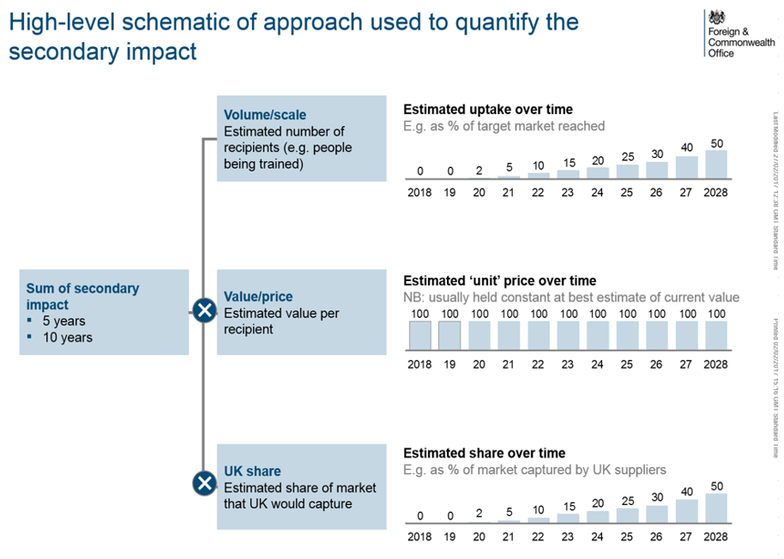

Specific detail for each intervention area is as follows.

Table 13 – Detail of Activities Resulting in Direct Secondary Benefits
Intervention | Activities | Assumed UK Market Share | Data Sources Used
NCD Programme | - Developing local clinical guidelines and a dissemination platform  - Technical assistance for public health programmes  - Training and education and continuous professional development for primary healthcare workers and community healthcare workers | 100% for a) and b)  40%/50%/60% for c) for high/central/low risk scenarios | - NICE clinical guidance international programmes  - technical assistance programme carried out by John Snow International in Pakistan  - Royal College of General Practicioners  - Health Education England
Provider Quality | - Technical assistance to design performance management framework  - Develop performance dashboard  - Provide training for performance management analytics | 100% as a binary contract and UK has distinctive international capabilities in this area | - Expert interviews  - Learning Tree
Digital Health | Reaching patients without access to primary healthcare via telemedicine. Assume reach 10%/40%/70% total country population in high/central/low risk scenarios | 20% based upon UK’s global market share in Digital Health | - Population statistics from World Bank  - Costs based upon Medicall (US) and Mediphone (India)  - Market share: Digital health in the UK: An industry study for the Office of Life Sciences, Monitor, Deloitte, 2015
Education & Training | - health systems management programme and MBAs  - primary care training and CPDs  - course accreditations  - data management | 100% based on university to university partnerships arrangement. UK Universities are internationally distinctive in this area | - Volume: OECD statistics on number of medical graduates  - Costs based upon MBA training costs in UK, NHS graduate training scheme, RCGP training costs, NHS Digital training costs
Life Science R&D | Investing in six Life Sciences R&D partnerships | 100% as UK companies will be participating in the partnerships | - Industry analyst reports (provided commercial in confidence) data on 3 previous R&D trials – probability of success and product sales

Indirect (wider) benefits
Structural benefits
The estimates of the structural benefits to the UK follow from the methodology for calculating the primary benefits (see above). Data for 2015 exports from the UK to programme countries is taken from tradingeconomics.com which uses UN COMTRADE statistics. A baseline scenario is then constructed in which these exports are projected out to 2027 using forecast GDP growth rates as a proxy for export growth. The process is then repeated with the elevated growth rates (due to longer life expectancy) over 2024-2027 under the central, low and high risk scenarios. The difference between each scenario and the baseline provides the estimate of additional UK exports over the appraisal period. These secondary benefits are discounted at 3.5% per year to 2017 using the HMT Green Book discount rate for costs/benefits accruing to the UK.
Market Access Reforms – Benefits specific to health sector
These benefits relate to the impact that is specific to the UK’s health exports, namely pharmaceuticals & healthcare and medical devices. Baseline projections of country imports of these medical goods for 2015-2026 (taken from Business Monitor International) were used to estimate the compound annual growth rate (CAGRs) in import demand over the appraisal period. UN COMTRADE statistics were then used to estimate the UK’s current level of exports to each country and its market share in imports. To give context, the UK’s share in pharmaceutical & healthcare imports in the programme countries was ~5.8% on average and its share in medical devices was ~1.5% in 2015.
A baseline projection of total medical good imports (and UK exports) for each country was then constructed based upon this information for the appraisal period 2018-2027. The increase in UK medical good exports was then calculated by repeating this exercise but by assuming UK market share increases for the period 2023-2027 by 0.5%, 1% and 1.5% for the high-risk, central-risk and low-risk scenarios respectively. The baseline projection of UK medical goods exports was subtracted in each case to give the increase in UK exports under each scenario. These secondary benefits are again discounted at 3.5% per year to 2017.
A summary of the methodology used to quantify the wider benefits is provided below:
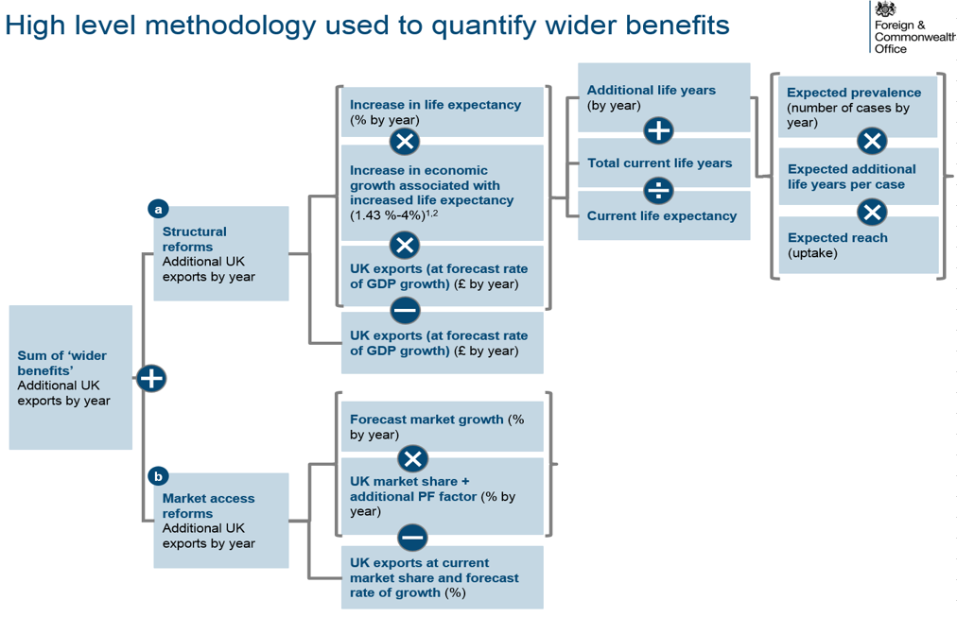

Risk Scenarios
The key assumption by which the secondary benefits vary over the risk scenarios is the additional market share for UK exporters of pharmaceuticals, healthcare and medical goods. (+0.5%, +1.0% and +1.5% under the high, central and low risk scenarios) assumed for the wider market reform secondary benefits. Table 14 illustrates how the secondary benefits and associated benefit-cost ratios change under each risk scenario. Note the scenarios also vary by other assumptions e.g. the population reached and the UK’s market share for the direct secondary benefits.

Table 14 – Variation in Secondary Benefits By Risk Scenario
Total for 2018-2027  £m (2016) | Option 1 |  |  | Option 2
Total for 2018-2027  £m (2016) | Low-Risk | Central-Risk | High-Risk | Low-Risk | Central-Risk | High-Risk
Total Secondary Benefit | 3.099 | 1,999 | 935 | 3,235 | 2,083 | 973
Total Secondary Benefit Discounted | 2,361 | 1,523 | 713 | 2,466 | 1,587 | 742
Benefit-Cost Ratio | 35 | 22 | 10 | 36 | 23 | 11

Sensitivity Analysis
The secondary benefits are not dependent on the realisation of the market reform benefits. Absent these market reform benefits, the secondary benefit cost-ratio is still positive e.g. it remains at ~3:1 in the high-risk scenario. This would allow for the UK’s assumed market shares in capturing the direct secondary benefits to fall by two-thirds and the programme would still break-even on secondary benefits.
Additional Tables
Prosperity Fund Better Health Programme Costs
Option 1 – Brazil, Mexico, South Africa, SE Asia
£millions | 2017 | 2018 | 2019 | 2020 | 2021 | 2022 | 2023 | 2024 | 2025 | 2026 | 2027 | Total
NCD programme | 0 | 5 | 5 | 3 | 0 | 0 | 0 | 0 | 0 | 0 | 0 | 12
Digital Health | 0 | 5 | 7 | 3 | 0 | 0 | 0 | 0 | 0 | 0 | 0 | 16
Education & training | 0 | 5 | 5 | 1 | 0 | 0 | 0 | 0 | 0 | 0 | 0 | 12
Provider quality improvement | 0 | 6 | 8 | 1 | 0 | 0 | 0 | 0 | 0 | 0 | 0 | 15
Life sciences R&D partnerships | 0 | 6 | 6 | 5 | 0 | 0 | 0 | 0 | 0 | 0 | 0 | 17
Total | 0 | 27 | 32 | 13 | 0 | 0 | 0 | 0 | 0 | 0 | 0 | 73
Discount Factor  (3.5% disc. rate) | 1.00 | 0.97 | 0.93 | 0.90 | 0.87 | 0.84 | 0.81 | 0.79 | 0.76 | 0.73 | 0.71
Total Discounted | 0 | 26 | 30 | 12 | 0 | 0 | 0 | 0 | 0 | 0 | 0 | 68
Option 2 – Brazil, Mexico, South Africa, SE Asia, Peru
£millions | 2017 | 2018 | 2019 | 2020 | 2021 | 2022 | 2023 | 2024 | 2025 | 2026 | 2027 | Total
NCD programme | 0 | 6 | 6 | 3 | 0 | 0 | 0 | 0 | 0 | 0 | 0 | 14
Digital Health | 0 | 6 | 8 | 4 | 0 | 0 | 0 | 0 | 0 | 0 | 0 | 18
Education & training | 0 | 6 | 6 | 2 | 0 | 0 | 0 | 0 | 0 | 0 | 0 | 15
Provider quality improvement | 0 | 6 | 8 | 1 | 0 | 0 | 0 | 0 | 0 | 0 | 0 | 15
Life sciences R&D partnerships | 0 | 6 | 6 | 5 | 0 | 0 | 0 | 0 | 0 | 0 | 0 | 17
Total | 0 | 30 | 34 | 15 | 0 | 0 | 0 | 0 | 0 | 0 | 0 | 79
Discount Factor  (3.5% disc. rate) | 1.00 | 0.97 | 0.93 | 0.90 | 0.87 | 0.84 | 0.81 | 0.79 | 0.76 | 0.73 | 0.71
Total Discounted | 0 | 29 | 32 | 13 | 0 | 0 | 0 | 0 | 0 | 0 | 0 | 74
Prosperity Fund Better Health Programme Primary Benefits
Option 1 – Brazil, Mexico, South Africa, SE Asia - Central Risk Scenario
£millions | 2017 | 2018 | 2019 | 2020 | 2021 | 2022 | 2023 | 2024 | 2025 | 2026 | 2027 | Total
NCD programme | - | - | - | - | - | - | - | 759 | 1,572 | 2,442 | 3,372 | 8,145
Digital Health | - | - | - | - | - | - | - | 1,277 | 2,633 | 4,075 | 5,606 | 13,590
Education & training | - | - | - | - | - | - | - | 1,001 | 2,045 | 3,133 | 4,267 | 10,445
Provider quality improvement | - | - | - | - | - | - | - | 3 | 6 | 10 | 13 | 32
Life sciences R&D partnerships | - | - | - | - | - | - | - | - | - | - | - | -
Total | - | - | - | - | - | - | - | 3,040 | 6,256 | 9,659 | 13,258 | 32,213
Discount Factor  (10% disc. rate) | 1.00 | 0.91 | 0.83 | 0.75 | 0.68 | 0.62 | 0.56 | 0.51 | 0.47 | 0.42 | 0.39
Total Discounted | - | - | - | - | - | - | - | 1,560 | 2,919 | 4,096 | 5,111 | 13,686
Total Discounted and Attributable | - | - | - | - | - | - | - | 156 | 292 | 410 | 511 | 1,369

Option 2 – Brazil, Mexico, South Africa, SE Asia, Peru - Central Risk Scenario
£millions | 2017 | 2018 | 2019 | 2020 | 2021 | 2022 | 2023 | 2024 | 2025 | 2026 | 2027 | Total
NCD programme | - | - | - | - | - | - | - | 797 | 1,649 | 2,561 | 3,538 | 8,545
Digital Health | - | - | - | - | - | - | - | 1,314 | 2,710 | 4,194 | 5,772 | 13,990
Education & training | - | - | - | - | - | - | - | 1,010 | 2,063 | 3,162 | 4,306 | 10,542
Provider quality improvement | - | - | - | - | - | - | - | 3 | 6 | 10 | 13 | 32
Life sciences R&D partnerships | - | - | - | - | - | - | - | - | - | - | - | -
Total | - | - | - | - | - | - | - | 3,124 | 6,429 | 9,927 | 13,629 | 33,109
Discount Factor  (10% discount rate) | 1.00 | 0.91 | 0.83 | 0.75 | 0.68 | 0.62 | 0.56 | 0.51 | 0.47 | 0.42 | 0.39
Total Discounted | - | - | - | - | - | - | - | 1,603 | 2,999 | 4,210 | 5,255 | 14,067
Total Discounted and Attributable | - | - | - | - | - | - | - | 160 | 300 | 421 | 525 | 1,407
Prosperity Fund Better Health Programme Secondary Benefits
Option 1 – Brazil, Mexico, South Africa, SE Asia - Central Risk Scenario
£millions | 2017 | 2018 | 2019 | 2020 | 2021 | 2022 | 2023 | 2024 | 2025 | 2026 | 2027 | Total
NCD programme | 0 | 0 | 1 | 2 | 15 | 9 | 7 | 7 | 9 | 1 | 1 | 53
Digital Health | 0 | 0 | 0 | 0 | 17 | 17 | 35 | 35 | 35 | 17 | 9 | 165
Education & training | 0 | 0 | 0 | 3 | 6 | 10 | 14 | 14 | 14 | 14 | 14 | 89
Provider quality improvement | 0 | 0 | 0 | 6 | 2 | 7 | 16 | 25 | 27 | 36 | 45 | 164
Life sciences R&D partnerships | 0 | 0 | 0 | 0 | 1 | 1 | 4 | 7 | 11 | 15 | 18 | 58
Market Reform Wider Benefits | 0 | 0 | 0 | 0 | 0 | 0 | 247 | 258 | 271 | 284 | 298 | 1,358
Structural Benefits | 0 | 0 | 0 | 0 | 0 | 0 | 0 | 10 | 21 | 33 | 46 | 111
Total | 0 | 0 | 1 | 11 | 40 | 46 | 323 | 358 | 389 | 401 | 431 | 1,999
Discount Factor  (3.5% discount rate) | 1.00 | 0.97 | 0.93 | 0.90 | 0.87 | 0.84 | 0.81 | 0.79 | 0.76 | 0.73 | 0.71
Total Discounted | 0 | 0 | 1 | 10 | 35 | 38 | 263 | 281 | 295 | 294 | 306 | 1,523
Option 2 – Brazil, Mexico, South Africa, SE Asia, Peru - Central Risk Scenario
£millions | 2017 | 2018 | 2019 | 2020 | 2021 | 2022 | 2023 | 2024 | 2025 | 2026 | 2027 | Total
NCD programme | 0 | 0 | 2 | 3 | 15 | 10 | 8 | 8 | 10 | 1 | 1 | 57
Digital Health | 0 | 0 | 0 | 0 | 19 | 19 | 38 | 38 | 38 | 19 | 9 | 178
Education & training | 0 | 0 | 0 | 3 | 7 | 12 | 16 | 16 | 16 | 16 | 16 | 103
Provider quality improvement | 0 | 0 | 0 | 6 | 2 | 7 | 16 | 25 | 27 | 36 | 45 | 164
Life sciences R&D partnerships | 0 | 0 | 0 | 0 | 1 | 1 | 4 | 7 | 11 | 15 | 18 | 58
Market Reform Wider Benefits | 0 | 0 | 0 | 0 | 0 | 0 | 256 | 268 | 281 | 295 | 310 | 1,410
Structural Benefits | 0 | 0 | 0 | 0 | 0 | 0 | 0 | 11 | 22 | 34 | 46 | 112
Total | 0 | 0 | 2 | 12 | 43 | 49 | 337 | 373 | 405 | 416 | 446 | 2,083
Discount Factor  (3.5% discount rate) | 1.00 | 0.97 | 0.93 | 0.90 | 0.87 | 0.84 | 0.81 | 0.79 | 0.76 | 0.73 | 0.71
Total Discounted | 0 | 0 | 2 | 11 | 38 | 41 | 274 | 293 | 307 | 305 | 317 | 1,587
APPENDIX E – COSTED INTERVENTIONS BY PILLAR
Pillar 1 NCD STRATEGY Costs

Pillar 2 DIGITAL HEALTH Costs

Pillar 3 EDUCATION / TRAINING Costs

Pillar 4 PROVIDER PERFORMANCE IMPROVEMENT Costs

Pillar 5 LIFE SCIENCES Costs

APPENDIX F – RISK REGISTER
Type | Description | Mitigation | Likelihood (low/medium/ high) | Impact (low / medium / high)
Stakeholder | Lack of partner capacity leads to  to inertia and resistance to change | The programme has engaged with [all] partner governments and capacity to work with the programme has been taken in account in deciding scope of the programme. The programme will also strengthen institutional capacity. Further stakeholder engagement will occur prior to programme implementation during the transitional ‘Strategic Partner’ phase, by posts and other providers brought in to support this initial phase. | Medium | High
Stakeholder | Political instability slows or stalls progress | The proposed countries have a relative degree of projected stability, although elections occur in Brazil, Mexico (2018) and South Africa (2019). The programmes have been tested through engagement with partners for their resilience to electoral and political change and the key programme objectives are insured against possible outcomes by having wide and relative apolitical nature. The transition work will broaden the range of stakeholders consulted to wider national party political stakeholders given the opportunity to shape future health priorities in some of the countries. During implementation, programme monitoring will flag need to modify the focus due to political risk. | Medium | High
Stakeholder | Lack of buy-in from national governments | This is linked to the previous risk. The programme design phase has engaged senior officials during design and will continue to do so during transition and through the continuous involvement of a strategic partner. Further engagement is planned across political spectra. | Medium | Medium
Stakeholder | Lengthy PF approval and procurement process reduces programme buy-in | There will be up to 4 months between completion of Phase 1 and the start of Phase 2 which could lead to lost momentum – especially in the context of electoral cycles. Strategic partners will be asked to maintain engagement beyond Phase 1 completion until the programme Strategic Advisory Facility – which is to be procured first – is established. | Medium | High
Stakeholder | Lengthy government approvals for ODA programming causes delay | Some countries are known to require high level sign-off for ODA programmes (e.g. Vietnam). We will work together with them early through the Strategic Development Phase to ensure that this approval process does not delay the programme | Medium | High
Design | There are insufficient funds to commission future projects flowing from the programme | In some countries spend on health is relatively low (e.g. below OECD average). Some of the shortfall can be made up by prioritising health objectives under other budget lines e.g. education. The interventions will also create savings in some area and therefore opportunities to reinvest in health. The transition / initial phase will assess the sources of future funding for downstream initiatives with a view to action with the framework of the programme to identify funds needed – for example, in order to institutionalise new initiatives in primary care training on a national scale. | Low | High
Benefits | UK companies do not advantage of these export opportunities | Assessment of sector capability and interest, as well as market testing, indicates a significant degree of capability and competitive advantage, while DIT is working closely to increase the export readiness via Healthcare UK. The strategy phase will explore how the involvement of a strategic partner can connect UK players to potential leads. The programme will secure additional DIT resource, with assistance from non-ODA funds, to follow-up commercial opportunities. During delivery, a benefits manager will track progress | Low | High
Benefits | The delivery model fails to capture opportunities and synergies from working across countries | The involvement of a strategic partner reporting to a global oversight board will ensure opportunities are not missed, even if multiple lead delivery partners are appointed. | Medium | Medium
Benefits | Health outcomes do not translate to productivity growth due to lack of job opportunities | The programme will not create jobs for beneficiaries of the programme who are returning to the workforce, but it will improve productivity in the existing workforce and the resulting growth is expected to lead to a positive, if unquantified level of job creation. This effect could be uneven due to structural issues outside the programme such as lack of mobility. | Medium | Medium
Design | Activities fail to produce the intended outcomes | The interventions are by and large based on what has worked elsewhere and the implementation of international best practice. Careful multi-disciplinary design, (including social, governance and economic aspects and stakeholder and community engagement including with poor, excluded groups and women, will be undertaken in inception to ensure ownership, buy-in an appropriateness of approaches proposed. The work carried out in the ‘Strategic Partner’ phase will determine the feasibility of the activities, and the full programme will utilise carefully evaluated pilots in order to test suitability of some work for new locations where needed. | Low | High
Design | Poor engagement at design stage that reinforces gender and income inequality | Pre-delivery ‘Strategic Development Phase’ will include specific remit for a strategic programme partner to agree pro-poor and gender programme content with partner countries | Low | High
Delivery | Delivery partners do not deliver the outputs as agreed | The interventions will be specific and measureable (via KPIs). Regular reporting points linked to payments will prioritise measurable impact in order to ensure that the programme and implementers demonstrate delivery before significant expenditures are incurred. Programme governance, including direct oversight by posts, will enhance these efforts. | Low | High
Delivery | Delivery partners fail to meet ODA/ IDA fund requirements | ODA/IDA funds requirements, management of risk and delivery of the project outputs and outcomes, including adverse effects of aid expenditure that have undesired and unexpected results upon recipients including any adverse gender related impact, are properly written into ToRs, assessed at procurement stage and monitored throughout the programme to ensure compliance and poverty and gender impact  To support corporate governance and transparency and to identify, reduce and manage risk we encourage suppliers to use the IFC Performance Standards for Environmental and Social sustainability (2012) which are based on international good practice and may be modified or supplemented to take into account particulate jurisdictional requirements or the local environment | Medium | High
Delivery | More specifically, the outputs fail to support inclusive growth and comply with the Gender Equality Act e.g. reinforce inequality | Outputs will be specific and measureable (via KPIs) and reflect gender and inclusion. Regular reporting points linked to payments will prioritise measurable impact in order to ensure that the programme and implementers demonstrate delivery before significant expenditures are incurred. Programme governance, including direct oversight by posts, will enhance these efforts. | Medium | High
Delivery | Staffing Gaps | Lack of central and supporting team at posts causes delays to programme implementation or weakness in overall governance. A central team is being recruited and is expected to be in place. Posts are reviewing their resourcing and planning recruitment where applicable | Medium | High
Delivery | Lack of sector expertise in central team | FCO’s role majors on delivery partner management and partner government engagement. The intelligent customer function will be provided by the programme Steering Committee and the Strategic Partner function. Sector-literate delivery partners will provide programme management and technical expertise. | Low | High
Commercial | Misuse of funds by delivery partners | Due diligence checks ahead of suppliers being appointed, and requirements for lead delivery partners of their supply chain. Adoption of standard financial reporting requirements. Payment on delivery. No advance payments. | Low | High
Commercial | Delivery partner organisational failure e.g. bankruptcy | Comprehensive due diligence of delivery partners before appointment. Milestone payments and payment in arrears limiting liability. A variety of delivery partners reduces the impact of this risk and potentially enables other partners to scale up. | Low | High
Commercial | Contract represents bad value for money | A competitive process will be followed for the majority of the programme, with the possible exception of the selection of a programme strategic partner (for both the transition and main delivery phases). PF framework to be used wherever possible to commission procurements. | Low | Medium
Benefits | Programme fragmentation weakens impact | The programme proposes to operate in a small number of countries, with funding levels broadly proportionate to country size and with a maximum of five target areas of intervention for each. The list of countries and target themes has been agreed by a programme steering committee. A transition phase and ongoing programme monitoring will test for dilution of impact. | Low | High

Appendix G – Draft Staffing Requirements
Title | Role | Grade | FTE | Location | New Resource / Already in place
Programme Lead | Overall lead for the programme | D6 | 1.0 | London
Programme Manager | Day to day management of the programme | C4 | 1.0 | London
Contract Manager | Management of delivery partners | C5 | 1.0 | London
Regional and Sector Liaison | Leading communications with Posts and other programmes | C4 | 0.5 | London
Portfolio Manager | Oversight of programme | D7 | 0.3 | London
Health Adviser | Expert advisory input [potentially non-programme] | [D6] | [1.0] | London
Gender and Benefits Advisers | Expert advisory input [potentially non-programme] | [D6] | [0.2] | London
South East Asia Programme Lead | Leadership of the programme in South East Asia | D6 | 0.2 | Singapore
South East Asia Post and Sector Liaison | Co-ordinating the work of Posts in South East Asia | C4L | 0.5 | Singapore
Post Programme Lead | Lead for the programme at Post | [D6] | [0.2 tbc] | Myanmar
Sector Adviser/ Programme Manager | Day to day oversight of contacts with programme implementers and G2G / other stakeholder engagement | C4 | [1.0 tbc] | Myanmar
Post Programme Lead | Lead for the programme at Post | [D6] | [0.2 tbc] | Thailand
Sector Adviser/ Programme Manager | Day to day oversight of contacts with programme implementers and G2G / other stakeholder engagement | C4 | [1.0 tbc] | Thailand
Post Programme Lead | Lead for the programme at Post | [D6] | [0.2 tbc] | Vietnam
Sector Adviser/ Programme Manager | Day to day oversight of contacts with programme implementers and G2G / other stakeholder engagement | C4 | [1.0 tbc] | Vietnam
Post Programme Lead | Lead for the programme at Post | [D6] | [0.2 tbc] | Malaysia
Sector Adviser/ Programme Manager | Day to day oversight of contacts with programme implementers and G2G / other stakeholder engagement | C4 | [1.0 tbc] | Malaysia
Post Programme Lead | Lead for the programme at Post | [C5/D6] | [0.2 tbc] | Philippines
Sector Adviser/ Programme Manager | Day to day oversight of contacts with programme implementers and G2G / other stakeholder engagement | C4 | [1.0 tbc] | Philippines
Post Programme Lead | Lead for the programme at Post | [D6] | [0.1 tbc] | Brazil
Sector Adviser/ Programme Manager | Day to day oversight of contacts with programme implementers and G2G / other stakeholder engagement | [C4/B3] | [1.5 tbc] | Brazil
Sector Adviser/ Programme Manager | Day to day oversight of contacts with programme implementers and G2G / other stakeholder engagement | [C4/B3] | [1.0 tbc] | Mexico
Post Programme Lead | Lead for the programme at Post | C5 | 0.2 | South Africa
Sector Adviser/ Programme Manager | Day to day oversight of contacts with programme implementers and G2G / other stakeholder engagement | C4 | 0.5 | South Africa

APPENDIX H – TRANSITION FUNDING

Programme Summary
This £79.5m (or £85.5m) FCO-led cross-Whitehall Prosperity Fund programme – developed with DH, DFID and DIT – is designed to increase life expectancy, improve productivity and deliver economic growth in nine emerging markets. The programme will also unlock opportunities for UK organisations and business with distinctive and world-leading capability to engage in mutually beneficial trade with these fast-growing economies.
A detailed design process, including external scoping, resulted in the selection of nine countries (Brazil, Mexico, South Africa, Vietnam, Malaysia, Philippines, Thailand and Peru), based on the relative potential impact, interest from in-country stakeholders, ease of doing business, and the health financing landscape. The programme comprises 5 pillars of activity that represent best match between partner country priorities, potential for development impact and areas of UK capability:

Pillar 1 | Strategies to Counter Non Communicable Disease
Pillar 2 | Digital Health initiatives
Pillar 3 | Education and Training
Pillar 4 | Provider Performance Improvement
Pillar 5 | Life Sciences Initiatives

Plan and Timeline
The programme is divided into two phases:
- A transitional Strategic Development Phase between February and May 2018 that will confirm and refine programme interventions in partner countries, based on the scope and indicative activities included in this Strategic Outline Business Case, and to inform commissioning of Phase 2;

- A Delivery Phase from September 2018 to April 2021 that will engage commercial delivery partners, supported by separately engaged programme management and strategic advisory partners to deliver the agreed interventions established at Phase 1.

The chart below depicts a high-level delivery plan for the programme.
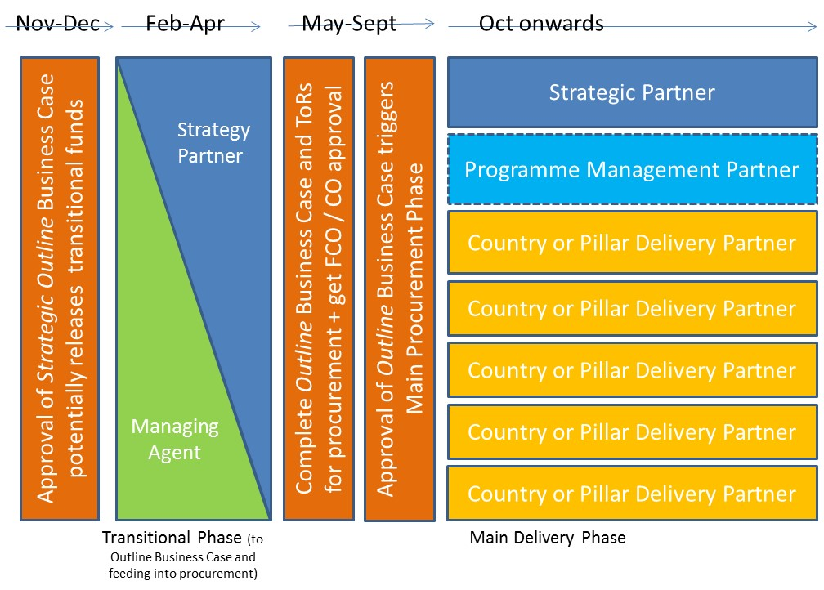

The table below sets out the proposed timeline for the programme:

Milestone | Deadline
Strategic Outline Business Case complete and agreed by Portfolio Board | Dec 2017
Strategic Development Phase | Feb–May 2018
Outline Business Case complete and agreed by CO/HMT | July 2018
Procurement of delivery partners | July–Sept 2018
Delivery phase commences | Oct 2018

Transition Funding Request
To deliver the programme as envisaged, a budget of £2.0m is being requested to cover staff costs and the Strategic Development Phase until commencement of the main delivery phase:
- £1.47m to cover delivery of phase 1 activity and staff costs from Jan-Jul 2018 (£0.85m in services and £0.62m in staffing);
- a contingency of £0.53m for staff during Aug-Dec 2018 should phase 1 take longer than planned, either to put a team in place or to complete the work. The funding would mean staff contracts could be put in place for the calendar year, thereby reducing bureaucracy and increasing the attractiveness of the roles to existing and new staff.
Transitional funding will be used to test local strategic fit of the proposed interventions, and provide sufficiently detailed specifications to ensure the best delivery partner is selected. Activities are listed in the table below.

The breakdown of the budget by financial year would be (1) 2017/18 – £0.47m; and (2) 2018/19 – £1.53m.
Activities to be funded:
Activity | Impact | Delivery Model and Cost
Strategic Development Phase:  - Building on the initial scoping studies and government-to-government engagement, liaise with key in-country stakeholders to agree / adapt programme interventions and thereby obtain partner country buy-in and endorsement of programme activity. (The SOBC contains indicative outputs based on initial scoping of partner country needs).  - Ensure these address key barriers to prosperity, are feasible and have clear development and secondary benefits.  - Establish clear outputs to feed into Terms of Reference for the main delivery phase.  - Ensure that interventions contribute to poverty reduction and are Gender Equality Act compliant, including an action plan to achieve gender equality outcomes, including women’s economic empowerment, and avoid unintended negative consequences; social and environmental safeguards. | - Increase likelihood of programme impact by confirming that the proposed programme interventions fit with the local strategic context – that they address key barriers to prosperity, having maximum impact and are feasible;  - Increase likelihood of success / impact / benefit by gaining buy-in from multiple stakeholders who will oversee longer term implementation  - Facilitate the selection of the most appropriate delivery partner by ensuring the programme is sufficiently defined, and mitigating the risk of an ineffective / unsuitable delivery partner  - Increase likelihood that programme interventions will have gender equality impact by ensuring they deliver against this goal from the outset | - HMG Experts from UK Health Non-Departmental Public Bodies are commissioned via MOU to undertake work in the 9 countries over the course of 3 months.  Cost: £500,000  - Contingency Opportunities Fund to be used to address strategic capacity building needs arising during this phase and in the run-up to the main delivery phase.  Cost: £200,000  - A commercial partner will be contracted via competition to provide programme management and organisational support to the lead experts.  Cost: £150,000
FCO staffing:  - Continued country-specific input to business case development, and scoping and strategic development phase support | - Broad strategic fit alongside wider HMG priorities  - Partner government engagement and buy-in for programme | - Staffing from Jan 18 to Dec 18 (£0.62m Jan-Jul 18; £0.53m Aug-Dec 18)  Cost: £1,150,000
Total: |  | Cost: £2,000,000

FCO Staffing plan:
The staffing costs detailed in the above table have been generated based on the general assumption that, as the programme enters the delivery phase, each country will require a 1.0 C4 FTE with health sector know-how and networks to lead government to government engagement, and oversee delivery. 0.2 D6 FTE per country would provide management oversight and ensure local synergies across PF and other HMG activity. An alternative model, involving a C5L regional health adviser for South East Asia, potentially an element of the HMG Strategic Partner role, is also being considered. Hubs will be needed in Singapore and London to coordinate programme activity. The central programme team in London plans to draw on technical expertise via the Strategic Partner, a dedicated London-based Health Adviser, a cross-directorate Benefits Manager, and a Gender expert.

2018 Staffing | Jan-Mar FTE | Apr-Jul FTE | Jul-Dec FTE
London | 2.8 | 4.3 | 5.0
Singapore Hub | 0.75 | 0.75 | 0.75
Posts | 4.8 | 9.0 | 9.5
TOTAL | 8.35 | 14.75 | 15.25

Who will be responsible and accountable for delivery?
The SRO for this work will be the FCO Director for Economic Diplomacy, supported by the Prosperity Fund programme team in London, the South East Asia regional hub in Singapore and posts in the programme’s partner countries.
Are there any significant risks?
There are no significant risks to delivery during the transitional period. There has been a significant degree of engagement with stakeholders on the broad scope and possible interventions of the programme already. There is a significant level of commitment from potential implementers. Delays to agreeing an MOU or contracting out to a commercial delivery partner will cause down-stream delays to programme implementation, making the continuity provided by the staffing element of this bid essential to maintain momentum. The activities are discrete, time bound, and will add value even if the programme is not subsequently approved.

Appendix I – Programme Cost Profile

N Engl J Med 2015; 372:2177-2181
The World Bank, Health expenditure, total (% of GDP), 2014
José Antonio González Anaya and Regina García Cuéllar, Health Systems & Reform Vol. 1 , Iss. 3,2015
Aslan M et al, The Effect of Population Health on Foreign Direct Investment Inflows to Low- and Middle-Income Countries, World Development, 2006, 34(4), 613:630
www.ons.gov.uk/economy/nationalaccounts/balanceofpayments/articles/theukstradeandinvestmentrelationshipwithafrica/2016
www.sadc.int/files/6114/0653/8757/SADC_Indicators_-_21_SSC_-June_2014_final.pdf
www.ons.gov.uk/economy/nationalaccounts/balanceofpayments/articles/uktradeandinvestmentwithsouthamerica/2016/pdf
www.ons.gov.uk/economy/nationalaccounts/balanceofpayments/articles/theukstradeandinvestmentrelationshipwithafrica/2016
The World Bank, Health expenditure, total (% of GDP), 2014
Coovadia H, Jewkes R, Barron P, Sanders D, McIntyre D. The health and health system of South Africa: historical roots of current public health challenges. Lancet 2009;374:817-834
N Engl J Med 2014; 371:1344-1353
Data drawn from 2 sources: 2009 – 2012: BDG Asia (analysts): http://bdg-asia.com/southeast-asias-growing-healthcare-market/ and 2014 (the latest year published): WHO Global health Observatory Data: http://www.who.int/gho/health_financing/per_capita_expenditure/en/
Deloitte: https://www2.deloitte.com/content/dam/Deloitte/global/Documents/Life-Sciences-Health-Care/gx-lshc-2016-health-care-outlook-regional.pdf
Collated from WHO country profiles such as http://www.who.int/countries/mmr/en/
This and the following from WHO Country profile
http://statisticstimes.com/economy/countries-by-projected-gdp.php
https://www.gov.uk/government/uploads/system/uploads/attachment_data/file/611551/East___South_East_Asia_Factsheet.pdf
This chart and the following tables from WHO Malaysia Non Communicable Diseases Profile
Source: Deloitte: https://www2.deloitte.com/content/dam/Deloitte/global/Documents/Life-Sciences-Health-Care/gx-lshc-2015-health-care-outlook-se-asia.pdf
This and the following from WHO Country profile
WHO Philippines Country Cooperation Strategy http://apps.who.int/iris/bitstream/10665/136828/1/ccsbrief_phl_en.pdf?ua=1
https://www.gov.uk/government/uploads/system/uploads/attachment_data/file/611551/East___South_East_Asia_Factsheet.pdf
The following sections taken from: https://www.gov.uk/government/publications/exporting-to-burma/doing-business-in-burma-burma-trade-and-export-guide
This and the following stats from WHO Country Profile
WHO Philippines Country Cooperation Strategy http://apps.who.int/iris/bitstream/10665/136828/1/ccsbrief_phl_en.pdf?ua=1
From WHO Philippines Non Communicable Diseases Profile
https://www.gov.uk/government/uploads/system/uploads/attachment_data/file/611551/East___South_East_Asia_Factsheet.pdf
https://www.allianzworldwidecare.com/en/support/view/national-healthcare-systems/healthcare-in-philippines/
https://www.gov.uk/government/publications/exporting-to-the-philippines/exporting-to-the-philippines
This and the following from WHO Country profile
https://www.gov.uk/government/uploads/system/uploads/attachment_data/file/611551/East___South_East_Asia_Factsheet.pdf
This and the following from WHO Country profile
https://www.gov.uk/government/uploads/system/uploads/attachment_data/file/611551/East___South_East_Asia_Factsheet.pdf
https://www.gov.uk/government/publications/exporting-to-vietnam/exporting-to-vietnam
Primary/secondary research depending upon country needs
Includes: quantification of baseline needs and potential impact, developing national and regional strategies, workforce analysis, stakeholder engagement, incentives and governance frameworks, regulation and funding models
Bringing education and training providers to meet local health system leaders and potential partners
Includes estimates of costs for 2 years joint pre-clinical work, one phase 1 trial, and one phase 2a trial
For local principal investigators
These uptake curves are judgment-based assumptions, which programme consultants tested with an Expert Steering Group.
Representatives from: Public Health England, Healthcare UK, Health Education England, NHS Improvement, Department for International Development and Department of Health
For the NCD population this should be interpreted as the proportion of the population with a NCD in that year that has been treated (at some point) over the appraisal period. For the Patient Quality population this should be interpreted as the proportion of the (baseline) patient quality incidents that are avoided in that year.
http://apps.who.int/gho/data/node.main.A875STANDARD?lang=en
http://databank.worldbank.org/data/home.aspx
Sacco et al, The heart of 25 by 25, Circulation, 2016, 135(1).
Tested with steering group
http://www.euro.who.int/en/health-topics/Health-systems/patient-safety/data-and-statistics. There are 95,000 avoidable deaths due to Patient Safety issues in the EU per year. This is approximately 0.02% of the EU population of 510 million.
Liu G, Hackney C, Yao Y. Health and Wealth: The role of health in economic growth. Working paper, China Centre for Health Economics Research, Peking University, 2016. This is based on citations of the main result. Liu et al was a study of 100 countries over a 20 year period, but unclear over what period the growth impact occurs
Bloom, David E., David Canning, and J. Sevilla, 2004,“The Effect of Health on Economic Growth: A Production Function Approach,” World Development,Vol. 32 (January), pp. 1–13. cited in Health, wealth and welfare, 2004. http://www.imf.org/external/pubs/ft/fandd/2004/03/pdf/bloom.pdf
Bloom et al. consider the possibility that life expectancy is a proxy for the general health of a country’s population i.e. reflects morbidity as well as mortality. In that sense an increase in life expectancy could have immediate impacts through labour productivity by improving population morbidity. There is some lack of clarity over period the growth impacts that have been estimated took place. It is a panel data set of different countries.
http://www.tradingeconomics.com/forecast/gdp-annual-growth-rate
[Original source to be added for the 10% discount rate, though it is what is used across the PF for primary benefits and understand 10% is what DfID/World Bank use in cost-benefit-analysis]
Noting of course that mitigating the need for informal care work will drive an increase in measured GDP if carers can then find formal employment, though the actual increase in the value of goods and services produced may be smaller, negligible or even negative.
An alternative approach would be to use income elasticities for imports since these are typically <1 e.g. a BEIS commissioned 2014 study estimated income elasticities for imports for BRICS countries at 0.74
£86.24m – £0.75m for MREL = £85.5m
ENDNOTES High-Level Commission on Health Employment and Economic Growth’, WHO: http://www.who.int/hrh/com-heeg/en/
World Bank, 2014, Poverty and Health, http://www.worldbank.org/en/topic/health/brief/poverty-health
UNICEF [source to add]
World Bank, 2014, Poverty and Health, http://www.worldbank.org/en/topic/health/brief/poverty-health
WHO and WEF, From burden to ‘best buys’: reducing the economic impact from non-communicable diseases in low and middle income countries, 2011: http://www.who.int/nmh/publications/best_buys_summary.pdf
The proportion of all NCD deaths occurring prematurely is nearly double that of high-income countries (48% to 26%)
DFID HEART: https://assets.publishing.service.gov.uk/media/57a08aafe5274a31e0000706/Demographic-Dividend-November-2012.pdf
UN Sustainable Development Goals: http://www.un.org/sustainabledevelopment/health/
Sources: Diagnostic; UN SDGs.
WHO: http://www.who.int/patientsafety/en/
Jha et al, ‘The global burden of unsafe medical care’, BMJ: http://qualitysafety.bmj.com/content/22/10/809
[TBC]
Gender, Health and Sustainable Development: http://www.who.int/bulletin/volumes/93/11/15-165027.pdf?ua=1; Promoting Gender Equality through Health: https://www.usaid.gov/what-we-do/global-health/cross-cutting-areas/gender-equality; Gender Inequality and Economic Development: https://www.omicsonline.org/open-access/gender-inequality-and-economic-development-2151-6219-1000180.php?aid=62181
Medical research has often wrongly assumed that women were biologically weaker (male bias) and extrapolated findings from trials with male subjects only (male norm) to both sexes, whereas female biology can affect the onset and progression of disease, and women's lower position in society can affect their health-seeking behaviours (Pinn 2003; Sen, George, and Ostlin, 2002).
References DFID guidance on gender
Health, Economic Growth and Poverty Reduction: http://apps.who.int/iris/bitstream/10665/42492/1/9241590092.pdf; Population Health and Economic Growth: https://siteresources.worldbank.org/EXTPREMNET/Resources/489960-1338997241035/Growth_Commission_Working_Paper_24_Population_Health_Economic_Growth.pdf; Health and Development: https://www.imf.org/external/pubs/ft/health/eng/hdwi/hdwi.pdf
References DFID guidance on health and strengthening health systems.
Population Health, Environment and Economic Growth: https://link.springer.com/article/10.1023/A:1019692328162; Environment and Health Economics: http://www.euro.who.int/en/health-topics/environment-and-health/health-impact-assessment/environment-and-health-economics
Prosperity Fund Theory of Change (2016).
It noted the presence of over 5,000 companies, nearly 235,000 employees and a £63.5 billion turnover in 2016. The government is currently considering its response to a series of recommendations put forward by industry for ensuring the UK remains a top global life sciences hub.
Prosperity Fund Portfolio Guide (2016).
Based on analysis of 8 large bilateral donors (Australia, France, Germany, Netherlands, Norway, Sweden, United Kingdom, United States) Schäferhoff, Marco, et al. "How much donor financing for health is channeled to global versus country-specific aid functions?." The Lancet (2015).
UK Aid Strategy, November 2015
HM Government, National Security Strategy and Strategic Defence and Security Review, 2015.
https://sustainabledevelopment.un.org/sdg11
https://www.gov.uk/government/uploads/system/uploads/attachment_data/file/587374/DFID-Economic-Development-Strategy-2017.pdf
WHO (2012), a comprehensive global monitoring framework, including indicators, and a set of voluntary global targets for the prevention and control of non-communicable diseases http://www.who.int/nmh/events/2012/discussion_paper3.pdf
WHO, Hidden cities – unmasking and overcoming health inequities in urban settings, 2010
Final countries tbc
Carlyle Group, 2016; IMF, 2015 World Economic Outlook Database. October 2015. Estimate based on fixed-effects regression model using the World Bank’s 2015 World Development Indicators data on Health Expenditures
Boston Consulting Group (2012) The Internet Economy in the G-20
The UK was the second largest exporter of services in 2015
[McKinsey], etc 2016 and 2017
Department for International Development, DH, DIT, FCO and – initially – DH Arms Length Bodies.
[Rationale for Thailand as exception]
World Bank; CIA World Factbook
Ease of Doing Business Ranking and Corruption Perceptions Index cited by World Bank, CIA World Factbook
World Bank, Schäferhoff, Marco, et al, 2015, How much donor financing for health is channelled to global versus country-specific aid functions? The Lancet
Healthcare UK Annual Review 2015-16
Challenges facing the target countries are set out in more detail in section 2 of the Diagnostic
Mirrors WB approach in Mexico
Global Health Observatory, WHO (2011).
World Health Organization (2008), The Global Burden of Disease
NCD Alliance (2011).
High-Level Commission on Health Employment and Economic Growth, WHO: http://www.who.int/hrh/com-heeg/en/
Visits carried out by Central Programme Team in August-September 2017 as part of stakeholder engagement.
A 10% attribution factor has been applied to the estimated primary benefits to calculate the primary benefits attributable to the Prosperity Fund investment cost. There are corollary activities that would be required to deliver the primary benefits plus deliver of the impacts are dependent upon the existing healthcare framework in each country; as such, it is not reasonable to attribute 100% of the estimated primary benefits to the Prosperity Fund expenditure alone. It is difficult to assess what this proportion should be – however, the Prosperity Fund expenditure accounts for approximately 10% of the total expenditure on direct activities to deliver the Better Health Programme as estimated by the programme consultants (the wider activities are used to inform estimates of the direct secondary benefits – see below).
UN COMTRADE Statistics
As part of data gathering and reporting requirements in support of MREL contract.
Sits on the Appendix I “Programme Cost Profile” as “Administrative and PM Partner”
£2.1m minus £0.375m for MREL
£3.4m minus £0.375m MREL

