

Customer State of Washington, Department of Labor and Industries

Date 09/21/2016

Author

Version 1.0

Table of Contents

1 Project Background 4

2 Document Purpose 4

3 Scope 4

4 Interface partners and interfaces 5

4.1 Online interfaces 5

4.2 Batch interfaces LNI internal 5

5 Interface types and migration strategy 5

5.1 IBM MQ (Message Queue) 5

LINIIS as a publisher 6

LINIIS as a subscriber 6

5.2 FTP 6

FTPS 6

SFTP 6

FTP 6

5.3 Processes remaining on the Mainframe 7

FTP synchronization: Mainframe 🡪 Windows 8

FTP synchronization: Windows 🡪 Mainframe 9

5.4 EOS Document repository 10

5.5 Shared datasets 10

5.6 Job archiving (JARS) 10

5.7 Online (Web) Interface 10

5.8 Shared Adabas 10

5.9 Printing 10

5.10 Demand In Schedules 10

6 Detailed interface description 11

6.1 ARC – Account Receivable and Collection system 11

6.2 Barcodes and Warrants 11

6.3 CAC – Claimant Account Center 11

6.4 Claims Mail 12

6.5 ECS – Early Claims solution 12

6.6 EOS – Enterprise Output Solution 13

6.7 Shared datasets: Exch235 + other agency specific datasets 13

6.8 JARS – JCL Archive Retrieval System 13

6.9 Lockbox 14

6.10 MIPS – Medical Information and Payment System 14

6.11 Orion 14

6.12 RAP – Rating Adjustment Process 15

6.13 Rates 15

6.14 Reptor 15

6.15 SFTP 15

6.16 Structured Settlement 16

6.17 Osha 16

6.18 Quickfile, DeluxeFile, ExpressFile 16

7 Detailed contact information 17

8 Linked Documents 18

# Project Background

The State of Washington Department of Labor & Industries (L&I or “Department”) is undertaking the migration of the current Labor & Industries Industrial Insurance System (LINIIS) from a mainframe environment to an enterprise environment. This project is supported by one external contract:

* innoWake to provide migration support and associated technical management

# Document Purpose

As part of the migration off the mainframe to a Windows environment all interfaces with the LINIIS application have to be migrated as well.  
This document describes the process and schedule of the interface migration.

# Scope

This document covers the full process of the interface migration. This includes:

* Full inventory of all known LINIIS interface partners (external and internal)
* Full inventory of all known LINIIS interfaces with their technical specification
* Detailed description of the replacement / migration strategy
* Test strategy for each interface
* Migration schedule
* Communication notes with external partner if applicable

# Interface partners and interfaces

This section contains a full list of all interface partners with their individual interfaces.

## Online interfaces

Online interfaces include

* Direct 3270 access
  + LNI internal (within the LNI domain)
  + External users
* Orion access
  + LNI internal (within the LNI domain)
  + External users
* MQ
* JCL through internal reader
* MIPS
* Claims Mail
* Lockbox
* ….

## Batch interfaces LNI internal

# Interface types and migration strategy

## IBM MQ (Message Queue)

IBM MQ enables programs to communicate with one another across a network of unlike components (processors, operating systems, subsystems, and communication protocols) using a consistent application programming interface. Applications designed and written using this interface are known as message queuing applications.

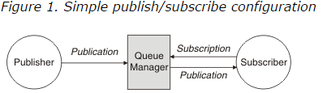

LINIIS interfaces implement both roles (sometimes at the same time):

* LINIIS as a publisher: LINIIS provides data for other application or publishes a request for data
* LINIIS as a subscriber: LINIIS processes incoming events and data created by other systems

An exemplary process flow could look like this:

1. LINIIS publishes a request on Queue A (e.g. “Create Letter”)
2. LINIIS subscribe to Queue B for the response
3. External application is subscribed to Queue A and processes the request
4. External application publishes the result (the letter) on Queue B
5. LINIIS processes the response on Queue B (the letter)

The implementation strategy depends on the MQ role of LINIIS

**Code refactoring:**   
MQ driver programs have to be refactored to use large A() fields instead of Arrays of A(1).

### LINIIS as a publisher

An interface with MQ has already been implemented and is used during the rollout. A (migrated) Natural Subprogram wraps the parameters and puts the message on a queue.

No additional implementation required.

### LINIIS as a subscriber

If LINIIS acts as a subscriber two different scenarios have to be considered:

* Scenario 1: “One time subscriber”: LINIIS publishes a request and subscribes to the response. This has already been implemented in production.
* Scenario 2: “LINIIS as a service”: LINIIS subscribed to a queue as a general service provider (consumer). In this case a “server process” has to be implemented and subscribed to the queue.

TODO: Details on Service process

## FTP

### FTPS

### SFTP

### FTP

## Processes remaining on the Mainframe

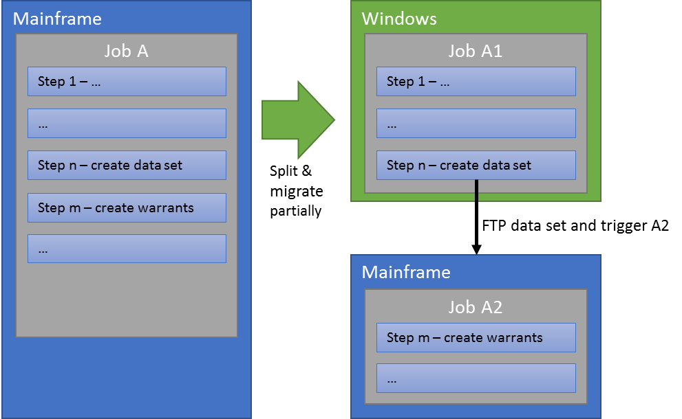

### FTP synchronization: Mainframe 🡪 Windows

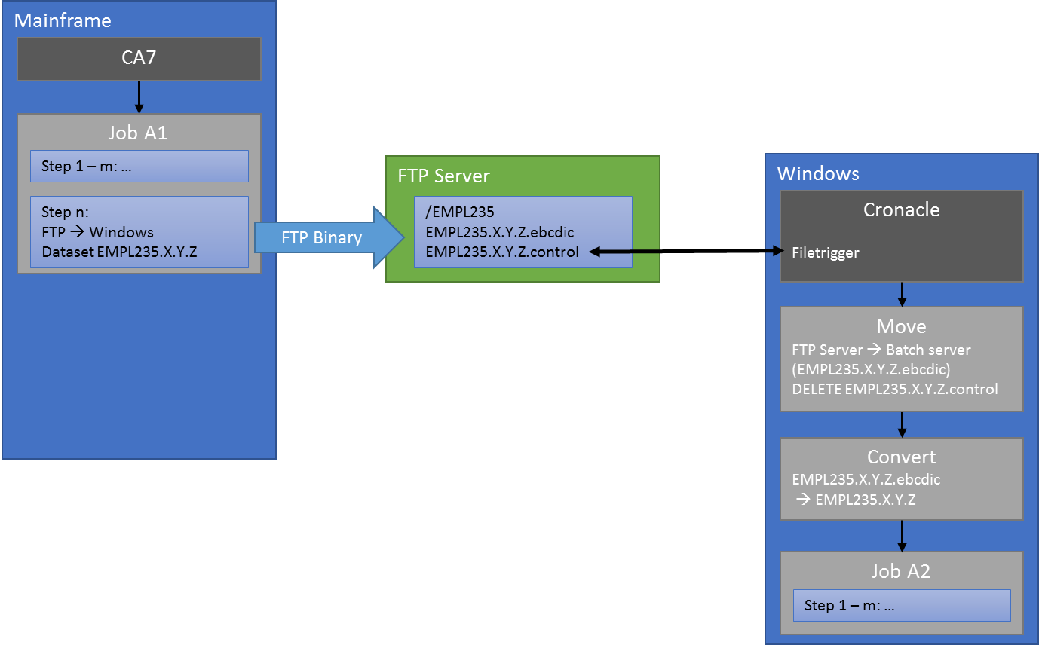

To synchronize data from the mainframe to Windows the datasets have to be FTP’d as binary and then converted using innoWake utilities to keep data integrity on binary fields such as packed, negative numerics and binaries.

**Mainframe:**

* CA7 submits the job on the mainframe
* The last step of this job transfers all datasets to a defined location on the existing SFTP servers.   
  The transfer has to be run in BINARY mode.   
  The target files are named DSN.ebcdic  
  If the files exist the Mainframe job abends.
* After successful transfer the mainframe job creates an empty file *.control

**Windows:**

* Cronacle has a file trigger for the *.control file. When this file arrives Cronacle will:
* Move (Copy + delete) the *.ebcdic files to the batch server
* Trigger a conversion job for the files (EBCDIC 🡪 ASCII) and rename the output file to its original name (no extension)
* Catalog the files in maxenso batch
* Submit the windows part of the original job.

### FTP synchronization: Windows 🡪 Mainframe

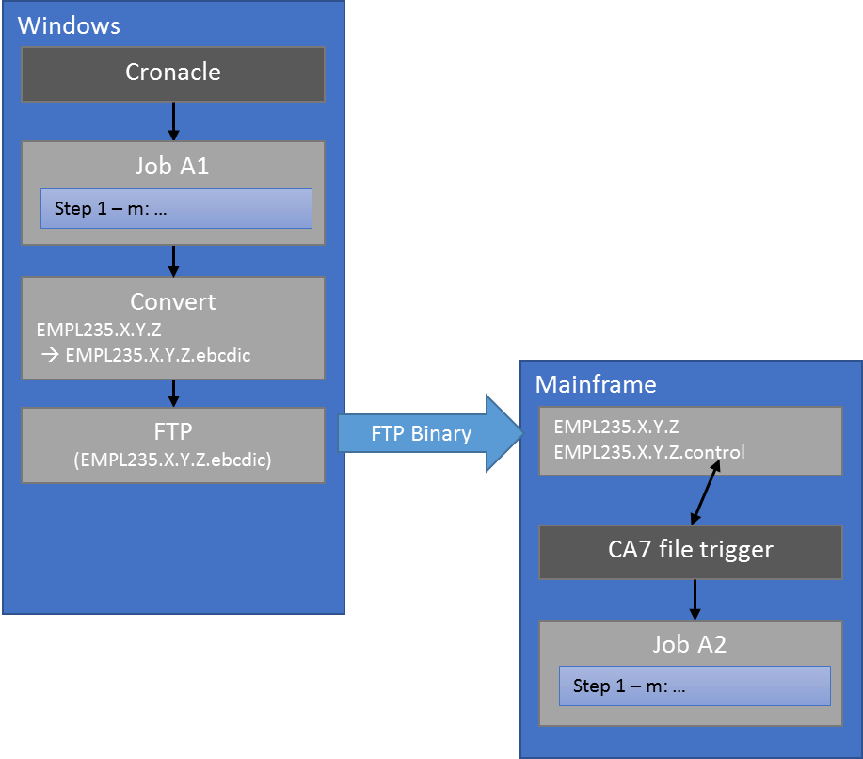

**Windows:**

* Cronacle triggers the windows part of the job
* After completion Cronacle triggers a conversion job (ASCII to EBCDIC) for each file
* The converted copy of the file is then FTPd (BINARY mode, initiated through Cronacle) to the mainframe
* After successful completion of all file transfers a control file is FTPd to the mainframe.

**Mainframe:**

* CA7 triggers the mainframe part of the job on the creation of the control file.
* After successful completion of the job the control file is deleted.

## EOS Document repository

Replace with file shares.

## Shared datasets

LINIIS creates/updates dataset 🡪 Upload to the mainframe

LINIIS reads datasets 🡪 Pull data from the mainframe

LINIIS reads and updates datasets: Two way sync.

The sync will be implemented in the schedule. For details see the sections FTP synchronization: Mainframe 🡪 Windows and FTP synchronization: Windows 🡪 Mainframe

## Job archiving (JARS)

The job output files are kept on the server. Archiving is not required. If necessary additional tools can be implemented after cutover.

## Online (Web) Interface

Regular online interface. Might require configuration of different entry points (URLs)

URLs:

* Development: <http://liniisweb.dev.wads.wa.gov/>
* Integration: <http://liniisweb.unit-test.wads.wa.gov/liniis/>
* Pre production: <http://liniisweb.test-inside.lni.wa.gov>
* Production: <http://liniisweb.apps-inside.lni.wa.gov>

## Shared Adabas

The MIPS interface is accessing LINIIS data directly through Adabas. MIPS will be changed to use either file exchange (data extracts) and/or MQ service calls to retrieve and update data. Details are documented within the MIPS interface subproject.

## Printing

LINIIS uses multiple printers and print options like FORMS and overlays.

The printers are already accessed through Windows print servers. The maxenso batch environment is configured similar to the mainframe and the same printers will be used. Forms and overlays are managed through the print servers and maxenso batch will be setup accordingly

List of known printers / output destinations:

* IBM2
* LOCAL
* N5
* R13
* R446
* RMT13
* RMT58
* RSD155
* RSD235
* U29
* U9235
* VPS
* WADIS
* WDPSC
* WLINPRT
* X013
* X058
* X58

## Demand-in batch jobs / schedules

LINIIS has functionality built in to demand in jobs through CA7. The following ways of submitting jobs dynamically are known:

* NATRJE  
  Natural utility to generate and submit jobs. Generated jobs run immediately. Builtin to maxenso batch
* CA7BTI / CA7BTRM  
  CA7 utilities to demand in jobs dynamically.

# Detailed interface description

## ARC – Account Receivable and Collection system

The ARC is a LNI internal Windows/SQL system that interfaces that interfaces with LINIIS.

|  |  |
| --- | --- |
| Interface partner | LNI application (internal) |
| Point of contact | Barbara Jensen |
| Interface | MQ  FTP |
| MQ Services | Get:   * LNI.AR.CLM_PRI_DATA_CHNG.SUB.QL * LNI.AR.CREAT_LIPYMT.SUB.QL * LNI.AR.POST_BPS_RCPT.SUB.QL * LNI.AR.RCPT_ITEM.SUB.QL * TRDPTY_FINCL * LNI.AR.RCVBL_INFO_REQST.SUB.QL * LNI.AR.LOCKBX_TRNSMT.SUB.QL * LNI.AR.ADD_NOTE.SUB.QL   Put:   * LNI.AR.DEBTR_ADDR_UPDT.PUB.QR * LNI.AR.ADD_NOTE.PUB.QR * Post_Receipt * LNI.AR.AR_ADJMT.PUB.QR * FINANCIAL_TRANSMITTAL * TRDPTY_FINCL   Put and Get:   * LNI.AR.CLM_CLMT_RQST.PUB.QR * ClaimStandard * GPNameInfo * LNI.ARC.PARTY_ADDR_RQST.PUB.QR * LNI.AR.LIST_ACT_CLM_BY_ID.SUB.QL |
| FTP / Shared datasets | ARC 🡪 LINIIS   * ARC puts file on FTP server where it is pulled from through LINIIS. No change required   LINIIS 🡪 ARC   * LINIIS processes DSHS file and sends data to ARC (see MQ)   List of datasets:   * See list of jobs:  <http://share/projects/IS-Mainframe-Conversion/Project%20Deliverables/10-Interfaces/Interfaces%20Plan%20Documents/ARC/ARC%20LINIIS%20JOBS.xlsx> |
| Replacement strategy | No changes (MQ + FTP) |
| Test strategy | MQ:   * Initial MQ testing in development * Engage Core team for BPS testing and additional testing in integration * Include ARC interface testing in BPS testing   FTP (monthly reconciliation):   * ARC needs to provide production file on FTP server (test folder or rename the dataset) * Cronacle listens on the dataset and submits the job in pre-prod * Core team verifies the results * ARC US Bank Lockbox needs to be tested separately in coordination with US Bank   Tasks:   * Define dataset names / folder for FTP server (or if a test server is available) * Setup jobs in Cronacle * Verify US Bank access for job D50AR235 (ARC Lockbox) |

## Barcodes and Warrants

The Barcode & Warrant process remains on the mainframe until an enterprise solution will be implemented.

The actual document generation remains on the mainframe. The current jobs will be broken up into Mainframe and Windows processing. Additional “glue” needs to be added to the Windows scheduler (Cronacle, FTP) and the Mainframe scheduler CA7 (Trigger)

|  |  |
| --- | --- |
| Interface partner | LNI application (internal) |
| Point of contact | Tracy Johnston  Ron Newell |
| Interface type | Mainframe – Work file transfer |
| Affected jobs | See joblist <http://share/projects/IS-Mainframe-Conversion/Project%20Deliverables/8-Batch/Analysis%20and%20Preparation/Code%20change%20job%20assignments.xlsm> |
| Replacement strategy | Split jobs into Mainframe and Windows steps. Add file transfer and triggers to the schedules. |
| Test strategy | Changes are tested on the mainframe today. Triggering will be reviewed by second developer prior cutover |

## CAC – Claimant Account Center

|  |  |
| --- | --- |
| Interface partner | LNI application (internal) with external customers |
| Point of contact | Chip Taylor |
| Interface type | MQ – LINIIS as a Subscriber |
| MQ Services | TODO |
| Dependencies | **CAC affected by Reptor replacement** |
| Replacement strategy | Setup LINIIS Web as a service. |
| Test strategy | Switch MQ services over to Windows and test individually |

## Claims Mail

Enhanced Editor for LINIIS Mail and Mail templates.

|  |  |
| --- | --- |
| Interface partner | LNI application (internal) |
| Point of contact | Tracy Johnston  Lisa Bruney |
| Interface type | MQ – LINIIS as a subscriber |
| MQ Services | TODO |
| Dependencies | -- |
| Replacement strategy | Setup LINIIS Web as a service |
| Test strategy | Switch MQ services over to Windows and test individually. Engage core team in testing  TODO |

## ECS – Early Claims solution

SOA/Web based portal claims data entry application used to create claims that get populated to LINIIS afterwards

|  |  |
| --- | --- |
| Interface partner | LNI application (internal) |
| Point of contact | Margaret Larkey |
| Interface type | MQ – LINIIS as a subscriber  MQ – LINIIS as a publisher |
| MQ Services | TODO |
| Called Dependencies | Affected by Reptor replacement |
| Replacement strategy | Setup LINIIS Web as a service |
| Test strategy | Switch services to Windows and test individually. Include MMM (Message ranking system in testing)  TODO |

## EOS – Enterprise Output Solution

LINIIS batch document repository. Used to archive reports and job output

|  |  |
| --- | --- |
| Interface partner | LNI application (internal) |
| Point of contact | Tom Henderson  Kris Hylton |
| Interface type | Batch  EOS is implemented as a file share on Windows. Printers etc. are configured to copy the generated output there. |
| Jobs / Reports | TODO |
| Replacement strategy | Push generated output to Sharepoint |
| Test strategy | TODO |

## Shared datasets: Exch235 + other agency specific datasets

LINIIS and other (Mainframe) applications share data through shared datasets. Updates can go both ways between LINIIS and the other application.

|  |  |
| --- | --- |
| Interface partner | TODO – list all parties |
| Point of contact | TODO – list all parties |
| Interface type | Shared dataset on the mainframe |
| Datasets | TODO – list all datasets (see Liniis_Interfaces_Plan.xlsx) |
| Replacement strategy | Phase 1: Preparation for cutover and cutover: - Implement sync between Mainframe and Windows  Phase 2: After cutover: Migrate non mainframe applications to directly transfer the data |
| Test strategy | TODO |

## JARS – JCL Archive Retrieval System

Mainframe application to archive the LINIIS job output.

|  |  |
| --- | --- |
| Interface partner | LINIIS developers / auditors |
| Point of contact | Tom Henderson |
| Interface type | Batch (JCL) |
| Replacement strategy | maxenso batch – the batch output is kept on the batch server |
| Test strategy | No test required |

## Lockbox

External interface. US Bank uses Lockbox to enter check numbers and information.

|  |  |
| --- | --- |
| Interface partner | US Bank – Online interface (external) |
| Point of contact | Kent Schweikert |
| Interface type | Online / Web interface |
| Replacement strategy | Part of the online LINIIS application.  Implemented as part of the “External User solution” |
| Test strategy | Tested as part of the “External User solution” |

## MIPS – Medical Information and Payment System

MIPS processes LINIIS Adabas data.

|  |  |
| --- | --- |
| Interface partner | LNI application (internal) |
| Point of contact | Patrick Woods |
| Interface type | Shared Adabas |
| Shared data | **Shared Adabas**  Batch   * TODO Full list of batch jobs required   Shared Datasets   * TODO list of datasets ( |
| Replacement strategy | Batch   * Split jobs between Mainframe and Windows where possible   Online / Batch   * Implement MQ services to provide the data * TODO Define full list of services / required changes   Shared Datasets   * Split jobs and synchronize datasets between MF and Windows |
| Test strategy | TODO |

## Orion

Windows and Browser based imaging and claims management tool. Multiple interfaces with LINIIS:

* Prepopulates data on LINIIS screens (online)

|  |  |
| --- | --- |
| Interface partner | LNI application (internal) |
| Point of contact | Tracy Johnston  Ron Newell  Kent Schweikert |
| Interface type | MQ: LINIIS as a subscriber  MQ: LINIIS as a publisher  JCL (TEXT2TIFF) |
| MQ service / queues | TODO |
| JCL | Jobs that FTP files directly to ORION:   * X2114235 * X10RA235 * X15RA235 * AL@22235 * BL@22235 * D3022235 * ML@22235 * QL@22235   Jobs that FTP to ECORR for forwarding to ORION:   * W1114235 * W1214235 * D11RA235   EASE jobs that FTP to Orion and Ecorr using APKACIF   * D0815235 * D9615235 * D9715235 * W1015235 |
| Replacement strategy | MQ: Setup LINIIS as a service  JCL: Split JCL to run text2tiff on the mainframe |
| Test strategy | TODO |

## RAP – Rating Adjustment Process

Cobol subsystem of LINIIS. Migrated to Java. Not an interface.

## Rates

Subsystem of LINIIS and migrated to Java. Not an interface.

## Replication (Reptor replacement)

LINIIS database replication. The Reptor migration is managed as a separate project. This entry is for tracking purposes only. Several other interfaces depend on Reptor.

|  |  |
| --- | --- |
| Interface partner | LNI application (internal) |
| Point of contact | Tom Henderson  Kris Johnson  Robert Barrett  Allan Gregerson (Data Warehouse |
| Interface type | MQ |
| Replacement strategy | Replaced by distributed SQL server replication |
| Test strategy | Separate project |

## Structured Settlement

Windows based application provides a one-time payout to the claimant.

|  |  |
| --- | --- |
| Interface partner | LNI application (internal) |
| Point of contact | Margaret Larkey |
| Interface type | MQ: LINIIS as a subscriber  MQ: LINIIS as a publisher |
| MQ services / queues | TODO |
| Replacement strategy | Implement LINIIS as a service |
| Test strategy | TODO |

## Osha

Federal agency - LINIIS sends data through Osha server hosted at LNI.

|  |  |
| --- | --- |
| Interface partner | Feds (external) |
| Point of contact | Andy Bakko |
| Interface type | TODO File based ?? FTP? |
| Datasets | TODO |
| Replacement strategy | TODO |
| Test strategy | TODO |

## Quickfile, DeluxeFile, ExpressFile

Employers file their premiums online

|  |  |
| --- | --- |
| Interface partner | External users |
| Point of contact | Dennis Hoffer  Alfred Patterson (path235) |
| Interface type | * Database replication (REPTOR) * Message Queues   + MQ: LINIIS as a subscriber     - “Regular” queue – Liniis is processing incoming messages immediately     - “Batch queue” – Incoming messages are queued until a batch job processes them at night   + MQ: LINIIS as a publisher * FTP LINIIS sends file to the FTP server where it is picked up by interface partner |
| Datasets | TODO |
| Message queues | EXPFILDataChng   * LNI.EMPL.EXPFIL_DATA_CHNG_TRAN.PUB.QR * LNI.EMPL.ERRORS.QL   EASERcpt   * LNI.EMPL.EASE_RCPT.PUB.QR * LNI.EMPL.ERRORS.QL   QrtlyPremRpt   * LNI.EMPL.QRTLY_PREM_RPT.PUB.QR * LNI.EMPL.QRTLY_PREM_RPT.ERROR.QL |
| Replacement strategy | Database replication   * Replaced as part of the REPTOR project. No changes on the interface partner’s side required.   Message Queues   * Replaced with Windows implementation. No changes on the interface partner’s side required.   FTP   * No changes to the process. LINIIS sends file to the FTP server where it is picked up by the partner |
| Test strategy | Database replication   * Tested as part of the REPTOR project.   Message queues   * “Regular queues” – coordinate testing with interface partner * “Batch queue” – Interface partner creates messages, Submit Liniis batch job to process messages   FTP   * Run job that sends the file to the FTP server on Windows * Quickfile tries to process generated file. |

## HRMS

|  |  |
| --- | --- |
| Interface partner | HRMS |
| Point of contact | Lisa Copen |
| Interface type | FTP  HRMS creates a file (\\lnixdbolysql9\LNIJobs\OHR\HRIEMP\hriemp.txt) and FTP’s it to the mainframe as : SHM235.P.HRIEMP.EXTRACT  Then jobs D01SH235 and D6815235 process that file |
| Datasets | * SHM235.P.HRIEMP.EXTRACT |
| Replacement strategy | * Prior cutover: FTP the file to the mainframe and copy it to a windows share * Cronacle triggers jobs D01SH235 and D6815235 accordingly * After cutover: Remove the FTP upload to the mainframe |
| Test strategy | * HRMS sends file to LINIIS windows. * Submit job to process file – verify results (could be part of OAT) |

## Internal Auditors (CAATS)

|  |  |
| --- | --- |
| Interface partner | Internal Auditors |
| Point of contact |  |
| Interface type | Manual file transfer Ron Newell transfers files from the mainframe and then processes them |
| Datasets | BPS Daily Warrants BPS235.P.TRSR.PRINT.WARRANTS  Crime Victims Warrants CVI235.P.W1534235.WARRANTS  EASE Data Files EASE235.P.M1415.REPORT0  Employer Services Ref. EASE235.P.W07.WARRANTS  MIPS Warrants MPI235.P.B1533235.WARRANTS  Pension Monthly Warr. PEN235.P.M1120.PRINT.WARRANTS  Pension Pay Daily Warrants   PEN235.P.BSP20.PRINT.WARRANTS  Retro Refunds RETR235.P.A8022.WARRANTS.OUT |
| Replacement strategy | Manual process – copy file from Windows |
| Test strategy | * Run Windows job to generate transfer files * Manual copy and test run on the other end |

## Purchasing system

|  |  |
| --- | --- |
| Interface partner | Purchasing system |
| Point of contact |  |
| Interface type | FTP   * Purchasing system is pushing datasets to the mainframe (APS jobs on Windows) * Liniis processes it and creates another output file for a FSMG125 job on the mainframe |
| Datasets | TODO |
| Replacement strategy | * Windows APS jobs are changed to copy the files to LINIIS (Windows) and the mainframe. * LINIIS processes the file and FTPs it to the mainframe where it gets picked up by other jobs. * After cutover the upload to the mainframe is removed. |
| Test strategy | * HRMS sends file to LINIIS windows. * Submit job to process file – verify results |

## E-corr

|  |  |
| --- | --- |
| Interface partner | E-corr |
| Point of contact |  |
| Interface type | File transfer and MQ message |
| Datasets | TODO |
| Replacement strategy | The interface is part of a “A2BTMAIN” job which remains on the mainframe. No changes necessary |
| Test strategy | * Submit the windows part of the job and monitor all triggering and processes on the mainframe. |

# Detailed contact information

|  |  |  |
| --- | --- | --- |
| Name | Contact | Contact for |
| Barbara Jensen (LNI) | jenh235  (360) 902 5547  [barbara.jensen@lni.wa.gov](mailto:barbara.jensen@lni.wa.gov) | ARC |
| Tracy Johnston (LNI) | joht235  (360) 902 5121  [tracy.johnston@lni.wa.gov](mailto:tracy.johnston@lni.wa.gov) | Barcodes & Warrants  Claims Mail |
| Ron Newell (LNI) | neww235  (360) 902 6405  [ronald.newell@lni.wa.gov](mailto:ronald.newell@lni.wa.gov) | Barcodes & Warrants |
| Chip Taylor (LNI) | tayf235  (360) 902 5950  [jesse.taylor@lni.wa.gov](mailto:jesse.taylor@lni.wa.gov) | CAC |
| Lisa Bruney (LNI) | brul235  (360) 902 5528 | Claims Mail |
| Margaret Larkey (LNI) | lara235  (360) 902 5970  [margaret.larkey@lni.wa.gov](mailto:margaret.larkey@lni.wa.gov) | ECS  Structured Settlement |
| Tom Henderson (LNI) | hent235  (360) 902 5861  thomas.henderson@lni.wa.gov | EOS |
| Kris Hylton (LNI) | hylk235  (360) 902 5930  [kris.hylton@lni.wa.gov](mailto:kris.hylton@lni.wa.gov) | EOS |
| Kent Schweikert (LNI) | schi235  (360) 902 5925  [kent.schweikert@lni.wa.gov](mailto:kent.schweikert@lni.wa.gov) | Lockbox / US Bank |
| Patrick Woods (LNI) | wopa235  (360) 902 6355  [patrick.woods@lni.wa.gov](mailto:patrick.woods@lni.wa.gov) | MIPS |
| Kris Johnson (LNI) | kris235  (360) 902 5389  [kris.johnson@lni.wa.gov](mailto:kris.johnson@lni.wa.gov) | Reptor |
| Robert Barrett (LNI) | barr235  (360) 902 5867  [robert.barrett@lni.wa.gov](mailto:robert.barrett@lni.wa.gov) | Reptor |
| Allan Gregerson (LNI) | grea235  (360) 902 5577  [richard.gregerson@lni.wa.gov](mailto:richard.gregerson@lni.wa.gov) | Reptor |
| Andy Bakko | bakk235  (360) 902 5902  [andrew.bakko@lni.wa.gov](mailto:andrew.bakko@lni.wa.gov) | Osha |
| Dennis Hoffer | hoff235  (360) 902 5962  [dennis.hoffer@lni.wa.gov](mailto:dennis.hoffer@lni.wa.gov) | QuickFile |

# Linked Documents

* ARC – Interface jobs:  
  <http://share/projects/IS-Mainframe-Conversion/Project%20Deliverables/10-Interfaces/Interfaces%20Plan%20Documents/ARC/ARC%20LINIIS%20JOBS.xlsx>
* ARC – MQ services:  
  <http://share/projects/IS-Mainframe-Conversion/Project%20Deliverables/10-Interfaces/Interfaces%20Plan%20Documents/ARC/ARC-Mainframe%20msg%20table.xlsx>
* Barcodes & Warrants – code changes (job splitting):  
  <http://share/projects/IS-Mainframe-Conversion/Project%20Deliverables/8-Batch/Analysis%20and%20Preparation/Code%20change%20job%20assignments.xlsm>
* d