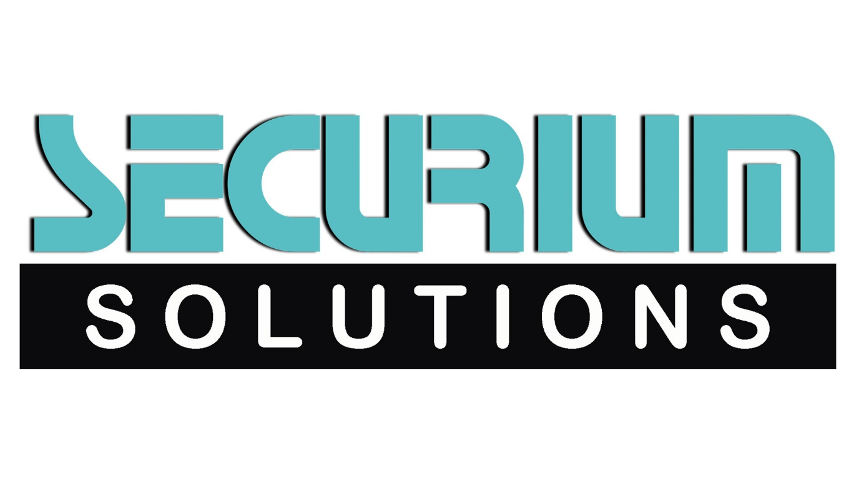

SUMMARY OF ONLINE PLATFORMS – TEACHABLE, UDEMY, UNACADEMY

**Teachable Platform:**

Teachable is an all-in-one platform that helps you create and sell courses online. Teachable handles everything from web hosting to payment processing. We want to give you more time so you can focus on what matters—creating awesome online courses.

**Advantages:**

* Landing pages, Blog, an easy-to-use course builder and a nice course interface.
* Video hosting, Quizzes & discussions.
* Good pricing scheme (you can get started for free) and good support.
* Integrations with other services, eCommerce functionality.
* You're dealing with your students and your courses and data are yours.
* What Teachable doesn't offer, is a course marketplace (like Udemy). You run your own "school".
* For the most part, you're in control of your classroom/job.

**Disadvantages:**

* You need to do your own marketing.
* If you don't drive traffic to your school, you won't sell your courses.
* Compared to full-featured LMS, the functionality and course components you can use are still a little limited.
* Very long work days/weeks - 10+ hours/day, sometimes six days a week, not including bringing work home.
* Low pay when considering the amount of education required to become a credentialed teacher.
* High stress job - demanding parents, difficult students, unrealistic educational expectations from the administration/state (ie. No Child Left Behind), non-supportive administrators, etc.
* Long relatively useless meetings.

**Udemy Platform:**

Udemy is an online learning platform where over 24 million students can take courses in a variety of subjects. With over 100,000 courses available and over 42,000 instructors teaching everything from programming to knitting, Udemy is a great resource for learning a new skill at a reasonable price.

All topics from programming to marketing and much more. Their Development category has courses on web development, software engineering, data science, machine learning, and just about every programming language under the sun. Look in the IT & Software category for courses on topics like cybersecurity, AWS, ethical hacking, various operating systems, and more.

**Advantages:**

* Relatively inexpensive to take a course.
* Learn at your own pace.
* Straightforward and user-friendly course layout.
* 100,000+ courses available.
* 80+ languages represented.
* 30-day money back guarantee.

**Disadvantages:**

* Restrictions on communication between instructors and students.
* Instructors are not always attentive to students.
* One-size-fits-all approach in teaching; no personalization.
* Courses can be created by anyone, with minimal vetting on behalf of Udemy.
* The certificate may not have a approved validity in your professional circle. So, you should take the courses only for the purpose of knowledge.
* Some courses may not be able to give you everything that you want.

**Unacademy Platform:**

Unacademy is an online platform to provide free education to the masses and change the landscape of education in India. This is a novel initiative with its popularity increasing with each passing day. However, being a UPSC aspirant myself, I can throw some light on the pros and cons that are associated with this platform:

**Advantages:**

* This website provides current affairs for UPSC and associated mock questions on a daily basis.
* The tutorials are short, crisp and the cost benefit ratio from these lessons of hardly 10 minutes is very high.
* Some of the former bureaucrats like @Roman Saini and @Awdhesh Singh (अवधेश सिंह) are directly involved in delivering lectures which enhances the credibility and authenticity of the lessons.
* This channel focuses not only on academics but also on some of the peripheral aspects that help you in enhancing your productivity. No such online platform has this novel feature.

**Disadvantages:**

* Most of the lessons that are started by the channel are not taken to their legitimate end. As a result the trust factor in the courses of unacademy is still a far fetched thing.
* Too many number of courses are started without proper planning and no fixed sequence is followed. As a result the channel seems like a book shop where the aspirants have to use their own wisdom to selectively enrol for the lessons.
* Even though, a large number of courses are started, but in some topics the depth that is required to crack the question from a particular topic is missing.
* The channel, rather than focussing on the content, focusses more on “how to do this in 10 days, how to do that, how to do this” which is not really relevant from the exam point of view.