**Bordario, Sid Andre P.  
  
CpE 3105: Computer Networks and Security**

**Skills Assessment 1**

**Instructions**

In this assessment, you will create a small network shown in the topology below, using your Packet Tracer and configure its devices. Configure the routers, switches and PCs to support IPv4 connectivity. Use the following resources: 1 **Cisco 2911 Router**, 3 **Cisco 2960 Switches** and 3 **PCs**. Follow the connections and its ports as shown in the topology.

**Topology**

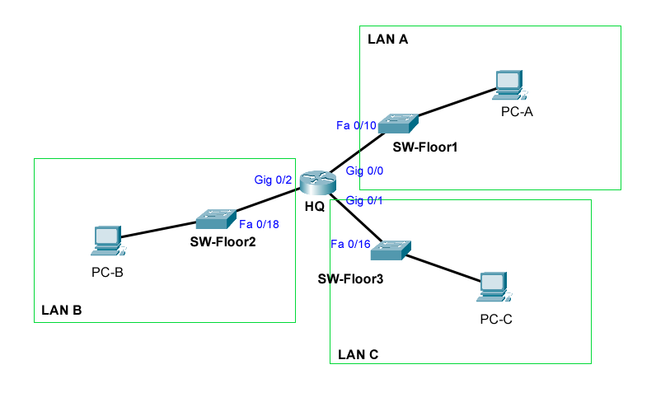

**IPv4 Addressing Scheme**

Given the network address shown below, design an IP addressing scheme that satisfies the requirement.

|  |  |
| --- | --- |
| **LAN** | **Network Address** |
| LAN A | 172.18.0.0/24 |
| LAN B | 10.0.0.0/16 |
| LAN C | 192.168.0.0/24 |

The host computers will use the **LAST** available IP address in the given network. Switches will use the **second to the last** available host address. Ports on the network router will use the **FIRST** available host address. Write down the IP address information for each device: (use red font)

|  |  |  |  |  |
| --- | --- | --- | --- | --- |
| **Device** | **Interface** | **IP Address** | **Subnet Mask** | **Default Gateway** |
| HQ | Gig 0/0 | 172.18.0.1 | 255.255.255.0 | NA |
| Gig 0/1 | 10.0.0.1 | 255.255.0.0 | NA |
| Gig 0/2 | 192.168.0.1 | 255.255.255.0 | NA |
| SW-Floor1 | VLAN 1 | 172.18.0.253 | 255.255.255.0 | 172.18.0.1 |
| SW-Floor2 | VLAN 1 | 10.0.255.253 | 255.255.0.0 | 10.0.0.1 |
| SW-Floor3 | VLAN 1 | 192.168.0.253 | 255.255.255.0 | 192.168.0.1 |
| PC-A |  | 172.168.0.254 | 255.255.255.0 | 172.18.0.1 |
| PC-B |  | 10.0.255.254 | 255.255.0.0 | 10.0.0.1 |
| PC-C |  | 192.168.0.254 | 255.255.255.0 | 192.168.0.1 |

**Configure Device IPv4 and Security Settings**

1. Configure the host computers. Use the IP addresses you provided on the address table above.
2. Configure HQ. Configuration tasks for HQ include the following:
   1. Router Name: **HQ**
   2. Encrypted privileged EXEC password: **cpe3105**
   3. Console access password: **usccpe**
   4. Telnet access password: **usccpevty**
   5. Encrypt the clear text passwords
   6. Provide the message of the day: **Warning! You are entering HQ router.**
   7. Interface Gig 0/0: Set the layer 3 IPv4 Address, Set a description, and activate interface
   8. Interface Gig 0/1: Set the layer 3 IPv4 Address, Set a description, and activate interface
   9. Interface Gig 0/2: Set the layer 3 IPv4 Address, Set a description, and activate interface
3. Configure the switches. Configuration tasks include the following:
   1. Switch names. Refer to the address table above.
   2. Set the Layer 3 IPv4 address on the vlan1 interface of each switch. Provide the default gateway as well.
   3. Encrypted privileged EXEC password: **cpe3105**
   4. Console access password: **usccpe**
   5. Telnet access password: **usccpevty**
   6. Encrypt the clear text passwords
   7. Provide the message of the day: **Welcome to** *<hostname>* **switch!**
4. Verify the network connectivity. Use the ping command to test the connectivity between all network devices. Use the following table to methodically verify connectivity with each network device:

|  |  |  |  |
| --- | --- | --- | --- |
| **From** | **To** | **IP Address** | **Ping Results** (success,fail) |
| PC-A | HQ, G0/0 | 172.18.0.1 | success |
| PC-A | HQ, G0/1 | 10.0.0.1 | success |
| PC-A | HQ, G0/2 | 192.168.0.1 | success |
| PC-A | SW-Floor1 | 172.18.0.253 | success |
| PC-A | SW-Floor2 | 10.0.255.253 | success |
| PC-A | SW-Floor3 | 192.168.0.253 | success |
| PC-A | PC-B | 10.0.255.254 | success |
| PC-A | PC-C | 192.168.0.254 | success |
| PC-B | HQ, G0/0 | 172.18.0.1 | success |
| PC-B | HQ, G0/1 | 10.0.0.1 | success |
| PC-B | HQ, G0/2 | 192.168.0.1 | success |
| PC-B | SW-Floor1 | 172.18.0.253 | success |
| PC-B | SW-Floor2 | 10.0.255.253 | success |
| PC-B | SW-Floor3 | 192.168.0.253 | success |
| PC-B | PC-A | 172.168.0.254 | success |
| PC-B | PC-C | 192.168.0.254 | success |
| PC-C | HQ, G0/0 | 172.18.0.1 | success |
| PC-C | HQ, G0/1 | 10.0.0.1 | success |
| PC-C | HQ, G0/2 | 192.168.0.1 | success |
| PC-C | SW-Floor1 | 172.18.0.253 | success |
| PC-C | SW-Floor2 | 10.0.255.253 | success |
| PC-C | SW-Floor3 | 192.168.0.253 | success |
| PC-C | PC-A | 172.168.0.254 | success |
| PC-C | PC-C | 192.168.0.254 | success |

1. Save your packet tracer file as **SKA1.pkt** and submit it together with this document (saved as **SKA1.pdf**) in your Canvas.