CpE 3105: Computer Networks and Security
Skills Assessment 2

Instructions

In this assessment, you will create a small network shown in the topology below, using your Packet Tracer and configure its devices. Configure the routers, switches and PCs to support IPv4 connectivity. Use the following resources: 1 Cisco 2911 Router, 3 Cisco 2960 Switches and 3 PCs. Follow the connections and its ports as shown in the topology.

Topology

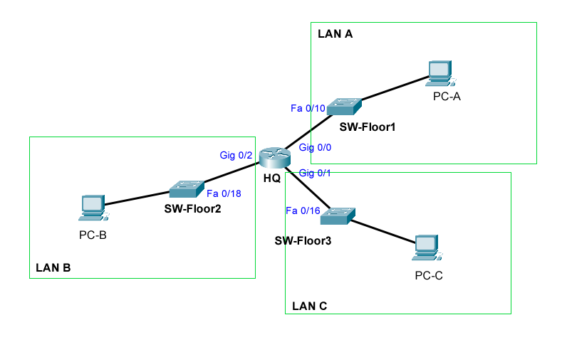

IPv4 Addressing Scheme
Given the network address shown below, design an IP addressing scheme that satisfies the requirement.

Network | Number of Hosts in LAN A | Number of Hosts in LAN B | Number of Hosts in LAN C
10.0.0.0/8 | 5 | 100 | 50

The host computers will use the LAST available IP address in the given network. Switches will use the second to the last available host address. Ports on the network router will use the FIRST available host address. Write down the IP address information for each device: (use red font)

Device | Interface | IP Address | Subnet Mask | Default Gateway
HQ | Gig 0/0 | 10.0.0.193 | 255.255.255.248 | NA
HQ | Gig 0/1 | 10.0.0.129 | 255.255.255.192 | NA
HQ | Gig 0/2 | 10.0.0.1 | 255.255.255.128 | NA
SW-Floor1 | VLAN 1 | 10.0.0.197 | 255.255.255.248 | 10.0.0.193
SW-Floor2 | VLAN 1 | 10.0.0.125 | 255.255.255.128 | 10.0.0.1
SW-Floor3 | VLAN 1 | 10.0.0.189 | 255.255.255.192 | 10.0.0.129
PC-A |  | 10.0.0.198 | 255.255.255.248 | 10.0.0.193
PC-B |  | 10.0.0.126 | 255.255.255.128 | 10.0.0.1
PC-C |  | 10.0.0.190 | 255.255.255.192 | 10.0.0.129

Configure Device IPv4 and Security Settings

- Configure the host computers. Use the IP addresses you provided on the address table above.
- Configure HQ. Configuration tasks for HQ include the following:
  - Router Name: HQ
  - Encrypted privileged EXEC password: cpeenpass
  - Console access password: cpeconpass
  - Telnet access password: admin1pass
  - Encrypt the clear text passwords
  - Provide the message of the day: You are in HQ router.
  - Interface Gig 0/0: Set the layer 3 IPv4 Address, Set a description, and activate interface
  - Interface Gig 0/1: Set the layer 3 IPv4 Address, Set a description, and activate interface
  - Interface Gig 0/2: Set the layer 3 IPv4 Address, Set a description, and activate interface
- Configure the switches. Configuration tasks include the following:
  - Switch names. Refer to the address table above.
  - Set the Layer 3 IPv4 address on the vlan1 interface of each switch. Provide the default gateway as well.
  - Encrypted privileged EXEC password: cpeenpass
  - Console access password: cpeconpass
  - Telnet access password: admin1pass
  - Encrypt the clear text passwords
  - Provide the message of the day: Welcome to <hostname> switch!
- Verify the network connectivity. Use the ping command to test the connectivity between all network devices. Use the following table to methodically verify connectivity with each network device:

From | To | IP Address | Ping Results (success,fail)
PC-A | HQ, G0/0
PC-A | HQ, G0/1
PC-A | HQ, G0/2
PC-A | SW-Floor1
PC-A | SW-Floor2
PC-A | SW-Floor3
PC-A | PC-B
PC-A | PC-C
PC-B | HQ, G0/0
PC-B | HQ, G0/1
PC-B | HQ, G0/2
PC-B | SW-Floor1
PC-B | SW-Floor2
PC-B | SW-Floor3
PC-B | PC-A
PC-B | PC-C
PC-C | HQ, G0/0
PC-C | HQ, G0/1
PC-C | HQ, G0/2
PC-C | SW-Floor1
PC-C | SW-Floor2
PC-C | SW-Floor3
PC-C | PC-A
PC-C | PC-C

- Save your packet tracer file as SKA2.pkt and submit it together with this document (saved as SKA2.pdf) in your Canvas.

enable
configure terminal
hostname HQ

enable secret cpeenpass
service password-encryption
banner motd "You are in HQ router."

line console 0
password cpeconpass
login
exit

line vty 0 4
password admin1pass
login
exit

interface gigabitEthernet 0/0
description Link to LAN A
ip address 10.0.0.193 255.255.255.248
no shutdown
exit

interface gigabitEthernet 0/1
description Link to LAN C
ip address 10.0.0.129 255.255.255.192
no shutdown
exit

interface gigabitEthernet 0/2
description Link to LAN B
ip address 10.0.0.1 255.255.255.128
no shutdown
end
Copy run start

enable
configure terminal
hostname SW-Floor1
enable secret cpeenpass
service password-encryption
banner motd "Welcome to SW-Floor1 switch!"

line console 0
password cpeconpass
login
exit
line vty 0 4
password admin1pass
login
exit

! IP Config
interface vlan 1
ip address 10.0.0.197 255.255.255.248
no shutdown
exit
ip default-gateway 10.0.0.193
end
Copy run start

enable
configure terminal
hostname SW-Floor2
enable secret cpeenpass
service password-encryption
banner motd "Welcome to SW-Floor2 switch!"

line console 0
password cpeconpass
login
exit
line vty 0 4
password admin1pass
login
exit

! IP Config
interface vlan 1
ip address 10.0.0.125 255.255.255.128
no shutdown
exit
ip default-gateway 10.0.0.1
end
Copy run start

enable
configure terminal
hostname SW-Floor3
enable secret cpeenpass
service password-encryption
banner motd "Welcome to SW-Floor3 switch!"

line console 0
password cpeconpass
login
exit
line vty 0 4
password admin1pass
login
exit

! IP Config
interface vlan 1
ip address 10.0.0.189 255.255.255.192
no shutdown
exit
ip default-gateway 10.0.0.129
end
write memory

