Portfolio

1. I will have 4 pages. In the first page I will have form when user will write his information with password. Second page will be main page for devops (normally this would be main page but because our teacher wanted form as home page this will be on next page). For the third page I will write what tools you can use for DevOps and in the last 4th page there will be user information that you wrote in form page.
2. In every page there will be same header and footer

1.page) It’s form so in this form there will be 9 input.

1. name
2. surname
3. gender
4. email
5. telephone
6. date of birth
7. password
8. confirmation of password
9. submit button

2.page) In this page I will make the main page that would be divided into half on left side there will be some quick info about devops just to make people interested in it and on the right side some nice picture that could go with it.

DevOps - DevOps is a collaborative approach to software and IT services that emphasizes automation and interoperability. It strives to simplify processes, break down silos, and provide continuous integration and delivery for faster and more reliable software releases.

3.page) This will be about tools you can use in DevOps

Git – is a version control system for tracking changes in code. It enables collaboration by allowing multiple developers to work on a project simultaneously. Git operates locally, allowing developers to create and merge branches for specific features. Its decentralized nature and branching capabilities make it a popular tool for software development.

Docker – is a platform for running applications in lightweight, portable containers, simplifying deployment and ensuring consistency across environments. It uses containerization to isolate applications and their dependencies, streamlining the development and distribution process.

Kubernetes - is an open-source platform for automating the deployment and management of containerized applications. It provides scalable, fault-tolerant orchestration, simplifying the deployment and scaling of applications in a cloud-native environment.

4.page) User information  
It will write everything that was saved into local storage through the 1page form

There should be:

1. name
2. surname
3. gender
4. email
5. telephone number
6. date of birth
7. password
8. the page how it looks

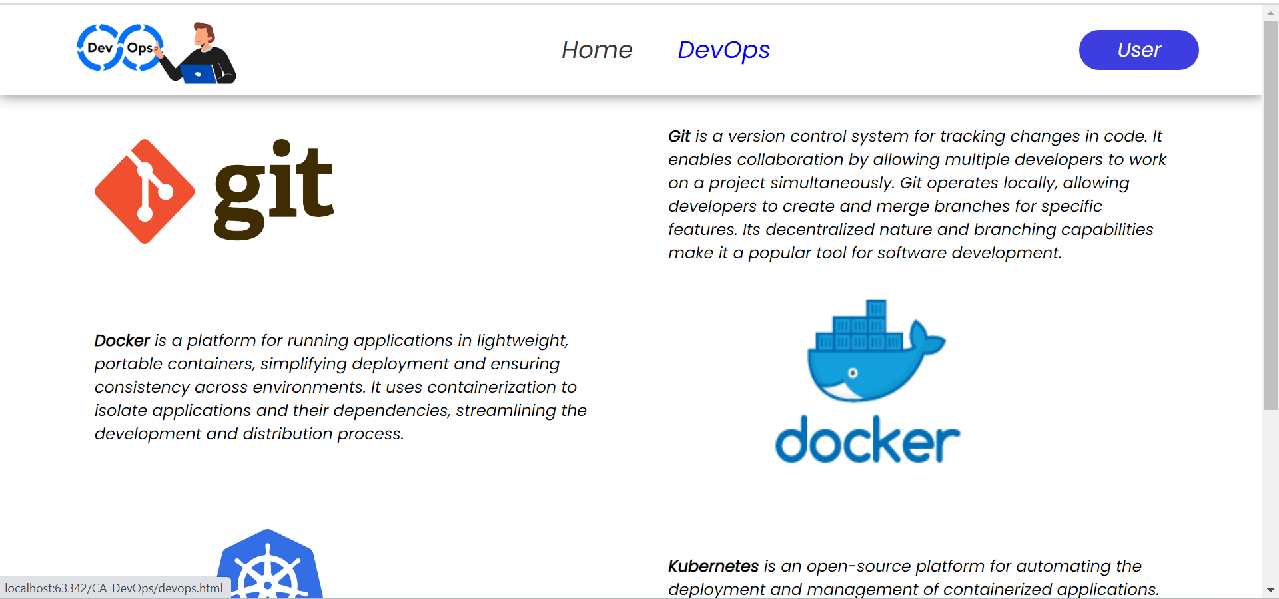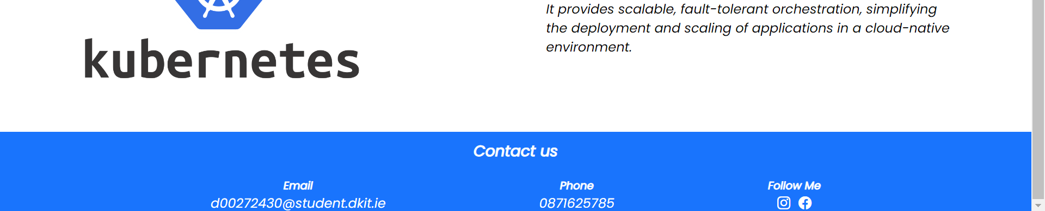

Reflection:  
The css and html part was easy for me because I was self learning the whole year a lot so I don’t have lot of references because I already did quite lot of stuff and remember them from in. Like flexbox that’s one of the first thing I learned and it was extremely useful in css. The worst part for me was javascript where I ended up in a lot of errors but I never back down from what I wanted to get. I visualized something I wanted and I couldn’t stop until it wasn’t finished the regex was quite hard for me I could’t understand it so I tried lot of different stuff I went to w3school to see the harder one and tried to get it from it and it turned out quite well I still think it can be done lot better or lot easier but I am glad with my result. The local storage was extremely hard and the hardest part was for me to write it down back to another page from local storage I couldn’t find any way to write it from local storage till I didn’t found video on youtube that gave me idea to improve my code. I use chatgpt as well for chatting with the bot and learning about something I don’t understand. And it’s the quickest way to find useful information instead of going through a lot webpages.

URL of the website: <https://mysql07.comp.dkit.ie/D00272430/CA_DevOps/>

Reference:  
<https://www.youtube.com/watch?v=fYTTUBa-lPc>

<https://www.youtube.com/watch?v=7y4f0Fx7XzY>

<https://www.w3schools.com/tags/att_input_pattern.asp>

<https://www.rexegg.com/regex-quickstart.html>

<https://chat.openai.com/>