Name:
Se'Deja Drigo
Project:
FreshCycle Flow - D1 Prototype Design & Setup Implementation
Link to Project:
https://marvelapp.com/prototype/11g5ibje
Test Cases:
- Access the Home Setup feature from the main menu, upload a floor plan, give it a name, and press continue.
- Tap on the floorplan to access the wide screen, then drag over the areas of the home where hampers are located, exit the wide screen, and press continue.
- Tap on the floorplan to access the wide screen, then drag over the areas where clothing is stored, exit the wide screen, and press continue.
- Tap on the floorplan to access the wide screen and verify that the selected areas are accurate, then exit the wide screen. Check that the floor plan summary is also accurate. If the information is correct, return to the home screen. If not, select edit to make changes.
Screens:
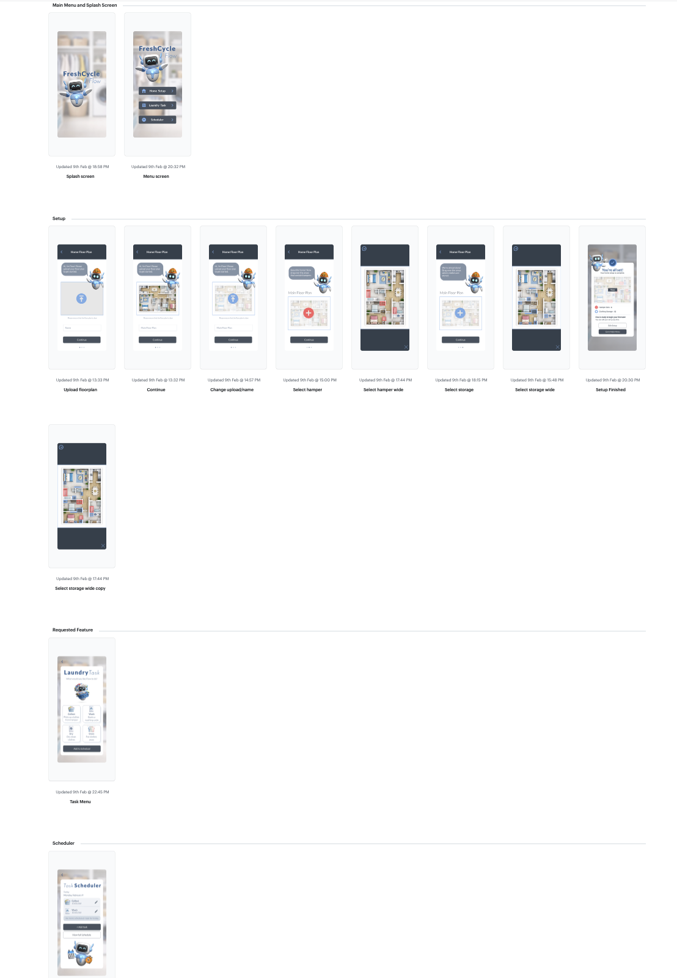
Citations list for all sources:
Tool: ChatGPT
Prompt used (floor plan):
Create a simple horizontal 2D floor plan layout of a home
Prompt used (robot – dirty laundry basket and clothes on head):
A cute floating 3D robot with no legs, rounded white body with soft blue accents, glossy plastic material, glowing blue circular chest light, small rounded arms, small blue ear fin shapes on both sides of the head, and a black face screen with soft cyan digital eyes. The robot must look exactly like the provided reference robot. The robot is holding a blue laundry basket filled with messy dirty clothes and also has a small pile of dirty clothes on its head. High quality 3D render with a transparent background.
Prompt used (task icons – collect):
Create a simple flat icon of a laundry basket filled with dirty clothes.
Prompt used (task icons – wash):
Create a simple flat icon of a washing machine.
Prompt used (task icons – dry):
Create a simple flat icon of a dryer.
Prompt used (task icons – store):
Create a simple flat icon of a clothing rack or hanger.
Prompt used (blurred laundry room background):
Create a blurred background of a modern laundry room/closet with soft lighting, shallow depth of field, and no people or subjects visible.
Tool: Canva
Source used (robot images and graphic elements):
Free robot images and graphic elements were selected from Canva’s built in free asset library. These assets were not AI generated and were used as visual references for ai and graphics within the prototype.

