

YAŞAR UNIVERSITY FACULTY OF ENGINEERING
DEPARTMENT OF COMPUTER ENGINEERING COMP 4811 INTERNSHIP

Internship Completion Report (Staj Sonuç Raporu) 20070001044
Seden Canpolat
20.08.2024

Etiya Bilgi Teknolojileri, İzmir 01.07.2024 - 16.07.2024
30 Workdays

Contents
1. Information About the Company/Organization 4
2. Evaluation of the Internship 4
1. Conclusions 7
2. Appendices and Supplementary Material 7
3. References 19

Information About the Company/Organization
- Briefly describe the company/organization.
Etiya is a software company which primarily focuses on customer relationship management (CRM), business support systems (BSS), artificial intelligence technologies and Digital Process Automation.

- What is the main sector of the business of the company/organization? Please write your observations and experience in the business sector.
Etiya operates in the software and technology sector, providing AI-based software solutions for telecommunications, media, and other industries. Their solutions are used across various operational teams, including management, online services, dealership networks, field teams, and end users.

- Describe the team you worked with.

I worked with the Flow-E team, including 12 people. My team was multidisciplinary, including developers, testers, and designers who collaborated on the project delivery. My team worked on an automation project, and I worked under the front-end development.

- What were your responsibilities in your team?
My responsibilities included developing separate front-end project tasks from the team and understanding Angular. In this project, my assignment was integrating APIs into a website, and working on UI design using HTML, CSS and Prime NG.

- Add some photographs taken in the organization, if possible

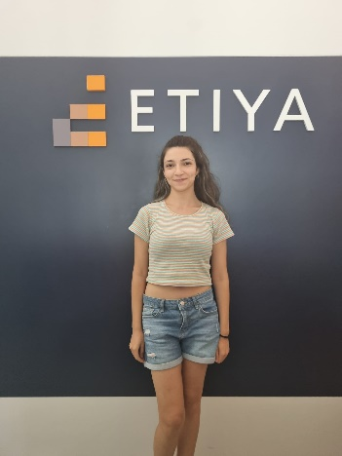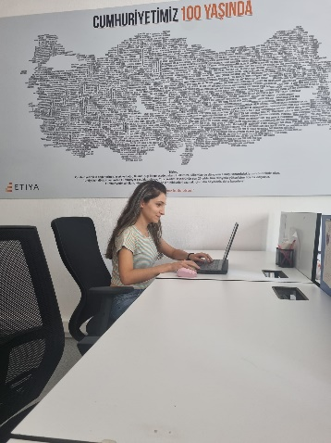

Evaluation of the Internship
  - Summarize your main internship activity in one sentence. If you have worked in different, that is, more than one, team/project of company/organization during your internship, write one sentence for each.
My primary activity was developing user interface components and integrating APIs into website using Angular and Prime NG.

  - Describe multidisciplinary nature of your team/project, if any. Also, describe if your team/project had any contacts to other groups/teams/projects of your company/organization for multidisciplinary work (for example cooperation for health certification with a quality group, etc)

The project involved integration with other internal CRM projects using a Low Code Strategy, requiring collaboration with teams across different departments to ensure smooth integration.

  - If you have given a presentation and/or have written a report about your work during your internship,
    - Describe and discuss all the documents that you have prepared in detail and if possible provide their copies in appendicies,
    - Describe if you have been given training for preparing the presentation and/or the report,
    - Describe if company/organization wide reporting and presentation rules and/or formats exist

i: During my internship, I regularly presented my work and submitted regular progress reports to my internship manager. These included the tasks I completed, the challenges I encountered, and the solutions I implemented. I gave my presentations directly on my project itself. I have attached a sample of my report in the appendix.

ii: I had not taken training for preparing the presentation and the report.

iii: My company did not expect me to obey specific reporting and presentation rules.

  - Regarding the team/project you work with;
    - Explain in detail standards used and certifications owned by the company/organization. For example, national/international standards, coding standards, quality/security certifications, etc.)
    - List and briefly explain the rules and regulations of your internship company/organization (such as Engineering/Business Ethics, Company Culture, Occupational Safety, Information Security, etc.)?
    - Describe if you have been given training for any of the above

i: Etiya follows ISO 27001 for information security and ISO 9001 for quality management, ensuring secure data handling and consistent quality. These standards help maintain the company's reliability and compliance with global regulations​.[1][2]

ii: Business Ethics: Etiya emphasizes ethical conduct and transparency in all operations, ensuring compliance with confidentiality and conflict-of-interest rules.​[3]
Company Culture: Etiya fosters a culture of respect, collaboration, and social responsibility. The company encourages teamwork, respects human rights, and promotes the well-being of its employees and partners. Etiya also supports local communities and offers opportunities for training and skill development​. [6]
Occupational Safety: Etiya has a solid Occupational Health and Safety (OHS) policy, which ensures that employees are trained to maintain a safe work environment and prevent incidents. The policy focuses on ongoing safety improvements and meeting legal requirements​. [5]
Information Security: The company adheres to data protection laws like GDPR and KVKK for ensuring secure data management. [4]

iii: I have not been given training for any of these but, I was informed by reading the documents that my company provided to me.

  - List and briefly describe the methods/methodologies/processes used by your team/project and/or by your internship company/organization, risk and change management?

Etiya uses Agile methodologies, involving sprints and daily meetings to track progress. Risk management follows structured guidelines, with risks categorized as financial, operational, and strategic. Risks are regularly monitored, assessed, and managed by the Risk Committee and upper management​. [7]

  - Describe and evaluate your experiences in your team/project and/or in your internship company/organization, from the points of view of following issues;
- Law
- Health
- Security
- Environmental

i: Etiya strictly adheres to legal requirements, including data protection regulations like GDPR and KVKK, ensuring secure handling of personal and company data​. As an intern, I signed a data protection agreement before starting my internship. [4]

ii: I learned that the company promotes health and safety through its OHS policy, ensuring a safe working environment and ongoing health and safety training for employees. [5]

iii: Information security was a key focus, with protocols in place to safeguard both personal and company data. This included following ISO 27001 standards for information security management​. Etiya also strictly emphasizes the importance of information and data security. I also signed agreements before starting my internship and obeyed these agreements. [4]

iv: Although my role did not directly involve environmental projects, Etiya demonstrates a commitment to sustainable practices, encouraging minimal environmental impact in its operations. [6]

  - List and briefly describe the financial analysis and decision-making methods that are used in your team/project and/or in your internship company/organization

The project followed a predefined template based on previous experiences. Work estimation was done by calculating man-days for basic, professional, and advanced tasks for efficient project planning.

  - List and briefly describe different types of incentives used for a more effective and efficient organization (for example, a financial award if you have patent, etc.)

The company motivates employees through year-end celebrations, performance evaluations, and awards, recognizing and rewarding contributions to encourage a more effective and engaged workforce.

  - Provide a comparison between the theory (learned at the university) and the practice (observed at your internship company/organization)

Theoretical knowledge from the university, about coding such as object-oriented programming provided a strong foundation, but practical implementation of web development at Etiya allowed me to experience knowledge about more specific areas and real-world challenges. I developed myself by doing a project in a field I had not worked in before and had a chance to experience work life.

  - If you have attended any meetings during your internship, give details of the meetings, such as date/time of the meeting, subject of the meeting, participants, notes about discussions and decisions, etc. If possible, add minutes of meeting document in Appendices Section.

I have not attended meetings because I was working on a separate project from the team. I demonstrated my project to the internship manager. However, I regularly communicated with my internship manager and team members to receive feedback and updates on my tasks.

  - List and briefly describe the technologies that you have used during your internship.

The technologies I used included Angular, PrimeNG, TypeScript, HTML, CSS, and Node.js. These tools were essential in developing and maintaining the front-end components of the project.

Conclusions
- A summary of key conclusions derived from the internship experience.
During my internship, I gained practical experience in front-end development, working with tools like Angular and PrimeNG. I learned how to apply theoretical knowledge to real projects, such as implementing secure login systems and integrating APIs. I also improved my problem-solving skills, learned how to work under supervision, and took feedback to improve my work and presentations. Overall, the internship helped me understand the importance of continuous learning and adaptability in the fast-paced world of front-end development.

- General observations about the sector in which your internship company/institution operates.

Etiya works in a very competitive industry where it's really important to keep up with the latest frameworks and front-end development practices. The company focuses on delivering high-quality software, which means being adaptable and always learning new things as technology changes and clients ask for more. Being part of this environment helped me understand both the challenges and opportunities in front-end development and how important it is to stay up-to-date.

Appendices and Supplementary Material

The contents of my entire project and all my codes are here: https://github.com/SedenCanpolat/IntershipAngularProject

Screenshots of My Internship Project Website:
Login Screen of my project
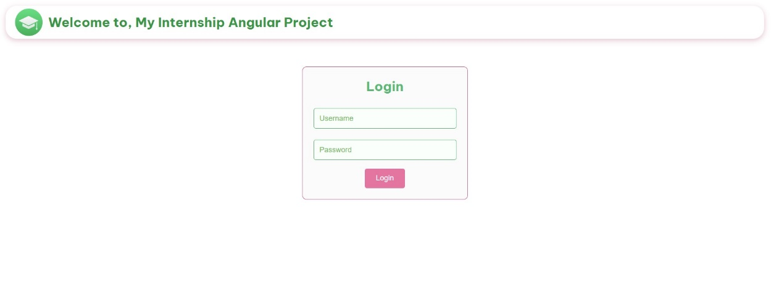

If the password or username is incorrect, the user will receive a warning message
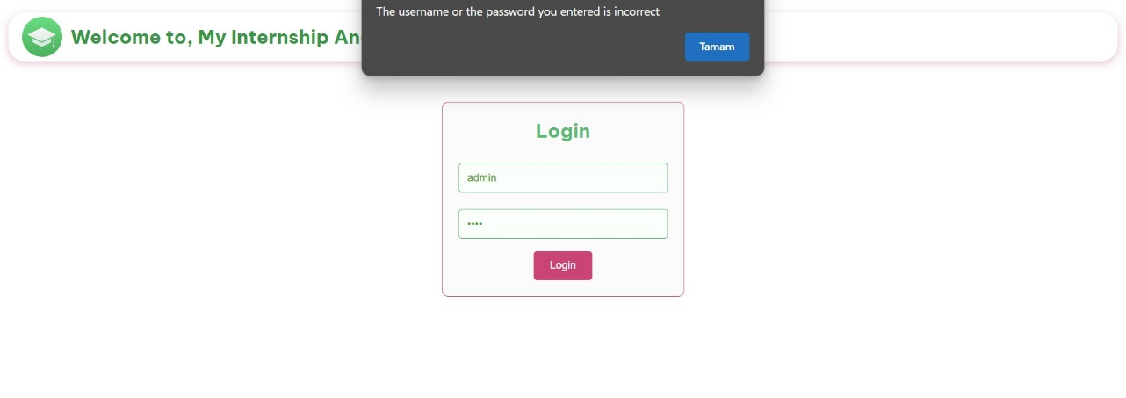

Main page of my project
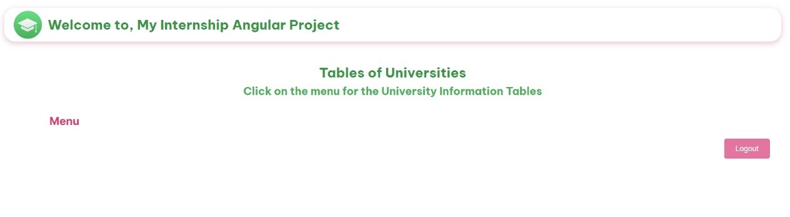

Sidebar of my project for changing components on the main page
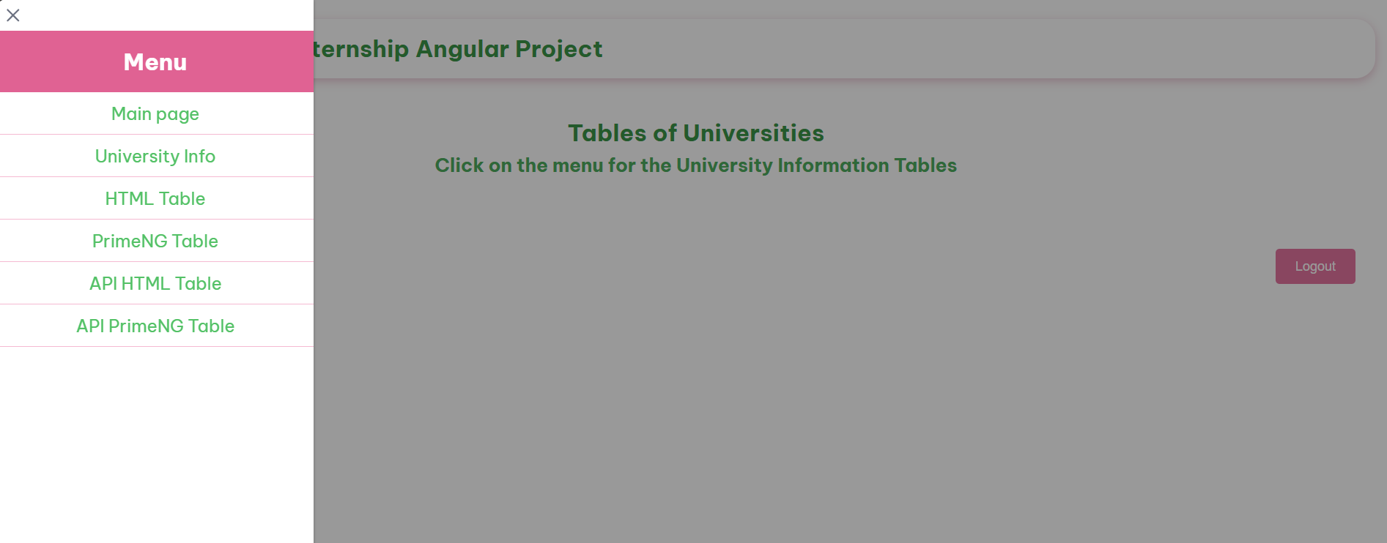

Information component of my project
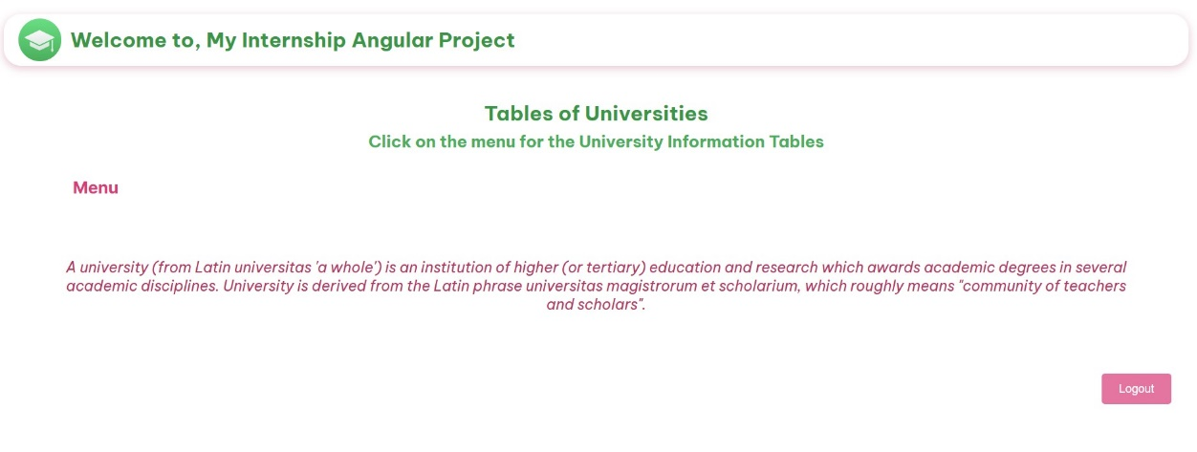

HTML table component of my project
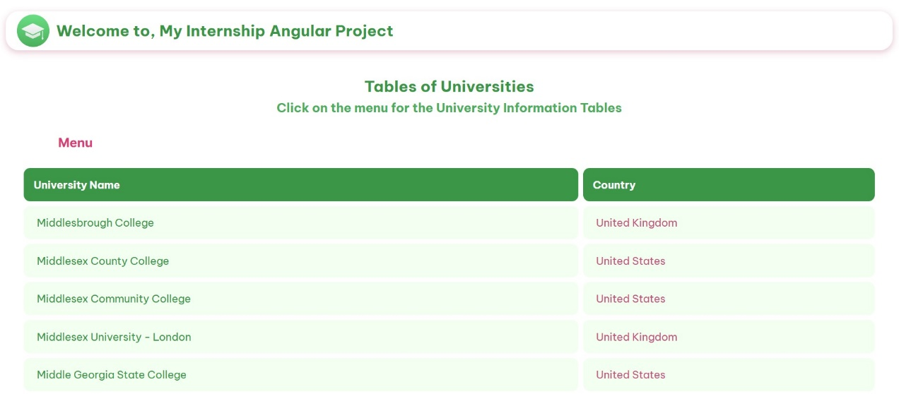

PrimeNG table component of my project
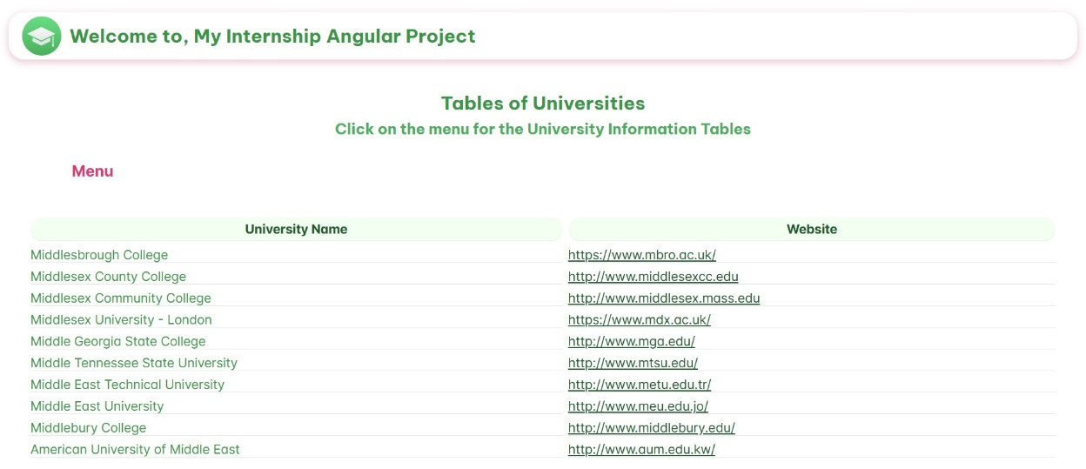

The HTML table I created by getting data from the API
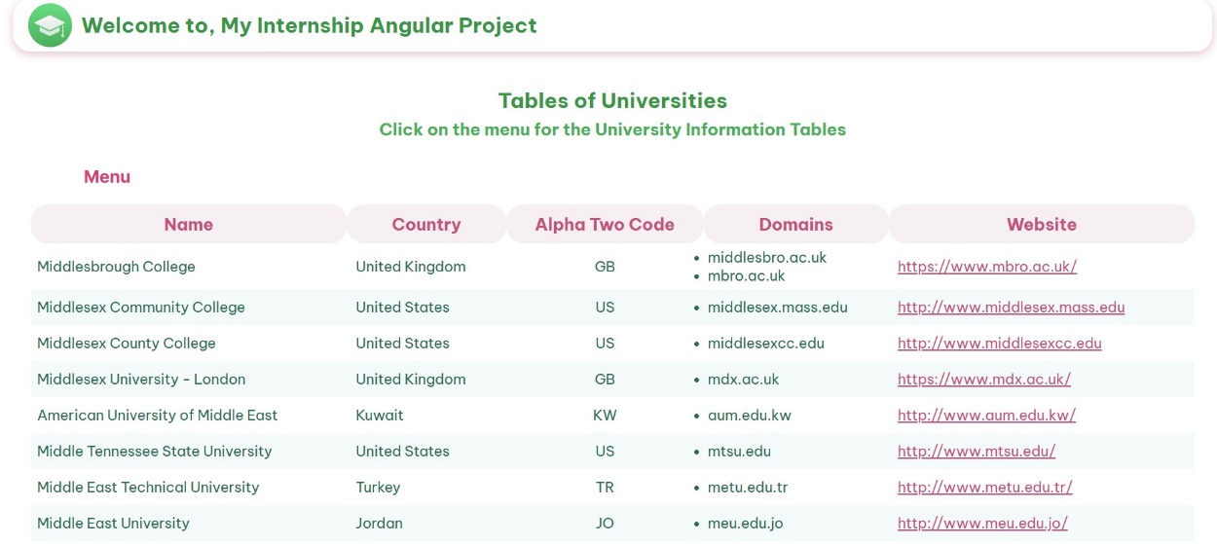

The PrimeNG table component that I created by getting data from the API
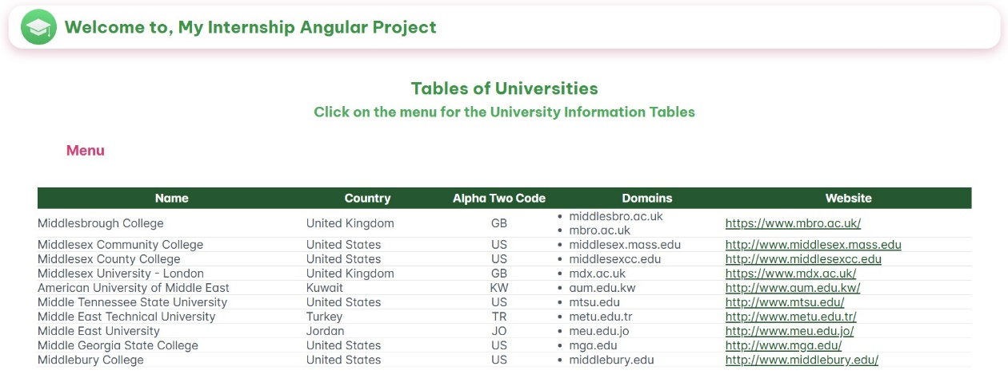

Codes for creating HTML table component with its CSS file for the styling from 16th day of my internship:
table-university-details.component.ts file
import { Component, Input } from '@angular/core';
import { UniversityCountries } from '../university-countries';
import { CommonModule } from '@angular/common';

@Component({
selector: 'app-table-university-details',
standalone: true,
imports: [CommonModule],
template: `
<table>
<thead>
<tr>
<th>University Name</th>
<th>Country</th>
</tr>
</thead>
<tbody>
<tr *ngFor="let university of universityCountriesList">
<td>{{ university.name }}</td>
<td>{{ university.country }}</td>
</tr>
</tbody>
</table>
`,
styleUrls: ['./table-university-details.component.css']
})
export class TableUniversityDetailsComponent {
universityCountriesList: UniversityCountries[] = [
{
"name": "Middlesbrough College",
"country": "United Kingdom"
},
{
"name": "Middlesex County College",
"country": "United States"
},
{
"name": "Middlesex Community College",
"country": "United States"
},
{
"name": "Middlesex University - London",
"country": "United Kingdom"
},
{
"name": "Middle Georgia State College",
"country": "United States"
},
{
"name": "Middle Tennessee State University",
"country": "United States"
},
{
"name": "Middle East Technical University",
"country": "Turkey"
},
{
"name": "Middle East University",
"country": "Jordan"
},
{
"name": "Middlebury College",
"country": "United States"
},
{
"name": "American University of Middle East",
"country": "Kuwait"
}
];
}

table-university-details.component.css file
table{
width: 100%;
border-collapse: separate;
border-spacing: 8px 8px;
margin-top: 20px;
}

th, td{
border: none;
padding: 15px;
text-align: left;

}

thead th{
background-color: rgb(24, 151, 77);
color: white;
border-radius: 10px;
}
tbody tr{
background-color: rgb(241, 255, 241);
overflow: hidden;
}

tbody td{
padding: 15px 20px;
vertical-align: middle;
border-radius: 10px;
}

tbody td:first-child{
color: rgb(24, 151, 77);
}

tbody td:last-child{
color: rgb(206, 82, 124);
}

Codes for creating PrimeNG table component that I created by getting data from the API with its CSS for the styling from 23rd day of my internship:
api-primeng.component.ts file
import { Component, OnInit } from '@angular/core';
import { HttpClientModule, HttpClient } from '@angular/common/http';
import { CommonModule } from '@angular/common';
import { ApiData } from '../api-data';
import { TableModule } from 'primeng/table';
@Component({
selector: 'app-api-primeng',
standalone: true,
imports: [HttpClientModule, CommonModule, TableModule],
template: `
<p-table [value]="universitiesList" [style]="{'padding': '20px'}">
<ng-template pTemplate="header">
<tr>
<th [ngStyle]="thStyle">Name</th>
<th [ngStyle]="thStyle">Country</th>
<th [ngStyle]="thStyle">Alpha Two Code</th>
<th [ngStyle]="thStyle">Domains</th>
<th [ngStyle]="thStyle">Website</th>
</ng-template>
<ng-template pTemplate="body" let-university>
<tr>
<td>{{ university.name }}</td>
<td>{{ university.country }}</td>
<td style="text-align: center;">{{ university.alpha_two_code }}</td>
<td>
<ul>
<li *ngFor="let domain of university.domains">{{ domain }}</li>
</ul>
</td>
<td><a href="{{university.web_pages}}" [ngStyle]="linkStyle">{{university.web_pages}}</a></td>
</tr>
</ng-template>
</p-table>
`,
styleUrl: './api-primeng.component.css'
})

export class ApiPrimengComponent {

thStyle = {
'background-color': 'rgb(23, 88, 50)',
'text-align': 'center',
'padding': '5px',
'color': 'white'
};

linkStyle = {
color: 'rgb(23, 88, 50)',
};

public universitiesList: any = [];

constructor(private http: HttpClient) {}

ngOnInit(): void {
this.getMethod();
}

public getMethod() {
this.http.get<ApiData[]>('http://universities.hipolabs.com/search?name=middle').subscribe((data) => {
this.universitiesList = data;
});
}
}

Codes for the sidebar component for creating a sidebar menu using PrimeNG's p-sidebar with its CSS for styling and the routing components were completed on the last week of my internship:
side.component.ts file
import { Component } from '@angular/core';
import { CommonModule } from '@angular/common';
import { RouterModule } from '@angular/router';
import { SidebarModule } from 'primeng/sidebar';
import { ButtonModule } from 'primeng/button';

@Component({
selector: 'app-side',
standalone: true,
imports: [CommonModule, RouterModule, SidebarModule, ButtonModule],
template: `
<button (click)="toggleSidebar()" pButton icon="pi pi-bars" label="Menu" class="p-button-text"></button>
<p-sidebar [(visible)]="visibleSidebar" [baseZIndex]="10000">
<h3>Menu</h3>
<ul>
<li><a routerLink="main" (click)="navigation('main')">Main page</a></li>
<li><a routerLink="info" (click)="navigation('info')">University Info</a></li>
<li><a routerLink="html" (click)="navigation('html')">HTML Table</a></li>
<li><a routerLink="prime" (click)="navigation('prime')">PrimeNG Table</a></li>
<li><a routerLink="api-html" (click)="navigation('api-html')">API HTML Table</a></li>
<li><a routerLink="api-prime" (click)="navigation('api-prime')">API PrimeNG Table</a></li>
</ul>
</p-sidebar>
`,
styleUrls: ['./side.component.css'],
})
export class SideComponent {
visibleSidebar: boolean = false;

toggleSidebar() {
this.visibleSidebar = !this.visibleSidebar;
}

navigation(route: string) {
this.toggleSidebar();
}
}

side.component.css file
p-sidebar h3{
padding: 16px;
background-color: rgb(234, 99, 146);
color: white;
font-size: 1.5rem;
text-align: center;
}

p-sidebar ul li{
padding: 10px 16px;
border-bottom: 1px solid rgb(251, 186, 209);
}

p-sidebar ul li a{
text-decoration: none;
color: rgb(46, 194, 107);
display: block;
transition: background-color 0.3s;
font-size: 1.1rem;
cursor: pointer;
text-align: center;
}

p-sidebar ul li a:hover{
background-color: #e1f6e3;
}

.p-button-text{
margin-top: 20px;
z-index: 10001;
background-color: transparent;
color: rgb(230, 62, 118);
border: none;
font-size: 1.2rem;
cursor: pointer;
margin-left: 80px;
}

.p-button-text:hover{
color: rgb(228, 109, 151);
}

university-routing.module.ts file
import { Routes } from '@angular/router';
import { InfoUniversityComponent } from '../info-university/info-university.component';
import { TableUniversityDetailsComponent } from '../table-university-details/table-university-details.component';
import { PrimeTableComponent } from '../prime-table/prime-table.component';
import { ApiExampleComponent } from '../api-example/api-example.component';
import { ApiPrimengComponent } from '../api-primeng/api-primeng.component';

export const universityRoutes: Routes = [
{ path: '', redirectTo: '', pathMatch: 'full' },
{ path: 'main', redirectTo: '' },
{ path: 'info', component: InfoUniversityComponent },
{ path: 'html', component: TableUniversityDetailsComponent },
{ path: 'prime', component: PrimeTableComponent },
{ path: 'api-html', component: ApiExampleComponent },
{ path: 'api-prime', component: ApiPrimengComponent },
];

app-routing.module.ts file
import { Routes } from '@angular/router';
import { UniversityComponent } from './university/university.component';
import { universityRoutes } from './university/university-routing.module';

export const routes: Routes = [
{ path: '', redirectTo: '/university', pathMatch: 'full' },
{ path: 'university', component: UniversityComponent, children: universityRoutes },
];

export class AppRoutingModule {}

The report from 10th day of my internship:
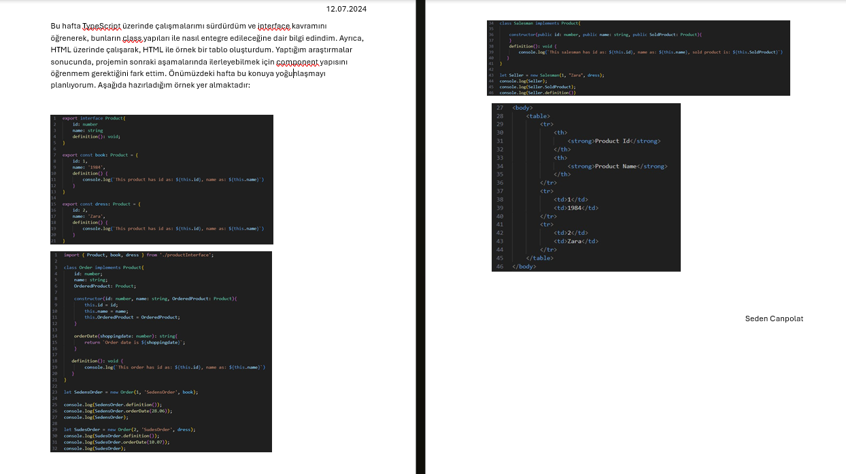

The report from 26th day of my internship:
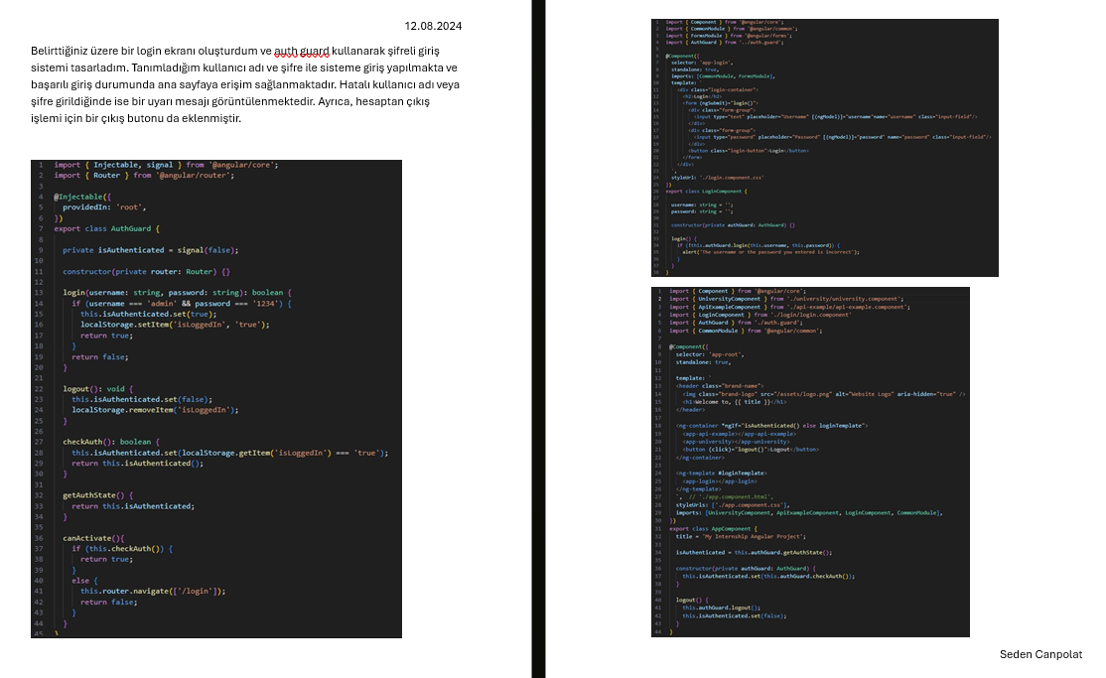

References

[1] https://www.etiya.com/tr/yasal/kurumsal-yonetim-sistemi
[2] https://www.etiya.com/file/27e88de0-b15c-4556-ad40-477326f31cdf/ETIYAISO27001Sertifikasi.pdf
[3] P-03_Is_Etigi_Kurallarimiz_133578060496322754.pdf
[4] veri_gizliligi_rehberi_133367296439816844.pdf
[5] Etiya_Is_Sagligi_ve_Guvenligi_Politikasi-_Etiya_Occupational_Health_and_Safety_Policy_133443557289866592.pdf
[6] Insan_Haklari_ve_Sosyal_Haklar_Politikasi-Human_Rights_and_Social_Policy_133443559049634448.pdf
[7] P-05_Risk_Yonetimi_Politikamiz_133578061073897069.pdf

