Лист 33 — иконки последнего ряда арканных приказов
Шаг 1. Приложи к сообщению картинку-образец ниже (она же лежит в Docs-Word/refs). Шаг 2. Скопируй промпт из рамки целиком.
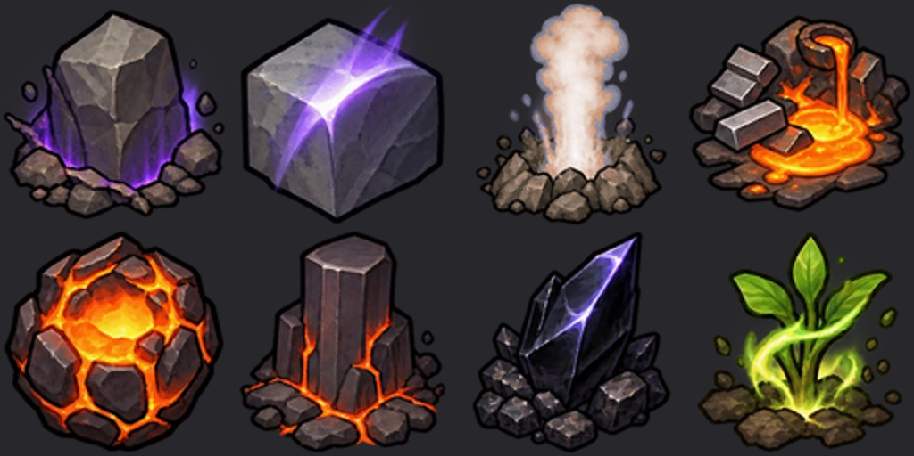
Куда: UI/Designators/Avir/ — LifeEmerald, LifeBathSteam, LightCrystalStore, LightCrystalSun, LavaPool, LavaSet. Лист 1536x1024, сетка 3x2.
A game sprite sheet, 1536x1024, 3x2 grid of equal cells, one item centred in each cell with an even margin, nothing crossing into a neighbouring cell. Match EXACTLY the style of the attached reference icons: chunky hand-painted RimWorld command icons in a 3/4 top-down view, a thick dark outline, rich saturated colours with soft painted shading, one glowing magical accent per icon, a few small rubble stones at the base, readable at 64 pixels. No text, no letters, no frames, no grid lines drawn. Background: fully transparent PNG. If transparency is not possible, a perfectly flat solid magenta (#FF00FF) with no shading; never use magenta inside the objects. Cells, left to right, top to bottom: (1) EMERALD STATUE - a small plant turned into a glossy faceted green emerald sculpture of itself standing on a clump of earth, a faint pale necrotic-green glow (2) BATH STEAM - a small round stone basin full of hot water, warm reddish-gold steam curling up, a few glowing hot pebbles at its rim (3) LIGHT CRYSTAL - a tall slender pale prism crystal standing in rubble, a cold white-blue light inside it, thin rays from its facets (4) SUN CRYSTAL - a cluster of warm golden crystals with a small sun-like glow above them, warm rays falling down onto a green sprout at their foot (5) LAVA POOL - a small round pool of bright molten lava in a ring of dark cracked stones (6) LAVA SET - the same pool crusting over into black stone, a few dying orange cracks, a thin grey wisp of cooling smoke

