Промпты эффектов магии
Как пользоваться: в начале каждого промпта набора вставляется единый стиль, потом строка нужного спрайта. Путь в скобках — куда положить файл в моде (папка Textures). Белые и серые спрайты игра перекрашивает под стихию.

ЕДИНЫЙ СТИЛЬ ЭФФЕКТОВ (вставлять в начало каждого промпта набора)
Top-down 2D magic effect sprite for the game RimWorld, hand-painted, soft painterly edges, fully transparent background, no ground, no shadows, no characters, no frame, centered, seen straight from above, bright saturated core fading to transparent edges, readable when drawn small (one map cell), slight glow, consistent with the other sprites of the set. PNG.
Цвет можно не задавать: игра перекрашивает белые/серые спрайты под элемент. Где цвет важен (магма, обсидиан) — он указан.

Набор «Пар» — `Things/Mote/Avir/Magic/Steam/Steam_A..C.png`, 256×256, белый-серый
Three variants: a wispy rolling cloud of steam, white to pale grey, curling edges, semi-translucent, a few thin rising wisps; each variant a different shape.

Набор «Буря» — `Things/Mote/Avir/Magic/Storm/`
- Bolt_Line.png 512×128: a straight horizontal bolt of lightning, jagged, white-blue core, thin forks along it, glowing.
- Bolt_Fork.png 256×256: a forked lightning strike seen from above, radiating from the centre.
- Strike.png 256×256: the flash where lightning hits the ground, a bright starburst with scorched sparks.

Набор «Магма» — `Things/Mote/Avir/Magic/Magma/`
- Fissure.png 512×128: a crack torn open in the ground, glowing orange-red lava inside, dark jagged edges.
- Crust_A..C.png 256×256: cooling magma: black crust with thin dull-red glowing seams (later stage than the pools).

Набор «Марево» — `Things/Mote/Avir/Magic/Haze/`
- Shimmer.png 256×256: a ring of rippling heat-haze lines, faint amber, like air bending over hot sand.
- Mirage.png 256×256: a faint glowing outline of a humanoid figure seen from above, amber, dissolving at the edges.

Набор «Топь» — `Things/Mote/Avir/Magic/Bog/`
- Splash.png 256×256: a splash of thick dark mud, droplets flung outwards.
- Bubbles.png 128×128: a few mud bubbles, one bursting.

Набор «Пыль» — `Things/Mote/Avir/Magic/Dust/`
- Cloud_A..C.png 256×256: a dense cloud of sand dust, sandy-beige, grainy edges.
- Devil.png 256×256: a dust devil from above: a tight spiral of sand around a clear eye.

Набор второго порядка (на будущее)
- Glass_A..C.png 256×256: ground fused into glass, cracked, sharp shards, pale green-clear with highlights.
- Obsidian_A..C.png 256×256: black volcanic glass shards scattered, glossy edges, faint red heat in the cracks.
- Ice_A..C.png 256×256: a frozen puddle patch, pale blue, frost feathers at the edges.
- Geyser.png 256×256: a burst of water and steam from a vent, seen from above, radial spray.
- Ash_A..C.png 256×256: drifting grey ash flakes with a few dying embers.

Набор «Купола-обереги» — `Things/Mote/Avir/Magic/Dome_Ward.png`, 512×512, белый (перекрашивается)
A translucent magical dome seen from above: a soft glowing circular barrier, brighter rim, faint runic lines across its surface, almost transparent centre.

Волна (Ride the Wave) — `Things/Mote/Avir/Magic/Wave_Water.png`, 512×512, прозрачный фон
Top-down view, a single curved crest of a magical water wave seen from above, shaped like a wide crescent bowing forward (towards the top of the image), thick rolling foam along the leading edge, translucent deep-blue to turquoise water body thinning to transparent at the back, small droplets and spray flung ahead of the crest, faint glowing pale-blue runic shimmer inside the water, painterly hand-drawn style matching RimWorld art, soft edges, no shadows on the ground, no characters, no background, fully transparent PNG, centered, wave fills about 80% of the width.

Волна — след (необязательно) — `Things/Mote/Avir/Magic/Wake_Water.png`, 256×256
Top-down view, a short trailing wake of foam and ripples left behind a magical wave, two diverging lines of white foam and small swirls, pale blue tint, painterly RimWorld style, transparent background, no ground, no characters.

Литьё магмой: базальт
Три текстуры для строительства магмой: стена, пол и форма, пока магма остывает. Стена в RimWorld рисуется атласом: одна картинка 1024×1024, разбитая на сетку 4×4 по 256 пикселей; игра сама выбирает кусок под соседей (угол, прямой участок, Т-образный стык, одиночная стена). Ниже — образец раскладки атласа: так должны быть расположены куски. Белый/серый цвет в образце — потому что игра красит стену в цвет материала; нашу базальтовую стену нужно рисовать сразу в её цветах.
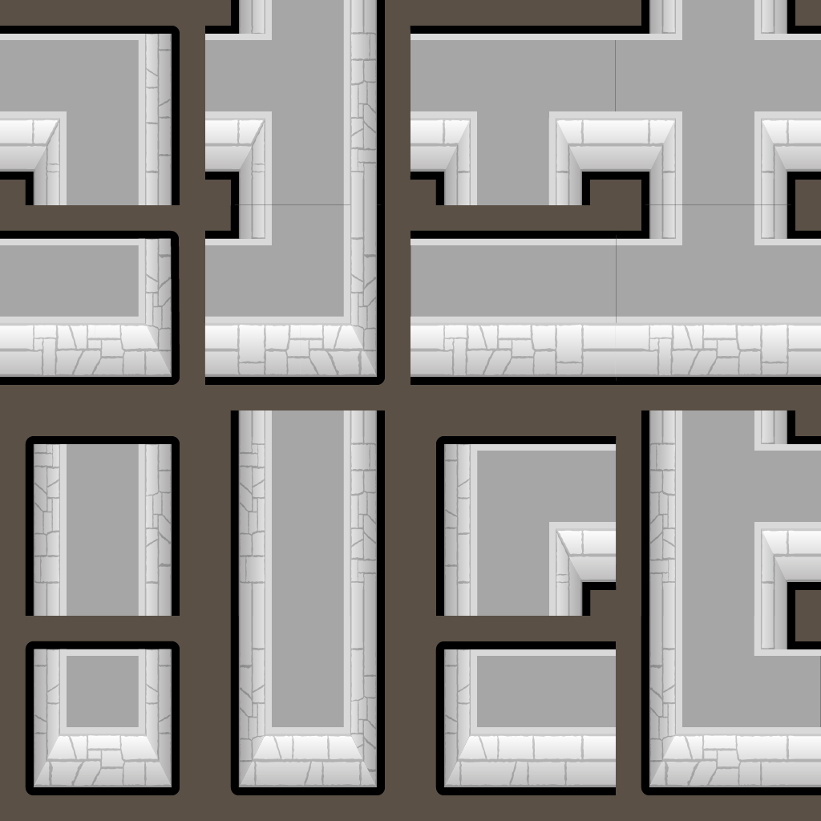
Образец формата атласа стены RimWorld (пример из мода LTS Furnishing — только как образец раскладки, не стиль).

Базальтовая стена — Things/Building/Avir/Magic/BasaltWall_Atlas.png, 1024×1024
Use the attached image ONLY as the layout reference (a RimWorld 4x4 wall atlas, 256 px tiles; keep exactly the same tile positions, shapes, outlines and the dark gaps between pieces). Repaint every piece as a wall of dark volcanic basalt: near-black grey stone with faint purple-grey sheen, columnar hexagonal cracks running vertically, a few thin dull-red seams of still-warm stone in the cracks, rough cooled-lava texture on the top faces, slightly lighter bevelled edges. Top-down RimWorld style, hand-painted, flat lighting from above, crisp black outline like the reference, transparent background outside the pieces. PNG.

Базальтовый пол — Terrain/Avir/BasaltFloor.png, 1024×1024 (бесшовная плитка)
Seamless tileable top-down floor texture for RimWorld: smooth polished basalt poured as a floor, dark grey-black stone with subtle hexagonal basalt-column pattern, faint flow lines frozen in the stone, very light speckle, no strong highlights, no shadows, edges tile perfectly in all directions. Hand-painted RimWorld style, muted colours. PNG, no transparency.

Форма с остывающей магмой — Things/Building/Avir/Magic/MagmaMold.png, 256×256
Top-down RimWorld building sprite, one cell: a square casting mould of rough dark stone slabs forming a frame, filled with glowing molten magma cooling inside - orange-red molten centre, darker crust forming at the edges, thin wisps of heat. Hand-painted RimWorld style, crisp dark outline, transparent background outside the frame. PNG.

