The Temperature Sensor LM35 series are precision integrated-circuit temperature devices with an output voltage linearly proportional to the Centigrade temperature.

The LM35 device has an advantage over linear temperature sensors calibrated in Kelvin, as the user is not required to subtract a large constant voltage from the output to obtain convenient Centigrade scaling. The LM35 device does not require any external calibration or trimming to provide typical accuracies of ±¼°C at room temperature and ±¾°C over a full −55°C to 150°C temperature range.

LM35 device

Technical Specifications

* Calibrated directly in Celsius (Centigrade)
* Linear + 10-mV/°C scale factor
* 0.5°C ensured accuracy (at 25°C)
* Rated for full −55°C to 150°C range
* Suitable for remote applications

Components Required

You will need the following components −

* 1 × Breadboard
* 1 × Arduino Uno R3
* 1 × LM35 sensor

Procedure

Follow the circuit diagram and hook up the components on the breadboard as shown in the image given below.

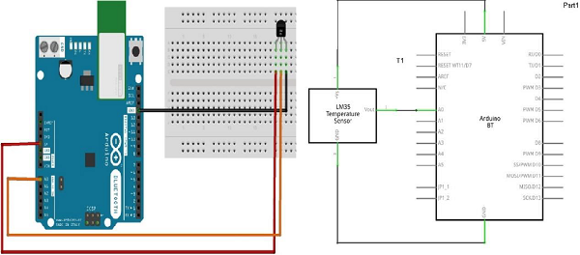

Sketch

Open the Arduino IDE software on your computer. Open a new sketch File by clicking New.

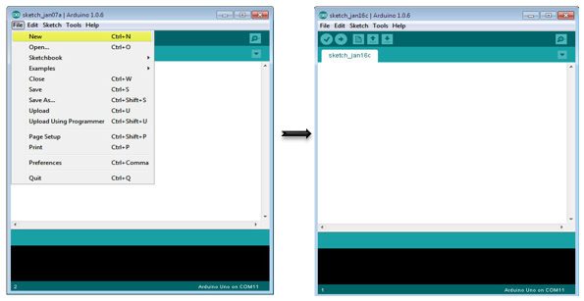

Write or copy the Arduino Code provided in the github

Simple note on LM35

LM35 sensor has three terminals - Vs, Vout and GND. We will connect the sensor as follows −

* Connect the +Vs to +5v on your Arduino board.
* Connect Vout to Analog0 or A0 on Arduino board.
* Connect GND with GND on Arduino.

The Analog to Digital Converter (ADC) converts analog values into a digital approximation based on the formula ADC Value = sample \* 1024 / reference voltage (+5v). So with a +5 volt reference, the digital approximation will be equal to input voltage \* 205.

Result

You will see the LED blinking inaccordance to the temperature output provided by the temperature sensor.