Useful refs on reverse intent:
- Kiros, R., Salakhutdinov, R., and Zemel, R. Multimodal neural language models. In ICML, 2014a.
- Karpathy, Andrej and Li, Fei-Fei. Deep visual-semantic alignments for generating image descriptions. In
CVPR, 2015.
- Vinyals, Oriol, Toshev, Alexander, Bengio, Samy, and Erhan, Dumitru. Show and tell: A neural image caption
generator. In CVPR, 2015.
- Xu, Kelvin, Ba, Jimmy, Kiros, Ryan, Cho, Kyunghyun, Courville, Aaron C., Salakhutdinov, Ruslan, Zemel,
Richard S., and Bengio, Yoshua. Show, attend and tell: Neural image caption generation with visual atten-
tion. In ICML, 2015.

Useful refs:
- Gregor, Karol, Danihelka, Ivo, Graves, Alex, and Wierstra, Daan. DRAW: A recurrent neural network for
image generation. In ICML, 2015.
- Denton, Emily L., Chintala, Soumith, Szlam, Arthur, and Fergus, Robert. Deep generative image models using
a laplacian pyramid of adversarial networks. In NIPS, 2015.
- Sutskever, Ilya, Vinyals, Oriol, and Le, Quoc V. Sequence to sequence learning with neural networks. In NIPS,
2014.
- Cho, K., van Merrienboer, B., Gülçehre, Ç., Bahdanau, D., Bougares, F., Schwenk, H., and Bengio, Y. Learning
phrase representations using RNN encoder-decoder for statistical machine translation. In EMNLP, 2014.
- Srivastava, Nitish, Mansimov, Elman, and Salakhutdinov, Ruslan. Unsupervised learning of video representations using LSTMs. In ICML, 2015.
- Denton, Emily L., Chintala, Soumith, Szlam, Arthur, and Fergus, Robert. Deep generative image models using
a laplacian pyramid of adversarial networks. In NIPS, 2015.

Speech transcription:
- Graves, A., Jaitly, N., and Mohamed, A.-r. Hybrid speech recognition with deep bidirectional LSTM. In IEEE
Workshop on Automatic Speech Recognition and Understanding, 2013.

Method:

Captions are considered a sequence of consecutive words
Images represent a sequence of patches drawn on a canvas over time

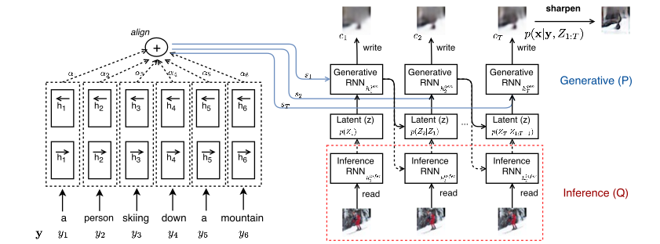

1. represent sentence as a m-dim vector representation using Bidirectional RNN
2 LSTMs process input sequence forward and backward

2. use DRAW Network (Gregor et al., 2015) but add dependencies to former hidden states to generate samples

3. drop interference level while generating images but sample from prior distribution

4. Perform post-filtering because created samples are blurry

