产品表格

XIAO Dev Boards

ESP32 Series

XIAO ESP32-C3
https://www.seeedstudio.com/Seeed-XIAO-ESP32C3-p-5431.html
Cost effective with Wi-Fi and BLE on board

XIAO ESP32-S3
https://www.seeedstudio.com/XIAO-ESP32S3-p-5627.html
High-performance dev board with Wi-Fi and BLE

XIAO ESP32-S3 Sense
https://www.seeedstudio.com/XIAO-ESP32S3-Sense-p-5639.html
Mini camera perfect for computer vision

XIAO ESP32-C6
https://www.seeedstudio.com/Seeed-Studio-XIAO-ESP32C6-p-5884.html
2.4GHz Wi-Fi 6, BLE 5.0, Zigbee, and Thread for Matter

XIAO ESP32-C5
https://www.seeedstudio.com/Seeed-Studio-XIAO-ESP32C5-p-6609.html
2.4 & 5 GHz Wi-Fi 6, BLE 5.0, Zigbee, and Thread for Matter

Nordic nRF52 Series

XIAO nRF52840
https://www.seeedstudio.com/Seeed-XIAO-BLE-nRF52840-p-5201.html
Ultra-low power consumption, perfect for BLE applications

XIAO nRF52840 Sense
https://www.seeedstudio.com/Seeed-XIAO-BLE-Sense-nRF52840-p-5253.html
Low power BLE with onboard microphone and 6-axis IMU

Nordic nRF54 Series

XIAO nRF54L15
https://www.seeedstudio.com/XIAO-nRF54L15-p-6493.html
Ultra low power consumption with multiple connectivity

XIAO nRF54L15 Sense
https://www.seeedstudio.com/XIAO-nRF54L15-Sense-p-6494.html
Ultra low power consumption with multiple connectivity and onboard sensors

XIAO nRF54LM20A
https://www.seeedstudio.com/Seeed-Studio-XIAO-nRF54LM20A-p-6841.html
Ultra low power, larger memory capacity and expanded IO

XIAO nRF54LM20A Sense
https://www.seeedstudio.com/Seeed-Studio-XIAO-nRF54LM20A-Sense-p-6840.html
Ultra low power, larger memory and expanded IO, paired with onboard sensors

Raspberry Pi RP Series

XIAO RP2040
https://www.seeedstudio.com/XIAO-RP2040-v1-0-p-5026.html
Raspberry Pi Ecosystem with great MicroPython support

XIAO RP2350
https://www.seeedstudio.com/Seeed-XIAO-RP2350-p-5944.html
MicroPython-ready based on Raspberry Pi RP2350

Silicon Labs MG Series

XIAO MG24
https://www.seeedstudio.com/Seeed-Studio-XIAO-MG24-p-6247.html
Super-low power for battery-powered Matter projects

XIAO MG24 Sense
https://www.seeedstudio.com/Seeed-XIAO-MG24-Sense-p-6248.html
Super-low power board with microphone & 6-axis IMU

Microchip SAMD Series

XIAO SAMD21
https://www.seeedstudio.com/Seeeduino-XIAO-Arduino-Microcontroller-SAMD21-Cortex-M0+-p-4426.html
Classic for Arduino beginners, with courses

Renesas RA Series

XIAO RA4M1
https://www.seeedstudio.com/Seeed-XIAO-RA4M1-p-5943.html
Renesas 32-bit ARM Cortex-M4 MCU, Arduino IDE-ready

XIAO Add-ons

Expansion
Seeed Studio XIAO Debug Mate
https://www.seeedstudio.com/Seeed-Studio-XIAO-Debug-Mate-p-6588.html
Seeed Studio XIAO Expansion Board
https://www.seeedstudio.com/Seeeduino-XIAO-Expansion-board-p-4746.html
Grove Shield For Seeed Studio XIAO
https://www.seeedstudio.com/Grove-Shield-for-Seeeduino-XIAO-p-4621.html
XIAO PowerBread, a Breadboard Power Supply and Meter
https://www.seeedstudio.com/XIAO-PowerBread-p-6318.html
Seeed Studio Grove Modules
https://www.seeedstudio.com/category/Grove-c-1003.html

Sensors
Grove Vision AI Module V2 with Camera
https://www.seeedstudio.com/Grove-Vision-AI-V2-Kit-p-5852.html
mmWave Human Presence Sensor
https://www.seeedstudio.com/Seeed-Studio-24GHz-mmWave-for-XIAO-p-5830.html
Grove Smart IR Gesture Sensor
https://www.seeedstudio.com/Grove-Smart-IR-Gesture-Sensor-p-5721.html
reSpeaker Lite 2-Mic Array
https://www.seeedstudio.com/ReSpeaker-Lite-Voice-Assistant-Kit-Full-Kit-of-2-Mic-Array-pre-soldered-XIAO-ESP32S3-Mono-Enclosed-Speaker-and-Enclosure.html
Quectel L76K GNSS Add-On
https://www.seeedstudio.com/L76K-GNSS-Module-for-Seeed-Studio-XIAO-p-5864.html
XIAO Logger HAT (Temp, Hum & Light)
https://www.seeedstudio.com/XIAO-LOG-p-6341.html
Grove Bundle Monitoring Kit for ESPHome
https://www.seeedstudio.com/Grove-Bundle-Kit-for-ESPHOME-p-5509.html
Sound Event Detection Module D1 - Sensor/Audio Boar
https://www.seeedstudio.com/Sound-Event-Detection-Module-D1-p-6652.html

Connectivity
Wi-Fi HaLow Module for XIAO
https://www.seeedstudio.com/Wio-WM6180-Wi-Fi-Halow-Module-for-XIAO-p-6395.html
Wio-SX1262 LoRa Add-on for XIAO
https://www.seeedstudio.com/Wio-SX1262-for-XIAO-p-6379.html
CAN BUS Breakout Board for XIAO
https://www.seeedstudio.com/Seeed-Studio-CAN-Bus-Breakout-Board-for-XIAO-and-QT-Py-p-5702.html
RS-485 Breakout Board for XIAO
https://www.seeedstudio.com/RS485-Breakout-Board-for-XIAO-p-6306.html
SenseCAP S2110 LoRaWAN Sensor Kit
https://www.seeedstudio.com/sensecap-outdoor-lorawan-sensor-kit-based-on-grove-p-5503.html

Actuators
COB LED DIY Kit for XIAO
https://www.seeedstudio.com/COB-LED-DIY-Kit-for-Seeed-Studio-XIAO.html
LED Driver Board for XIAO
https://www.seeedstudio.com/LED-Driver-Board-for-Seeed-Studio-XIAO-p-6451.html
Bus Servo Driver Board for XIAO
https://www.seeedstudio.com/Bus-Servo-Driver-Board-for-XIAO-p-6413.html
1-Channel Relay for XIAO
https://www.seeedstudio.com/Relay-add-on-module-for-XIAO-p-6310.html
6x10 RGB WS2812B Matrix For XIAO
https://www.seeedstudio.com/6x10-RGB-MATRIX-for-XIAO-p-5771.html
1.28'' Round Display for XIAO
https://www.seeedstudio.com/Seeed-Studio-Round-Display-for-XIAO-p-5638.html
ePaper Driver Board for XIAO
https://www.seeedstudio.com/ePaper-breakout-Board-for-XIAO-V2-p-6374.html
E-Paper Breakout Board
https://www.seeedstudio.com/ePaper-Breakout-Board-p-5804.html
2.9" 4-Color ePaper Display, 128x296 Pixels
https://www.seeedstudio.com/2-9-Quadruple-Color-ePaper-Display-with-128x296-Pixels-p-5783.html
4.2" Monochrome ePaper Display, 400x300 Pixels
https://www.seeedstudio.com/4-2-Monochrome-ePaper-Display-with-400x300-Pixels-p-5784.html
Accessories
7-pin male header for Seeed Studio XIAO
https://www.seeedstudio.com/XIAO-Series-7-Pin-Male-Header-5-pcs-p-5460.html
2.4GHz FPC Antenna (1.16dBi) for XIAO ESP32-S3
https://www.seeedstudio.com/2-4GHz-FPC-Antenna-1-16dBi-for-XIAO-ESP32S3-p-6440.html
2.4GHz FPC Antenna (2.9dBi) for XIAO ESP32-C3
https://www.seeedstudio.com/2-4GHz-FPC-Antenna-2-9dBi-for-XIAO-ESP32C3-p-6439.html
2.4GHz Rod Antenna for XIAO ESP32C3
https://www.seeedstudio.com/2-4GHz-2-81dBi-Antenna-for-XIAO-ESP32C3-p-5475.html
Aluminum Heat Sink For XIAO ESP32S3 Sense (2 Pcs)
https://www.seeedstudio.com/Aluminum-Heat-Sink-For-XIAO-2pcs-p-5972.html
OV5640 Camera for XIAO ESP32S3 Sense
https://www.seeedstudio.com/OV5640-Camera-for-XIAO-ESP32S3-Sense-With-Heat-Sink-p-5739.html
Micro SD Card Tool Kit for XIAO ESP32S3 Sense
https://www.seeedstudio.com/Micro-SD-Card-Tool-Kit-p-5772.html
Acrylic Case for Seeed Studio XIAO Expansion Board
https://www.seeedstudio.com/XIAO-p-4812.html
Kits
The XIAOML Kit
https://www.seeedstudio.com/The-XIAOML-Kit.html
Vibration Anomaly Detection Kit for XIAO ESP32-S3
https://www.seeedstudio.com/Vibration-Anomaly-Detection-Kit-for-XIAO-ESP32-S3.html
Seeed Studio XIAO Machine Learning Practical Class Kit
https://www.seeedstudio.com/Machine-Learning-Practical-Class-Kit-p-5951.html
Grove Starter Kit For Seeed Studio XIAO
https://www.seeedstudio.com/Seeed-XIAO-Starter-Kit-p-5378.html

XIAO Gadgets

Home Automation
XIAO Soil Moisture Sensor
https://www.seeedstudio.com/XIAO-Soil-Sensor-p-6452.html
XIAO Smart IR Mate
https://www.seeedstudio.com/XIAO-Smart-IR-Mate-p-6492.html
XIAO 2-Channel Wi-Fi AC Energy Meter w/ CTs
https://www.seeedstudio.com/XIAO-2-Channel-Wi-Fi-AC-Energy-Meter-Bundle-Kit.html
XIAO 7.5" ePaper Panel
https://www.seeedstudio.com/XIAO-7-5-ePaper-Panel-p-6416.html
XIAO 6-Channel Wi-Fi 5V DC Relay
https://www.seeedstudio.com/6-Channel-Wi-Fi-5V-DC-Relay-p-6373.html
XIAO Soil Moisture Sensor
https://www.seeedstudio.com/XIAO-Soil-Sensor-p-6452.html
XIAO Smart IR Mate
https://www.seeedstudio.com/XIAO-Smart-IR-Mate-p-6492.html
XIAO 2-Channel Wi-Fi AC Energy Meter w/ CTs
https://www.seeedstudio.com/XIAO-2-Channel-Wi-Fi-AC-Energy-Meter-Bundle-Kit.html
XIAO 7.5" ePaper Panel
https://www.seeedstudio.com/XIAO-7-5-ePaper-Panel-p-6416.html
XIAO 6-Channel Wi-Fi 5V DC Relay
https://www.seeedstudio.com/6-Channel-Wi-Fi-5V-DC-Relay-p-6373.html

Vision Al & Al Agent
XIAO Vision AI Camera
https://www.seeedstudio.com/XIAO-Vision-AI-Camera-p-6450.html
SenseCAP Watcher, Physical AI Agent
https://www.seeedstudio.com/SenseCAP-Watcher-W1-A-p-5979.html
OpenUC2 10x AI Microscope
https://www.seeedstudio.com/XIAO-Microscope-p-5971.html

Maker
XIAO W5500 Ethernet Adapter
https://www.seeedstudio.com/XIAO-W5500-Ethernet-Adapter-p-6472.html
XIAO Bus Servo Adapter
https://www.seeedstudio.com/XIAO-Bus-Servo-Adapter-for-XIAO-p-6397.html
XIAO MIDI Synthesizer
https://www.seeedstudio.com/XIAO-MIDI-Synthesizer-p-6462.html
1-Channel LoRaWAN Gateway / Meshtastic Node
https://www.seeedstudio.com/XIAO-ESP32S3-for-Meshtastic-LoRa-with-3D-Printed-Enclosure-p-6314.html
SenseCAP S2110 Sensor Builder
https://www.seeedstudio.com/SenseCAP-XIAO-LoRaWAN-Controller-p-5474.html

Scale-up Co-Create Projects
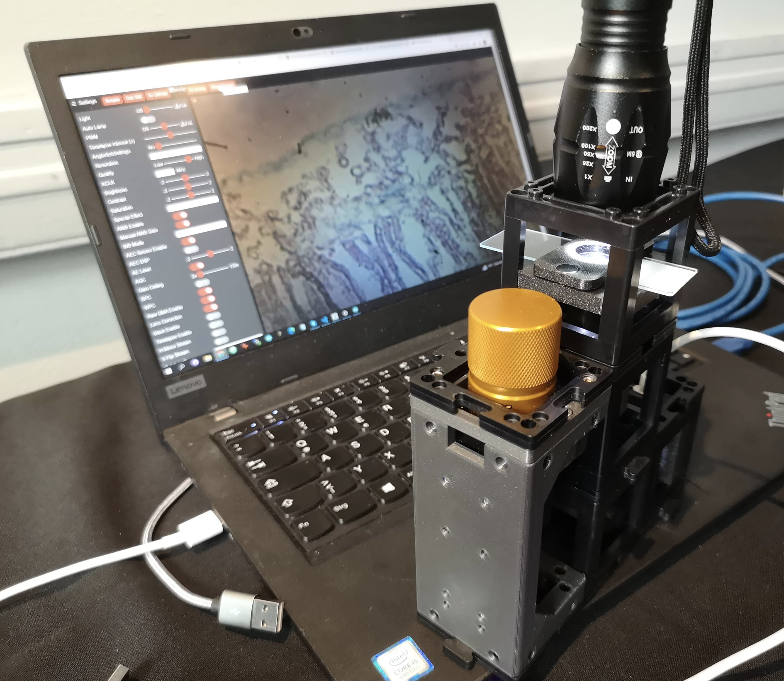

OpenUC2 10x AI Microscope by OpenUC2
链接：https://www.seeedstudio.com/XIAO-Microscope-p-5971.html
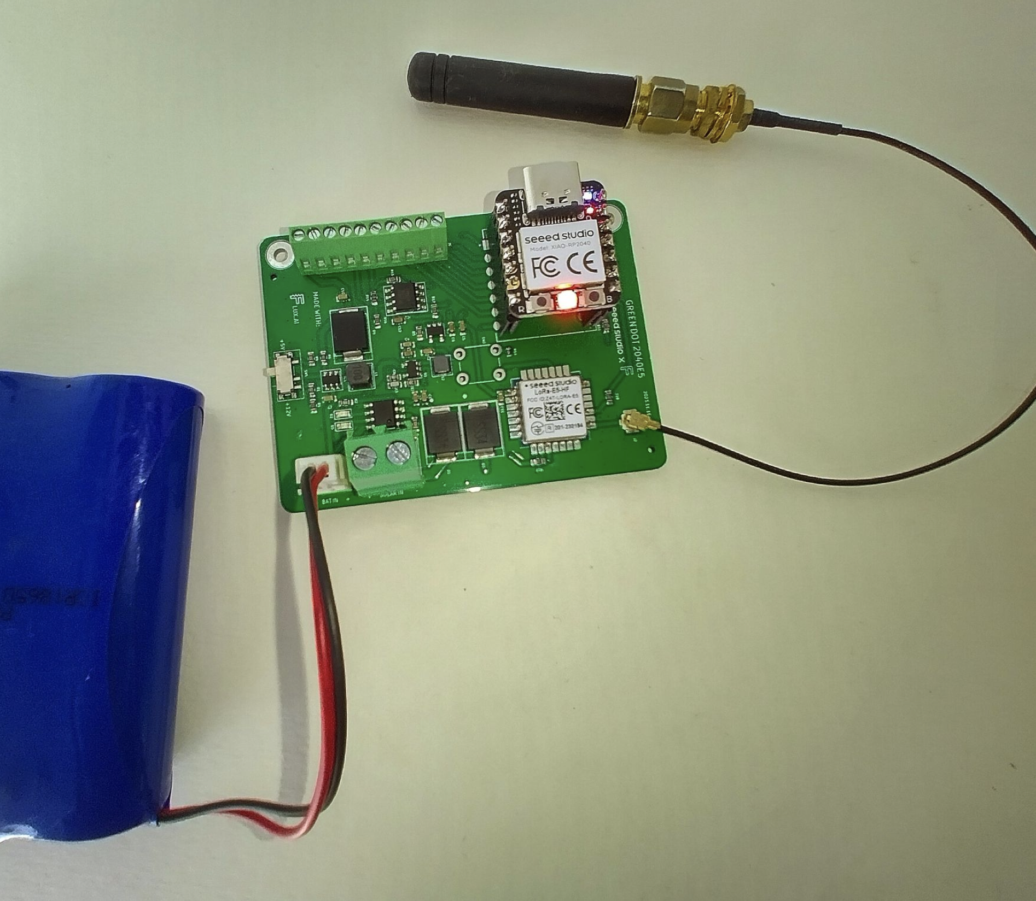

Green Dot Board by Collins Emasi
链接：https://www.seeedstudio.com/blog/2025/07/17/how-to-build-an-iot-sensor-node-with-flux-ai-wio-e5-lora-module-and-xiao-rp2040-mcu/

6 Channel Temperature Meter by Gokul
链接：https://www.seeedstudio.com/6-Channel-Temperature-Meter-g-1402461


TOTEM by Marc Rühl
链接：https://github.com/mchldotdev/totem
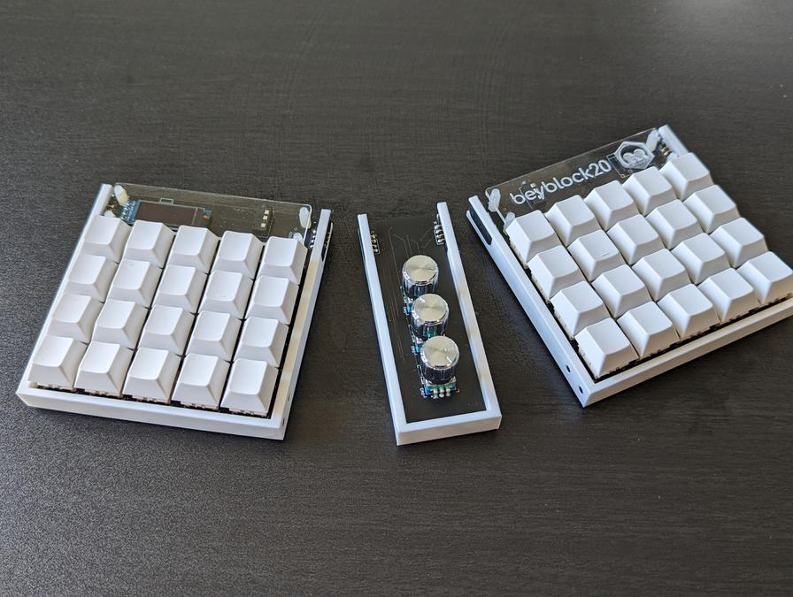

Beyblock20 by Christian Lo
链接：https://github.com/ChrisChrisLoLo/beyblock20
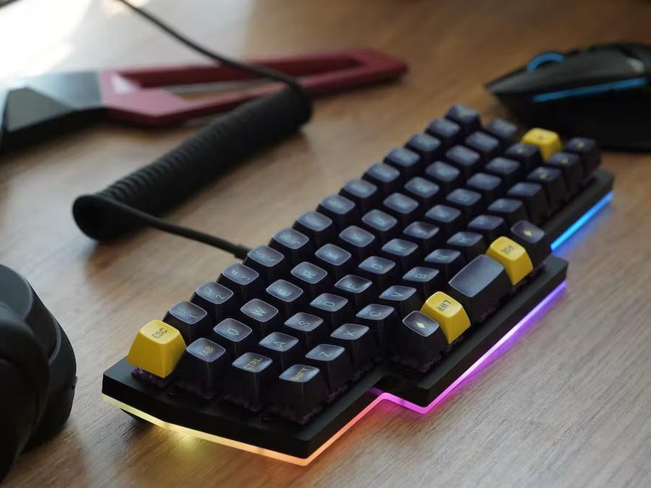

Purple Owl by Sonal Pinto
链接：https://github.com/SonalPinto/purple-owl
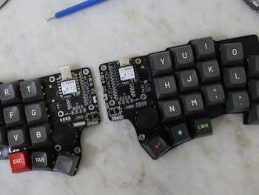

KLEIN by Shashank
链接：https://github.com/snsten/Klein/
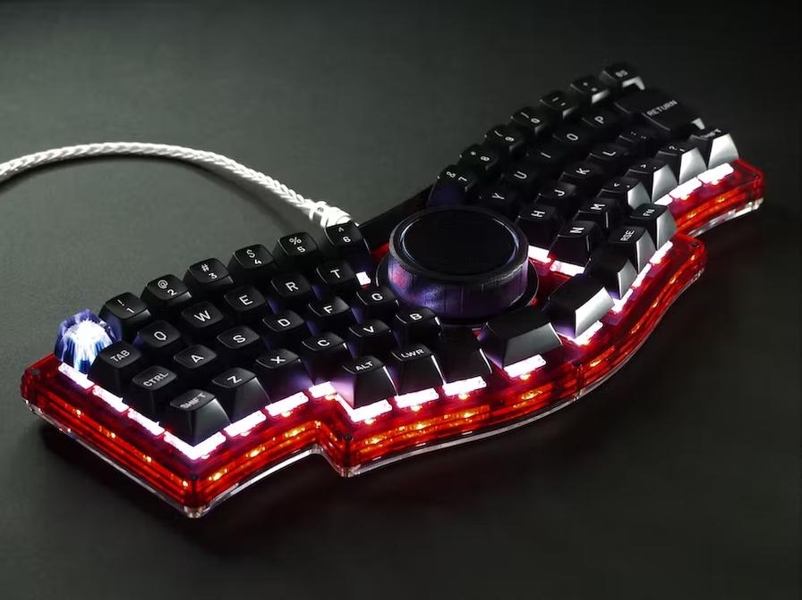

GRIN Quern by 伊藤彰悟
链接：https://www.hackster.io/policium/grin-quern-ergonomic-keyboard-on-center-trackpad-8b58c3
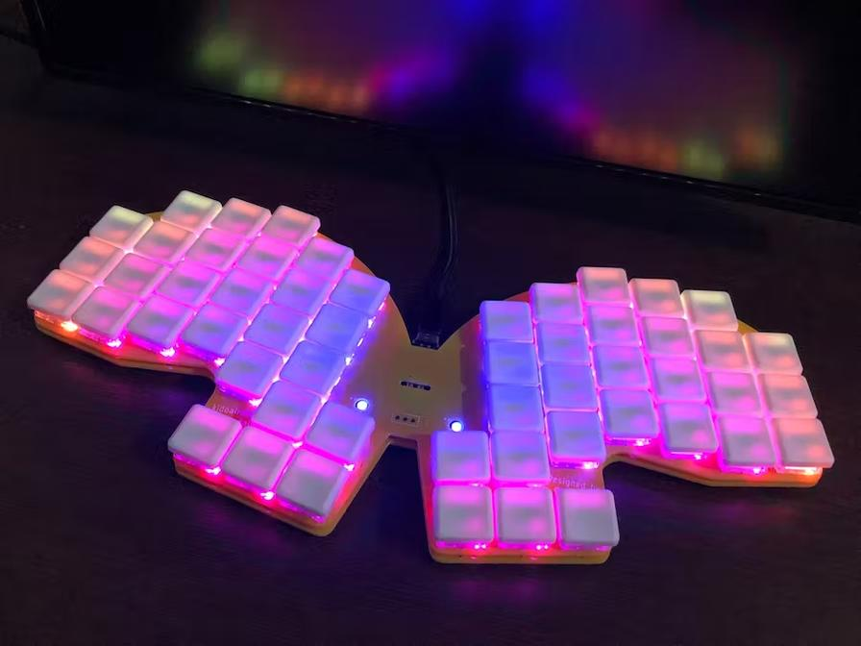

Kidoairaku Swallowtail by Yu Sanagi
链接：https://github.com/yswallow/kidoairaku-swallowtail


Seeed Studio XIAO Use Case
链接：https://files.seeedstudio.com/wiki/XIAO/XIAO-Reference-Design.pdf

PIN OUT
S3 plus
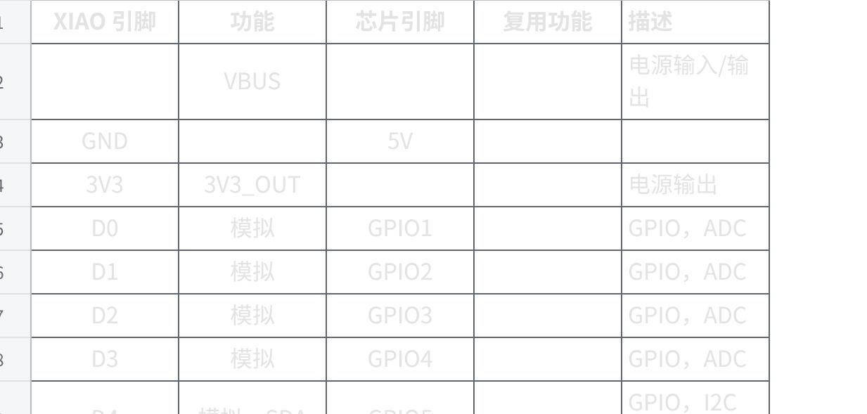
点击图片可查看完整电子表格
RP2040 plus
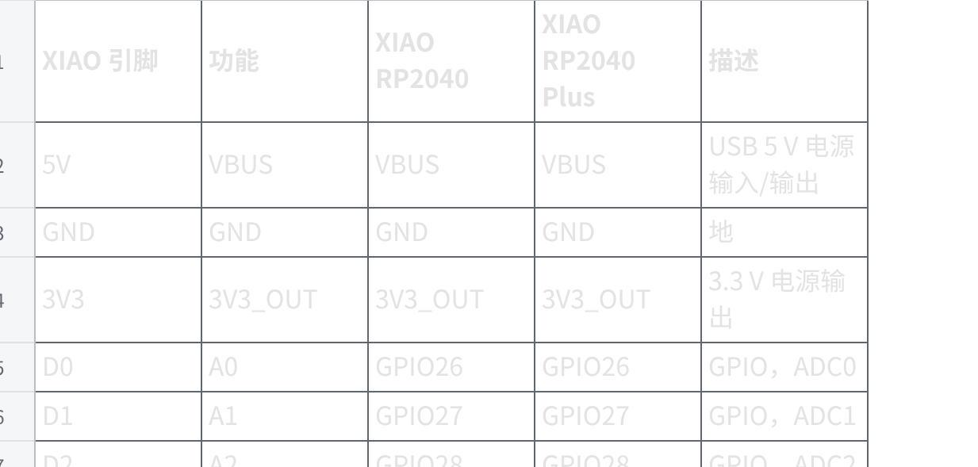
点击图片可查看完整电子表格
D21plus
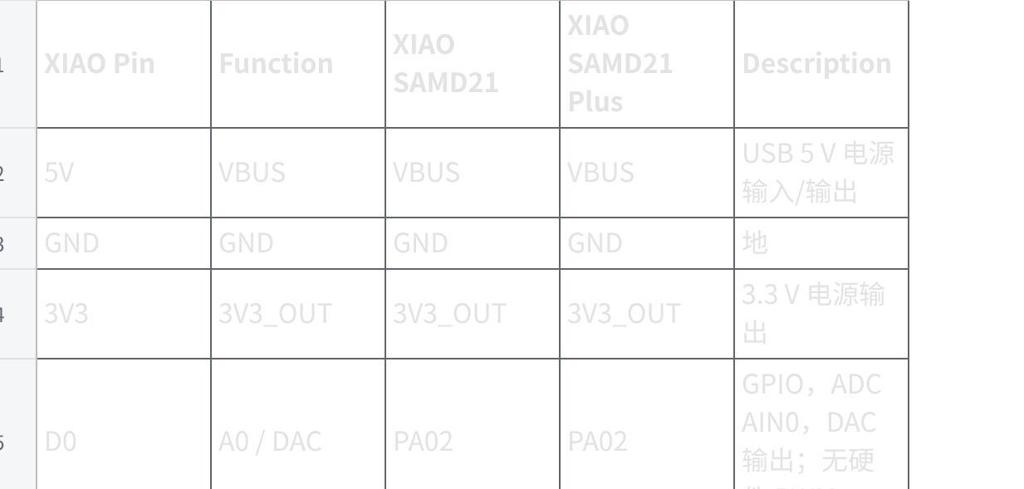
点击图片可查看完整电子表格
nrf52840 plus
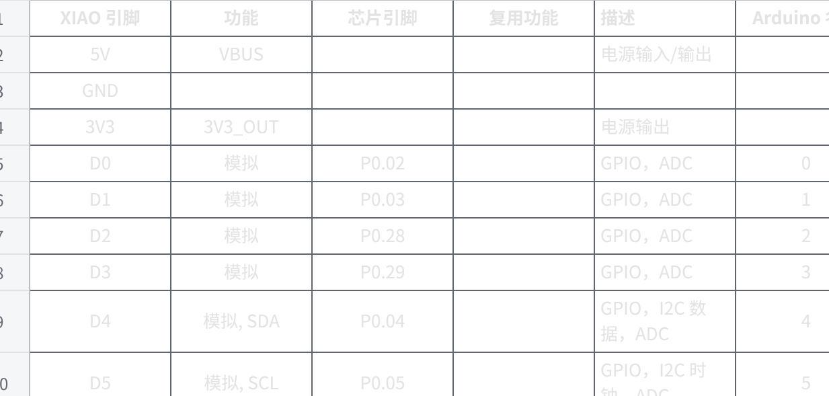
点击图片可查看完整电子表格

|（注：部分内容可能由 AI 生成）

