The concrete steps of converting two-dimensional code to lattice data
are as follows:

- Convert the text into a two-dimensional code by software. This software can be

found on the website.

2) Save the generated two-dimensional code picture.

3) unzip file Lattice modulo software .

4) Open application PCtoLCD2002.

5) Click "选项"，Select "阳码" at the options "点阵格式" . The final set as flows.

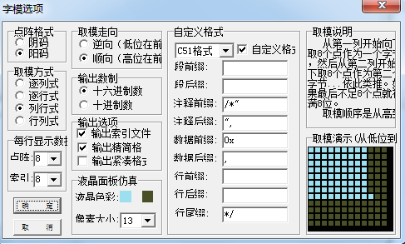
7) When finish the setting,you can click the "确定".

8) Click "确定" after clicking the "文件 ->新建",input 25 at "图片宽度" and input 32 at "图片高度".

- Start drawing a image pictures exactly the same the two-dimensional code image from the upper left corner.
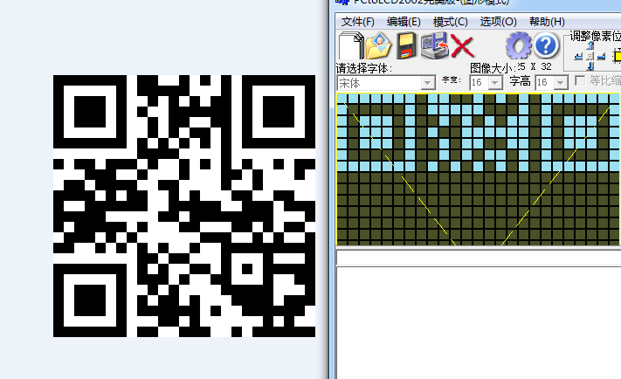

10) When finish drawing, Click "生成字模".

11) Copy the generated data to the array dimensionalData[].

If you have a good way, please tell us.

