BOTTLE DYNAMO SPECIFICATION
SX-1105B

SUPPLIER:
THINKSTAR TRADING CO.,LTD.
ADD:223,10 WuxingyiLu,Wuhou Scien-tech Park,Chengdu China

MANUFACTURER:
CIXI SUNSHINE PHOTOELECTRIC TECHNOLOGY CO.,LTD. NO.18South Tangdun Rd. Shengshan CiXi.Zhejiang,China

BOTTLE DYNAMO SPECIFICATION
SX-1105B
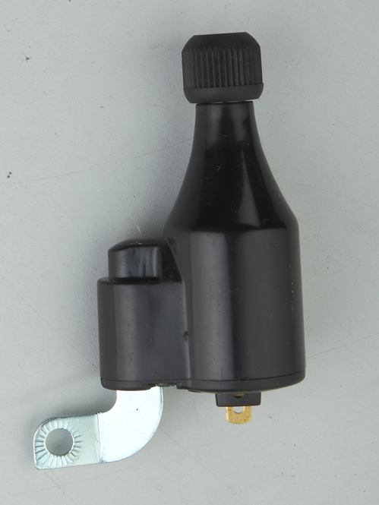
Ⅰ. INTRODUCTION
Ⅱ PRODUCT FEATURE
Ⅲ BISIC INFORMATION
Ⅳ TECHNICAL SPECEFICATION
Ⅴ INSTALLATION
Ⅵ ATTENTION MATTERS

Ⅰ INSTRUCTION

This product provide clean and green energy, it produce electric without any fuel. it works safty and silence. It's fashion, users can make a contribution for protect the world by low carbon life.
Ⅱ PRODUCT FEATURES

- simple and beautiful outshape and heat dissipation design raining proof ,dustproof, anti-shake,
- constant current output
Ⅲ BISIC INFORMATION

1) .DYNAMO OVRAL SIZE AND STRUCTURES
The max dia of the dynamo body is:40.5mm, the longest length of the main body is:94.5mm。
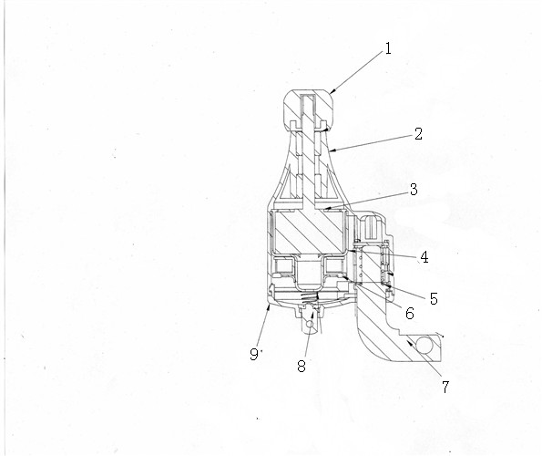
- friction roller
- the dynamo body
- Magnetic steel
- Winding support
- Spring housing
- Coil
- Wrench
- Lug plate
- Rear cover

2).OUTPUT: 6V,3W
3).WARRENTY: 1 year
4). WORKING LIFE: 2-3 years
Ⅳ Technical parameters
output power test under constant voltage
Speed(km/h) | Output power(W) | Output volt(V) | Output current(A)
5 | 0.56 | 6.00 | 0.126
15 | 1.89 | 6.00 | 0.369
30 | 4.09 | 6.00 | 0.560
constant-resistance load testing （18 ohms）
speed（km/h） | Output power(W) | Output volt(V) | Output current(A)
5 | 0.45 | 2.45 | 0.115
15 | 1.89 | 5.78 | 0.325
30 | 3.21 | 7.23 | 0.435
Tempreture test ：
Surroundings temp. | Shell temp. | Temp. rise | Remarks
20℃ | 55.2℃ | 32.2℃ | keep 30cm distances test

Ⅴ INSTALLATION
Fix the dynamo on the front fork near to the wheel of the bicycle ,adjust the height to the suitable place .(pay attention to fixed side of the dynamo “left or right “, that must be matching.)
- Move the wrench , let the dynamo roller touch the wheel edge at proper position .

Ⅵ、ATTENTION MATTERS
1、Don’t touch the shell of the dynamo after long time riding ,it might scald your body . Keep waiting at least 10 minutes .
2、It can be use in raining day , but don’t put it into water ,keep it away from kids.

