Iotea

## 材料清单：

网关：

1. <https://www.seeedstudio.com/LoRa-LoRaWAN-Gateway-868MHz-Kit-with-Raspberry-Pi-3-p-2823.html>
2. <https://www.seeedstudio.com/Raspberry-Pi-Ultimate-Cooling-Dual-Fan-p-2926.html>
3. SMA天线延长线

节点：

1. Seeeduino LoRaWAN: <https://www.seeedstudio.com/s/Seeeduino-LoRaWAN-p-2780.html>
2. BME 280: <https://www.seeedstudio.com/s/Grove-Temp%26Humi%26Barometer-Sensor-(BME280)-p-2653.html>
3. Dust sensor: <https://www.seeedstudio.com/s/Grove-Dust-Sensor%EF%BC%88PPD42NS%EF%BC%89-p-1050.html>
4. CO2 sendor: <https://www.seeedstudio.com/s/Grove-Carbon-Dioxide-Sensor(MH-Z16)-p-1863.html>
5. O2 sensor: <https://www.seeedstudio.com/s/Grove-Oxygen-Sensor(ME2-O2-%D0%A420)-p-1541.html>
6. Digital Light Sensor: <https://www.seeedstudio.com/s/Grove-Digital-Light-Sensor-p-1281.html>
7. Soil Moisture & Temperature Sensor: <https://www.seeedstudio.com/s/Soil-Moisture-%26-Temperature-Sensor-p-1356.html>

结构件：

1. 170mm x 140mm x 95mm防水盒，2个
2. 内径62mm的百叶箱1个。
3. 10W太阳能电池板
4. 2020欧标工业铝型材：

16cm x 2

40cm x 2

50cm x 1

60cm x 2

70cm x 2

1. 30mm x 3mm铝排：长30cm，2个（有加工图纸）
2. 其他配件：

M5螺帽40个

M5普通螺栓8个

M4普通螺栓、螺帽4套

M5 T型螺栓36个

型材T型连接板6个

2020任意角度角槽连接件4个

2020直角角槽连接件6个

M5顶丝16个

其他一些五金工具和M3螺栓螺帽

1. 电路部分：

洞洞板，跳线，8芯电缆，4芯电缆，2芯、4芯、9芯防水连接器和一些电路必备器件。

## What parameters do we collect?

1. Air temperature and humidity - BME280
2. Altitude - BME280
3. Soil temperature and humidity – SHT1X
4. Illumination - TSL2561
5. CO2 concentration – MH-Z16
6. O2 percentage - ME2-O2
7. Dust concentration – PPD42NS

We have one sensor can collect air Temp&Hum&pressure: BME280.

## How to transfer data to the cloud?

We use this project in the mountains. We plan to arrange multiple sets of sensors to collect this information and upload them to the cloud. So we consider using LoRaWAN gateway and nodes to complete this project. We connect the sensor to the Lora node, then transfer the data from nodes to a gateway, and finally the gateway uploads all the data to the cloud. Ok, let’s do this.

## Use the Lorawan Kit transfer data

Open the Lorawan Kit, you can find one Lorawan getway(Based on Raspberry Pi) , one Seeeduino Lorawan node and some other accessories. Follow this wiki(http://wiki.seeedstudio.com/LoRa_LoRaWan_Gateway_Kit/) to connect the gateway to the Internet and configure the nodes and gateways. Run the ABP routine on Seeeduino LoRaWAN and you will see the data sent by the node in the cloud. A free account can have one gateway and 10 nodes.

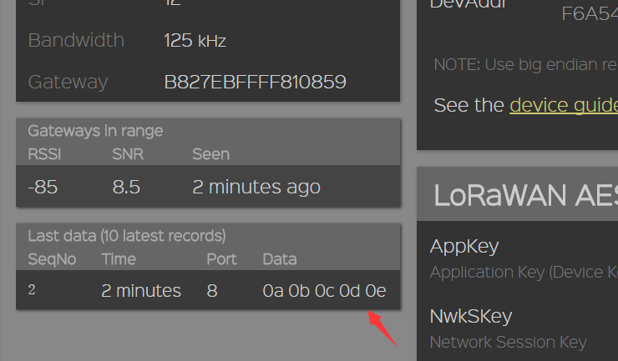

## Collect the sensor data

Here we have six sensors. The BME280 and TSL2561 is I2C port, the O2 sensor is analog port, and others are in digital port.

#define O2_pin A1

#define Dust_pin 3

#define CO2_TX 4

#define CO2_RX 5

#define dataPin 6 //Soil Temp&Hum sensor data pin

#define clockPin 7 //Soil Temp&Hum sensor clock pin

I defined a global array to store the data for each sensor. Since the LoRaWAN library only receives 8 bits of data, I need to split some data into high 8 bits and low 8 bits for transmission.

unsigned char Lora_data[15] = { 0, 1, 2, 3, 4, 5, 6, 7, 8, 9,10,11,12,13,14 };

Below is an index of each data:

Lora_data[0]：Air temperature

Lora_data[1]：Air humidity

Lora_data[2]：Altitude high 8-bits(reserve)

Lora_data[3]：Altitude low 8-bits(reserve)

Lora_data[4]：CO2 data high 8-bits

Lora_data[5]：CO2 data low 8-bits

Lora_data[6]：Dust data high 8-bits

Lora_data[7]：Dust data low 8-bits

Lora_data[8]：Light data high 8-bits

Lora_data[9]：Light data low 8-bits

Lora_data[10]：O2 data(thousandth)

Lora_data[11]：Soil temperature

Lora_data[12]：Soil humidity

Lora_data[13]：Battery voltage(reserve)

Lora_data[14]：Error code(reserve)

Collect and fill the sensor data into the array and use Lora_send(data_length) to send the data to the LoRaWAN gateway. Open loriot.io and find WebSocket in the Output:

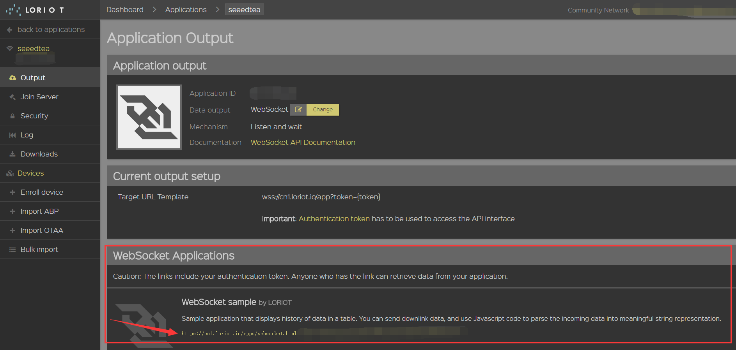

After clicking the WebSocket link, you can see the data shown below.

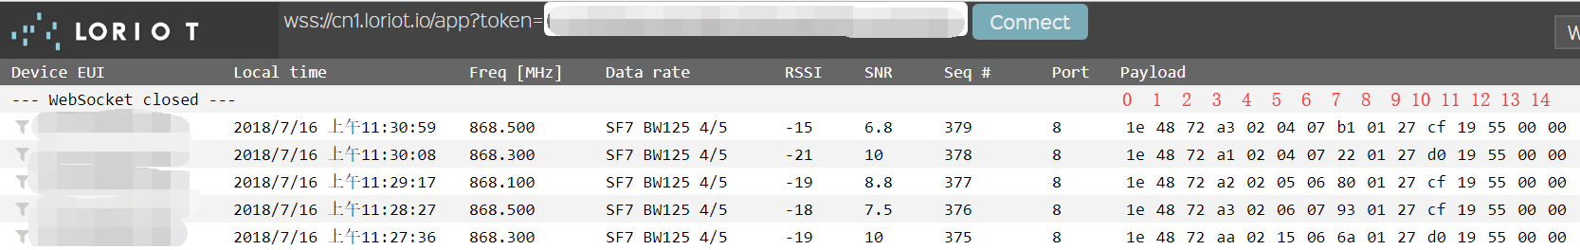

Device EUI: Your Seeeduino Lorawan Dev EUI.

RSSI: Received Signal Strength Indicator.

SNR: Signal Noise Ratio.

Payload: The data from your Lorawan Getway.

We need to pay attention to Payload. Do you remember the previously defined array Lora_data[]? Yes, Payload shows Lora_data[]. From left to right are Lora_data[0], Lora_data[1]. . . Lora_data [14]. These data are all in hexadecimal, which is not the same as our commonly used decimal. So let's make a simple hex conversion:

Click on "Decode Data", delete the original content on the right and enter "v;". Then click "Save". Refresh the page and you will see the decimal data.

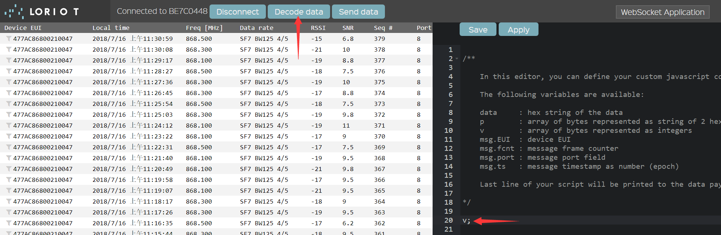

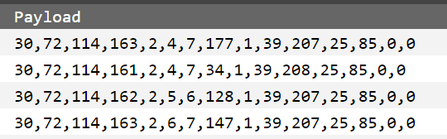

Ok, it looks good. And you can see the air temperature is 30 degrees Celsius and the humidity is 72%. The air is a bit hot and humid because it is raining outside.

## Make a waterproof platform for these electronic devices