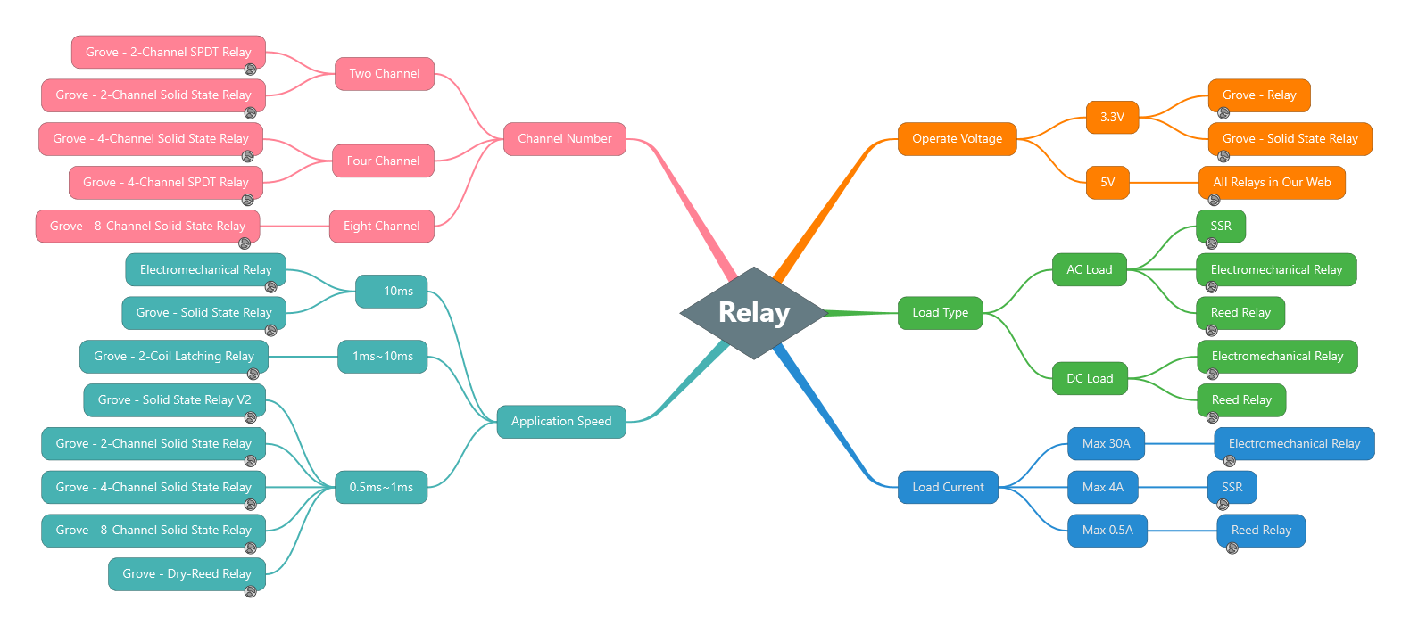

# **Relay**

* Operate Voltage
  + 3.3V
    - Grove - Relay  
      <https://www.seeedstudio.com/Grove-Relay-p-769.html>
    - Grove - Solid State Relay  
      <https://www.seeedstudio.com/Grove-Solid-State-Relay-p-1359.html>
  + 5V
    - All Relays in Our Web  
      <https://www.seeedstudio.com/tag/RELAY.html>
* Load Type
  + AC Load
    - SSR  
      <https://www.seeedstudio.com/tag/SSR.html>
    - Electromechanical Relay  
      <https://www.seeedstudio.com/tag/ELECTROMECHANICAL-RELAY.html>
    - Reed Relay  
      <https://www.seeedstudio.com/tag/REED-RELAY.html>
  + DC Load
    - Electromechanical Relay  
      <https://www.seeedstudio.com/tag/ELECTROMECHANICAL-RELAY.html>
    - Reed Relay  
      <https://www.seeedstudio.com/tag/REED-RELAY.html>
* Load Current
  + Max 30A
    - Electromechanical Relay  
      <https://www.seeedstudio.com/tag/ELECTROMECHANICAL-RELAY.html>
  + Max 4A
    - SSR  
      <https://www.seeedstudio.com/tag/SSR.html>
  + Max 0.5A
    - Reed Relay  
      <https://www.seeedstudio.com/tag/REED-RELAY.html>
* Application Speed
  + 10ms
    - Electromechanical Relay  
      <https://www.seeedstudio.com/tag/ELECTROMECHANICAL-RELAY.html>
    - Grove - Solid State Relay  
      <https://www.seeedstudio.com/Grove-Solid-State-Relay-p-1359.html>
  + 1ms~10ms
    - Grove - 2-Coil Latching Relay  
      <https://www.seeedstudio.com/Grove-2-Coil-Latching-Relay-p-1446.html>
  + 0.5ms~1ms
    - Grove - Solid State Relay V2  
      <https://www.seeedstudio.com/Grove-Solid-State-Relay-V2-p-3128.html>
    - Grove - 2-Channel Solid State Relay  
      <https://www.seeedstudio.com/Grove-2-Channel-Solid-State-Relay-p-3129.html>
    - Grove - 4-Channel Solid State Relay  
      <https://www.seeedstudio.com/Grove-4-Channel-Solid-State-Relay-p-3130.html>
    - Grove - 8-Channel Solid State Relay  
      <https://www.seeedstudio.com/Grove-8-Channel-Solid-State-Relay-p-3131.html>
    - Grove - Dry-Reed Relay  
      <https://www.seeedstudio.com/Grove-Dry-Reed-Relay-p-1412.html>
* Channel Number
  + Two Channel
    - Grove - 2-Channel SPDT Relay  
      <https://www.seeedstudio.com/Grove-2-Channel-SPDT-Relay-p-3118.html>
    - Grove - 2-Channel Solid State Relay  
      <https://www.seeedstudio.com/Grove-2-Channel-Solid-State-Relay-p-3129.html>
  + Four Channel
    - Grove - 4-Channel Solid State Relay  
      <https://www.seeedstudio.com/Grove-4-Channel-Solid-State-Relay-p-3130.html>
    - Grove - 4-Channel SPDT Relay  
      <https://www.seeedstudio.com/Grove-4-Channel-SPDT-Relay-p-3119.html>
  + Eight Channel
    - Grove - 8-Channel Solid State Relay  
      <https://www.seeedstudio.com/Grove-8-Channel-Solid-State-Relay-p-3131.html>