|  |  |  |  |  |
| --- | --- | --- | --- | --- |
| Jetbot-Snail 装箱单 | | | | |
| 序号 | 部件名称 | 编号 | 用量 | 备注 |
| 1 | 主架 | Chassis | 1 |  |
| 2 | 摄像机 IMX219  Pi Camera V2 | Camera | 1 |  |
| 3 | Intel Dual Band  Wireless-Ac 8265 W/Bt | Wi-fi | 1 |  |
| 4 | 双频天线 | Antennas | 2 |  |
| 5 | TT motor | TT | 2 |  |
| 6 | 车轮 | Wheel | 2 |  |
| 7 | 马达驱动板 PCA9685+TB6612 | P | 1 |  |
| 8 | 万向轮 | Universal [wheel](javascript:;) | 1 |  |
| 9 | 充电宝电池 | Power bank | 1 |  |
| 10 | Usb电源线 | U | 1 |  |
| 11 | PiOLED display 128x32 OLED | OLED | 1 |  |
| 12 | OLED接插板 | Pinboard | 1 |  |
| 13 | TF卡 64G | TF | 1 |  |
| 安装附件 | | | | |
| 13 | M2*5 | Screw-A | 12 | 固定主板、马达板、摄像头。 |
| 14 | M3*5 | Screw-B | 2 | 固定万向球 |
| 15 | M3*30 | Screw-C | 4 | 固定马达 |
| 16 | M3 | Nut | 4 |
| 17 | M2*5+5。 | Screw-D | 4 | 固定摄像头。 |
| 18 | M2*5+5。 | Screw-D | 4 | 固定主板 |
| 赠送配线 | | | | |
| 19 | 电机连接线 |  | 3 | 3条双色线 |
| 20 | Nano与驱动板连接线 |  | 8 | 8根双母头线 |

## 安装步骤

|  |  |
| --- | --- |
| C:\Users\wenjo\AppData\Local\Microsoft\Windows\INetCache\Content.Word\1.jpg | C:\Users\wenjo\AppData\Local\Microsoft\Windows\INetCache\Content.Word\2.jpg |
| C:\Users\wenjo\AppData\Local\Microsoft\Windows\INetCache\Content.Word\3.jpg | C:\Users\wenjo\AppData\Local\Microsoft\Windows\INetCache\Content.Word\4.jpg |
| C:\Users\wenjo\AppData\Local\Microsoft\Windows\INetCache\Content.Word\5.jpg | C:\Users\wenjo\AppData\Local\Microsoft\Windows\INetCache\Content.Word\6.jpg |
| C:\Users\wenjo\AppData\Local\Microsoft\Windows\INetCache\Content.Word\7.jpg | C:\Users\wenjo\AppData\Local\Microsoft\Windows\INetCache\Content.Word\8.jpg |
| C:\Users\wenjo\AppData\Local\Microsoft\Windows\INetCache\Content.Word\9.jpg | C:\Users\wenjo\AppData\Local\Microsoft\Windows\INetCache\Content.Word\10.jpg |
| C:\Users\wenjo\AppData\Local\Microsoft\Windows\INetCache\Content.Word\11-1.jpg | C:\Users\wenjo\AppData\Local\Microsoft\Windows\INetCache\Content.Word\12..jpg |
| C:\Users\wenjo\AppData\Local\Microsoft\Windows\INetCache\Content.Word\15.jpg  Pinboard | C:\Users\wenjo\AppData\Local\Microsoft\Windows\INetCache\Content.Word\16.jpg  OLED |
| C:\Users\wenjo\AppData\Local\Microsoft\Windows\INetCache\Content.Word\17.jpg  Camera | C:\Users\wenjo\AppData\Local\Microsoft\Windows\INetCache\Content.Word\18.jpg  Antennas |
| C:\Users\wenjo\AppData\Local\Microsoft\Windows\INetCache\Content.Word\19.jpg  Power bank | C:\Users\wenjo\AppData\Local\Microsoft\Windows\INetCache\Content.Word\JT02-20.png  完成 |

## 电气连接

### PCA9685+TB6612

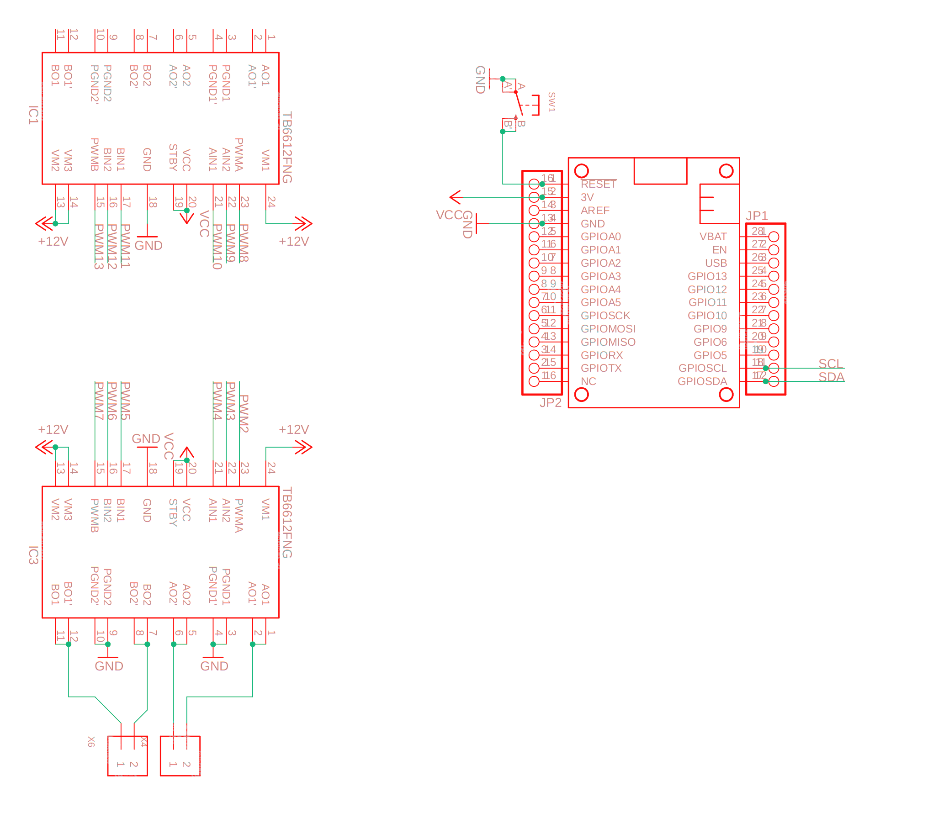

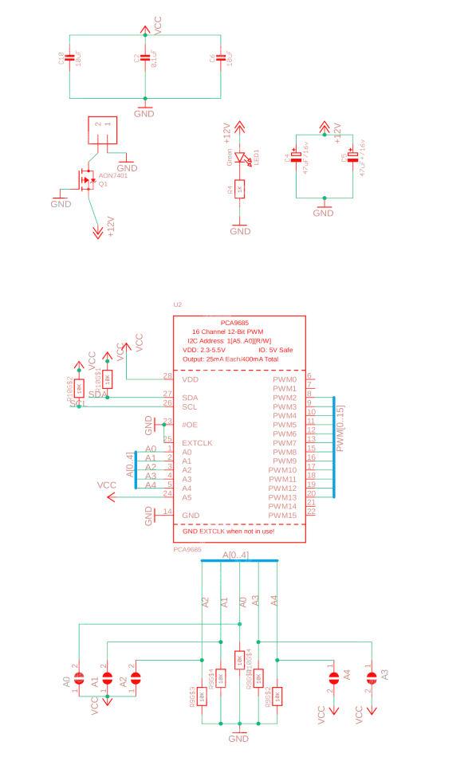

Nano Kit

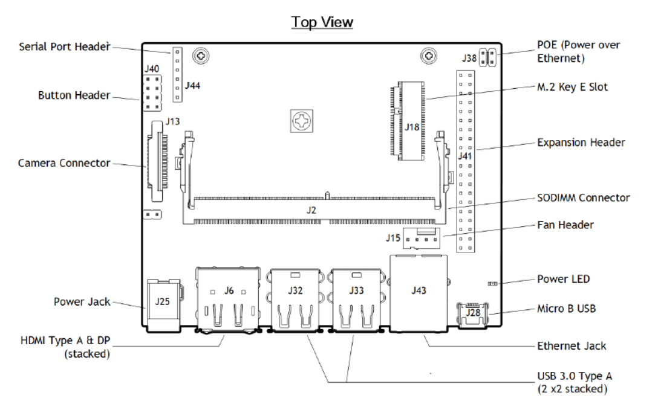

[J41] 40-pin expansion header includes:

• Power pins.

Two 3.3V power pins and two 5V power pins. These are not switchable; power is always available when the developer kit is connected to power.

Two 5V pins can be used to power the developer kit at 3A each.

• Interface signal pins.

All signals use 3.3V levels.

By default, all interface signal pins are configured as GPIOs, except pins 3 and 5 and pins 27 and 28, which are I2C SDA and SCL, and pins 8 and 10, which are UART TX and RX. L4T provides a Python library, Jetson.GPIO, for controlling GPIOs. The library has the same API as RPi.GPIO. See /opt/nvidia/jetson-gpio/doc/README.txt on your Jetson system for details.