Datasheet of YF-B1
Feature:
- All materials are in line with ROHS testing standards.
- Copper material, small size, easy to install.
- The water flow sensor is applied for water heater, and can be used as flow switch.
- Maximum water pressure: 1.75MPa, flow range: 1-30L/min.
- Stable, high temperature, low water pressure start, safe.

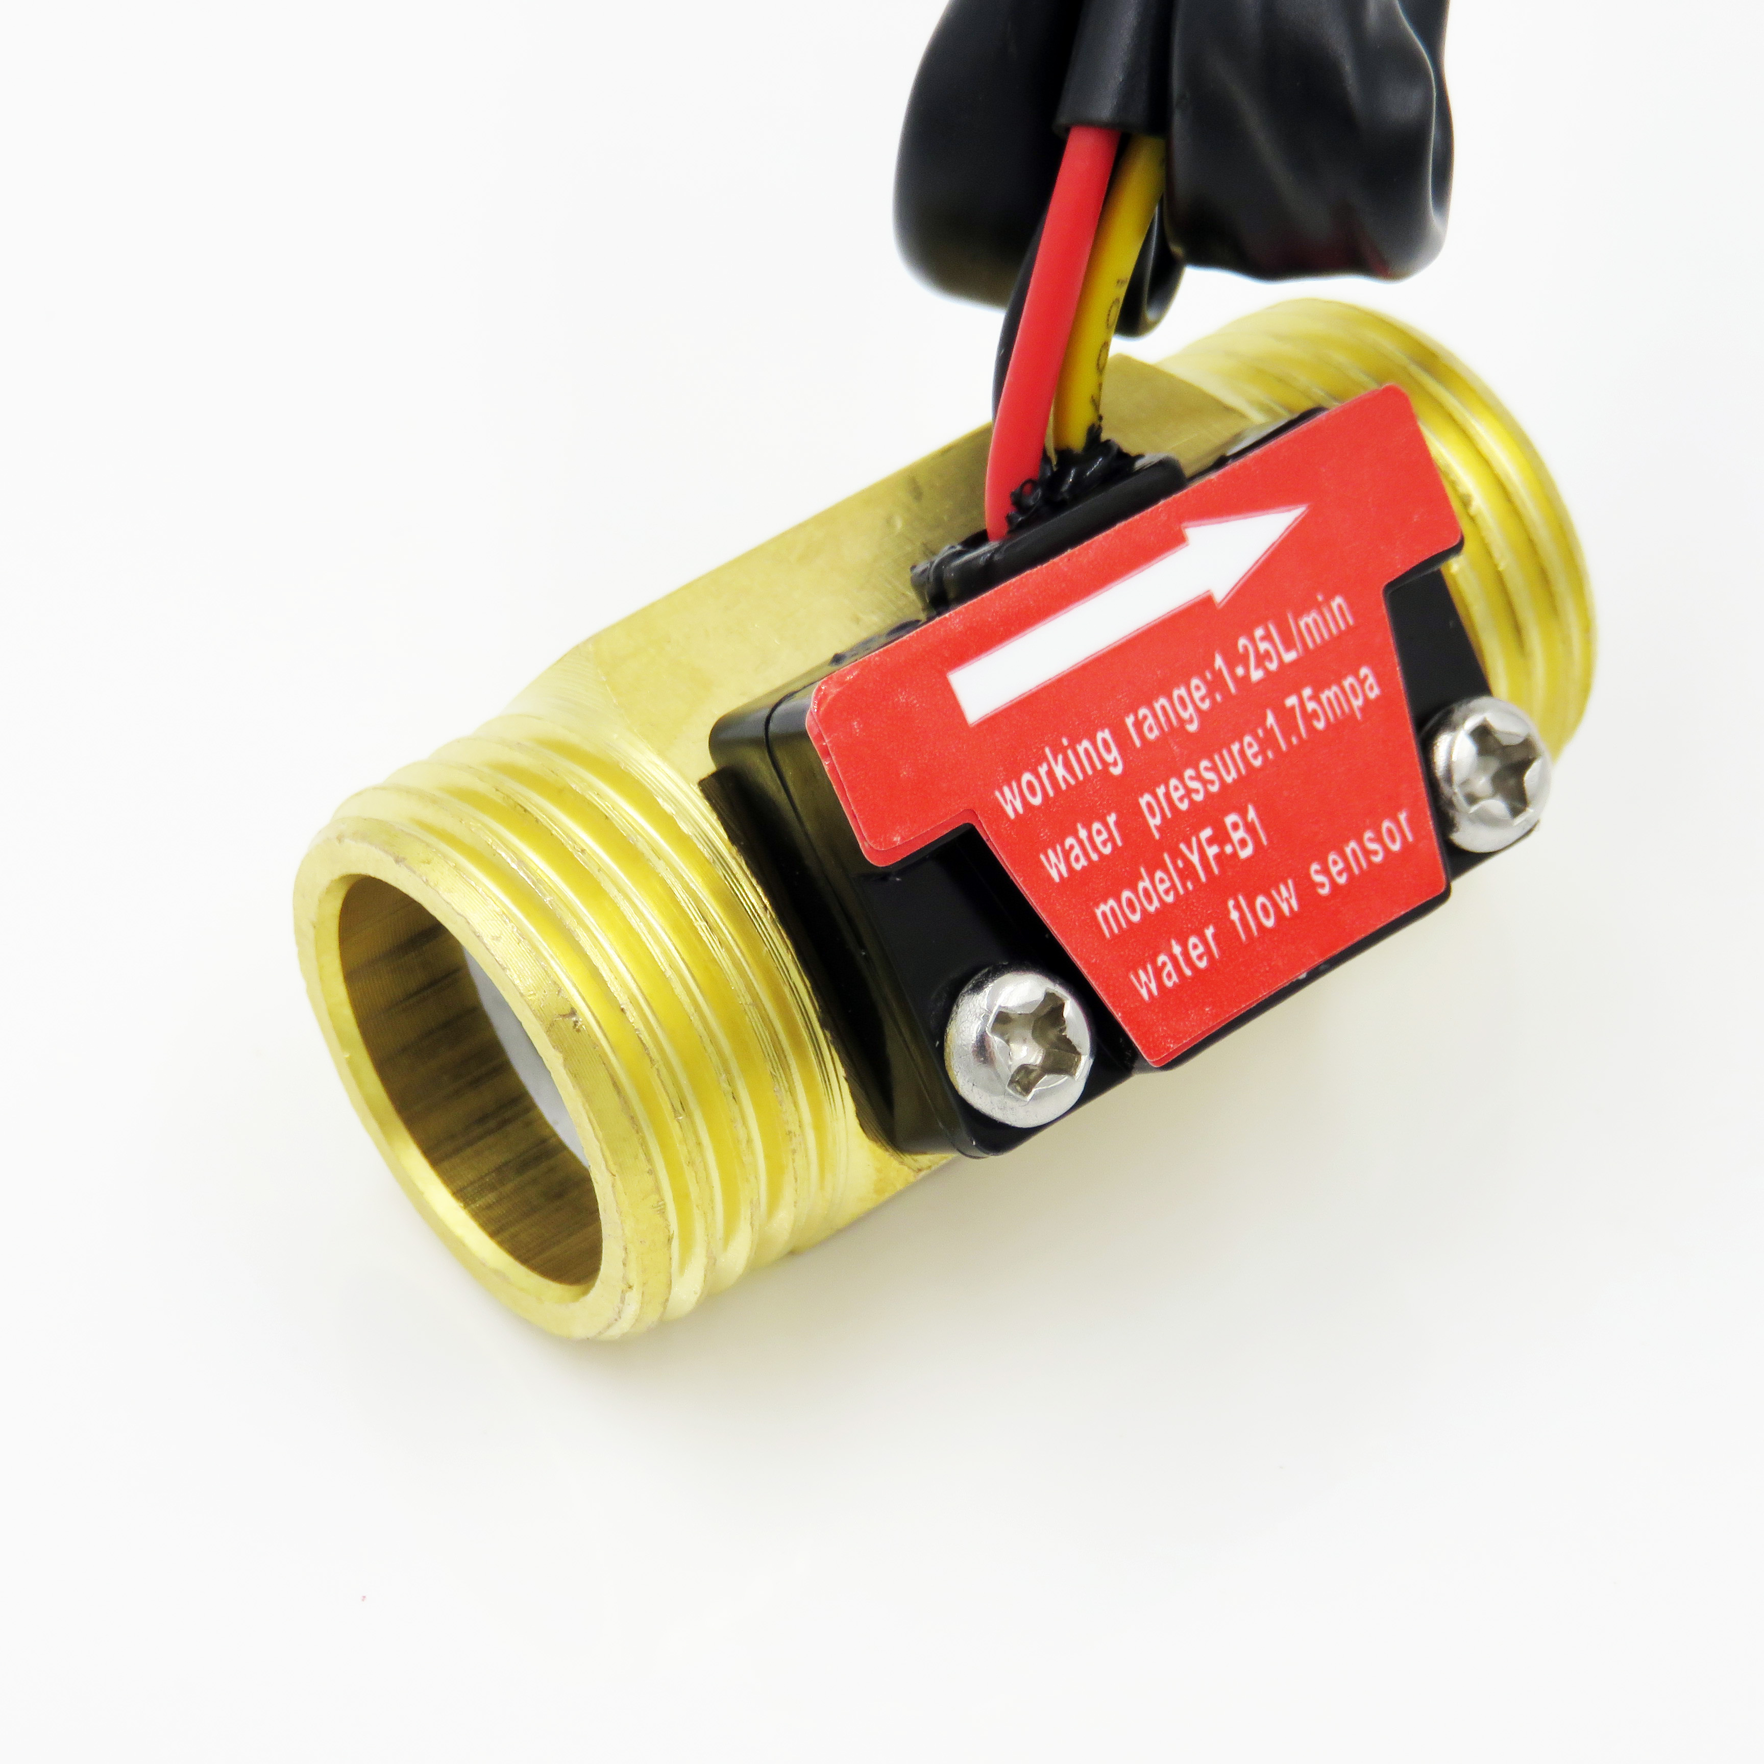
Descriptions：
1. The Water Flow Sensor is light, nimble outline, small size and easy to install. All materials are in line with ROHS testing standards.
2. There is an integrated hall effect sensor that outputs an electrical pulse with every revolution. The hall effect sensor is sealed from the water pipe and allows the sensor to stay safe and dry.
3. Stable, high temperature, low water pressure start, safe.
4. Can use for Water heaters, credit card machines, water vending machine, flow measurement device.
5. Three wire connection: Red for positive, black for negative, yellow for pulse signal.

Warning
1.Severe impact and chemical erosion are strictly prohibited
2.Do not throw or crash
3.Medium temperature should not exceed 1200 C

Assembly drawings
OUT

Output waveform：

Duty Cy=40%～60%
Wiring：

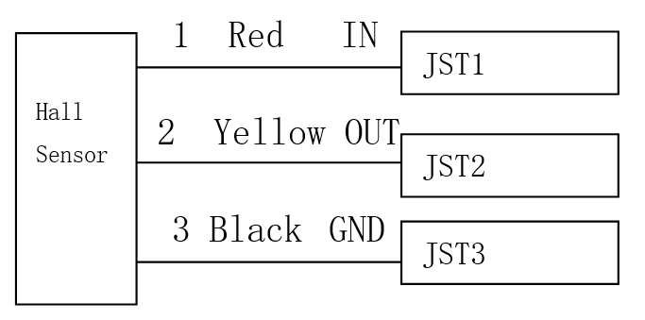

Specifications:
Product Name: Water Flow Sensor
Material: Copper(Shell)
Liquid Temperature: Not More Than 60C
Flow Range: 1-30L/min
Working Voltage Range: DC4.5-18V
Max Current: 10mA
Maximum Water Pressure: 1.75MPa
Instantaneous Flow Pulse Characteristic F=(10Q-4)+/-10%
Connector: Male SM-3P Plug
Cable Length: 35cm
Size: 44mm x 26mm x 24mm(L*W*H)
External Thread Diameter: G1/2 inch
Tube Length: 44mm
Color: Gold Tone
Net Weight: 77g

flow --- pulse reference table F=11*Q
flow | plus | inaccuracy error | MAX | MIN | flow | plus | inaccuracy error | MAX | MIN
2 | 22 | ±1.020 | 22.44 | 21.56 | 6.1 | 67.1 | ±3.2 | 68.44 | 65.76
2.1 | 23.1 | ±1.021 | 23.59 | 22.64 | 6.2 | 68.2 | ±3.3 | 69.56 | 66.90
2.2 | 24.2 | ±1.022 | 24.68 | 23.72 | 6.3 | 69.3 | ±3.4 | 70.69 | 67.91
2.3 | 25.3 | ±1.023 | 25.83 | 24.79 | 6.4 | 70.4 | ±3.5 | 71.81 | 69.06
2.4 | 26.4 | ±1.024 | 26.93 | 25.87 | 6.5 | 71.5 | ±3.6 | 72.93 | 70.07
2.5 | 27.5 | ±1.025 | 28.08 | 26.95 | 6.6 | 72.6 | ±3.7 | 74.05 | 71.22
2.6 | 28.6 | ±1.026 | 29.17 | 28.03 | 6.7 | 73.7 | ±3.8 | 75.17 | 72.23
2.7 | 29.7 | ±1.027 | 30.32 | 29.11 | 6.8 | 74.8 | ±3.9 | 76.30 | 73.38
2.8 | 30.8 | ±1.028 | 31.42 | 30.18 | 6.9 | 75.9 | ±3.10 | 77.42 | 74.38
2.9 | 31.9 | ±1.029 | 32.57 | 31.26 | 7 | 77 | ±3.11 | 78.54 | 75.54
3 | 33 | ±1.030 | 33.66 | 32.34 | 7.1 | 78.1 | ±3.12 | 79.66 | 76.54
3.1 | 34.1 | ±1.031 | 34.82 | 33.42 | 7.2 | 79.2 | ±3.13 | 80.78 | 77.70
3.2 | 35.2 | ±1.032 | 35.90 | 34.50 | 7.3 | 80.3 | ±3.14 | 81.91 | 78.69
3.3 | 36.3 | ±1.033 | 37.06 | 35.57 | 7.4 | 81.4 | ±3.15 | 83.03 | 79.85
3.4 | 37.4 | ±1.034 | 38.15 | 36.65 | 7.5 | 82.5 | ±3.16 | 84.15 | 80.85
3.5 | 38.5 | ±1.035 | 39.31 | 37.73 | 7.6 | 83.6 | ±3.17 | 85.27 | 82.01
3.6 | 39.6 | ±1.036 | 40.39 | 38.81 | 7.7 | 84.7 | ±3.18 | 86.39 | 83.01
3.7 | 40.7 | ±1.037 | 41.55 | 39.89 | 7.8 | 85.8 | ±3.19 | 87.52 | 84.17
3.8 | 41.8 | ±1.038 | 42.64 | 40.96 | 7.9 | 86.9 | ±3.20 | 88.64 | 85.16
3.9 | 42.9 | ±1.039 | 43.80 | 42.04 | 8 | 88 | ±3.21 | 89.76 | 86.33
4 | 44 | ±1.040 | 44.88 | 43.12 | 8.1 | 89.1 | ±3.22 | 90.88 | 87.32
4.1 | 45.1 | ±1.041 | 46.05 | 44.20 | 8.2 | 90.2 | ±3.23 | 92.00 | 88.49
4.2 | 46.2 | ±1.042 | 47.12 | 45.28 | 8.3 | 91.3 | ±3.24 | 93.13 | 89.47
4.3 | 47.3 | ±1.043 | 48.29 | 46.35 | 8.4 | 92.4 | ±3.25 | 94.25 | 90.64
4.4 | 48.4 | ±1.044 | 49.37 | 47.43 | 8.5 | 93.5 | ±3.26 | 95.37 | 91.63
4.5 | 49.5 | ±1.045 | 50.54 | 48.51 | 8.6 | 94.6 | ±3.27 | 96.49 | 92.80
4.6 | 50.6 | ±1.046 | 51.61 | 49.59 | 8.7 | 95.7 | ±3.28 | 97.61 | 93.79
4.7 | 51.7 | ±1.047 | 52.79 | 50.67 | 8.8 | 96.8 | ±3.29 | 98.74 | 94.96
4.8 | 52.8 | ±1.048 | 53.86 | 51.74 | 8.9 | 97.9 | ±3.30 | 99.86 | 95.94
4.9 | 53.9 | ±1.049 | 55.03 | 52.82 | 9 | 99 | ±3.31 | 100.98 | 97.12
5 | 55 | ±1.050 | 56.10 | 53.90 | 9.1 | 100.1 | ±3.32 | 102.10 | 98.10
5.1 | 56.1 | ±1.051 | 57.28 | 54.98 | 9.2 | 101.2 | ±3.33 | 103.22 | 99.28
5.2 | 57.2 | ±1.052 | 58.34 | 56.06 | 9.3 | 102.3 | ±3.34 | 104.35 | 100.25
5.3 | 58.3 | ±1.053 | 59.52 | 57.13 | 9.4 | 103.4 | ±3.35 | 105.47 | 101.44
5.4 | 59.4 | ±1.054 | 60.59 | 58.21 | 9.5 | 104.5 | ±3.36 | 106.59 | 102.41
5.5 | 60.5 | ±1.055 | 61.77 | 59.29 | 9.6 | 105.6 | ±3.37 | 107.71 | 103.59
5.6 | 61.6 | ±1.056 | 62.83 | 60.37 | 9.7 | 106.7 | ±3.38 | 108.83 | 104.57
5.7 | 62.7 | ±1.057 | 64.02 | 61.45 | 9.8 | 107.8 | ±3.39 | 109.96 | 105.75
5.8 | 63.8 | ±1.058 | 65.08 | 62.52 | 9.9 | 108.9 | ±3.40 | 111.08 | 106.72
5.9 | 64.9 | ±1.059 | 66.26 | 63.60 | 10 | 110 | ±3.41 | 112.20 | 107.91

