Apply Twilio API Key Procedure

1. Open <https://www.twilio.com/>
2. Click Get a free API key >

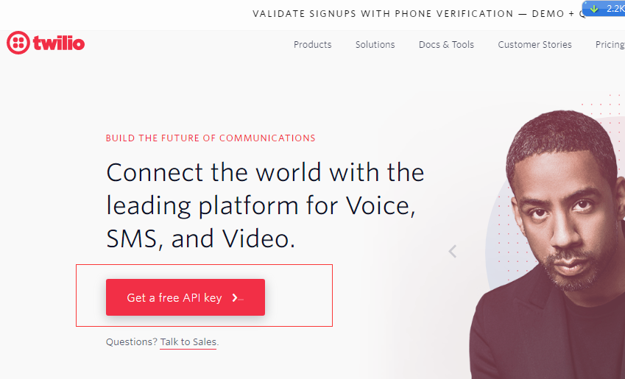

1. Sign up for free and get Started, please select the SMS, SMS and phone surveys, and python.

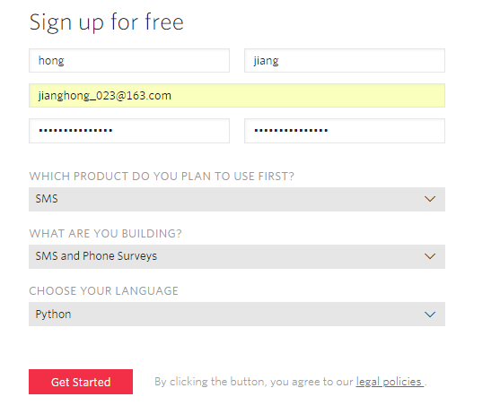

1. Select your Country and enter your phone number, then click the verify via SMS.

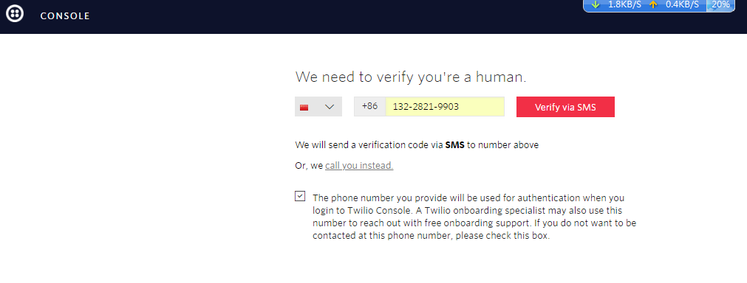

1. Key in the verification code and click the submit

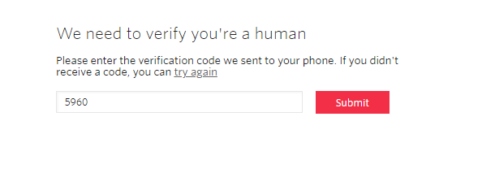

1. Type the project name

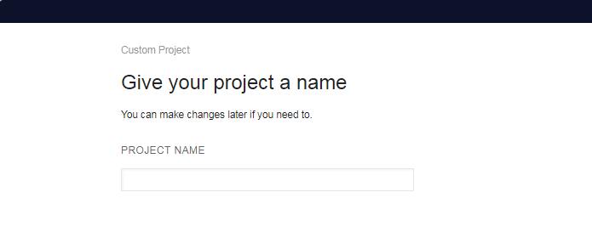

1. Click the console dashboard and click Get Started

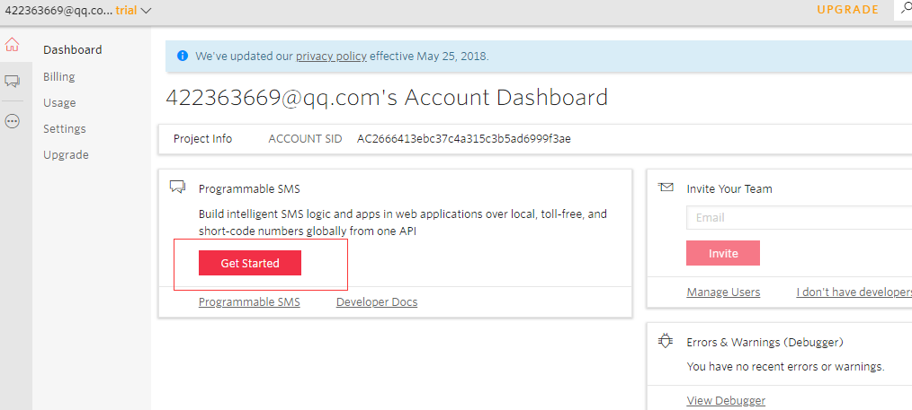

1. Click [Programmable SMS](https://www.twilio.com/console/sms) 🡪 Learn & Build 🡪 **Build**, select **SMS & Phone Surveys** at “Build Your Application” and then click **Get a number**.

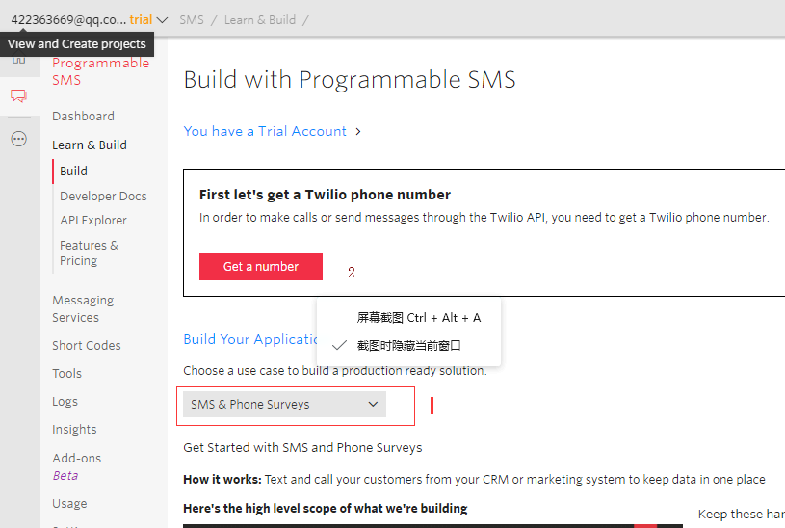

1. Click **choose this Number**

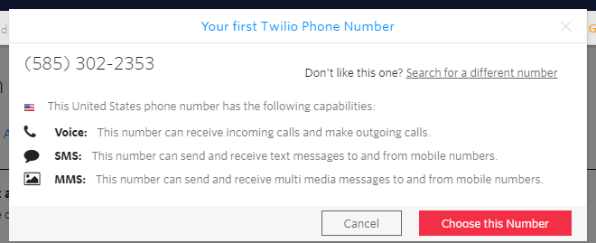

1. Click **Done.**

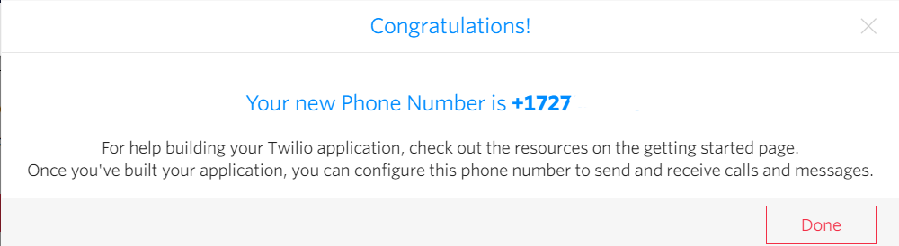

1. Enter message inside of **BODY a**nd click **Make request** to test the message function.

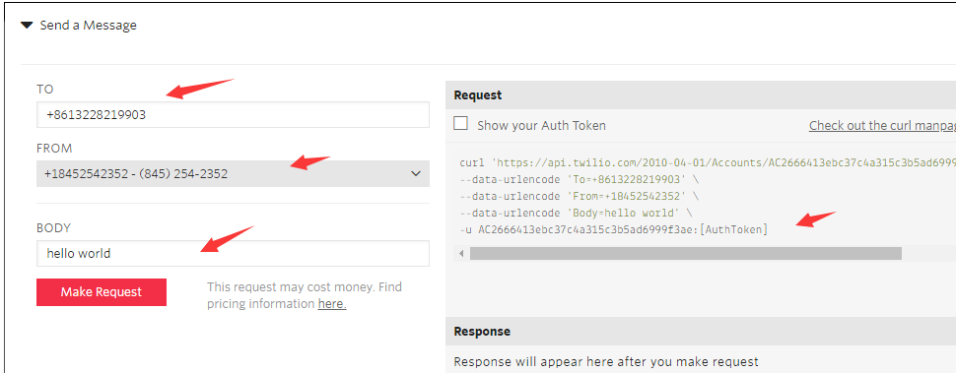

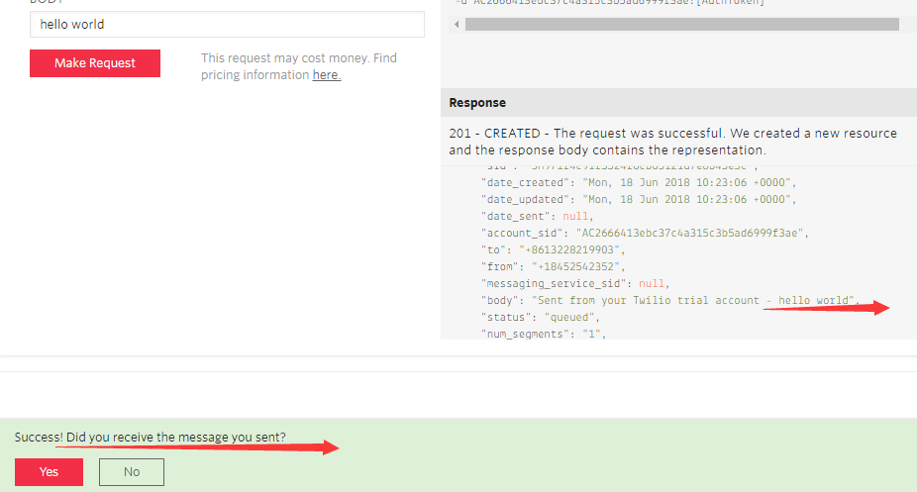

1. You will receive the message as below

