*KRCP Lecture 5*

*Memory*

**Memory**

* **Encoding**: processing of new information, 2 forms: **Acquisition** and **Consolidation**
* **Acquisition**: sustaining some of the sensory stimuli to enter into memory
* **Consolidation**: stabilize a memory over time resulting on long term memory
* **Storage**: record the information
* **Retrieval**: accessing stored information

**Types of Memory**

* **Long term memory:** holds information permanently, unlimited capacity, 2 different types: **Declarative** and **Nondeclarative** memory
* **Declarative (explicit) memory**: things you can describe, 2 types: **episodic** (events in your life) and **semantic** (facts you know) memory
* **Nondeclarative (implicit) memory**: things you can do, 2 types: **procedural memory** (skills) and **classical conditioning** (conditioned responses between 2 stimuli)
* **Short term memory**: distraction causes to forget, limited capacity, 2 different types: **Sensory** and **Working** memory
* **Sensory memory**: 2 types: **iconic** (visual) and *echoic* (auditory) memory
* **Working memory**: storage and processing of new and already-stored information, important for reasoning

**Atkinson & Shiffrin’s modal (or multi-store) model**

*Sensory Inputs*

⬇⬇⬇ 

Sensory Register *Attention*

⬇⬇⬇       

Short-term Storage

  ⬆⬆⬆   *Rehearsal*

  ⬇⬇⬇      

Long-term Storage

**Baddeley’s working memory model**

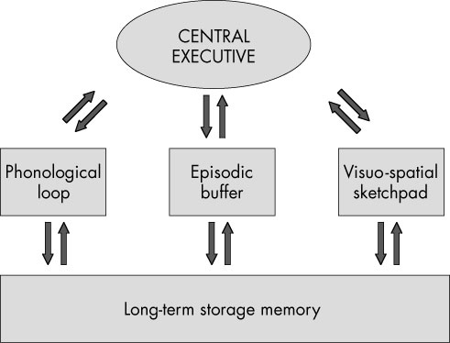

* **Central Executive**: drives the whole system and allocates data to the subsystems
* **Phonological loop**: part of working memory that deals with spoken and written material
* **Visual-spatial sketchpad**: deals with visual and spatial information
* **Episodic buffer**: “backup” store

**Consolidation by studying/rehearsal**

* **Consolidation**: integrating new information
* **Rehearsal**: **elaborative** (thinking about the meaning) or **maintenance** (repeatedly verbalizing or thinking about something)
* **Distributed** practice is more effective than **massed**
* **Mnemonics**: add meaning to lists

**Free recall experiments**

* Show serial position curve
* **Primacy effect**: superior recall of items near beginning
* **Recency effect**: superior recall of items near end

**Forgetting**

* 2 theories: **interference** and **decay**
* **Interference**: competing information, 2 types: **retroactive** (new interferes with something already learned) and **proactive** (already learned interferes with something new)
* **Decay**: memory trace gradually fades away

**Constructive memory**

* Memory is not only reconstructive
* **Prior experience** has an influence on memory
* **Flashbulb memories** (eg. Where were you at 9/11?)
* **Encoding specificity**: memory performance is optimal when there is a match in processes/context between learning and retrieving (experiment Godden and Baddeley)

**Anatomy of memory**

* **Hippocampus** is essential for memory consolidation
* Standard consolidation theory (Squire): Memory consolidation in hippocampus via **entorhinal cortex**; during sleep consolidation in **other parts of cortex**

**Memory deficits**

* **Amnesia**: **anterograde** (no new memories formed 🡪 no consolidation) and **retrograde** (no old memories remembered 🡪 no retrieval)
* **Alzheimer disease**: Amyloid plaques and neurofibrillary tangles in brain 🡪 memory impairment and general impairment (starts with episodic memory)