itle: “QRM2”
uthor: “Groepje 47”
ate: “2026-09-04”
utput: html_document

Week 1

1 Dataset
Find the dataset “movies5.tsv” on Canvas. Describe your data set: How many observations does it have? How many variables are there? How many subjects? What consists of a subject? [4 points]
# Load the dataset
movies <- read.delim("movies5.tsv")
# Count the rows (observations)
nrow(movies)
## [1] 909
# Count the columns (variables)
ncol(movies)
## [1] 19
# Count the unique movies and identify them
length(unique(movies$index))
## [1] 909
Your Answer:
Number of observations: 909 observations (rows).
Number of variables: 19 variables (columns).
Number of subjects: 909 subjects (films)
The dataset contains 909 observations and 19 variables, including the identifier “index”. There are 909 subjects, each representing an individual movie. Each row contains one observation with information about a movie, such as its title, budget, revenue, and runtime etc. Since each movie appears exactly once in the dataset, the number of observations equals the number of subjects.

2 Types of variables
Which of the following types of variables are present in your data set? (i) nominal; (ii) ordinal; (iii) interval; (iv) ratio. If present, name one example of such a variable present in your data set. [4 points]
# Show the variables and their data types
str(movies)
## 'data.frame': 909 obs. of 19 variables:
## $ index : int 4749 1744 960 1810 2889 1527 3520 2050 3755 1390 ...
## $ budget : num 0.0 3.0e+07 5.0e+07 3.0e+07 1.2e+06 ...
## $ keywords : chr "love independent film best friend true love irish catholic" "alcohol one-night stand bed pregnancy and birth condom" "imaginary friend outcast" "christianity jewry roman empire jesus christ suffering" ...
## $ original_language : chr "en" "en" "en" "en" ...
## $ title : chr "The Brothers McMullen" "Knocked Up" "The Adventures of Sharkboy and Lavagirl" "The Passion of the Christ" ...
## $ popularity : num 1.58 22.53 12.31 38.17 3.58 ...
## $ release_date : chr "1995-08-09" "2007-06-01" "2005-06-10" "2004-02-25" ...
## $ revenue : num 0.00 2.19e+08 6.94e+07 6.12e+08 0.00 ...
## $ runtime : int 98 129 92 127 86 137 112 96 93 92 ...
## $ vote_average : num 6.3 6.2 4.4 6.9 6.2 6.9 6.2 5.2 5.3 6.2 ...
## $ vote_count : int 23 1214 269 864 50 113 578 559 26 1428 ...
## $ genre : chr "Drama" "Drama" "Adventure" "Drama" ...
## $ release_year : int 1995 2007 2005 2004 2002 1995 2002 2015 2001 2009 ...
## $ release_month : int 8 6 6 2 5 12 4 9 11 1 ...
## $ release_day : int 9 1 10 25 24 29 11 3 16 22 ...
## $ first_actor : chr "Shari Albert" "Seth Rogen" "Taylor Lautner" "Jim Caviezel" ...
## $ first_actor_gender : chr "female" "male" "female" "male" ...
## $ director_first_name: chr "Edward" "Judd" "Robert" "Mel" ...
## $ director_gender : chr "male" "male" "male" "male" ...
# Show the different genres
unique(movies$genre)
## [1] "Drama" "Adventure" "Comedy" "Thriller" "Documentary"
## [6] "Action" "Fiction" "Music" NA "Animation"
## [11] "Family" "Horror" "Romance" "Western" "Crime"
# Show the different ratings from lowest to highest
sort(unique(movies$vote_average))
## [1] 0.0 2.3 2.8 2.9 3.0 3.2 3.3 3.4 3.7 3.8 3.9 4.0 4.1 4.2 4.3 4.4 4.5 4.6 4.7
## [20] 4.8 4.9 5.0 5.1 5.2 5.3 5.4 5.5 5.6 5.7 5.8 5.9 6.0 6.1 6.2 6.3 6.4 6.5 6.6
## [39] 6.7 6.8 6.9 7.0 7.1 7.2 7.3 7.4 7.5 7.6 7.7 7.8 7.9 8.0 8.3 9.5
# Show the first six release years
head(movies$release_year)
## [1] 1995 2007 2005 2004 2002 1995
# Show the first six runtimes
head(movies$runtime)
## [1] 98 129 92 127 86 137
Your Answer:
- “Genre” is a nominal variable, since categories like Comedy, Drama, and Action don’t have any natural order.
- The dataset does not include an ordinal variable. We treat “vote_average” as an interval variable, which assumes the rating points have a even distance apart.
- “Release_year” qualifies as an interval variable. The gap between two years always means the same thing—ten years is ten years—yet there’s no true zero. So, moving from 2000 to 2010 is just as much time as 2010 to 2020.
- “Runtime” is a ratio variable. Time has a true zero, and we can talk about its values in terms of multiples—a 120-minute movie is twice as long as a 60-minute one.

3 Movie profits and ratings
A movie studio wants to know which types of movies give maximal profit. Perform the following steps to provide the movie studio with an analysis which corresponds to their request:
- Create the variable profits as the revenue of a movie minus its budget. Report its mean, median, maximum, and minimum. [2 points]
- Which movie has the highest profits in your data set and how much are these profits? Which movie has the lowest and how much are its profits? If multiple movies have the exact same highest or lowest profits, give only one example. [2 points]
- Create a boxplot of the variable profits. Make sure it has an appropriate title, and appropriate titles and labels for the x- and y-axis. Give Q1, Q2, Q3, and Q4. What does this tell you about the nature of making money in the movies industry? [2 points]
- Add a new variable to your data set the log of profits. When creating this variable, what happens to movies for which profits is zero or negative? What then happens when you calculate the mean of log of profits? [2 points]
- For movies that have a profit of zero or less, replace log of profits with “NA”. What is now the mean of log of profits? Create a boxplot for log of profits, again with an appropriate title, x- and y-axis labels. How does it compare to the boxplot you made under c.)? [2 points]
- Create a scatterplot of with the runtime of movies on the x-axis and the average vote of movies on the y-axis. What do you conclude from the scatterplot? Are movies with a longer runtime considered worse or better by the audience, or does the audience not have a preference? Why do you think this is the case? [2 points]
For each step, you should provide first all the code you used to answer the question and then formulate an answer using full sentences.

Step a
# Create profits variable
movies$profits <- movies$revenue - movies$budget
# Calculate mean/median/max/min
mean(movies$profits)
## [1] 56284650
median(movies$profits)
## [1] 2942221
max(movies$profits)
## [1] 1082730962
min(movies$profits)
## [1] -98301101
Your Answer:
We calculated profit by subtracting the budget from the revenue. The mean profit is 56,284,649.70, and the median is 2,942,221. The highest profit is 1,082,730,962, and the lowest is −98,301,101.

Step b
# Movie with the highest profit and its profit
movies$title[which.max(movies$profits)]
## [1] "Minions"
# Show the highest profit
max(movies$profits)
## [1] 1082730962
# Movie with the lowest profit and its profit
movies$title[which.min(movies$profits)]
## [1] "The 13th Warrior"
# Show the lowest profit
min(movies$profits)
## [1] -98301101
Your Answer:
“Minions” has the highest profit, earning 1,082,730,962 above its budget. “The 13th Warrior” has the lowest profit, with a loss of 98,301,101. This result was also found with max/min in step a.

Step c
# Boxplot of profits in millions
boxplot(movies$profits / 1000000,
main = "Movie profits",
xlab = "All movies",
ylab = "Profit (millions)",
col = "lightblue")
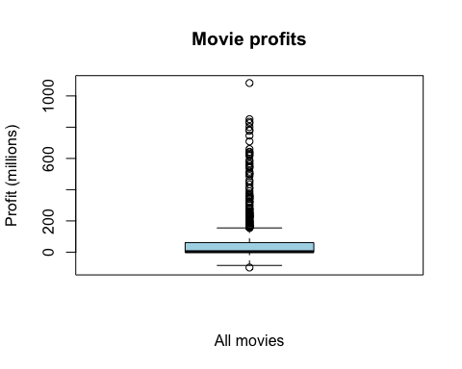
# Summary of profits in the original monetary units
summary(movies$profits)
## Min. 1st Qu. Median Mean 3rd Qu. Max.
## -98301101 -1260859 2942221 56284650 61340801 1082730962
Your Answer:
Q1 is −1,260,859, Q2 is 2,942,221, and Q3 is 61,340,801. We interpret Q4 as the maximum, which is 1,082,730,962.
The boxplot shows that a few movies make much higher profits than the rest, which pulls the mean above the median. Based on the recorded revenue and budget, at least a quarter of the movies made a loss. This suggests that making movies can be risky: some earn huge profits, while many others earn much less or lose money.

Step d
# Create the natural logarithm of profits
movies$log_profits <- log(movies$profits)
## Warning in log(movies$profits): NaNs produced
# Count movies with zero or negative profits
sum(movies$profits == 0)
## [1] 162
sum(movies$profits < 0)
## [1] 261
# Calculate the mean of log profits
mean(movies$log_profits)
## [1] NaN
Your Answer:
For movies with zero profit, taking the logarithm gives −Inf. For movies with negative profit, it gives NaN, and R shows a warning. There are 162 movies with zero profit and 261 with negative profit. Because the log-profit variable contains these values, it means the calculation of the mean becomes NaN. You would have to filter out these NaN and -Inf to correctly calculate the mean of movies with more than 0 profit.

Step e
# Replace log profits with NA for non-positive profits
movies$log_profits[movies$profits <= 0] <- NA
# Calculate the mean, excluding missing values
mean(movies$log_profits, na.rm = TRUE)
## [1] 17.5448
# Create a boxplot of log profits
boxplot(
movies$log_profits,
main = "Distribution of Log Movie Profits",
xlab = "Movies",
ylab = "Natural logarithm of profit",
names = "Positive-profit movies",
col = "lightgreen"
)
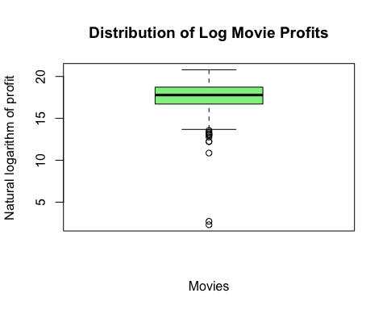
Your Answer:
After replacing the log values for zero and negative profits with NA, the mean log profit is about 17.5448. We used na.rm = TRUE to leave out the missing values, so this mean only includes the 486 movies with positive profits.
The new boxplot is less stretched towards high values because the logarithm brings large profits closer together. There are still several outliers on the lower side. The plots also include different movies: the first includes all movies, while the second only includes movies that made a positive profit.

Step f
# Create a scatterplot of runtime and average rating
plot(
movies$runtime,
movies$vote_average,
main = "Movie Runtime and Average Audience Rating",
xlab = "Runtime (minutes)",
ylab = "Average audience rating",
pch = 19,
col = rgb(0, 0.3, 0.7, 0.4)
)
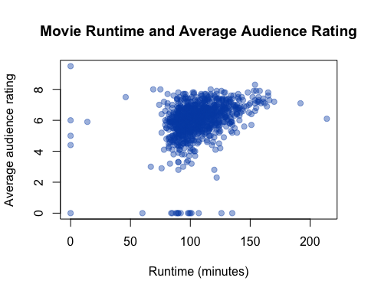
# Calculate the correlation to support the interpretation
cor(movies$runtime, movies$vote_average)
## [1] 0.3204062
Your Answer:
The scatterplot suggests that longer movies tend to receive slightly higher ratings. The correlation is about 0.32, but the points are spread out, so there are plenty of exceptions.
Longer movies might have more time to develop their characters and stories, which could help explain the higher ratings. Genre and movie quality could also play a role. The plot does not prove that making a movie longer will improve its rating. There are also some zero values for runtime and rating that may represent missing or incorrectly recorded data. these values should be invested before drawing firm conclusions.

Week 2

1 Population and sample
Is your dataset movies5.tsv the full population, or is it a sample of a larger population? If the latter, how would you describe the full population? [4 points]
Your Answer:
The dataset is a sample of a larger population because it contains 909 movies, rather than every movie. The full population would be all movies we want to draw conclusions about. For example, if we want to study movies released between 1990 and 2016, the population would include all movies released during those years. We cannot assume that the movies in our dataset were selected randomly.

2 Actors and movie revenue

Step a
For which actor in your data set do you observe the most movies? [2 points]
# Count the movies for each actor
actor_counts <- table(movies$first_actor)
# Show the highest counts first
head(sort(actor_counts, decreasing = TRUE))
##
## Bruce Willis Tom Hanks Johnny Depp Sandra Bullock Tom Cruise
## 8 8 7 7 7
## Drew Barrymore
## 6
Your Answer:
Bruce Willis and Tom Hanks appear most often, with 8 movies each. We use Bruce Willis for the next steps. These counts are based on the first_actor column, so they do not include appearances by actors elsewhere in a movie’s cast.

Step b
What is the average revenue of the movie in which this actor plays and does the revenue lie above or below the revenue of an average movie according to your data set? [2 points]
# Average revenue of movies with Bruce Willis as first_actor
mean(movies$revenue[movies$first_actor == "Bruce Willis"],
na.rm = TRUE)
## [1] 228062987
# Average revenue of all movies
mean(movies$revenue, na.rm = TRUE)
## [1] 88846315
Your Answer:
The average revenue of the movies with Bruce Willis is 228,062,987.38. The average revenue across all movies in the dataset is 88,846,314.90. His movies therefore earn more revenue on average than the average movie in this dataset.

Step c
How trustworthy do you consider your conclusion to answer 2b? Use the term “law of large numbers” in your explanation. [2 points]
# Number of movies used for the Bruce Willis average
sum(movies$first_actor == "Bruce Willis", na.rm = TRUE)
## [1] 8
Your Answer:
The comparison is correct for this dataset, but it is based on only 8 Bruce Willis movies. One or two very successful movies could have a large effect on his average.
The law of large numbers tells us that, with a sufficiently large random sample, the sample mean tends to get closer to the population mean. Since we only have 8 movies and do not know whether they were randomly selected, we should be careful about applying this result to all Bruce Willis movies. It also does not show that Bruce Willis himself causes higher revenue.

3 Population and sample variance
For this question, you will assume that your data set is the full population.

Step a
Recode profits such that it is expressed in millions. What is the variance of the variable profits (in millions) in your data set? [2 points]
# Calculate profits in millions
movies$profits <- (movies$revenue - movies$budget) / 1000000
# Calculate the population variance
population_variance <- mean(
(movies$profits - mean(movies$profits))^2
)
# Show the population variance
population_variance
## [1] 17802.62
Your Answer: The population variance of profits is approximately 17,802.62 squared million dollars.The Variance is calculated using squared deviations from the mean, so negative and positive deviations do not cancel each other out. We divide by N, rather than N−1, because the assignment asks us to treat the dataset as the full population.

Step b
Create a new data set, called movies_sample. Make sure that it is a random sample of your data set of 25 movies. What is the variance of profits in this random sample? How does it compare to the variance of profits in 2a? [2 points]
# Make the random sample reproducible
set.seed(47)
# Select a random sample of 25 movies
movies_sample <- movies[sample(nrow(movies), 25), ]
# Calculate the sample variance
var(movies_sample$profits)
## [1] 15728.93
Your Answer:
The sample variance is approximately 15,728.93 squared millions. This is lower than the population variance of 17,802.62 from the previous step.
The values differ because the sample contains only 25 of the 909 movies. A different sample could give a higher or lower variance, depending on which movies are selected. Different random samples can produce different sample variances, depending on which movies you select.

Step c
In a for loop, create 100 different samples of 25 movies, as in b, and estimate the variance within each sample. Save the variance of each sample in a vector called sample_vars. So the first position of the vector would have the variance of the first sample, the second position the variance of the second sample, etc. Print the start of this vector. [2 points]
# Make the random samples reproducible
set.seed(47)
# Create space for 100 sample variances
sample_vars <- numeric(100)
# Take 100 samples and save their variances
for (i in 1:100) {
# Select 25 movies at random for this sample
movies_sample <- movies[sample(nrow(movies), 25), ]
# Save this sample variance in position i
sample_vars[i] <- var(movies_sample$profits)
}
# Show the first six sample variances
head(sample_vars)
## [1] 15728.93 31971.87 16532.82 28257.89 24848.85 56289.00
Your Answer:
We took 100 random samples of 25 movies and saved each sample variance in sample_vars. The first six variances are approximately 15,728.93, 31,971.87, 16,532.82, 28,257.89, 24,848.85, and 56,289.00.
The variances differ because each sample contains a different selection of movies, as explained in step 3b.

Step d
Summarize and make a histogram of sample_vars. What is the mean, standard deviation and shape of its distribution? [2 points]
# Summarize the sample variances
summary(sample_vars)
## Min. 1st Qu. Median Mean 3rd Qu. Max.
## 875.3 6303.8 16465.8 19982.6 26872.9 80456.9
# Calculate the mean and standard deviation
# Calculate the average of the sample variances
mean(sample_vars)
## [1] 19982.63
# Calculate the standard deviation of the sample variances
sd(sample_vars)
## [1] 16853.97
# Create a histogram
hist(sample_vars,
main = "Sample variances of movie profits",
xlab = "Sample variance (squared millions)",
ylab = "Frequency",
col = "lightblue")
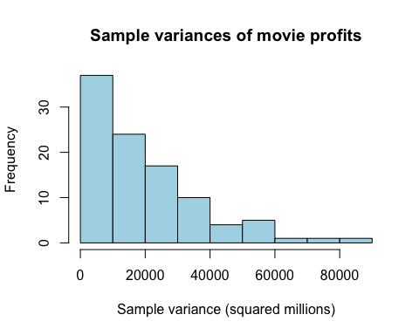
Your Answer:
The mean of the 100 sample variances is approximately 19,982.63, and the standard deviation is approximately 16,853.97. Both are expressed in squared millions.
The histogram shows many lower sample variances and a smaller number of much higher values, creating a long tail to the right. Samples that include movies with exceptionally high profits can have much larger variances than samples without those movies, because their profits are far above the sample mean. These large differences are squared, giving them a strong effect on the result.

Step e
In your opinion, is a sample of 25 movies sufficient to get a reliable estimate of the population variance of profits, using the sample variance? Explain. [2 points]
Your Answer:
A sample of 25 movies does not seem large enough to give a reliable estimate of the population variance in this dataset. The sample variances differ a lot, and their standard deviation is large compared with their mean.
A few movies have exceptionally high profits. Including or missing one of these movies can strongly change the sample variance. A larger random sample would generally give a more stable estimate of the population variance, in this data-set.

Week 3
For the next part of the assignment, assume that the movies in your data frame are a random sample of a larger population of movies.

1 Confidence intervals for runtime

Step a
Create a new data set that only includes movies that are of the genre “Thriller”. For these thriller movies, give a 99 percent confidence interval for the variable runtime. Interpret the result. [2 points]
# Create a dataset with only thriller movies
movies_thriller <- subset(movies, genre == "Thriller")
# Calculate the number of thrillers and their average runtime
n_thriller <- nrow(movies_thriller)
mean_runtime <- mean(movies_thriller$runtime)
n_thriller
## [1] 127
mean_runtime
## [1] 106.1969
# Calculate the 99% confidence interval for the mean runtime
test_runtime <- t.test(movies_thriller$runtime, conf.level = 0.99)
test_runtime$conf.int
## [1] 102.6930 109.7007
## attr(,"conf.level")
## [1] 0.99
Your Answer:
There are 127 thriller movies in total, with an average runtime of approximately 106.20 minutes. The 99% confidence interval for the population mean runtime is from; 102.69 to 109.70 minutes.
We are 99% confident that the mean runtime of thriller movies in the population lies within this interval. This interval is about the population mean, rather than the runtime of an individual movie. We use an t-distribution because the population variance is unknown in this question.

Step b
Now, assume that the variance of runtime amongst thriller movies in your data is exactly the same as the variance of runtime in the population. Under this assumption, give a 99 percent confidence interval for the variable runtime among thriller movies. Interpret the result. Is your confidence interval wider or less wide than the one you found under question 1a? Why is that the case? [2 points]
# Use the sample variance as the known population variance
population_variance_runtime <- var(movies_thriller$runtime)
# Calculate the standard error
standard_error_runtime <- sqrt(population_variance_runtime / n_thriller)
# Critical z-value for a 99% confidence interval
z_value <- 2.576
# Calculate the lower and upper limits
lower_runtime <- mean_runtime - z_value * standard_error_runtime
upper_runtime <- mean_runtime + z_value * standard_error_runtime
# Show the confidence interval
c(lower_runtime, upper_runtime)
## [1] 102.7458 109.6479
Your Answer:
Under this assumption, the 99% confidence interval is from 102.75 to 109.65 minutes. This means that we are 99% confident that the true mean runtime of all thriller movies lies between those two values.
This interval is a little bit narrower than the interval in step a. In this question, we assume that the population variance is known, so we use the normal distribution instead of the t-distribution as we did earlier. For a 99% confidence interval, we get a critical z-value of 2.576. Because this value is slightly smaller than the t-value used in the previous step , the confidence interval is also slightly narrower.

2 Testing the variance of runtime

Step a
Using an appropriate five-step procedure, set up a test for the null hypothesis that the variance of runtime equals 500. Clearly state your null hypothesis, alternative hypothesis, your test statistic, your critical value, and your conclusion. [2 points]
# Number of movies
n <- nrow(movies)
# Variance of runtime in the sample
sample_variance <- var(movies$runtime)
# Calculate the chi-square test statistic
chi_square <- (n - 1) * sample_variance / 500
# Critical values for a 5% two-sided test
critical_values <- qchisq(c(0.025, 0.975), df = n - 1)
# Show the results
sample_variance
## [1] 396.6046
chi_square
## [1] 720.234
critical_values
## [1] 826.3872 993.4009
Your Answer:
- First, we set up the hypotheses. The null hypothesis, written as H0, says that the population variance of runtime is 500. This is the value we are testing here. The alternative hypothesis (H1) says that the population variance is not 500. So we want to find out if the real variance is different from 500 or not.
- We use a significance level of 5%, which can be written as alpha = 0.05. This is the limit we use to decide if the result is unusual enough to reject the null hypothesis (H0). We use a two-sided test because the variance can be either lower or higher than 500.
- There are 909 movies in the sample. The variance of runtime in our sample comes in at about 396.60. This is lower than 500, but we cannot just reject H0 just because these two numbers are different from eachother. We first have to check if the difference is large enough. For this, we calculate the chi-squared test statistic; our calculations found out the test statistic is 720.23.
4.In this step we calculate the critical value, these are the limits that we use to decide whether we reject H0 or not. The critical values are 826.39 and 993.40. If the test statistic is between these two values, we don’t reject the null hypothesis. If the test statistic is lower than 826.39 or higher than 993.40, we reject H0.
- Our test statistic comes out at 720.23. This is below the lower critical value of 826.39. This means that our result is outside of the range where we would keep the Null hypothesis. Therefore, are able to reject it. There is enough evidence to say that the population variance of runtime is different from 500. In our sample, the variance is 396.60, so the variance is lower than 500 that is found in the sample.

Step b
For the validity of your test in 2a, what assumption about the distribution of revenue needs to hold? Make an appropriate plot to test this assumption. What do you conclude? [2 points]
# Create a histogram to check whether runtime is approximately normal
hist(movies$runtime,
main = "Distribution of movie runtime",
xlab = "Runtime (minutes)",
ylab = "Number of movies",
col = "lightblue")
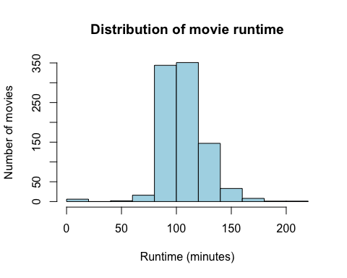
Your Answer: The chi-squared test in step a relies on the idea that runtime follows a normal distribution in the population. To check this, we looked at a histogram. There’s a clear cluster of movies between 80 and 120 minutes, and the center does look somewhat bell-shaped. But the right side stretches out much further, and there are a few very short runtimes—some are even zero. So, the distribution isn’t clearly normal. With this in mind, the normality assumption is shaky, and we need to be cautious about any conclusions from step a.

3 Movie ratings and profits
There is an argument going on in the movie studio. Bob claims that they should make higher-quality movies, as this will bring in more profits. Chantal disagrees. She tells Bob that mediocre movies bring the most profits. You are asked to advise on who is right.

Step a
Create a new variable called vote_average_rounded. Make sure this variable is the same as vote_average, but without any decimals (i.e., a 6.3 becomes a 6, a 8.7 an 8, etc.). Display a histogram of vote_average_rounded. [2 points]
# Remove decimals, following the examples in the question
movies$vote_average_rounded <- floor(movies$vote_average)
# Create a histogram with one bar for each whole-number rating
hist(movies$vote_average_rounded,
breaks = seq(-0.5, 10.5, by = 1),
main = "Distribution of movie ratings",
xlab = "Rating without decimals",
ylab = "Number of movies",
col = "lightblue")
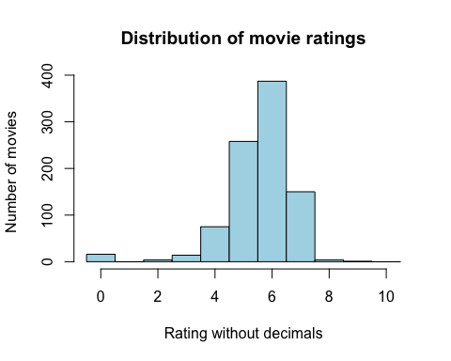
# Count the movies in each rating group
table(movies$vote_average_rounded)
##
## 0 2 3 4 5 6 7 8 9
## 16 4 14 75 258 387 150 4 1
Your Answer:
We removed the decimals using floor(), so 6.3 becomes 6 and 8.7 becomes 8, as in the question. Most movies are in rating groups 5, 6 and 7. Group 6 is the largest, with 387 movies. There are only 4 movies in group 8 and 1 movie in group 9.

Step b
Create a scatter plot with vote_average_rounded on the x axis and the mean of profits within each category of vote_average_rounded on the y-axis. Make sure it has an appropriate title, and appropriate titles and labels for the x- and y-axis. At which rating of movies are the profits the highest? [3 points]
# Calculate the mean profit for each rating group
# Profits are already expressed in millions in week 2
profits_by_rating <- aggregate(profits ~ vote_average_rounded,
data = movies, FUN = mean)
# Show the mean profits for each rating group
profits_by_rating
## vote_average_rounded profits
## 1 0 -0.4679164
## 2 2 0.0000000
## 3 3 -6.3909355
## 4 4 7.1176854
## 5 5 32.9318060
## 6 6 66.8883377
## 7 7 107.5850569
## 8 8 51.4821905
## 9 9 0.0000000
# Create a scatterplot of rating groups and mean profits
plot(profits_by_rating$vote_average_rounded,
profits_by_rating$profits,
main = "Average movie profits by rating",
xlab = "Rating without decimals",
ylab = "Mean profit (millions)",
pch = 19,
col = "blue")
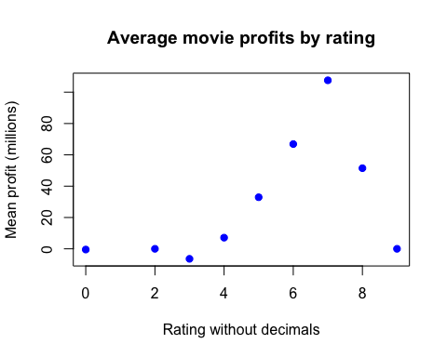
# Show the rating group with the highest mean profit
profits_by_rating[which.max(profits_by_rating$profits), ]
## vote_average_rounded profits
## 7 7 107.5851
Your Answer: Rating group 7 has the highest mean profit, at approximately 107.59 million. This group contains movies with original ratings from 7.0 up to (but not including) 8.0.
Mean profits climb as you move from the lower rating groups to group 7. After that, profits drop off for groups 8 and 9. So, in this given sample, the movies with the highest ratings don’t actually bring in the highest average (mean) profits.

Step c
Recreate the scatter plot with year on the x axis and mean profits on the y-axis, but now add bars around each point, indicating the 95% confidence interval. [3 points]
# List the release years from lowest to highest
years <- sort(unique(movies$release_year))
# Create space for the mean and confidence limits for each year
mean_profits_year <- numeric(length(years))
lower_profits_year <- numeric(length(years))
upper_profits_year <- numeric(length(years))
# Calculate the mean profit and 95% confidence interval for each year
for (i in 1:length(years)) {
# Select the profits of movies released in this year
year_profits <- movies$profits[movies$release_year == years[i]]
# Calculate the mean and standard error
mean_profits_year[i] <- mean(year_profits)
standard_error_year <- sd(year_profits) / sqrt(length(year_profits))
# Calculate the margin of error using the t-distribution
margin_year <- qt(0.975, df = length(year_profits) - 1) *
standard_error_year
# Save the lower and upper confidence limits
lower_profits_year[i] <- mean_profits_year[i] - margin_year
upper_profits_year[i] <- mean_profits_year[i] + margin_year
}
# Create the scatterplot, leaving room for all confidence intervals
plot(years, mean_profits_year,
main = "Average movie profits by release year",
xlab = "Release year",
ylab = "Mean profit (millions)",
ylim = range(lower_profits_year, upper_profits_year),
pch = 19,
col = "blue")
# Add the confidence interval bars
arrows(x0 = years, y0 = lower_profits_year,
x1 = years, y1 = upper_profits_year,
angle = 90, code = 3, length = 0.05,
col = "blue")
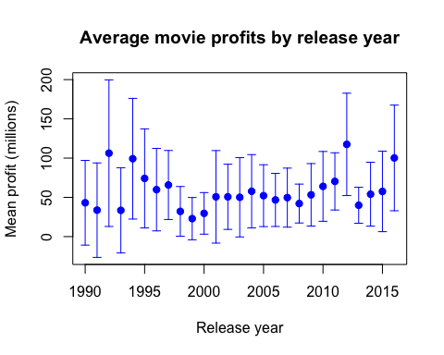
Your Answer:
The plot shows the mean profit for each release year, with bars showing its 95% confidence interval. The highest mean profit is in 2012, at approximately 117.49 million. Its confidence interval runs from 52.28 to 182.70 million.
Many intervals are wide, showing that the estimates are uncertain. Movie profits vary a lot, and some years contain few movies. These t-intervals are approximate because profits are strongly skewed, especially for years with small samples. This plot compares release years, as requested in the question.

Step d
Write an advice to settle the argument between Bob and Chantal. [4 points]
Your Answer: Our results don’t settle the debate between Bob and Chantal. Movies in rating group 7 do best, pulling in an average profit of about $107.59 million. Groups 5 and 6 lag behind at $32.93 million and $66.89 million. If you call groups 5 and 6 “mediocre,” then Chantal’s claim doesn’t hold up.
Still, it’s not as simple as higher ratings equal higher profits. Group 8 averages $51.48 million, and group 9 earns nothing at all. To be fair, group 8 has only 4 movies, and group 9 just one, so there’s not enough data to draw firm conclusions.
Here’s what we actually recommend: focus on making movies people like, but don’t expect that higher ratings alone bring bigger profits. Many things—budget, genre, marketing—can shift the numbers. Our data doesn’t prove that a “better” movie means higher profit. Also, the confidence intervals from step c only compare release years, not rating groups, so we can’t say if differences between the rating groups are statistically meaningful.

