CPU Scheduling Simulator
Round Robin vs SRTF

1.introduction
This project implements and compares two CPU scheduling algorithms:
Round Robin (RR) and Shortest Remaining Time First (SRTF).

The simulator was developed using Python and Tkinter GUI.
The main objective is to evaluate the performance of both algorithms
using scheduling metrics such as Waiting Time (WT),
Turnaround Time (TAT), and Response Time (RT).

The project also demonstrates how different scheduling techniques
affect fairness, responsiveness, and CPU efficiency.

2.Algorithms Explanation
2.1.Round Robin
Round Robin is a preemptive CPU scheduling algorithm.
Each process receives a fixed time quantum.
If the process does not finish during its quantum,
it is moved to the end of the ready queue.
Advantages:
- Fair scheduling
- Good response time
- Suitable for interactive systems
Disadvantages:
- High context switching overhead
- Performance depends on quantum size
2.2.srtf
Shortest Remaining Time First (SRTF) is the preemptive version
of Shortest Job First (SJF).
The scheduler always selects the process with the smallest
remaining burst time.
Advantages:
- Minimum average waiting time
- Efficient for short processes
Disadvantages:
- Starvation of long processes
- Requires burst time prediction
3.System Features
The simulator provides the following features:
- Dynamic process input
- Input validation
- Round Robin simulation
- SRTF simulation
- Separate Gantt charts
- Metrics calculation:
- Waiting Time (WT)
- Turnaround Time (TAT)
- Response Time (RT)
- Average metrics comparison
- Dark mode graphical interface

4.Test cases
4.1. Scenario A — Basic Mixed Workload
SRTF produced lower average waiting time because it always selected the shortest remaining process.
Round Robin distributed CPU time more fairly among all processes.
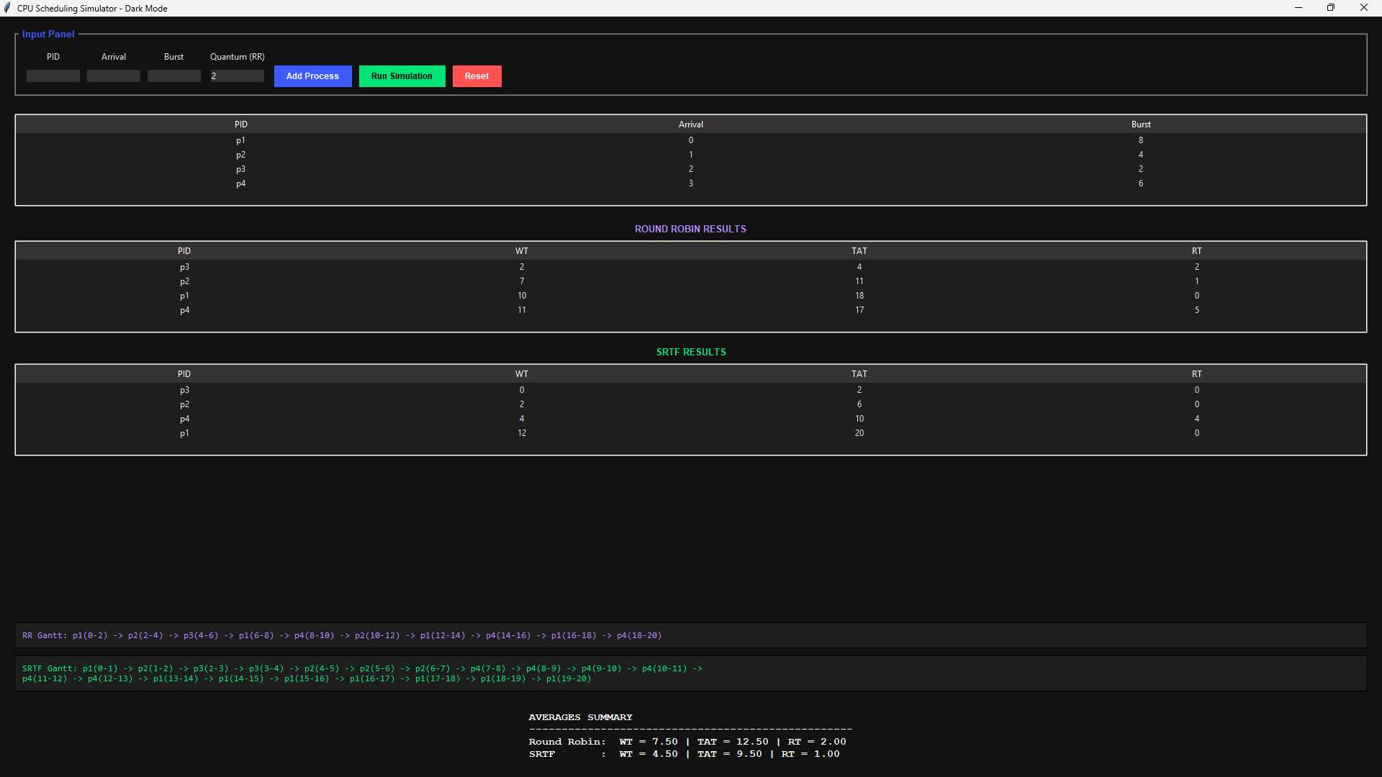

4.2. Scenario B — Quantum Sensitivity
A small quantum improved fairness and response time but increased context-switch overhead.
A large quantum caused Round Robin to behave similarly to FCFS.

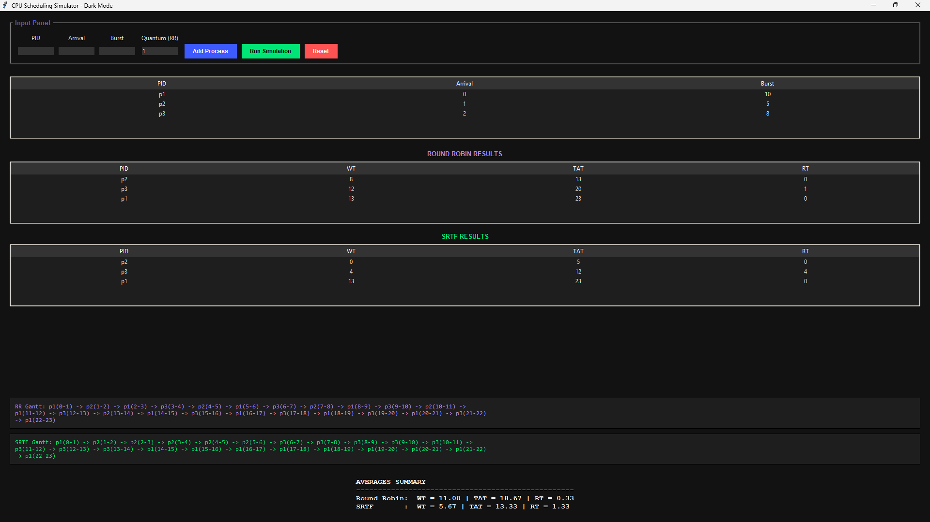
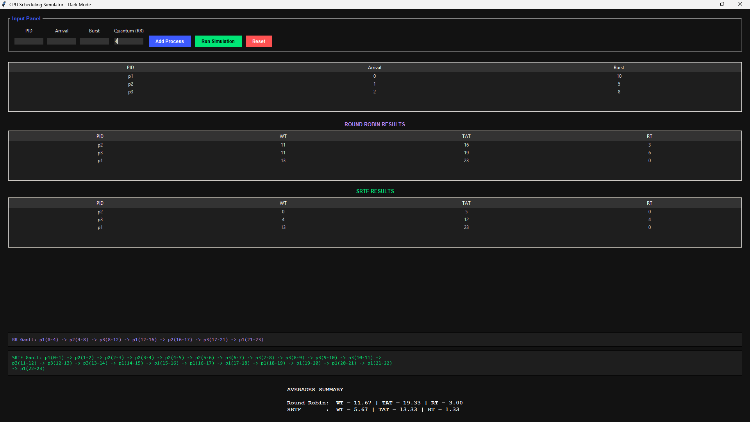
4.3.Scenario C — Short-Job-Heavy Case
SRTF strongly favored short processes and completed them much faster than Round Robin.
Round Robin treated all processes more equally but increased waiting time for short jobs.

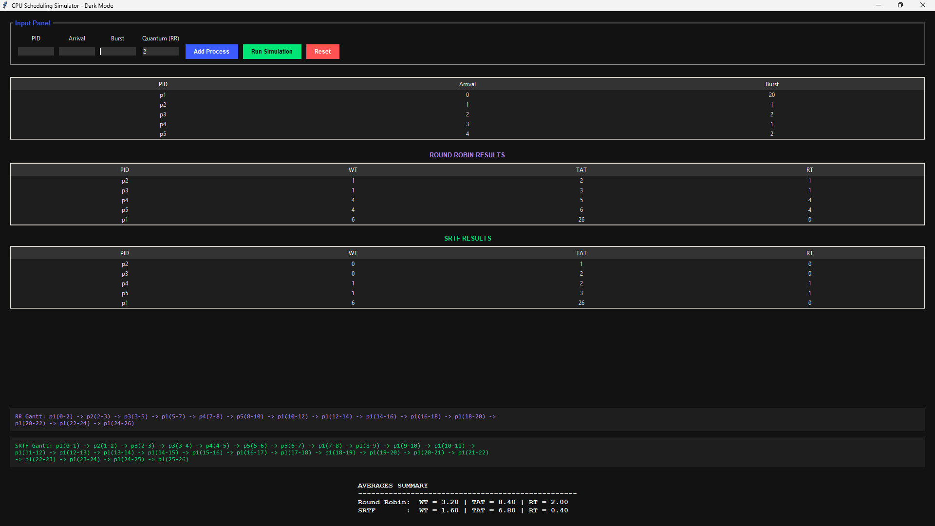

4.4. Scenario D — Interactive Fairness Case
Round Robin distributed CPU time evenly across all processes.
All processes received fast initial response times, demonstrating fairness.
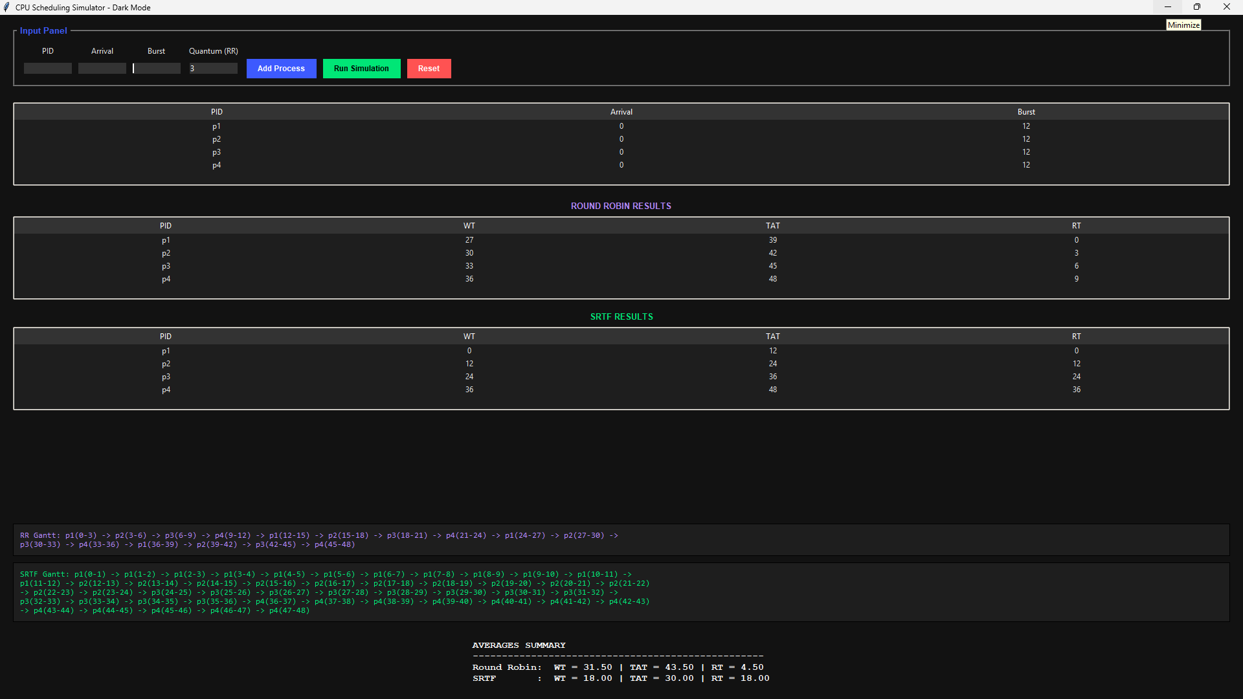

4.5. Scenario E — Validation Case
The simulator safely rejected invalid inputs such as negative burst times and invalid quantum values.
Input validation improved simulator reliability and prevented runtime errors.
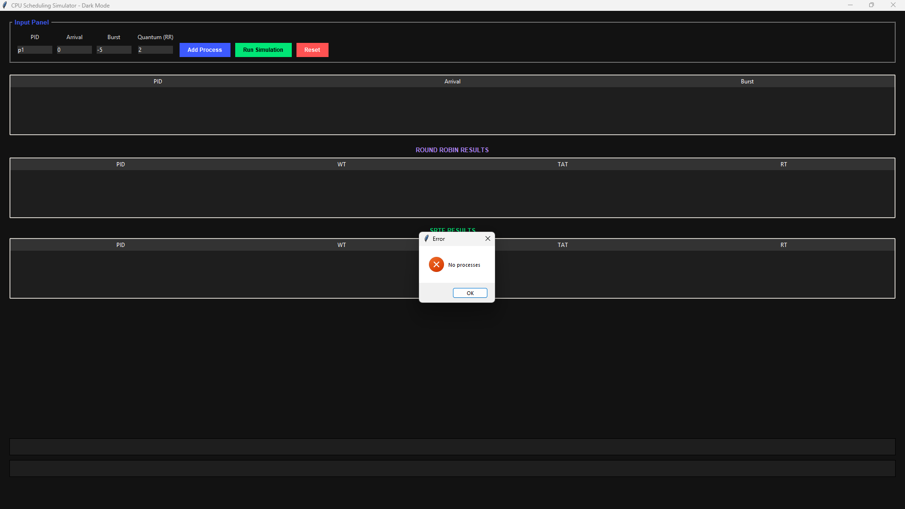
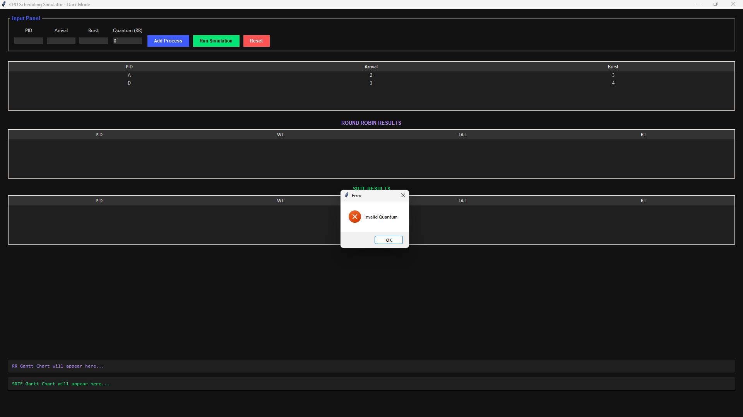

7. Comparison
Comparison between RR and SRTF:
- SRTF produced lower average waiting time.
- RR provided better fairness among processes.
- RR achieved faster response for interactive tasks.
- SRTF was more efficient for short processes.
- Increasing the quantum in RR reduced context switching
but made the algorithm behave similarly to FCFS.

