Exploratory Data Analysis on Heathcare Data

Taranpreet Singh

## Introduction

Thorough data exploration is one of the most important aspects of the predictive modelling. It helps a lot in building insights for feature engineering and feature selection. In this data notebook, I have covered data visualisation part.

In this classification problem hicov is the target variable.

## Missing Values

Variable wkhp has around 50% misssing obseravtions.Other varaibales with missing values are income variables, esr schl and povpip.

**Pattern in Missing Values**

Missing values are for the rows with variable Agep less than 15. For wkhp missing values other than agep less than 15 are for either unemployed or ‘not in labour force’ esr levels.

## Exploration

**Loading libraries and importing data**

#jsonlite for reading json   
library(jsonlite)  
#tisyverse to load all wickham family packages  
library(tidyverse)  
#themes for plots  
library(ggthemes)  
  
train <- fromJSON("train.json")  
# Base theme for plots  
thm=theme_tufte()

**First look at the data**

#glimpse(train)  
#View(train)  
  
  
# Converting character vars to factors  
fac <- lapply(train, class) == "character"  
train[, fac] <- lapply(train[, fac], as.factor)  
  
  
#summarising train   
#summary(train)  
  
#saving output locally for future record  
  
#capture.output(summary(train), file = "summTrain.txt")

**Initial obseravations**

* 391,282 rows and 20 variables
* id not ordered
* It seems that variables intp, pap, retp have gernerated numbers in them
* Imbalanced binary classifiaction
* Same number of missing rows in income variables

** Target variable**

#imbalanced binary classification   
ggplot(train,aes(x=hicov))+geom_bar()+thm+ggtitle(" Proportion of the Target variable")

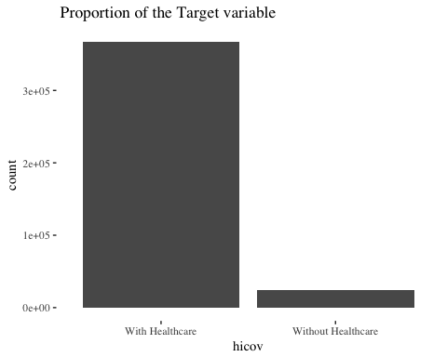

round(prop.table(table(train$hicov))*100)

##   
## With Healthcare Without Healthcare   
## 94 6

** Proportion of missing values in Columns**

round(colSums(is.na(train))/nrow(train)*100,2)

## id st puma hicov vet deye dear sex race mar   
## 0.00 0.00 0.00 0.00 0.00 0.00 0.00 0.00 0.00 0.00   
## esr cit schl agep pincp intp pap retp povpip wkhp   
## 18.36 0.00 3.06 0.00 17.11 17.11 17.11 17.11 3.35 48.83

** Exploring relation of factor variables with target**

#comparison of relation with target and training variables  
  
#function to calculate proportion of categorical vars wrt Targget i.e hicov   
#calculating proportions from table and rounding to 2 digits  
catProp <- function(var) {  
 round(prop.table(table(train$hicov,var),2)*100,2)  
}  
  
# factor vars   
  
# variation of target with fac vars   
lapply(train[,names(Filter(is.factor, train))],catProp)

## $hicov  
## var  
## With Healthcare Without Healthcare  
## With Healthcare 100 0  
## Without Healthcare 0 100  
##   
## $vet  
## var  
## Not Veteran Veteran  
## With Healthcare 93.42 98.35  
## Without Healthcare 6.58 1.65  
##   
## $deye  
## var  
## No Yes  
## With Healthcare 93.69 94.75  
## Without Healthcare 6.31 5.25  
##   
## $dear  
## var  
## No Yes  
## With Healthcare 93.57 97.31  
## Without Healthcare 6.43 2.69  
##   
## $sex  
## var  
## Female Male  
## With Healthcare 94.74 92.66  
## Without Healthcare 5.26 7.34  
##   
## $race  
## var  
## Alaska Native alone Amer. Indian + Alaska Nat. tribes  
## With Healthcare 90.27 89.09  
## Without Healthcare 9.73 10.91  
## var  
## Amer. Indian alone Asian alone  
## With Healthcare 86.11 95.58  
## Without Healthcare 13.89 4.42  
## var  
## Black or African Amer. alone  
## With Healthcare 93.24  
## Without Healthcare 6.76  
## var  
## Nat. Hawaiian + Other Pac. Isl. Some other race alone  
## With Healthcare 91.51 86.26  
## Without Healthcare 8.49 13.74  
## var  
## Two or more White alone  
## With Healthcare 94.76 94.58  
## Without Healthcare 5.24 5.42  
##   
## $mar  
## var  
## Divorced Married Never Married Separated Widowed  
## With Healthcare 93.05 94.87 92.53 87.62 97.62  
## Without Healthcare 6.95 5.13 7.47 12.38 2.38  
##   
## $esr  
## var  
## Employed Not in labor force Unemployed  
## With Healthcare 92.86 93.73 84.68  
## Without Healthcare 7.14 6.27 15.32  
##   
## $cit  
## var  
## Citizen Not citizen  
## With Healthcare 95.50 78.16  
## Without Healthcare 4.50 21.84  
##   
## $schl  
## var  
## Grad. Degree HS Degree Less than HS Undergrad. Degree  
## With Healthcare 98.25 92.76 91.56 96.73  
## Without Healthcare 1.75 7.24 8.44 3.27

#saving output  
#capture.output(lapply(train[,names(Filter(is.factor, train))],catProp),file="catVarsProp.txt")

With this table we can clearly see the effect of different classes of the factor variables on the Target variable. For instance, Veterans have very high probability of getting an health coverage

Variables having significant difference with target variable are vet, cit, race.

Citizenship has most prominent effect

**Plots**

catPlot <- function(var) {  
 ggplot(train,aes_string(x=deparse(substitute(var)),fill="hicov"))+geom_bar(position="dodge")+thm+  
 theme(axis.text.x=element_text(angle=45,hjust=1))  
}  
  
# plot of target with factor variables  
catPlot(cit)

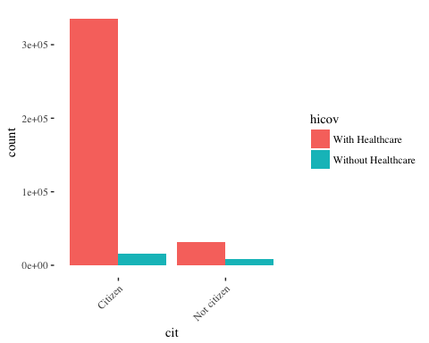

catPlot(race)

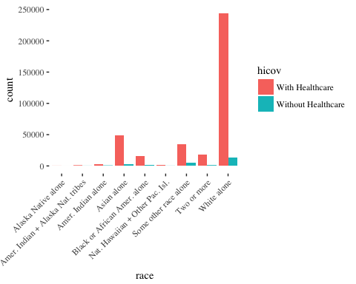

Puma and state should be factor variables, state has only 3 levels but puma has more than 300 levels. For modelling Puma can be encoded as factor but that will increase number of variables a lot. Another approach can be to cluster it or create buckets. I have trained model with puma classes as independent variables and then selected important variables from that.

**Distribution of Puma with target variable**

ggplot(train,aes(x=puma,fill=hicov))+geom_density(alpha=0.5)+  
 theme(axis.text.x=element_text(angle=60))+  
 scale_x_continuous(breaks=round(seq(min(train$puma), max(train$puma), by = 1700),1))

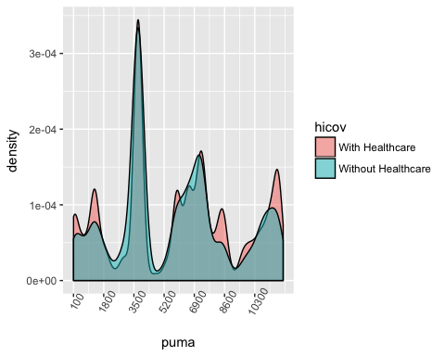

**My approach for Handling variables such as age and puma**

By zooming on x axis we can find the values to create buckets, I use this approach extensively in my analysis. This helps in creating buckets for variables such as age.

Since we have similar distribution of variables for train and test set. For this challenge this approach might help.

Loading test set

test <- fromJSON("test.json")  
# 97405 obs  
  
#glimpse(test)  
  
#converting char to factors  
  
test[, fac] <- lapply(test[, fac], as.factor)  
#round(colSums(is.na(test))/nrow(test)*100,2)  
  
ggplot()+geom_density(data=test,aes(x=puma))+  
 geom_density(data=train,aes(x=puma),color='blue')+  
 thm+ggtitle("Puma dist for train and test data")

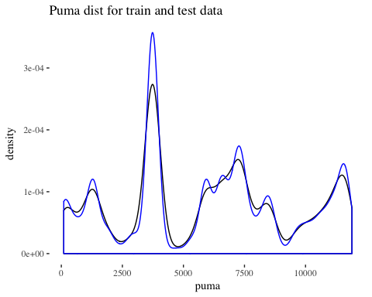

**Age Variable**

Using similar method we can find buckets for income and age. Sometimes models work better with the bucketed data than continous. Moreover, for very large data set creating sparse dataframe saves memory.

ggplot(train,aes(x=agep,fill=hicov))+geom_density(alpha=0.5)+ggtitle("Age & hicov")+  
 scale_x_continuous(breaks=round(seq(min(train$agep), max(train$agep), by = 4),1))+  
 theme_fivethirtyeight()

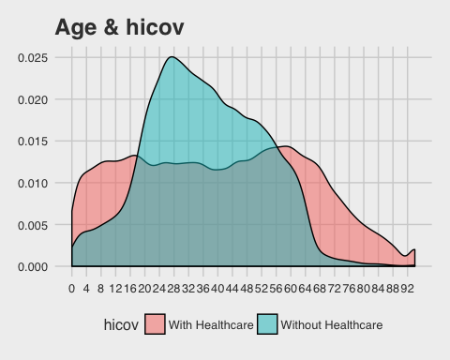

#ggplot()+geom_density(data=test,aes(x=agep))+  
 # geom_density(data=train,aes(x=agep),color='blue')+  
 #thm+ggtitle("Agep dist for train and test data")

We can see that the range for people with Health cover is less and more skewed. Using this grid we can find the boundaries for the age variable buckets. The distribution for test and train is also same.

**Povpip variable**

ggplot(train,aes(x=povpip,fill=hicov))+geom_density(alpha=0.5)+  
 scale_x_continuous(breaks=round(seq(0, 500, by = 25),1))+  
 theme_fivethirtyeight()+theme(axis.text.x=element_text(angle=60))+  
 ggtitle("Povpip and Hicov")

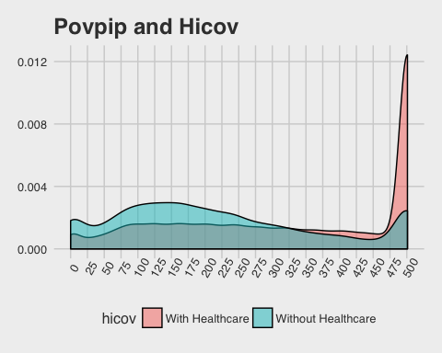

As this plot shows high values of Pivpop have very high rate of health coverage. Since this variable has missing values, so this variable needs careful imputation. Mode for this variable is 501. To impute it we can use value of 330 as at that value both the target classes have same distribution.

For imputation of povpip, I have also tried to find the relation of povpip and puma with the assumption that povpip should be similar for puma values but I could not find any strong relation.

ggplot(train,aes(x=puma,y=povpip))+ geom_point(alpha=0.1,shape='.',color='orange')+  
 geom_density2d(color='blue',alpha=0.3)+thm+facet_grid(~hicov)+  
 ggtitle("povpip and puma 2d density plot")

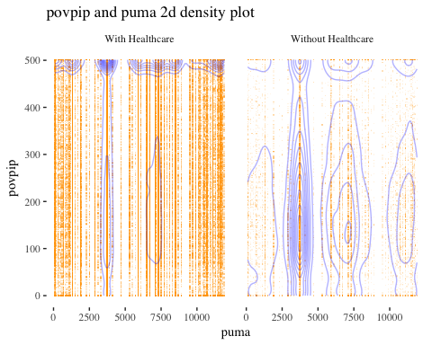

**Exploring Income variables**

I have created extensive graphs to see the relationship and found that these variables are important for the target variable. Though the actual usefulness can be found after modelling. We can also see the difference in the mean for the target variable.

train %>% select(intp,pap,retp,pincp,hicov,wkhp) %>%   
 filter(!is.na(intp)) %>%   
 group_by(hicov) %>%   
 summarise(mean(intp),mean(pap),mean(retp),mean(pincp))

## # A tibble: 2 x 5  
## hicov `mean(intp)` `mean(pap)` `mean(retp)` `mean(pincp)`  
## <fctr> <dbl> <dbl> <dbl> <dbl>  
## 1 With Healthcare 3044.1290 63.95369 2928.1522 44540.46  
## 2 Without Healthcare 498.9271 50.27221 237.7802 19195.83

train %>% filter(pap>=10000 ) %>% ggplot(aes(x=pap,fill=hicov))+geom_density(alpha=0.5)+  
 #scale_x_continuous(breaks=round(seq(0,100, by =5),1))+  
 theme_fivethirtyeight()

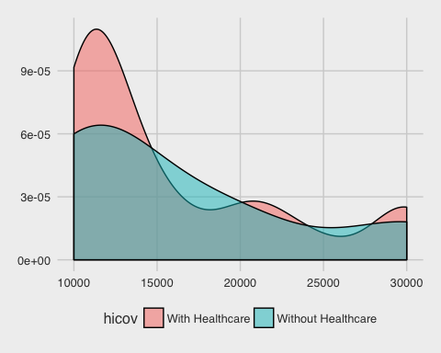

* The detailed analysis can be found in the EDA file attached alongwith.