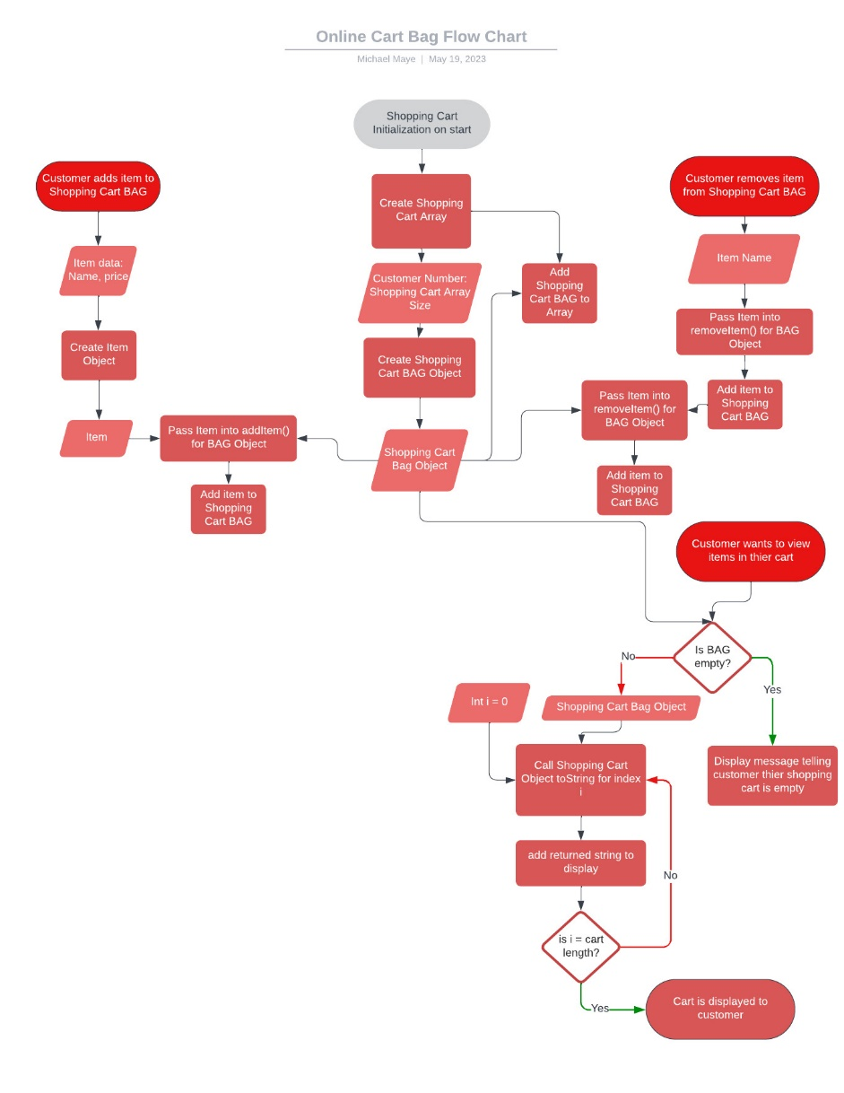

OnlineDeliveryBag Class:

* Represents the shopping cart for the online food delivery service.
* Uses an ArrayList to store the items in the cart.
* Provides methods to add, remove, and retrieve items, as well as check if the cart is empty and get the size of the cart.

1. Constructor(customer number):

Initializes an empty ArrayList to store the items in the shopping cart with

attribute [int customer number].

1. addItem(item: Item) Method:

Adds the provided item to the shopping cart.

1. removeItem(item: Item) Method:

Removes the provided item from the shopping cart if it exists.

Returns a boolean value indicating whether the item was successfully removed.

1. getItems() Method:

Retrieves all the items in the shopping cart as an ArrayList.

Iterate over ArrayList and print toString() method for each item in ArrayList.

1. emptyCart():

Remove all items from shopping cart object.

1. isEmpty() Method:

Checks if the shopping cart is empty.

Returns a boolean value indicating whether the cart is empty.

1. size() Method:

Returns the number of items in the shopping cart.

Item Class:

* Represents an item that can be added to the shopping cart.
* Contains properties for the item's name and price.
* Provides getters and setters to access and modify the item's properties.
* Overrides the toString() method to provide a string representation of the item.

1. Constructor(name, price):

Create a new instance of an Item with attributes [String name] [double price].

1. getName():

Get name of item object.

1. setName():

Set name of item object.

1. getPrice():

Get price of item object.

1. setPrice():

Set price of item object.

1. toString():

Return object information in format “[name] ($[price])”.