**Web Interaction Widget Overview**

Michael Maye

Colorado State University Global

CSC475: Platform-Based Development

Dr. Muhammad A Khan

07/16/2023

**Web Interaction Widget Overview**

This paper examines the submitted Android application 'Web Interaction Application'. The application is a blank 'bottom navigation' framework and contains three views 'home', 'dashboard', and 'notifications'. Along with this framework, this application has the added functionality of a widget. The widget's location is on the home screen, and when clicked, it redirects the user to the system browser and requests the browser to load a user registration example webpage.

**Main Activity and Navigation**

The application's core is contained in 'MainActivity.java' along with the home, dashboard, and notifications fragment classes. MainActiviy employs a bottom navigation bar system that has not been altered from the Android Studio new project default.

**Android Widget**

The application includes a 'WebInterfaceWidget.java' class which handles the functionality of the application's widget. Using the 'AppWidgetProvider' and 'updateAppWidget()', this class passes a PendingIntnet to the widget, which requests the system to retrieve the given URL 'https://form.jotform.com/232098305355153'. During testing, there were several occasions where the processing of this intent merely opened the application on the 'home' view, which was not the desired function, so 'updateAppWidget()' also passes the 'setPackage("com.android.chrome")' method onto the intent in order to specify that the widget wants the chrome browser to handle the URL call. Then the widget view is built using RemoteViews and passed to the 'AppWidgetManager' to embed into the widget for display.

**Widget XML**

The 'web_interface_widget_info.xml' file provides the system with attributes and settings for the application's widget, such as target width and height and the initial layout view of the widget. The web_interface_widget.xml is the view used inside the widget, an image in the mipmap resource folder.

**Figure 1**

*Screenshots of application:*

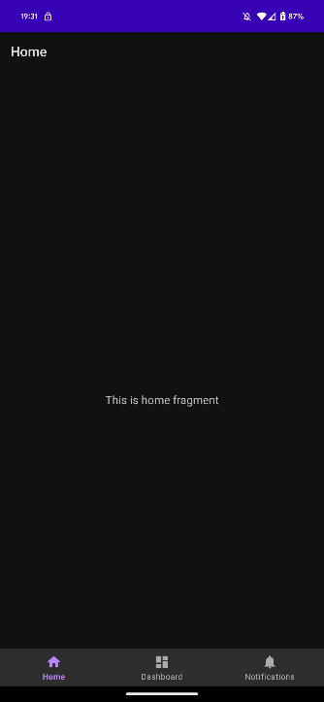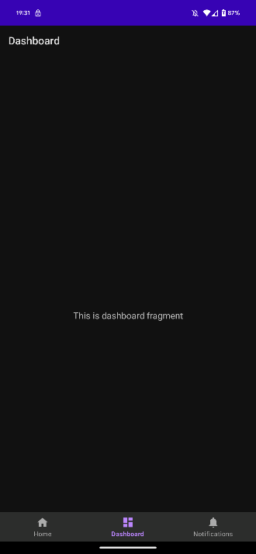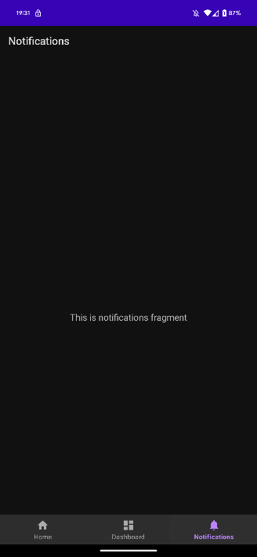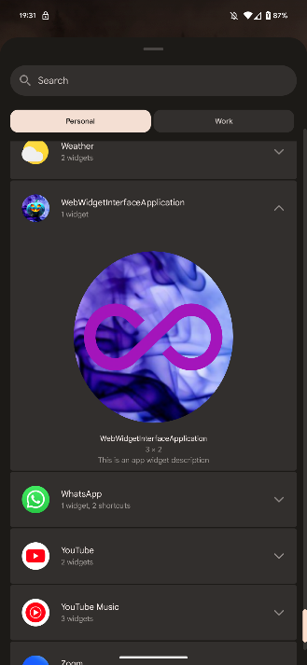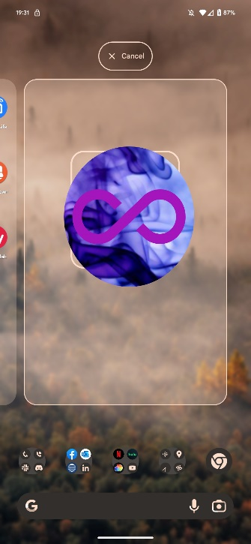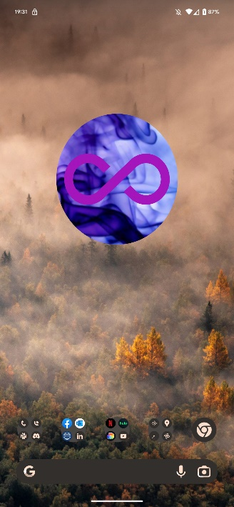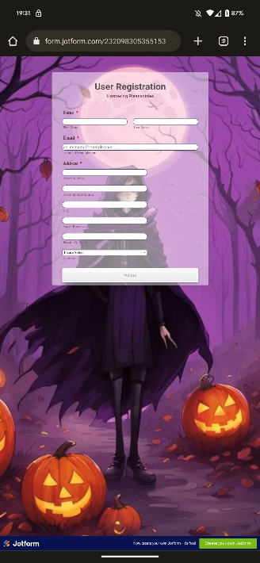

**Conclusion**

Throughout this overview, the various components that make up the application have been explored, including the test component, question component, user component, and test layout component. Each component is critical in creating a seamless and interactive user experience. The application successfully educates users on traffic signs by leveraging the Test, Question, and User classes along with the well-structured test layout..

**References**

*Android.appwidget  :  android developers*. Android Developers. (n.d.-a). https://developer.android.com/reference/android/appwidget/package-summary

*AppWidgetManager  :  android developers*. Android Developers. (n.d.-b). https://developer.android.com/reference/android/appwidget/AppWidgetManager#requestPinAppWidget(android.content.ComponentName,%20android.os.Bundle,%20android.app.PendingIntent)

*AppWidgetProvider  :  android developers*. Android Developers. (n.d.-c). https://developer.android.com/reference/android/appwidget/AppWidgetProvider

*Create a simple widget  :  Android developers*. Android Developers. (n.d.-d). https://developer.android.com/develop/ui/views/appwidgets

*Start an activity from a notification  :  android developers*. Android Developers. (n.d.-e). https://developer.android.com/develop/ui/views/notifications/navigation