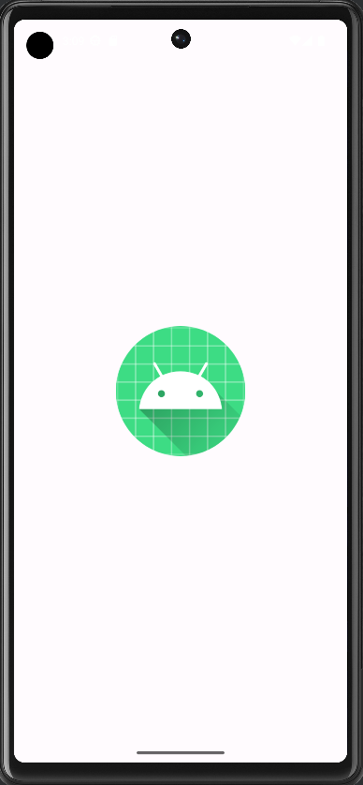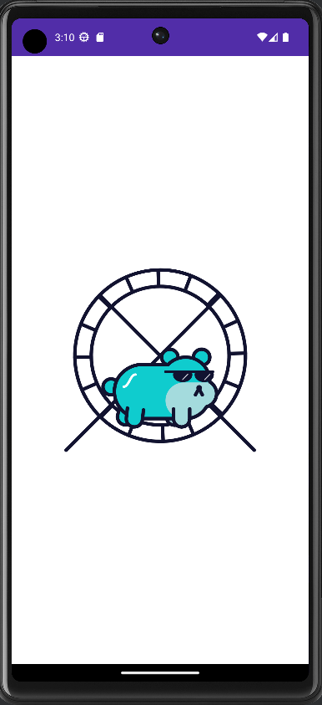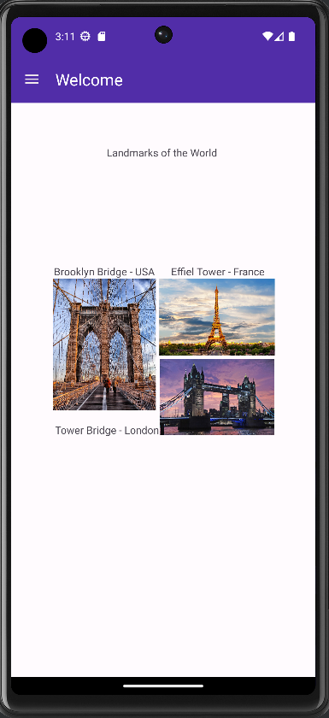
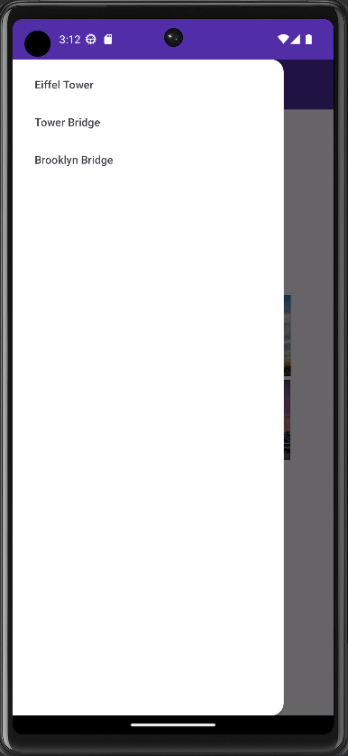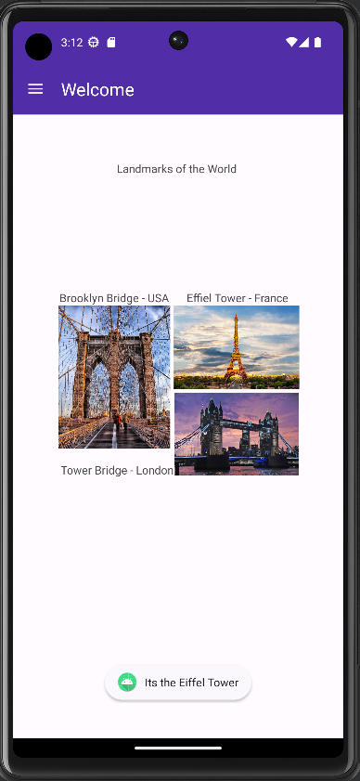

In order to complete this application I began by creating a splash screen that contained a lottie animation JSON file, and use the lottie system to animate it on the splash screen for 2 seconds. Then I created a new intent called ‘toMain’ that would run the take the user from the splash screen to the main_activity screen that contained the application. In order to make this work, I had to swap the .MainActivity and .SplashActivity in the android manifest so the application would export the splash activity and use the main activity as the secondary activity.
Once in the main activity I setup an action bar at the top that would have a navigation drawer. Within that drawer layout I inserted the main content of three pictures, the Eiffel Tower, the Tower Bridge, and the Brooklyn Bridge. Using a constraint layout I organized them on the screen in a collage format, then added text views to identify them, also organizing them in the constraint layout.
I then made a toolbar layout to pass into the main activities view, as well as a menu resource that would hold the menu items to be placed in the toolbar.
Then in MainActivity I setup the logic to set the toolbar to replace the default actionbar, also set the theme to NoActionbar in the theme xml, then setup the Icon for the toolbar and later replaced with a hamburger menu. Then setup variables to be our drawer object and drawer view, created the onOptionsItemSlelected function to open the drawer, created a setupDrawerContent function that would setup the navigation menu items, the selectDrawerItem function to track which option the user selects then make a toast based off that selection then close the drawer.

