Online Shopping System UML Use Case Diagram Analysis

Michael Maye
Colorado State University Global
CSC-470: Software Engineering
Dr. Shaher Daoud
July 2nd, 2023

Online Shopping System UML Use Case Diagram Analysis
Use Case diagrams are instrumental in the design of software systems as they provide insight into the requirements and typical actions of the different users of the system. Software Development teams can use these to analyze, reformat, and course correct the design of a given system prior to beginning development. The ability to test and analyze systems in this theoretical way allows teams and stakeholders to save an incredible amount of both development time as well as investment capital during the actual production cycle. The following is an overview and analysis of the provided use case diagram of an unnamed online shopping system
Overview and Analysis
. The submitted use case diagram depicts the shopping system from the perspective of three main actors: 'Customer' representing registered users, 'Guest' representing users who have not registered yet, and 'Admin' which represents internal administrators of the system.
USER “Customer”
The USER actor, 'customer', is a registered user of the system, giving them full access to view products and personal functionality to manage their account. Once they perform a login, search Products allows the customer to search for various products the site offers. While performing the search, a registered user can view additional details on a given product. As a registered users, they can then add the product to their cart. While on the product page, they can view their shopping cart, remove items from the cart, or proceed to check out. Once the user initiates 'check out', they can finalize their order details and make a payment. In addition to shopping functionality, they can view their past and pending orders and cancel orders.
GUEST “Guest”
The Guest User has limited functionality of the registered user; however, the system owner would still like them to be able to search and view products to entice them to register. As a guest, they can view their own 'guest' home page, which gives them the option to register as a user immediately, or they can use a GUEST Search Products function which allows them to search for and view product details with minimal functionality. Once on the product details page, they have the option to register as a user in order to purchase the item. At all points of the Guest User cycle, they can register anytime while continuing to view available products fully.
ADMIN “Admin”
The Admin user is an internal administrator for the shopping system. They have a Manager Login function that verifies their right to access the management tools, which adds security to the system and prevents unauthorized access to the internal system functions. They have a Manage Products function that allows them to add, remove, or update products offered by the store. All three of these options trigger the Update Store function, which forwards the changes to the store system and allows the customer to have an up-to-date product view. They also have the Update Orders function, which allows admin personnel to change or update customer orders as needed. This Update Orders function triggers the Update Customer function, which forwards the changes to the customer and keeps them informed of changes to their order.
UML Use Case Diagram
The following UML Use Case diagram contains the three actors, all functionality, as well as the connections between functionalities. The Registered User utilizes green, the Guest User blue, and the Admin User red. Purple lines indicate connections between internal functions. For example, the Registered User chooses to view their cart, then while inside that view, they can initiate the Remove from Cart function, so the connection between View Cart and View from Cart is purple.
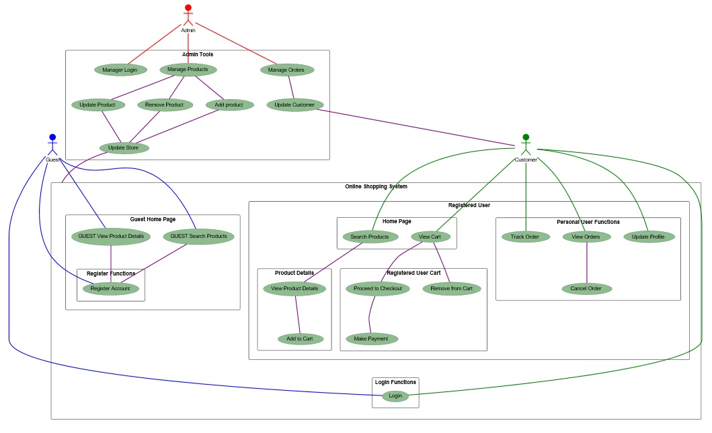
Conclusion
Overall, the Use Case Diagram provides a clear and concise representation of the system's functionalities and interactions from the perspective of the three main actors. The diagram serves as a valuable blueprint for system development, guiding the implementation of features and ensuring a user-friendly and secure online shopping platform. By understanding the roles and tasks of each actor, system developers can make informed decisions to enhance user satisfaction, attract new customers, and streamline administrative tasks for efficient platform management.
As the online shopping system continues to evolve, the Use Case Diagram will prove instrumental in eliciting feedback from stakeholders and users, identifying potential improvements, and guiding future iterations of the system. It serves as a valuable communication tool to align development teams, stakeholders, and users on the vision and functionality of the online shopping platform ultimately contributing to the success and competitiveness of the system.
References
Fakhroutdinov, K. (2014, January 4). UML use case diagrams. UML graphical notation overview, examples, and reference. https://www.uml-diagrams.org/use-case-diagrams.html
Fenn, B. (2017). UML in agile development. Control Engineering, 64(10), 48. Retrieved from https://csuglobal.idm.oclc.org/login?qurl=https%3A%2F%2Fwww.proquest.com%2Ftrade-journals%2Fuml-agile-development%2Fdocview%2F2130716718%2Fse-2%3Faccountid%3D38569
Unhelkar, B. (2020). 1-6. In Software engineering with UML. essay, CRC PRESS.
Zaman, Q. uz, Nadeem, A., & Sindhu, M. A. (2020). Formalizing the use case model: A model-based approach. PLoS ONE, 15(4), 1–29. https://doi.org/10.1371/journal.pone.0231534

