Library System Search Activity Diagram Analysis

Michael Maye
Colorado State University Global
CSC-470: Software Engineering
Dr. Shaher Daoud
July 9th, 2023

Library System Search Activity Diagram Analysis
The provided Activity Diagram (Figure 1) represents the flow of a search function within a library management computer system. The diagram shows a user requesting a search within the library system, the system searching for available resources within the current locations inventory as well as other libraries in the system, then finally displaying the results to the user.
Search Request
The activity begins with the user requesting a search from the system. Once they initiate this search request, the system prompts the user for input to use as search parameters. Once the user inputs their search parameters, the system validates the input to verify it is of the correct form (i.e., Authors Name, ISBN, Genre) and forwards it to the library database once verified. If the input does not pass verification, it rejects it and prompts the user for input again. This loop repeats until valid input is received or the search window is closed.
Once a valid search is obtained, the system initiates two threads. One to run through the library database and another to render and display the search results page to the user. The initial search results page has a ‘loading’ message until results are received.
Library Database Search
Passing in user input to the "Check local library and other locations" function initiates contact with the Library Database Partition. The system passes in the user input, and the database partition forks threads between checking the current library's inventory and other libraries within the system to see if the book requested is in stock either locally or at another location. Both the "Check this location" thread(s) and "Check other locations" thread(s) verify if the requested book is in inventory. If it is, they sort the results in the default order and pass them into the "Aggregate results" function upon joining. "Aggregate results" takes in the results from the search and aggregates them by "At local library" and "At other location" for the user.
Displaying Results
Finally, once "Aggregate results" finishes, the fork for the search and the rendering of the search results page join. The system updates the search results page with the results and renders it to them for analysis.
Figure 1
Library System Search Activity Diagram
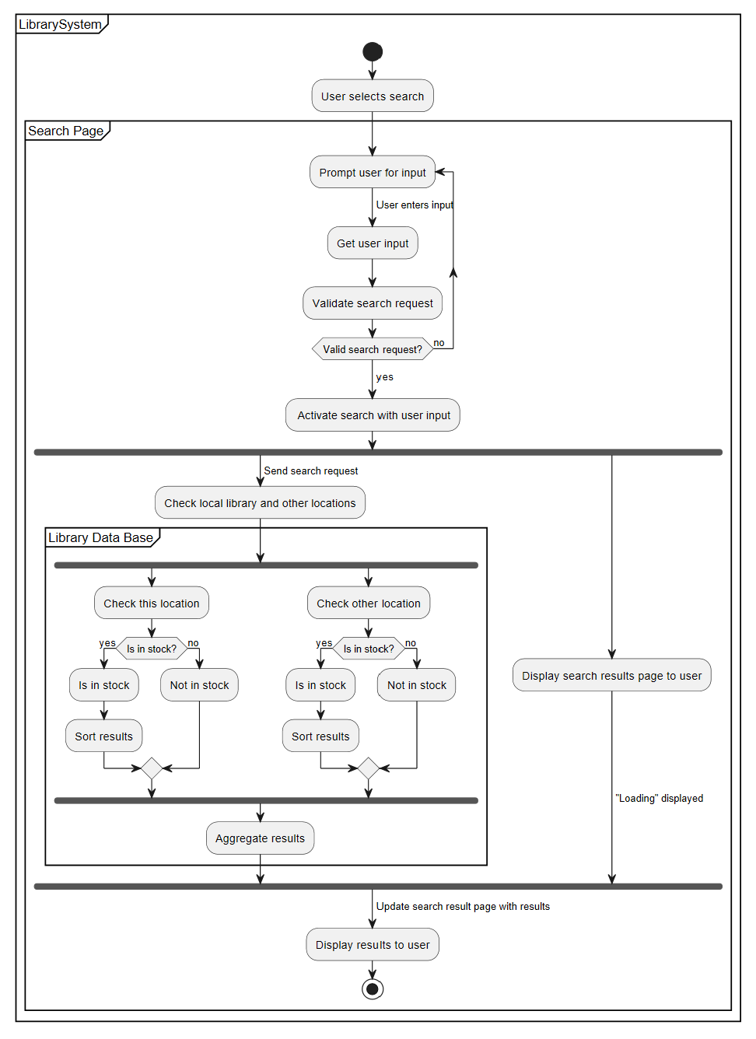
Use of multithreading
Multithreading is utilized twice in this system. First, immediately after receiving valid input, the system splits the workload of passing the input to the search function and setting up the 'loading' search page to the user between threads. Forking threads in this way optimizes resources between threads and gives the user a more efficient experience. In contrast, when the system builds the search results page and then puts all threads into the search function, it will be lingering on 'loading' for significantly longer as it initialized first and now must wait for the system to complete the search. By building the search results page and getting the results simultaneously, we decrease the time a user will spend on the loading page, which gives a much faster and more efficient experience.
The second use of multithreading is within the Library Data Base. Upon receipt of the search input, the Library Data Base splits the workload of searching locations between threads. The first is searching the local library inventory, meaning the user's current location, to see if the book is available for checkout without traveling to another location. Simultaneously, the system looks within the extended library system at other locations to see if it is also available there. Each forked thread then retrieves the 'in stock' results, sorts them by the default order, and joins them with the other fork in the "Aggregate results" function. The system can up to halve the time required to obtain results by splitting the workload up simultaneously. Similar to the way splitting into multithreading increased response speed and efficiency in the previous use, the Library Database can obtain results and pass them back to the user much faster with multithreading.
Conclusion
In conclusion, the Library System Search activity diagram effectively describes the system flow within the system, giving a detailed understanding of information flows and how the system makes decisions. Furthermore, the analysis highlights the benefits of utilizing multiple threads. By leveraging parallel computations, the system optimizes the search process within both the search page component and the Library Database search component, optimizing the search process within the database and displaying the results to the user.
References
IBM. (n.d.). Activity diagrams. UML activity diagrams. https://www.ibm.com/docs/en/rsm/7.5.0?topic=diagrams-activity
PlantUML. (n.d.). New activity diagram beta syntax and features. PlantUML.com. https://plantuml.com/activity-diagram-beta
UML activity diagram - javatpoint. Java T Point. (n.d.). https://www.javatpoint.com/uml-activity-diagram
Unhelkar, B. (2020). 7. In Software engineering with UML (pp. 109–125). essay, CRC PRESS..

