Module 6 Critical Thinking

Michael Maye
Colorado State University Global
CSC450-1: Programming III
Farhad Bari
06/25/2023

Module 6 Critical Thinking

With the given code there are several potential vulnerabilities to sensitive information. Given that this is an exercise in the vulnerabilities to sensitive information, this analysis will assume that any information read from the file is sensitive and should be protected. Through the flow of readData() function it throws an IOException, creates a BufferedReader that takes in the input from a called InputStreamReader that then uses FileInputStream to read the file. The data is then stored in a String variable 'data' by using readLine().
Analysis
The first potential issue is that this function throws a straight IOException. If the file contains secure and sensitive information, then a given user who may not have access rights to it should not know the path to that file. As advised by "CERT Oracle Secure Coding Standard for Java" by the CERT Coordination Center at Carnegie Mellon University, programmer should check the return values of I/O methods. In addition, Guideline 2-1 of the "Secure Coding Guidelines for the Java Programming Language" by produced by Oracle states that the IOException throws an error message that contains the file path that was unable to be read. "Propagating this exception back to the method caller exposes the layout of the file system. Many forms of attack require knowing or guessing locations of files." (Oracle, 2023). Given this, there should be an exception reporter method that redirects the exception to a secure logging system as in FIO13-J (McManus, 2018). This will allow for proper logging of the exception without potential exposure to unauthorized users.
In addition to the exception vulnerability, hardcoding the name of the file directly into the buffer is a potential security hazard. If a file is directly hardcoded in this way, the file path is potentially accessible by unauthorized users through different kind of vulnerabilities. With a file that contains sensitive information, this could be disastrous. The use of a secrets system like .env or separate storage for the file path can avoid exposing the file path to unauthorized users. ENV02-J advises to use system properties as opposed to .env files as they are user defined. Using a call to the system properties during initialization of the system could allow for the file location to be set (McManus, 2018). Additional setting up a purge of sensitive information after use, applications of access controls to the file, as well as encryption at rest, will also increase its security level and prevent unauthorized access. Using a hash or cypher on the Buffer/InputStreamReader combination as well as encrypting the file while not in use will also increase the security level of the sensitive data of this system and protect the file as well as the information contained within.

This program uses a BufferReader readLine() to pull information from the file and place it into the String 'data'. The String object will be automatically disposed of during garbage collection, but the program never closes the BufferReader after use. Guideline 1-2 / DOS-2 of the Secure Coding Guideline advises to release all resources after use. Implementing a try/catch block will allow the buffer reader to automatically close properly and prevent manipulation or unauthorized access.
As an example, I have created a file reader class that will read an encrypted file. The flow of this system includes a file writing class that creates an encrypted file for the reader class to use, the file reader then run into an if statement that requires the functions userPerimsions() and systemPermissions() to both return true. These functions would both include logic to verify that the user and the system itself have permissions to view the data in the file. Once it has passed these checks, the system then decrypts the data and displays it to the user. Below is a screen shot of this systems output:
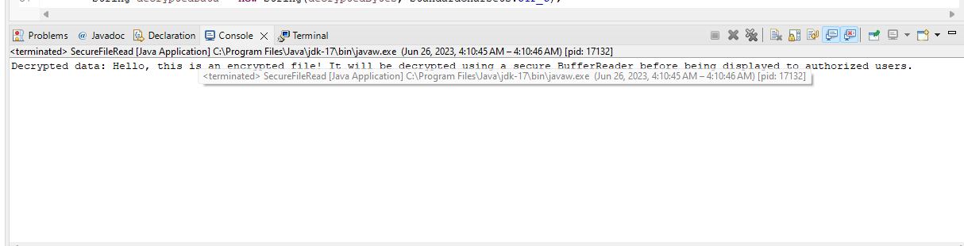

References
Oracle Corporation. (2023, May). Secure coding guidelines for java SE. https://www.oracle.com/java/technologies/javase/seccodeguide.html
McManus, J. (2018, June 11). Sei cert Oracle Coding Standard for Java. SEI CERT Oracle Coding Standard for Java - SEI CERT Oracle Coding Standard for Java - Confluence. https://wiki.sei.cmu.edu/confluence/display/java/SEI+CERT+Oracle+Coding+Standard+for+Java
Wu, J., Cai, W., Watkins, D., & Glanz, J. (2020, March 22). How the virus got out [Interactive infographic]. The New York Times. https://www.nytimes.com/interactive/2020/03/22/world/coronavirus-spread.html

