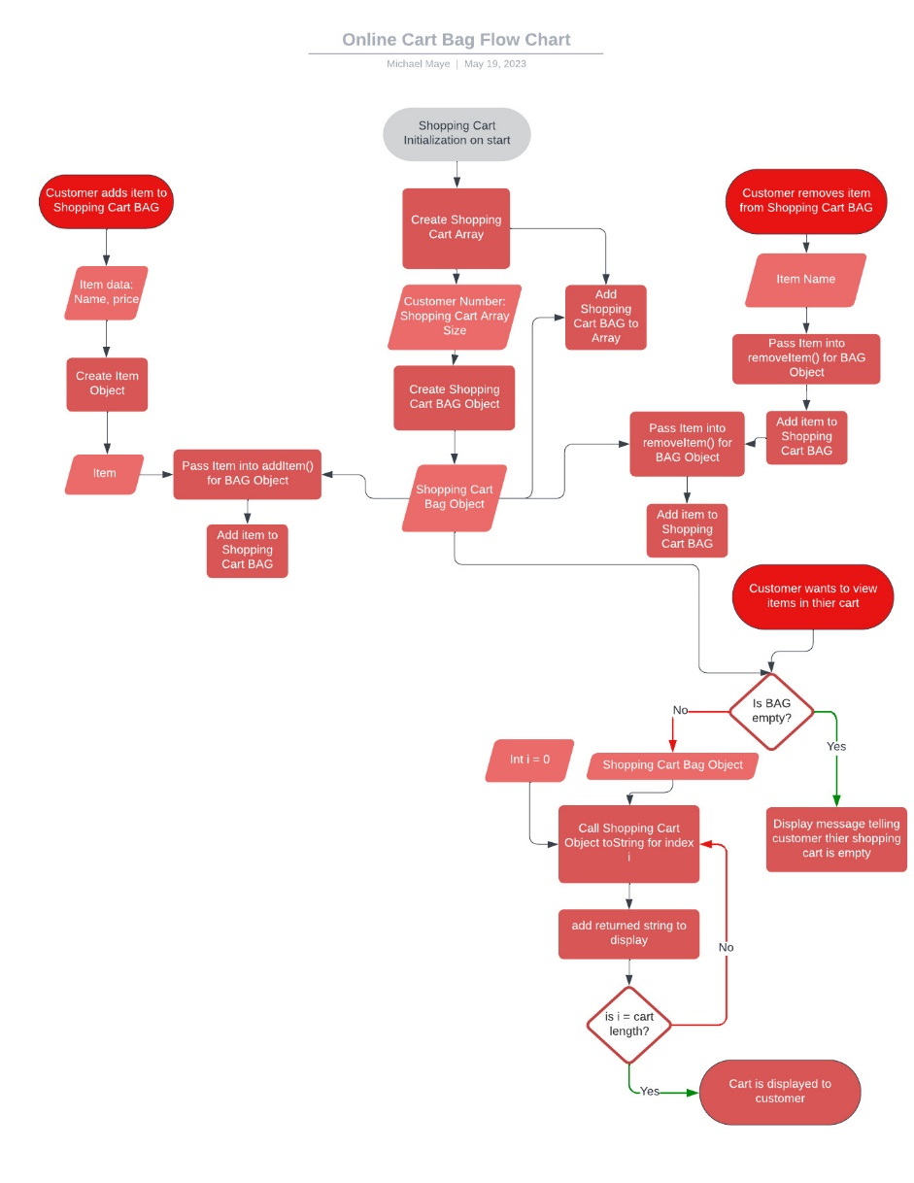
OnlineDeliveryBag Class:
- Represents the shopping cart for the online food delivery service.
- Uses an ArrayList to store the items in the cart.
- Provides methods to add, remove, and retrieve items, as well as check if the cart is empty and get the size of the cart.

- Constructor(customer number):
Initializes an empty ArrayList to store the items in the shopping cart with
attribute [int customer number].

- addItem(item: Item) Method:
Adds the provided item to the shopping cart.

- removeItem(item: Item) Method:
Removes the provided item from the shopping cart if it exists.
Returns a boolean value indicating whether the item was successfully removed.

- getItems() Method:
Retrieves all the items in the shopping cart as an ArrayList.
Iterate over ArrayList and print toString() method for each item in ArrayList.

- emptyCart():
Remove all items from shopping cart object.

- isEmpty() Method:
Checks if the shopping cart is empty.
Returns a boolean value indicating whether the cart is empty.

- size() Method:
Returns the number of items in the shopping cart.

Item Class:
- Represents an item that can be added to the shopping cart.
- Contains properties for the item's name and price.
- Provides getters and setters to access and modify the item's properties.
- Overrides the toString() method to provide a string representation of the item.

- Constructor(name, price):
Create a new instance of an Item with attributes [String name] [double price].

- getName():
Get name of item object.

- setName():
Set name of item object.

- getPrice():
Get price of item object.

- setPrice():
Set price of item object.

- toString():
Return object information in format “[name] ($[price])”.

