package CriticalThinking.Module5;

public class RecursiveFactorials {
// Straight recursive calculation by submitting n-1 on each recursive call
public static int straightFactorail(int n) {
if (n == 0) {
return 1;
} else {
System.out.println(n + " * " + (n-1));
return n * straightFactorail(n - 1);
}
}

// Factorial by multiplying a ‘factorial’ accumulator value by n on each recursion, then submitting n-1 into the next iteration
public static int factorailWithAccumulator(int n, int factorial) {
if (n == 0) {
return factorial;
} else {
System.out.println(n + " * " + factorial);
return factorailWithAccumulator(n - 1, n * factorial);
}
}

public static void main(String[] args) {
int n1 = 5;

// Straight recursion
int factorial1 = straightFactorail(n1);
System.out.println("Factorial of 5 using straight recursion: " + factorial1);

// Recursion with an accumulator
int factorial2 = factorailWithAccumulator(n1, 1);
System.out.println("Factorial of 5 using an accumulator: " + factorial2);

int n2 = 7;

int factorial3 = straightFactorail(n2);
System.out.println("\nFactorial of 7 using straight recursion: " + factorial3);

int factorial4 = factorailWithAccumulator(n2, 1);
System.out.println("Factorial of 7 using an accumulator: " + factorial4);

}
}
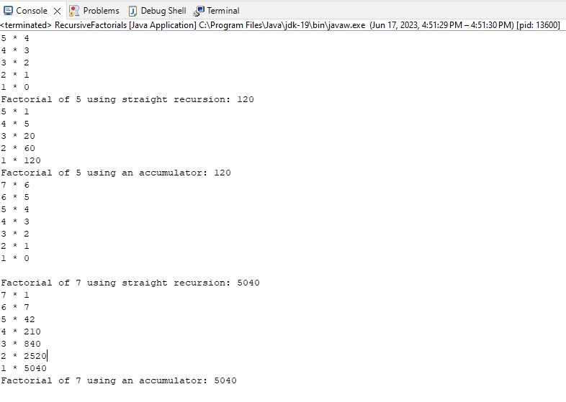
The dominant operations in this algorithm are the two factorial recursive functions. The functions ‘straightFactorail()’ and ‘factorailWithAccumulator()’ both process once for each integer between 1 and n, so both process through n times.
‘straightFactorail()’ multiplies the current n by the recursion of n-1, so by the end we have n*n-1*n-2*...*2*1, build up from 1 to n by one over each iteration. This shows that ‘straightFactorial()’ is of linear complexity, as the level of complexity increases linearly with n.
‘factorialWithAccumulator()’ takes the current n and multiplies it by the ‘accumulator’ value, which in this case is 1, then passes n-1 and the product of n*accumulator as the new accumulator into the recursion so that the next iteration is n-1*n*accumulator and so on, so the end result would be 1*2*...n-2*n-1*n. This function is simply the reverse of ‘straightFactorial()’, and as such has linear complexity since it’s time complexity increases linearly for each integer in the value of n.
As both of these are linear, or O(n), and the contained operations is of constant time, namely the multiplication of two variables and the recursion call, the overall time complexity of this program is also O(n).

package CriticalThinking.Module5;

import javafx.application.Application;
import javafx.geometry.Insets;
import javafx.geometry.Pos;
import javafx.scene.Scene;
import javafx.scene.control.Button;
import javafx.scene.control.TextArea;
import javafx.scene.layout.VBox;
import javafx.stage.Stage;
import java.util.Random;

public class RandomArrayBackwards extends Application {
private String[] arr;
private Random random = new Random();
private TextArea inputArea;
private TextArea resultArea;
private Button displayButton;
private String result;

@Override
public void start(Stage primaryStage) {
primaryStage.setTitle("Array Portion Reverse");

// Create GUI components
displayButton = new Button("Display Random Portion");
displayButton.setOnAction(e -> displayRandomPortion());

inputArea = new TextArea();
inputArea.setPromptText("Enter a string");

resultArea = new TextArea();
resultArea.setPromptText("A portion will be displayed backwards");
resultArea.setEditable(false);

inputArea.setDisable(true);

// Create a VBox and add components
VBox vbox = new VBox(10);
vbox.setPadding(new Insets(20));
vbox.setAlignment(Pos.CENTER);
vbox.getChildren().addAll(inputArea, displayButton, resultArea);

Scene scene = new Scene(vbox, 300, 200);
primaryStage.setScene(scene);
primaryStage.show();

displayButton.requestFocus();
inputArea.setDisable(false);

}

private void displayRandomPortion() {
result = "";
String input = inputArea.getText();
arr = input.split("");

if (input.length() > 0) {
int start = random.nextInt(arr.length);
int end = random.nextInt(arr.length);

// Ensure start index is smaller than end index
if (start > end) {
int temp = start;
start = end;
end = temp;
}

displayArrayPortionBackwards(start, end);

resultArea.setText(result);
} else {
displayButton.setText("Please enter a string, then click the button");
}
}

private void displayArrayPortionBackwards(int start, int end) {
if (start > end) {
return;
}

result += arr[end];
displayArrayPortionBackwards(start, end - 1);
}

public static void main(String[] args) {
launch(args);

}
}

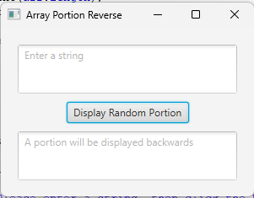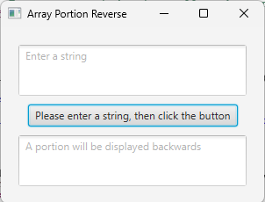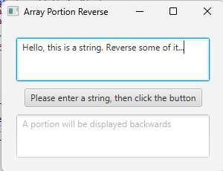
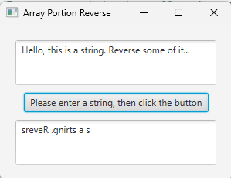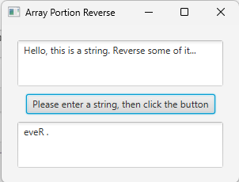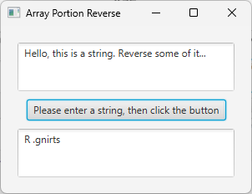

Breaking down this whole program, we have the import statements, declaration of variables, the start method, the displayRandomPortion method, the displayArrayPortionBackwards method, and the main method.

The import statements have no impact on time complexity as they happen during compilation. The variables that are declared but not instantiated with a value also have no impact on time complexity and the instantiation of the random variable as a Random is in constant time.

The Start method is then called and sets up the JavaFX components. During this step the creation of the components does not involve any computation complexity so this step does not impact the time complexity of the system.

The method displayRandomPortion that is called when the button is pressed. First it initializes the variable ‘result’ with an empty string, which takes constant time. It then takes the input text and splits it into an array with the split("") method and has a complexity proportional to the length of the input string, thus has a linear time complexity of O(n). It then runs into the ‘If’ statement that takes in the variables ‘end’ and ‘start’ to verify that ‘start’ is less than ‘end’. If not, it swaps the values to ensure that our start is always less than the end integer, which takes constant time.

Then the method displayArrayPortionBackwards is called and takes in the ‘start’ and ‘end’ variables. It then appends the element at index ‘end’ from the array ‘arr’ to the string ‘result’ starting at index 0, then recursively calls displayArrayPortionBackwrds passing in the same ‘start’ variable along with ‘end - 1’ which this method uses to append the next character to the right of the previous one. This method would iterate from the integers ‘end’ to ‘start’ so it would have a time complexity of (end - start). Since the difference between ‘start’ and ‘end’ it randomly generated we can say that that number is k, so it would have O(k) complexity. To take worst case scenario, we can assume that ‘start’ is randomly selected as ‘1’ and ‘end’ is randomly selected to be ‘n’ since ‘n’ is the largest random integer in range 1 - n. If this is the case, then this method would have complexity O(n).

The main method is called to initiate the launch(args) function and has no relevance to this analysis.

Given that the dominant operations in this program have time complexity O(n), we can say that this program has an overall complexity of O(n).

