Lab 6 Spring Boot Event Registration API
Alexey V
Group: It302502 DS

Purpose
Create a Spring Boot backend for event registration, return JSON through HTTP endpoints, and use constructor-based dependency injection to connect a controller and a service.

Implementation
EventRegistrationApplication starts the server. RegistrationController handles requests under /api. EventService provides a welcome message and three events stored in memory. EventInfo holds the ID, title and location of each event. The controller receives EventService through its constructor and reads configuration using @Value. The project uses JDK 21, Spring Boot 4.1.2 and Gradle wrapper 9.8.2.
Figure 1. GET /api/hello returns the welcome message as JSON.
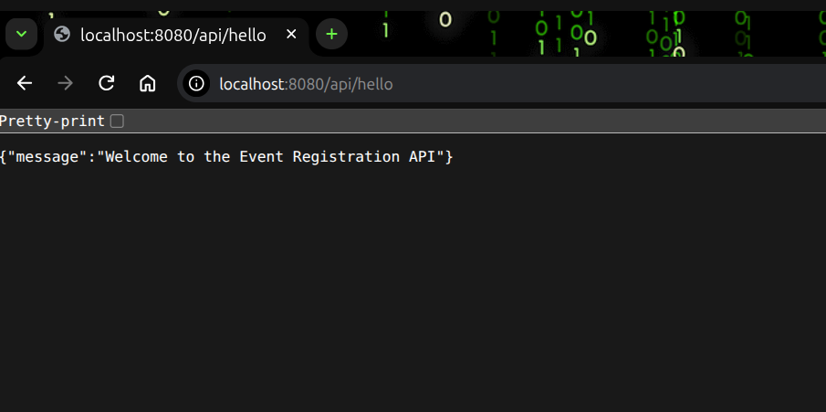

Event list
GET /api/events returns exactly three event objects from EventService. Each object contains id, title and location. The controller returns the list, which is serialized into a JSON array.
Figure 2. The three events returned by GET /api/events.
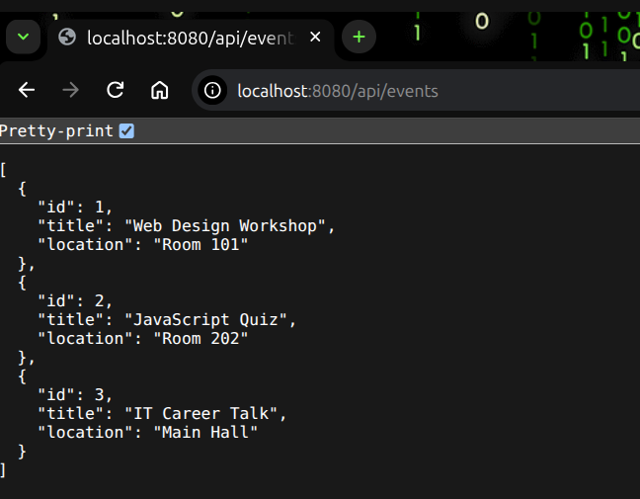

Application configuration
GET /api/info returns the application name, course and semester from application.properties. These values are injected into the controller fields using @Value.
Figure 3. GET /api/info displays the configured values.
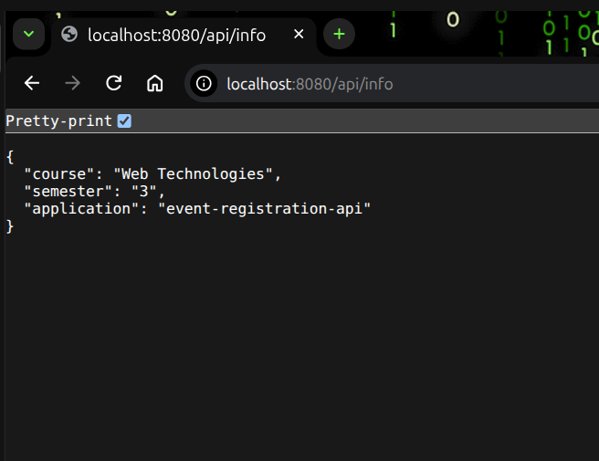

Conclusion
The application uses Spring Boot to run a web server and handle HTTP requests. The controller returns JSON while the service provides the application data. Constructor injection allows Spring to supply the service to the controller. Application properties store settings separately from Java code, and the event list is kept in memory.

