Lab 5 Event Registration
Alexey V
Group: It302502 DS

Purpose
Build a Java console application to manage event registrations and practise classes, objects, encapsulation, ArrayList and input validation. The application supports adding, displaying, searching, filtering and deleting registrations.

Implementation
Registration stores one record using private fields, a constructor and getters. RegistrationManager owns the list, validates new records and assigns IDs. Main reads input with Scanner and calls the manager through a repeating menu. The project targets Java 17 and was built with OpenJDK 21 and Gradle 8.14.3.
The screenshots show the application running in the terminal.
Figure 1. Valid registration receives ID 1.
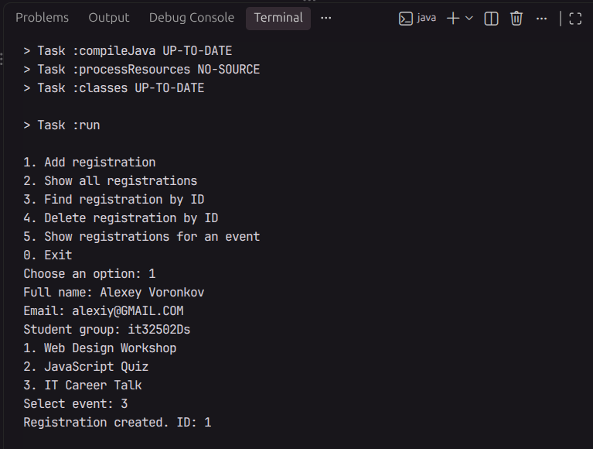

Validation and filtering
Figure 2. A two-character name is rejected. No record is added.
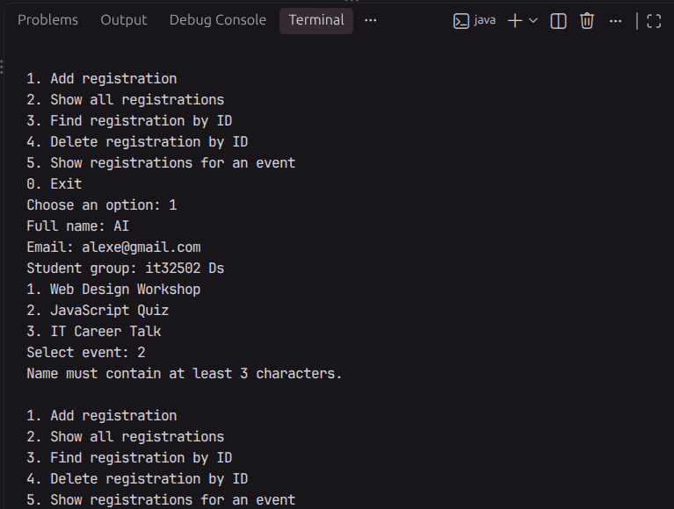
Figure 3. Filtering by IT Career Talk shows the matching registration.
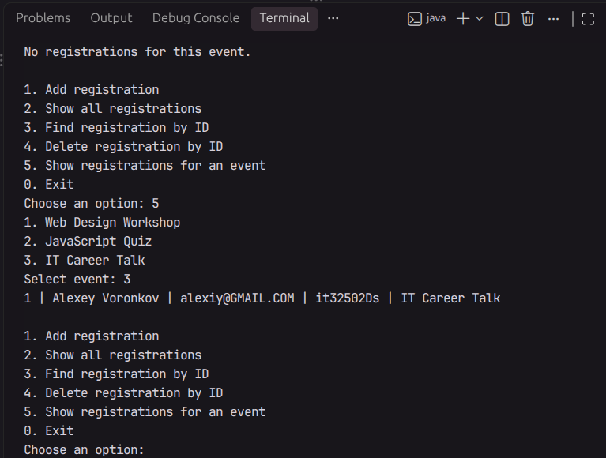

Deletion and checks
Figure 4. Deleting ID 1 leaves an empty list.
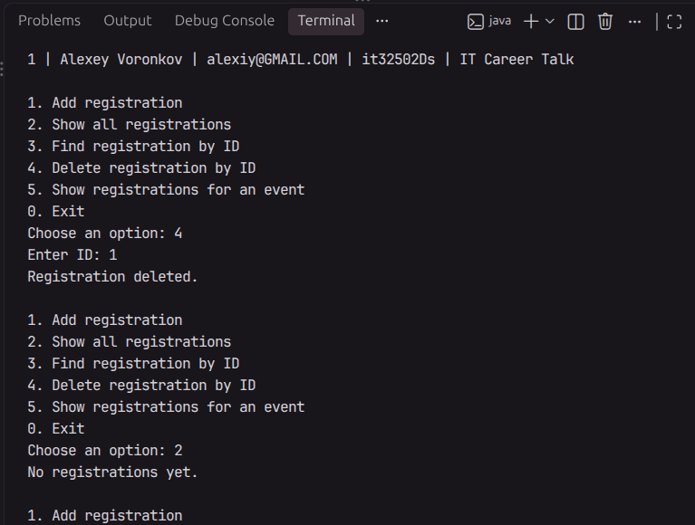
Thirteen input scenarios passed: empty list; two valid registrations; short and blank names; missing @; email with no text before or after @; blank group; invalid numbers; invalid event choice; existing and missing IDs; event filtering; deletion followed by another addition. After deletion, the next registration received ID 2. The Gradle build also completed successfully.

Conclusion
The application uses separate classes for record data, list operations and console input. Private fields and getters provide access to registration data through methods. Validation prevents invalid records from entering the list, and try/catch handles incorrect numeric input. The checks confirmed that search, filtering and deletion work and that deleted IDs are not reused.

