Lab 7 Spring Boot REST Controller
Alexey V | Group: It302502 DS

Purpose
Extend the Event Registration API with HTTP CRUD operations, title search, JSON request bodies and appropriate response status codes.

Implementation
RegistrationController handles HTTP requests and checks title and location. EventService stores events in an ArrayList, assigns increasing IDs and performs list operations. EventInfo supports JSON input through a no-argument constructor and setters. The service is injected through the controller constructor.
Figure 1. GET returns the initial list (200), title search returns JavaScript Quiz (200), and ID 999 returns 404.
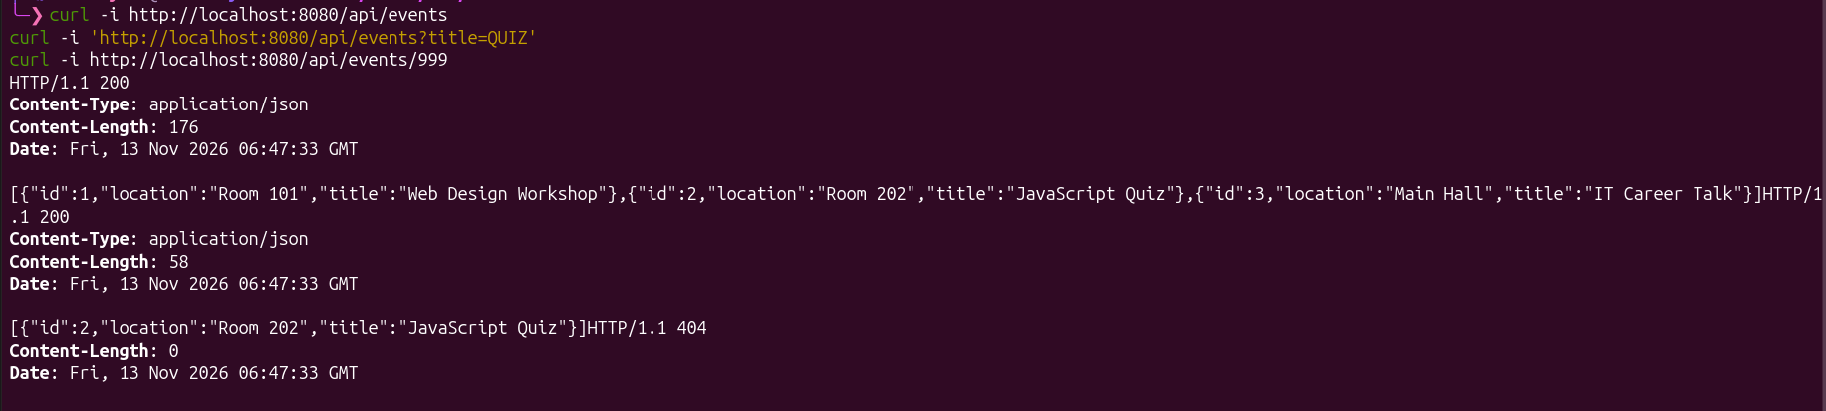

Creating and updating events
Figure 2. POST creates Java Workshop in Room 303 with server-assigned ID 4 and status 201.

Figure 3. PUT changes both fields to Spring Workshop and Room 404, preserves ID 4 and returns 200. GET confirms the update.
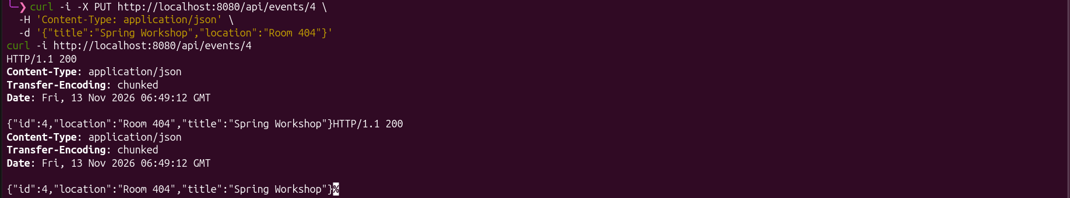

Deletion and input validation
Figure 4. DELETE removes ID 4 with status 204 and no response body. A subsequent GET returns 404.

Figure 5. A blank title returns 400. The next valid POST returns 201 with ID 5, so deleted ID 4 is not reused.


Conclusion
The API supports creating, reading, updating, deleting and searching events through HTTP. Path variables, query parameters and JSON bodies provide different ways to pass request data. The controller handles HTTP responses while the service manages the in-memory list and assigns IDs. Invalid input is rejected without changing data, and restarting the application restores the sample events.

