Project 1: World Population
2025-10-21

Summary
This project aims to conduct a focused data analysis on global population trends, utilizing datasets from the World Population Data and the World Bank Group. The core objective is to identify and visualize key demographic shifts, with a specific focus on population growth rates across different countries and regions.
The analysis will address the following key questions:
Population Growth Extremes: Identify countries with the most significant increases and decreases in population, both historically and over the last five years.
Growth Rate Dynamics: Analyze the distribution of annual growth rates through histograms to highlight countries with the highest and lowest average rates, as well as those with the highest and lowest deviations.
Regional and Economic Influences: Visualize and examine how population growth varies across different geographic regions and is influenced by a country’s income group.

Data
The data is available from the World Bank Group: https://data.worldbank.org/
The data sets used in this project are downloaded from the following sources:
- Total Population: https://data.worldbank.org/indicator/SP.POP.TOTL
- Death rate: https://data.worldbank.org/indicator/SP.DYN.CDRT.IN
- Birth rate: https://data.worldbank.org/indicator/SP.DYN.CBRT.IN
- Population distribution: https://data.worldbank.org/indicator/SP.POP.1564.TO.ZS
- Net Migration Data: https://data.worldbank.org/indicator/SM.POP.NETM

Data Cleaning and Transformation
The datasets was first tidied to transform it into a long format, making it easier to manage and visualize. The names of the columns were standardized for better clarity. Rows with any missing values were removed. Invalid country names removed using Valid ISO3 country codes (available in library ‘countrycode’).

Preview the aggregated data sets
World population (first 3 rows of merged datasets)
Code | Name | Year | Population | BirthRate | DeathRate | Net_Migration | Percent_15_64 | Region | IncomeGroup
AFG | Afghanistan | 1,960 | 9,035,043 | 50.516 | 31.672 | 2,606 | 55.22988 | Middle East & North Africa | Low income
AFG | Afghanistan | 1,961 | 9,214,083 | 50.566 | 31.129 | 6,109 | 55.16205 | Middle East & North Africa | Low income
AFG | Afghanistan | 1,962 | 9,404,406 | 50.666 | 30.630 | 7,016 | 55.09435 | Middle East & North Africa | Low income

Part 1: EDA (Exploratory Data Analysis) of population growth:
Population (annual) growth rate, $λ_{t}$, can be defined as the number of individuals in one year compared to the year before:
$$λ_{t}=\frac{N_{t}}{N_{t-1}},$$
where $N_{t}$ be the population at year $t$.
If this rate of growth is constant over $t$ number of years and the initial population size is $N_{o}$, then the population size at year t is: $N_{t}=N_{o}λ^{t}$. This is the model of geometric population growth, i.e., a population growing in discrete time-steps with constant growth rate $λ$.
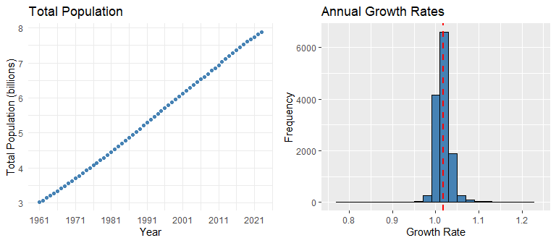
Based on the Total Population plot, the world’s population from 1960 to 2020 exhibited a tendency of continuous growth. The overall trend appears largely linear over this period, indicating a relatively constant rate of growth.
The histogram of annual growth rates shows that most countries have growth rates above 1.0 (slightly right skewed) which indicates a positive growth overall. A few outliers on the right represent rapid growth, while a few on the left indicate decline.

Which countries have experienced the highest increase/decrease in population over time?
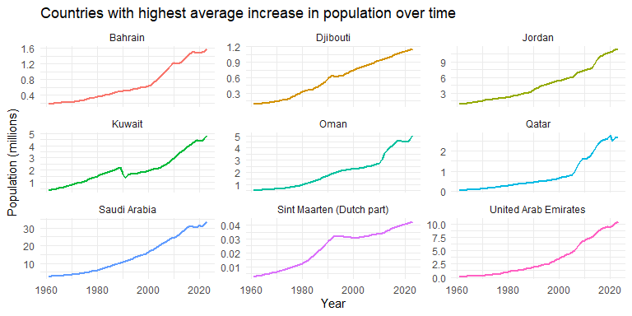
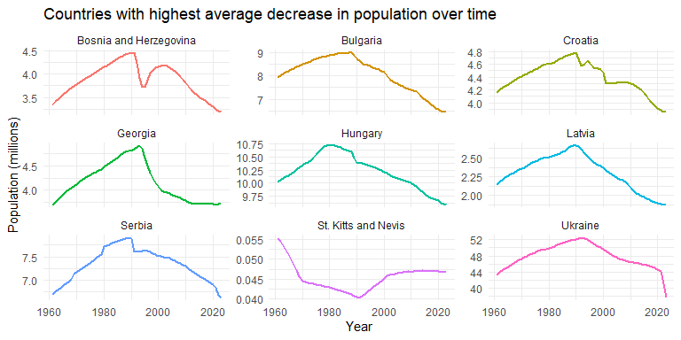

Which countries have been experiencing the highest increase/decrease in population in the last five years?
Top Countries highest increase in population in last 5 years
Name | Pop_2020 | Pop_2024 | Growth_Percent
Seychelles | 98,462 | 119,773 | 21.64388
Chad | 17,224,679 | 19,319,064 | 12.15921
Syrian Arab Republic | 21,049,429 | 23,594,623 | 12.09151
Oman | 4,522,497 | 5,049,269 | 11.64781
United Arab Emirates | 9,401,038 | 10,483,751 | 11.51695
Kuwait | 4,400,267 | 4,853,420 | 10.29831
Niger | 23,717,613 | 26,159,867 | 10.29722
Somalia, Fed. Rep. | 16,651,191 | 18,358,615 | 10.25407
Congo, Dem. Rep. | 95,989,998 | 105,789,731 | 10.20912
Countries with highest decrease in population in last 5 years
Name | Pop_2020 | Pop_2024 | Growth_Percent
Ukraine | 44,680,014 | 37,732,836 | -15.548737
St. Martin (French part) | 31,786 | 27,515 | -13.436733
Marshall Islands | 42,706 | 38,827 | -9.083033
Moldova | 2,635,130 | 2,457,783 | -6.730104
Tuvalu | 10,399 | 9,816 | -5.606308
Northern Mariana Islands | 47,528 | 45,143 | -5.018095
Qatar | 2,794,148 | 2,656,032 | -4.943045
American Samoa | 49,761 | 47,521 | -4.501517
Serbia | 6,899,126 | 6,623,183 | -3.999681

Histograms of annual growth rates with highest average rates.
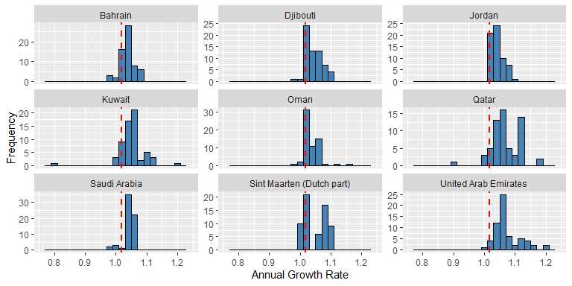

Histograms of annual growth rates with lowest average rates.
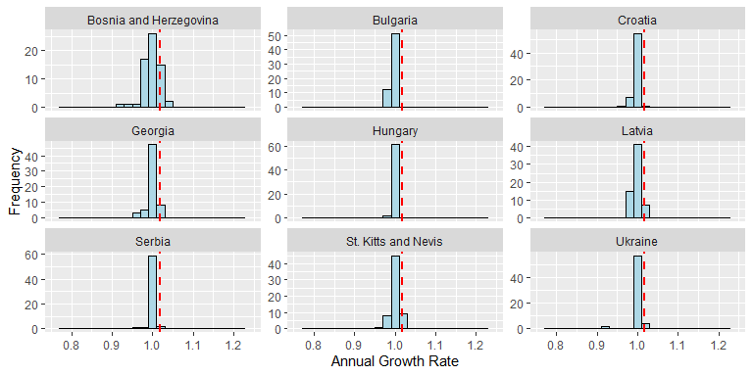

Population growth of countries over time grouped by region.
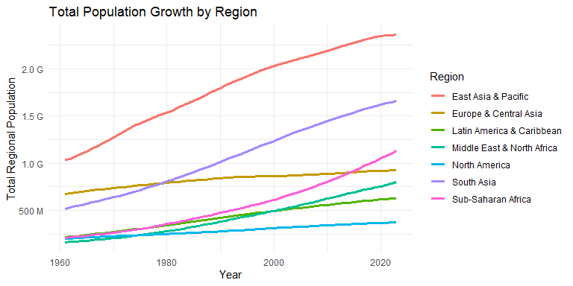
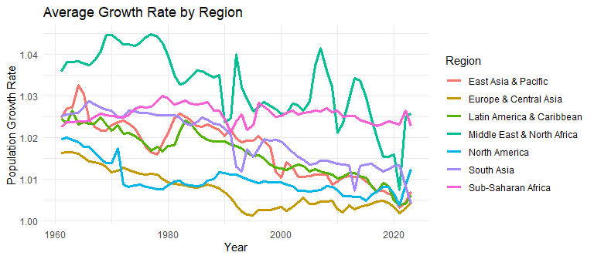
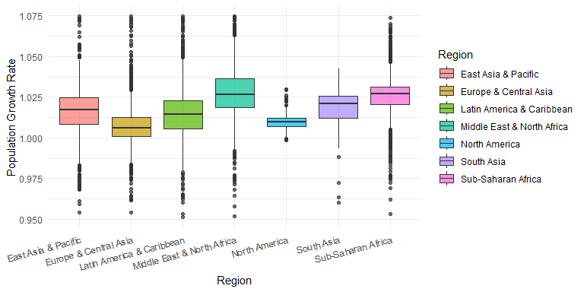

Population growth of countries over time grouped by income group.
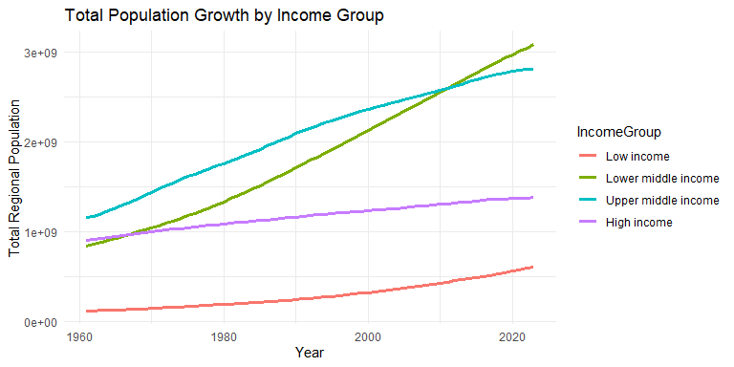
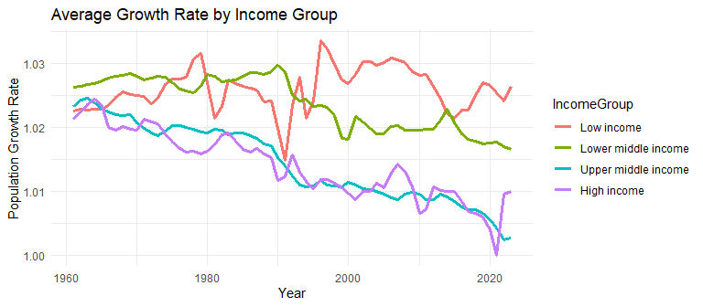
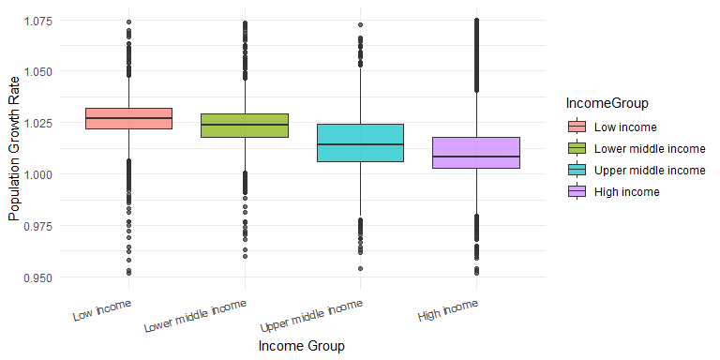

Part 2: Exponential population growth model
Population growth is determined by the difference between the birth rate (number of births per 1,000 people) and the death rate (number of deaths per 1,000 people), a value known as the rate of natural increase. When the birth rate is higher than the death rate, the population grows. When the death rate is higher, the population declines.
Exponential population growth occurs when a population is growing in continuous time with a constant growth rate, $r$:
$$N_{t}=N_{o}e^{rt},$$
where $r$ is the instantaneous rate of growth which is the birth rate (births per individual) minus the death rate (deaths per individual) at any given time scale.
Geometric and exponential growth models are very similar, except that they differ in several mathematical properties. But given a certain time unit, we can go between the two models easily by substituting $λ=e^{r}$ and $ln\left(λ\right)=r$.
Let $N_{t}$ be the population at year $t$, define the annual instantaneous rate for t years as $\overset{‾}{r}$ that
$$N_{t}=N_{0}e^{\overset{‾}{r}t}.$$
Let the one-year instantaneous rate at year $t$ as $r_{t}$. We have
$$N_{t}=N_{t-1}e^{r_{t}}.$$
$$∴r_{t}=ln\left(\frac{N_{t}}{N_{t-1}}\right)$$
So,
$$\overset{‾}{r}=\frac{1}{t}\sum_{i=1}^{t}{r_{i}}=\frac{1}{t}ln\left(\prod_{i=1}^{t}{\frac{N_{i}}{N_{i-1}}}\right)=\frac{1}{t}ln\left(\frac{N_{t}}{N_{0}}\right).$$
That is, the annual instantaneous rate across multiple years is the mean of the one-year instantaneous rates. And the respective average annual growth rate should be computed as a geometric mean of the one-year growth rates:
$$\overset{‾}{λ}={\left(\frac{N_{t}}{N_{0}}\right)}^{\frac{1}{t}}={\left(\prod_{i=1}^{t}{\frac{N_{i}}{N_{i-1}}}\right)}^{\frac{1}{t}}={\left(\prod_{i=1}^{t}{λ_{i}}\right)}^{\frac{1}{t}}$$

EDA of Instantaneous Rates

Countries with highest instantaneous rate over time.
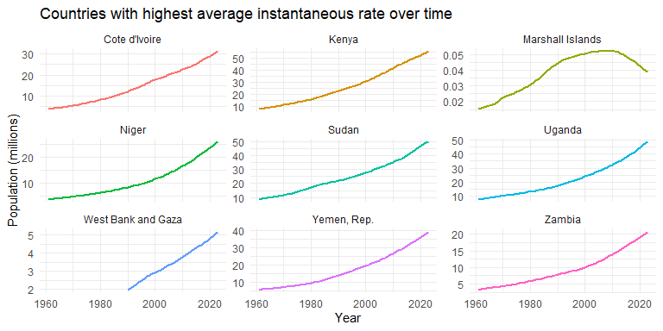

Countries with lowest instantaneous rate over time.
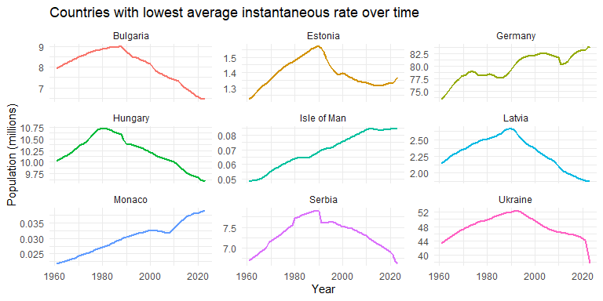

Which countries have been experiencing the highest/lowest instantaneous rate in the last five years?
Top Countries highest increase in population in last 5 years
Name | Pop_2020 | Pop_2024 | mean_inst_rates
Niger | 23,717,613 | 26,159,867 | 0.03281650
Congo, Dem. Rep. | 95,989,998 | 105,789,731 | 0.03272750
Somalia, Fed. Rep. | 16,651,191 | 18,358,615 | 0.03265250
Mali | 21,713,836 | 23,769,127 | 0.03144375
Chad | 17,224,679 | 19,319,064 | 0.03144300
Angola | 33,451,132 | 36,749,906 | 0.03105450
Uganda | 44,457,152 | 48,656,601 | 0.03088925
Mozambique | 30,783,688 | 33,635,160 | 0.03048700
Yemen, Rep. | 36,134,863 | 39,390,799 | 0.03009250
Countries with highest decrease in population in last 5 years
Name | Pop_2020 | Pop_2024 | mean_inst_rates
Monaco | 38,050 | 38,956 | -0.01343250
Bulgaria | 6,550,696 | 6,446,596 | -0.01007500
Ukraine | 44,680,014 | 37,732,836 | -0.00826350
Serbia | 6,899,126 | 6,623,183 | -0.00785000
Latvia | 1,900,449 | 1,877,445 | -0.00757500
Bosnia and Herzegovina | 3,299,349 | 3,185,073 | -0.00731025
Lithuania | 2,810,369 | 2,871,585 | -0.00720000
Belarus | 9,379,952 | 9,178,298 | -0.00637475
Croatia | 3,914,206 | 3,859,686 | -0.00575000

Histograms of instantaneous rates with highest average rates over time.
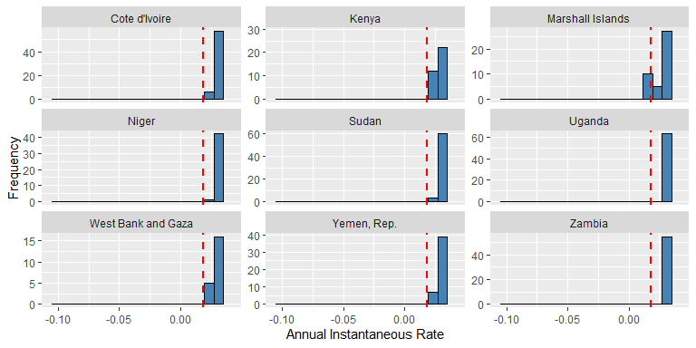

Histograms of instantaneous rates with lowest average rates over time.
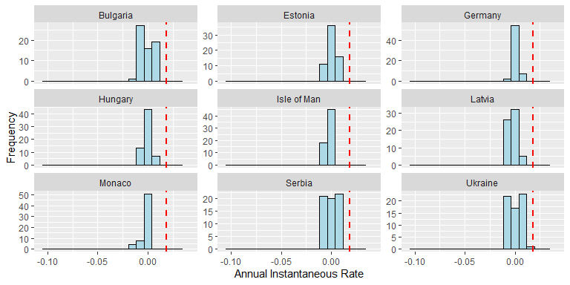

Instantaneous rates of countries over time grouped by region.
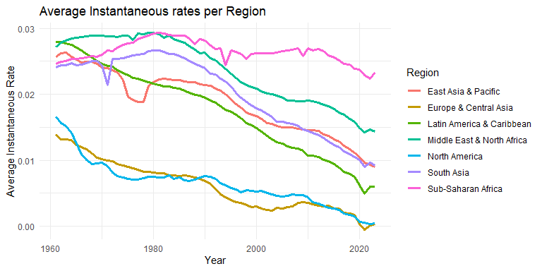
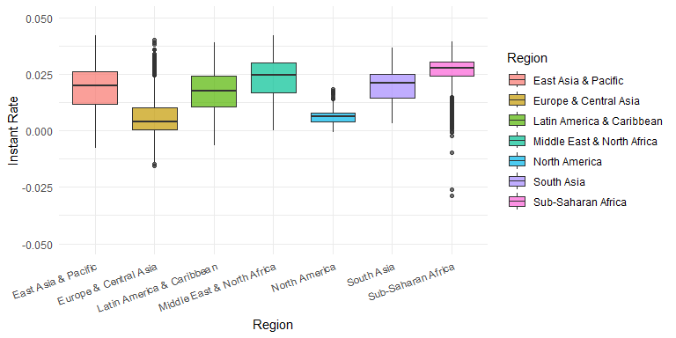

Instantaneous rates of countries by income group.
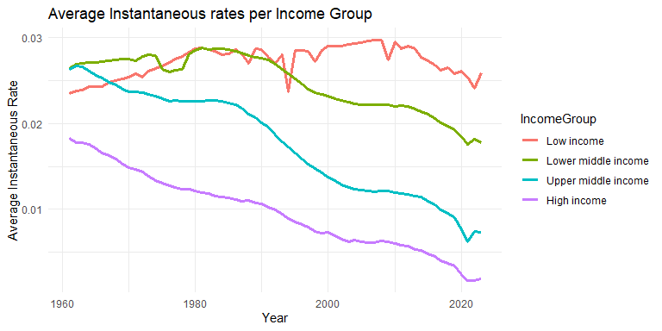
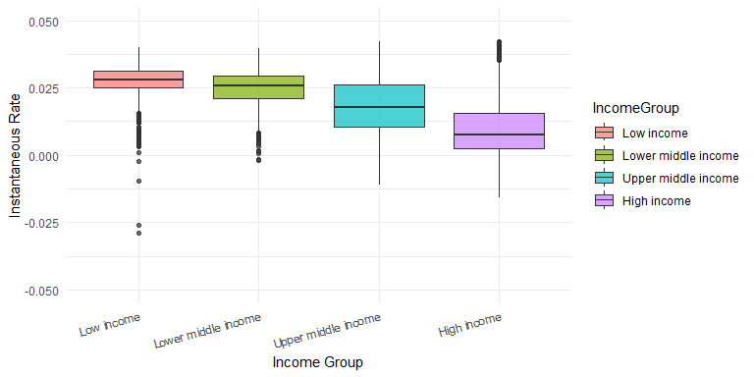

Comparing the results in Parts 1 & 2
N_years <- yearly_totals$Year[length(yearly_totals)] - yearly_totals$Year[1]
t <- yearly_totals$Year
t <- t - t[1] + 1
N_years <- length(t)
P <- yearly_totals$Total_Population
P0 <- P[1]
PL <- P[N_years]
geom_ave_growth <- (PL/P0)^(1/N_years)
yearly_totals <- yearly_totals %>%
mutate(
pop_est1 = P0 * mean_growth^t,
pop_est2 = P0 * geom_ave_growth^t,
pop_est3 = P0 * (exp(mean_R))^t
)
plot(yearly_totals$Year, yearly_totals$Total_Population / 1e9, col="steelblue",
xlab = "Year", ylab= "Total Population (billions)")
lines(yearly_totals$Year, yearly_totals$pop_est1 / 1e9,
col = "blue")
lines(yearly_totals$Year, yearly_totals$pop_est2 / 1e9,
col = "darkgreen")
lines(yearly_totals$Year, yearly_totals$pop_est3 / 1e9,
col = "salmon")
legend("topleft", legend = c("Original", "Arith mean", "Geom mean", "Exp"), col = c("steelblue", "blue", "darkgreen", "salmon"), pch = 19)
grid()
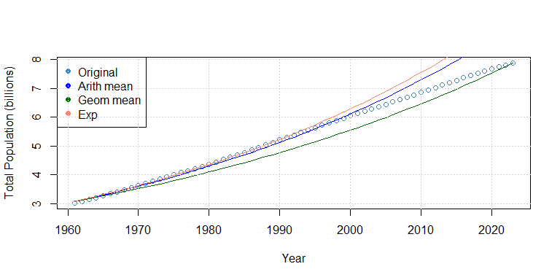
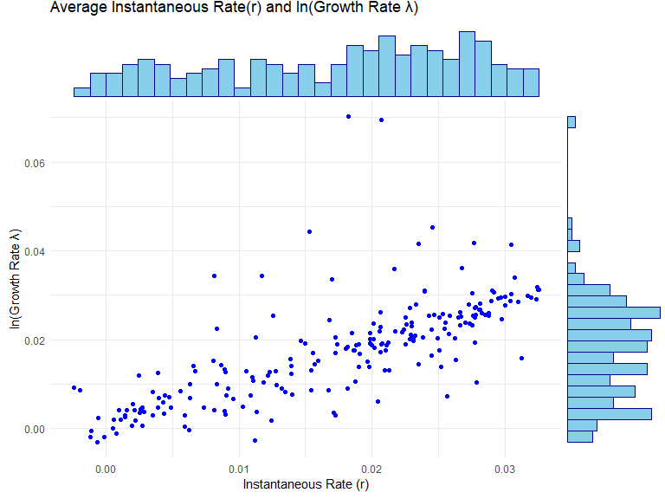
The correlation coefficient is 0.7225977, indicating that the average instantaneous rates $r$ and $ln\left(λ\right)$ have a strong positive linear relationship. Some anomalies on the plot suggests that the formula is not perfect in some cases. Adding net migration into instantaneous rate may improve the formula.

Other Factors influencing growth: Migration and Age Distribution

Age Distribution factor
A population with a large proportion of young adults will likely have a high birth rate and experience natural increase, even with moderate fertility.
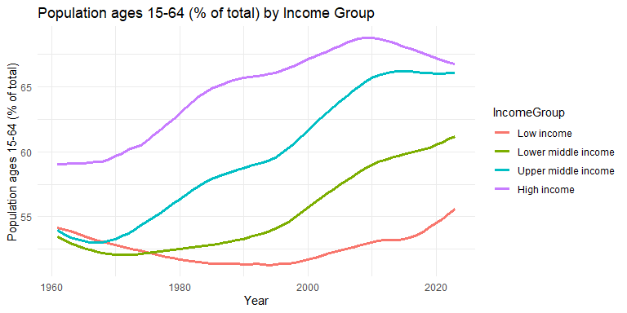
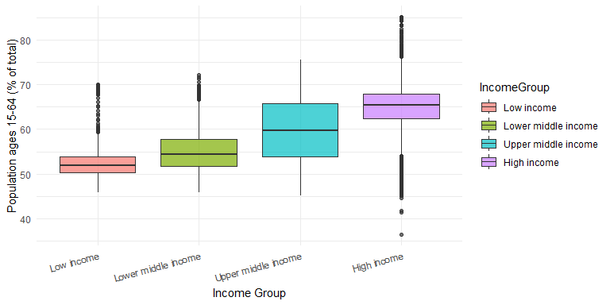

Migration factor
In addition to natural increase, population growth is also affected by immigration (people entering a population) and emigration (people leaving a population).
“Net migration” is the difference between the number of people entering a country or region (immigrants) and the number of people leaving (emigrants) over a specific period. A positive net migration indicates more people are entering than leaving, while a negative number means more people are emigrating.
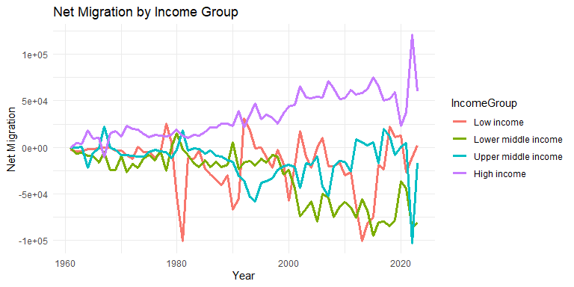
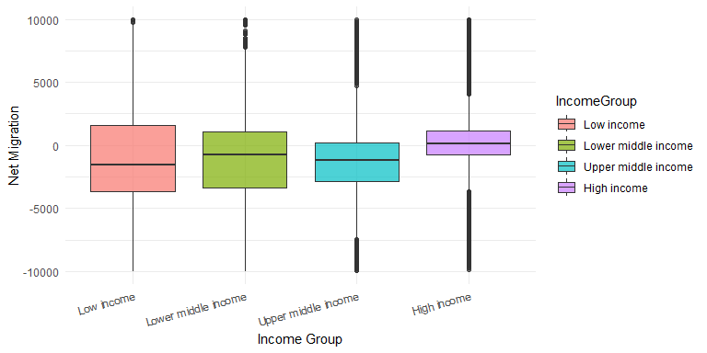
The net migration rate expresses this figure as a proportion per 1,000 people, using the formula following formula (https://en.wikipedia.org/wiki/Net_migration_rate):
Net Migration Rate = 1,000 * (Immigrants - Emigrants) / Mid-Year Population.
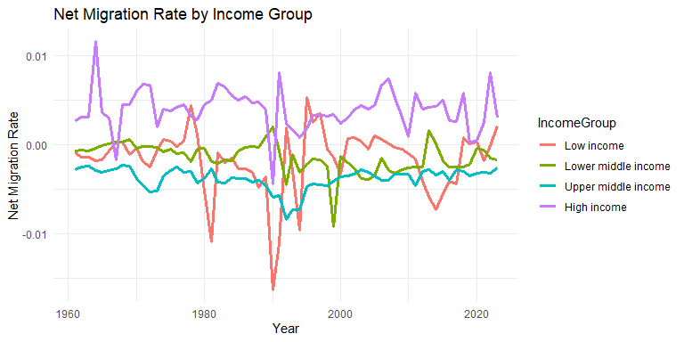
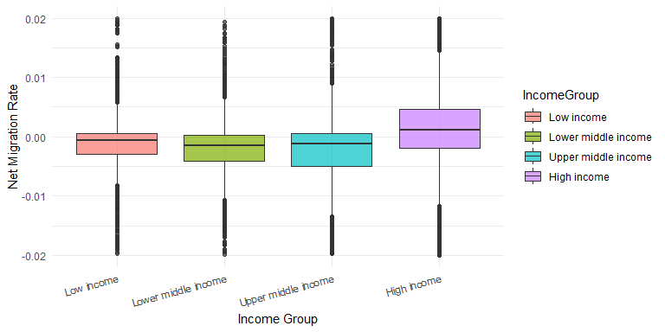
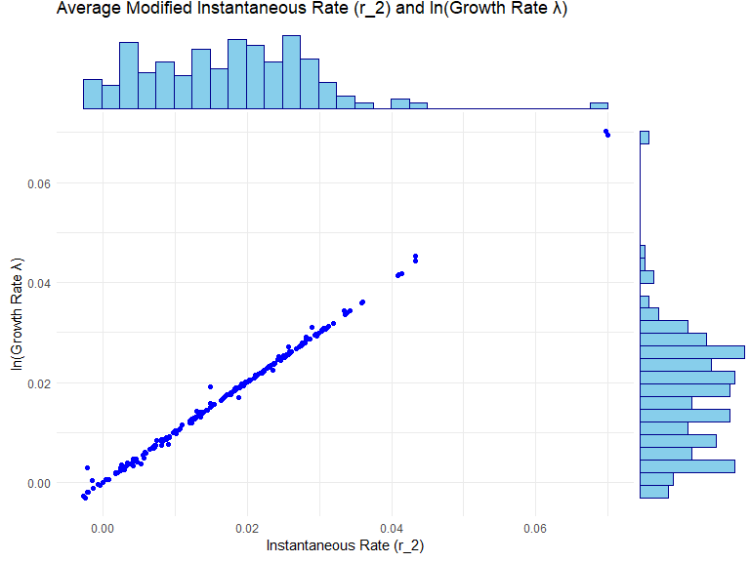
The correlation coefficient for originally defined Instantaneous growth rate, $r$ was 0.7225977. Inclusion of the Net migration in the formula, the correlation coefficient has increased to 0.9985804.

Hypothesis testing
The boxplot of Net Migtation per Income Group shows that the Net Migration (on average) is higher for High Income group then for all other Income Groups. We can use the Hypothesis Testing framework to statistically verify our visual observations.
High_Inc <- subset(data_final, IncomeGroup == "High income")
Up_Mid_Inc <- subset(data_final, IncomeGroup == "Upper middle income")
t.test(High_Inc$Migration_Rate, Up_Mid_Inc$Migration_Rate, alternative = "greater", var.equal = FALSE)
##
## Welch Two Sample t-test
##
## data: High_Inc$Migration_Rate and Up_Mid_Inc$Migration_Rate
## t = 21.891, df = 8003.1, p-value < 2.2e-16
## alternative hypothesis: true difference in means is greater than 0
## 95 percent confidence interval:
## 0.007145407 Inf
## sample estimates:
## mean of x mean of y
## 0.003971228 -0.003754767
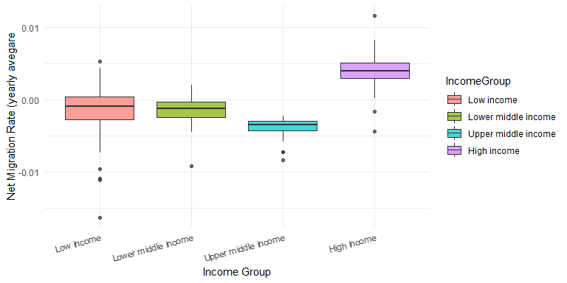
High_Inc <- subset(migration_rate_IG, IncomeGroup == "High income")
Up_Mid_Inc <- subset(migration_rate_IG, IncomeGroup == "Upper middle income")
t.test(High_Inc$mean_migration_rate, Up_Mid_Inc$mean_migration_rate, alternative = "greater", var.equal = FALSE)
##
## Welch Two Sample t-test
##
## data: High_Inc$mean_migration_rate and Up_Mid_Inc$mean_migration_rate
## t = 23.067, df = 91.999, p-value < 2.2e-16
## alternative hypothesis: true difference in means is greater than 0
## 95 percent confidence interval:
## 0.00716948 Inf
## sample estimates:
## mean of x mean of y
## 0.003971228 -0.003754767

