Project_part2
Chu Lin
2025-11-23
## X Code Name Year Population BirthRate DeathRate Net_Migration
## 1 1 AFG Afghanistan 1961 9214083 50.566 31.129 6109
## 2 2 AFG Afghanistan 1962 9404406 50.666 30.630 7016
## 3 3 AFG Afghanistan 1963 9604487 50.787 30.168 6681
## 4 4 AFG Afghanistan 1964 9814318 50.852 29.672 7079
## 5 5 AFG Afghanistan 1965 10036008 50.889 29.193 10695
## 6 6 AFG Afghanistan 1966 10266395 51.018 28.733 3563
## Percent_15_64 Region IncomeGroup Lambda R
## 1 55.16205 Middle East & North Africa Low income 1.019816 0.019437
## 2 55.09435 Middle East & North Africa Low income 1.020656 0.020036
## 3 54.98899 Middle East & North Africa Low income 1.021275 0.020619
## 4 54.83267 Middle East & North Africa Low income 1.021847 0.021180
## 5 54.61609 Middle East & North Africa Low income 1.022588 0.021696
## 6 54.36296 Middle East & North Africa Low income 1.022956 0.022285
Convert the categorical:

EDA
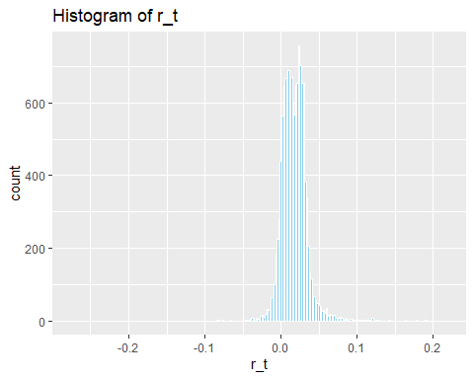
model_v1 <- lm(
r_t ~ BirthRate + DeathRate + Net_Migration + IncomeGroup + Region,
data = df_v1
)
summary(model_v1)
##
## Call:
## lm(formula = r_t ~ BirthRate + DeathRate + Net_Migration + IncomeGroup +
## Region, data = df_v1)
##
## Residuals:
## Min 1Q Median 3Q Max
## -0.310307 -0.004693 -0.000202 0.004033 0.195676
##
## Coefficients:
## Estimate Std. Error t value Pr(>|t|)
## (Intercept) 2.914e-03 4.515e-04 6.455 1.12e-10 ***
## BirthRate 1.003e-03 1.602e-05 62.599 < 2e-16 ***
## DeathRate -1.123e-03 2.798e-05 -40.124 < 2e-16 ***
## Net_Migration 2.207e-08 8.094e-10 27.271 < 2e-16 ***
## IncomeGroupLow income -6.829e-03 5.939e-04 -11.500 < 2e-16 ***
## IncomeGroupLower middle income -6.031e-03 4.303e-04 -14.014 < 2e-16 ***
## IncomeGroupUpper middle income -6.915e-03 3.347e-04 -20.656 < 2e-16 ***
## RegionMiddle East & North Africa 9.851e-03 4.843e-04 20.338 < 2e-16 ***
## RegionSub-Saharan Africa 3.991e-03 4.908e-04 8.132 4.61e-16 ***
## RegionEurope & Central Asia 8.869e-04 4.023e-04 2.204 0.0275 *
## RegionEast Asia & Pacific -2.513e-04 4.072e-04 -0.617 0.5373
## RegionSouth Asia 6.472e-03 8.169e-04 7.923 2.51e-15 ***
## RegionNorth America -7.562e-03 1.118e-03 -6.764 1.40e-11 ***
## ---
## Signif. codes: 0 '***' 0.001 '**' 0.01 '*' 0.05 '.' 0.1 ' ' 1
##
## Residual standard error: 0.01386 on 13164 degrees of freedom
## Multiple R-squared: 0.4207, Adjusted R-squared: 0.4202
## F-statistic: 796.6 on 12 and 13164 DF, p-value: < 2.2e-16

Extended Linear model to v2 by timing categorical variables
First, do EDA
GAM
plot(model_v1, which = 1)
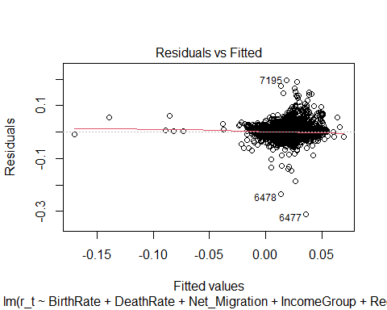
which shows the mean value is near to 0, it means the linear model doesn’t need to do polynomial
QQ plot
plot(model_v1, which=2)
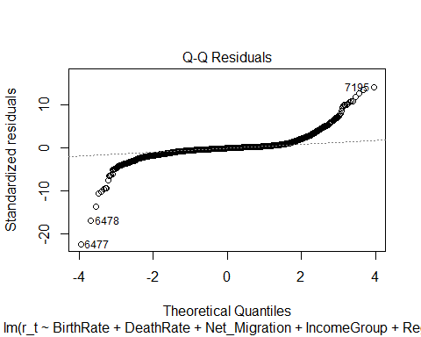
QQ plot shows heavy tails
Let’s see the residual
plot(model_v1, which=4)
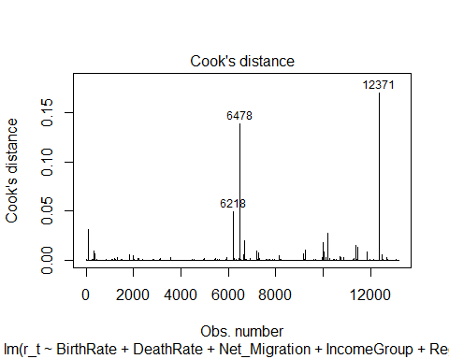
car::residualPlots(model_v1)
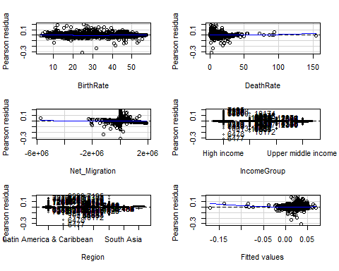
## Test stat Pr(>|Test stat|)
## BirthRate 5.3951 6.965e-08 ***
## DeathRate 3.5370 0.000406 ***
## Net_Migration 1.1157 0.264561
## IncomeGroup
## Region
## Tukey test 7.5745 3.606e-14 ***
## ---
## Signif. codes: 0 '***' 0.001 '**' 0.01 '*' 0.05 '.' 0.1 ' ' 1
Through to cook’s distance and residuals plot, Seems like Death Rate and Net_migration have some outliers
Evaluate if it needs Ridge or Lasso (L1/L2) to expand the model
car::vif(model_v1)
## GVIF Df GVIF^(1/(2*Df))
## BirthRate 3.021280 1 1.738183
## DeathRate 1.708827 1 1.307221
## Net_Migration 1.142695 1 1.068969
## IncomeGroup 3.084144 3 1.206486
## Region 3.707045 6 1.115370
So, we don’t have to use L1 or L2
After all the plots, here is the new models on different parameters

First method by manually change the parameters:
# version 2 is: times the category
model_v2 <- lm(r_t ~ BirthRate * Region +
DeathRate * Region +
Net_Migration * IncomeGroup +
Region +
IncomeGroup,
data=df_v1)
plot(model_v2)
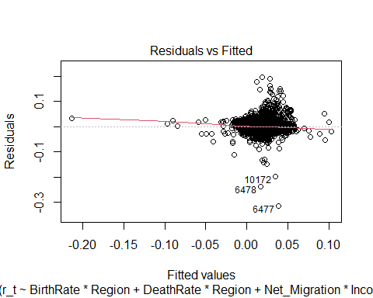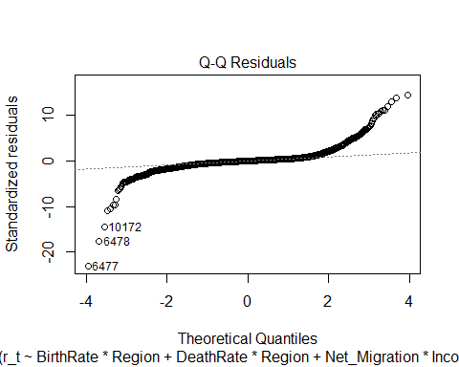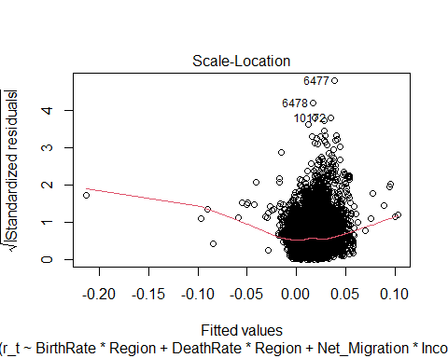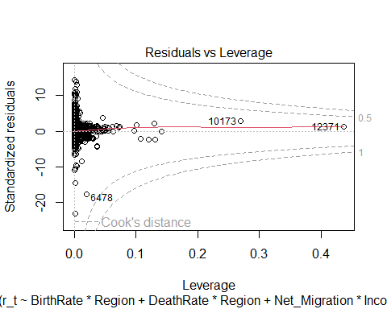
anova(model_v1, model_v2)
## Analysis of Variance Table
##
## Model 1: r_t ~ BirthRate + DeathRate + Net_Migration + IncomeGroup + Region
## Model 2: r_t ~ BirthRate * Region + DeathRate * Region + Net_Migration *
## IncomeGroup + Region + IncomeGroup
## Res.Df RSS Df Sum of Sq F Pr(>F)
## 1 13164 2.5278
## 2 13149 2.4312 15 0.096604 34.832 < 2.2e-16 ***
## ---
## Signif. codes: 0 '***' 0.001 '**' 0.01 '*' 0.05 '.' 0.1 ' ' 1
it shows RSS reduce 0.096604, and P value smaller than .001, which means not bad
model_v3 <- lm(
r_t ~ BirthRate +
DeathRate +
Net_Migration +
IncomeGroup + Region +
Net_Migration:IncomeGroup,
data = df_v1
)
plot(model_v3)
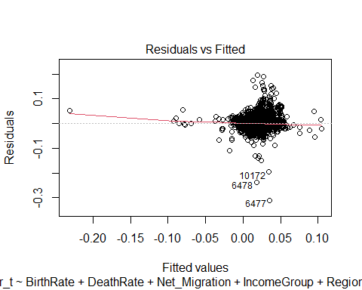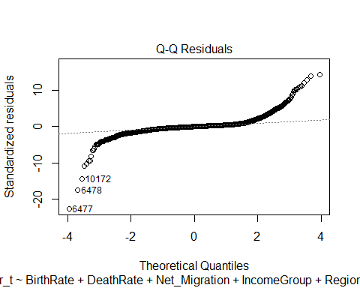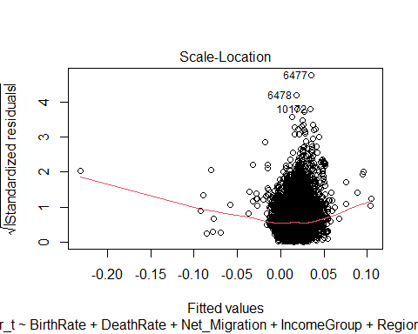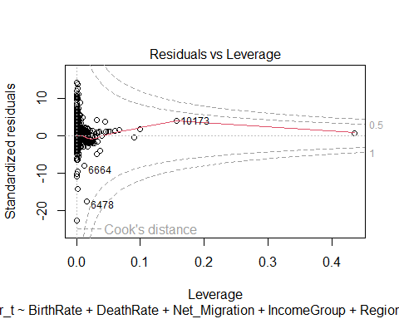
anova(model_v2, model_v3)
## Analysis of Variance Table
##
## Model 1: r_t ~ BirthRate * Region + DeathRate * Region + Net_Migration *
## IncomeGroup + Region + IncomeGroup
## Model 2: r_t ~ BirthRate + DeathRate + Net_Migration + IncomeGroup + Region +
## Net_Migration:IncomeGroup
## Res.Df RSS Df Sum of Sq F Pr(>F)
## 1 13149 2.4312
## 2 13161 2.4718 -12 -0.040553 18.277 < 2.2e-16 ***
## ---
## Signif. codes: 0 '***' 0.001 '**' 0.01 '*' 0.05 '.' 0.1 ' ' 1
Seems like model 2 is better than model 3 because of RSS, lets choose the version 2 one.

Second method by GAM (Just for better verify the models):
gam_model <- gam(r_t ~ s(BirthRate, k=10) +
s(DeathRate, k=10) +
s(Net_Migration, k=10) +
IncomeGroup +
Region,
data=df_v1,
method="REML")
summary(gam_model)
##
## Family: gaussian
## Link function: identity
##
## Formula:
## r_t ~ s(BirthRate, k = 10) + s(DeathRate, k = 10) + s(Net_Migration,
## k = 10) + IncomeGroup + Region
##
## Parametric coefficients:
## Estimate Std. Error t value Pr(>|t|)
## (Intercept) 0.0188549 0.0003303 57.080 < 2e-16 ***
## IncomeGroupLow income -0.0043714 0.0005950 -7.347 2.14e-13 ***
## IncomeGroupLower middle income -0.0032818 0.0004398 -7.463 9.00e-14 ***
## IncomeGroupUpper middle income -0.0050278 0.0003392 -14.823 < 2e-16 ***
## RegionMiddle East & North Africa 0.0057681 0.0005083 11.347 < 2e-16 ***
## RegionSub-Saharan Africa 0.0017413 0.0004906 3.549 0.000388 ***
## RegionEurope & Central Asia 0.0013747 0.0004164 3.301 0.000965 ***
## RegionEast Asia & Pacific -0.0020431 0.0004033 -5.066 4.11e-07 ***
## RegionSouth Asia 0.0044246 0.0008175 5.412 6.33e-08 ***
## RegionNorth America -0.0051011 0.0011520 -4.428 9.59e-06 ***
## ---
## Signif. codes: 0 '***' 0.001 '**' 0.01 '*' 0.05 '.' 0.1 ' ' 1
##
## Approximate significance of smooth terms:
## edf Ref.df F p-value
## s(BirthRate) 5.499 6.693 600.4 <2e-16 ***
## s(DeathRate) 8.306 8.857 190.8 <2e-16 ***
## s(Net_Migration) 8.862 8.994 129.9 <2e-16 ***
## ---
## Signif. codes: 0 '***' 0.001 '**' 0.01 '*' 0.05 '.' 0.1 ' ' 1
##
## R-sq.(adj) = 0.454 Deviance explained = 45.6%
## -REML = -37958 Scale est. = 0.00018072 n = 13177
plot(gam_model, pages=1, shade=TRUE)
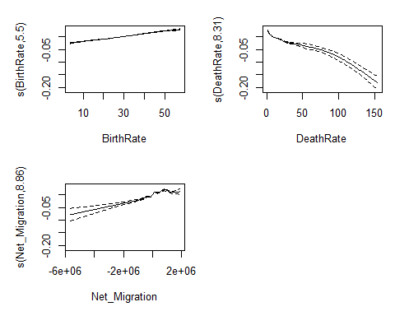
After the plot, we can see Brith rate doesn’t need to do GAM, so lets change it to version 2:
gam_model_v2 <- gam(
r_t ~ BirthRate +
s(DeathRate, k=10) +
s(Net_Migration, k=10) +
IncomeGroup +
Region,
data = df_v1,
method = "REML"
)
plot(gam_model_v2, pages=1, shade=TRUE)
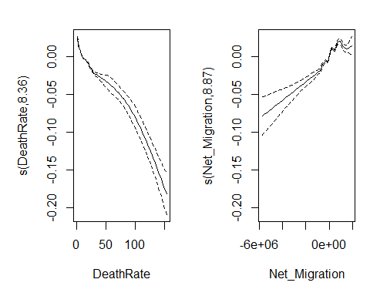
ANOVA test:
anova(model_v1, gam_model_v2)
## Analysis of Variance Table
##
## Model 1: r_t ~ BirthRate + DeathRate + Net_Migration + IncomeGroup + Region
## Model 2: r_t ~ BirthRate + s(DeathRate, k = 10) + s(Net_Migration, k = 10) +
## IncomeGroup + Region
## Res.Df RSS Df Sum of Sq F Pr(>F)
## 1 13164 2.5278
## 2 13149 2.3818 15.226 0.14599 52.932 < 2.2e-16 ***
## ---
## Signif. codes: 0 '***' 0.001 '**' 0.01 '*' 0.05 '.' 0.1 ' ' 1
anova(model_v2, gam_model_v2)
## Analysis of Variance Table
##
## Model 1: r_t ~ BirthRate * Region + DeathRate * Region + Net_Migration *
## IncomeGroup + Region + IncomeGroup
## Model 2: r_t ~ BirthRate + s(DeathRate, k = 10) + s(Net_Migration, k = 10) +
## IncomeGroup + Region
## Res.Df RSS Df Sum of Sq F Pr(>F)
## 1 13149 2.4312
## 2 13149 2.3818 0.22591 0.049388 1206.9 < 2.2e-16 ***
## ---
## Signif. codes: 0 '***' 0.001 '**' 0.01 '*' 0.05 '.' 0.1 ' ' 1
Through to ANOVA test, RSS reduce 0.14599. The P value smaller than 0.001, which means significant
Result: shows the GAM model is better than version 2 model

Subset selection
Model_v2:
$$r_{t}=β_{0}+β_{1}\left(BirthRate*Region\right)+β_{2}\left(DeathRate*Region\right)+β_{3}\left(Net_{Migration}*IncomeGroup\right)+β_{4}*Region+β_{5}*IncomeGroup+ϵ_{t}$$
reg_subset <- regsubsets(
r_t ~ BirthRate * Region +
DeathRate * Region +
Net_Migration * IncomeGroup+
IncomeGroup + Region,
data = df_v1,
nvmax = 27
)
summary_reg <- summary(reg_subset)
names(summary_reg)
## [1] "which" "rsq" "rss" "adjr2" "cp" "bic" "outmat" "obj"
summary_reg$rsq
## [1] 0.2416551 0.3354125 0.3733289 0.3950313 0.4079564 0.4201034 0.4238786
## [8] 0.4271751 0.4306093 0.4327815 0.4344376 0.4363890 0.4390959 0.4397884
## [15] 0.4403173 0.4407640 0.4410750 0.4414552 0.4417108 0.4420152 0.4422334
## [22] 0.4425187 0.4426447 0.4427734 0.4428169 0.4428287 0.4428287
par(mfrow = c(2,2))
plot(summary_reg$rss,
xlab = "Number of variables",
ylab = "RSS",
type = "l")
plot(summary_reg$adjr2,
xlab = "Number of Variables",
ylab = "Adjusted R-Squared",
type = "l")
best_adjr2 <- which.max(summary_reg$adjr2)
plot(summary_reg$adjr2,
xlab = "Number of Variables",
ylab = "Adjusted R-Squared",
type = "l")
points(best_adjr2, summary_reg$adjr2[best_adjr2], col = "red", pch = 19)
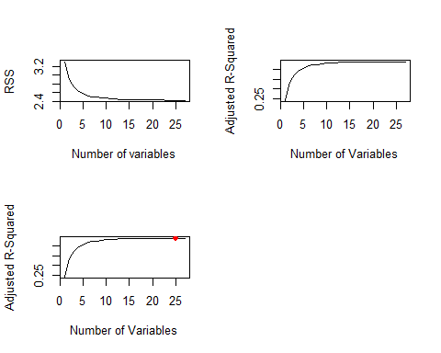
par(mfrow = c(1,2))
plot(summary_reg$cp,
xlab = "Number of Variables",
ylab = "Cp",
type = "l")
best_cp <- which.min(summary_reg$cp)
points(best_cp, summary_reg$cp[best_cp],
col = "red", cex = 2, pch = 20)
best_cp
## [1] 24
plot(summary_reg$bic,
xlab = "Number of Variables",
ylab = "BIC",
type = "l")
best_bic <- which.min(summary_reg$bic)
points(best_bic, summary_reg$bic[best_bic],
col = "red", cex = 2, pch = 20)
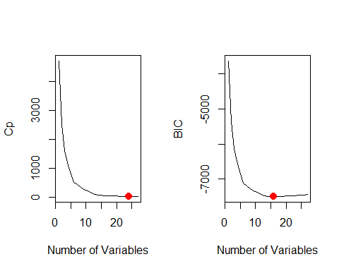 So, the best number may select from 15 to 25
Cross-Validation: select the best number.
predict_regsubset <- function(object, newdata, id) {
coefi <- coef(object, id = id)
vars <- names(coefi)
X <- model.matrix(
as.formula(object$call[[2]]),
newdata
)
return(X[, vars] %*% coefi)
}
set.seed(1)
k <- 10
folds <- sample(1:k, nrow(df_v1), replace = TRUE)
cv_errors <- matrix(NA, k, 27)
for (j in 1:k) {
train_data <- df_v1[folds != j, ]
test_data <- df_v1[folds == j, ]
reg_k <- regsubsets(
r_t ~ BirthRate * Region +
DeathRate * Region +
Net_Migration * IncomeGroup +
IncomeGroup + Region,
data = train_data,
nvmax = 27
)
for (i in 1:27) {
pred <- predict_regsubset(reg_k, test_data, id = i)
cv_errors[j, i] <- mean((test_data$r_t - pred)^2)
}
}
mean_cv_errors <- apply(cv_errors, 2, mean)
# Best model size selected by CV
best_size <- which.min(mean_cv_errors)
best_size <- which.min(summary_reg$bic)
cat("Best size:", best_size, "\n")
## Best size: 16
The result shows below:
final_model <- regsubsets(
r_t ~ BirthRate * Region +
DeathRate * Region +
Net_Migration * IncomeGroup +
IncomeGroup + Region,
data = df_v1,
nvmax = 16
)
coef(final_model, best_size)
## (Intercept) BirthRate
## 4.343122e-03 1.091977e-03
## RegionMiddle East & North Africa RegionNorth America
## 1.015023e-02 3.233607e-02
## DeathRate Net_Migration
## -1.631064e-03 1.691412e-08
## IncomeGroupLow income IncomeGroupLower middle income
## -6.854530e-03 -6.181384e-03
## IncomeGroupUpper middle income BirthRate:RegionSub-Saharan Africa
## -6.955353e-03 -8.653131e-05
## BirthRate:RegionEast Asia & Pacific RegionSub-Saharan Africa:DeathRate
## -2.547213e-04 6.928270e-04
## RegionEurope & Central Asia:DeathRate RegionEast Asia & Pacific:DeathRate
## 3.232249e-04 8.797823e-04
## RegionSouth Asia:DeathRate RegionNorth America:DeathRate
## 6.107139e-04 -4.629556e-03
## Net_Migration:IncomeGroupLow income
## 3.805936e-08
After cross validation’s plot:
plot(mean_cv_errors, type = "b",
xlab = "Number of Variables",
ylab = "CV MSE",
main = "Cross Validation to Select Best Model (regsubsets)")
abline(v = 16, col = "red", lwd = 2)
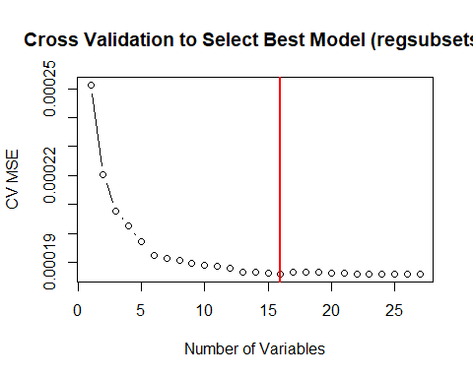

Projected forecast
First thought: predict instantaneous rate to calculate the Population rate.
Predict r
$$r_{t+h}=β_{0}+β_{1}BirthRate+β_{2}DeathRate+β_{3}Net_{Migration}+β_{4}Region+β_{5}IncomeGroup+ϵ_{t}$$
Through r to calculate N
$$N_{t+h}=N_{t}*e^{r_{t+h}}$$
- base year: the year of the earliest population size used to make a forecast,
- launch year: the year of the latest population size used to make a forecast,
- target year: the year for which population size is forecast
- base period: the interval between the base year and launch year
- forecast horizon: the interval between the launch year and target year.

Rolling window Cross-validation and model
Thus, 1960 – 1980 → train 1981 – 1981 → test when h=1 1981 – 1985 → test when h=5 1981 – 1990 → test when h=10
model <- lm(
r_t ~ BirthRate + DeathRate + Net_Migration + IncomeGroup + Region,
data = df_v1
)
Make functions for validations based on:
$$\text{MAPE}=\frac{1}{n}\sum_{t=1}^{n}{\left|PE_{t}\right|}$$
$$PE_{t}=\left(\frac{F_{t}-N_{t}}{N_{t}}\right)×100$$
$$\text{MALPE}=\frac{1}{n}\sum_{t=1}^{n}{P}E_{t}$$
because this model is based on cross-validation, so I want to build a function to easy train and test the model.
# h to control the test data size.
rolling_cross_validation <- function(df, h = 1, window_size = 20) {
years <- sort(unique(df$Year))
# create a data frame to save the result
results <- data.frame()
for (start_year in years) {
train_end <- start_year + window_size - 1
test_start <- train_end + 1
test_end <- train_end + h
# Auto break out from the loop if their no year inside the data
if (!(test_end %in% years)) next
train_block <- df[df$Year >= start_year & df$Year <= train_end, ]
test_block <- df[df$Year >= test_start & df$Year <= test_end, ]
keep_idx <- iqr_filter(train_block$r_t, k = 1.5)
train_block_clean <- train_block[keep_idx, ]
model <- lm(
r_t ~ BirthRate + DeathRate + Net_Migration + IncomeGroup + Region,
data = train_block_clean
)
model_best <- lm(
r_t ~ BirthRate + DeathRate + Net_Migration +
Region + IncomeGroup +
BirthRate:Region +
Region:DeathRate +
Net_Migration:IncomeGroup,
data = train_block_clean
)
test_block$pred_r <- predict(model, newdata = test_block)
test_block$pred_r_best <- predict(model_best, newdata = test_block)
test_block$pred_N <- test_block$Population * exp(test_block$pred_r)
test_block$pred_N_best <- test_block$Population * exp(test_block$pred_r_best)
test_block$tb <- start_year
test_block$tf <- test_end
test_block$base_len <- window_size
test_block$horizon <- h
results <- rbind(results, test_block)
}
return(results)
}
cv_h1_window10 <- rolling_cross_validation(df_v1, h = 1, window_size = 10)
cv_h1_window20 <- rolling_cross_validation(df_v1, h = 1, window_size = 20)
cv_h1_window30 <- rolling_cross_validation(df_v1, h = 1, window_size = 30)
cv_h5_window10 <- rolling_cross_validation(df_v1, h = 5, window_size = 10)
cv_h5_window20 <- rolling_cross_validation(df_v1, h = 5, window_size = 20)
cv_h5_window30 <- rolling_cross_validation(df_v1, h = 5, window_size = 30)
cv_h10_window10 <- rolling_cross_validation(df_v1, h = 10, window_size = 10)
cv_h10_window20 <- rolling_cross_validation(df_v1, h = 10, window_size = 20)
cv_h10_window30 <- rolling_cross_validation(df_v1, h = 10, window_size = 30)
cv_list <- list(
h1_w10 = cv_h1_window10,
h1_w20 = cv_h1_window20,
h1_w30 = cv_h1_window30,
h5_w10 = cv_h5_window10,
h5_w20 = cv_h5_window20,
h5_w30 = cv_h5_window30,
h10_w10 = cv_h10_window10,
h10_w20 = cv_h10_window20,
h10_w30 = cv_h10_window30
)
par(mfrow = c(3, 3), mar = c(4,4,2,1))
for (name in names(cv_list)) {
df <- cv_list[[name]]
plot(df$r_t, df$pred_r,
pch = 16, col = "steelblue",
xlab = "True r_t",
ylab = "Predicted r_t",
main = name)
abline(0, 1, lty = 2)
}
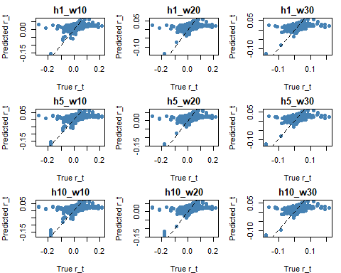 ` Function for validation:
evaluate_cv <- function(cv_df) {
cv_df <- cv_df[!is.na(cv_df$pop_N_t) & !is.na(cv_df$pred_N), ]
mape_validation <- mape(cv_df$pop_N_t, cv_df$pred_N)
malpe_validation <- malpe(cv_df$pop_N_t, cv_df$pred_N)
mape_validation_best <- mape(cv_df$pop_N_t, cv_df$pred_N_best)
malpe_validation_best <- malpe(cv_df$pop_N_t, cv_df$pred_N_best)
data.frame(
MAPE = mape_validation,
MALPE = malpe_validation,
MAPE_best = mape_validation_best,
MALPE_best = malpe_validation_best
)
}
all_results <- rbind(
data.frame(Horizon = 1, Window = 10, evaluate_cv(cv_h1_window10)),
data.frame(Horizon = 1, Window = 20, evaluate_cv(cv_h1_window20)),
data.frame(Horizon = 1, Window = 30, evaluate_cv(cv_h1_window30)),
data.frame(Horizon = 5, Window = 10, evaluate_cv(cv_h5_window10)),
data.frame(Horizon = 5, Window = 20, evaluate_cv(cv_h5_window20)),
data.frame(Horizon = 5, Window = 30, evaluate_cv(cv_h5_window30)),
data.frame(Horizon = 10, Window = 10, evaluate_cv(cv_h10_window10)),
data.frame(Horizon = 10, Window = 20, evaluate_cv(cv_h10_window20)),
data.frame(Horizon = 10, Window = 30, evaluate_cv(cv_h10_window30))
)
Make a plot to show their results:
final_table <- all_results %>%
pivot_wider(
names_from = Window,
values_from = c(MAPE, MALPE),
names_sep = "_W"
) %>%
arrange(Horizon)
print(final_table)
## # A tibble: 9 × 9
## Horizon MAPE_best MALPE_best MAPE_W10 MAPE_W20 MAPE_W30 MALPE_W10 MALPE_W20
## <dbl> <dbl> <dbl> <dbl> <dbl> <dbl> <dbl> <dbl>
## 1 1 1.77 1.61 1.76 NA NA 1.61 NA
## 2 1 1.70 1.53 NA 1.69 NA NA 1.54
## 3 1 1.60 1.40 NA NA 1.59 NA NA
## 4 5 1.77 1.63 1.76 NA NA 1.63 NA
## 5 5 1.70 1.54 NA 1.69 NA NA 1.55
## 6 5 1.57 1.40 NA NA 1.56 NA NA
## 7 10 1.78 1.63 1.76 NA NA 1.63 NA
## 8 10 1.69 1.53 NA 1.68 NA NA 1.54
## 9 10 1.54 1.39 NA NA 1.54 NA NA
## # ℹ 1 more variable: MALPE_W30 <dbl>
Look at this table, we can compare different window sizes and different horizon sizes.
Window sizes (training data): which shows the model after subset is better than original model on the MAPE validation. whatever the window size is.
Horizon sizes (forecast after h years data): I did not expect the result, the data after 10 years should hard to predict, but the table shows the model can predict the population after 10 years even better than 1 or 5 years.
Conclusion: In this case by using 1, 5 and 10 as horizon sizes, and 10, 20 and 30 as train data sizes, the best prediction size is: horizon: 10 window: 30

