TCAS File Format Specification

Version 0.96 – Date: July 5th, 2011

Introduction
TCAS is short for Ternary Color Advanced Subtitle, it is extended from TCS. TCAS files have an extension .TCAS. TCAS is part of the RIXE project. A TCAS filename looks like example.tcas. TCAS is a file format that mainly stores raw pixel data as well as its position and living duration. Theoretically speaking, TCAS allows you to draw anything on video frames, although it is mainly designed to store karaoke effects. After parsing the data stored in the TCAS file, you will get TCAS frames, which are going to be rendered on the video frames. See also the libtcas and tcasFilter project for its implementation and usage.

TCAS File Structures
Summary

TCAS file is mainly organized by two part the Header and the Body. Header contains 4 signature bytes (a DWORD) indicating the TCAS file format, other general information about TCAS file is also stored in the Header. Body holds the main TCAS data, and this part is consisted of many data chunks. The data stored in the TCAS file is aligned to 4 bytes (a DWORD), so DWORD is the unit used when talking about the size of a certain chunk in TCAS file instead of BYTE. The minimum unit of TCAS data is a Dynamic Isolated Pixel (DIP), which holds information about its living duration, position and pixel values. Dislike videos whose data is stored in a linear time-line sequence form, the data of TCAS file (TCAS data chunks) can be stored in any order. This feature is to guarantee the flexibility of using TCAS file to store karaoke effects, since we can write the effects in any order as we like without caring about their effective duration. However non-linear timing makes it inefficient to parse the TCAS file, so TCAS brings in the indexing technique to make time-line linearization possible, hence increasing performance dramatically, moreover, as a side effect of such indexing technique, multi-threading becomes possible and can be easily implemented at the parsing phase. Another important improvement is that TCAS brings in key-framing which can enormously decrease the target file size.

Detail

Header
The size of the Header part is 16 DWORDs, the same with TCS.

Offset | Size | Name | Purpose
0000h | 1 DWORD | Signature | Identify the TCAS file
0004h | 1 DWORD | Version | TCAS file version
0008h | 1 DWORD | Flag | HIWORD indicates TCAS file type, LOWORD indicates whether to use key framing
000Ch | 1 DWORD | Resolution | Resolution of TCAS FX
0010h | 1 DWORD | MinTime | Minimal time of the TCAS FX
0014h | 1 DWORD | MaxTime | Maximal time of the TCAS FX
0018h | 1 DWORD | Chunks | Number of data chunks
001Ch | 1 DWORD | fpsNumerator | Numerator of TCAS FX frame rate
0020h | 1 DWORD | fpsDenominator | Denominator of TCAS FX frame rate
0024h | 7 DWORDs | Reserved | May be used in the future

Remarks:
1. The Signature of TCAS file is 0x54 0x43 0x41 0x53, which means TCAS in ASCII.
2. Low word of Version indicates minor TCAS file version, the initial minor TCAS file version is 0. High word of Version indicates major TCAS file version, the initial major TCS file version is 1.
3. The meaning of Flag in TCAS is slightly different from the old TCS file format. HIWORD of Flag is just the same with Flag in TCS file, but LOWORD of Flag indicates whether to enable key framing. TCAS file type can be 0 - raw TCAS file, 1 - compressed TCAS file.
4. Low word of Resolution indicates the horizontal resolution that the TCAS FX is dealing with. High word of Resolution indicates the vertical resolution that the TCAS FX is dealing with. The unit of Resolution is pixel. Note that the maximal width and height can both reach 65535, but they are regarded as reserved value, so, in fact the maximal valid width and height are both 65534, which is still much enough as video resolution.
5. MinTime indicates the first time that the TCAS FX has taken effects. The unit of MinTime is millisecond, so the range of MinTime is [0, 4294967295], more than 1 thousand hours.
6. MaxTime indicates the first time that the TCAS FX has ended its effects. The unit of MaxTime is millisecond, so the range of MaxTime is [0, 4294967295], more than 1 thousand hours.
7. Chunks indicate the number of data chunks in the body part of the TCAS file.
8. TCAS FX FPS = fpsNumerator / (double) fpsDenominator, fpsNumerator and fpsDenominator indicate in which frame rate the TCAS FX has been generated. However, in most cases of rendering a TCAS file, they will simply be ignored.

Body
The Body part starts at 0040h, right after the Header part. A TCAS file is created by receiving raw TCAS data chunks.

Raw TCAS Data Chunk Stream
Raw TCAS data chunk stream is made up of dozens of raw DIPs. The data is organized as below

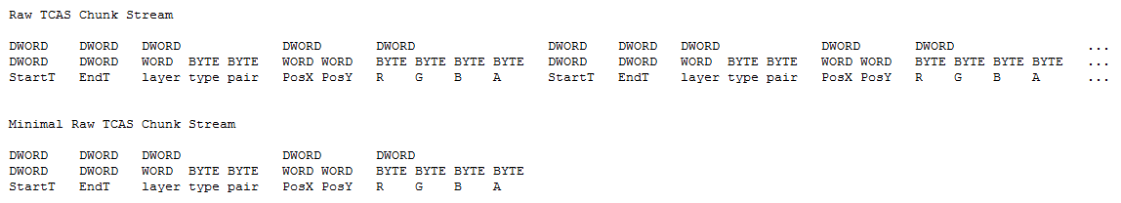

Compressed TCAS Data Chunk Stream
Compressed TCAS data chunk stream is made up of dozens of packed DIPs. The data is organized as below

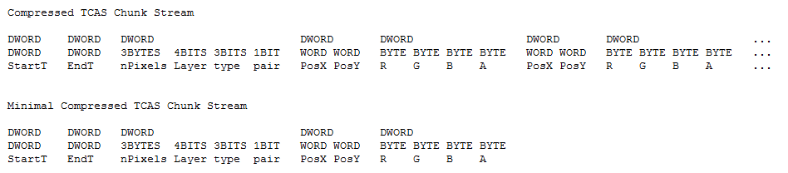

Definition of Chunk
Chunk is the minimal unit of complete TCAS FX data, but when talking about its exact meaning, it is different between raw TCAS data and TCAS data.
- When used to describe raw TCAS data: A chunk means data of a DIP. The size of a chunk in raw TCAS data stream is 5 DWORDs.
- When used to describe TCAS data: A chunk stands for several packed DIPs. The size of a chunk in TCAS file can be calculated by the following formula: size = (3 + 2 * nPixels) DWORDs.

Remarks:
1. We obtain such a file format partly because that karaoke FXs usually occupy relatively small area and their time durations are relatively short compared to the host videos.
2. The unit of StartT/EndT is millisecond, so the range of StartT/EndT is [0, 4294967295] ms, more than 1 thousand hours. The unit of PosX/PosY is pixel, so the range of PosX/PosY is 65535 pix. Note that, 65535 is reserved, so the maximal valid PosX and PosY are both 65534. When coming to the rendering phase, the range of valid PosX/PosY is -32767 to 32767, while -32768 is reserved.
3. Layer will contribute when coming to render the TCAS FX, TCAS frames with higher layers will overlay upon TCAS frames with lower layers to make up a whole FX frame. However, in one FX frame, if two TCAS frames are on the same layer, then the one which is placed in a larger part of TCAS file will overlay upon the one which is placed in a prior TCAS file. Its value is between 0 and 15 (inclusive).
4. nPixels indicates the number of packed DIPs in the chunk. It occupies the low 24 bits of a DWORD.
5. The smallest size of a chunk is 5 DWORDs.
6. In the compression process, adjacent raw DIPs who have the same StartT EndT Layer type and pair can share the same chunk. Here, adjacent is a big issue. It indicates that you should consider the locality when creating the original raw TCAS FX data. Every compression of two raw DIPs saves 3 DWORDs space.
7. Any two packed DIPs in the same chunk if they have the same position the latter will cover the former at the rendering phase;
8. When parsing, the TCAS frame should be merged according to their layers and orders;
9. type indicates which key framing algorithm should be applied, 0 indicates no key framing, 1 indicates fast generation, 2 indicates bilinear filtered. Its value is between 0 and 7 (inclusive), and in TCAS file chunks with the same type except for type 0, should appear in pairs, and their layer must be the same. Intermediate frame chunks will be generated between two key frames, that’s why they should appear in pairs. With key frames, StartT = EndT.

TCAS File Creation

Please refer to the libtcas project.

Indexing Technique

Please refer to the libtcas project.

Key Framing Technique

Please refer to the libtcas project.

TCAS FX Frame Generation Technique

Please refer to the libtcas project.

Note:
1. libtcas is the implementation of this specification, and this specification is also a description of libtcas.
2. To see the usage of libtcas please check the tcax project and the tcasFilter project.

