Create Database HRData;

Use HRData;

# KPI-1: Query to fetch Employee count, Attrtion count, Attrtion Rate, Active Employees, Monthly Income, Average age



# KPI-2: Average Attrition rate for all Departments

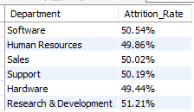

# KPI-3: Average Hourly rate of Male Research Scientist

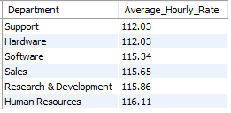

# KPI-4: Attrition rate Vs Monthly income stats

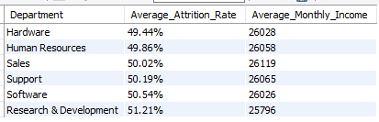

# KPI-5: Average working years for each Department

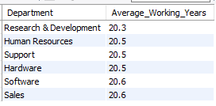

# KPI-6: Department wise No of Employees

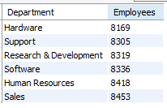

# KPI-6: Count of Employees based on Educational Fields

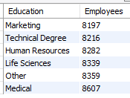

# KPI-7: Job Role Vs Work life balance

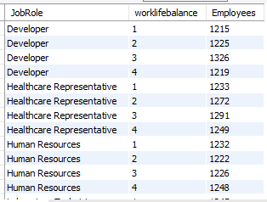

# KPI-8: Attrition rate Vs Year since last promotion relation

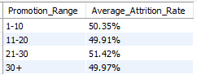

# KPI-9: Gender based Percentage of Employee

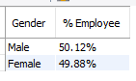

# KPI-10: Attrition by marital status

