#Session1:
Task 1:
I checked the uploaded dataset. It contains 39 matches and 10 columns.

Classification
Type | Columns | Why
Raw Data | match_id, date, venue, team1, team2, stage, toss_winner, toss_decision, first_ings_score, first_ings_wkts | These are individual, unprocessed facts recorded for each match.
Information | Examples: average first-innings score, number of matches by venue, toss-decision counts, average wickets lost | These are obtained by processing/aggregating the raw columns.
Insight | Teams scoring around 200+ in the first innings generally have a strong scoring performance and can set a challenging target for the opponent. | This is a conclusion drawn from the match scoring data.

One insight from the dataset
The first-innings scores vary considerably across matches, with some teams scoring above 200 while others are dismissed for much lower totals. This shows that batting performance differs significantly from match to match.
Note: The uploaded file is named matches-selected-columns.csv, although its contents correspond to the requested match dataset structure.

TASK 2, 3, 4: Pending

Task 5:

Predictive Analytics – Zomato Example
Predictive Analytics uses past and current data to predict what may happen in the future.
For example, Zomato can analyze a user's previous orders, favorite cuisines, location, and ordering time to predict which restaurants or dishes the user may want to order next.
How it improves user experience:
- Shows personalized restaurant recommendations.
- Suggests dishes based on previous orders.
- Predicts popular choices during lunch or dinner.
- Helps users find suitable food faster.
Example insight: If a user frequently orders pizza on Friday evenings, Zomato can predict this preference and show pizza restaurants and offers prominently on Friday evening.
Conclusion: Predictive analytics makes the app more personalized and saves users time when choosing what to order.

# Session 2:
Task 1:
Using the provided IPL match CSV file (matches-selected-columns(1).csv) as the sample dataset, here are two differences you would notice when opening it in Excel and Notepad:
Excel | Notepad
1. Data is displayed in separate rows and columns, making it easy to read, sort, and filter fields such as teams, venue, score, and wickets. | 1. Data appears as plain text, with values separated by commas (CSV format), so it is harder to visually distinguish columns.
2. Excel automatically presents values in a structured way and can format numbers and dates for easier analysis. | 2. Notepad shows the raw CSV content exactly as text, without tables, formatting, sorting, or filtering.
Example: The file contains columns such as match_id, date, venue, team1, team2, first_ings_score, and first_ings_wkts, with 39 matches and 10 columns.

Task 2, 3, 4 ,5 : Pending

# Session 3:

Task 1:

Zomato – Food Delivery
Understanding the Zomato domain is important before analyzing its data because we need to know how food delivery works and what each data field represents. For example, understanding orders, delivery time, restaurant ratings, cancellations, and customer feedback helps an analyst correctly identify patterns and measure customer satisfaction. Without domain knowledge, the data may be misinterpreted and lead to incorrect business decisions.
Task 2:
For the Flipkart (E-commerce) domain, the analytics team could track these 4 important KPIs:
- Total Sales / Revenue – Measures the total value of products sold over a specific period. Higher sales indicate business growth.
- Customer Acquisition Rate – Measures how many new customers Flipkart gains through marketing campaigns and promotions.
- Repeat Purchase Rate – Measures the percentage of customers who return to Flipkart and make another purchase. A higher rate indicates strong customer loyalty.
- Average Order Value (AOV) – Measures the average amount spent by a customer per order.
Formula: AOV = Total Revenue ÷ Number of Orders.
These KPIs help Flipkart understand sales performance, customer growth, customer loyalty, and spending behavior.
Task 3:

Customer Acquisition Cost (CAC) for Paytm
Customer Acquisition Cost (CAC) is the average amount of money Paytm spends to acquire one new customer.
Formula:
CAC = Total Customer Acquisition Cost ÷ Number of New Customers Acquired

Example
Suppose Paytm runs a campaign to attract new users:
- Digital advertising on Google and social media: ₹5 lakh
- Cashback and promotional offers: ₹3 lakh
- Marketing campaign expenses: ₹2 lakh
- Total cost = ₹10 lakh
- New customers acquired = 20,000
Therefore:
CAC = ₹10,00,000 ÷ 20,000 = ₹50 per customer
So, Paytm's Customer Acquisition Cost is ₹50 per new customer.
This helps Paytm understand whether its marketing campaigns are cost-effective and whether it should increase or reduce spending on customer acquisition.

Task 4:
As a data analyst for Swiggy, I would define a new metric called the On-Time Delivery Rate (OTDR) to measure customer satisfaction. This metric would show the percentage of orders delivered within the estimated delivery time promised to the customer. I would calculate it by dividing the number of orders delivered on time by the total number of delivered orders and multiplying by 100. Tracking OTDR by restaurant, location, time of day, and delivery partner would help Swiggy identify delays and take corrective actions, ultimately improving the customer experience and satisfaction.

#Session 4:
Task 1:
A real-world analytics problem for Zomato is understanding which food categories are most popular among customers in Ahmedabad. The business question I would like to answer is: “Which food categories are ordered most frequently on Zomato in Ahmedabad?” By analyzing order data, customer preferences, locations, and order frequency, Zomato can identify popular food categories and use this information to improve restaurant recommendations, offers, and customer experience.
Eg: A specific analytics problem for Zomato is to find out which food categories generate the most orders from customers aged 18–30 in Ahmedabad during dinner hours (7 PM–10 PM). The business question is: “Which food categories are most frequently ordered by 18–30-year-old customers in Ahmedabad between 7 PM and 10 PM?” By analyzing order history, customer age, food category, location, and order time, Zomato can identify customer preferences and create targeted discounts and recommendations to increase evening orders.
Task 2:
Here are 5 types of raw data needed to analyze music listening trends on Spotify:
- User ID – Unique identifier for each listener.
- Song Name / Track ID – Identifies the song being played.
- Artist Name – Identifies the artist of the song.
- Play Timestamp – Date and time when the song was played.
- Listening Duration – How long the user listened to the song.
These raw data points can help analyze popular songs, artists, listening patterns, and user preferences over time.

Task 3:
Here is the cleaned and standardized data:
Field | Cleaned Value
product_id | ₁₂₃
name | iPhone 14
price | 79999
category | mobiles
rating | _{4.5}
stock | _{Yes}

Final analysis-ready record:
123, iPhone 14, 79999, mobiles, 4.5, Yes
This removes extra spaces, converts price to an integer, and standardizes category to lowercase.
Task 4:
User | Total Spend
A | ₹450
B | ₹150

Task :5
Here is a simple example using 3 movies and illustrative ticket-sales data:
Tickets Sold per Movie
Number of tickets sold for three selected movies.
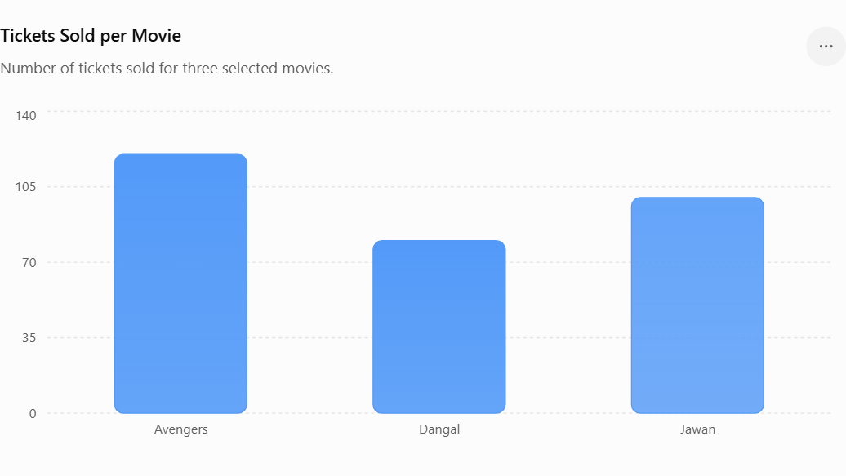

Insight for the manager:
Avengers has the highest ticket sales with 120 tickets, followed by Jawan with 100 tickets and Dangal with 80 tickets. The manager could focus marketing and additional show timings on Avengers, as it shows the strongest customer demand.

#Session 5:
Tasks: All Tasks Pending

#Session 6:
Task 1:

Case Study: Zomato (Food Delivery)
- Which food categories generate the highest number of orders?
- Which restaurants have the highest average customer ratings?
- What time of day has the highest order volume?
Task 2: Pending
Task 3:
For the Zomato case study, the expected outcomes from analyzing the dataset could be:
- Identify the most popular food categories and restaurants.
- Measure average order value and delivery time.
- Find customer ordering patterns and peak ordering hours.
- Identify factors affecting customer ratings and satisfaction.
These outcomes can help Zomato make better decisions about restaurant partnerships, delivery staffing, promotions, and customer experience.
Task 4:
As a data analyst for a food delivery app like Swiggy, a key business question could be: “Which factors are causing delays in food deliveries, and how can delivery time be reduced?” I would need a dataset containing order ID, restaurant, customer location, delivery partner, order time, preparation time, delivery time, distance, and customer rating. The analysis could identify common causes of delays and help Swiggy optimize delivery routes, improve restaurant preparation processes, and increase customer satisfaction.

