Beer Recommender System – ratebeer.com

Motivation: Beer is a drink which is the source of pleasure and complement of celebration but it is harmful too. This recommenar system aims to provide the recommendations to beer lovers.

Data – Description: We’ve scraped two different dataset. One is the beer information data and other is review data. This data contains about the 1200 beer reviews along with the beer description, breweries information, overall ratings, user’s name & address etc. We have across 250,000 reviews of top 20 beers in every states of U.S.

Below is the web data that we have scraped.
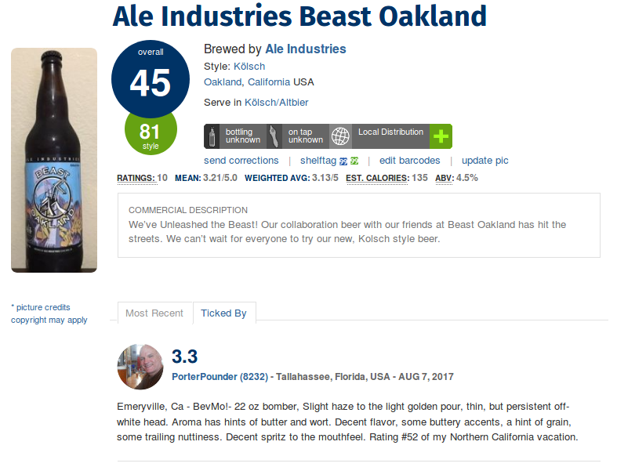
Progress : To achieve this, we decided to scrape the data from the ratebeer.com as this was the easy source to get the data. But we had constraint ourselves to U.S beers only.
To move ahead further, we have cleaned both the dataset i.e. beer infomation and beer reviews.
Our next step is to do the Exploratory data analysis and then apply NLP model.
Final step is to make the collaborative filtering model and deploy them as a Flask based web-application.

