Sr No. | Lab Title | Link
 | https://microsoftlearning.github.io/mslearn-fabric/
1 | Create and ingest data with a Microsoft Fabric lakehouse | https://microsoftlearning.github.io/mslearn-fabric/Instructions/Labs/01-lakehouse.html
2 | Create and use a Dataflow Gen2 in Microsoft Fabric | https://microsoftlearning.github.io/mslearn-fabric/Instructions/Labs/05-dataflows-gen2.html
3 | Analyze data with Apache Spark | https://microsoftlearning.github.io/mslearn-fabric/Instructions/Labs/02-analyze-spark.html
4 | Work with Delta Lake tables in Microsoft Fabric | https://microsoftlearning.github.io/mslearn-fabric/Instructions/Labs/03-delta-lake.html
5 | Ingest data with a pipeline | https://microsoftlearning.github.io/mslearn-fabric/Instructions/Labs/04-ingest-pipeline.html
6 | Organize your Fabric lakehouse using a medallion architecture | https://microsoftlearning.github.io/mslearn-fabric/Instructions/Labs/03b-medallion-lakehouse.html
7 | Explore Real-Time Intelligence in Fabric | https://microsoftlearning.github.io/mslearn-fabric/Instructions/Labs/07-real-time-Intelligence.html
8 | Ingest real-time data with Eventstreams in Microsoft Fabric | https://microsoftlearning.github.io/mslearn-fabric/Instructions/Labs/09-real-time-analytics-eventstream.html
9 | Get started with Real-Time Dashboards in Microsoft Fabric | https://microsoftlearning.github.io/mslearn-fabric/Instructions/Labs/13-real-time-dashboards.html
10 | Analyze data in a data warehouse | https://microsoftlearning.github.io/mslearn-fabric/Instructions/Labs/06-data-warehouse.html
11 | Load data into a data warehouse in Microsoft Fabric | https://microsoftlearning.github.io/mslearn-fabric/Instructions/Labs/06a-data-warehouse-load.html
12 | Monitor a data warehouse in Microsoft Fabric | https://microsoftlearning.github.io/mslearn-fabric/Instructions/Labs/06c-monitor-data-warehouse.html
13 | Secure a warehouse in Microsoft Fabric | https://microsoftlearning.github.io/mslearn-fabric/Instructions/Labs/06d-secure-data-warehouse.html
14 | Implement deployment pipelines in Microsoft Fabric | https://microsoftlearning.github.io/mslearn-fabric/Instructions/Labs/21-implement-cicd.html
15 | Monitor Fabric activity in the Monitor hub | https://microsoftlearning.github.io/mslearn-fabric/Instructions/Labs/18-monitor-hub.html
16 | Secure data access in Microsoft Fabric | https://microsoftlearning.github.io/mslearn-fabric/Instructions/Labs/19-secure-data-access.html

Sr No. | Title | Link
1 | Survey Link: Participants | https://forms.office.com/r/tmRz2Ki21x
2 |  | 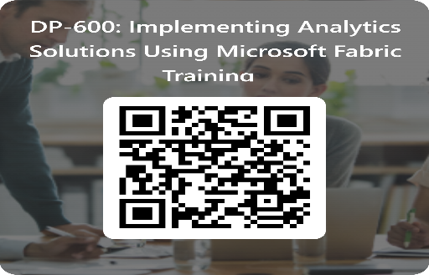
3 | Course Link | STEP 1: Using this link Register for the Test Prep using Corporate Mail ID - https://testprep.cloudthat.com/login/signup.php  Step 2: Click on link to activate this account, that link you received in your registered email account.  Step 3: https://testprep.cloudthat.com/course/view.php?id=2942  Enrolment key : 5RYebGXZa9
4 |  | Test User : seema.mandlik01@cloudthat820.onmicrosoft.com  SeemaMandlik@cloudthat820.onmicrosoft.com
5 |  | I appreciate your participation in this course. I hope you find the sessions engaging and informative, and that you enjoy interacting with me during this training.  Please fill out the feedback form using the link provided here. Your feedback is very important to us, and it will only take a few minutes of your time. Thank you very much for your cooperation and support.

Survey Link: Participants

