Seema Hanumanthappa
26, Reichenhainer Str. 35, Chemnitz, Germany ·  +49- 176 –567 10 202 ·
 seemahanumanthappa@gmail.com
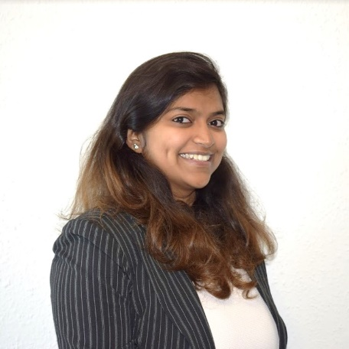  Educational Background | Seema Hanumanthappa  Masters in automotive software engineering  Technische Universität, Chemnitz  08.06.1991, Bangalore, India  Marital Status: Single  Nationality: Indian  LinkedIn: Seema Hanumanthappa  XING: Seema Hanumanthappa
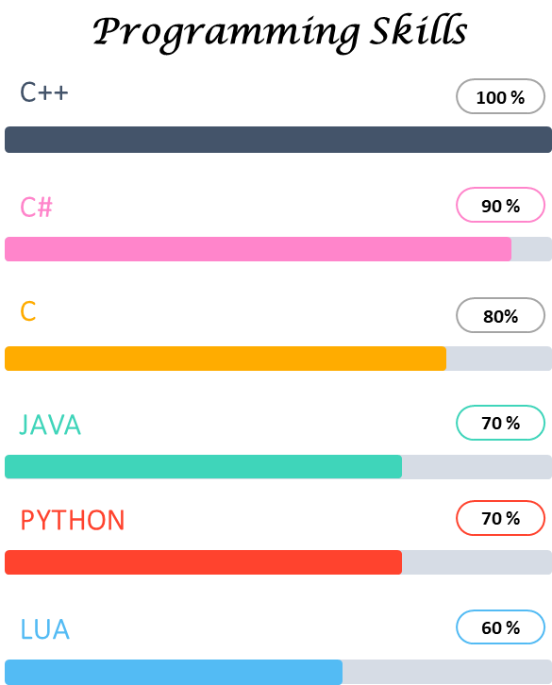
Work Experience

Technische Universität Chemnitz (10/2017 – present)

- Automotive Software Engineering (M.Sc.)
- Focus on: Software Platform & Automotive Systems, Automotive Software Lab
- Other subjects: Design of Software for Digital Systems, Automotive Sensor System, Hardware-Software Co-design
SRM University, India (09/2009 – 03/2013)
- Electronics & Communication (Bachelor of Technology)
- Focus on: Embedded System, Neural Networks & Fuzzy logic
- Other subjects: Bio-medical instrumentation, Microprocessors & Microcontrollers, Microwave & RF Design, Digital Signal Processing
- Grade: 9.015/10 (German System – 1.5/4.0)
Kendriya Vidyalaya, New Delhi (04/2007 – 03/2009)
- High School
- Focus on: Mathematics, Physics, Chemistry, Computer Science
- Grade: 87.4%
05/2018 – present | Intenta GmbH, Chemnitz, Germany  Student Job, Software Development  - Developing a software platform to automate testing for Audi Fusion and other ECUs using C++  - Developing libraries to establish Flexray communication with the ECUs  - Developing Python based GUI application for user interface
Seema Hanumanthappa
26, Reichenhainer Str. 35, Chemnitz, Germany ·  +49- 176 –567 10 202 ·
 seemahanumanthappa@gmail.com

10/2016 – 09/2017 | Continental Automotive, Bangalore, India  Executive Engineer, Vehicle Diagnostics, CVAM  - Automate integration testing by developing software platform in C++ to parse configuration files (XML), establish CAN communication and execute Lua test scripts  - Tool development using C# for supporting End of Line testing, Development board testing, Flashing software on ECUs etc.  - Developed software platforms containing libraries for the standard communication protocols like CAN, UDS, XCP etc.  - Training and guiding new members in the team with new technologies and network protocols  - Hands-on experience with ECU development boards and CAN Vector tools like CANoe, CANdela etc.  - Working experience of V-model, Scrum based projects  - Working experience and understanding of project planning.
08/2013 – 09/2016 | TATA Consultancy Services, Bangalore, India  System Engineer, Engineering Services  - Developed Windows Presentation Framework (WPF) based GUI for enabling Bluetooth communication with a medical device using C#  - Experience in system/white box testing a for medical device  - Experience in Unit testing for medical device containing 16-bit microcontroller  - Full Software Development Life Cycle (SDLC) experience including - Requirement Analysis, Design and Validation-Verification activities as per V&V software development model  Good communication skills and experience managing client
Extra-Curricular Activities

 | - Scholarship holder (Germany): e-fellows.net supports the best 10% of a year starting from November, 2017
Voluntary Work, Memberships & Awards

- We The People Foundation, Chennai
Civil Rights and Social Action
- Regular blood donator back in India, every 6 months
- Chennai Rotaract club member from 2009-2013.
 | Interests: Reading, writing short stories, playing Badminton and Tennis
 | Seema Hanumanthappa
Place, Date | Chemnitz, 01.06.2018

